Supplementary Materials
HSF2 Expression Is Inversely, Not Positively, Associated with a NETosis-Core Gene Signature Across Liver and Lung Fibrosis
This document reports every intermediate and final data table, statistical result, and figure generated for the accompanying manuscript that is not reproduced in the main text, so that the full analysis is documented and independently checkable. All items are also available as machine-readable CSV files and high-resolution PNG figures in the project's version-controlled repository (GitHub: bioinform25/project2, folders results/ and figures/), generated by the numbered R scripts in scripts/ (00-12). Very large per-sample data tables (hundreds of rows) are described here with summary statistics and referenced by file name rather than reproduced row-by-row; the full CSV is available in the repository.
Contents: Section S1 (fibrosis cohorts, full statistics), Section S2 (individual NETosis panel gene results per cohort), Section S3 (ChEA3 in silico enrichment, full output), Section S4 (HCC immune-checkpoint-inhibitor cohorts, full statistics), Section S5 (supplementary figures: all cohort-level scatter and boxplots not shown in the main text).

S1. Fibrosis cohorts: full statistics

Table S1a. Primary endpoint results, all 4 fibrosis cohorts, full statistics including bootstrap CI and leave-one-out (LOO) sensitivity range.
Source: results/ALL_COHORTS_primary_endpoint_summary.csv. Corresponds to main-text Table 2, shown here with organ/comparison labels and full precision.
cohort | organ | comparison | n | rho | p_value | ci_lo | ci_hi
liver_GSE135251 | Liver | GSE135251_liver: HSF2 vs NET_core (NAFLD subset, primary) | 206 | -0.1447 | 0.03793 | -0.2876 | -0.002054
liver_GSE14323 | Liver | GSE14323_liver: HSF2 vs NET_core (diseased subset, primary/replication) | 96 | -0.5505 | 6.236e-09 | -0.6889 | -0.3806
lung_GSE47460 | Lung | GSE47460_lung: HSF2 vs NET_core (UIP/IPF subset, primary) | 122 | -0.3917 | 8.122e-06 | -0.5385 | -0.2183
lung_GSE53845 | Lung | GSE53845_lung: HSF2 vs NET_core (IPF subset, primary/replication) | 40 | -0.04991 | 0.7597 | -0.3498 | 0.2736

Table S1b. Random-effects meta-analysis summary (overall and organ-restricted).
Source: results/ALL_COHORTS_meta_analysis_summary.csv.
level | pooled_rho | ci_lo | ci_hi | p_value | I2
Overall (4 cohorts) | -0.3075 | -0.5079 | -0.07561 | 0.01007 | 83.46
Liver only (2 cohorts) | -0.3594 | -0.6858 | 0.08721 | 0.1117 | 93
Lung only (2 cohorts) | -0.2519 | -0.5445 | 0.0953 | 0.1529 | 73.24

Table S1c. Specificity control: HSF2/NET_core/PTPRC pairwise correlations, full statistics with bootstrap CI and LOO range.
Source: results/SPECIFICITY_check_PTPRC_vs_NETcore.csv. Corresponds to main-text Table 3, shown here with full precision and LOO sensitivity range.
comparison | n | rho | p_value | ci_lo | ci_hi | loo_rho_min | loo_rho_max
GSE135251_liver: HSF2 vs PTPRC (NAFLD subset) | 206 | 0.1784 | 0.01031 | 0.04455 | 0.3123 | 0.1667 | 0.1946
GSE135251_liver: HSF2 vs NET_core (NAFLD subset) [repeat] | 206 | -0.1447 | 0.03793 | -0.2876 | -0.002054 | -0.1591 | -0.1326
GSE135251_liver: PTPRC vs NET_core (NAFLD subset) | 206 | 0.2515 | 0.0002656 | 0.113 | 0.3764 | 0.2409 | 0.2642
GSE14323_liver: HSF2 vs PTPRC (diseased subset) | 96 | 0.4483 | 4.65e-06 | 0.2567 | 0.623 | 0.4309 | 0.4896
GSE14323_liver: HSF2 vs NET_core (diseased subset) [repeat] | 96 | -0.5505 | 6.236e-09 | -0.6889 | -0.3806 | -0.5758 | -0.5361
GSE14323_liver: PTPRC vs NET_core (diseased subset) | 96 | -0.2239 | 0.02828 | -0.4266 | -0.01613 | -0.258 | -0.1996

Table S1d. Per-sample gene detection rate, GSE135251 (RNA-seq), NETosis panel genes.
Source: results/liver_GSE135251_gene_detection_rate.csv. Fraction of the 216 samples with a nonzero raw count for each panel gene; reported because several NETosis-lineage genes are lowly and sparsely expressed in bulk liver tissue (neutrophils are a minor fraction of the cell mixture), which is expected biology rather than a quality defect, but is relevant to interpreting the strength of individual-gene correlations.
gene | detection_rate
AZU1 | 0.4259
CAMP | 0.6019
CTSG | 0.963
DEFA4 | 0.4537
ELANE | 0.4167
HSF2 | 1
ITGAM | 1
LCN2 | 1
LTF | 1
MPO | 0.9491
NCF2 | 1
PADI4 | 0.7917
S100A12 | 0.9028

S2. Individual NETosis-panel gene results per cohort
Full per-gene Spearman correlation with HSF2 (bootstrap CI, LOO range, BH-FDR-adjusted p-value) for every gene in the NETosis-extended panel, in each of the four fibrosis cohorts individually. The cross-cohort summary derived from these tables is main-text Table 4 (abbreviated) and Table S2e (full, below).

Table S2. GSE135251 (liver, primary): individual-gene results.
Source: results/liver_GSE135251_individual_gene_results.csv.
comparison | n | rho | p_value | ci_lo | ci_hi | loo_rho_min | loo_rho_max | p_FDR
GSE135251_liver: HSF2 vs PADI4 (NAFLD subset) | 206 | -0.1197 | 0.08646 | -0.2602 | 0.03173 | -0.1347 | -0.1075 | 0.1729
GSE135251_liver: HSF2 vs ELANE (NAFLD subset) | 206 | -0.1919 | 0.005729 | -0.3224 | -0.05175 | -0.2076 | -0.179 | 0.02292
GSE135251_liver: HSF2 vs MPO (NAFLD subset) | 206 | -0.02532 | 0.7179 | -0.1662 | 0.1193 | -0.0382 | -0.01117 | 0.7179
GSE135251_liver: HSF2 vs CTSG (NAFLD subset) | 206 | -0.2086 | 0.002622 | -0.3448 | -0.06714 | -0.2213 | -0.1973 | 0.01797
GSE135251_liver: HSF2 vs LTF (NAFLD subset) | 206 | -0.2058 | 0.002994 | -0.3409 | -0.05384 | -0.2217 | -0.1945 | 0.01797
GSE135251_liver: HSF2 vs CAMP (NAFLD subset) | 206 | -0.05591 | 0.4248 | -0.204 | 0.08435 | -0.07005 | -0.04252 | 0.5339
GSE135251_liver: HSF2 vs DEFA4 (NAFLD subset) | 206 | -0.09005 | 0.198 | -0.231 | 0.05066 | -0.1052 | -0.07606 | 0.297
GSE135251_liver: HSF2 vs AZU1 (NAFLD subset) | 206 | -0.1414 | 0.0427 | -0.2881 | 0.004912 | -0.1578 | -0.1281 | 0.1281
GSE135251_liver: HSF2 vs ITGAM (NAFLD subset) | 206 | -0.09776 | 0.1621 | -0.2286 | 0.04064 | -0.1118 | -0.08586 | 0.2779
GSE135251_liver: HSF2 vs NCF2 (NAFLD subset) | 206 | -0.05351 | 0.4449 | -0.1862 | 0.0881 | -0.06779 | -0.04014 | 0.5339
GSE135251_liver: HSF2 vs S100A12 (NAFLD subset) | 206 | -0.02684 | 0.7018 | -0.1648 | 0.1093 | -0.04079 | -0.01354 | 0.7179
GSE135251_liver: HSF2 vs LCN2 (NAFLD subset) | 206 | -0.1278 | 0.06714 | -0.2582 | 0.01064 | -0.1409 | -0.1152 | 0.1611

Table S2. GSE14323 (liver, replication): individual-gene results.
Source: results/liver_GSE14323_individual_gene_results.csv.
comparison | n | rho | p_value | ci_lo | ci_hi | loo_rho_min | loo_rho_max | p_FDR
GSE14323_liver: HSF2 vs PADI4 (diseased subset) | 96 | -0.4963 | 2.707e-07 | -0.635 | -0.3198 | -0.5223 | -0.4813 | 3.248e-06
GSE14323_liver: HSF2 vs ELANE (diseased subset) | 96 | -0.4216 | 1.891e-05 | -0.5867 | -0.231 | -0.4467 | -0.4031 | 7.564e-05
GSE14323_liver: HSF2 vs MPO (diseased subset) | 96 | -0.2775 | 0.006198 | -0.4495 | -0.09065 | -0.3019 | -0.2554 | 0.009297
GSE14323_liver: HSF2 vs CTSG (diseased subset) | 96 | 0.05111 | 0.6209 | -0.1751 | 0.2587 | 0.02472 | 0.08063 | 0.6209
GSE14323_liver: HSF2 vs LTF (diseased subset) | 96 | 0.1763 | 0.08568 | -0.03822 | 0.3652 | 0.1542 | 0.2077 | 0.1028
GSE14323_liver: HSF2 vs CAMP (diseased subset) | 96 | -0.4595 | 2.492e-06 | -0.6091 | -0.2836 | -0.4769 | -0.4422 | 1.495e-05
GSE14323_liver: HSF2 vs DEFA4 (diseased subset) | 96 | -0.3371 | 0.0007841 | -0.5172 | -0.1362 | -0.367 | -0.3161 | 0.001344
GSE14323_liver: HSF2 vs AZU1 (diseased subset) | 96 | -0.353 | 0.0004193 | -0.5439 | -0.1466 | -0.388 | -0.3344 | 0.001006
GSE14323_liver: HSF2 vs ITGAM (diseased subset) | 96 | 0.3429 | 0.000626 | 0.15 | 0.5265 | 0.3236 | 0.3784 | 0.001252
GSE14323_liver: HSF2 vs NCF2 (diseased subset) | 96 | 0.3884 | 9.198e-05 | 0.1982 | 0.5556 | 0.3712 | 0.4267 | 0.0002759
GSE14323_liver: HSF2 vs S100A12 (diseased subset) | 96 | 0.218 | 0.03284 | 0.01734 | 0.4081 | 0.1956 | 0.2501 | 0.04379
GSE14323_liver: HSF2 vs LCN2 (diseased subset) | 96 | 0.1348 | 0.1902 | -0.06864 | 0.3393 | 0.1119 | 0.1691 | 0.2075

Table S2. GSE47460 (lung, primary): individual-gene results.
Source: results/lung_GSE47460_individual_gene_results.csv.
comparison | n | rho | p_value | ci_lo | ci_hi | loo_rho_min | loo_rho_max | p_FDR
GSE47460_lung: HSF2 vs PADI4 (UIP/IPF subset) | 122 | -0.2051 | 0.02342 | -0.3682 | -0.02085 | -0.2317 | -0.1858 | 0.02862
GSE47460_lung: HSF2 vs ELANE (UIP/IPF subset) | 122 | -0.3475 | 8.792e-05 | -0.5009 | -0.1761 | -0.3701 | -0.3324 | 0.0001612
GSE47460_lung: HSF2 vs MPO (UIP/IPF subset) | 122 | -0.3204 | 0.0003212 | -0.4695 | -0.1401 | -0.3445 | -0.3036 | 0.0004417
GSE47460_lung: HSF2 vs CTSG (UIP/IPF subset) | 122 | -0.04815 | 0.5985 | -0.2394 | 0.1281 | -0.07011 | -0.02811 | 0.5985
GSE47460_lung: HSF2 vs LTF (UIP/IPF subset) | 122 | 0.4356 | 5.326e-07 | 0.2843 | 0.5708 | 0.4225 | 0.4611 | 1.172e-06
GSE47460_lung: HSF2 vs CAMP (UIP/IPF subset) | 122 | -0.4568 | 1.236e-07 | -0.5823 | -0.3096 | -0.4846 | -0.4445 | 4.532e-07
GSE47460_lung: HSF2 vs DEFA4 (UIP/IPF subset) | 122 | -0.328 | 0.000226 | -0.4871 | -0.1389 | -0.3546 | -0.3115 | 0.0003552
GSE47460_lung: HSF2 vs ITGAM (UIP/IPF subset) | 122 | -0.4759 | 3.037e-08 | -0.6175 | -0.3136 | -0.4982 | -0.4629 | 1.67e-07
GSE47460_lung: HSF2 vs NCF2 (UIP/IPF subset) | 122 | -0.477 | 2.774e-08 | -0.6114 | -0.32 | -0.5089 | -0.465 | 1.67e-07
GSE47460_lung: HSF2 vs S100A12 (UIP/IPF subset) | 122 | -0.1995 | 0.02763 | -0.38 | 0.006996 | -0.2278 | -0.1803 | 0.03039
GSE47460_lung: HSF2 vs LCN2 (UIP/IPF subset) | 122 | 0.4425 | 3.345e-07 | 0.2774 | 0.5767 | 0.4286 | 0.4683 | 9.2e-07

Table S2. GSE53845 (lung, replication): individual-gene results.
Source: results/lung_GSE53845_individual_gene_results.csv.
comparison | n | rho | p_value | ci_lo | ci_hi | loo_rho_min | loo_rho_max | p_FDR
GSE53845_lung: HSF2 vs PADI4 (IPF subset) | 40 | 0.1807 | 0.2646 | -0.1164 | 0.4581 | 0.1267 | 0.2405 | 0.4535
GSE53845_lung: HSF2 vs ELANE (IPF subset) | 40 | 0.07542 | 0.6437 | -0.2745 | 0.3829 | 0.01336 | 0.1219 | 0.7431
GSE53845_lung: HSF2 vs MPO (IPF subset) | 40 | -0.4124 | 0.008187 | -0.6599 | -0.09826 | -0.4611 | -0.3674 | 0.01965
GSE53845_lung: HSF2 vs CTSG (IPF subset) | 40 | -0.05966 | 0.7146 | -0.3826 | 0.2575 | -0.1008 | 0.009514 | 0.7431
GSE53845_lung: HSF2 vs LTF (IPF subset) | 40 | 0.6463 | 6.632e-06 | 0.4434 | 0.766 | 0.6229 | 0.6802 | 2.653e-05
GSE53845_lung: HSF2 vs CAMP (IPF subset) | 40 | -0.5295 | 0.000443 | -0.7201 | -0.2549 | -0.5745 | -0.4962 | 0.001329
GSE53845_lung: HSF2 vs DEFA4 (IPF subset) | 40 | -0.09681 | 0.5523 | -0.3989 | 0.2122 | -0.1437 | -0.03057 | 0.7364
GSE53845_lung: HSF2 vs AZU1 (IPF subset) | 40 | -0.05347 | 0.7431 | -0.4089 | 0.2923 | -0.1366 | 0.009514 | 0.7431
GSE53845_lung: HSF2 vs ITGAM (IPF subset) | 40 | -0.3466 | 0.02843 | -0.6027 | -0.02797 | -0.3934 | -0.2989 | 0.05687
GSE53845_lung: HSF2 vs NCF2 (IPF subset) | 40 | -0.6647 | 2.896e-06 | -0.81 | -0.4539 | -0.6998 | -0.6397 | 2.653e-05
GSE53845_lung: HSF2 vs S100A12 (IPF subset) | 40 | -0.1186 | 0.4662 | -0.3901 | 0.1909 | -0.1729 | -0.06377 | 0.6993
GSE53845_lung: HSF2 vs LCN2 (IPF subset) | 40 | 0.6548 | 4.559e-06 | 0.4324 | 0.7979 | 0.6338 | 0.7259 | 2.653e-05

Table S2e. Cross-cohort gene consistency, full 12-gene table.
Source: results/CROSS_COHORT_gene_consistency.csv. Corresponds to main-text Table 4 (which shows only the 5 most reproducible genes); this table includes all 12 NETosis-panel genes tested (AZU1 tested in 3/4 cohorts only - no probe/gene match on the GSE47460 platform).
gene | liver_GSE135251_rho | liver_GSE14323_rho | lung_GSE47460_rho | lung_GSE53845_rho | liver_GSE135251_FDR | liver_GSE14323_FDR | lung_GSE47460_FDR | lung_GSE53845_FDR | n_cohorts_tested | n_cohorts_sig_FDR05 | direction_consistent | n_negative | n_positive
CAMP | -0.05591 | -0.4595 | -0.4568 | -0.5295 | 0.5339 | 1.495e-05 | 4.532e-07 | 0.001329 | 4 | 3 | True | 4 | 0
ELANE | -0.1919 | -0.4216 | -0.3475 | 0.07542 | 0.02292 | 7.564e-05 | 0.0001612 | 0.7431 | 4 | 3 | False | 3 | 1
LTF | -0.2058 | 0.1763 | 0.4356 | 0.6463 | 0.01797 | 0.1028 | 1.172e-06 | 2.653e-05 | 4 | 3 | False | 1 | 3
MPO | -0.02532 | -0.2775 | -0.3204 | -0.4124 | 0.7179 | 0.009297 | 0.0004417 | 0.01965 | 4 | 3 | True | 4 | 0
NCF2 | -0.05351 | 0.3884 | -0.477 | -0.6647 | 0.5339 | 0.0002759 | 1.67e-07 | 2.653e-05 | 4 | 3 | False | 3 | 1
DEFA4 | -0.09005 | -0.3371 | -0.328 | -0.09681 | 0.297 | 0.001344 | 0.0003552 | 0.7364 | 4 | 2 | True | 4 | 0
ITGAM | -0.09776 | 0.3429 | -0.4759 | -0.3466 | 0.2779 | 0.001252 | 1.67e-07 | 0.05687 | 4 | 2 | False | 3 | 1
LCN2 | -0.1278 | 0.1348 | 0.4425 | 0.6548 | 0.1611 | 0.2075 | 9.2e-07 | 2.653e-05 | 4 | 2 | False | 1 | 3
PADI4 | -0.1197 | -0.4963 | -0.2051 | 0.1807 | 0.1729 | 3.248e-06 | 0.02862 | 0.4535 | 4 | 2 | False | 3 | 1
S100A12 | -0.02684 | 0.218 | -0.1995 | -0.1186 | 0.7179 | 0.04379 | 0.03039 | 0.6993 | 4 | 2 | False | 3 | 1
CTSG | -0.2086 | 0.05111 | -0.04815 | -0.05966 | 0.01797 | 0.6209 | 0.5985 | 0.7431 | 4 | 1 | False | 3 | 1
AZU1 | -0.1414 | -0.353 | nan | -0.05347 | 0.1281 | 0.001006 | nan | 0.7431 | 3 | 1 | True | 3 | 0

S3. ChEA3 in silico transcription-factor enrichment: full output
HSF2 rank, total transcription factors ranked, gene overlap (intersect), FDR, and odds ratio, extracted from every ChEA3 evidence library in which HSF2 was returned, for all three queried gene sets. Corresponds to main-text Table 5 (which shows only the NET_core_consistent query).

Table S3. ChEA3 full results, all 3 queries.
Source: results/CHEA3_HSF2_enrichment_results.csv. NET_core_consistent = PADI4/ELANE/MPO/CAMP/DEFA4; NET_organ_divergent = LTF/NCF2/ITGAM/LCN2; NET_core_only = PADI4/ELANE/MPO (the original pre-specified panel).
query | library | rank | total_TFs_ranked | intersect_n | FDR | odds_ratio
NET_core_consistent | Integrated--meanRank | 1444 | 1632 | nan | nan | nan
NET_core_consistent | Integrated--topRank | 1383 | 1632 | nan | nan | nan
NET_core_consistent | GTEx--Coexpression | 1417 | 1607 | 0 | 1 | 0
NET_core_consistent | Enrichr--Queries | 695 | 1404 | 0 | 1 | 0
NET_core_consistent | ARCHS4--Coexpression | 1209 | 1628 | 0 | 1 | 0
NET_organ_divergent | Integrated--meanRank | 1459 | 1632 | nan | nan | nan
NET_organ_divergent | Integrated--topRank | 1424 | 1632 | nan | nan | nan
NET_organ_divergent | GTEx--Coexpression | 1417 | 1607 | 0 | 1 | 0
NET_organ_divergent | Enrichr--Queries | 752 | 1404 | 0 | 1 | 0
NET_organ_divergent | ARCHS4--Coexpression | 1208 | 1628 | 0 | 1 | 0
NET_core_only | Integrated--meanRank | 1444 | 1632 | nan | nan | nan
NET_core_only | Integrated--topRank | 1384 | 1632 | nan | nan | nan
NET_core_only | GTEx--Coexpression | 1417 | 1607 | 0 | 1 | 0
NET_core_only | Enrichr--Queries | 695 | 1404 | 0 | 1 | 0
NET_core_only | ARCHS4--Coexpression | 1208 | 1628 | 0 | 1 | 0

S4. HCC immune-checkpoint-inhibitor cohorts: full statistics

Table S4a. Pooled HCC-ICI HSF2 summary with random-effects meta-analysis.
Source: results/hcc_ICI_POOLED_HSF2_with_meta.csv. Corresponds to main-text Table 6.
cohort | regimen | n | n_R | n_NR | r_rb | ci_lo | ci_hi | p_value
GSE215011 | anti-PD-1 monotherapy (nivolumab) | 10 | 5 | 5 | 0.44 | -0.2853 | 1 | 0.2963
GSE279750 | anti-PD-L1 combination, post-tx | 10 | 6 | 4 | -0.9167 | -1 | -0.619 | 0.02518
GSE235863 | anti-PD-1+lenvatinib combo, post-tx | 15 | 11 | 4 | -0.7273 | -1 | -0.2308 | 0.04301
Pooled (random-effects) | 3 cohorts combined | 35 | nan | nan | -0.5904 | -0.9435 | 0.3907 | 0.223

Table S4. GSE215011 (anti-PD-1 monotherapy (nivolumab), n=10): group comparison (HSF2 / NET_core / NET_extended, responder vs. non-responder).
Source: results/hcc_ICI_GSE215011_group_comparison.csv.
comparison | n_R | n_NR | mean_R | mean_NR | diff_R_minus_NR | p_value
HSF2: Responder vs Non-responder | 5 | 5 | 2.144 | 1.971 | 0.1736 | 0.3095
NET_core: Responder vs Non-responder | 5 | 5 | 0.1861 | -0.1861 | 0.3722 | 0.6723
NET_extended: Responder vs Non-responder | 5 | 5 | -0.003646 | 0.003646 | -0.007292 | 0.6905

Table S4. GSE215011: HSF2 vs. NET_core correlation (all tumors).
Source: results/hcc_ICI_GSE215011_HSF2_vs_NETcore.csv.
comparison | n | rho | p_value | ci_lo | ci_hi | loo_rho_min | loo_rho_max
GSE215011_HCC: HSF2 vs NET_core (all 10 tumors) | 10 | 0.1657 | 0.6474 | -0.5094 | 0.9245 | -0.05021 | 0.4519

Full per-patient sample-level data for GSE215011 (n=10 tumors; columns: sample/patient ID, response group, HSF2, NET_core, NET_extended expression) is available in results/hcc_ICI_GSE215011_sample_level_data.csv in the repository and is not reproduced row-by-row here.

Table S4. GSE279750 (anti-PD-L1 combination, post-treatment, n=10): group comparison (HSF2 / NET_core / NET_extended, responder vs. non-responder).
Source: results/hcc_ICI_GSE279750_group_comparison.csv.
comparison | n_R | n_NR | mean_R | mean_NR | diff_R_minus_NR | p_value
HSF2: Responder vs Non-responder | 6 | 4 | 1.721 | 2.443 | -0.7217 | 0.01905
NET_core: Responder vs Non-responder | 6 | 4 | 0.3855 | -0.5783 | 0.9638 | 0.1714
NET_extended: Responder vs Non-responder | 6 | 4 | 0.374 | -0.561 | 0.935 | 0.06667

Table S4. GSE279750: HSF2 vs. NET_core correlation (all tumors).
Source: results/hcc_ICI_GSE279750_HSF2_vs_NETcore.csv.
comparison | n | rho | p_value | ci_lo | ci_hi | loo_rho_min | loo_rho_max
GSE279750_HCC: HSF2 vs NET_core (all 10 tumors) | 10 | -0.1273 | 0.7261 | -0.8113 | 0.7777 | -0.4 | 0.2

Full per-patient sample-level data for GSE279750 (n=10 tumors; columns: sample/patient ID, response group, HSF2, NET_core, NET_extended expression) is available in results/hcc_ICI_GSE279750_sample_level_data.csv in the repository and is not reproduced row-by-row here.

Table S4. GSE235863 (anti-PD-1 + lenvatinib combination, post-treatment, n=15): group comparison (HSF2 / NET_core / NET_extended, responder vs. non-responder).
Source: results/hcc_ICI_GSE235863_group_comparison.csv.
comparison | n_R | n_NR | mean_R | mean_NR | diff_R_minus_NR | p_value
HSF2: Responder vs Non-responder | 11 | 4 | 1.402 | 2.077 | -0.6745 | 0.04301
NET_core: Responder vs Non-responder | 11 | 4 | 0.1115 | -0.3065 | 0.418 | 0.2671
NET_extended: Responder vs Non-responder | 11 | 4 | 0.08706 | -0.2394 | 0.3265 | 0.1332

Table S4. GSE235863: HSF2 vs. NET_core correlation (all tumors).
Source: results/hcc_ICI_GSE235863_HSF2_vs_NETcore.csv.
comparison | n | rho | p_value | ci_lo | ci_hi | loo_rho_min | loo_rho_max
GSE235863_HCC: HSF2 vs NET_core (all 15 tumors) | 15 | 0.08929 | 0.7517 | -0.4098 | 0.6273 | -0.02418 | 0.2879

Full per-patient sample-level data for GSE235863 (n=15 tumors; columns: sample/patient ID, response group, HSF2, NET_core, NET_extended expression) is available in results/hcc_ICI_GSE235863_sample_level_data.csv in the repository and is not reproduced row-by-row here.

S5. Supplementary Figures
Cohort-level scatter plots (HSF2 vs. NET_core score) and boxplots (HSF2 across disease groups/stages) for every individual cohort. The multi-cohort forest-plot summaries of these same data are shown as Figures 1-2 in the main text.
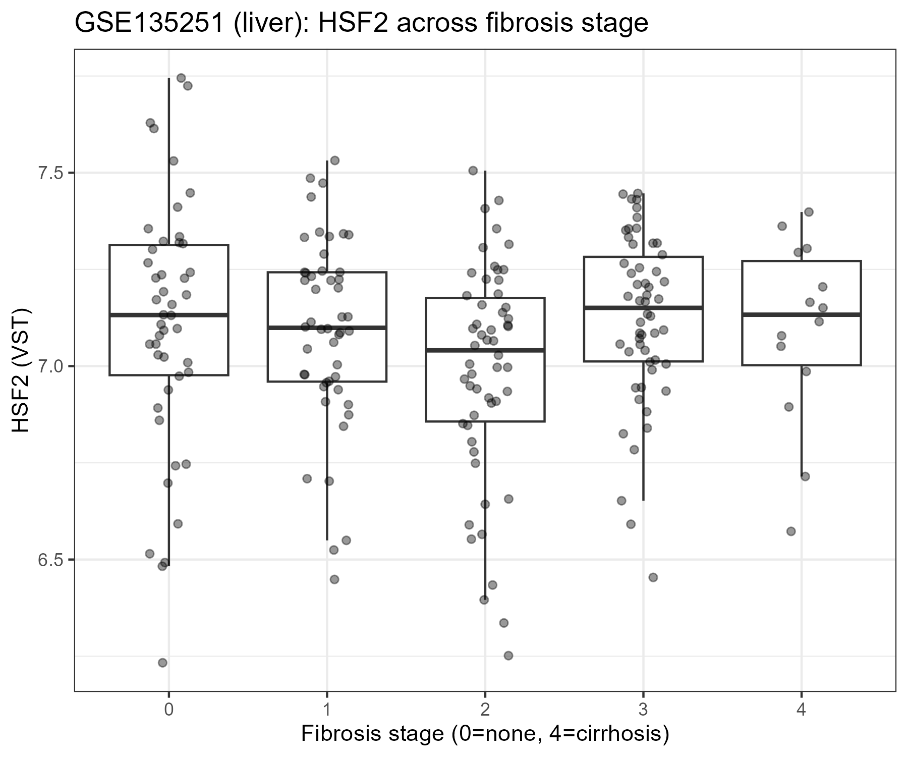
Figure S1. GSE135251 (liver): HSF2 expression across histological fibrosis stage (0-4).
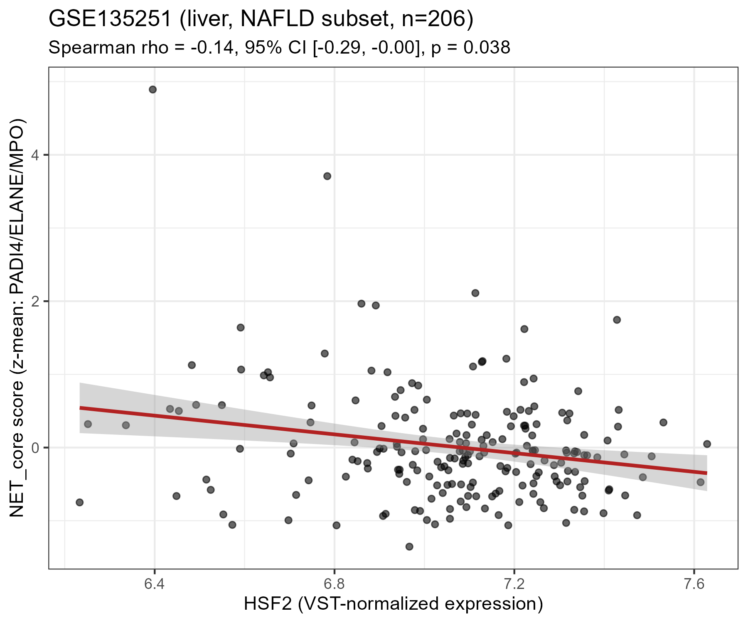
Figure S2. GSE135251 (liver, NAFLD subset, n=206): HSF2 vs. NET_core score scatter plot with linear fit.
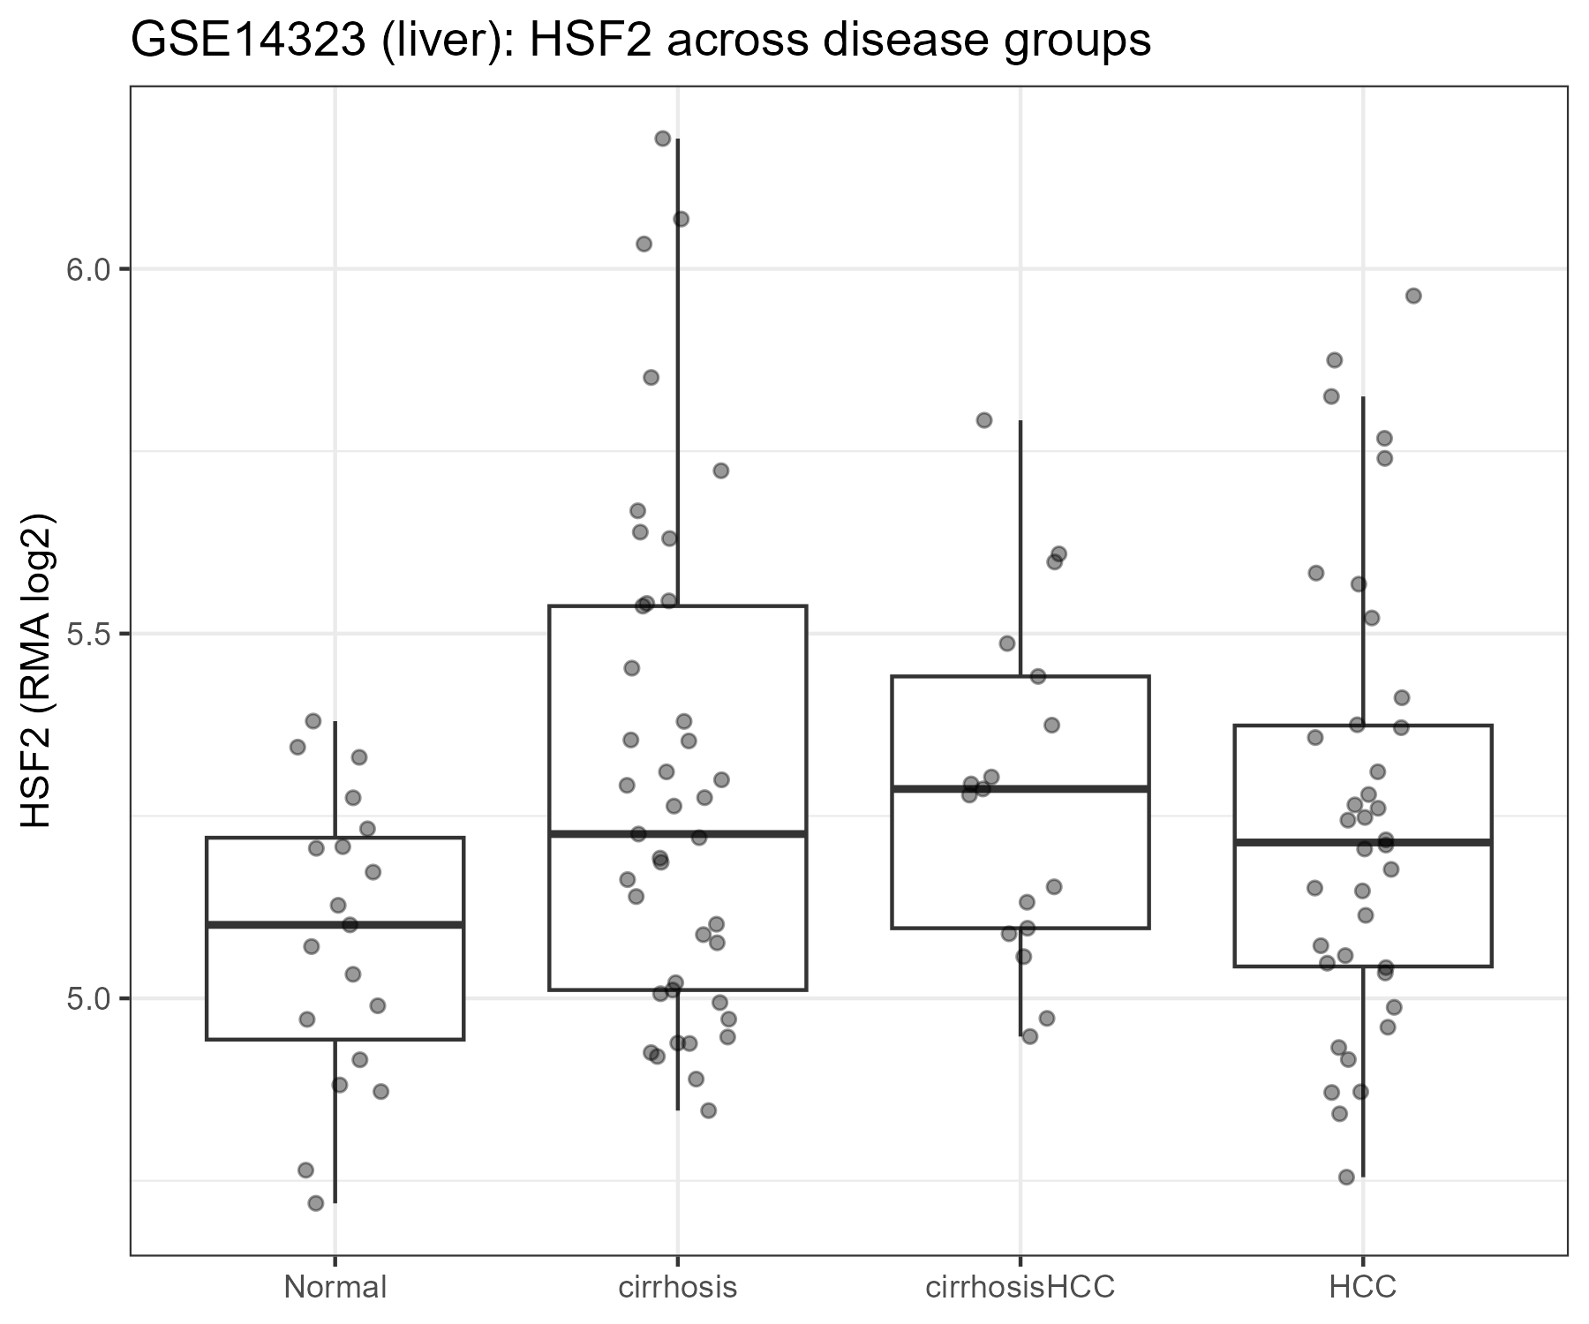
Figure S3. GSE14323 (liver): HSF2 expression across disease groups (Normal, cirrhosis, cirrhosisHCC, HCC).
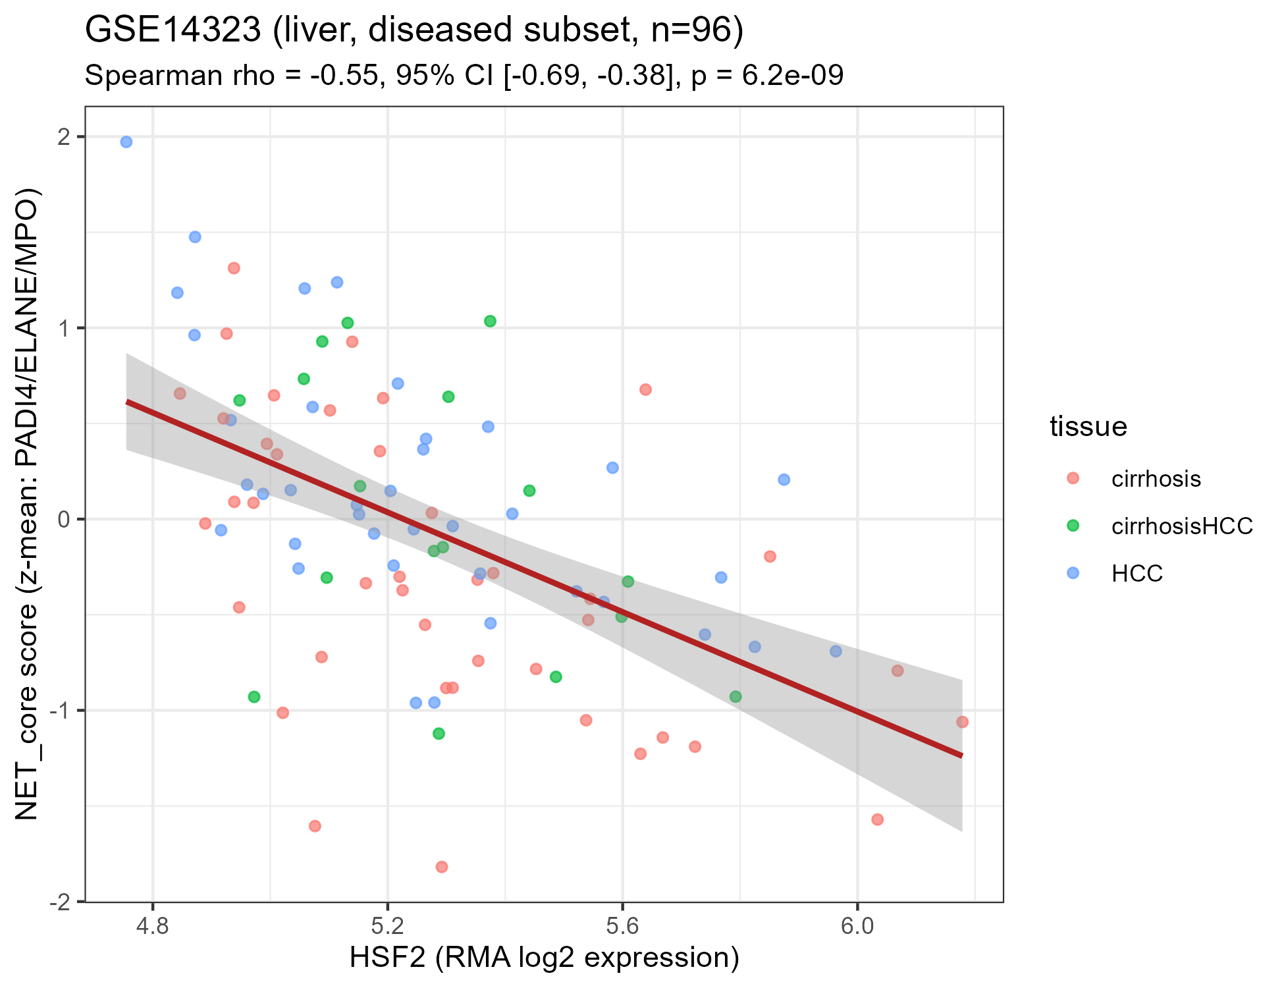
Figure S4. GSE14323 (liver, diseased subset, n=96): HSF2 vs. NET_core score scatter plot, colored by tissue group.
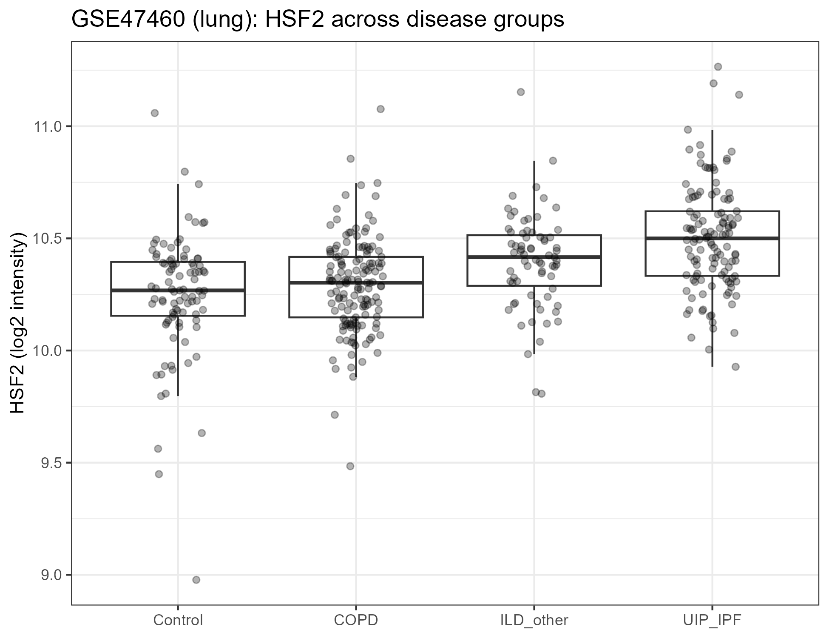
Figure S5. GSE47460 (lung): HSF2 expression across disease groups (Control, COPD, other ILD, UIP/IPF).
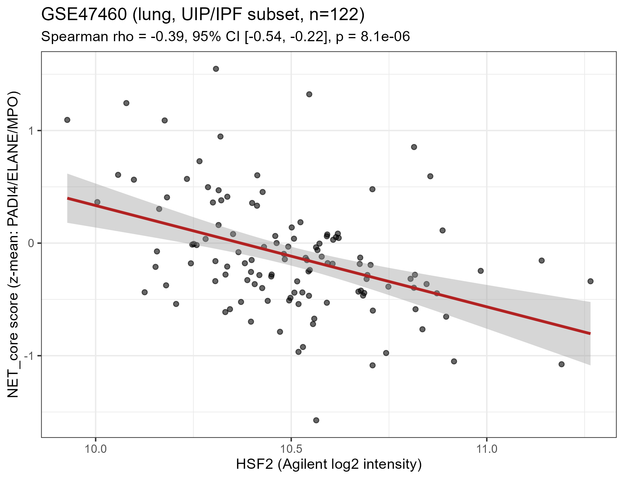
Figure S6. GSE47460 (lung, UIP/IPF subset, n=122): HSF2 vs. NET_core score scatter plot with linear fit.
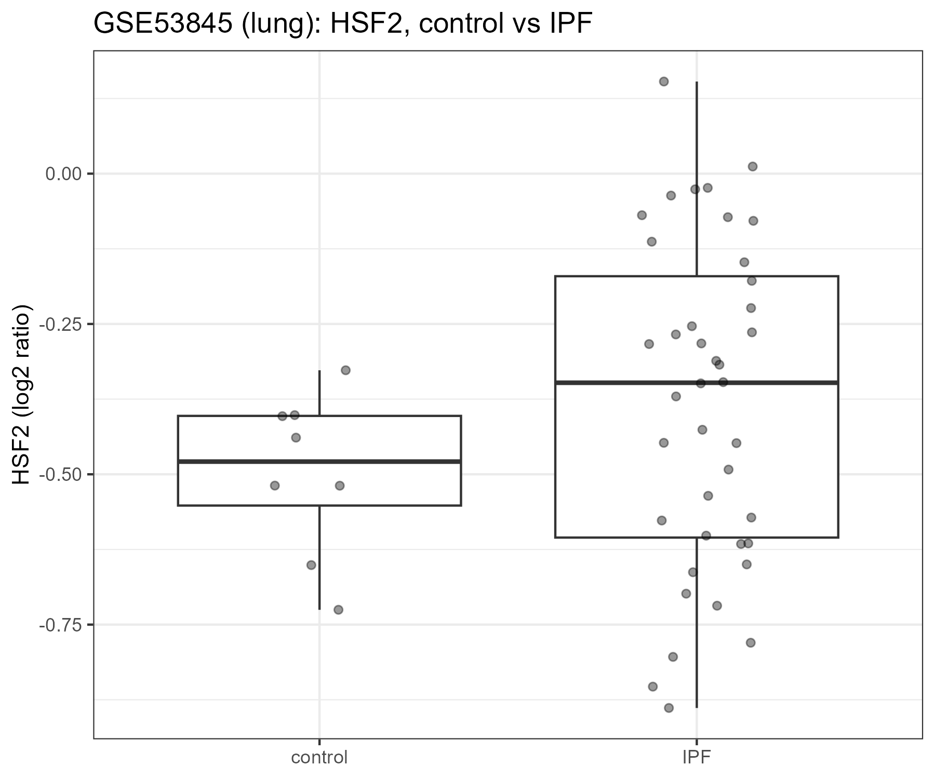
Figure S7. GSE53845 (lung): HSF2 expression, control vs. IPF.
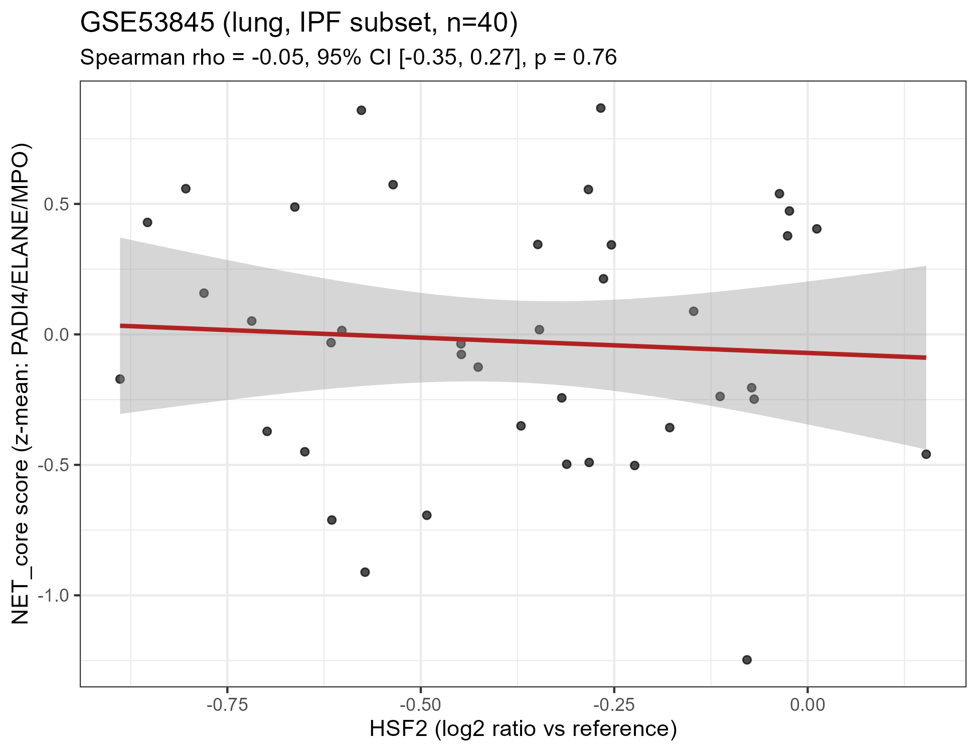
Figure S8. GSE53845 (lung, IPF subset, n=40): HSF2 vs. NET_core score scatter plot with linear fit.
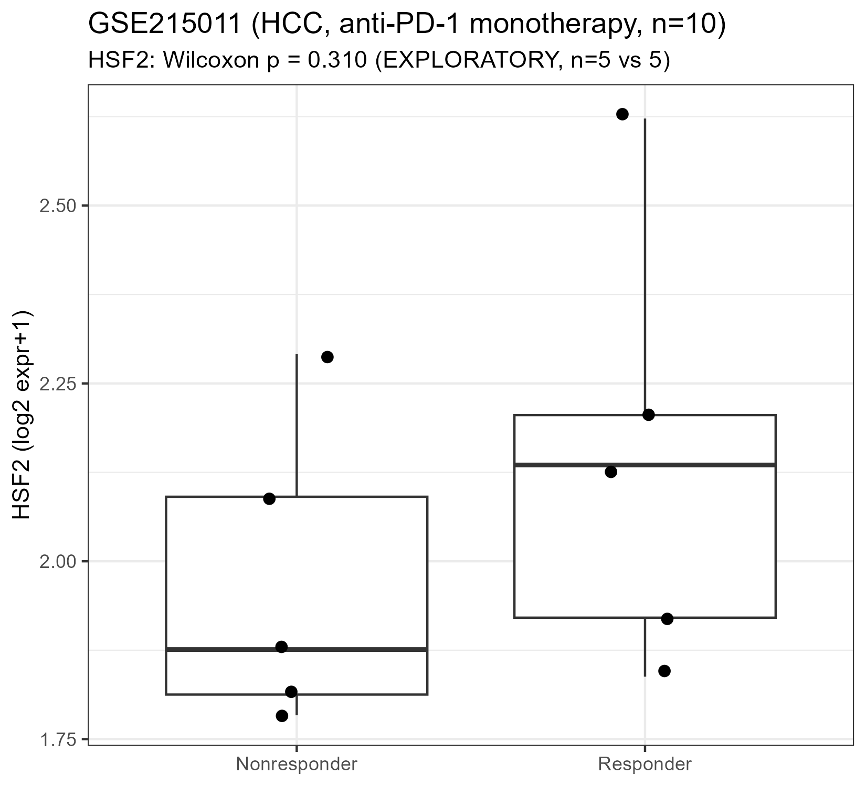
Figure S9. GSE215011 (HCC, anti-PD-1 monotherapy): HSF2 expression, responder vs. non-responder.
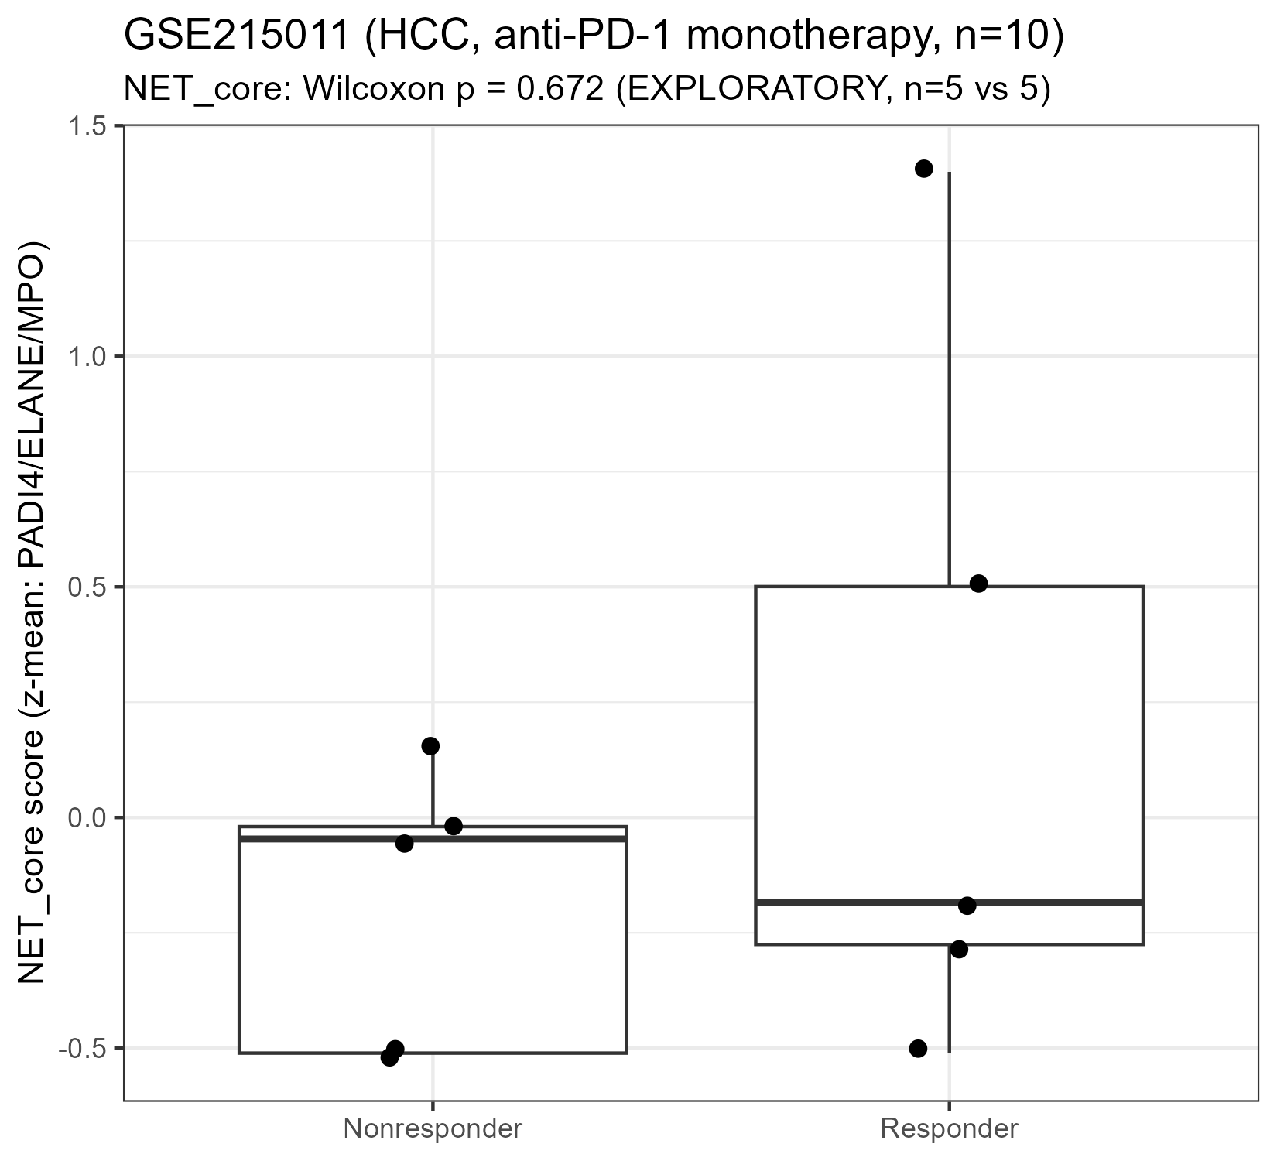
Figure S10. GSE215011 (HCC, anti-PD-1 monotherapy): NET_core score, responder vs. non-responder.
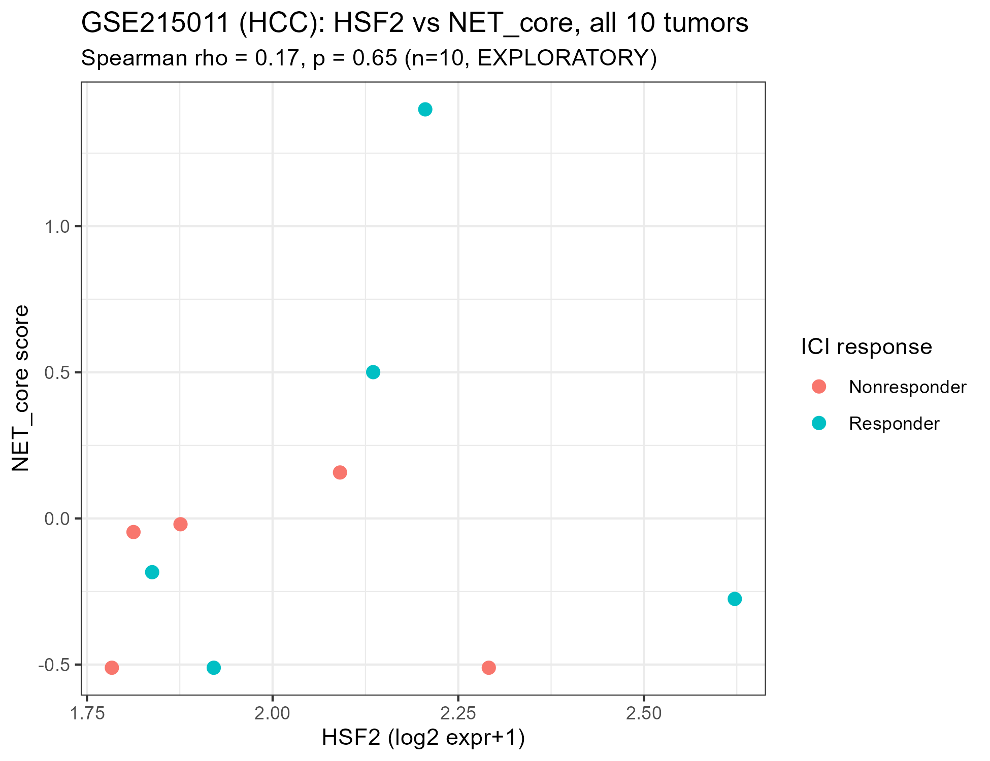
Figure S11. GSE215011 (HCC, n=10): HSF2 vs. NET_core score scatter plot, colored by ICI response.
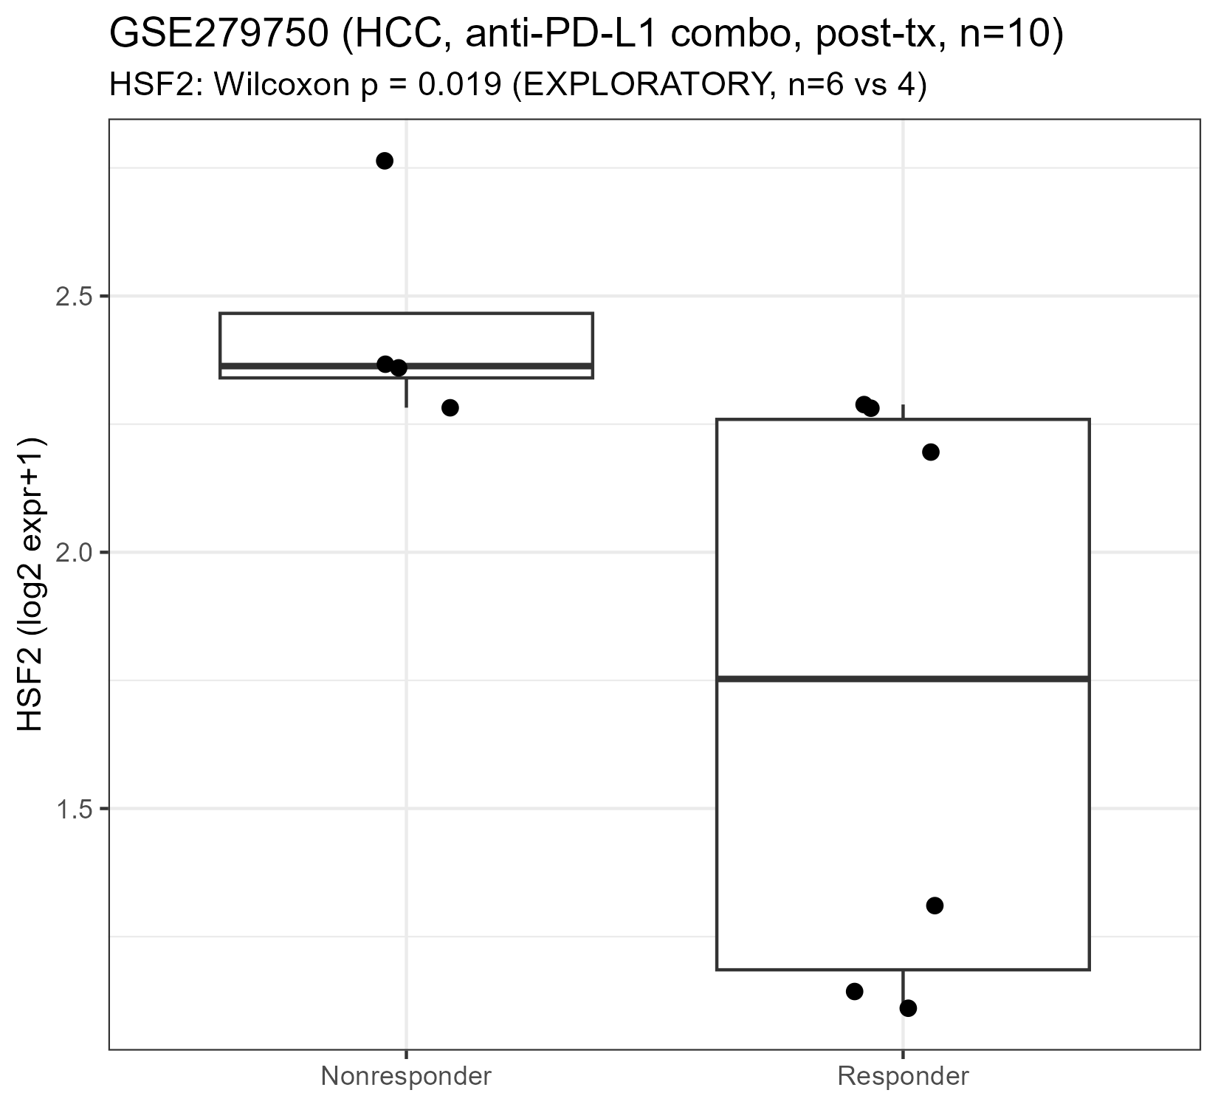
Figure S12. GSE279750 (HCC, anti-PD-L1 combination, post-treatment): HSF2 expression, responder vs. non-responder.
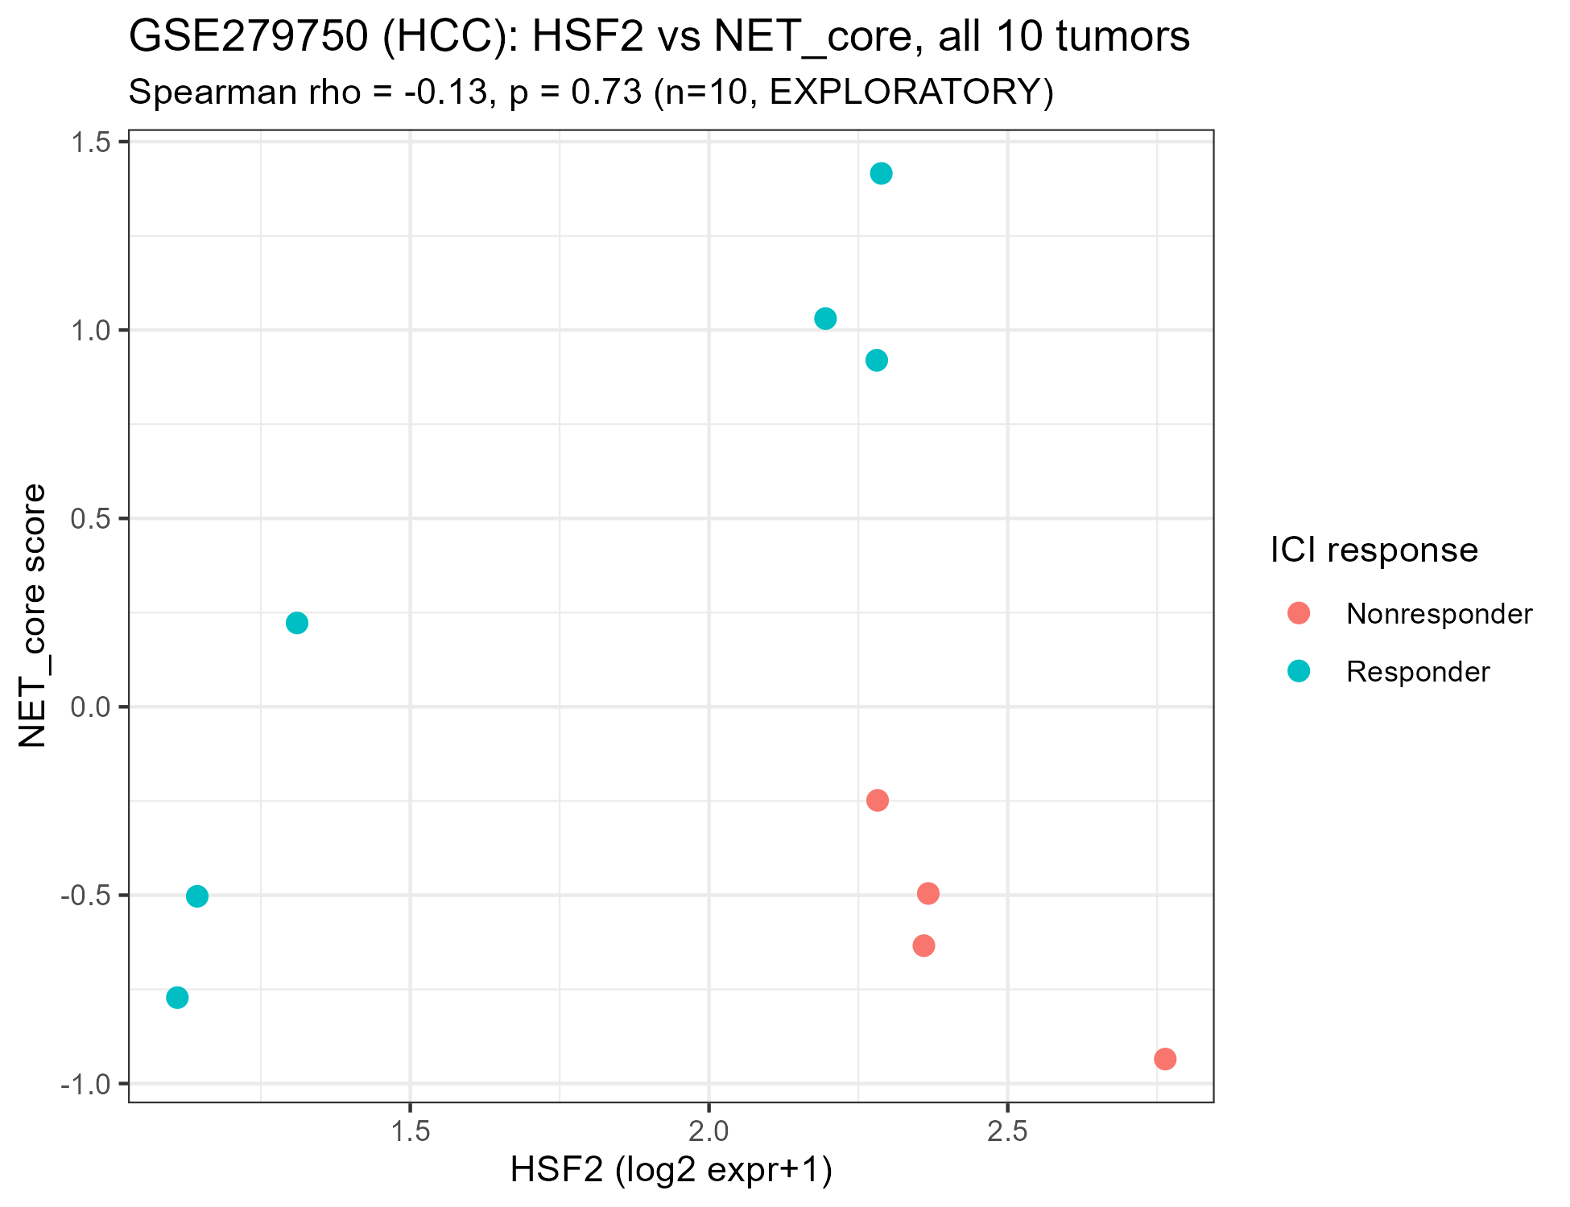
Figure S13. GSE279750 (HCC, n=10): HSF2 vs. NET_core score scatter plot, colored by ICI response.
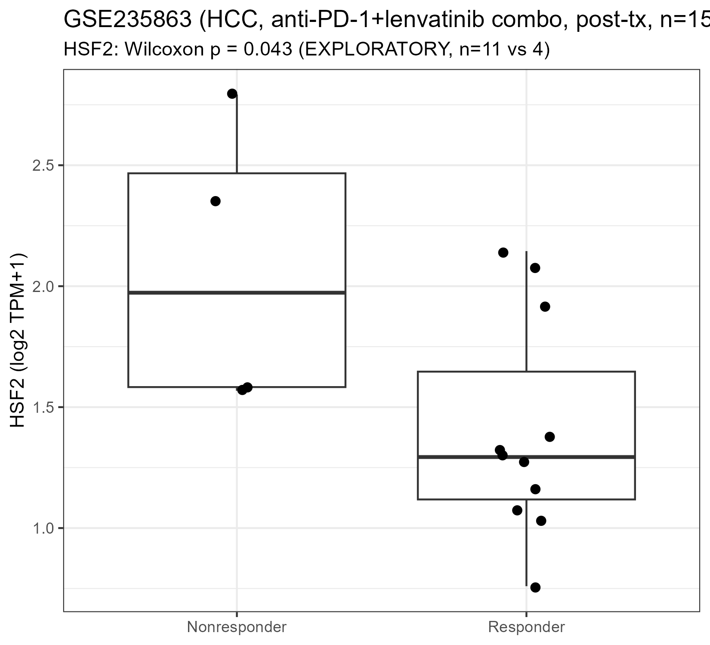
Figure S14. GSE235863 (HCC, anti-PD-1+lenvatinib combination, post-treatment): HSF2 expression, responder vs. non-responder.
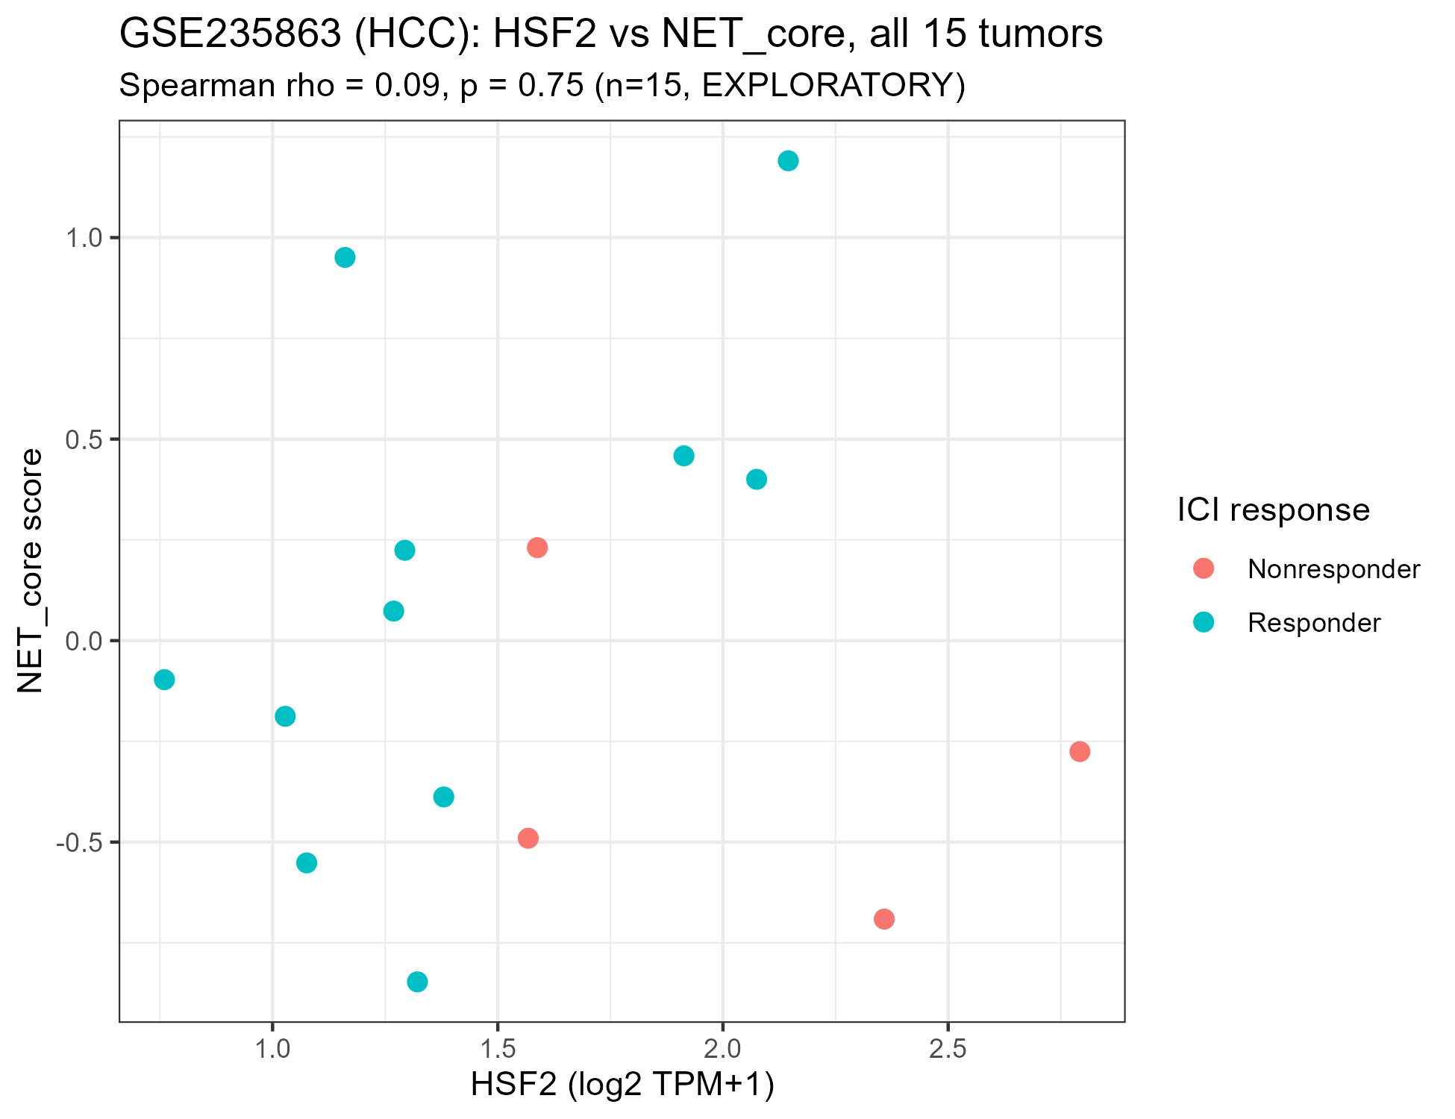
Figure S15. GSE235863 (HCC, n=15): HSF2 vs. NET_core score scatter plot, colored by ICI response.

