Donadeo East Entrance to Room ICE 8207
Photo-by-photo directions via the elevators to the eighth floor. Begin at the east entrance of the Donadeo Innovation Centre for Engineering.

1 Enter through the Donadeo east entrance
Find the glass entrance beside the Donadeo Innovation Centre for Engineering name and the Engineering crest. Go through these doors.
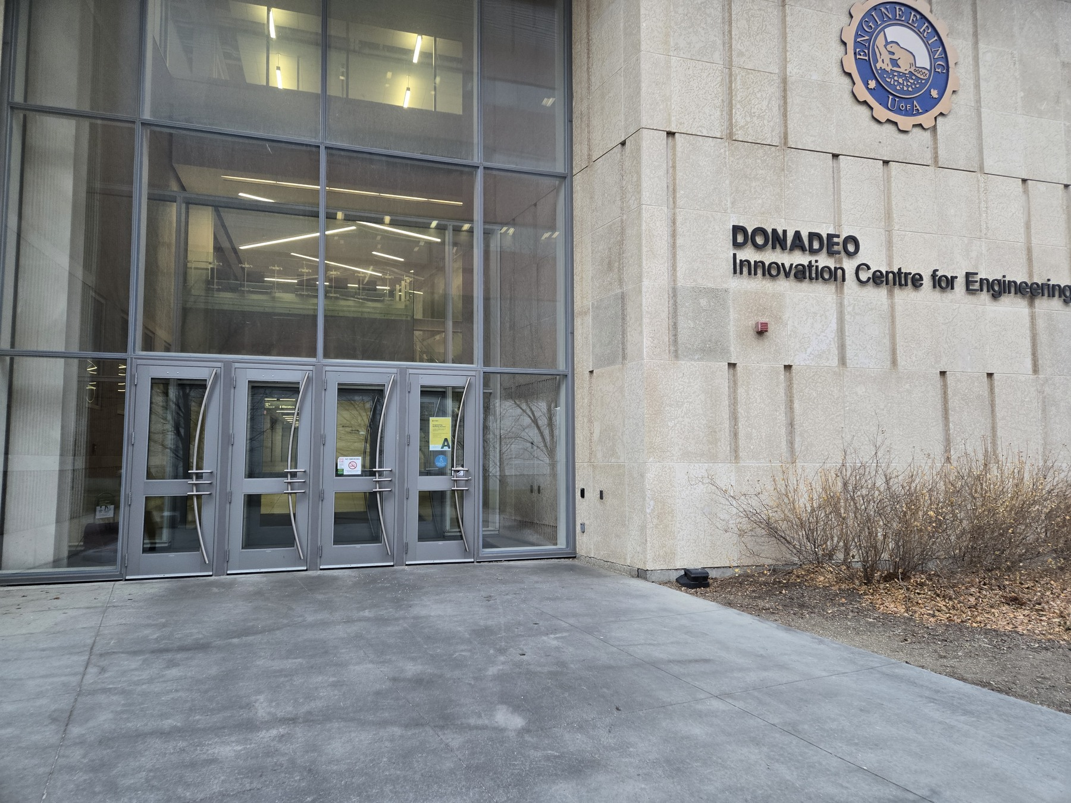
Photo 1 of 9

2 Walk straight past the atrium stairs
Once inside, continue straight along the ground-floor passage, keeping the glass staircase on your right. Head toward the overhead Elevators sign.
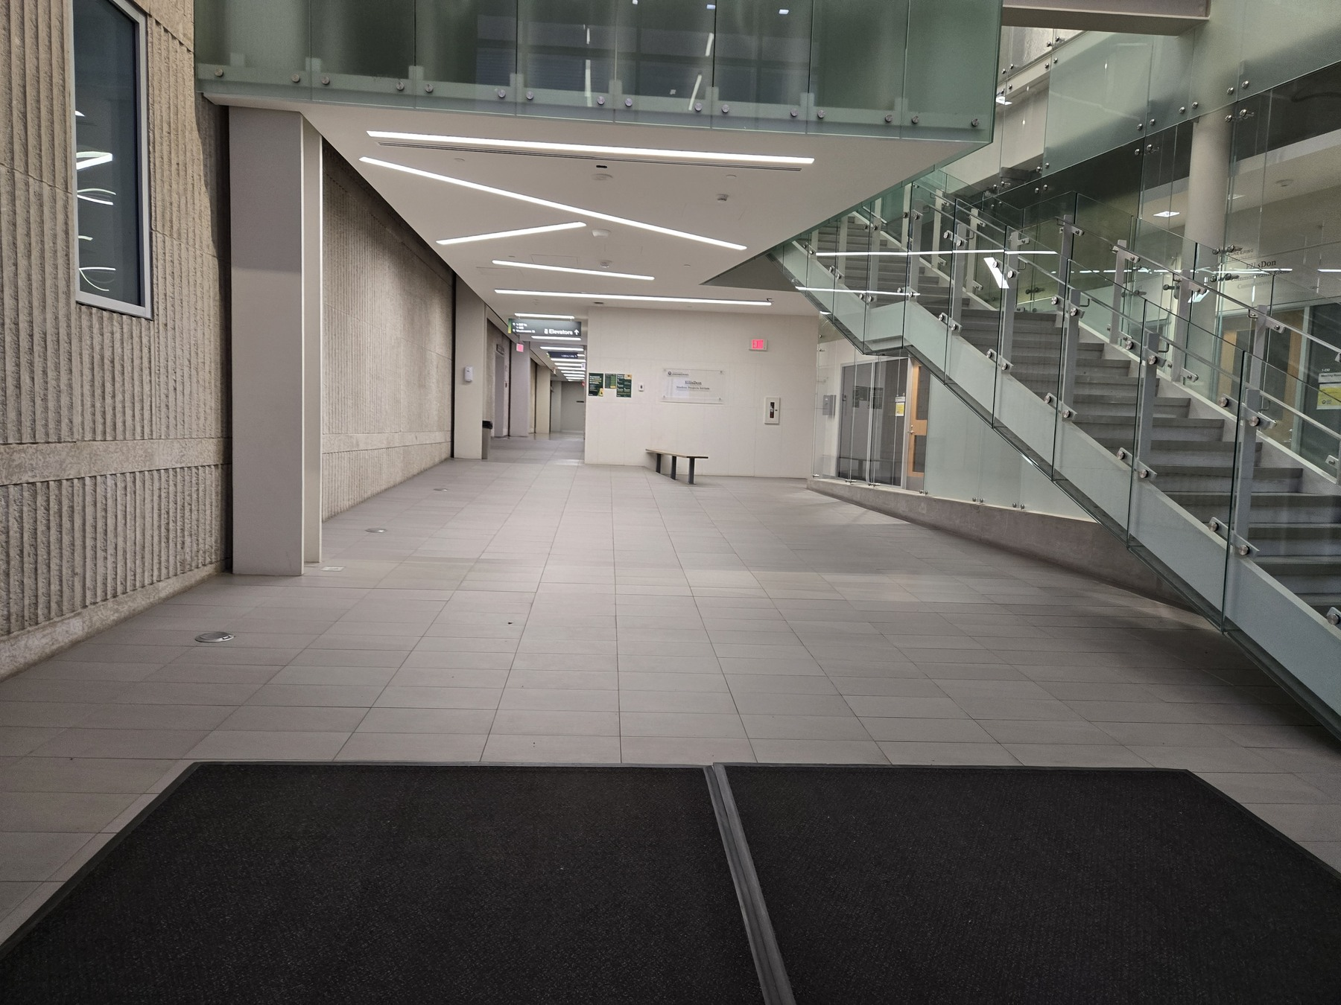
Photo 2 of 9

3 Follow the Elevators sign
Continue straight under the overhead sign marked Elevators with an upward arrow. Follow the corridor ahead.
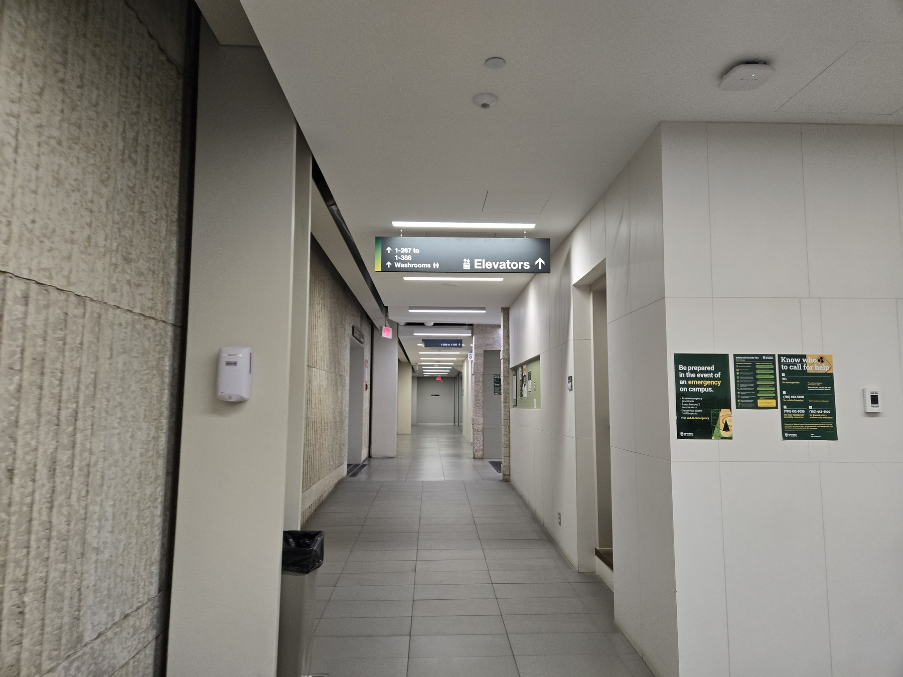
Photo 3 of 9

4 Reach the elevator lobby
Enter the elevator lobby beside the building directory. Continue to the passenger elevators shown beyond the large service door.
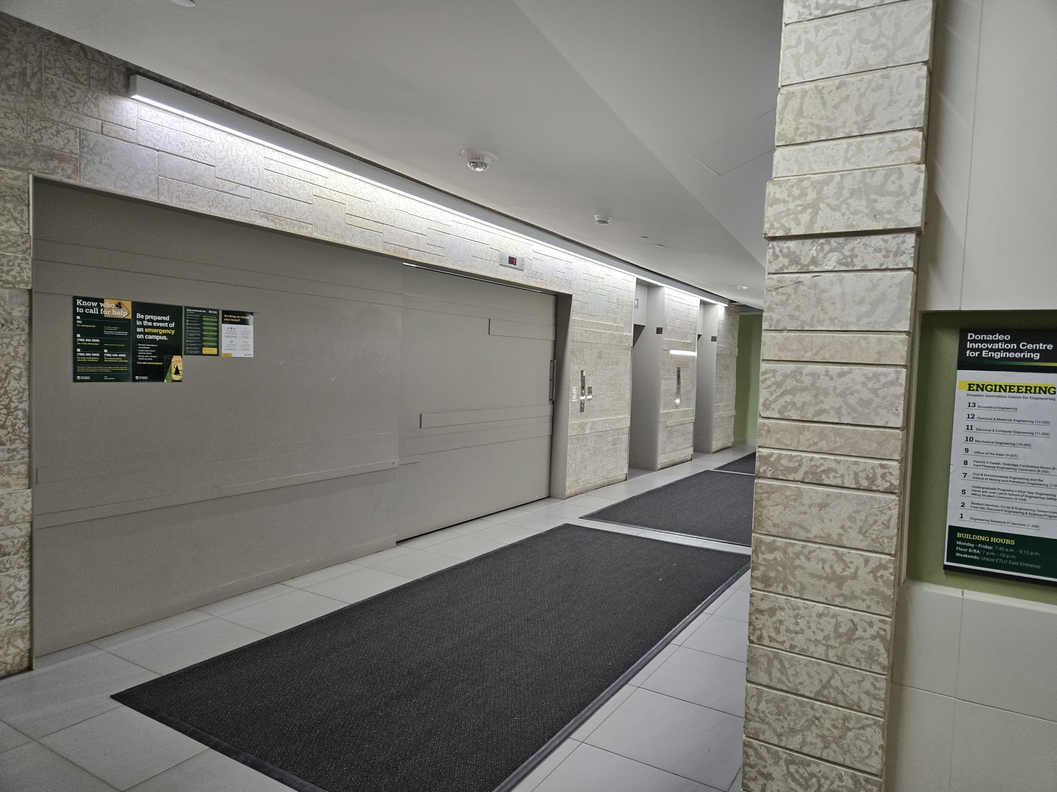
Photo 4 of 9

5 Find the passenger elevators
The passenger elevators face one another in this lobby.
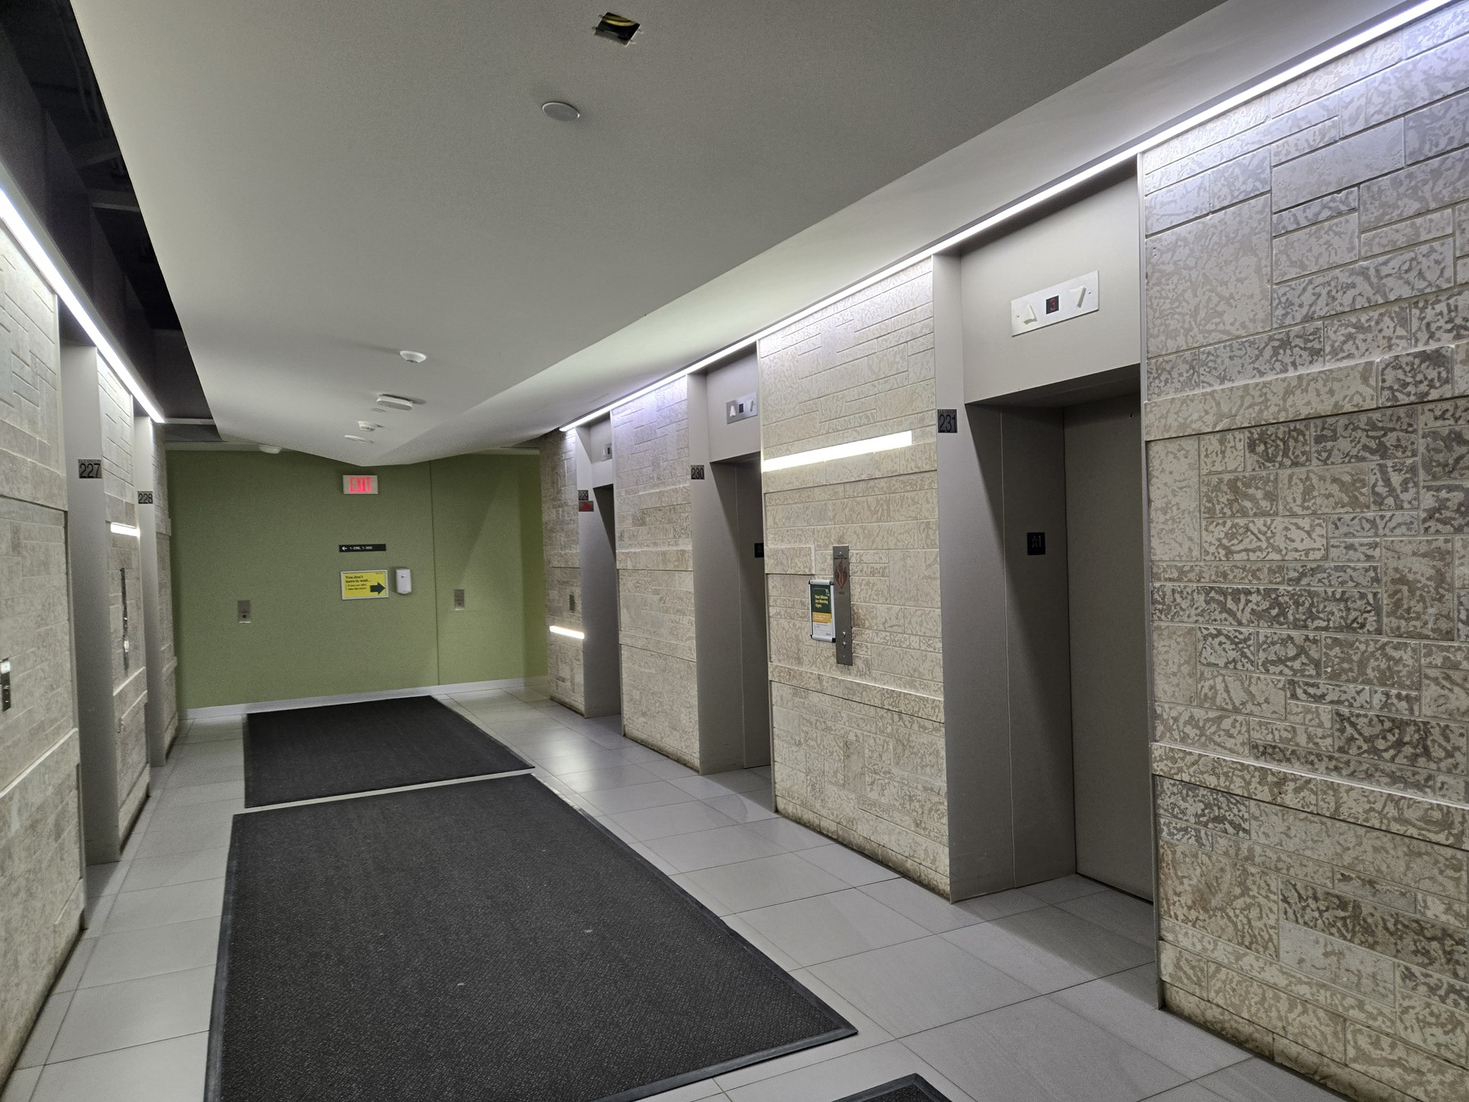
Photo 5 of 9

6 Press the button for floor 8
Inside the elevator, press 8, as shown by the illuminated button. Take the elevator to the eighth floor and exit when it arrives.
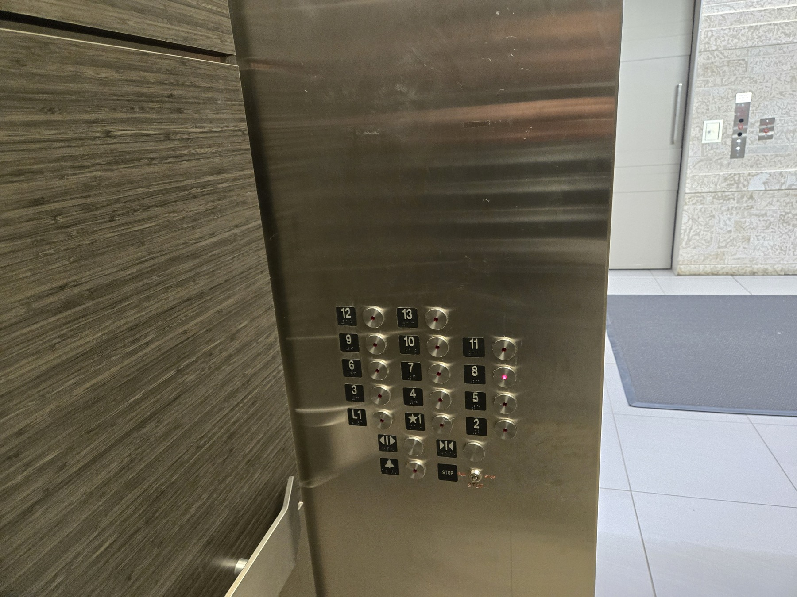
Photo 6 of 9

7 Head toward the glass doors and turn left
On the eighth floor, go toward the glass doors shown here, then turn left. The wall sign points left toward rooms 8-207 to 8-246 and identifies the Engineering Conference Room 8-207.
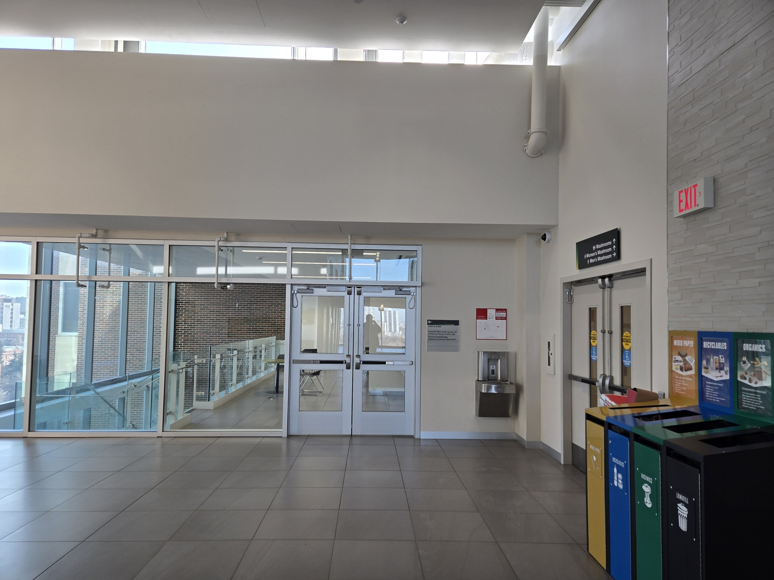
Photo 7 of 9

8 Find Room 8-207
Look for the wooden double doors with the room plaque 8-207. The sign above reads Patrick D Daniel / Enbridge Engineering Conference Room. This is the workshop room.
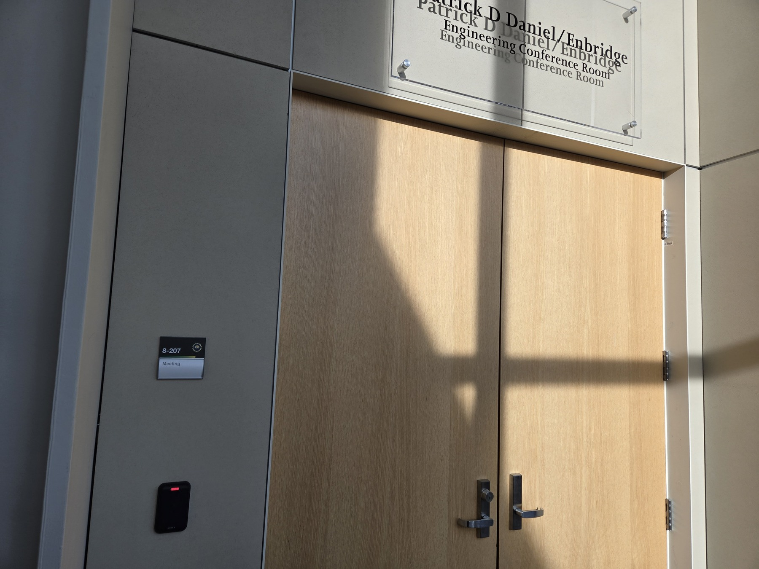
Photo 8 of 9

9 The second entrance of Room 8207
Room 8207 also has a second entrance along the same corridor. Recognize it by the matching Patrick D Daniel / Enbridge Engineering Conference Room sign and the nearby blue seating.
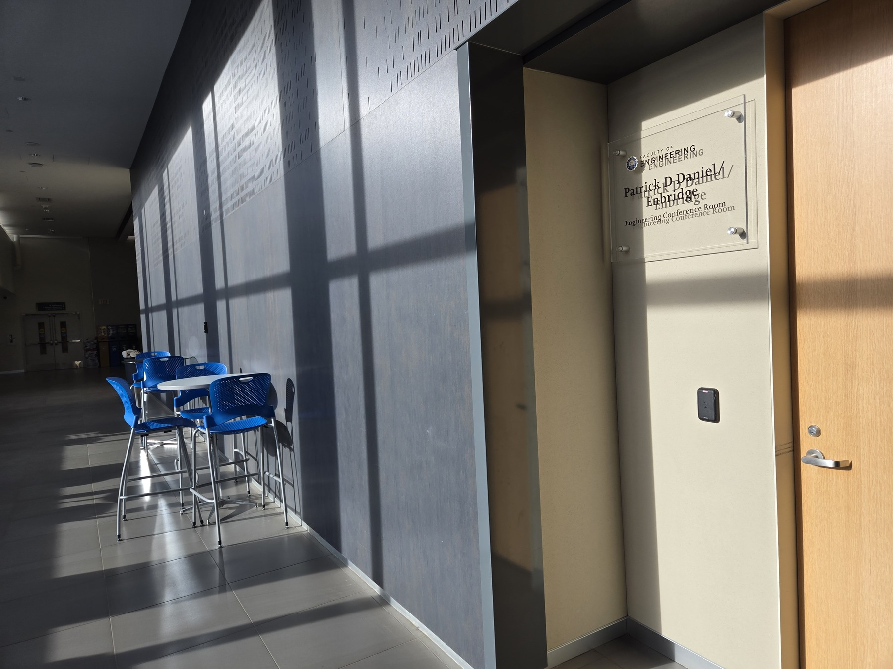
Photo 9 of 9

