ETLC Entrance to ICE 8207
Photo-by-photo walking directions for conference participants
1. Find ETLC and its east entrance  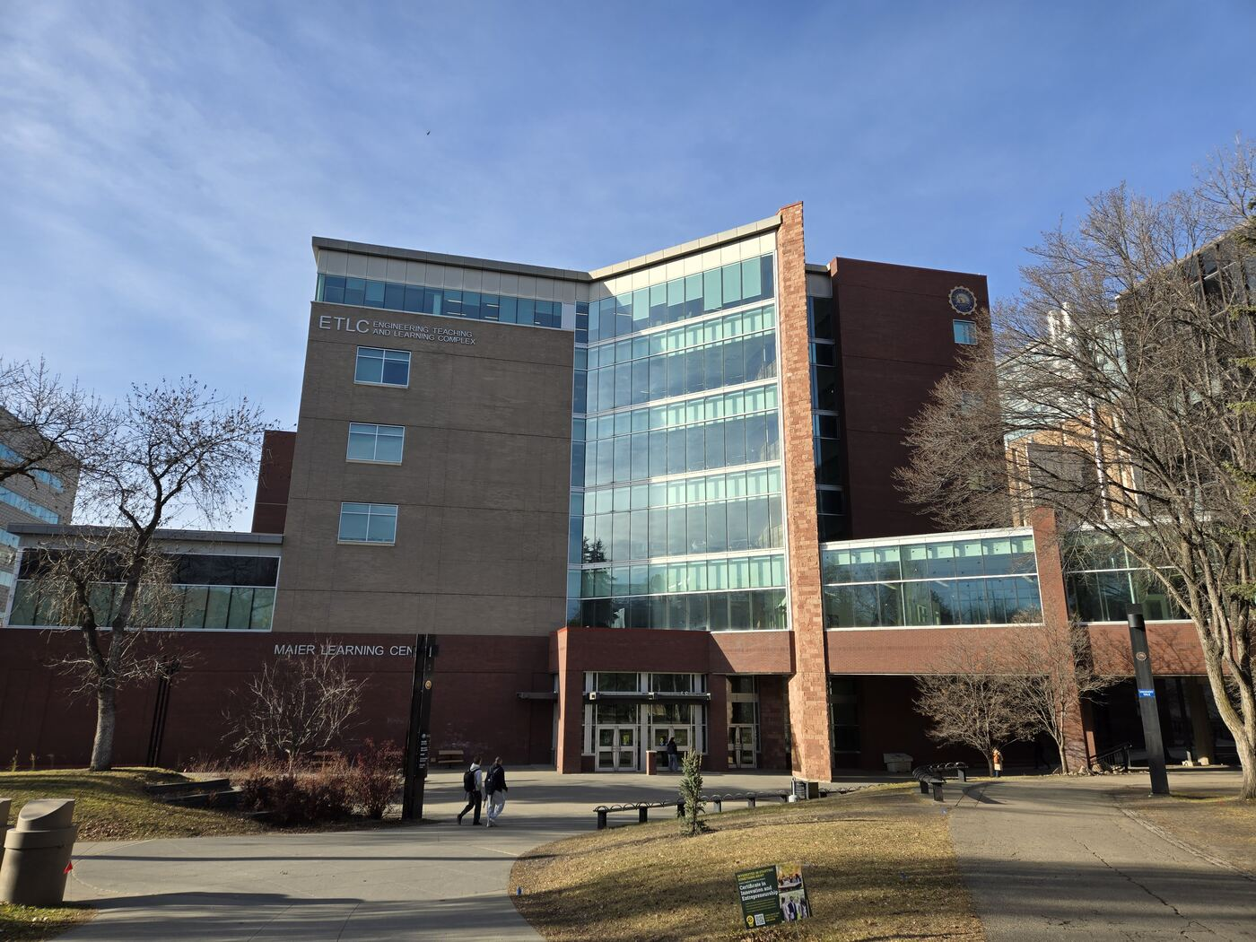  Locate the ETLC building and head to its east entrance, shown in the next photo. | 2. Enter ETLC  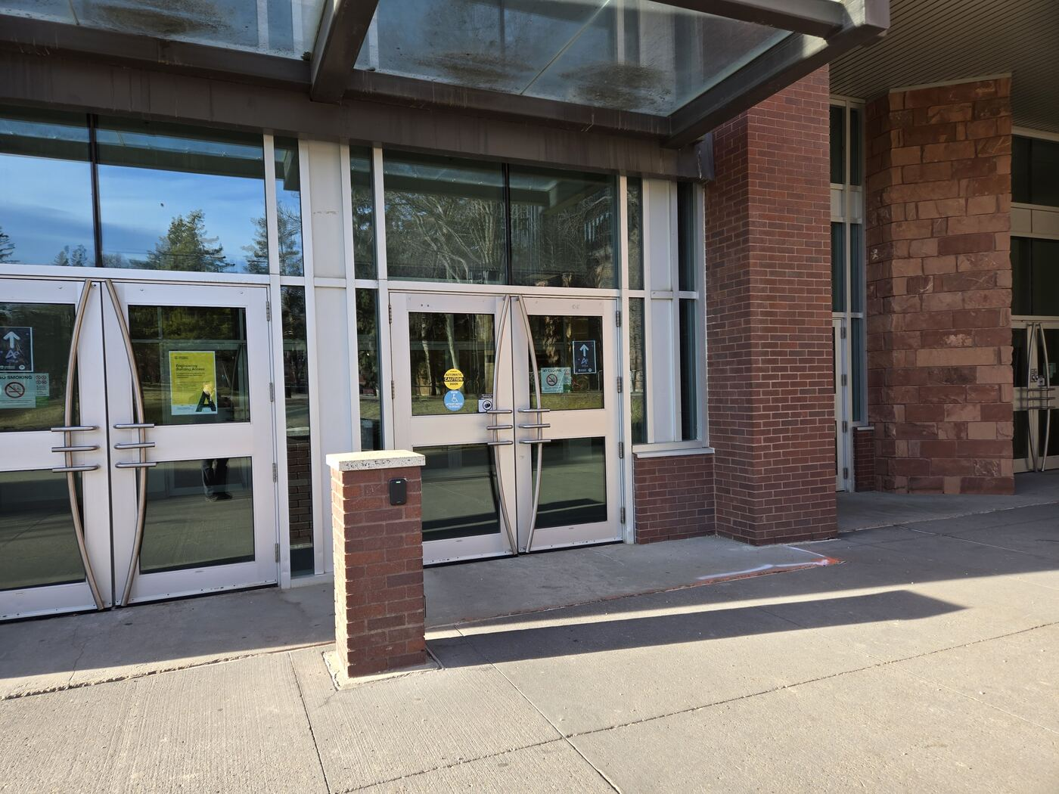  Use the glass entrance doors pictured here and go inside.

3. Go up to the main interior level  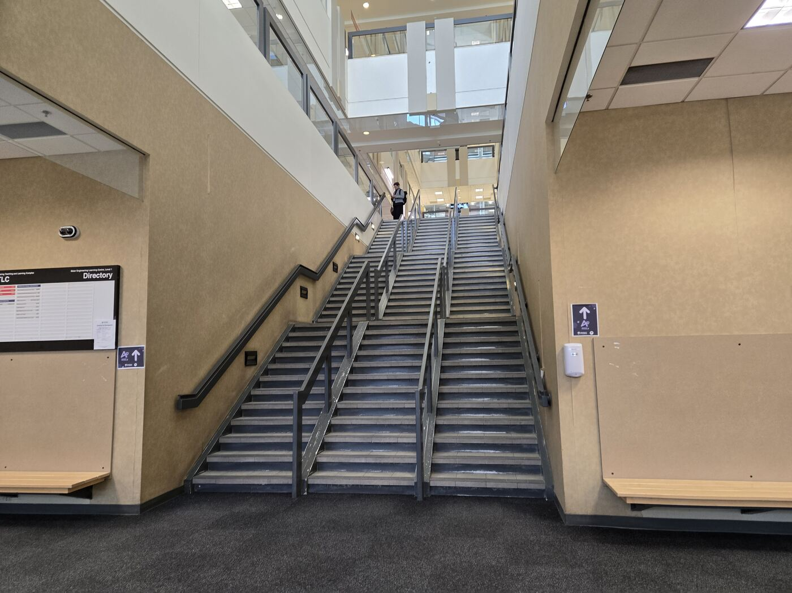  Follow the interior stair route shown. If stairs are not suitable, locate and use elevators nearby. | 4. Turn around at the atrium  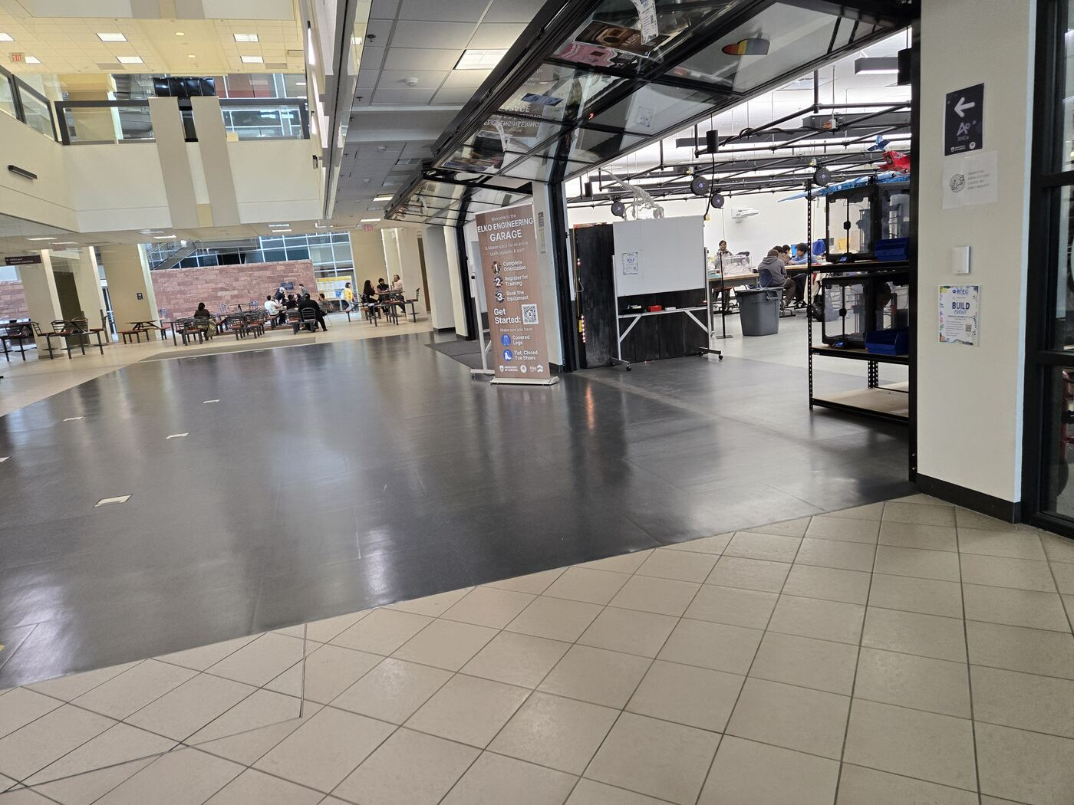  At the top, when you reach the open atrium, do not continue straight toward the print shop. Turn 180 degrees and go in the opposite direction.

5. Follow the glazed corridor  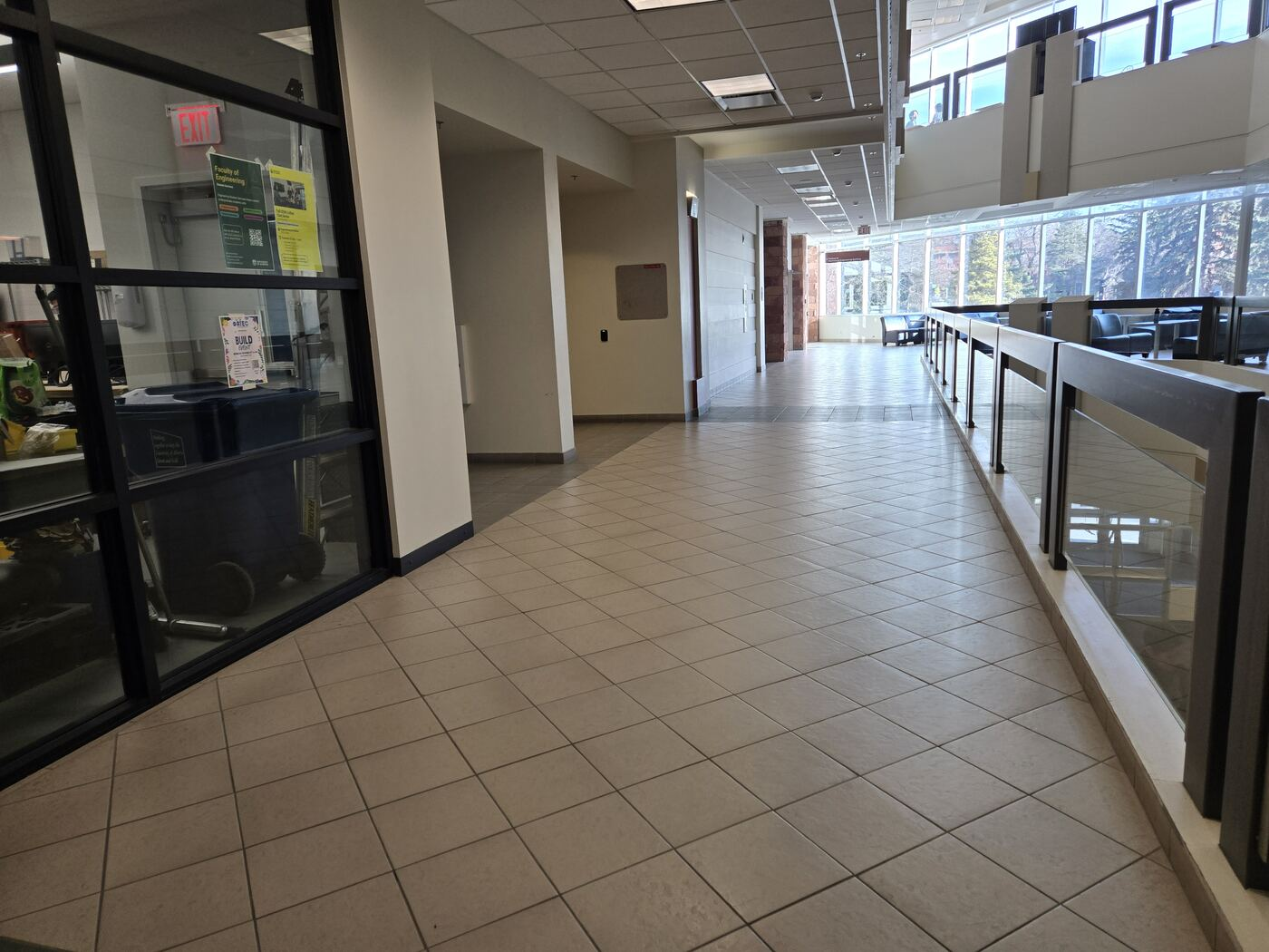  Walk along the corridor beside the glass railing, keeping toward the interior passage. | 6. Continue through the lounge area  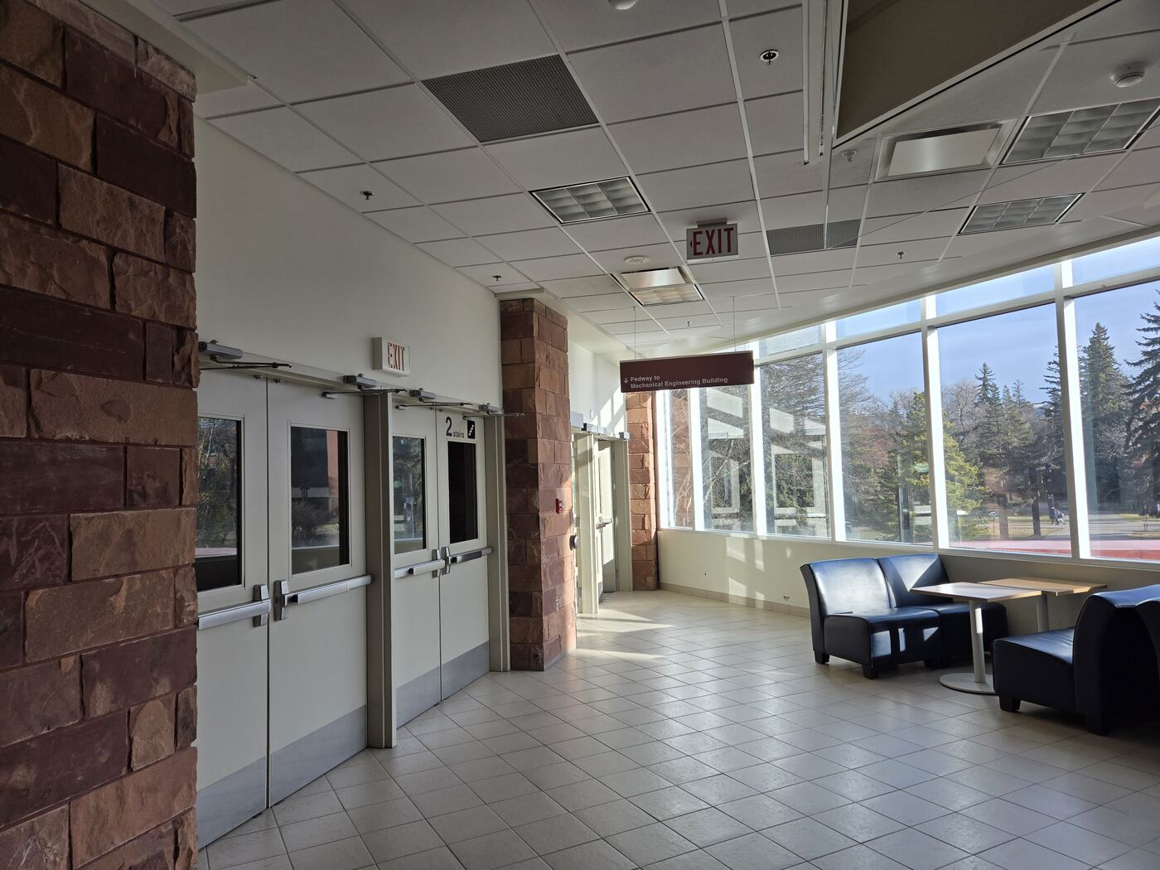  Pass the seating area and keep following the route toward the interior doors.

7. Pass the seating area  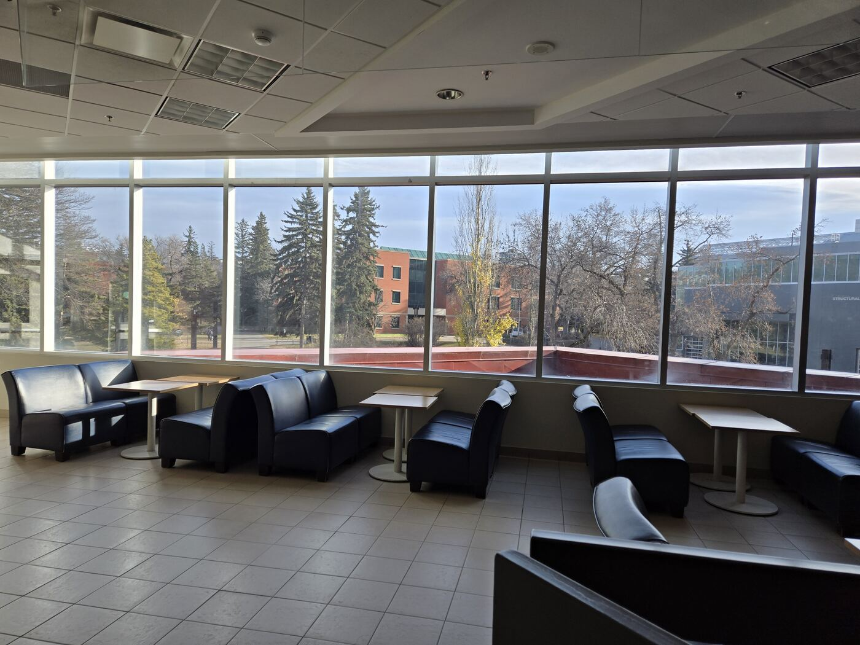  Continue past the lounge seating toward the doors at the far side. | 8. Go through the interior doors  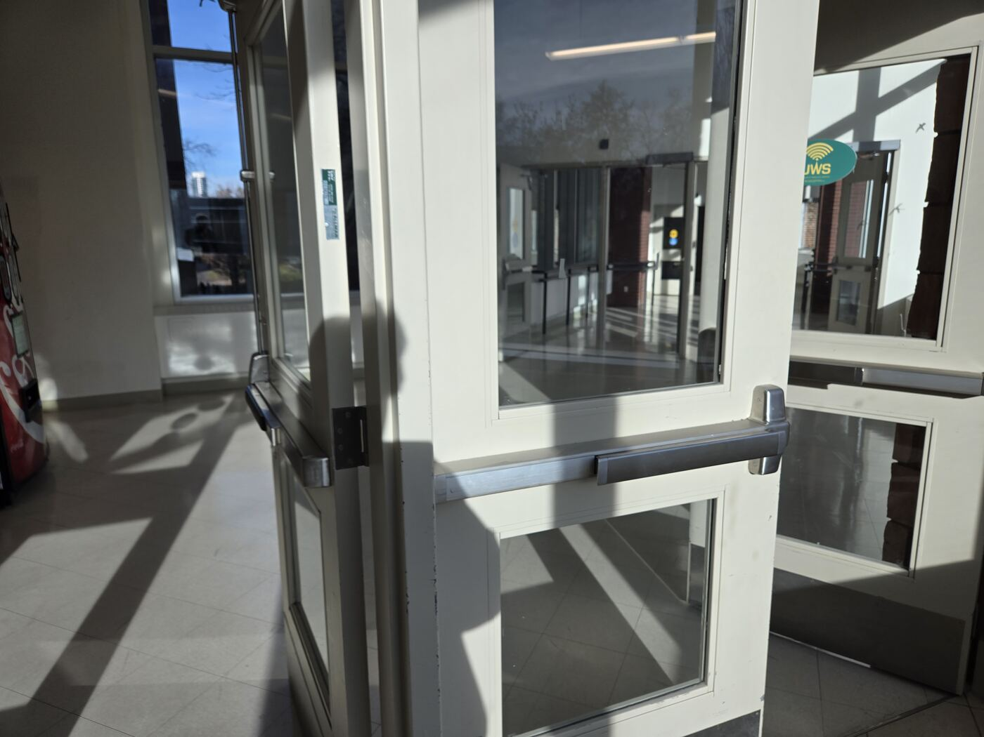  Proceed through the doors shown to enter the connecting corridor.

9. Follow the corridor  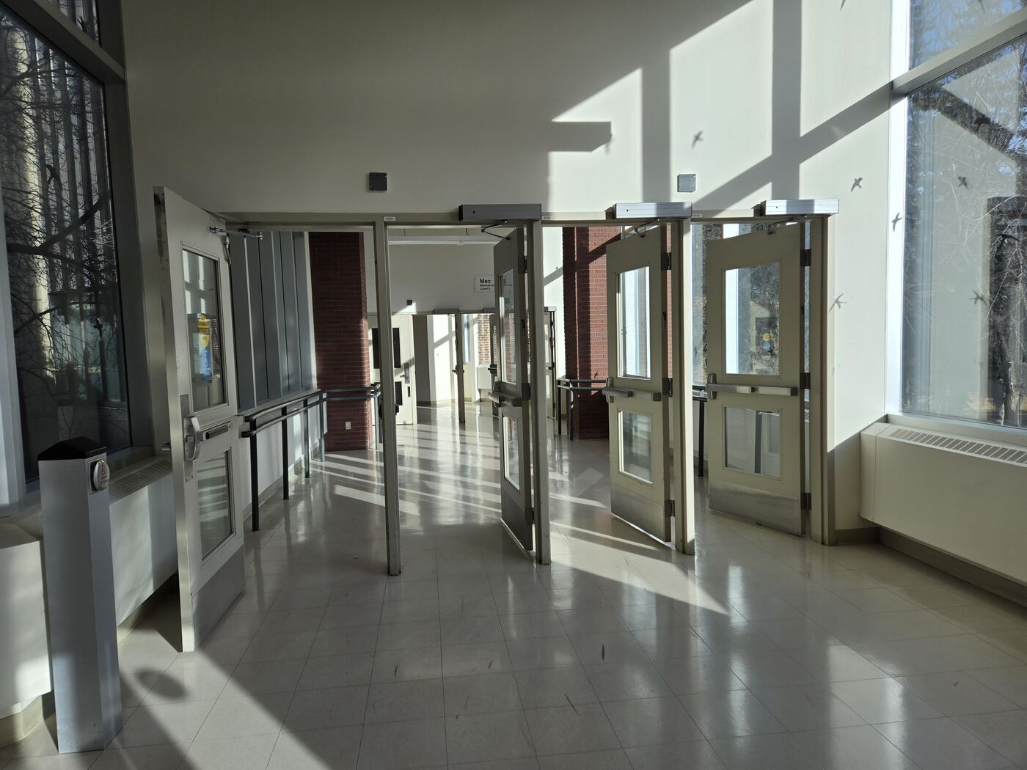  Continue straight along the corridor, using the door and windows shown as landmarks. | 10. Follow the elevator wayfinding sign  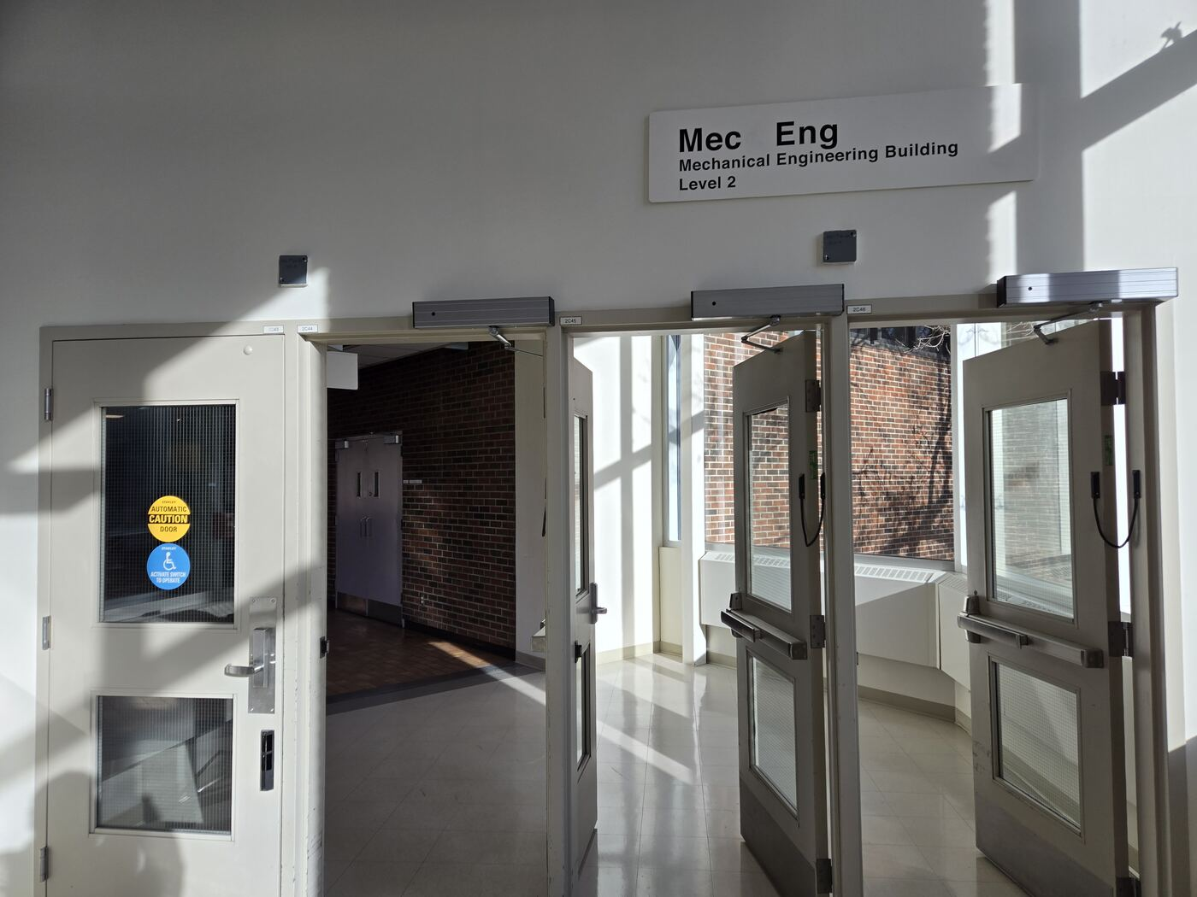  Follow the elevator wayfinding sign. The separate “Mec Eng” sign identifies the Mechanical Engineering Building, Level 2.

11. Continue along the windowed hall  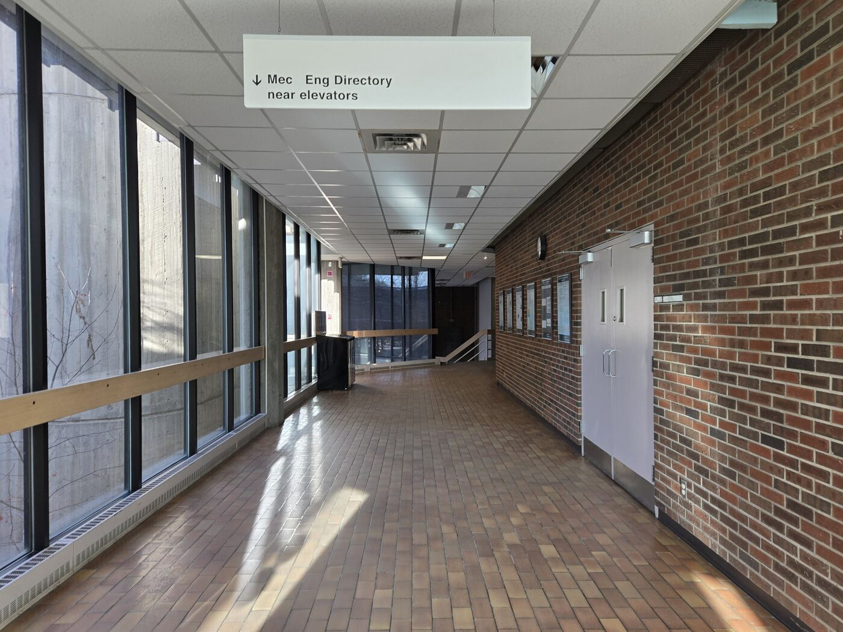  Walk straight through the long corridor toward the next interior junction. | 12. Keep to the main corridor  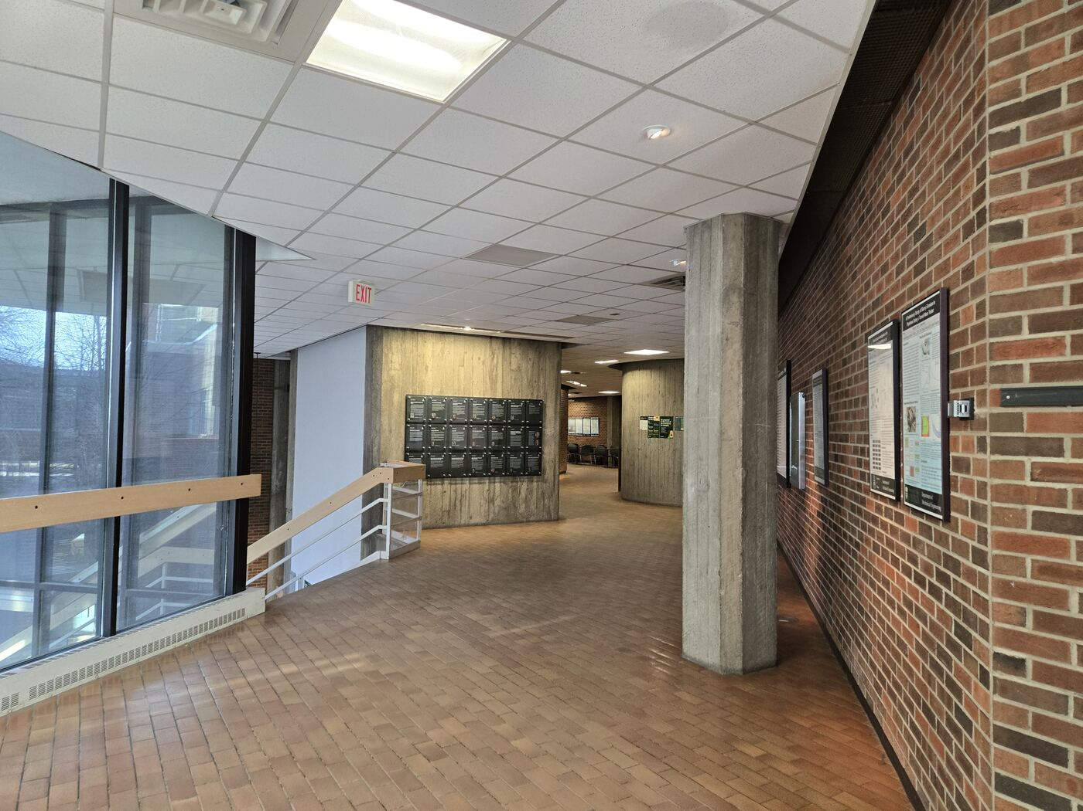  Continue past the open area and follow the brick wall toward the next passage.

13. Pass the round concrete wall  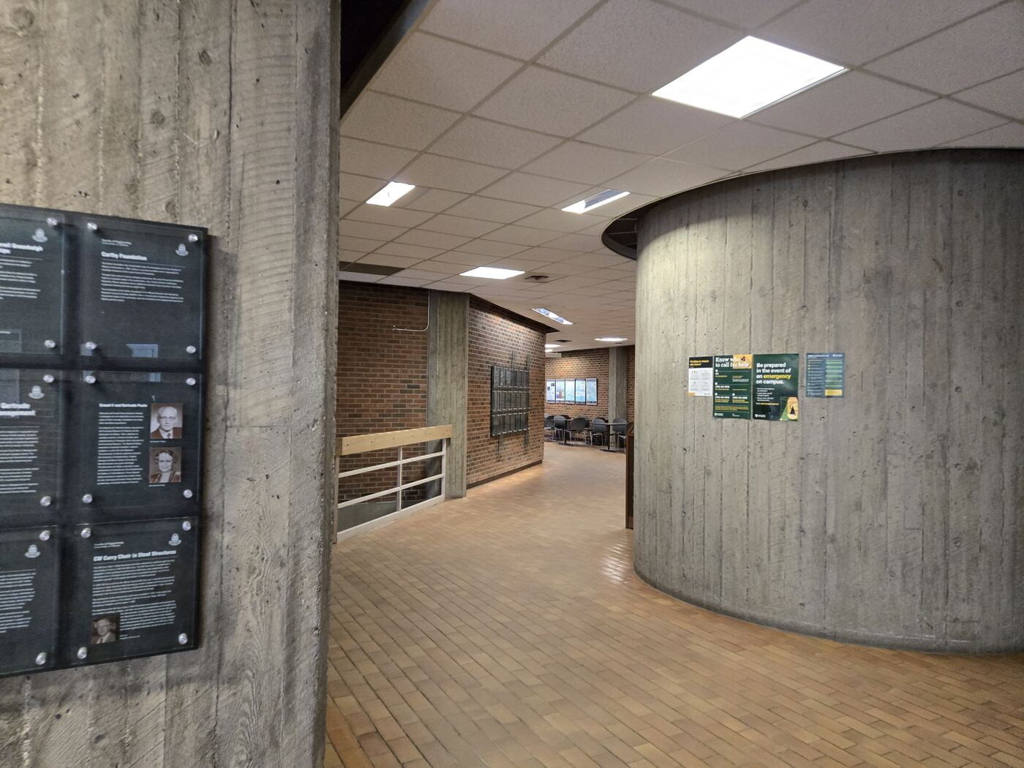  Go around the curved concrete feature and continue into the corridor beyond it. | 14. Follow the brick corridor  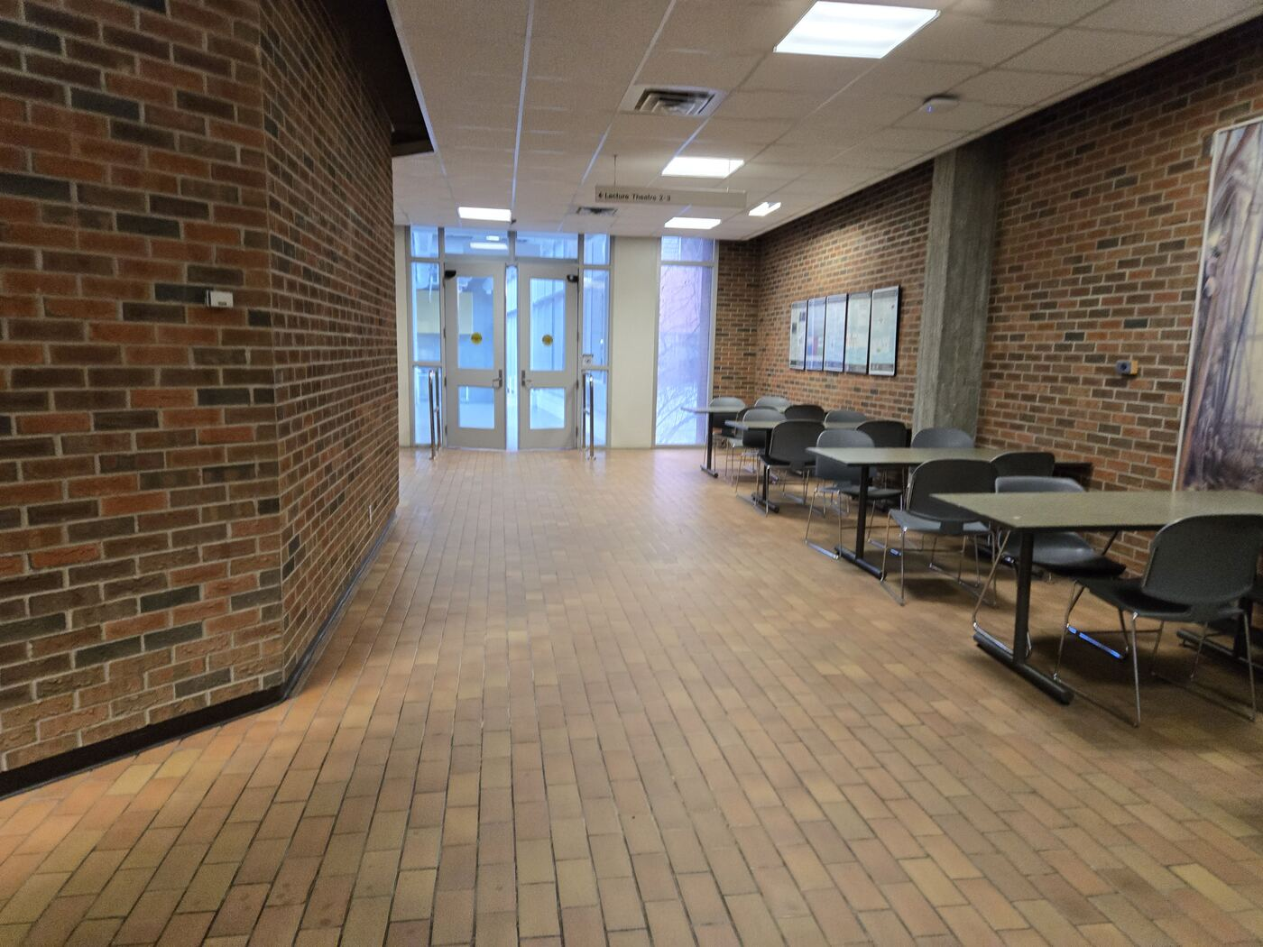  Continue straight past the study tables and toward the glass doors.

15. Enter the connecting bridge  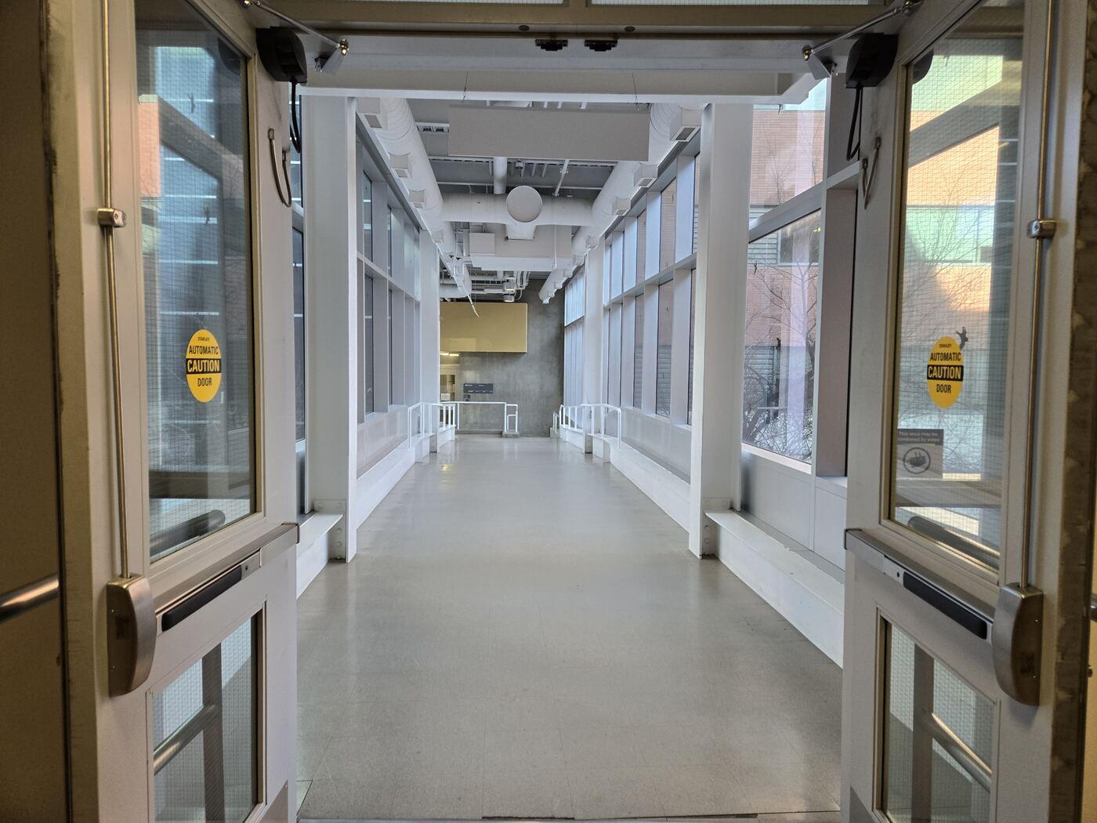  Go through the doors into the enclosed connector. | 16. Walk through the bridge  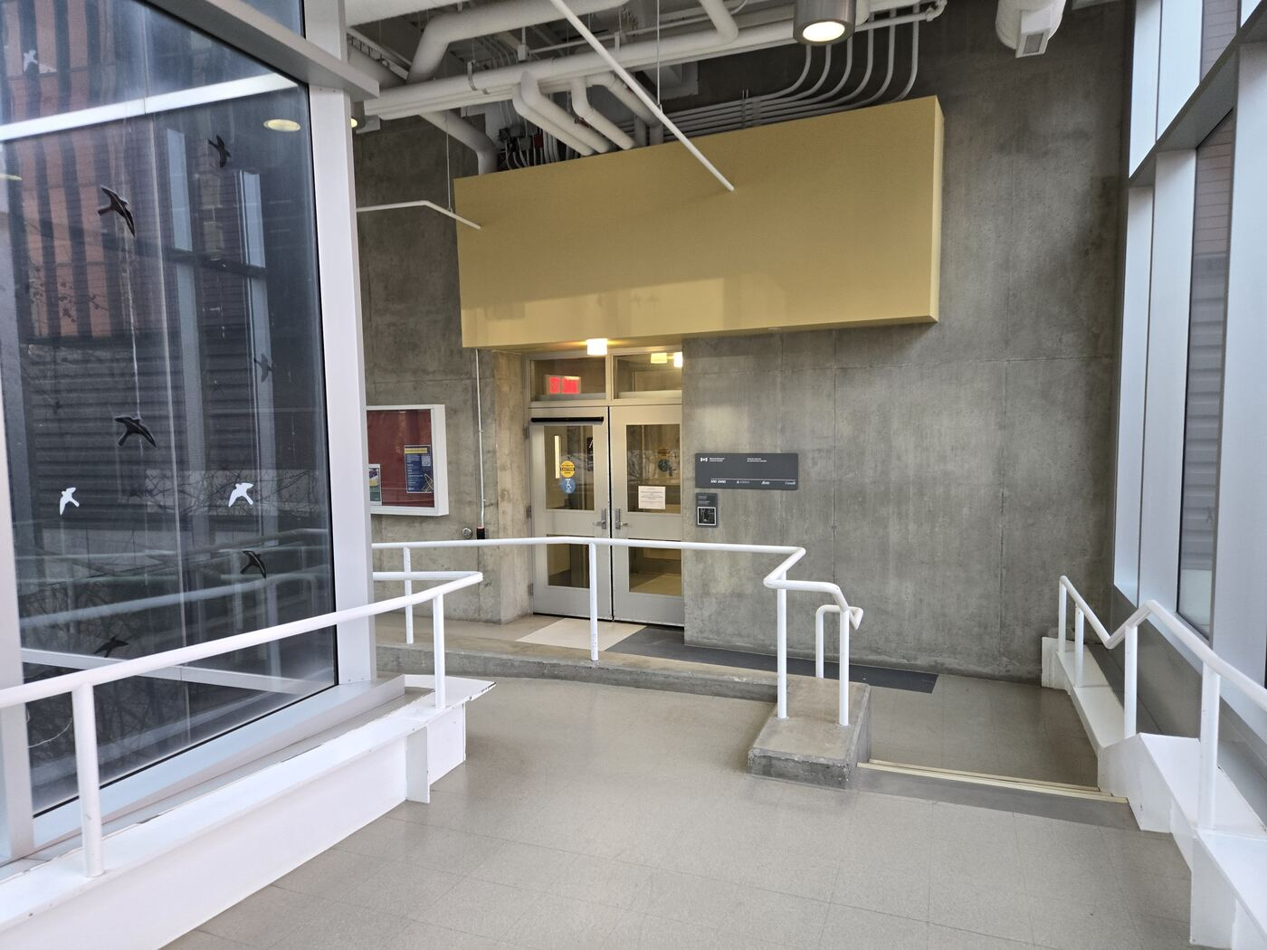  Continue straight through the glass-sided connector.

17. Turn left onto another bridge  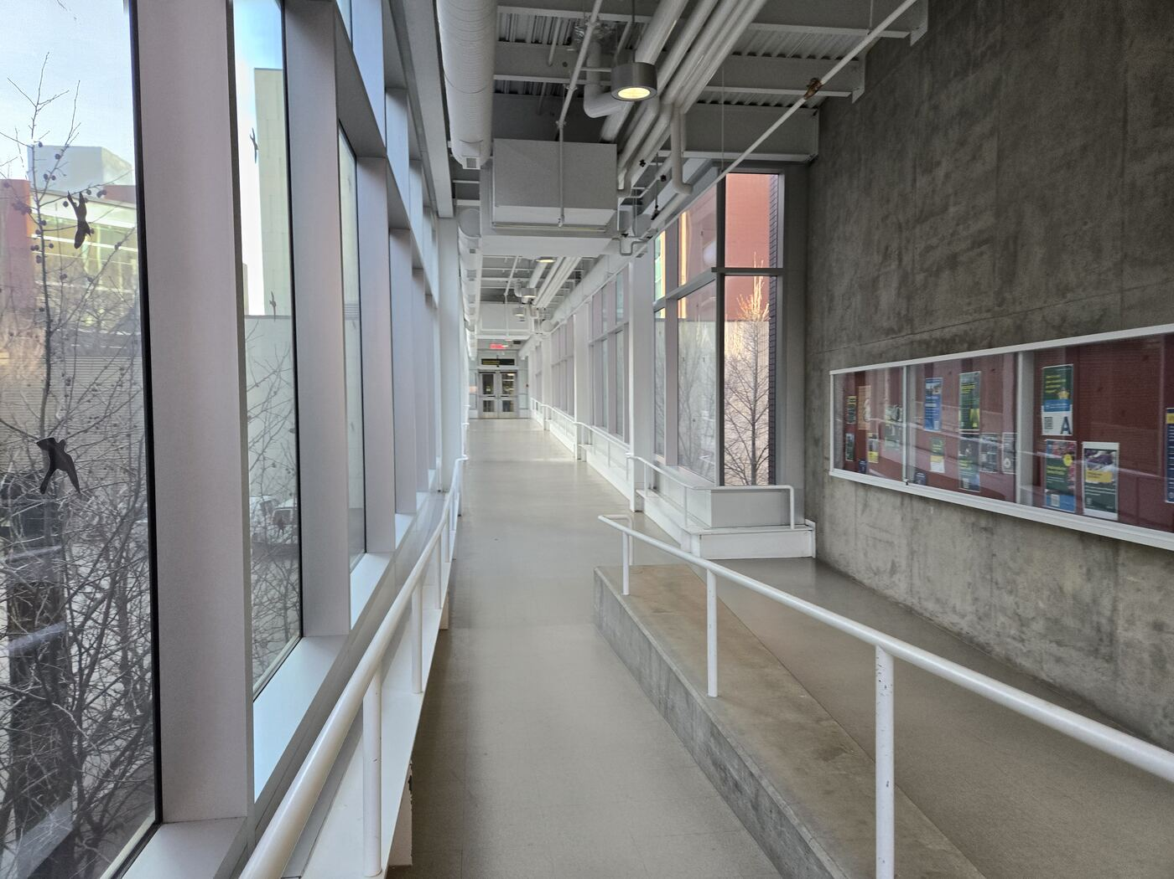  At the end of this bridge, turn left and continue onto the next bridge. | 18. Continue through the hallway  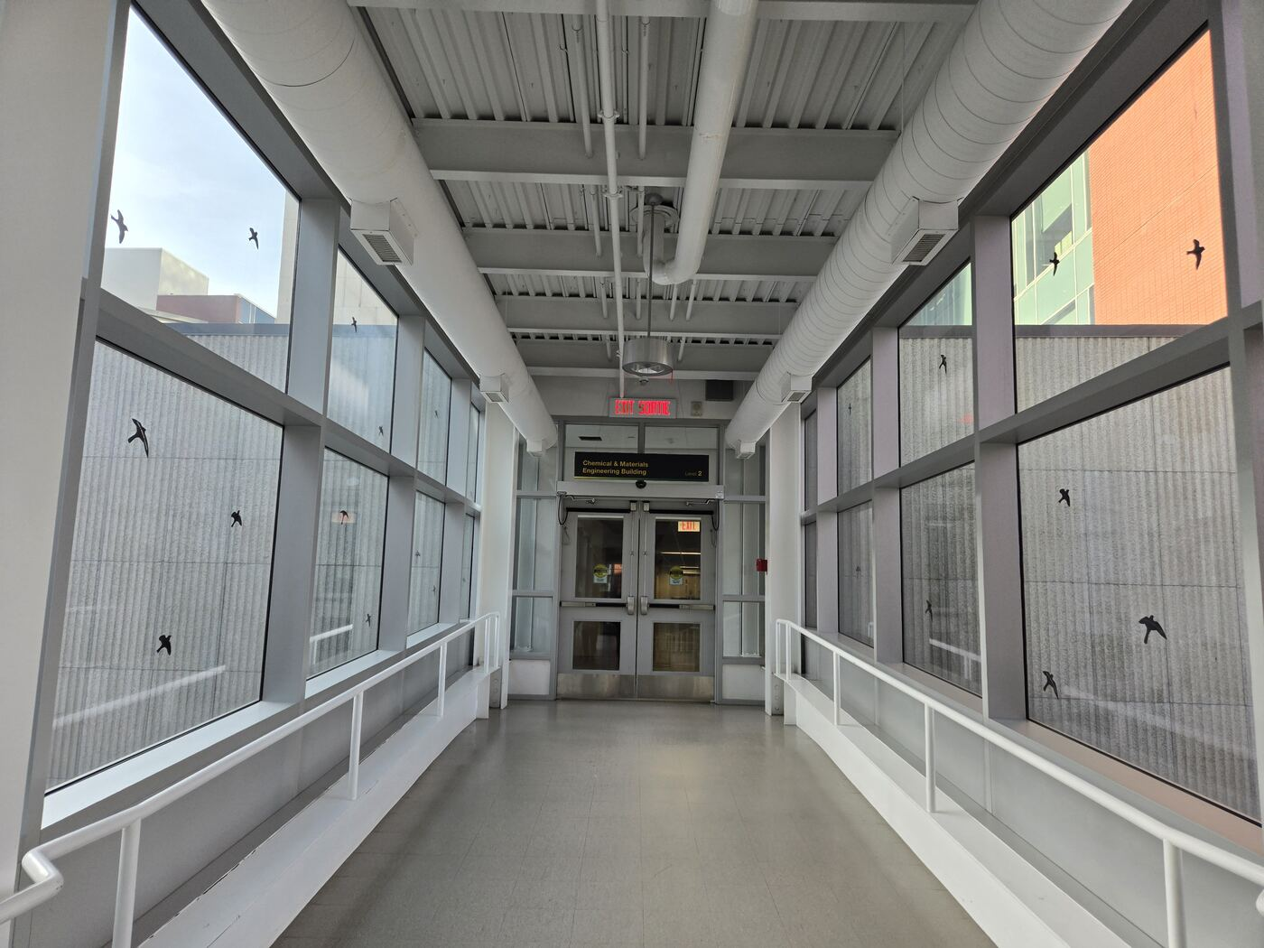  Follow the corridor straight ahead, passing the notice boards.

19. Exit the second bridge through automatic doors  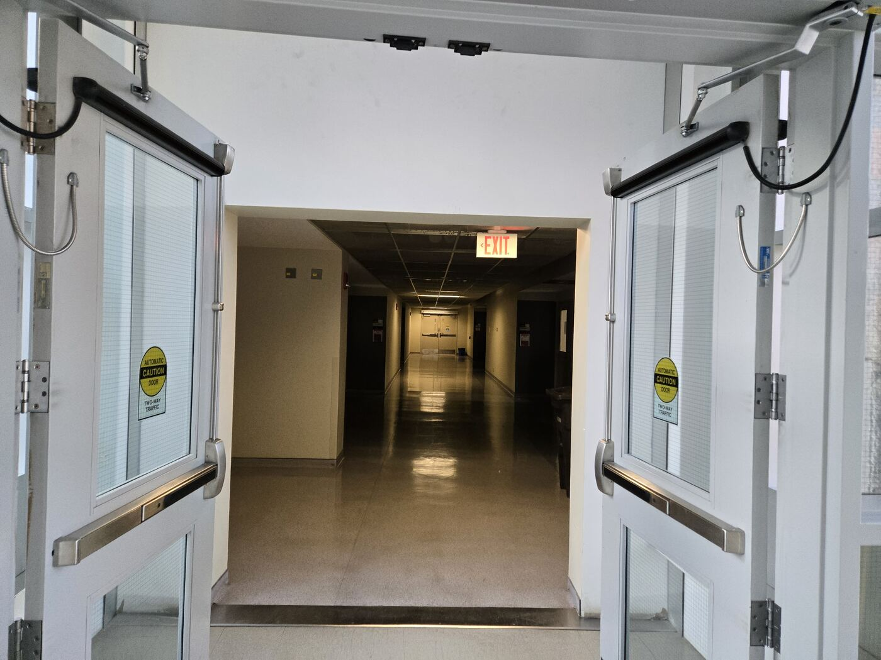  Leave the second bridge through the automatic doors shown. | 20. Exit another set of doors  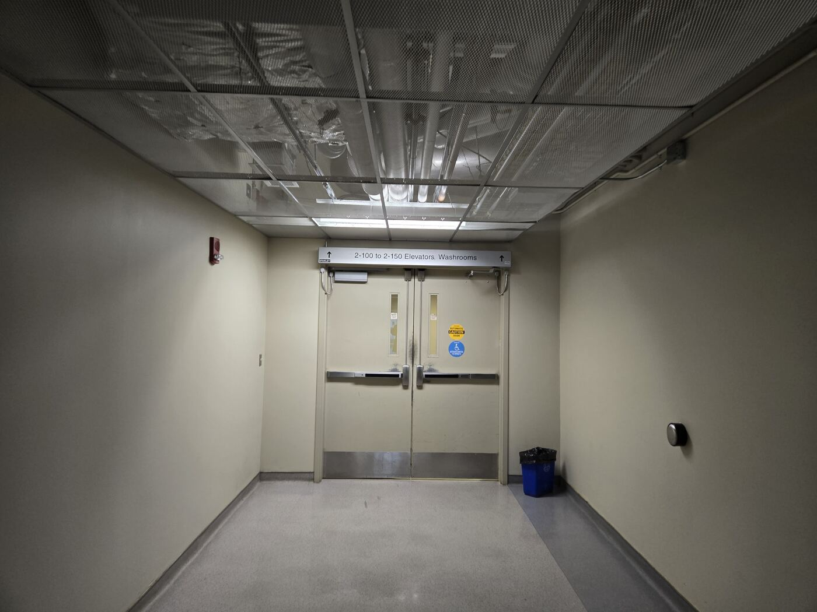  Continue through another set of doors as shown.

21. Turn right to the mail area  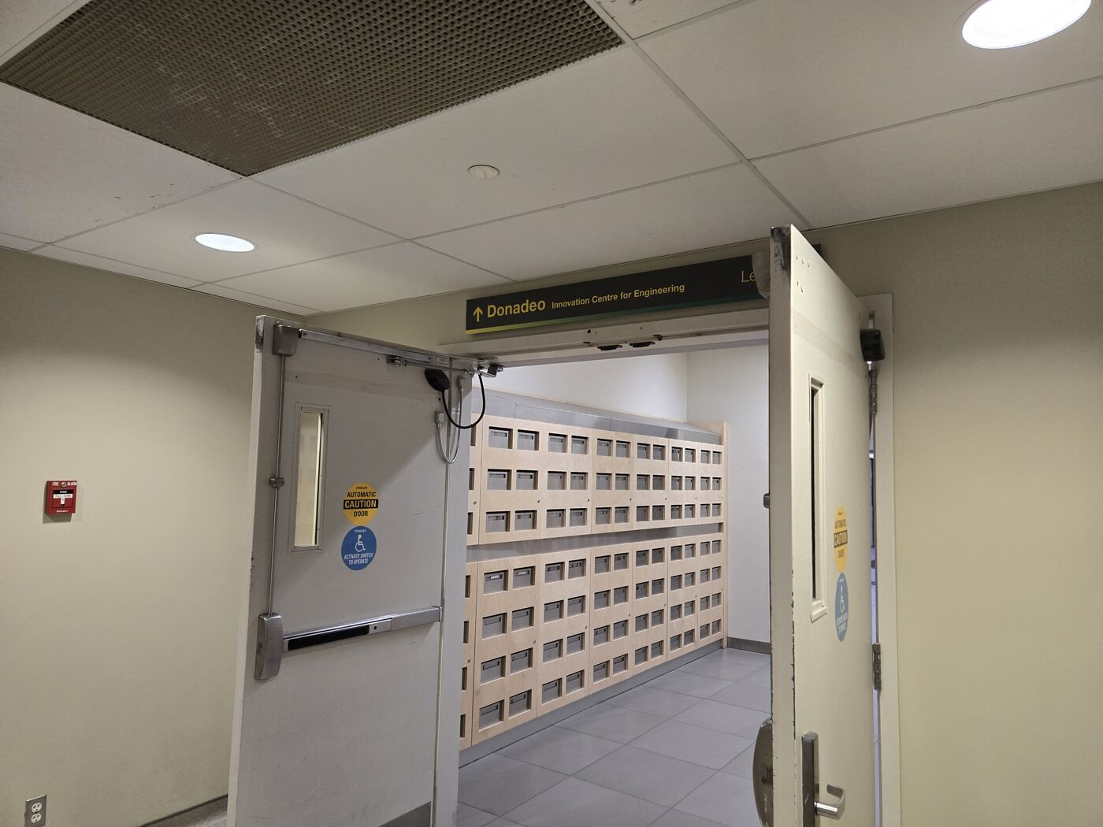  At this junction, turn right toward the mail area. | 22. Follow the Donadeo Level 2 sign  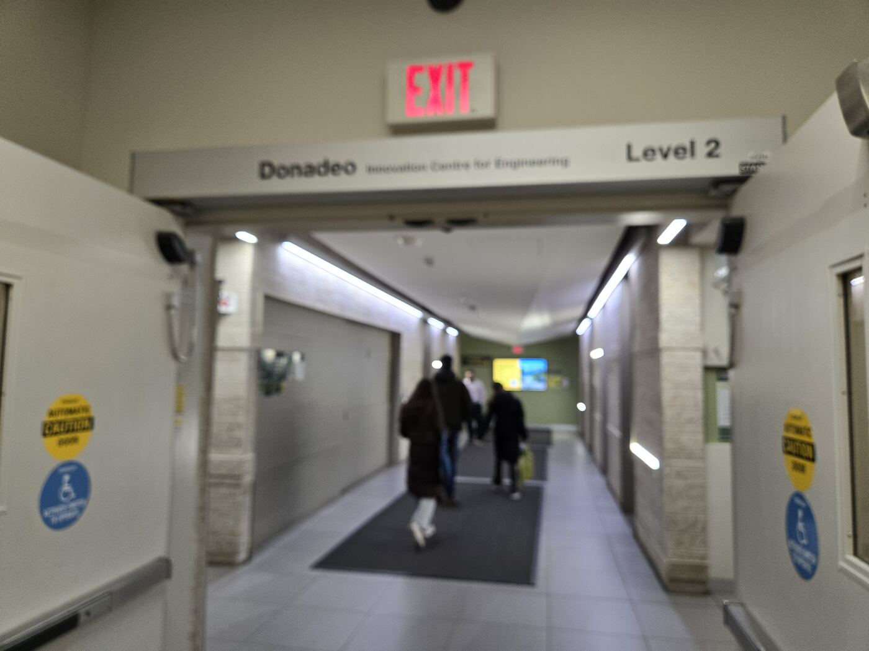  At this junction, follow the overhead Donadeo / Level 2 direction sign toward the elevators.

23. Take the elevator up  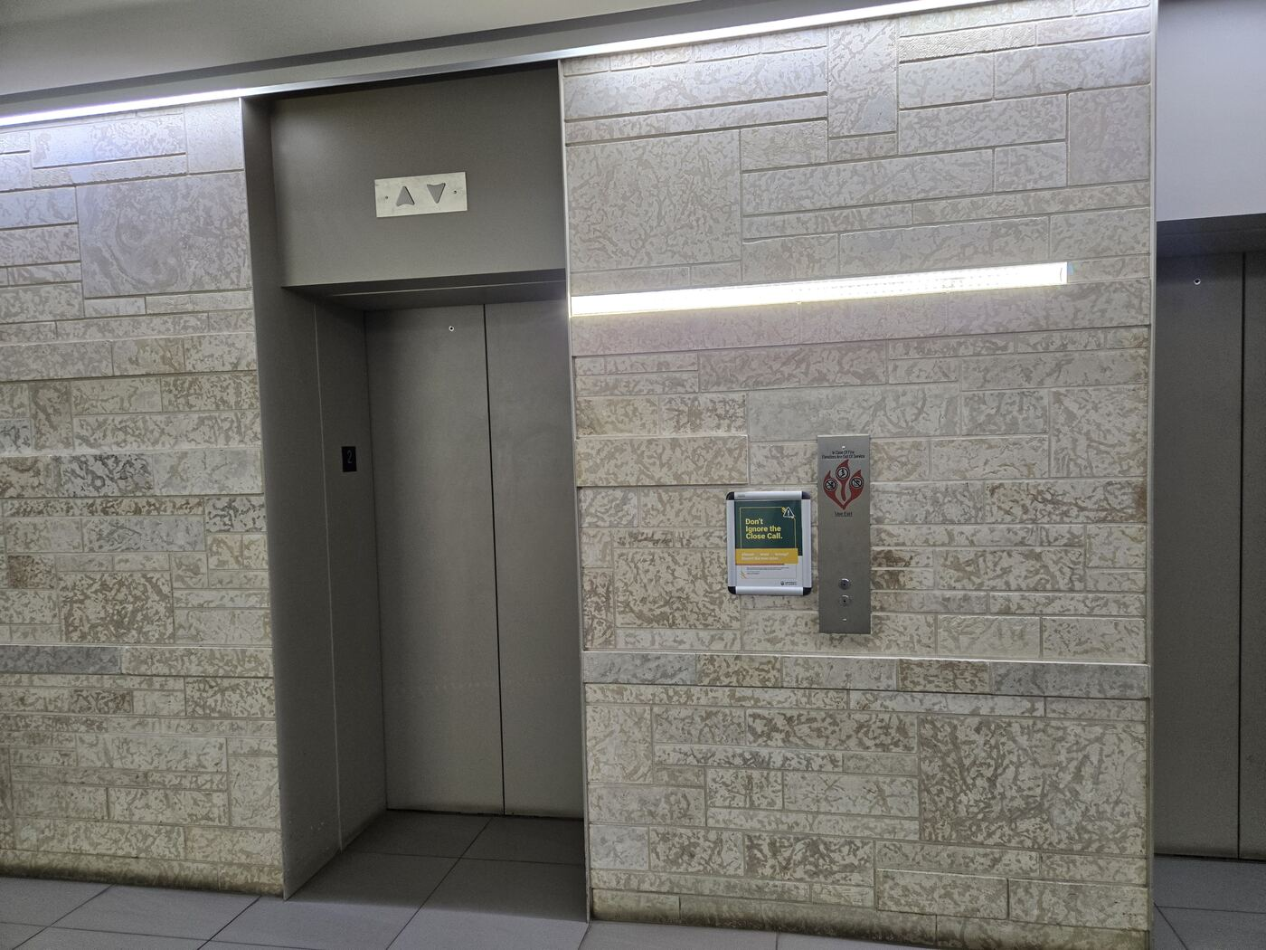  Use the elevator bank shown and select floor 8. | 24. Elevator is also on the opposite side  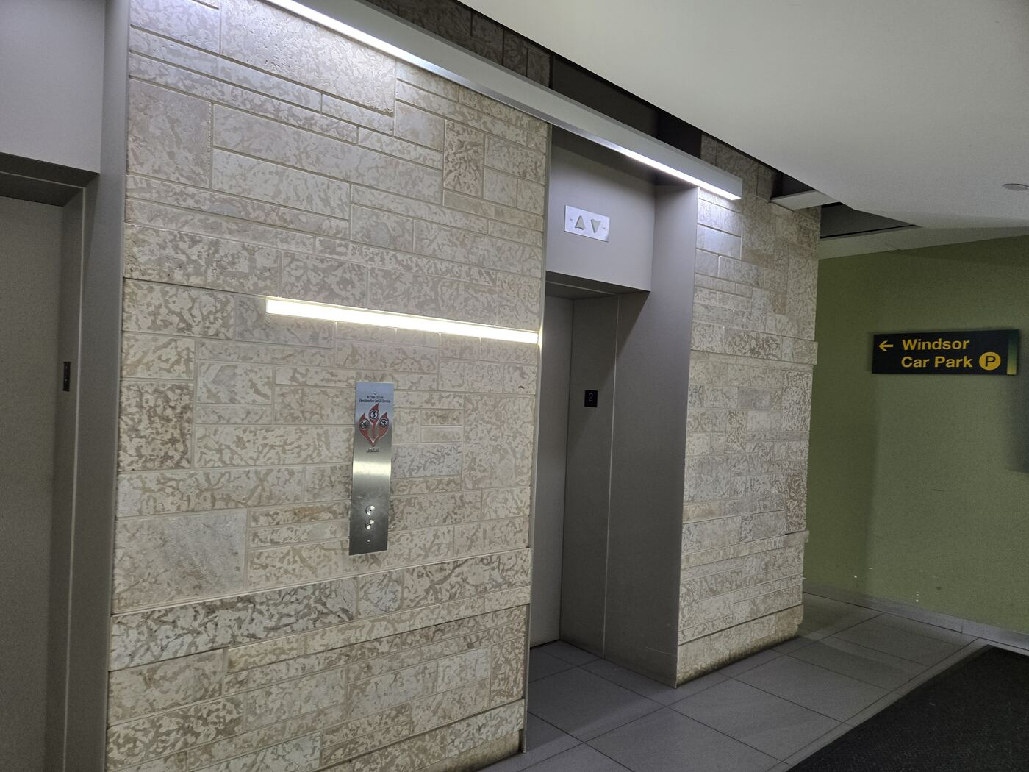  The elevator can also open on the opposite side, between the in-car floor indicator and the freight elevator.

25. Press the button for the 8th floor  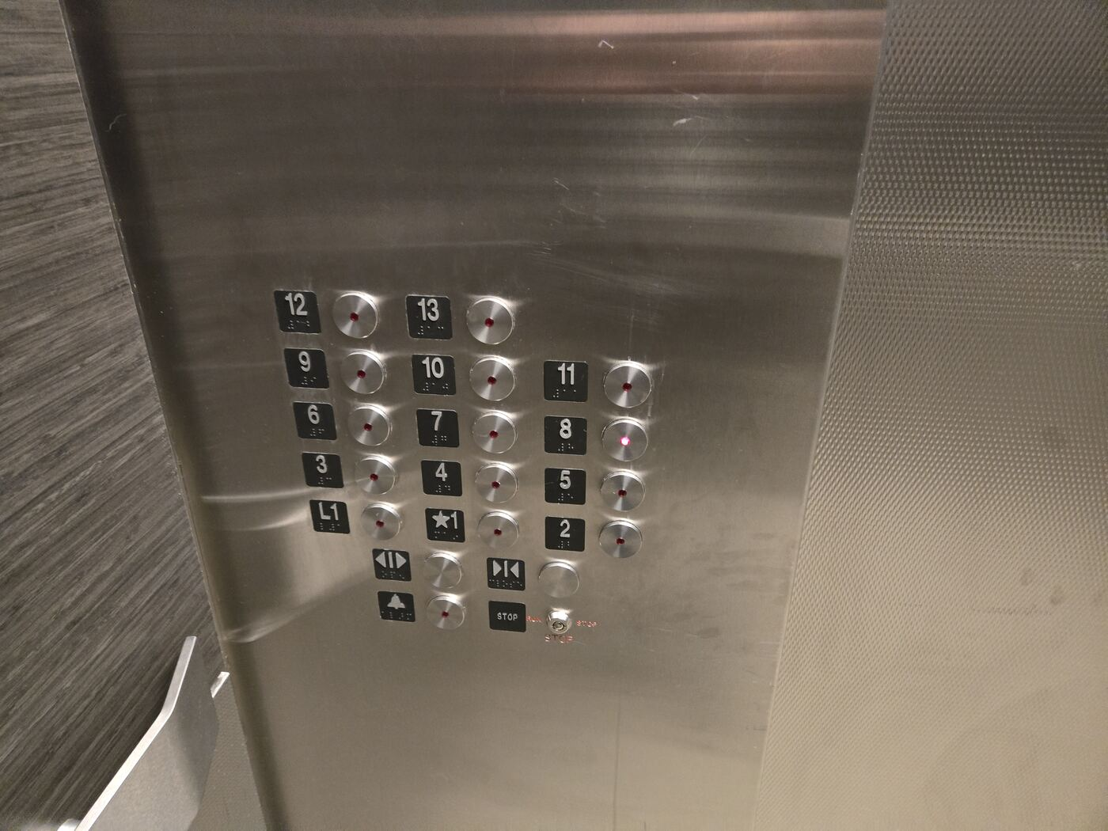  Inside the elevator, press the button for floor 8. | 26. Head toward the glass doors and turn left  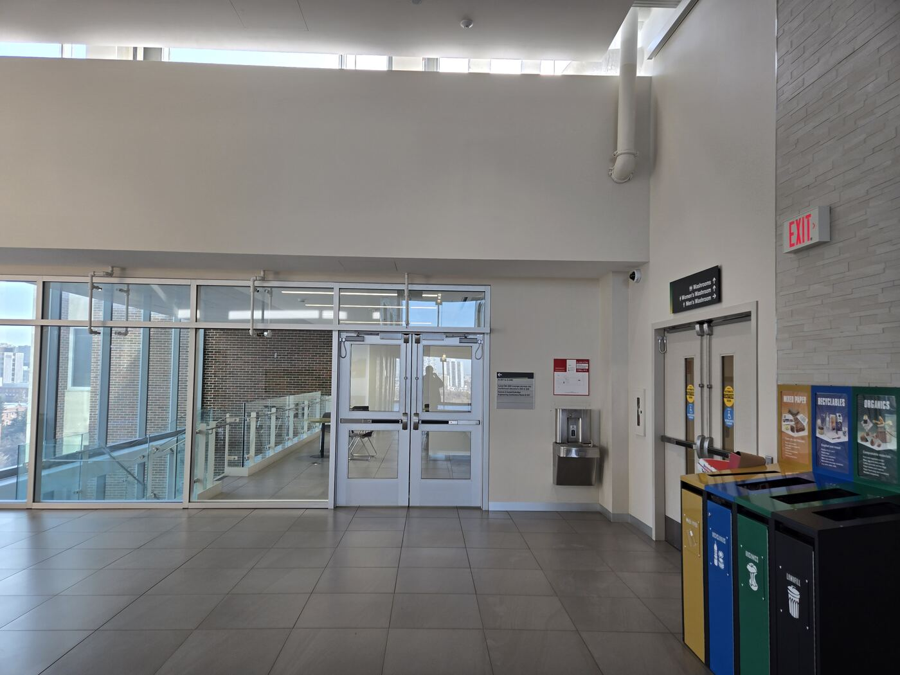  On the 8th floor, go toward the glass doors, then turn left.

27. Locate ICE 8207  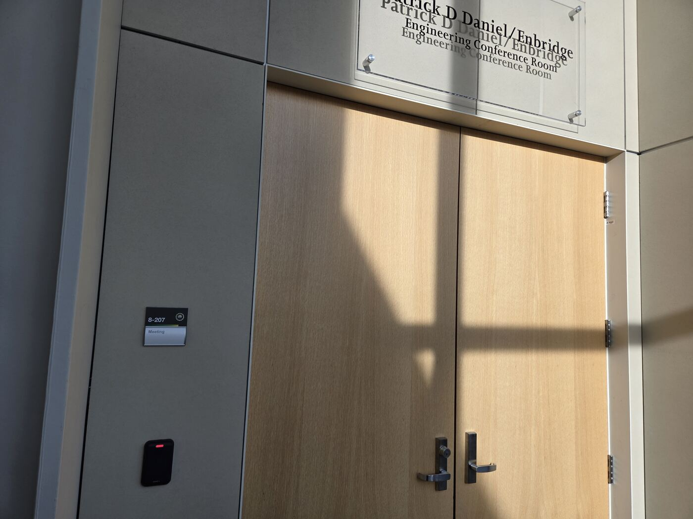  Look for the room plaque identifying ICE 8207 at the doorway. | 28. The second entrance of room 8207  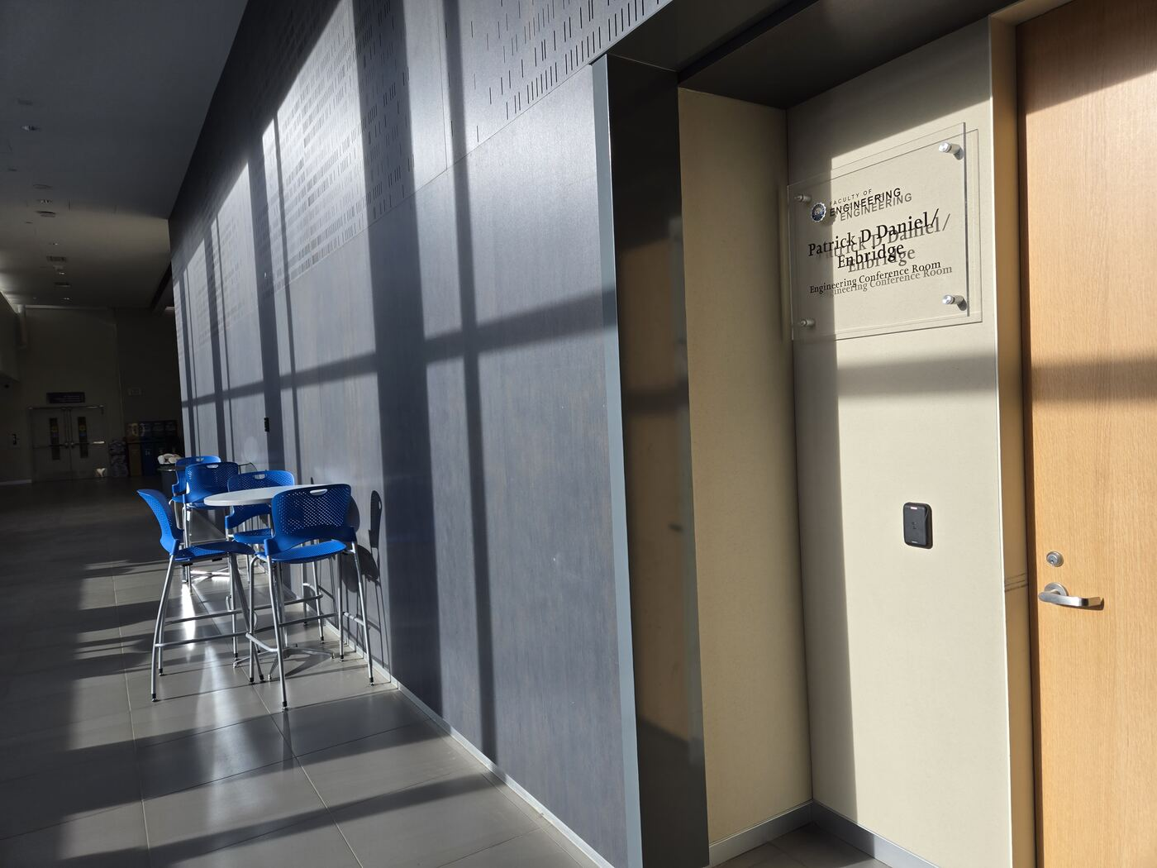  The final photo shows a Room 8207 entrance. The room also has a second entrance.

