Donadeo West Entrance to Room ICE 8207
Photo-by-photo directions via the elevators to the eighth floor. Begin at the west entrance of the Donadeo Innovation Centre for Engineering.

1 Find the Donadeo west entrance
Find the west entrance of the Donadeo Innovation Centre for Engineering at 9211 – 116 Street. Look for the building name and Engineering crest beside the recessed glass doors.
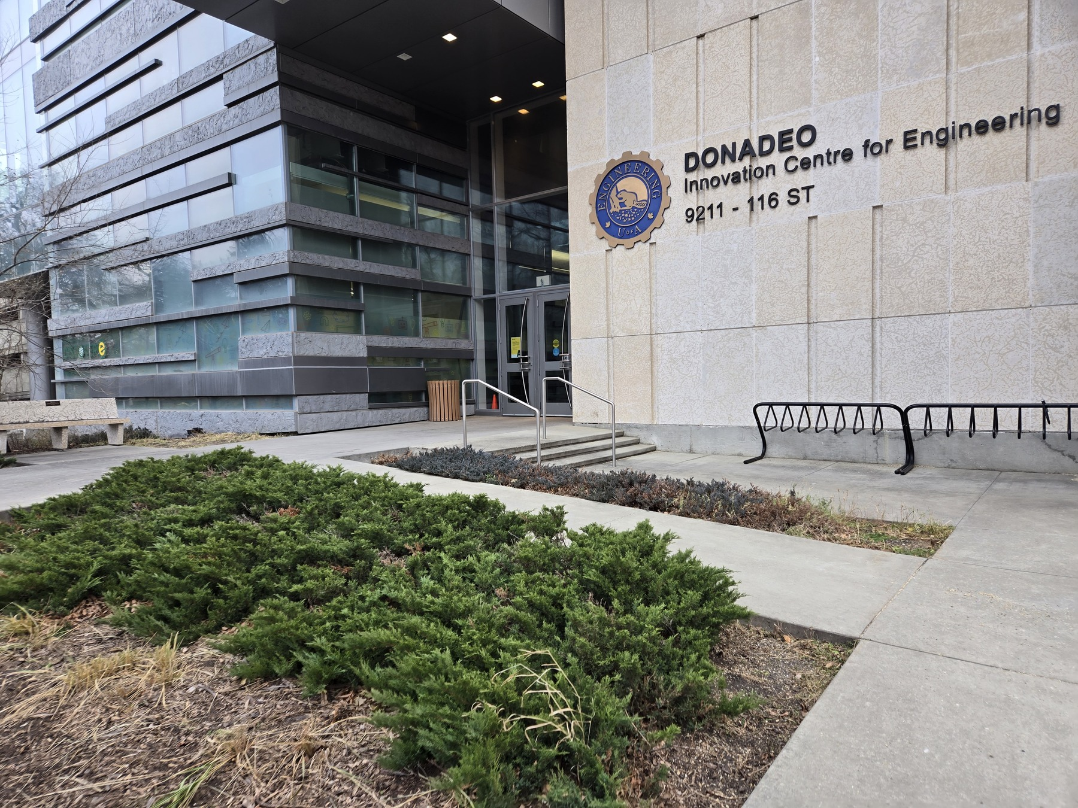
Photo 1 of 10

2 Go through the entrance doors
Enter through the glass double doors shown here. An automatic door switch is beside the entrance.
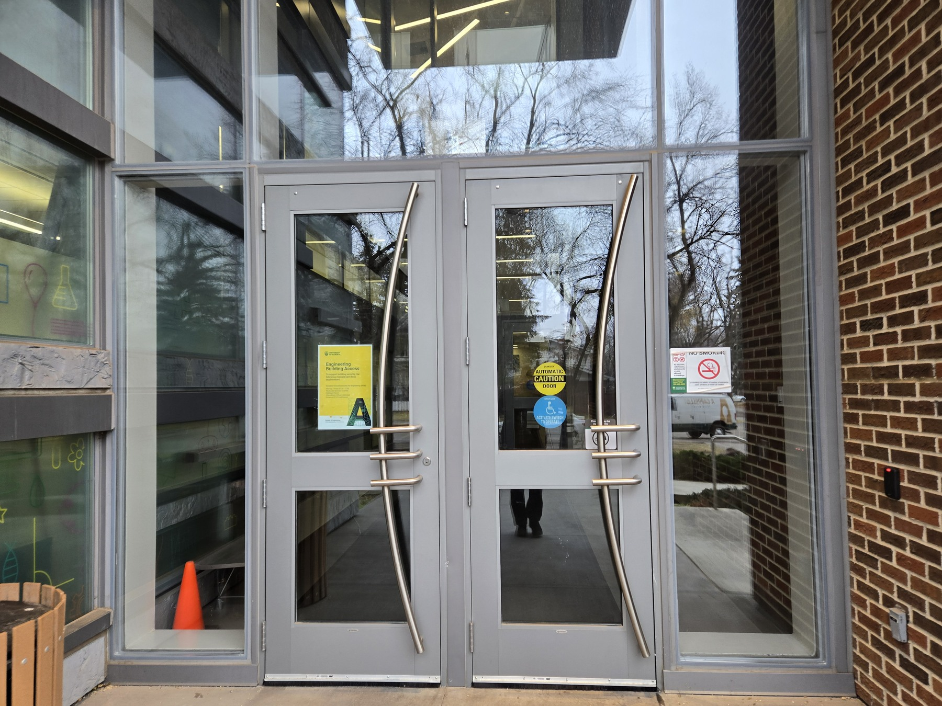
Photo 2 of 10

3 Follow the sign toward the elevators
Walk along the corridor with the brick wall on your right. At the end, follow the overhead Elevators sign pointing left.
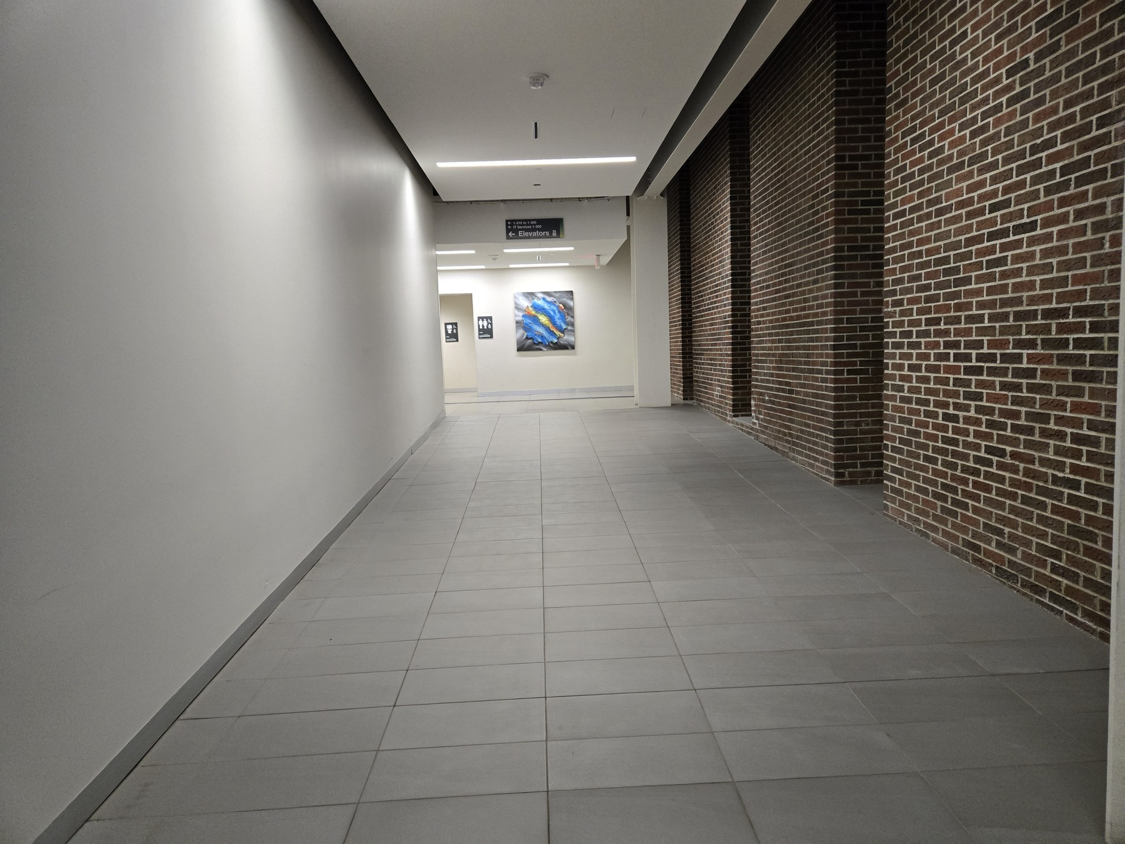
Photo 3 of 10

4 Go through the double automatic doors
Turn left through the double automatic doors beside the washrooms, shown on the left of this photo.
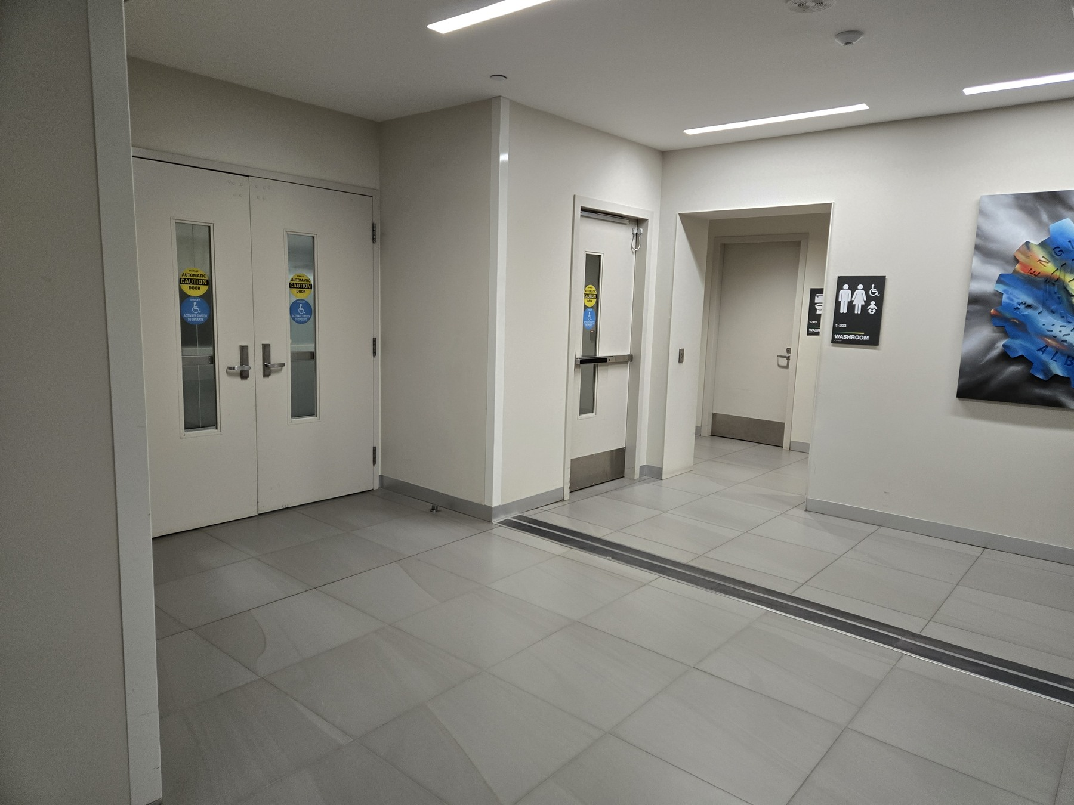
Photo 4 of 10

5 Continue along the corridor
Walk straight along the corridor, keeping the frosted glass wall on your left. Continue toward the elevator lobby ahead.
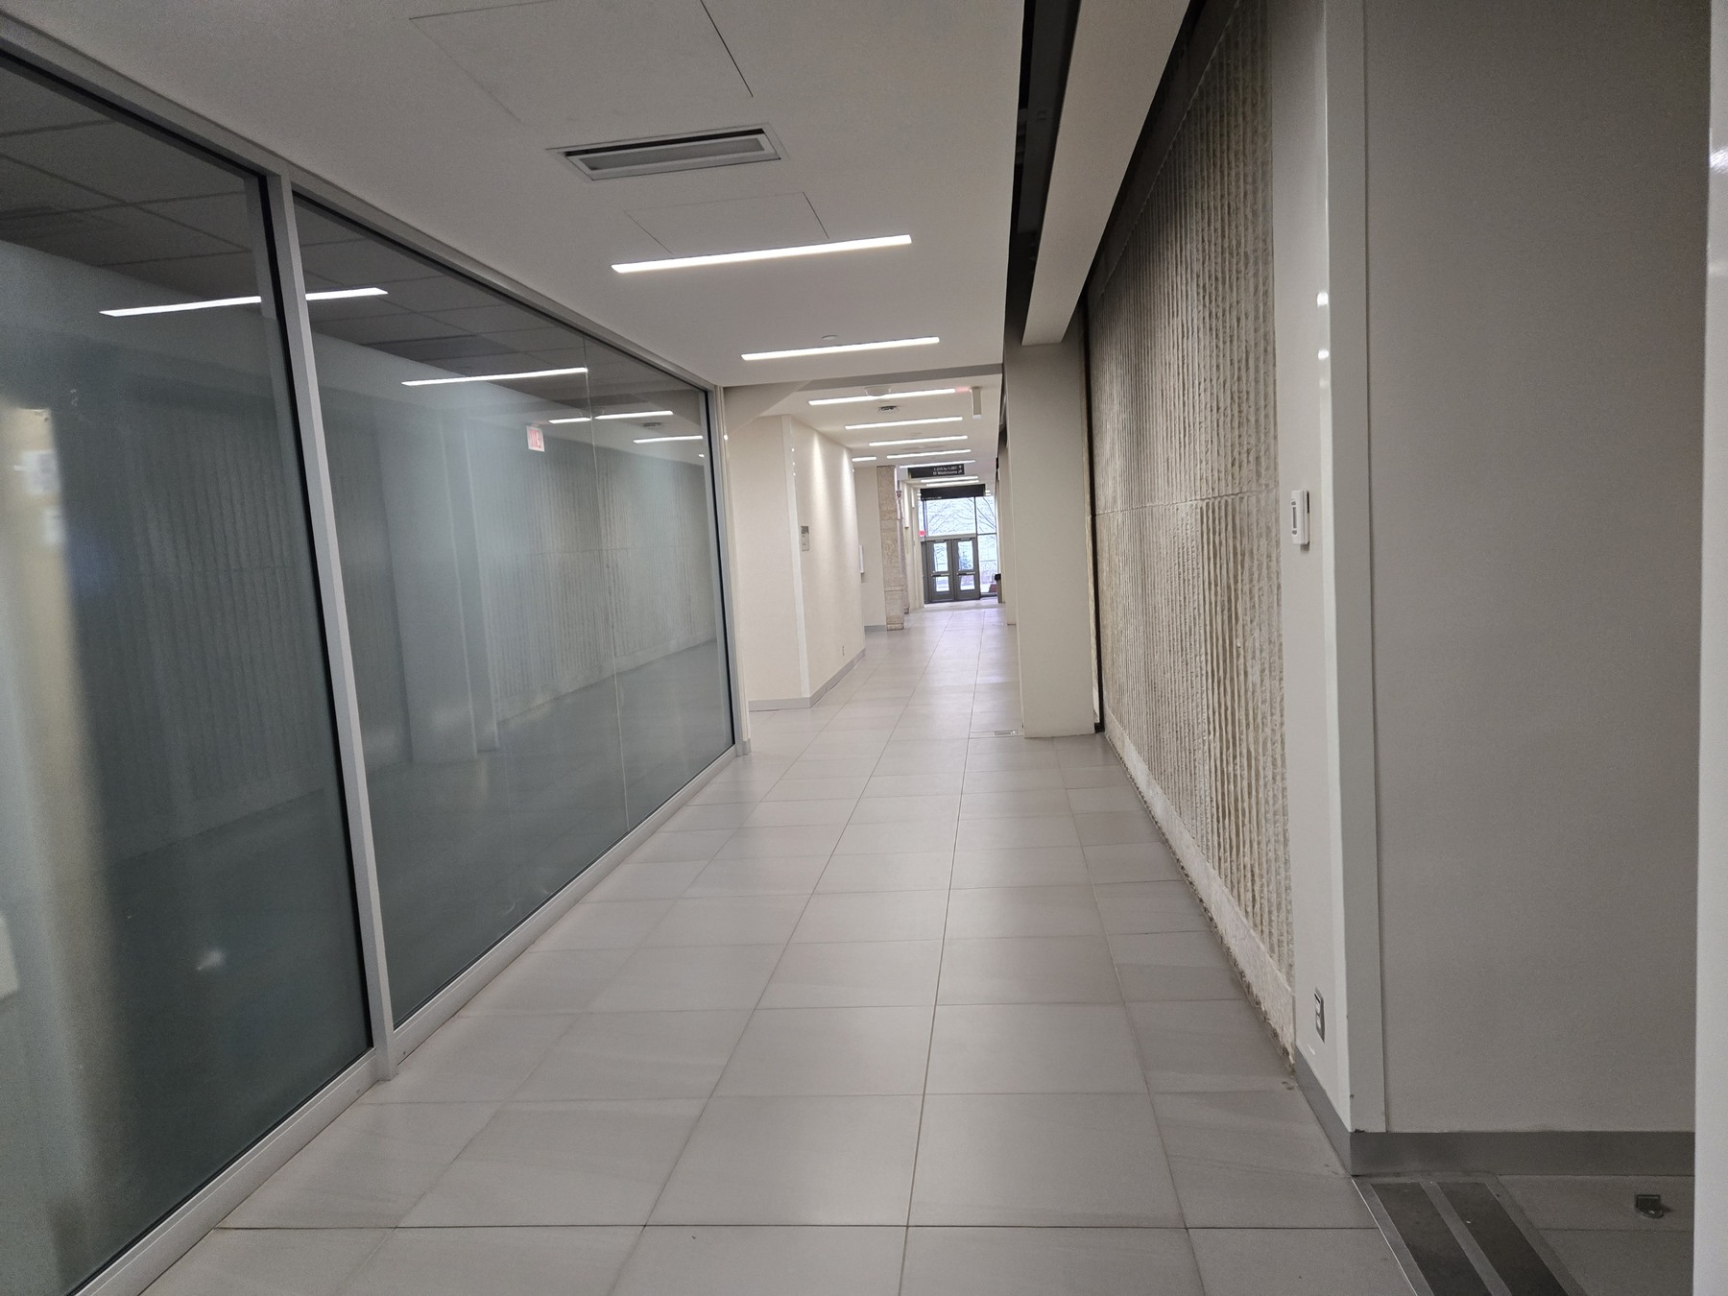
Photo 5 of 10

6 Take a passenger elevator
Enter the elevator lobby and use the passenger elevators shown on the right. Press the up call button and enter an elevator when it arrives.
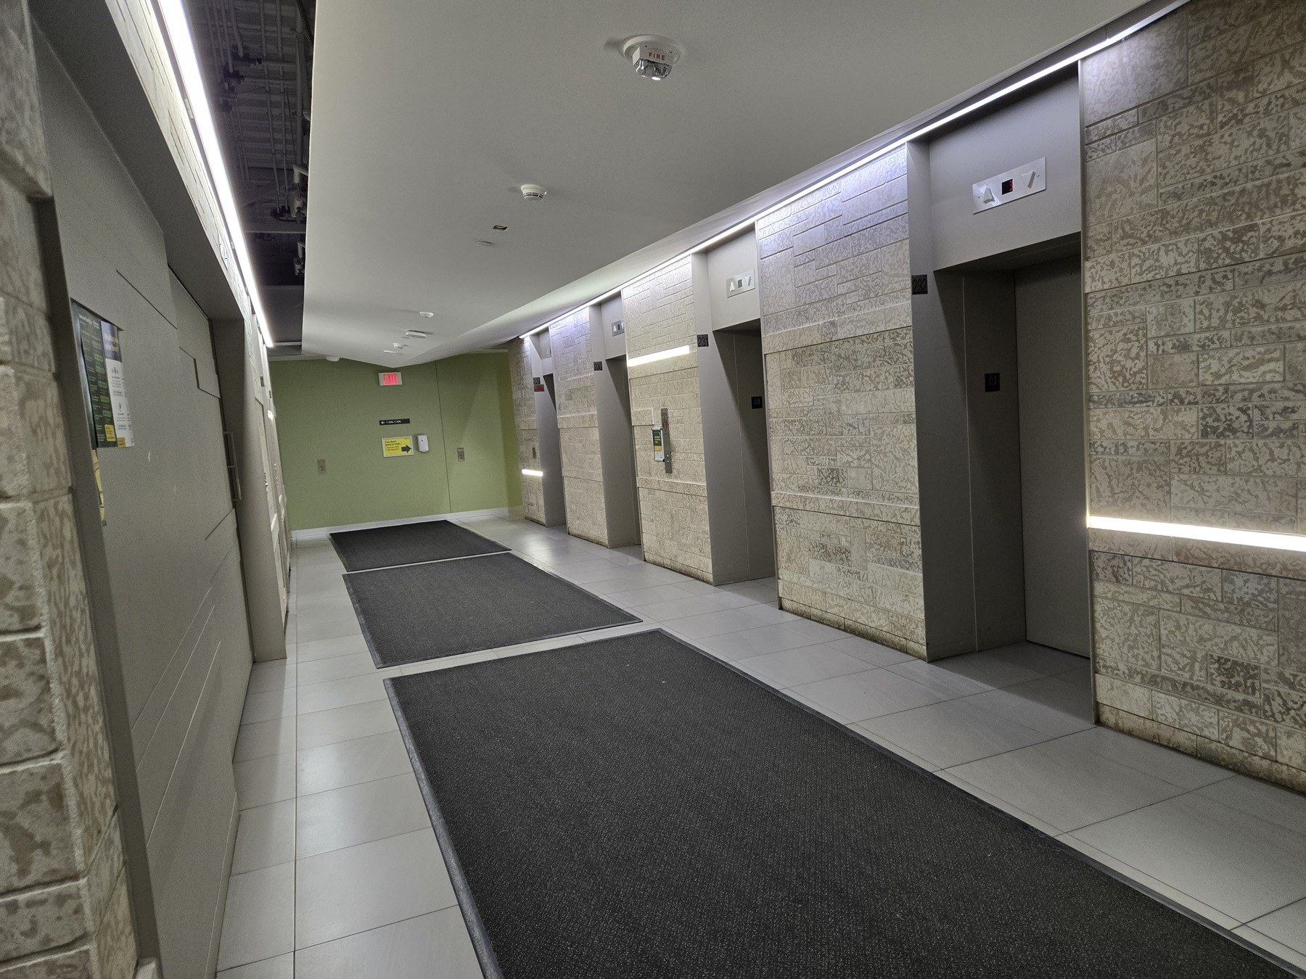
Photo 6 of 10

7 Press the button for floor 8
Inside the elevator, press 8, as shown by the illuminated button. Take the elevator to the eighth floor and exit when it arrives.
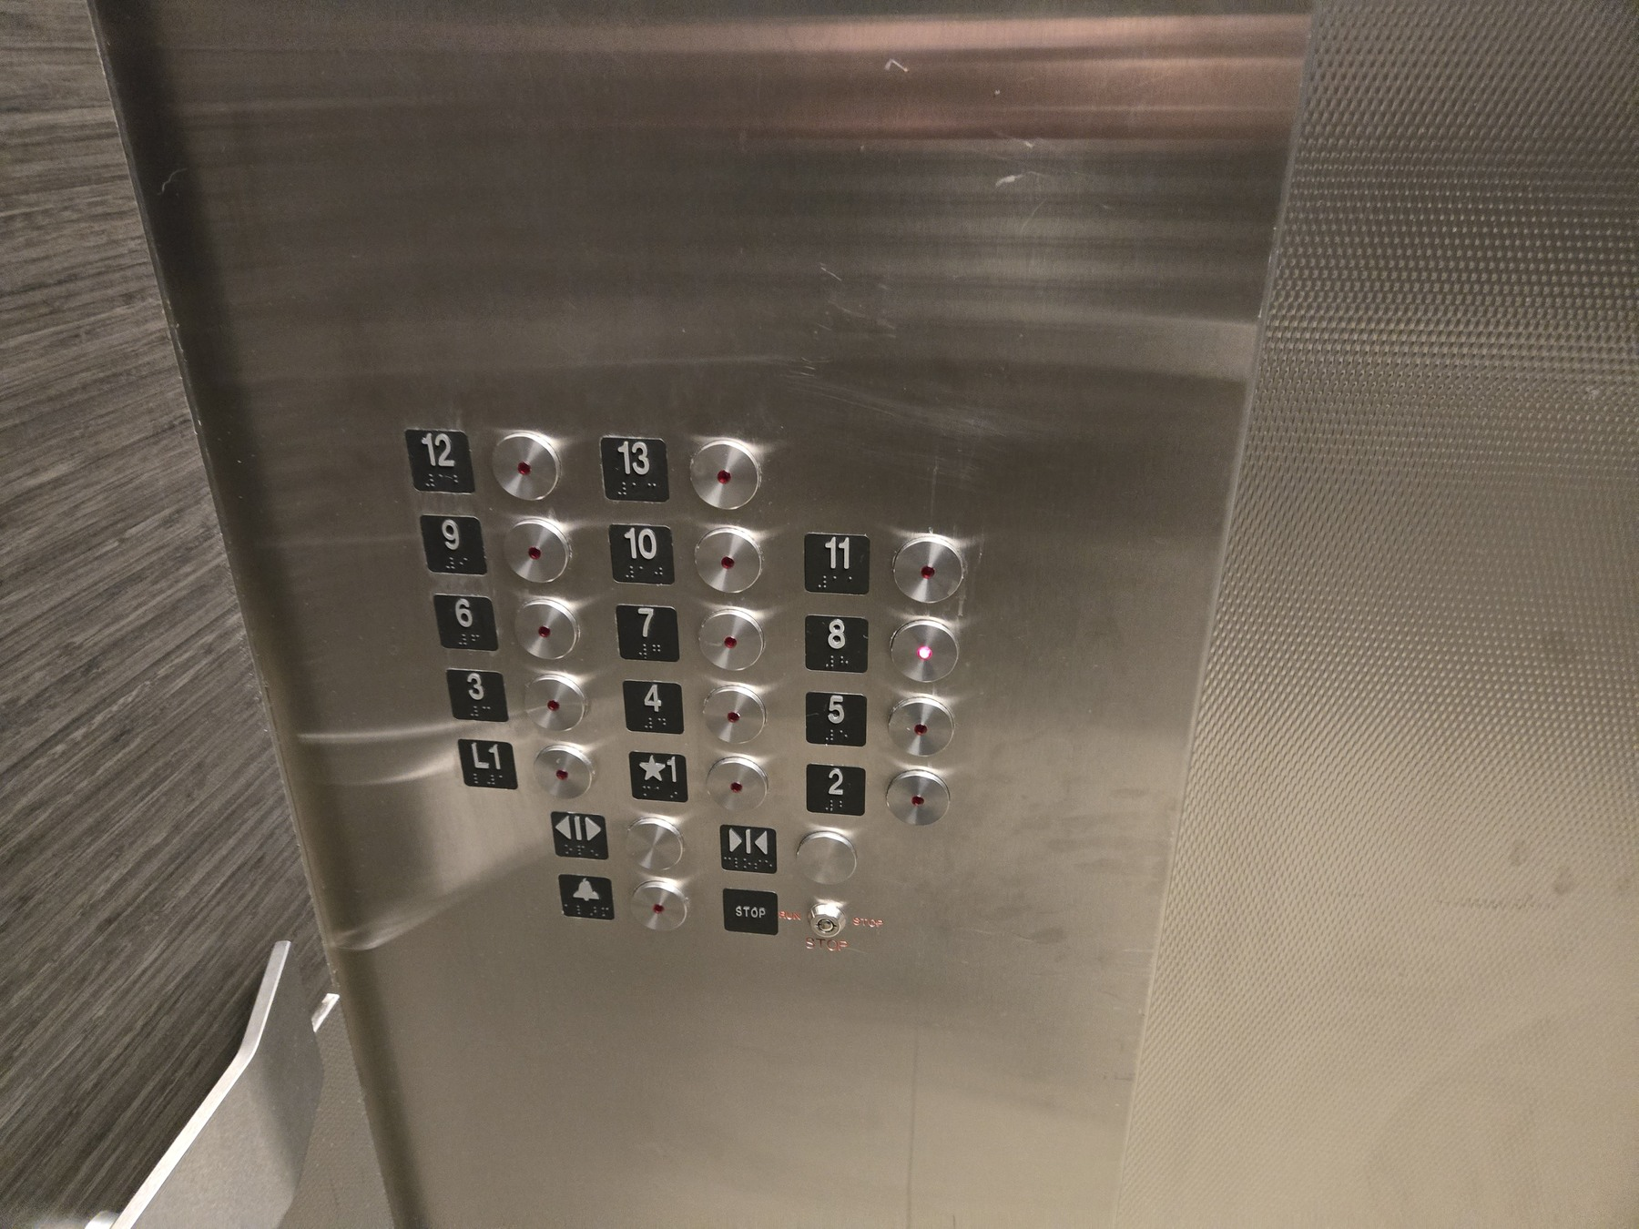
Photo 7 of 10

8 Head toward the glass doors and turn left
On the eighth floor, go toward the glass doors shown here, then turn left. The wall sign points left toward rooms 8-207 to 8-246 and identifies the Engineering Conference Room 8-207.
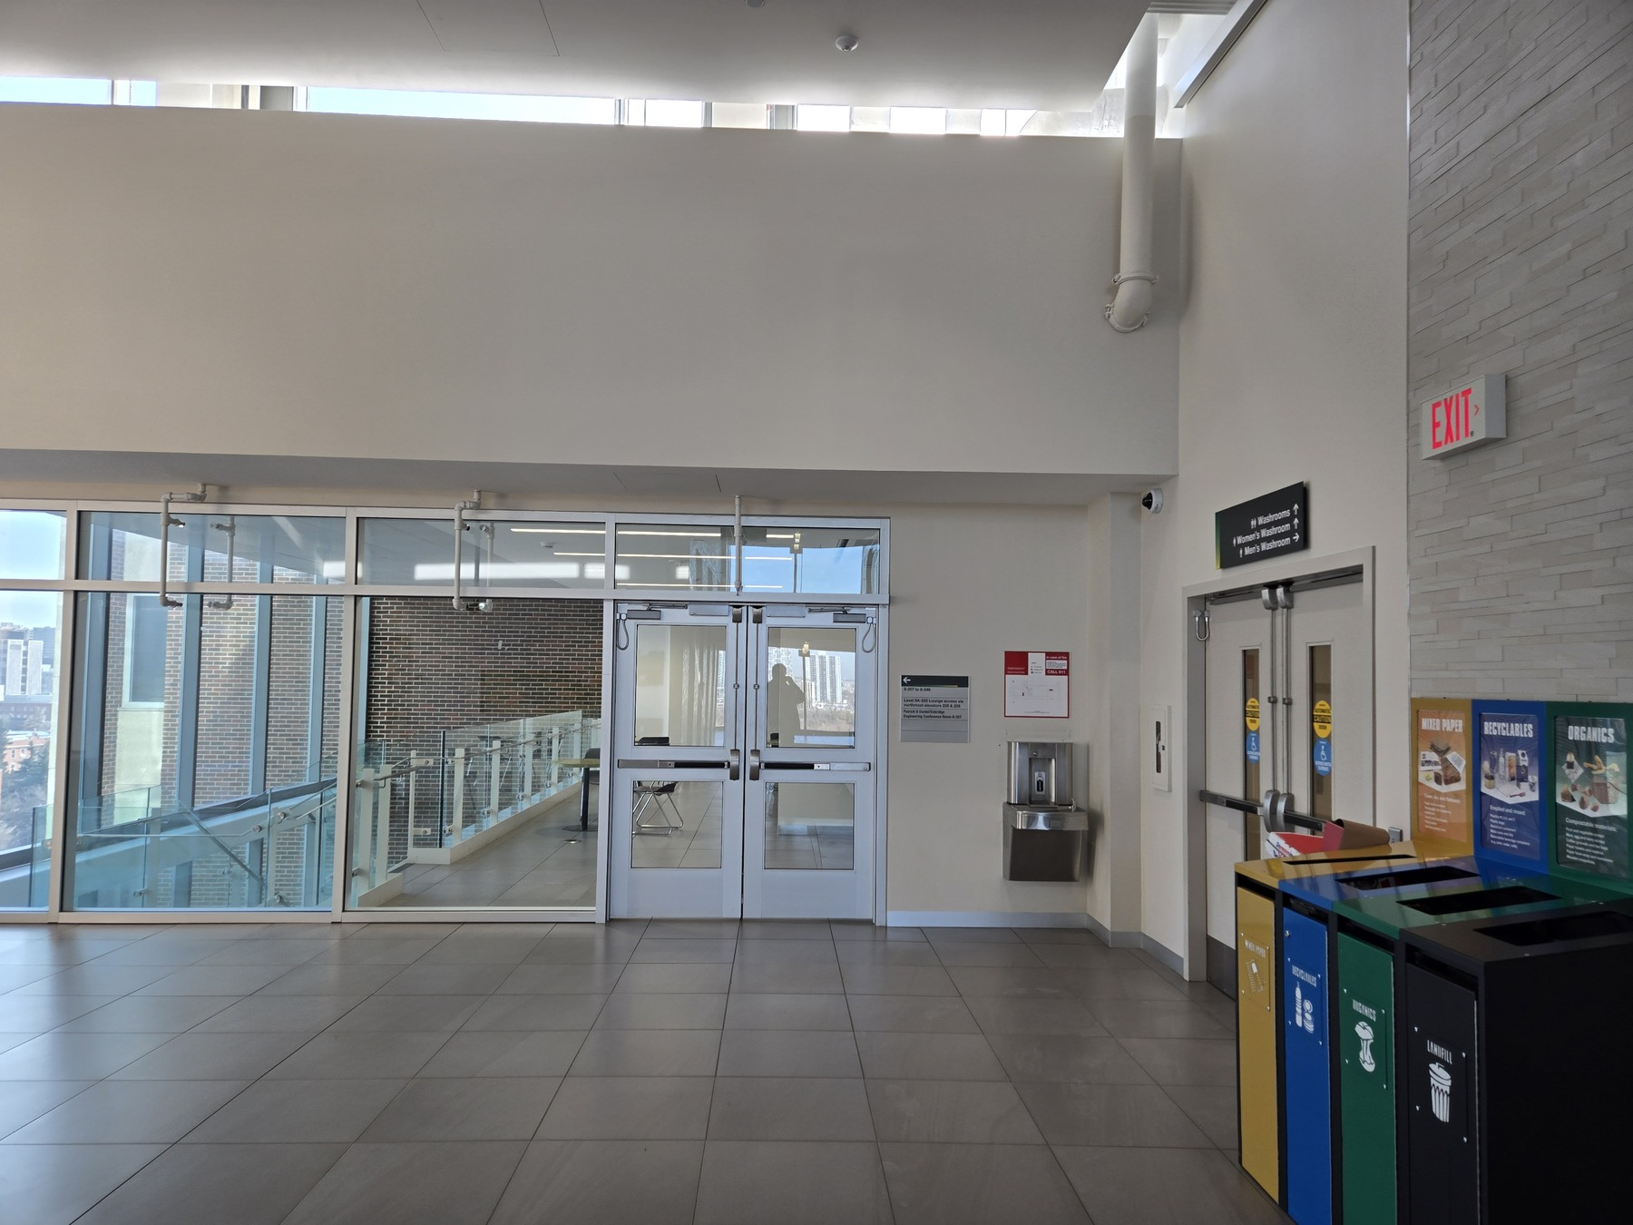
Photo 8 of 10

9 Find Room 8-207
Look for the wooden double doors with the room plaque 8-207. The sign above reads Patrick D Daniel / Enbridge Engineering Conference Room. This is the workshop room.
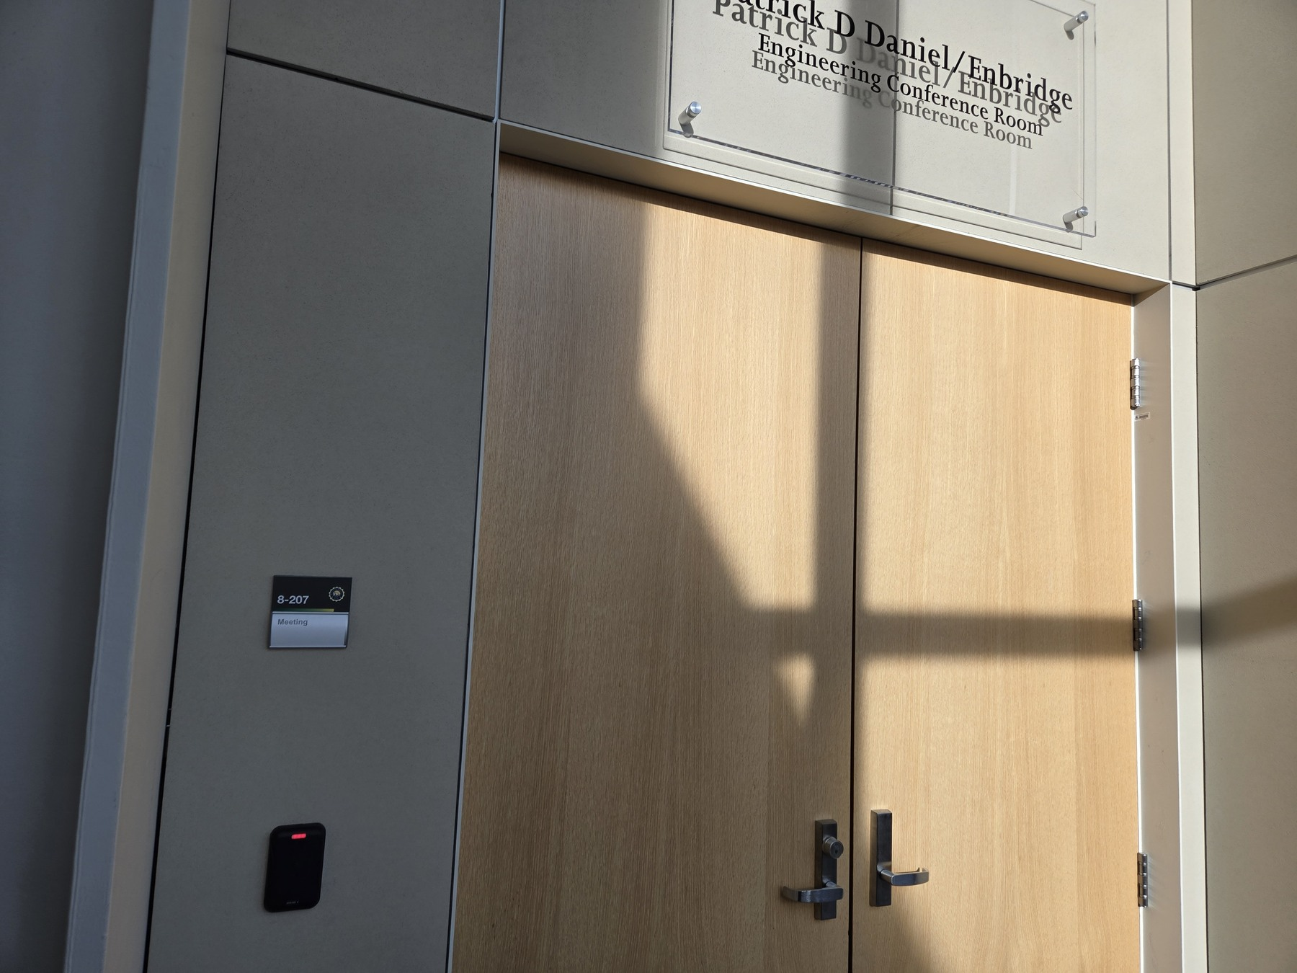
Photo 9 of 10

10 The second entrance of Room 8207
Room 8207 also has a second entrance along the same corridor. Recognize it by the matching Patrick D Daniel / Enbridge Engineering Conference Room sign and the nearby blue seating.
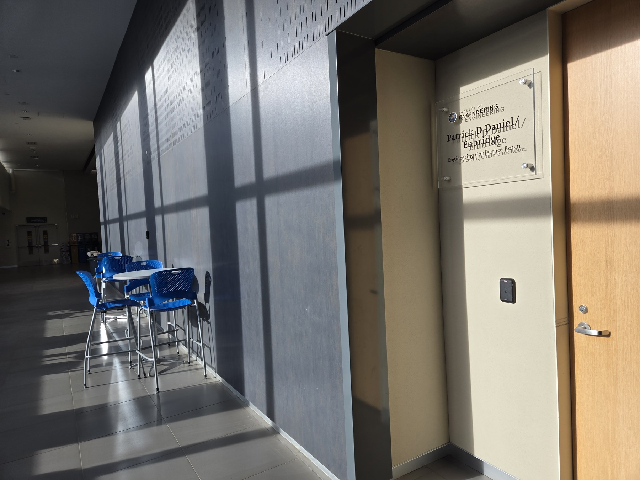
Photo 10 of 10

