Supplementary Materials
Figure S1
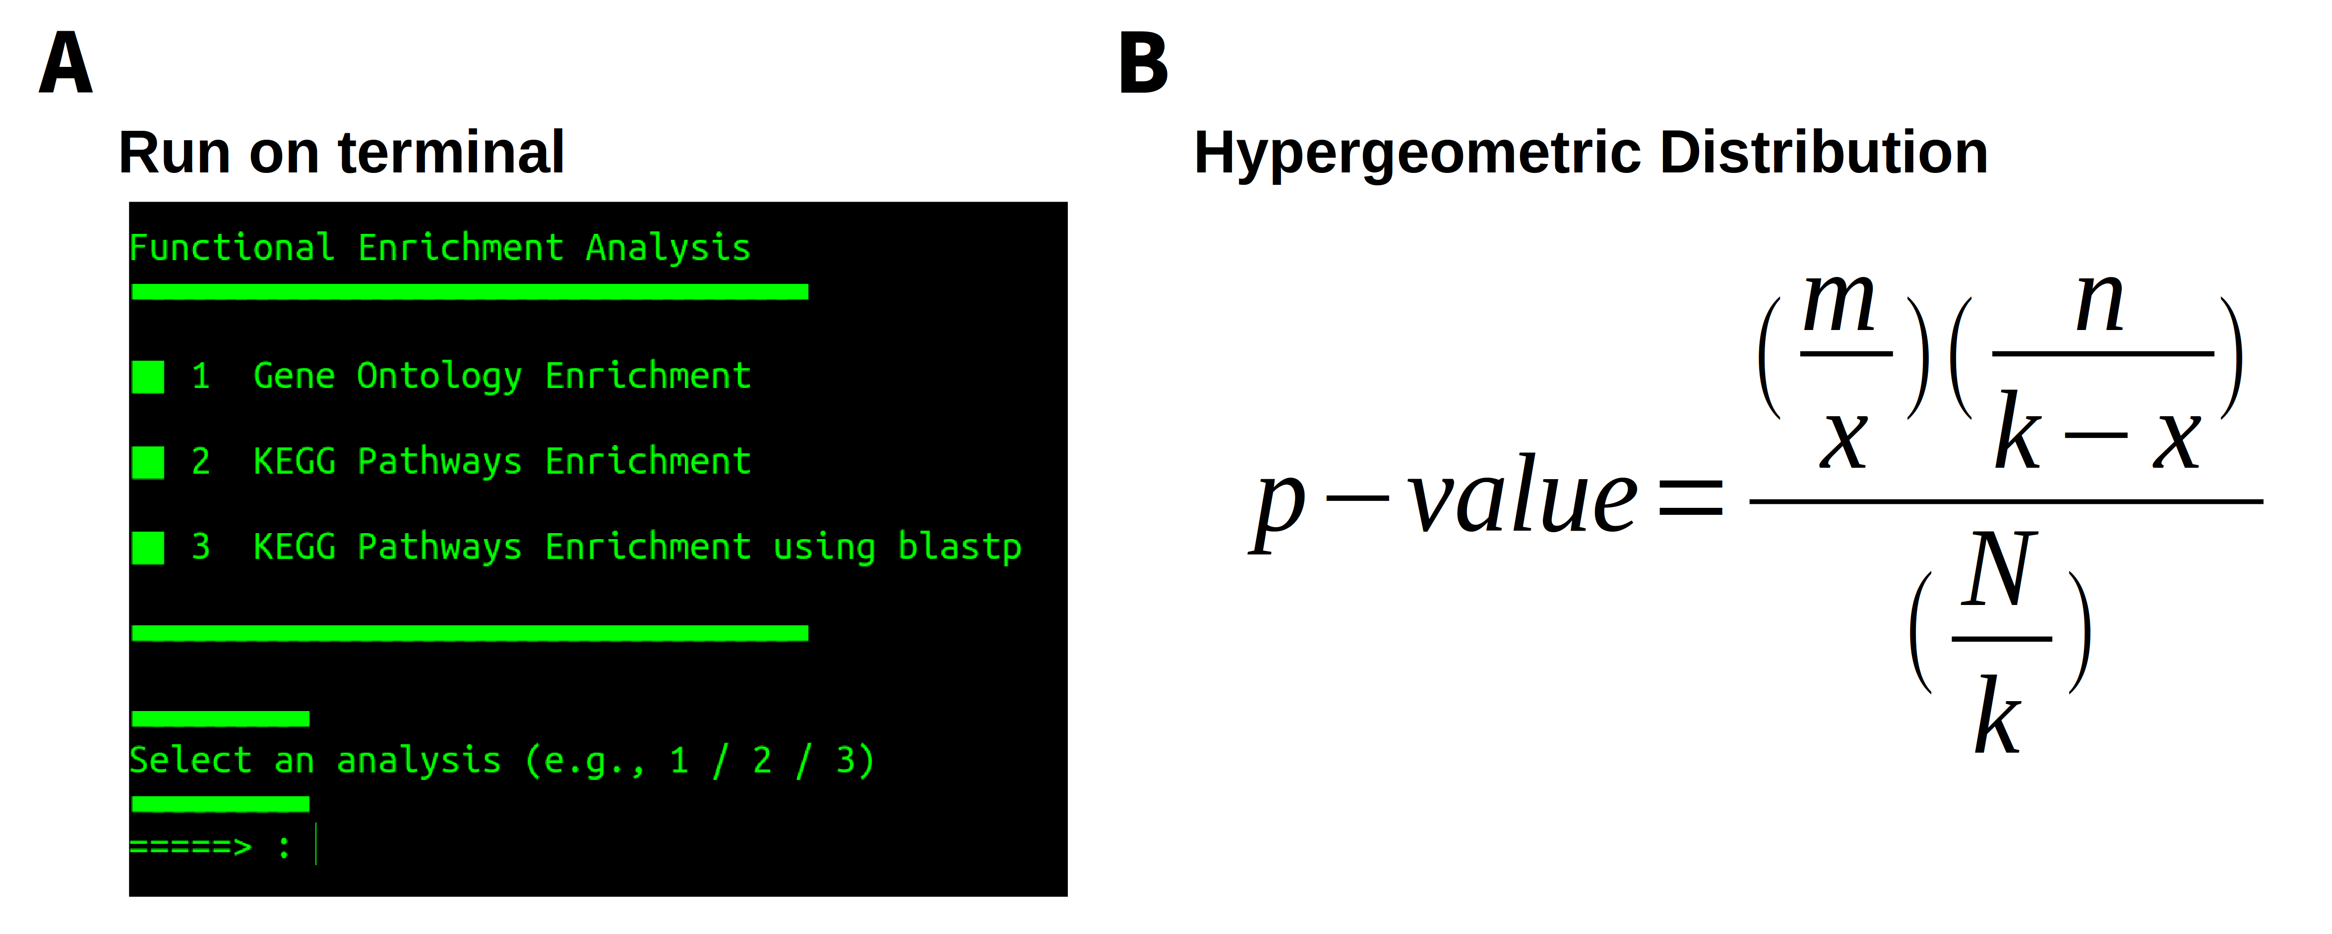
Table S1. Comparison of GOmics features with other functional enrichment tools
Enrichment tool | Organism | GO Ontology | KEGG Pathways | Statistical method | Correction | Graphical  Visualization | Time | Ref
g:Profiler* | 213 (species) | A | L | H | FDR | Network | 1 min | [1]⁠
GORILLA* | 8 | A | Na | H | FDR | DAG | 30 sec | [2]⁠
DAVID* | Unknown | A | A | F | FDR Bonferroni | NA | 2 min | [3]⁠
GOEAST* | 60 (species) | A | Na | F, H, Chi-square | FDR  Bonferroni | DAG | 20 min | [4]⁠
WebGIVI* | Unknown | A | Na | F | Unknown | Network and Graphics | 3 min | [5]⁠
WebGestalt* | 12 | A | A | H | FDR | DAG  Network | 3 min | [6]⁠
BiNGO | Unknown | A | Na | H | FDR  Bonferroni | Network | Unknown | [7]⁠
Funrich | Annoted species | A | Na | Unknown | Unknown | Network and Graphics | Unknown | [8]⁠
GOmics | Annoted species | A | A | H | FDR  Bonferroni | Network and Graphics | 2-5 min

A: Applicable
Na: Not Applicable
L: Limited, not applicable to all organisms
H: Hypergeometric distriution
F: Fisher’s exact test
FDR: Fasle discovery Rate
DAG: Directed Acyclic Graph
* : Web tools

References

[1] J. Reimand et al., “g:Profiler-a web server for functional interpretation of gene lists (2016 update).,” Nucleic Acids Res., vol. 44, no. W1, pp. W83-9, 2016.
[2] E. Eden, R. Navon, I. Steinfeld, D. Lipson, and Z. Yakhini, “GOrilla: a tool for discovery and visualization of enriched GO terms in ranked gene lists.,” BMC Bioinformatics, vol. 10, p. 48, Feb. 2009.
[3] D. W. Huang et al., “The DAVID Gene Functional Classification Tool: a novel biological module-centric algorithm to functionally analyze large gene lists.,” Genome Biol., vol. 8, no. 9, p. R183, 2007.
[4] Q. Zheng and X.-J. Wang, “GOEAST: a web-based software toolkit for Gene Ontology enrichment analysis.,” Nucleic Acids Res., vol. 36, no. Web Server issue, pp. W358-63, Jul. 2008.
[5] L. Sun et al., “WebGIVI: a web-based gene enrichment analysis and visualization tool,” BMC Bioinformatics, vol. 18, no. 1, p. 237, Dec. 2017.
[6] B. Zhang, S. Kirov, and J. Snoddy, “WebGestalt: an integrated system for exploring gene sets in various biological contexts.,” Nucleic Acids Res., vol. 33, no. Web Server issue, pp. W741-8, Jul. 2005.
[7] S. Maere, K. Heymans, and M. Kuiper, “BiNGO: a Cytoscape plugin to assess overrepresentation of Gene Ontology categories in Biological Networks,” Bioinforma. Appl. NOTE, vol. 21, no. 16, pp. 3448–3449, 2005.
[8] M. Pathan et al., “A novel community driven software for functional enrichment analysis of extracellular vesicles data,” J. Extracell. Vesicles, vol. 6, no. 1, p. 1321455, Dec. 2017.

Case study 1: Enrichment analysis in early-stage lung or head of pancreas cancer
Figure S2

Figure S3

Figure S4

Case study 2: Identification of GO terms from Proteome and Phosphoproteome dataset in Beauveria bassiana
NaCl
Figure S4

Figure S5

Figure S6

Figure S7

H₂O₂
Figure S8

Figure S9

Figure S10

Figure S11

