DRONE SYNTH V3 BUILD GUIDE

Obsah
Tools and materials 1
Essential 1
Recommended 1
Other 2
General notes 2
PCB 4
Schematic 5
Parts list 6
Build guide 7
Wiring diagram and mods 9
Useful links 10

Tools and materials

Essential
- soldering iron
- sponge or brass wool
- solder – preferably 1 mm or smaller
- flux or soldering paste
- wire cutters
- wire strippers or at least box cutter
- power drill + bits
- plyers or wrenches
- M3 screws or mirror tape

Recommended
- multimeter
- iPrOH for cleaning, toothbrush
- desoldering tool/solder sucker
- tweezers
- fan or fumes extractor
- stepped drill bit
- PCB holder or third hand

Other
Enclosure is not included. Try to lay out the panel mount components before choosing one. 9 V battery is also not included.

General notes
This guide will walk you through each step of building the synthesizer. I will try to answer any questions on Instagram @biokodein. Any feedback is welcome. The synth is a long term project of mine and there is a lot of ways to modify it or build upon it.
Throughout the guide there will be notes of advice encouraging experimentation. Some of them will require self-sourcing parts, many can be desoldered from junk. The kit uses common parts and most component values can be modified within specified ranges. There are two main options with the build: each oscillator can be set by a potentiometer or a photoresistor (or a combination), those need a transparent enclosure or a window. This determines how the instrument is played. Any of the buttons can be omitted in principle but I strongly suggest not doing so. There will also be short explanations as to what the components do.
Read the whole guide before starting work and think through all of the steps, picture yourself doing them and plan everything. There is nothing more frustrating than having something almost done only to realize you have no space left for a battery etc. etc.
Work in a ventilated space, especially when using leaded solder. Previous experience with building simple electronics projects is not essential for the minimal version of the build but advantageous. Train soldering before starting work. 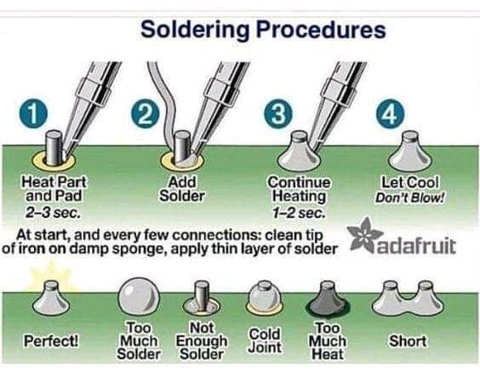
Components should be placed on the side with the symbols identifying them. Wearing synthetic fiber can cause you to fry the ICs by static discharge in theory. The board is designed in KiCAD, files are available at: https://github.com/biokodein/drone-synth-version-3

PCB
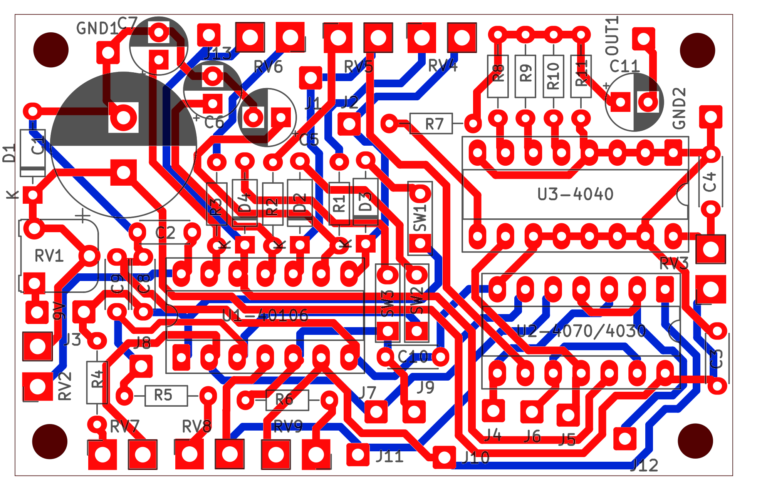

Schematic
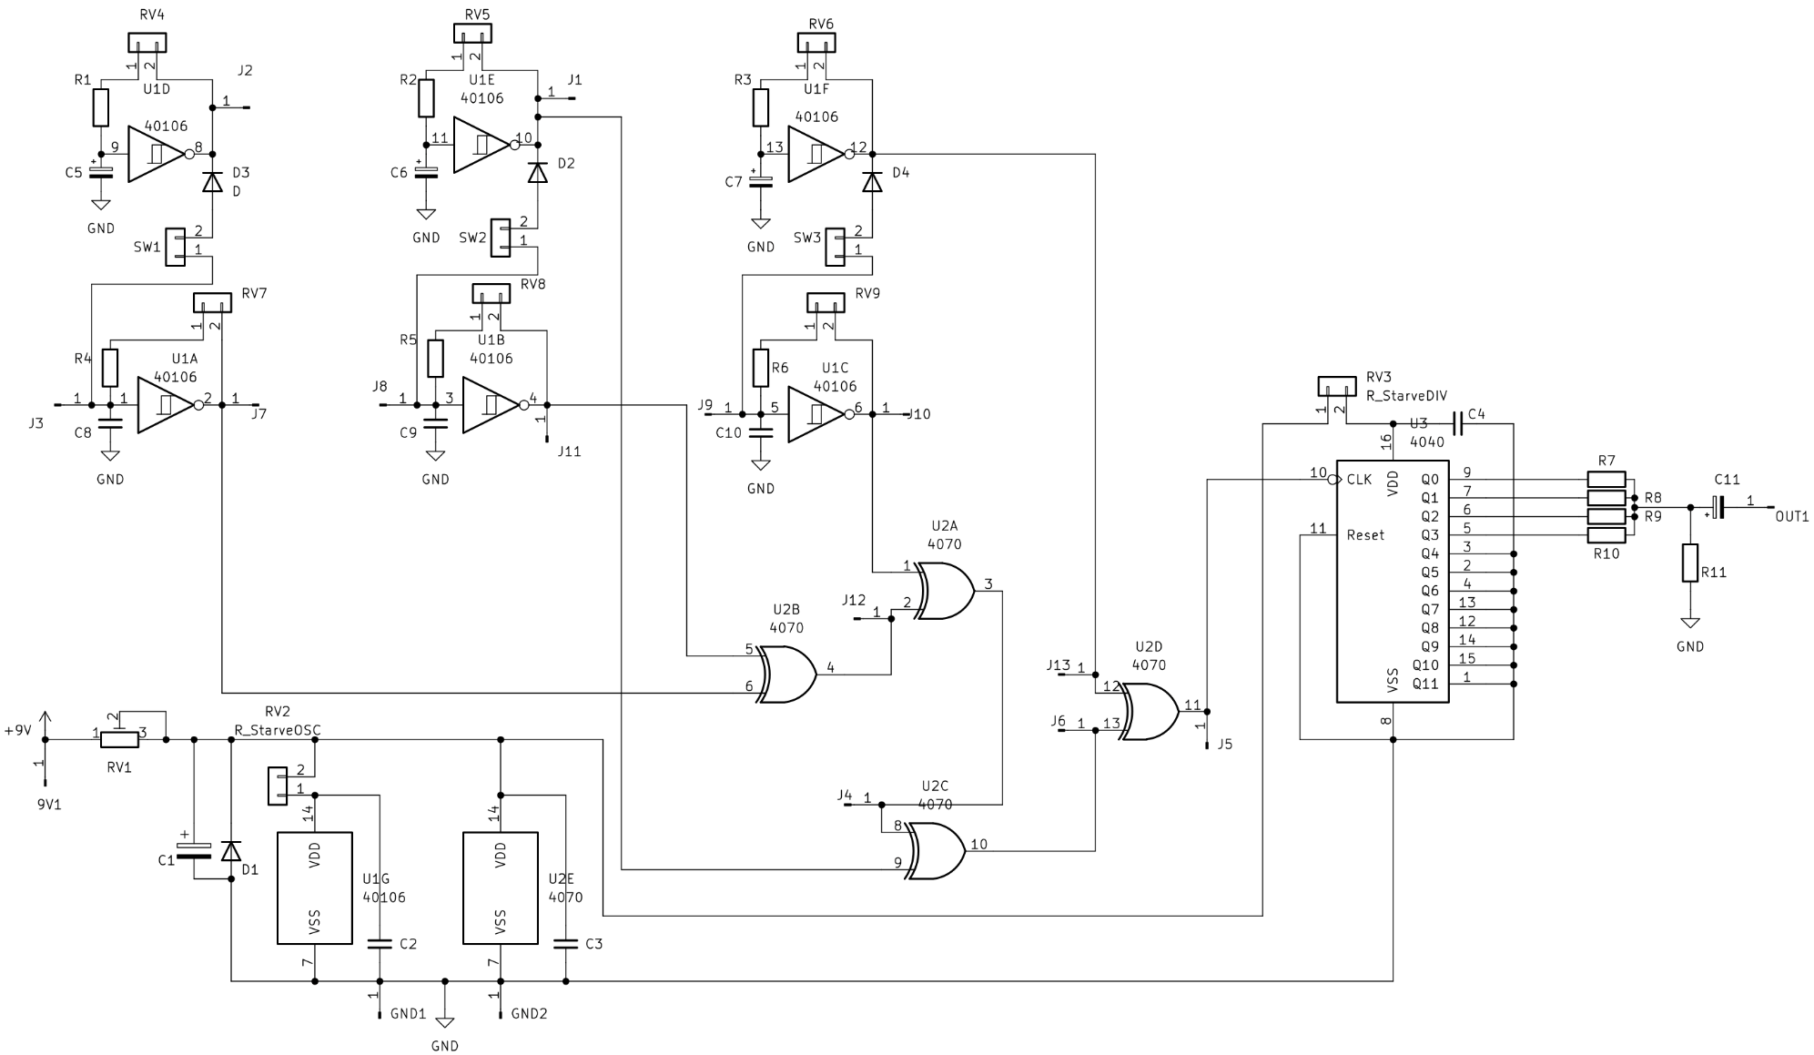

Parts list
 | Reference | Qty | Value in kit | Value range | Note
connect with wires | volume control potentiometer | 1 | 100K linear or log
 | stereo jack audio output | 1 | 6.3 mm stereo jack | optionally 3.5 mm | can use mono jack plus on/off switch
 | wire | 3-4 m | 26 awg stranded | 24-26 awg
 | extra buttons | 0+ | momentary button (normally OFF) |  | connect to solder points labeled J1-J13, try
 | SW1,SW2,SW3 | 3 | momentary button (normally ON)
 | RV4,RV5,RV6,RV7,RV8,RV9 | 6 | 1M linear/photoresistor
 | RV3 | 1
 | RV2 | 1 | 10K linear
 | 9V battery | 1
 | 9V battery holder | 1
 | 9V battery clip | 1
onboard | DIP socket 14 pin | 2
 | DIP socket 16 pin | 1
 | U1 | 1 | CD40106
 | U2 | 1 | CD4070 or CD4030
 | U3 | 1 | CD4040
 | RV1 | 1 | 500R trimmer | under 1K
 | R1,R2,R3,R4,R5,R6 | 6 | 10K | 1K-47K
 | R7,R8,R9,R10 | 4 | 10K | 4.7K-22K
 | R11 | 1 | 100K
 | D1 | 1 | 4007 | 4001 or similar
 | D2,D3,D4 | 3 | 4148 | optionally LEDs
 | C1 | 1 | 3300 uF electrolytic | 1000-4700 uF
 | C2,C3,C4 | 3 | 10 nF ceramic | 10-100 nF
 | C5,C6,C7 | 3 | 1 or 2.2 uF electrolytic | 10 nF - 22 uF | get DPDT lever switches to make oscillator range selectable
 | C8,C9,C10 | 3 | 10 nF ceramic | 4.7-47 nF
 | C11 | 1 | 22 uF electrolytic | 10-47 uF

Build guide
- Start the soldering with the IC (integrated circuit) sockets. They have a cut out denoting the orientation. The ICs should go in as the last thing, bend the legs gently before they go into the sockets if needed. Tip: secure the sockets with the a bit of tape to prevent them from falling out of the board once you flip it over.
- Solder the resistors R1-6. (These resistors set the minimum resistance for each of the six oscillators in the build. Together with RV4-9 and C5-10 they set the RC constant and therefore the pitch of the six oscillators built around CD40106.)
- Solder R7-11 (R7-10 mix the output signals from frequency divider built around CD4040 and form a voltage divider with R11 to bring the amplitude down – calculate before mods or measure.)
- Solder C2-4 (Power decoupling caps, value does not matter much.)
- Solder D1, mind polarity (Protects from reverse voltage frying the whole thing.)
- Solder D3-4 (These hard sync some of the oscillators together, polarity is not essential or even the type of diode and can be modified. LEDs will blink with the frequency.)
- Solder C5-10, mind polarity with electrolytics! (Explained in 2., values can be modified within specified ranges. The oscillators need not be always in audible range, later they are mixed via XOR logic gates on the CD4030 or 4070 which are interchangeable. Optionally you can solder wires instead and use a DPDT switch to have the range switchable, see wiring diagram)
- Solder C11 (Output cap to isolate from any DC going into an amp.)
- Solder RV1 (Trimmer to drop power supply voltage globally.)
- Inspect for any bad joints, misplaced components or polarity issues and after that solder C1 (Global reservoir to smooth out the power supply voltage. Value is not essential, feel free to use some smaller electrolytic cap if short on space.)
- Double check everything before moving onto the wiring as after that it will get harder to correct your mistakes. Think about how it will all fit into the enclosure of choice and from now on ALWAYS consider that before soldering any wires. Pre-solder wire of correct length to the off-board components according to the wiring diagram.
- Solder the potentiometers or photoresistors RV4-9 onto the board. Photoresistors can be put directly onto the board (or use wire and mount them into the enclosure using LED holders, not included)
- Solder the normally ON buttons SW1-3. (Short the pads with wire to omit these buttons.)
- Solder RV2 and RV3 (these “starve” the CD40106 and CD4040 respectively and make them glitch out in a way. The values might need some trial and error to get a range of effect you like and the “correct” one can vary because of the differences between the ICs. Can be omitted by joining the pads with a bit of wire.)
- Solder the output jack, volume potentiometer and battery clip according to the wiring diagram. The jack should be stereo, inserting mono jack cable will connect the circuit ground to the battery negative terminal and turn the synth on and off upon the removal of said cable. (You can use a mono jack and have a separate on/off switch in series with the positive terminal of the battery.)
- Place the ICs correctly into the sockets. Now if everything is correct you should have a working synth. Try if you get an output and try all the pots and buttons you have in place now.
- If all went well, it is time to try out the optional buttons. With a piece of wire try shorting the various square soldering pads J1-13. You can also use different diodes to connect these points. Do not short any other points on the circuit unless you know why you are doing it, otherwise do whatever. Try different combinations and write down what you like, then solder buttons or lever switches with or without diodes on them that will make the chosen connections.
- Check all the joints.
- Drill the enclosure and mount everything, including the battery holder.
- Now you should be done. Or you can try changing some values, add a button or a switch to get the desired sounds. If there was any issue and you got stuck somewhere along the way, try troubleshooting with a multimeter for bad connections, values or supply voltages. If frustrated, sleep.
- Enjoy the fruit of your labour.

Wiring diagram and mods
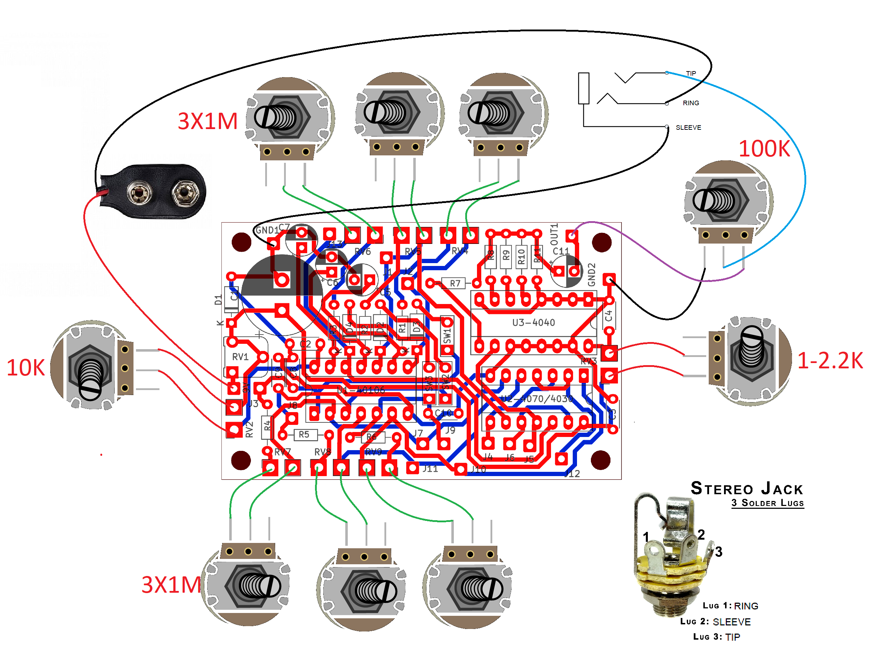
Instead of the 1M pots you can use photoresistors soldered directly to the board. The jack is wired so that the battery disconnects if you unplug your cable. If you do not want this feature, you can use a mono jack and wire the battery ground straight to the board while adding a switch to the red battery wire to turn it off manually. Volume pot is not necessary and the 1-2.2K starve pot also reduces volume along with altering the tone. After you wire up the off-board components according to the diagram above and it works, you can proceed to the buttons and levers (step 17.). Here are the options for mods:
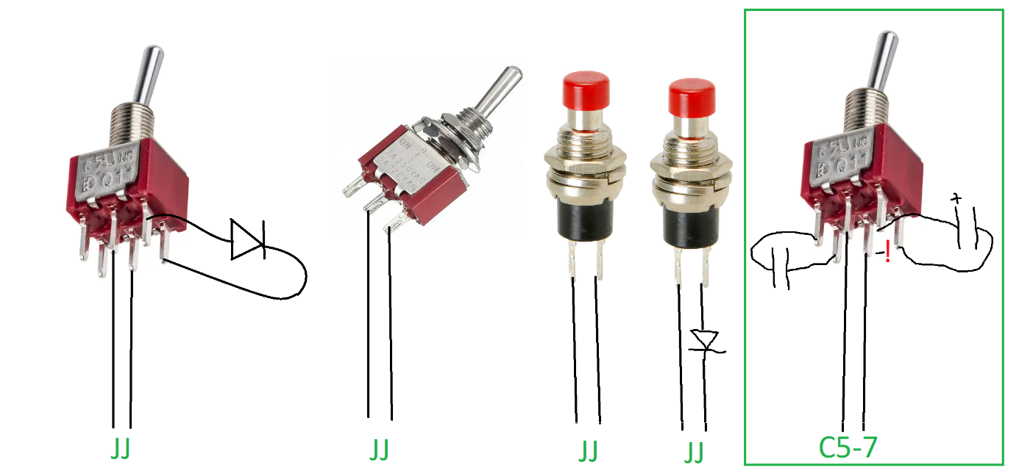
Connect the wires to the square holes labeled Jx (x being a number). Never connect it to the 9V pin or GND. In the green square is shown how to make some of the oscillators have a switchable range with the polarity of the cap denoted.
Have as many of these as you want. Be aware that they interact inbetween themselves and with the knob positions so check the behaviour before making a final decision. Use any diodes, LEDs will also blink.
You can also take sound output from various Jx pins etc, just be aware you need to add a decoupling cap in series and after that a 100K resistor to GND to bring the level down a bit, then wiring it to the jack. Have an option to turn this off with a switch.

Another thing you can try is have the signal from the Jx be fed into a VCO. Here is a schematic for a simple one:
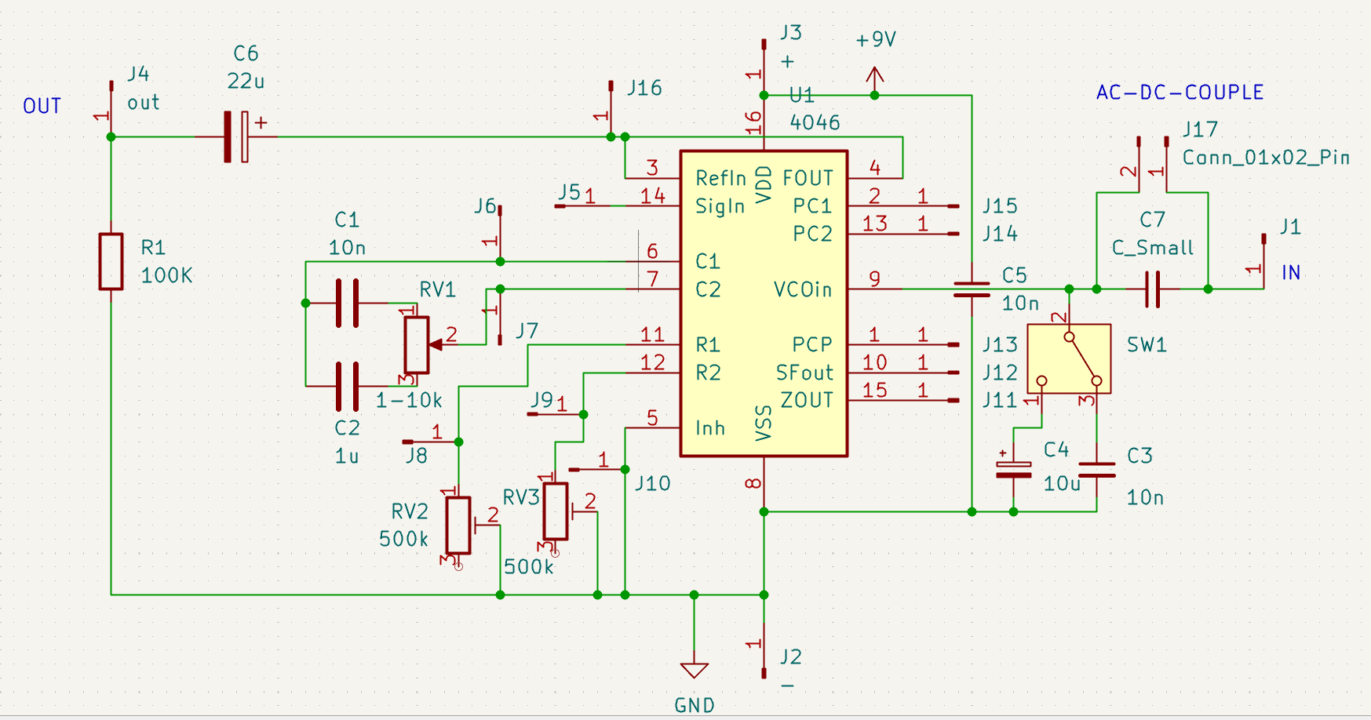
Note that this is more of an idea and the schem itself is very messy, the values are a bit random. Guide will not be provided, but if you have some experience, you can get something out of it.

Useful links
https://stompboxelectronics.com/resources/schmitt-trigger-oscillator-calculator/
https://syntherjack.net/catophonator/
https://theremin.us/Circuit_Library/cacophonator.html
https://web.archive.org/web/20110623064107/http://beavisaudio.com/Projects/CMOS%5FSynthesizers/
https://web.archive.org/web/20110723211334/http://milkcrate.com.au/_other/sea-moss/
https://web.archive.org/web/20110727203455/http://www.nicolascollins.com/read.htm
http://electro-music.com/forum/forum-160.html
https://electro-music.com/forum/topic-42772.html
https://www.fluxmonkey.com/electronoize/
https://www.bugbrand.co.uk/media/LunettaSchematics.zip

