Chlorophyta – Green Algae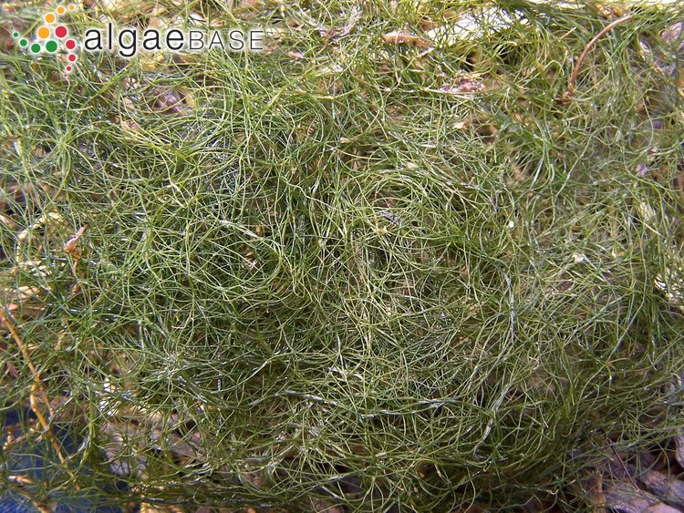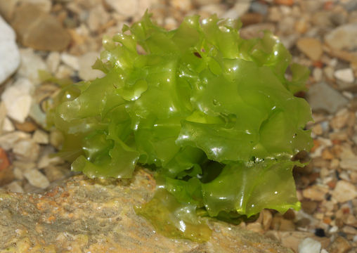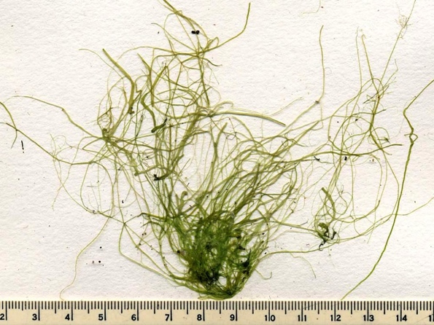

Filamentous Green (FG)

- Wiry/hairy/tufty, no vesicles

Blady Ulvoid (UV)

Sea Lettuce
- lettuce

Tubular Ulvoid (TUV)

Sea Lettuce
- Flat thin branches

Phaeophyta – Brown Algae

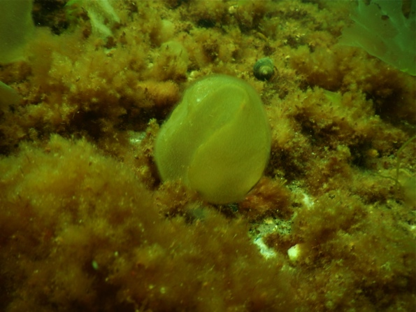

Colpomenia peregrina (COPE)

Sea Potato
- Potato-like sacs
- Squishy

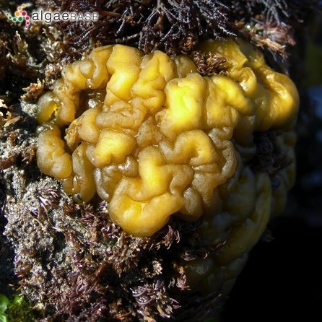

Leathesia marina (LEMA)

Sea Cauliflower
- Stiff, brain like
- Solid

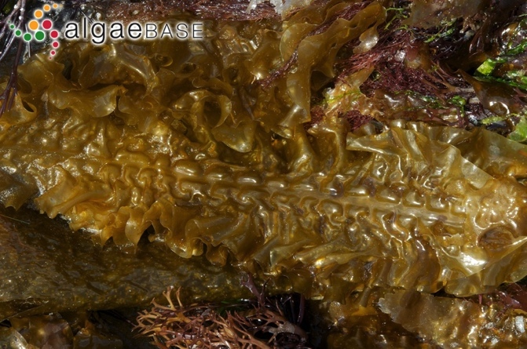

Saccharina sp. (SL)

Sugar Kelp/Sea Belt
- (latissima and longicuris)
- Lasagna-like blade
- <10cm = Juvenile (SLJ)

Rhodophyta – Red Algae
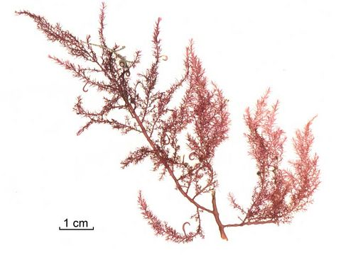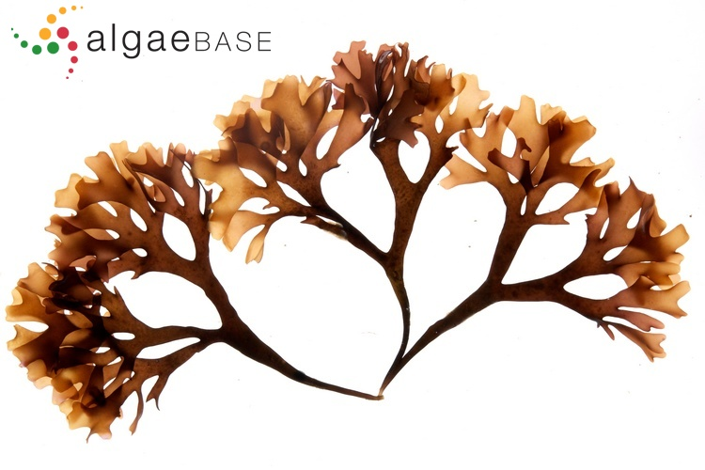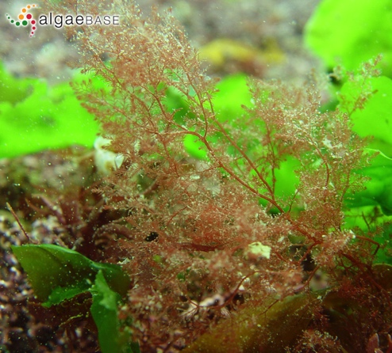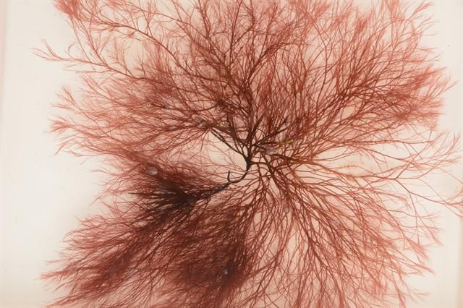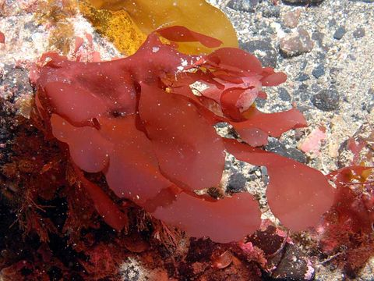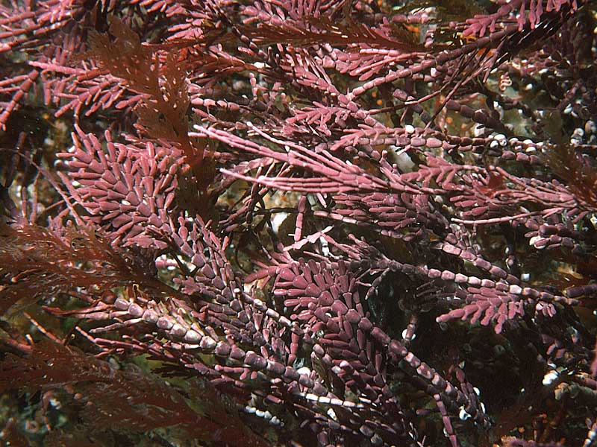
Arthropods

Bonnemaisonia hamifera (BOHA)

Hooked Weed
- Hooks along thalli
- Bushy but conical

Chondrus crispus (CHCR)

Irish Moss
- Flat bade, fan like branching
- Iridescent

Dasysiphonia japonica (DJ)

Japanese Red Algae
- Bushy, feathery
- Fragments easily

Polysiphonia spp. (POLS)

Lobster Horns
- Fine branched filaments
- Like Dasysiphonia but heartier. Breaks from holdfast. Darker.

Porphyra spp. (PORS)

- Red ulva, thin
- Like tissue paper

Corallina officinalis (CO)

Coral Weed
- Feather-like, but hard
- Erect corraline

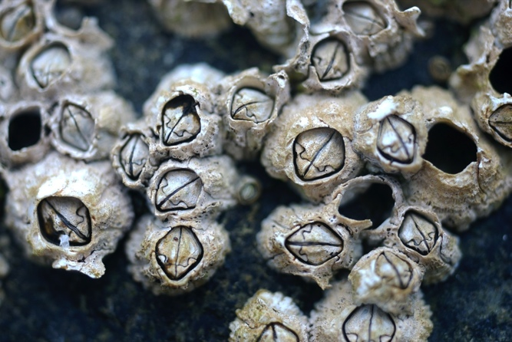
Molluscs

Semibalanus balinoides
- Rough, ribbed
- Barnacle

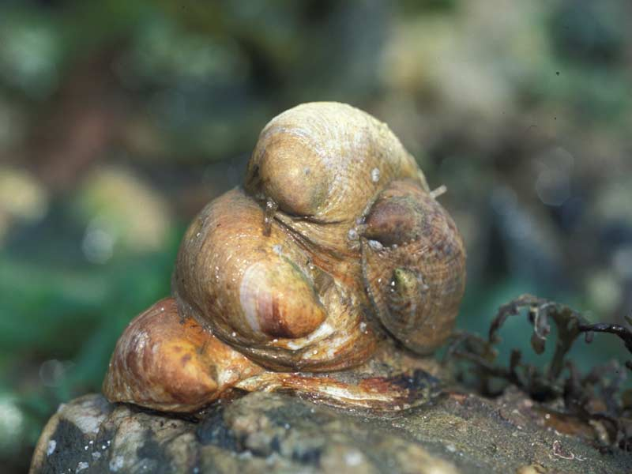

Crepidula fornicata (CF)

Slipper Snail
- Whitish, brown markings
- Forms stacks
- Curved hook at apex

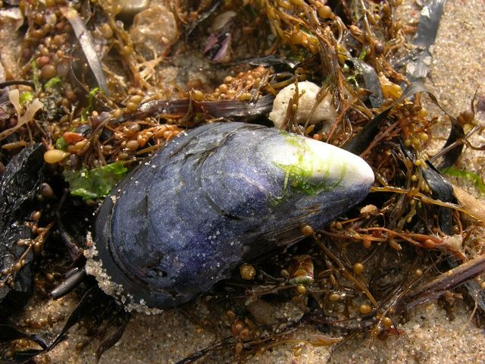

Mytilus edulis (MYED)

Blue Mussel
- Elongated, Narrow end
- Pointed umbo

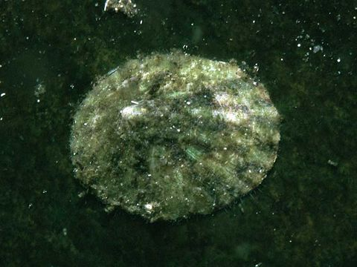

Tectura testudinalis (TETE)

Plate Limpet
- Can have checkered, radiating lines
- Small and flat

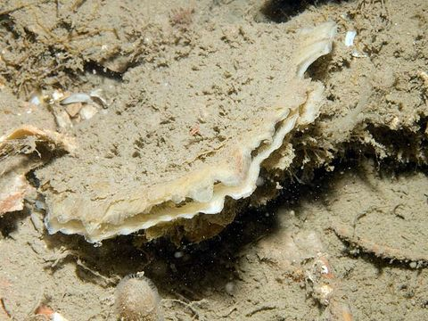

Ostrea edulis (OSED)

European flat oyster
- Flat, circular, concentric bands
- If elongate, Crossotrea virginica

Bryozoans
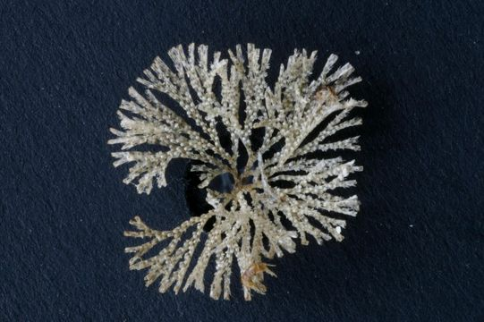

Bugula sp (BUSP)

- Bushy, non spiraling tufts
- White to cream

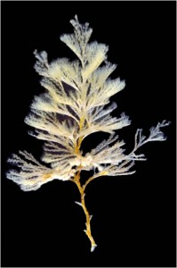

Bugula turrita (BUTU)

Spiral Tufted Bryozoan
- X mas tree
- Obvious

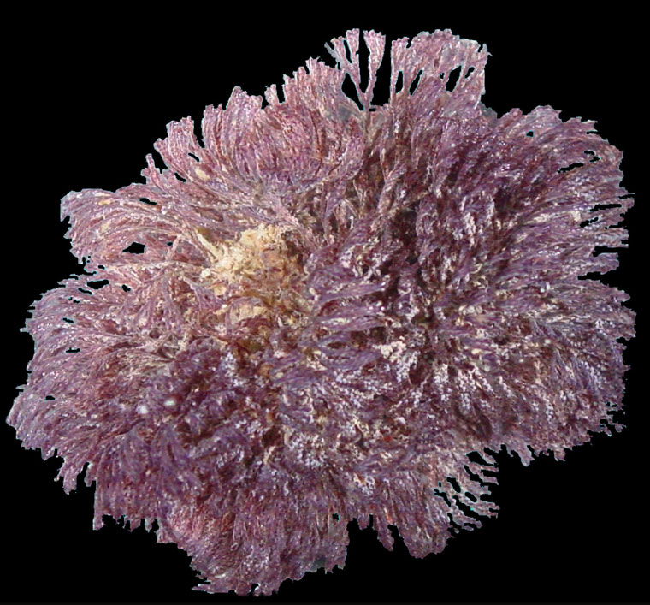

Bugula neritina (BUNE)

- purple
- Coarse

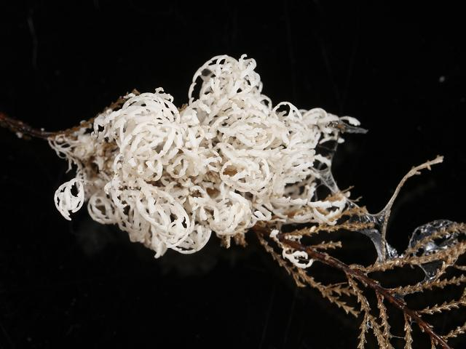

Crisia eburnea (CREB)

Tufted Ivory Corraline
- Fragile white tufts
- Delicate

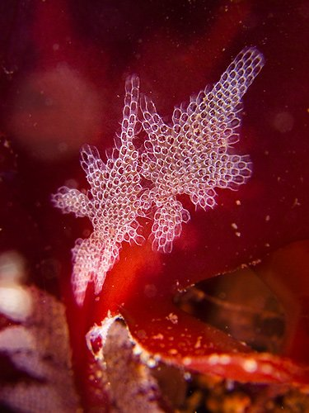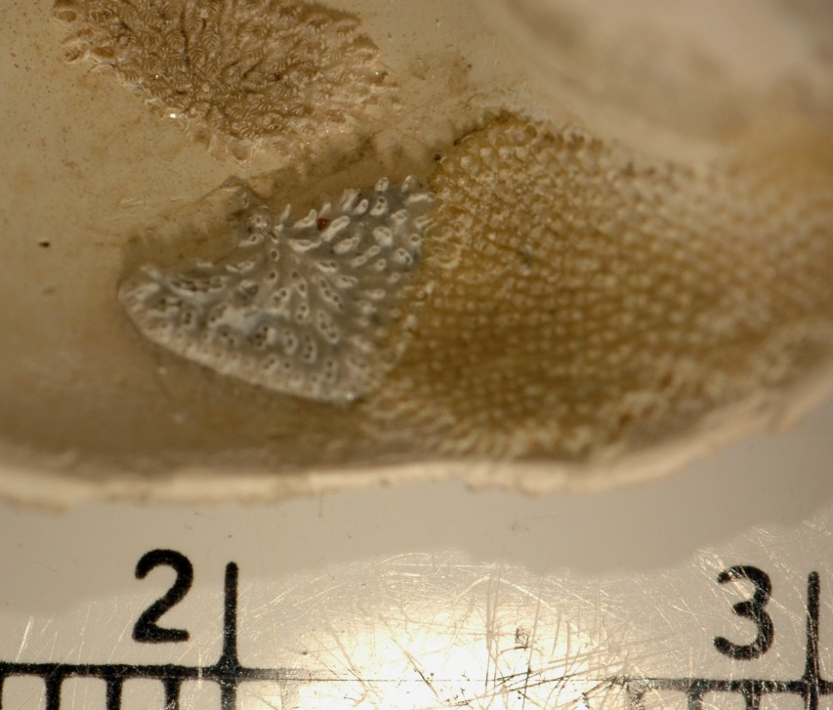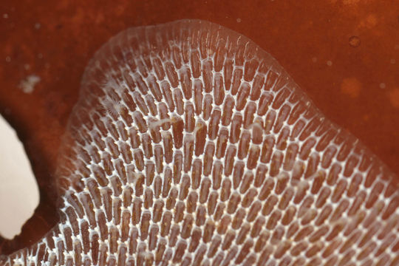

Electra pilosa (ELPI)

Hairy Sea Mat
- White star patches, hairy
- On algae

Lichenopora verrucaria (LIVE)

- Thick in middle, white
- Solid crust

Mambranipora membranacea (MEMA)

Sea Lace
- Lacy epizootic
- Clear boxes
- Only on other organisms

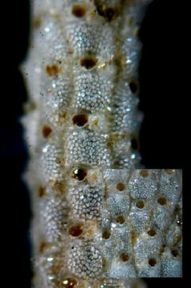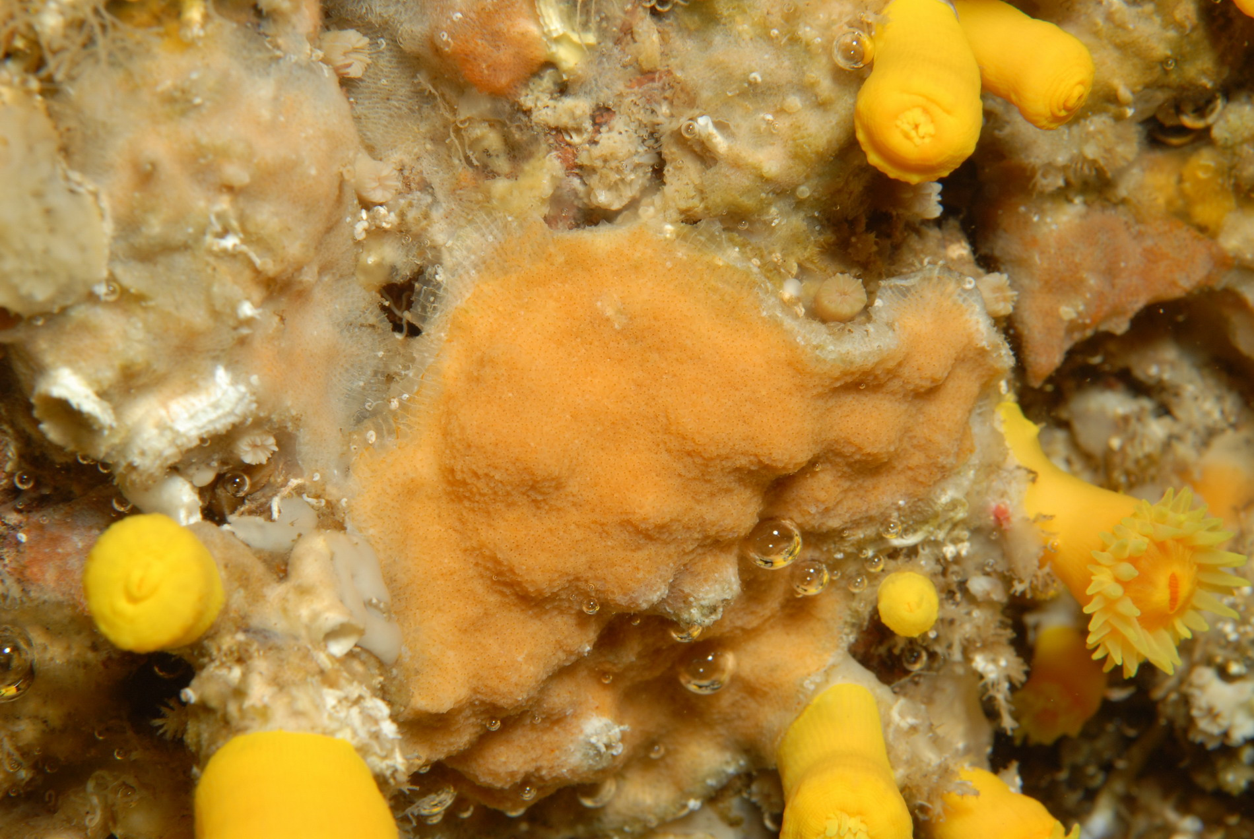

Mambranipora membranacea (MEMA)

Sea Lace
- Lacy epizootic
- On algae
- Solid sheets

Schizoporella unicornis (SCUN)

Single Horn Bryozoan
- Bumpy thick crust
- Mix of orange and white
- Amorphous, on rocky substrate
- UPC

Schizomavella auriculata (SCAU)

- Bumpy, solid orange, round zooids
- JUST orange/orange cream soda

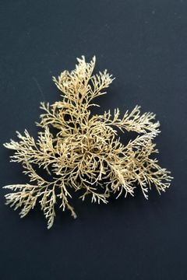

Tincellaria inopinata (TRIN)

- Crunchy arborescent
- Forms big balls

Cnidarians
Medusozoa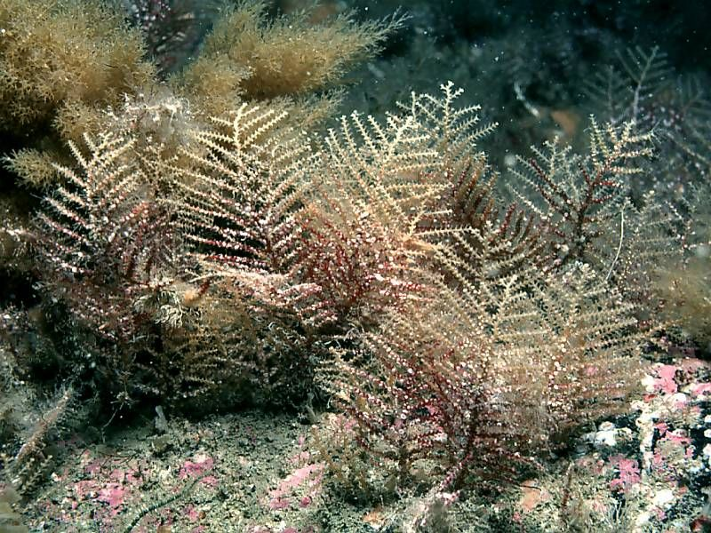

Abietinaria abietina (ABAB)

Sea fir
- Corticated, unbranched main stem, coarse

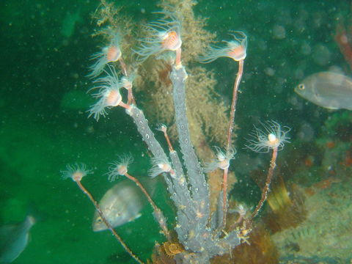

Ectopleura sp. (ECSP)

Pink hearted hydroid
- Grey to pink, bushy growths

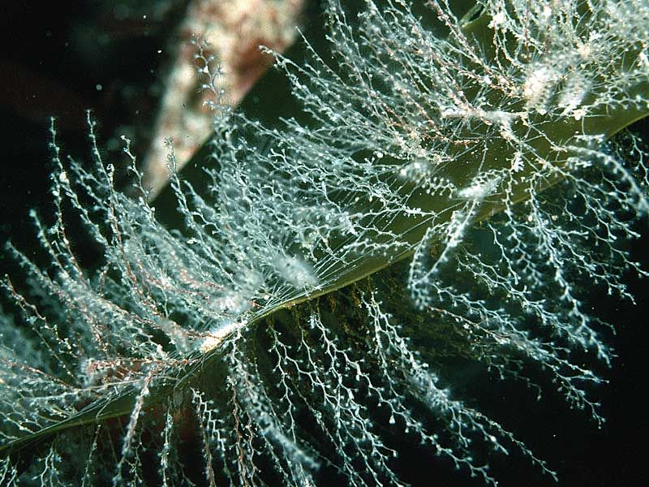

Obelia spp. (OBSP)

- delicate

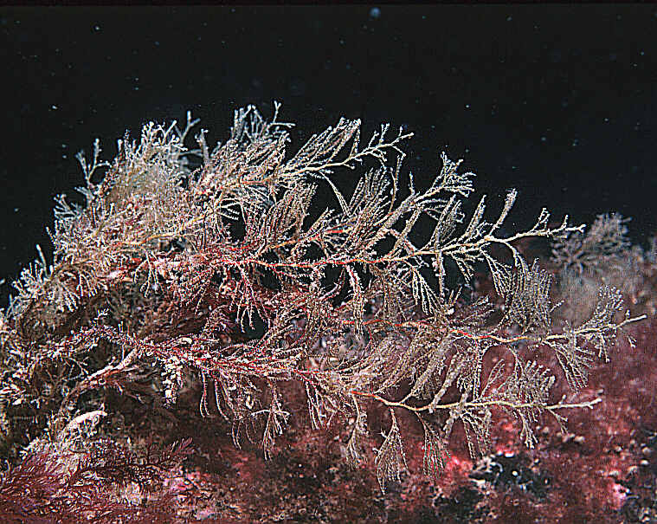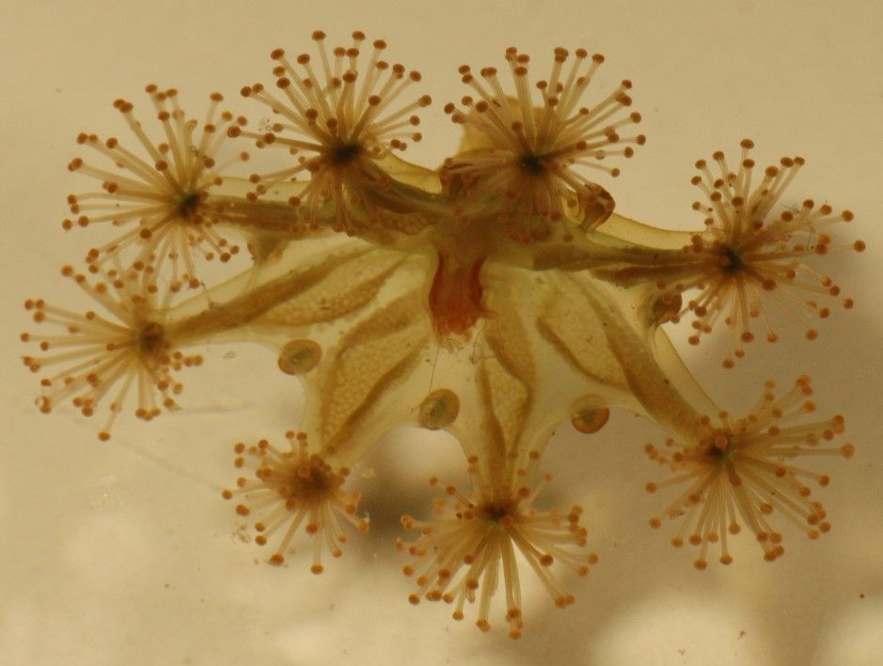

Sertularia sp. (SESP)

Sea Fir
- Bushy corticated

Haliclystus spp. (HASP)

Stalked Jellyfish
- Upside-down, attached jelly

Cnidarians
Anthozoa

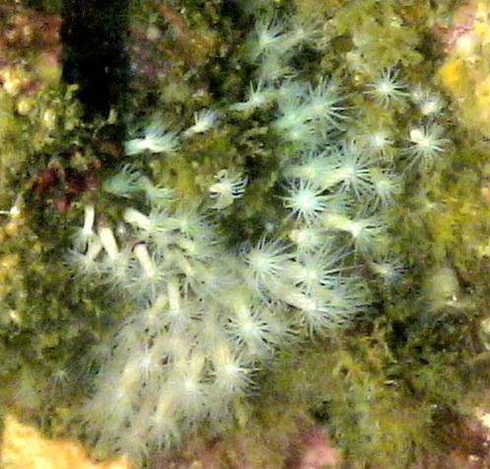

Fagesia lineata (FALI)

Tiny White Anemone
- Small, white

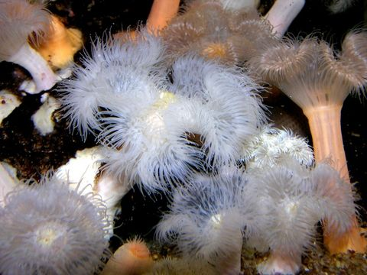

Metridium senile (MESE)

Clonal Plumose Anemone
- White frilled
- Can be quite large

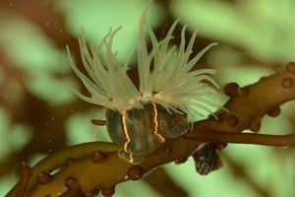

Diadumene lineata (DILI)

Orange striped green anemone
- Orange striped
- Small, invasive

Porifera

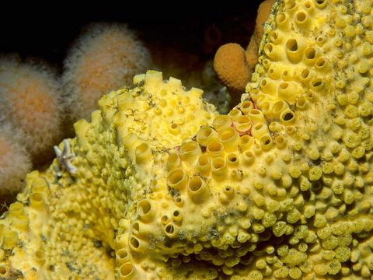

Cliona sp. (CLSP)

- Large osculum
- Yellow
- Boring

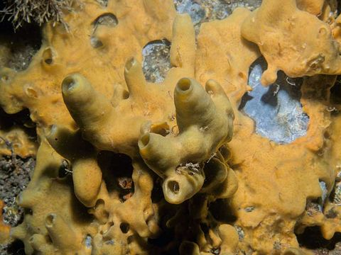

Halichondria panicea (HAPA)

Breadcrumb sponge
- Tear it and the interior looks like breadcrumbs

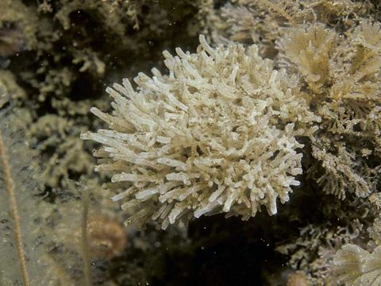

Leucosolenia spp. (LEUC)

- Many small tubes or vases

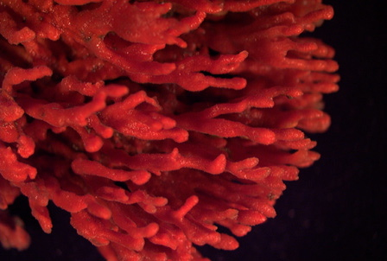

Microclona prolifera (MIPR)

Red Beard Sponge
- Red, finger/beard
- Chetos

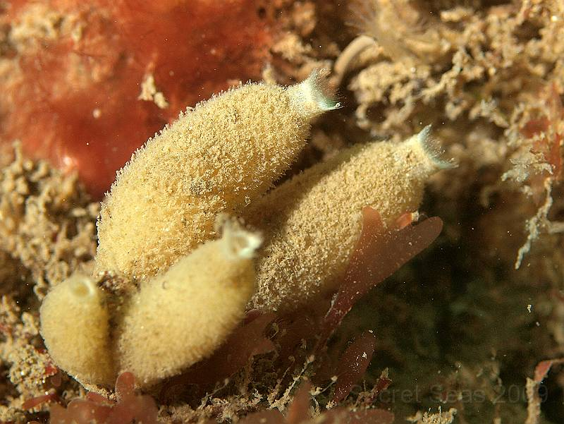

Scypha sp. (SCSP)

- Little vases
- Often fouled

Chordates
Tunicates
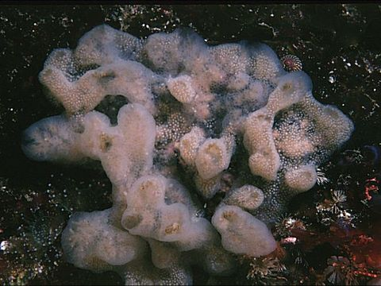

Aplidium pallidum (APPA)

- Brown staining around cloacal opening, drop of jelly
- Looks like lard

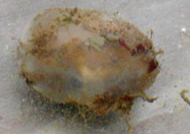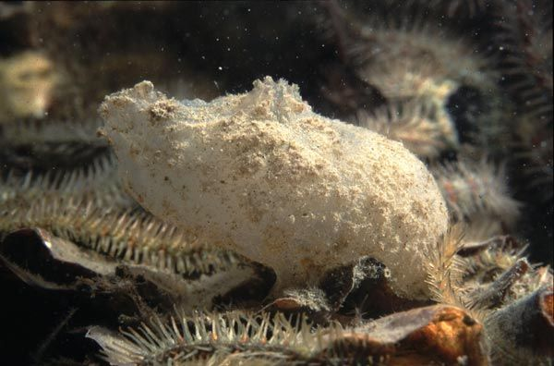

Ascidia callosa (ASCA)

- Solitary, opaque tunic

Ascidiella aspersa (ASAS)

Dirty Sea Squirt
- Firm transparent test
- Snags detritus
- Tentacles in siphons
- Elongate oval

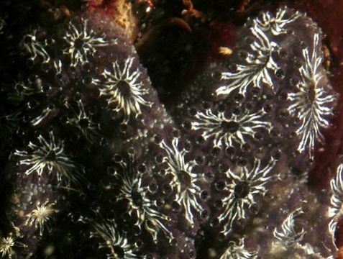

Botryllus schlosseri (BOSC)

Golden star tunicate
- Star-shaped collections of zooids
- Black and white or orange

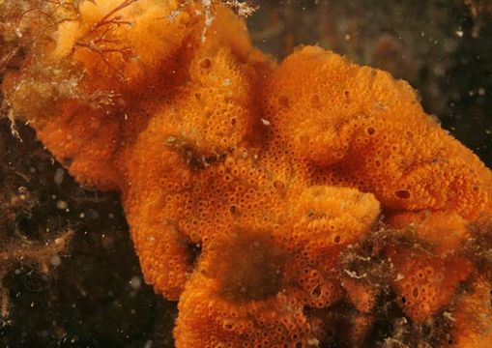

Botrylloides violaceus (BOVI)

Orange sheath tunicate
- Orange or red, thin, fleshy
- Solid colored sheed

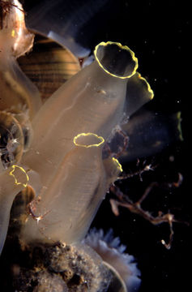

Ciona intestinalis (CIIN)

Sea Vase
- Transparent, yellow or colorless siphon rim
- Red dot on intestine

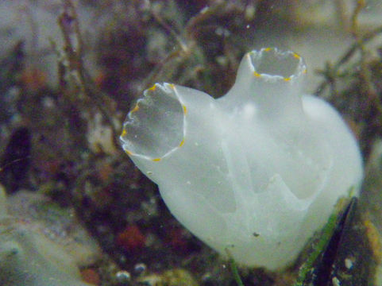

Ciona savingyi (CISA)

Pac. Transparent Sea Squirt
- Transparent, yellow speckled siphon rim

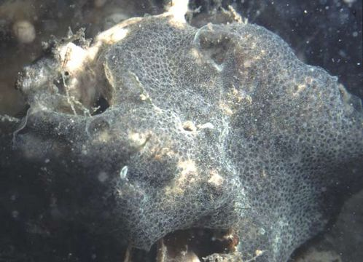

Diplosoma listerianum (DIP)

Colonial tunicate
- Transparent, gelatinous
- Thin, grey & yellow & white

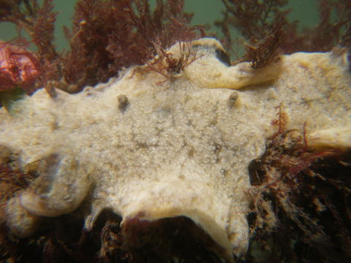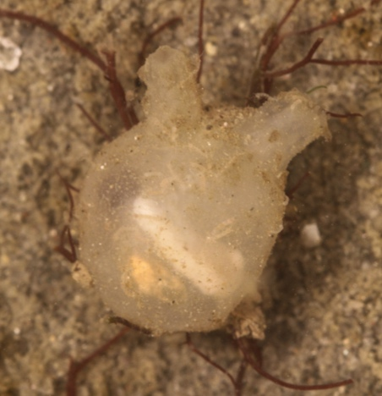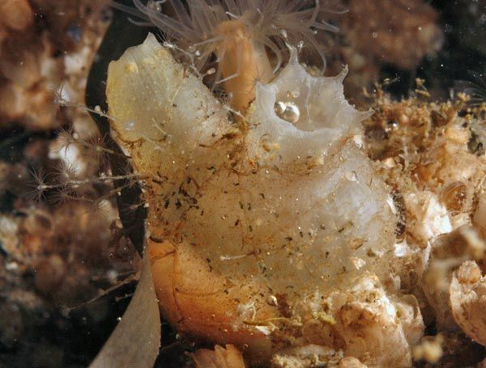

Didemnum vexillum (DIVE)

Rock vomit
- White to yellow to grey
- Thick, forms pendulous lobes

Molgula manhattensis (MOMA)

Sea grape
- Sea grape – small, round, like a peeled grape

Molgula citrina (MOCI)

Sea grape
- More color than M. manhattensis
- Potentially more fouled tunic

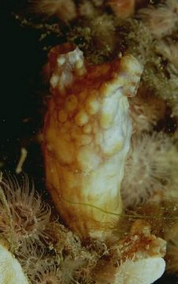

Styela clava (STCL)

Club Tunicate
- Warty, elongate, club shaped
- On a stalk

