Long to Wide Pivot for Putting Field Data Into a Shape for Analysis
With Excel Pivot Tables
Biol 311

- First, make sure your data is in a long format, with each row being a single measurement from one replicate. One replicate will therefore have many rows. For example:
Site # | Conditions | Species | % Coverage
1 | direct sun, low flow | Barnacles |  | 25
1 | direct sun, low flow | Botryllus |  | 5
1 | direct sun, low flow | Bare space |  | 29
2 | moderate sun & flow | Mussels |  | 40
2 | moderate sun & flow | Barnacles |  | 35

- Select the data you wish to rotate, and select summarize with Pivot Table from the Data menu.
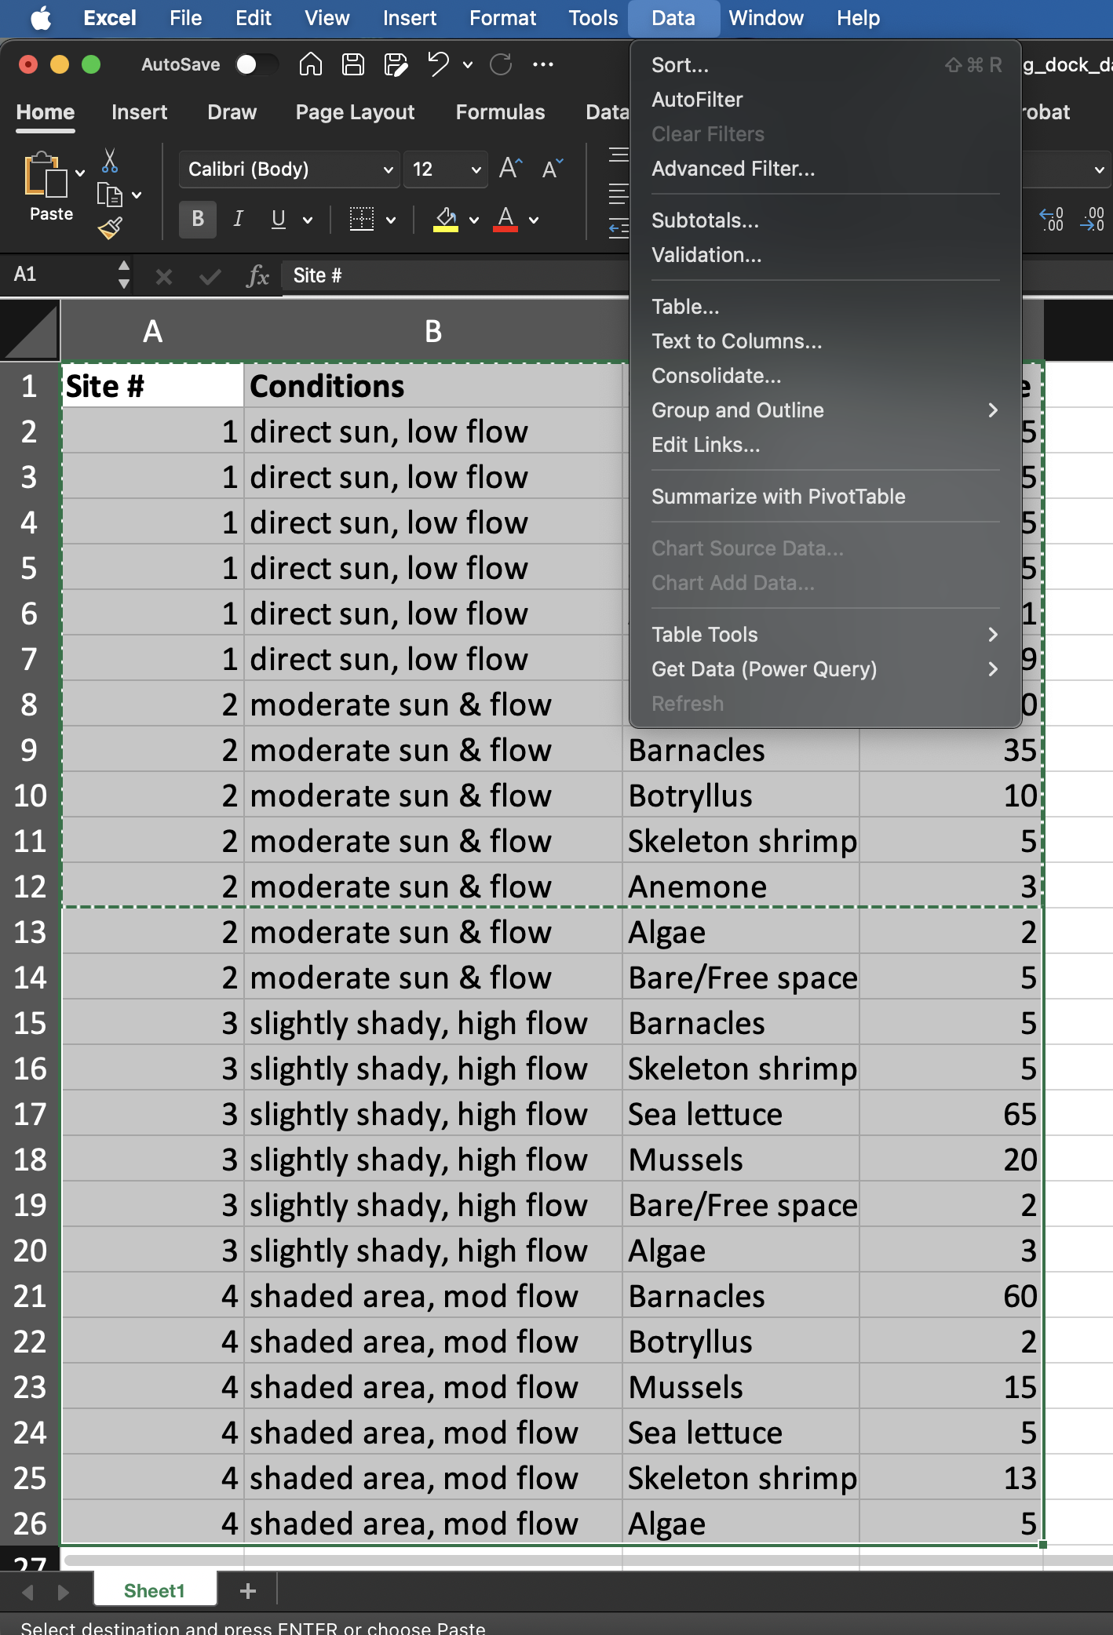
- Choose new worksheet for your pivot table.
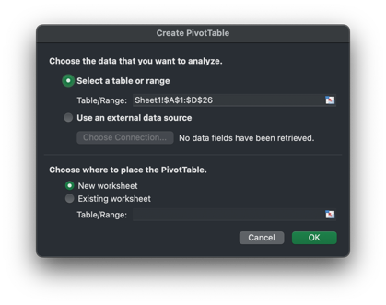
- Add predictors/identifying variables to rows (e.g., site and condition), what you want pivoted out into a wider form to columns, and then what column contains the actual numbers you want to analyze as values. Check to make sure it’s not applying a transformation you don’t want to those numbers if you’re doing any data aggregating.
So this:
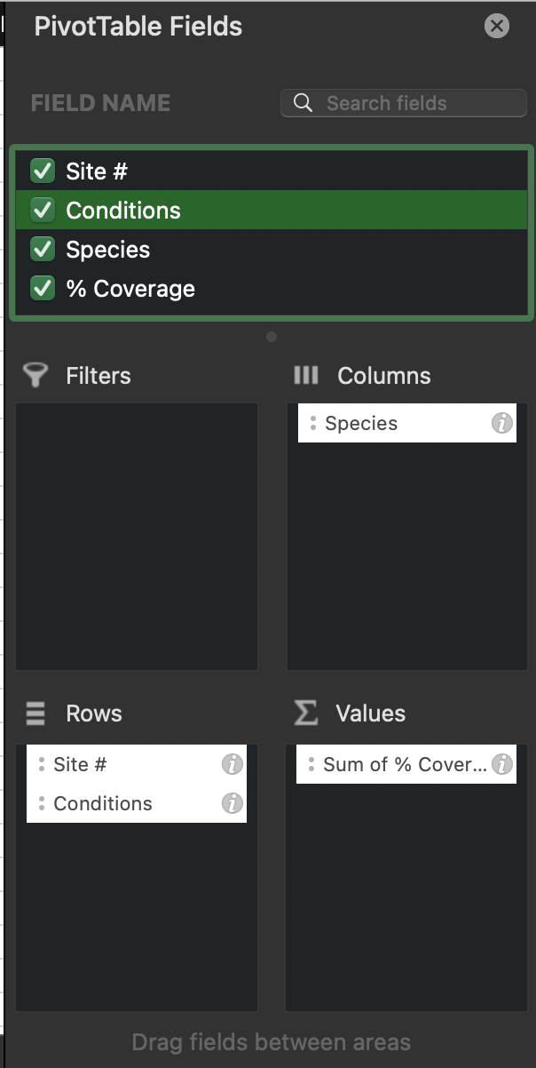

Will produce a table like this:
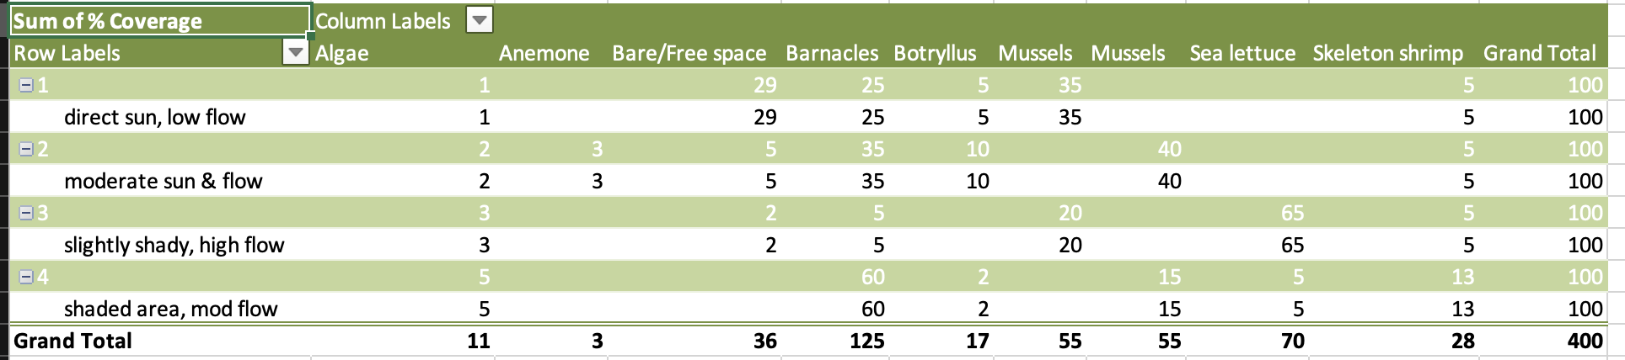

- We can then make formatting nicer. First, let’s remote all of those grand total and subtotal rows and columns. Go to the Design Tab. Use the Subtotals and Grand Totals tools to remove them.
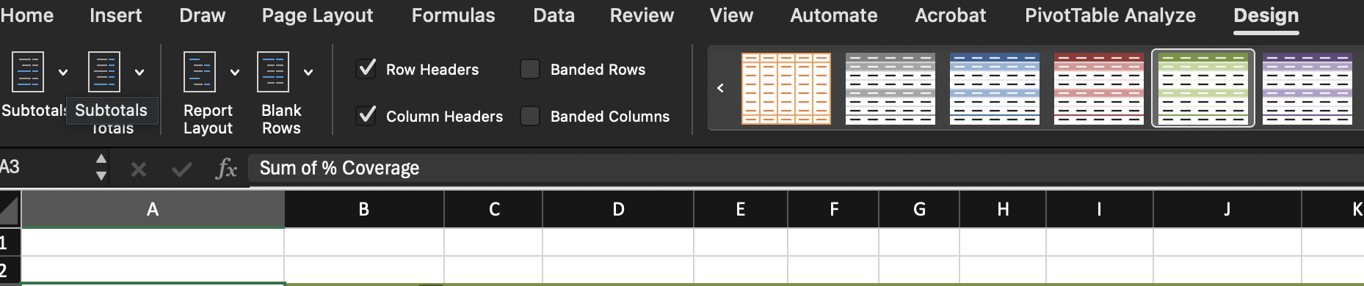
This will leave you with something like this
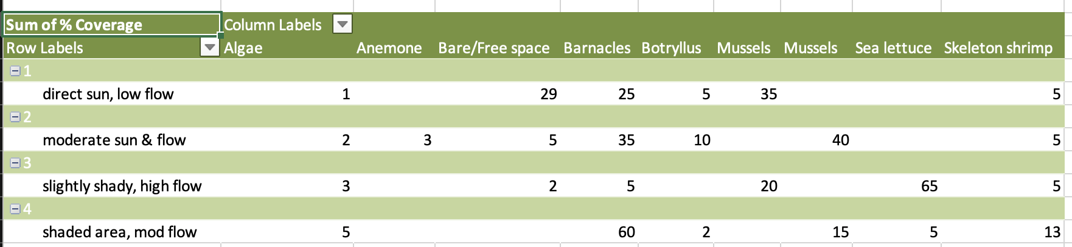
- Now, to change the row labels into separate columns for condition and site, right click on the upper left corner of the pivot table.
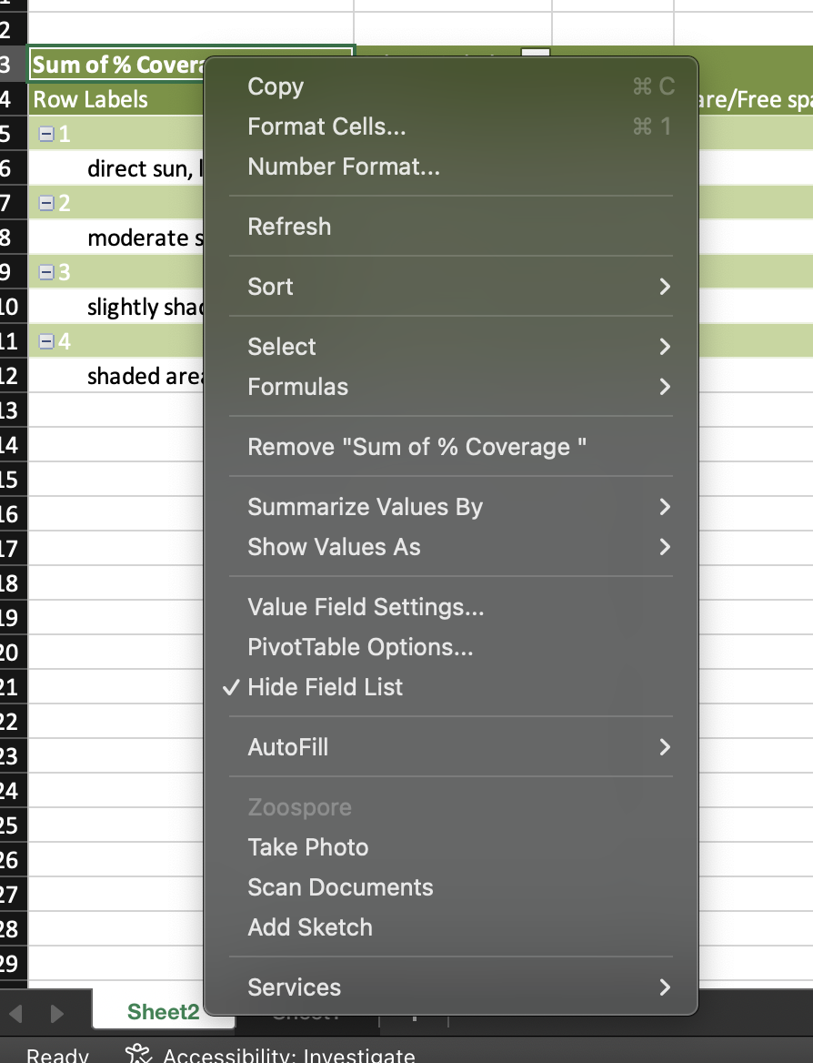

And select pivot table options. There, select “Classic Pivot Table Layout” and make sure it’s checked.
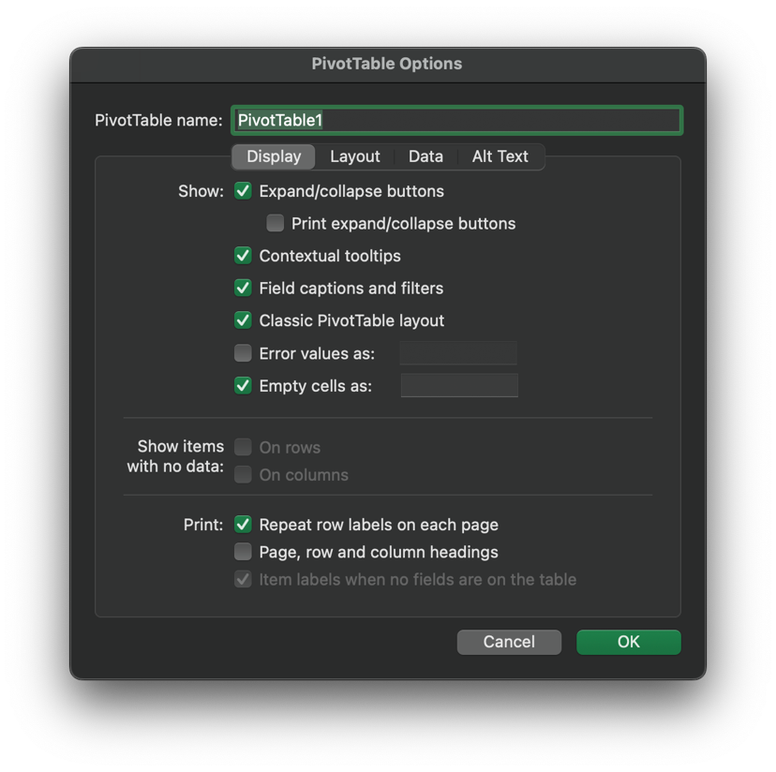
- Now that is done, copy and paste your pivoted table into a new spreadsheet, and you can add additional columns, etc., from there, or use it for analysis!

