Environmental Conditions and Animal Abundance
Biol 312

Introduction
Low tide exposes the lower reaches of the seashore to our exploration. We can begin to see the environment that organisms interact with and understand how organisms partition space. Today, we’ll look at the distribution of organisms in the intertidal.

Methods
- Spend ~20 minutes exploring the area uncovered by the tides. Systematically explore the factors that appear to determine the abundance of Littorina littorea on rock surfaces and the abundance of Hemigrapsus sanguineus or other crabs on or under rocks. Ask us for species IDs beyond these four below.

Littorina littorea Fucus vessiculosus
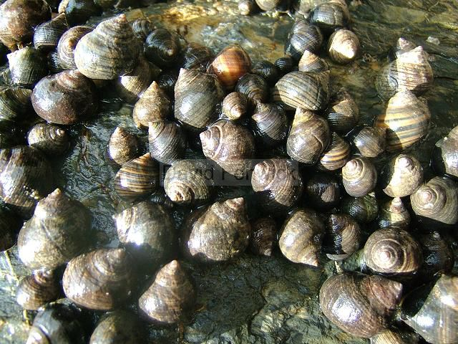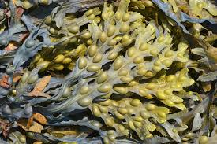
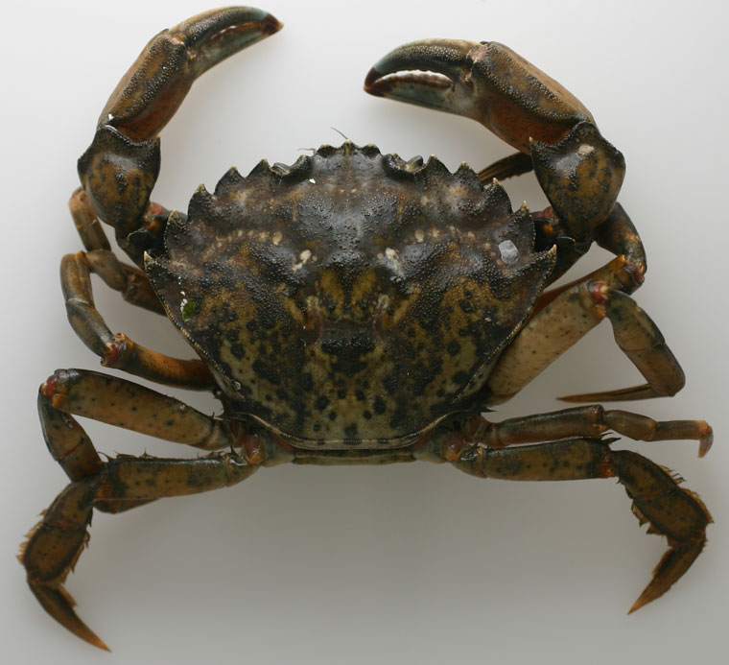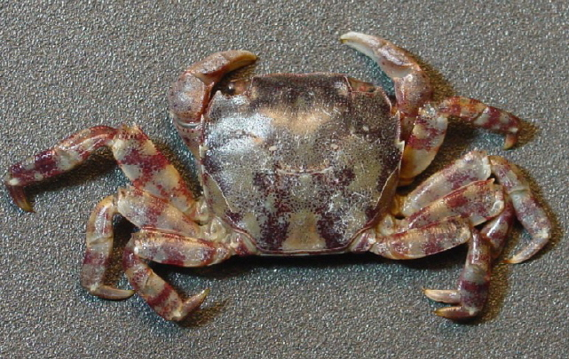

Carcinus maenas Hemigrapsus sanguineus

- Based on your observations, construct a hypothesis about what regulates the abundances of crabs and snails.

- Draw out how you think the system works using a box and arrow diagram. Think about things you have observed versus cannot. Think about what matters to the different organisms.

- Choose one organism to target to understand what influences its distribution. Choose one influence you are particularly interested in isolating. Come up with a clear hypothesis about the relationship between the species and the factor that influences its distribution.

- Based on your hypothesis, diagram, and observations, create and draw out a sampling design to understand whether that influence regulates the distribution of your species of interest on the shore. Think about our principles of good sampling design – handling confounders, replication, etc. You make take additional measurements with tools provided, such as size of rocks, cover of algae, distance from the high-tide line, etc., if you think them warranted.

- Execute your sampling design after running it by us! Then, that’s it for the day!

Analysis and Write-up
Please provide:

- A brief introduction to what you observed. Discuss your hypothesis at length and proffer any alternatives. Provide a drawing of how you think the system works.
- State the methods you used to conduct your study. Justify why, given your diagram, this is a good sampling design.
- Provide a narrative discussion of results.
- End with a conclusion regarding the weight of evidence for or against your hypothesis.

