Regulons

Based on gene selection and networks
Due to large number of genes, many of which have no very close neighbours, I perfomed pre-selection of genes. This ensures that genes in the same cluster or close on tSNE have very similar profiles. The preprocessing used to get clusters, tSNE and networks consisted of two parts: 1.) Extraction of genes (based on RPKUM profile neighbours). Before calculation of expression profile cosine similarity (gene neighbours) the RPKUM data was log transformed and scaled.
2.) Data of genes selected in the first step was preprocessed to be apropriate for clustering and tSNE in Orange. I used the same transformation and scaling as for the first step.
Scaling is needed in both steps so that genes with similar profile shape are detected as similar regardless of the expression strength.

Regulons
For regulons extraction genes were selected if they had at least one very close neighbour based on expression profile pattern across all replicates. This was done on log2 transformed RPKUM data scaled to mean=0 and sd=1 with cosine similarity metric for comparison of the profiles. Genes with all 0 expression were removed. To find genes with at least one close neighbour for each genes two closest neighbours were obtained (one being itself and thus excluded). These neighbours are saved in dict_kNN2_m0s1log.pkl and can be used for extraction of genes with at least one neighbour at different similarity thresholds (described for Regulo_extraction.ows). I have chosen threshold 0.95 and file kNN2_threshold0.95_m0s1log_Orange.tsv lists the genes that were retained (have such a close neighbour).

Inverse regulons
For each gene 200 closest neighbours based on inverse expression profile (when one genes's expression goes up the other's goes down) were obtained. This was done for each replicate separately, using log2 transformed RPKUM data scaled either with mean=0 and sd=1 or min-max (0 to 1). Genes with all 0 expression were removed for each replicate separately. Cosine similarites were used to compare profiles. Afterwards, gene pairs were filtered based on cosine similarity (e.g. min = 0.96 or 0.86) and only gene pairs present in at least 25 replicates (after similaritiy filtering) were retained. These pairs were converted to edges on a graph with nodes being the genes. Files merged_kNN200_T"X"_min"Y"_"preprocessing scheme".pkl contain the gene pairs that passed initial filtering at specified similarity and replicate presence thresholds. They can be used to obtain smaller or larger netwroks, as described for Regulons_inverse.ows.
The profile calculation similarity was done on each replicate separately at it was previously determined that calculation of similarities using the whole dataset at once results in spurious connections - e.g. a highly expressed gene and mostly 0 expressed genes with a only a few low spikes in certain samples get high similarity. Requiring that connection is present in many replicates automatically removes genes that have 0 expression in most replicates.
I have used two different preprocessing schemes: log2 + minmax and log2 + m0s1 (mean=0, sd=1). It was determined that log2+m0s1 preprocessing results in the most consistent selection of genes with close neighbours. - When searching for genes that have a close neighbour with at least specified similarity in two seprate groups of replicates the results obtained in both groups were the most consistent. However, a graph was constructed also with gene neighbours obtained with log2+minmax scaling. Many of its highly connected nodes (e.g. the most notable junctions) represent regulatory genes and thus it was decided that this graph may be of interest as well.

Workflows

Regulon_extraction.ows:
For extraction of regulons of genes with similar profiles (e.g. both go up or down at the same time). Genes are clustered (resolution parameter regulates cluster tightness) and plotted in tSNE based on expression profile across all samples. This can be used to select genes that have similar profile. Profiles of these genes can be plotted as average profile for each strain. Red arrows show where connections between widgets can be made to plot profiles of the selected gene groups.
Uses files:
-- kNN2_threshold0.95_RPKUM+pattern_m0s1log_Orange.tab (File widget input): Data of selected genes (each gene has at least one neighbour with profile similarity above the threshold specified in the file name - here 0.95, described in more detail below). Includes RPKUM which is log2 transformed and scaled to mean=0 and sd=1 for each selected gene across all samples - required for clustering and tSNE; and profile pattern data obtained on averaged RPKUM AX4 data (no preprocessing): peak- time, mass_center- time at which half of the expression hapens before and half after, N_atleast - how many time points have expression equal or greater than (min(expression)+max(expression))/2 for each gene - indicates whether there is a narrow peak (or valley) or not.
-- genes_averaged_orange.tsv (File1 widget input): RPKUM averaged across each strain. Used to plot expression profiles.
The workflow also contains an option to retain genes with the closest neighbour that passes a different similarity threshold - retaining more or less genes (Python Script widget). The instructions are at the top of the script and threshold parameter must be set. This will produce a new file of type e.g. kNN2_thresholdX_m0s1log_Orange.tsv that contains selected gene names. It must be processed with Preprocessing_RPKUM.ows to obtain other files described above.

Regulons_inverse.ows:
For extraction of regulons of genes with opposite/inverse profiles (e.g. when one goes up the other goes down). Oposite profiles are shown as connections on the graph. Clustering and tSNE can be performed (done on non-inverse profiles) - genes connected on graph will belong to different clusters and will be shown on oposite parts of the tSNE. Genes can be then selected for profile plotting as described in Regulon_extraction.ows.
Uses files:
-- *.net (Network file widget input): A network with edges representing opposite profile similarity between two genes (nodes). Consturction of netwroks is described below.
-- matching file with ...inverse...RPKUM+pattern notation (File widget input): As described for Regulon_extraction.ows file of type RPKUM+pattern. Matches .net file in the prefix.
-- genes_averaged_orange.tsv (File1 widget input): As described for Regulon_extraction.ows.
The workflow also contains option to obtain a network with more or less edges and nodes, depending on the node weight (inverse profile similarity) and number of replicates in which this edge was present with specified similarity. For this use Python Script (similarly as described for Regulon_extraction.ows). Sensible range of parameters is specified. This produces a file containing the word 'nodes' (akin to the file from Regulon_extraction.ows) and a .net network file.

Preprocessing_RPKUM.ows:
Prepares RPKUM data of selected genes (scaling, log transformation) for clustering and tSNE. This is required if python scripts within the other two workflows are used to extract genes with different similarity thersholds - obtaining more or less genes (and connections on the graph). It can be also used to change preprocessing of RPKUM data, affecting clustering and tSNE. Log can be used or not, and a scaling option (mean=0 + sd=1 or min-max e.g. 0 to 1) must be used. At the end a file of type RPKUM+pattern can be saved.
Uses files:
-- gene_patterns_orange.tsv (File1 widget input): Characteristics of gene expression patterns in AX4, as described above for this part of kNN2_threshold0.95_RPKUM+pattern_m0s1log_Orange.tab file.
-- File produced by Python Script in Regulon_extraction.ows (e.g. knn2_threshold0.95_m0s1log_Orange.tsv) or in Regulons_inverse.ows (name contains word 'nodes') (File widget input): Names of genes for which expression data and expression patterns data will be extracted.
-- mergedGenes_RPKUM.tsv (File2 widget input): RPKUM expression data for all samples.

File prefix notation for regulons data files:
- kNN: N of neighbours that was initially calculated for each gene
- threshold (also 'T'): only gene pairs (neighbours/edges) with similarity equal or greater than threshold were retained
- minPresentReplicates (also 'min') (when calculations were done for each replicate separately): edges above specified similarity threshold were present in at least that many replicates
- m0s1/minmax/log: preprocessing used for expression profile similarity calculation; In the currently provided files same preprocessing was used both in the retrieval of the closest neighbours and to make files (of type RPKUM+pattern) that Orange uses for clustering and tSNE.
- inverse: gene pairs with most similar opposite/inverse profiles were sought

Groups of genes with similarity above a threshold
Selection of regulons with t-SNE and/or Louvain clustering resulted in large gene groups that often had low similarity between some of the members. This was especially evident in certain strains. Thus gene groups were created such that for every gene pair within the group the profile similarity was above a certain threshold.
Gene neighbours were calculated with cosine similarities based on vector of all measurements, log2 transformed and scaled to mean 0 and std 1. Genes that have multiple close neighbours (e. g. 5 with similarity at least 0.96) were selected as ‘hub genes’. For these genes the closest neighbours were obtained (e. g. 100 neighbours). Only the neighbours with high enough similarity to the hub were retained (e. g. again at least 0.96). Neighbourhoods were created from hub genes and their neighbours. Neighbourhoods that were replicated or contained within other neighbourhoods were removed, preserving a single copy of each neghourhood. These neighbourhoods were then merged. The merging was done based on the order of hierarchical clustering. The clustering was performed with distances between neighbourhoods based on proportion of genes from the smaller neighbourhood contained within the larger neighbourhood. This distance was selected to remove neighbourhoods that heavily overlap with other neighbourhoods. Neighbourhoods were merged if the similarity between any two genes within the merged group did not fall below the minimal similarity within any of the original neighbourhoods (not just the two that were to be merged). This protocol is implemented in http://localhost:8888/notebooks/networks/hub_genes_neighbourhoods.ipynb.
However, most of the neighbourhoods were largely overlapping or similar to the neighbouring neighbourhoods. Furthermore, despite using high similarity threshold the gene groups that were co-expressed only in a subset of strains were present among neighbourhoods.
Workflow
Gene_groups_min_similarity.ows. The files relevant for this workflow are ...neighbourhood_genes.tsv and ...neighbourhoods.tsv. The file description denotes the similarity threshold (sim) and the number of neighbours a hub gene needed to have at that threshold (minkN). These are in the docker folder shared_data/regulons/clusters/merge_similarity.

Clustering of selected genes from individual strains
This workflow extracted regulons within individual strains to find regulons present in all strains. For each strain potential regulon genes were selected. Data of each strain consisted of all its measurement from all its replicates, log2 transformed and scaled to mean 0 and std1. This used a naive approach where for each strain N genes (e.g . 1000 or 500) with highest average cosine similarity to the closest 5 neighbours (actually 6 as the closest neighbour is itself) were selected. This does not account for different number of tightly co-regulated genes between strains and could be adjusted in the future. Genes of individual strains were clustered with tight clustering algorithm. This clustering algorithm clusters genes in tight groups. If it can not assign a gene into a tight group it leaves it unclustered. It requires as a parameter the number of groups to create, which is hard to determine in advance. Thus a somewhat higher number of groups was specified than expected, based on t-SNEs examined in previous workflows. The obtained groups were then merged if the new group still had minimal similarity between any two genes above a threshold. Merging order was determined with hierarchical clustering. The distances used for hierarchical clustering were based on average distance of all gene pairs between the two groups. E. g. for groups [A,B], [C,D] the distance was avg([AC, AD, BC, BD]), where XY is a distance between two genes (= 1 – cosine similarity). The merging was performed only if the minimal similarity between any two genes in the newly selected group was equal or greater than minimal similarity within any of the groups created by tight clustering for that strain.
Workflow
Based on this data Orange workflow named Strain_clusters.ows was created. The files it uses are in shared_data/regulons/clusters/by_strain. In the file name selectedGenesN represents the number of genes selected in each strain. The sharedCount files are for the heatmap of how often genes were in the same cluster – the ones with notation ‘filterN’ do not contain genes that did not have neighbours located in the same cluster in at least N strains.
It allows comparison of tight gene groups across strains (under Gene group membership by strain and in t-SNE). However, as initially a threshold of 1000 genes per strain was used some genes that are co-expressed were filtered out. This could be changed to further improve the visualisations.
The t-SNE includes all genes that were present in any of the strain clusters (data pre-processing is the same as before). It currently shows gene groups of individual strains. It might also be interesting to colour genes based on similarity of closest neighbour/closest N neighbours. This could potentially indicate which genes are important in individual strain’s metabolism.
The workflow also contains a heatmap that shows in how many strains two genes were placed into the same cluster. This could help to find regulons present in all strains. To speed up the visualisation the data for this heatmap was filtered to remove any genes for which there were no co-expressed genes that would be placed in the same cluster in many strains (e.g. at least 5). However, the count shown in the heatmap is affected by the arbitrary threshold of 1000 or 500 selected genes by strain and clustering. Thus there was no pair of genes that would be present in the same group across all strains. This reduces the informativeness of the heatmap for the selection of genes that are co-expressed in all strains.

Count of strains where a gene pair is co-expressed
The workflow Clustering of selected genes from individual strains was limited by selection of only N genes in each strain and clustering, for which it is hard to chose parameters or customise it (e. g. used distance, exact cluster tightness in individual clusters, …). This workflow thus extracts all pairs of co-expressed genes in individual strains and counts in how many strains two genes had high cosine similarity.
The below described steps were done for each strain separately. For each gene 300 closest neighbours based on cosine similarity of log2 transformed and mean 0 and std 1 scaled data were obtained. From these neighbours only those that had similarity at strain specific threshold or higher were retained (see By strain similarity threshold). The genes and their neighbours were thus transformed into gene pairs. A heatmap with the same genes on both axes was created by counting the strains in which the gene pair was co-expressed. For the visualisation purposes this was further filtered to remove any genes that had no neighbours co-expressed in at least N strains (e. g. 18) and are thus not members of any regulons. Threshold 18 was selected simply because this ensures that each gene has a neighbour that is besides other strains also present in at least one of the four ag- strains – a group that was previously causing most problems regarding regulons not being consistent in it.
Workflow
Regulons_by_strain.ows. The data is in shared_data/regulons/by_strain/kN300_mean0std1_log/mergedGenes… The file with ‘filterN’ in the name contains only the genes that have at least one co-expressed neighbour in at least N strains.

Lowering the threshold
Some genes are co-regulated in some strains and are unexpressed/lowly expressed in others, thus they do not show co regulation in these strains. However, it is debatable if lack of expression in a pair of genes is as informative as their co-expression.
To obtain such genes instead of using a fixed strain threshold this can be adjusted based on N of strains where the gene is expressed. For this a 99th percentile of each genes’ expression across all measurements was obtained (almost maximum). A strain was termed to have that gene’s expressed highly enough if expression in it ever reached X percent (such as 30%) of the 99th percentile expression. The threshold for N of strain in which a gene must have at least one close neighbour was set to the N of strains where gene was termed to be expressed highly enough, with minimum of one. The thresholds were then reduced to maximum of 18 (instead of up to N of strains), to account for false negatives in determining if gene has a close neighbour in each strain. This is an approximate threshold as genes can have close neighbours in strains in which they were determined to be ‘not expressed enough’.
Workflow
The data is in files with format: mergedGenes_minExpressed0.99XStrainsProportion1Min1Max18.tsv, where X denotes the proportion of 99th percentile, as described above. If X is higher more genes are retained. This happens because thresholds for N strains in which gene must have a close neighbour are lowered as less strains have high enough expression.

Clustering of selected genes into regulons
To obtain regulons from selected genes clustering was used. For gene selections with smaller N of genes hierarchical clustering (Ward, cosine) was used on the N strains co-expression count matrix. This approach did not perform well when more genes were selected. In such cases Louvain clustering with cosine similarities was used on RPKUM data scaled to interval [0,1] for each gene followed by PCA within Louvain clustering. The pre-processing was selected empirically (comparing A: log2 transformation + scaling to mean = 0 and std = 1 and B: scaling to [0,1] followed by PCA feature selection). Despite A working better on extraction of stable gene neighbours across whole profile the B might work better here due to many measurements becoming irrelevant, as they present non-expression. Thus using preprocessing B that does not reduce the importance of peaks (which are now more interesting) compared to low regions might work better than A which does the former. For clustering based on AX4 data alone the preprocessing A was used, as most genes were expressed in AX4. The preprocessing A performed slightly better than B on AX4, based on visual evaluation.

Regulons summary
All methods for extraction of regulons that we have used were based on three main steps:
- Definition of similarities between gene profiles.
- Extraction of regulons. In general, this consisted of first finding genes that are likely part of a regulon and then assigning them to regulon clusters.
- Visualisation in Orange, including manual regulon extraction/refinement.

Gene profile similarities
Gene profile similarities are based on cosine similarities that with our data pre-processing indicate the correlation between gene profiles (going up or down together and to a similar extent). We tried two approaches for calculating similarities between gene profiles.
First, we used all the measurements (from all strains) together, obtaining a single profile similarity score for a gene pair. However, as we have different number of measurements (time points, replicates) in different strains this was biased towards strains with more measurements. Thus the obtained regulons did not have consistent expression in some strains.
The other approach (the one we are currently using) includes calculation of gene profile similarities in individual strains. Information about a gene pair being co-expressed or not in individual strains is then used to find regulons. Therefore each strain has the same weight in finding regulons. We can also see in how many strains a gene pair was co-expressed.

Extraction of regulons
The workflow we are currently using consists of three steps (more detail in the section ‘Count of strains where a gene pair is co-expressed’):
- Find pairs of co-expressed genes in each strain separately. Two genes are said to be co-expressed if they have similarity above a certain threshold (threshold selection is described in more detail in section ‘By strain similarity threshold’).
- For each possible pair of genes it was counted in how many strains it was termed as co-expressed. This can be easily visualised using a heatmap with symmetrical genes on both axes (Figure 1).
We are interested only in genes that have some gene neighbours (e.g. pair genes) consistent in almost all strains. Thus only genes that have at least one neighbour present in the majority of strains were retained. In the heatmap this can be seen by each gene having at least one bright cell in its row/column (excluding the diagonal). This reduced the data as shown on Figure 1 to the data of Figure 2.
- To obtain regulons the data, as shown on the below heatmap (Figure 2), was clustered with Orange hierarchical clustering. This clustering is similar (but not identical) to the one shown in the heatmap.
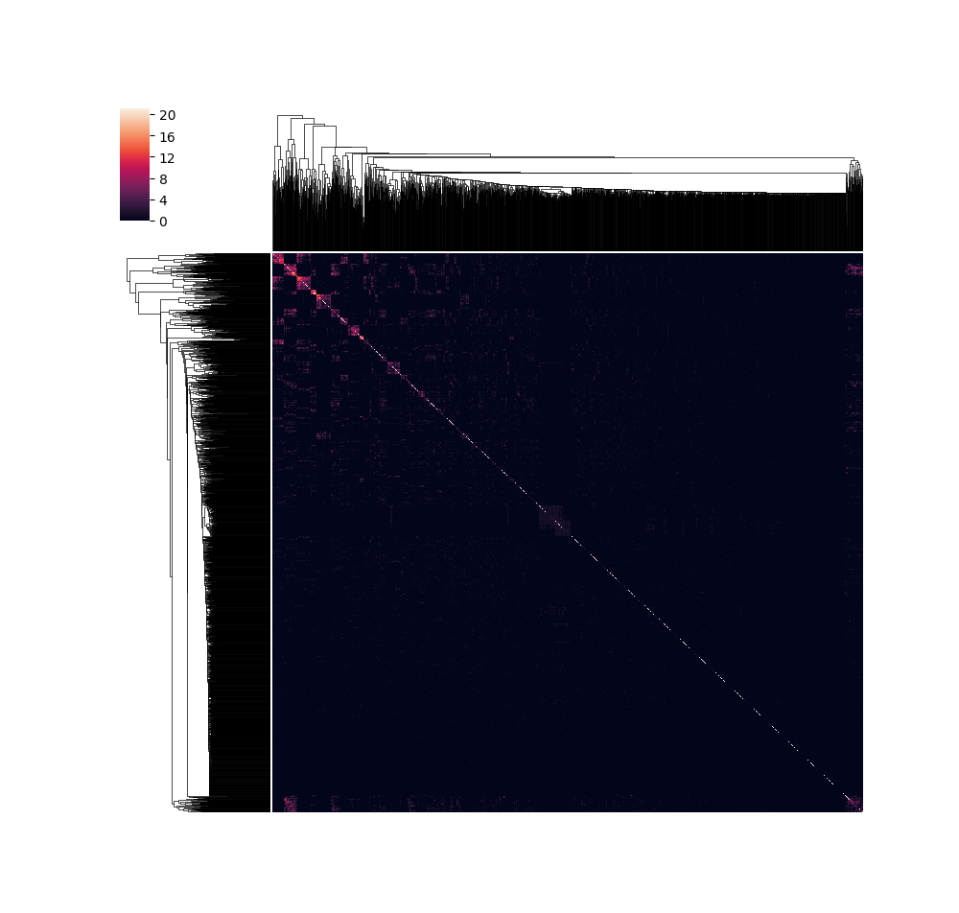Illustration 1: Count of strains where two genes are termed as co-expressed. First 2000 genes were selected and plotted symmetrically on both axes.
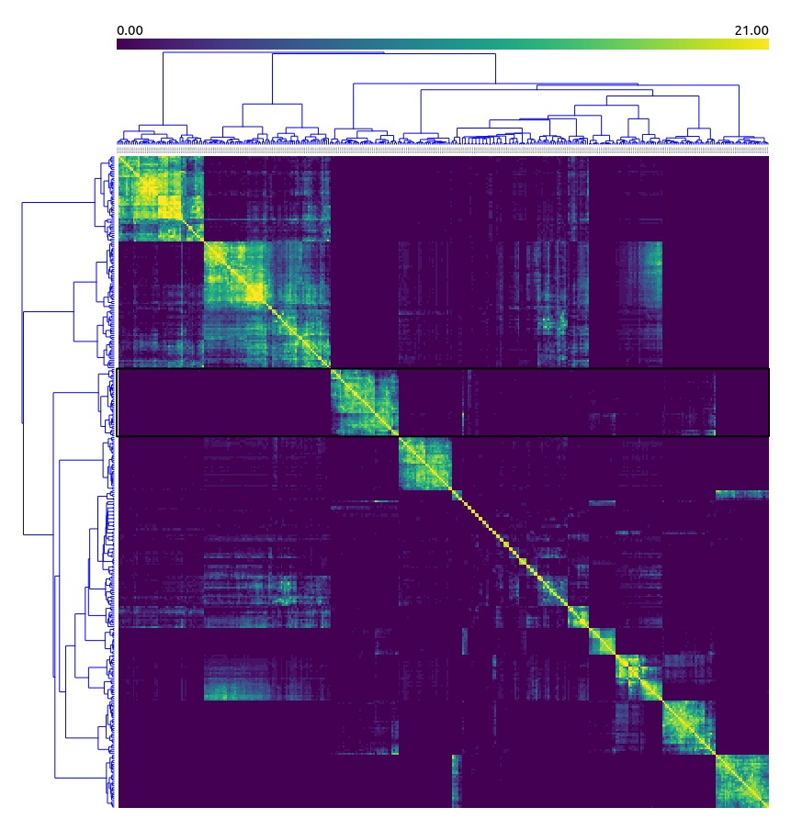Illustration 2: Regulons heatmap. The same 365 genes are written symmetrically on both axes. Colours (0 to 21) denote in how many strains a gene pair was termed to be co-expressed. An example regulon is selected with a black rectangle.

WT bias: Selection of genes for comparison of potential regulon genes obtained in strain and on vector of all measurements ('all')
Before, we selected genes to use in Orange clustering/t-SNE if they had at least one close neighbour (with cosine similarity being equal or greater than a threshold). The cosine similarity is calculated between two vectors. I have used all measurements for individual genes (452 measurements for all strains/replicates/times) as a single vector (e.g. concatenating all measurements together). However, while looking at expression profiles in Orange, I have noticed that some genes we selected seem to be more correlated in certain strains, but not the all of them. Thus I wanted to perform the gene selection and subsequent clustering on individual strains/replicates and then latter find patterns conserved between strains/replicates. However, we decided on the last meeting not to go in this direction - e.g. to rather analyse data as before, on the whole concatenated measurement vector.

As the start of above mentioned 'per strain/replicate analysis' I first needed to select candidate regulon genes for each strain/replicate. The replicates/strains have different numbers of measurements (time points) which affects cosine similarity. Thus a single threshold could not be used for all replicates/strains. Additionally, having a minimal regulon threshold size above initial two genes could eliminate noise (e.g. random correlation between two genes). Due to the above two notions I used a different approach for identification of potential regulon genes: I calculated 6 closest neighbours for each gene (which is actually 5 neighbours as first neighbour is always itself and has max similarity 1). I then ordered genes by average similarity to their 6 closest neighbours. I selected 1000 genes with highest average similarity to present potential regulon genes. I did this on data of individual strains (e.g. concatenating all time points of its replicates into a single vector) or on replicates (concatenating all time points of the replicate). The group termed 'all' is the vector of all measurements (strains/replicates/times), as described above. I compared the genes selected on 'all' and genes previously used in Regulons_extraction workflow in Orange and they seem to correspond well. - So the slightly modified gene selection method seems to be able to identify regulon genes.

Then I compared selected genes between all pairs of groups (e.g. within strains+all or replicates+all). For heatmaps I used number of shared genes between 2 groups and for hierarchical clustering I used Jaccard distance as the measure (number of shared/not shared genes between two groups). As all groups have the same number of genes the two measures should be in fact equivalent. The heatmap Compare_... shows the pairwise comparisons and heatmap CompareWithAll_... shows comparison of individual strain/replicate gene groups against 'all'. - Same as in the Compare_... heatmap row/column for 'all' but easier to look at if we want to see how the 'all' vector (which we were using in Orange and similar to what we will be using in the regulon grouping discussed on Tuesday) matches the selected genes in other groups. Additionally, I sought genes that would be present in all groups (excluding 'all' group). When genes were selected separately for each of 49 replicates I could not find a single gene that would be present in all the groups. When I did this in each of the 20 strains I found only a couple of genes present in all of them (less than 5). It is evident that genes selected on 'all' are closest to AX4, probably as we had more AX4 replicates than replicates of other individual strains. Furthermore, replicates clustering could show if any of the replicates of a strain do not occur where we would expect them. However, a better method to look at this would be a PC1 vs time or another dimension reduction method. The results for individual strains are in https://github.com/biolab/baylor-dicty/blob/master/networks/selected_genes.ipynb under Comparison of selected genes in strains and all. The results of replicates are on docker in shared_data/images/regulons/selected_genes.

Milestone genes

Selection of genes for comparison between strains
It was hypothesised that genes that are involved in metabolism of a strain will have some co-expressed genes, due to being part of a metabolic processes. Selection of top N genes with close neighbours (e. g. as in Selection of genes for comparison of potential regulon genes obtained in strain and on vector of all measurements ('all') ) does not take into the account if N is indeed the number of genes with close neighbours. Thus an attempt was made to select all genes that have close neighbours based on strain specific similarity threshold (see By strain similarity threshold).
The below was performed for each strain separately. Gene data consisted of all measurements for individual strain, log2 transformed and scaled to mean 0 and std1. For each gene 6 closet neighbours were calculated (one being itself). Genes that had 5 neighbours (excluding itself) above strain specific similarity threshold (based on N measurements in strain) were retained.
The similarities of gene groups across strains were compared with hierarchical clustering. The distance was based on p value of hypergeometric test and not Jaccar index. Namely, as different numbers of genes were selected across strains the Jaccard index would be biased towards strains that all have a lot of selected genes. This would happen due to the population of genes being finite, meaning that if many genes (or almost all genes) are selected in two strains they will necessarily be more similar. The hypergeometric test can be used to compute the significance of overlap of two sets from the same population (brief explanation in https://www.gungorbudak.com/blog/2016/05/25/computing-significance-of-overlap/ ). The clustering is in https://github.com/biolab/baylor-dicty/blob/master/networks/selected_genes.ipynb under Selected genes based on similarity.
However, the sets of selected genes contained false positives – genes that are unlikely to be important in that strain. These occurred as mostly zero expressed genes with a few random peaks are likely to have close neighbour among other such genes.
Workflow
The workflow Selected_genes_strain.ows is currently in development. The idea was to Select genes by requiring that they were selected in some groups of strains but not others. (E. g. never selected in ag- and selected in almost all strains from other groups.)

Similarity to AX4 neighbours
Information about genes having close neighbours seems to be biologically relevant (as seen in results of WT bias and Selection of genes for comparison between strains). However, selection of genes in individual strains based on close neighbours includes false positives, as described in Selection of genes for comparison between strains. Therefore, the selection of potentially metabolically active genes in individual strains can not be used for comparison of potentially important genes across strain groups. However, as there are multiple strains that develop (WT, PD), the information about which genes have close neighbours can be used to find genes potentially important in all developing strains. This can be then used to assess whether the same gene groups (consisting of genes and their close neighbours from developing strains) are co-expressed in non-developing strains. This is an indicator of whether the molecular environment of a gene (e. g. co-expressed genes) has changed in certain strain groups.
First, AX4 genes that do not have completely zero expression in any of the AX4 replicates were used to find neighbours. AX4 expression data was log2 transformed and scaled to mean=0 and std=1. For each gene 11 best neighbours (including itself, thus actually 10 neighbours) based on cosine similarity of expression profiles were extracted. Similarities to the same 10 neighbours were calculated in all other strains individually, excluding gene pairs that contained a gene with all 0 expression in at least one of the replicates of that strain. The missing similarities to a neighbour were assigned value 0. For each gene the similarities to the 10 neighbours were averaged in individual strains. Genes with missing averages (due to being unexpressed in AX4 or other strains) were assigned value 0 in individual strains.
For each of the strains in WT and PD (precocious development) groups genes with average similarities equal or greater than the 30th percentile of average similarities were selected. From these only those were retained that were selected in all WT and PD strains. This should mitigate the effect of a gene having a random close neighbour if its expression is mainly 0, as the same neighbours must be good neighbours in multiple strains. Furthermore, it selects genes that are probably important in normal development and their similarity data can then be compared to results obtained in less well developing strains.
For these genes the below procedure was used to determine if their molecular environment is changed in poorly developing strains. Strain groups were ordered based on their developmental progression: Ag-, LAD (loose Ag dis-aggregating), TAD (tight Ag dis-aggregating), TA (tight Ag arrest), CD (culmination defect), WT, PD; currently the SFB (small fruiting body) strains were excluded, as their progression is shifted from the developmental axis in t-SNE/MDS. For each gene strains were split into two groups based on having low or high average similarity to the neighbours. Strains from the same developmental group were kept together, order of the strain groups was retained (e. g. if Ag- and TAD were assigned to the low group so was LAD), and WT and PD were always kept in the same group. One tailed Mann Whitney u test was used to compare the average neighbour similarities of the strains from the two groups, with WT/PD containing group assumed to have higher similarity. Benjamini-Hochberg correction was used to adjust the p values across genes. Genes that have low FDR and high difference between the means of the two groups (e. g. the mean of average similarities to the neighbours in individual strains) are potential candidates for deregulation in poorly developing strains. These can then be classified based on which strain groups are present in the low and high similarity groups. These genes may thus be involved in developmental progression absent from the nondeveloping strain groups (groups with low similarities to the neighbours from AX4).
Workflow
The workflow is in workflows/milestones/stages_neighbours.ows. The comparisons (e.g. 1, 2, etc. or C1, C2, etc.) denote after which strain groups from those listed above the separation into two groups was made. For example, 2 or C2 would be separation after the second strain group (LAD), thus creating groups Ag-, LAD and TAD, TA, CD, WT, PD. The Difference parameter denotes the difference between the means of the two groups for each gene.

Presence of expression peaks in certain stages
This workflow finds genes that often peak in a certain developmental stage. For each gene in each replicate it was determined in which stage(s) (there can be multiple stages present at the same time point) the gene peaks. No peak was determined if gene had 0 expression in a replicate. Stage-peak data was pooled across replicates to produce the number of replicates in which a gene peaks in a certain stage. This was normalised by the number of replicates that have that stage annotated in their development. Same procedure was also performed for WT replicates (AX4, MybBGFP).
Workflow
The workflow is in workflows/milestones/peaks.ows. Data is in shared_data/milestones/peaks/, with the file ending in WT being WT specific file.

Genes with low variability in phenotypically similar samples
It was hypothesized that genes involved in the development have relatively low expression variability within similar phenotypes compared to the variability across all measurments. For example, if a gene is expressed in the FB and not in the other stages it should have consistently high expression in images depicting FB and consistently low expression in other images.
Images were embedded into vector space with Inception v3. For each image the four closest neighbours (including itself) based on cosine similarity were extracted. For each gene the relative std (RSD = std/mean) was calculated in each image group (consisting of an image and three neighbours). These RSDs of each gene were scaled by RSD of a gene obtained on all measurements (including those without images): RSDgroup/RSDtotal. Genes with median RSDgroup or RSDtotal equal to zero were excluded, as many of these are mostly unexpressed genes. To obtain null distribution the same procedure was used on the same number of image groups that consisting of four random images. Median RSDgroup was compared to median RSDgroup of null distribution. Genes with median RSDgroup no greater than the 5th percentile of the median null RSDgroup were retained. As no p values were obtained this does not adjust for multiple testing (e.g. selecting multiple genes based on the null distribution threshold).
For the selected genes the average expression in each of the phenotypic stages across all replicates was obtained. The expression across stages was scaled by maximal expression in any of that stages for a gene: avg_stage_expression/max_avg_stage_expression. This can give some information on when the gene is express. However, it does not give any information on strain specific genes.
Workflow
Workflow is in workflows/milestones/images_selected_genes.ows.

Selection of genes overexpressed in a stage
Genes overexpressed in a certain stage compared to all other stages were obtained with DESeq2. Two different designs were used: samples annotated with a stage vs other samples of WT with replicate batch effect and stage vs other samples using all strains (without batch effects). Replicates were not used as batch effects in all strain model as strains differed substantially in stages present in the control/reference subset (samples without the stage of interest). In all strains model the reference included all available samples, even those belonging to strains not present in the case. In WT model only replicates present in both case and the reference were used.
Used samples were those that were assigned stages based on images and those at t=0 (assigned with no_agg). Sample was used as ‘case’ if it was annotated with the stage of interest and ‘control’ if it was not annotated the stage.
Workflow
The workflow is in workflows/milestones/milestones_summary.ows. The data is nobatchrep_cobined.tsv for all strains and WT_batchrep_combined.tsv for WT. These files contain DESeq2 reports (to be filtered on log2FoldChange and padj) merged for all stages. A column Stage has been added denoting which enrichment test generated the result rows (e.g. test for which stage as case).

Selection of genes with smooth changes across stages
ImpulseDE2 was used for extracting genes with smooth expression changes across stages. ImpulseDE2 fits a sigmoid or two sigmoid models to expression through time (here stages), modeling up/downregulated or peak/valley expression profiles, respectively. The information about fitted models of genes well described by the models (e. g. termed significantly DE through time by ImpulseDE2) can be extracted to (approximately) determine at which times (stages) was the gene at up-level or down-level.
Models were fit with ordered stages as times to all data (no batch effects) or WT data using replicates as batches. Replicates were not used as batches in all strain model as strains differed substantially in present stages. Used samples were those that were assigned stages based on images and those at t=0 (assigned with no_agg). Each sample was used in each stage (model time point) it had annotated. Namely, if a sample was annotated with multiple stages it was used as a sample for all of them. Genes significantly DE across stages (monotonous or transient) were extracted (using the default padj). For those genes the model information was parsed to obtain stages of up and down expression. Stage yem was not used due to high overexpression, masking expression patterns in the rest of the stages. Namely, upregulation at FB and yem was not detected for FB when yem was placed after FB in ‘time’ .
The gene profile models were parsed based on the more appropriate model (impulse – 2 sigmoids or sigmoid – 1 sigmoid), transition times between up/down level (‘t’ parameters of the model) and predicted expression at each side of the transition times (‘h’ parameters of the model, denoting expression at different expression levels). Stages were assigned to groups (expression levels) based on the t parameters (separating the stages into groups) and were assigned an up/down level based on the h parameters.

Model parsing details
If gene was termed monotonous a model (sigmoid/impulse) that had lower padj was selected. In sigmoid the t was used as transition stage and in impulse the t (t1,t2) that was closer to the t from sigmoid was used. If t was smaller or larger than the ‘time’ assigned to first/last stage it was modified so that it made separation after/before first/last stage, respectively (here termed ‘border reassignment’). The up/down level was determined based on h0,h1 of the selected model. Namely, if h0<h1 then stages before t were assigned down and stages after t were assigned up.
If gene was termed transient the impulse model was used. If the t1,t2 were between the same stages the two stages nearest to the t1,t2 were termed as peak/valley (t1,t2 were reassigned so that the two stages were between t1,t2) (peak reassignment). Instead of h0,1,2 the mean of predicted expression at each level (defined by t1,2) was used for predicting up/down. If t1>t2 the t1,t2 were swapped and borders were reassigned if necessary. The h0,1,2 were substituted by average model predictions, as for peak reassignment. Afterwards t1,t2 were reassigned border if needed (for any cases not dealt with in peak reassignment or swapping). If afterwards any t1,t2 were between the same stages again (e. g. because of border reassignment), the model was dealt with as sigmoid – single t was selected and h parameters were replaced with mean predicted expression at each side of the t. For transient models two up/down and one down/up stage in the middle were annotated based on t1,2 and h0,1,2 (or mean predicted expression) parameters.
To keep track of the assignment the results were added an Assignment column: ‘impulse’ if no changes in t/h were needed, ‘impulse_manual_border’ if t was moved due to being before/after first/last stage and this was the only change, ‘impulse_manual_peak’ if t1 and t2 of impulse transient model were between the same stages and ‘impulse_manual_swapped’ if t1>t2 for a transient gene. The assigned Type of the model shape was either ‘transient’, ‘monotonous’ (both assigned by ImpulseDE2) or ‘transient_monotonous’ if after all other parsing of the transient gene t1 and t2 were between the same stages.
Workflow
The workflow is in workflows/milestones/milestones_summary.ows. The data is DEacrossStages_summary_noyem.tsv for all strains and DeacrossStages_summary_WT_noyem_batchrep.tsv for WT. The files contain information about padj of impulse and sigmoid models, Type (transient / monotonous / transient_monotonous), Direction (up/down – up is either sigmoid up through stages or impulse peak and down is sigmoid down or a valley for impulse), Assignment (how was the assignment to up/down made, described above), and stage names (listing up/down for each).

Classification
Different classification methods were used for feature (gene) selection: one vs rest logistic regression, regressior chain logistic regression, (ordinal regression – not really appropriate for multi label data), and random forest. Among these the one vs rest logistic regression was selected. Feature selection was performed with l1 regularisation.
Used samples were those that were assigned stages based on images and those at t=0 (assigned with no_agg). Used expression data consisted of RPKUM of genes with non null expression across all used samples, scaled to range [0,1] per gene (scaler was fitted in the training set). Gene selection was done by fitting the model to all retained samples and selecting all genes with positive weights at certain regularisation strength.
For evaluation cross validation with leave one strain out was used. Analysis of F scores and ROC-AUC showed that ROC-AUC is often more optimistic than F score – this is because of different optimal prediction thresholds across strains.

Parameter selection

Pre-processing for similarity calculations
Four different options of pre-processing of RPKUM data were considered for cosine similarity calculation of expression profiles. These consist of combinations of log2 (with pseudocount +1) or no log2 transformation followed by scaling of each genes’ data to [0,1] or mean=0 and std=1.
Replicates were divided into two groups at random. Genes with non null expression were selected and pre-processed. For each gene the closest neighbor was calculated (N neighbours=2, first is itself).

Similarity threshold

Whole vector similarity threshold

By strain similarity threshold
The number of measurements in expression profile affects the noisiness of the data – comparison of profiles with more measurements results in lower similarities. Thus it was desired to find a similarity threshold with biological meaning. This would enable comparison of results across strains that have different number of measurements.
In each strain the closest neighbour for each gene, which is not itself, was calculated. Data was log2 transformed and mean 0 and std1 scaled. This produced list of cosine similarities to the closest neighbours in each strain. This distribution was plotted in https://github.com/biolab/baylor-dicty/blob/master/networks/Npoints_similarity_thresholds.ipynb . It was hypothesized that the bulk of genes that have high similarities to their closet neighbour represent genes potentially involved in metabolism. Namely, it was assumed that if gene is part of a metabolic process it is more likely to have close neighbours. Thus a threshold just above the knee of distribution could be used to estimate biologically meaningful similarity threshold.
However, the knee could not be determined in some strains. Thus for each strain the threshold was chosen as the 30th percentile of distribution of similarities to the closest neighbour, excluding genes with all 0 expression in individual strains.

Visualisation

Expression preprocessing
In contrast to other protocols the data for expression profile visualisation in Orange is based on expression data averaged across replicates for individual strain (in Line Plot and Heatmap, not in t-SNE or for clustering). The data is in genes_averaged_orange.tsv and genes_averaged_orange_AX4groups.tsv (the latter has besides strains also averages for 3 AX4 groups).
Data was initially scaled for each strain separately (e. g. after strain selection in Orange). However, the use of [0,1] or mean 0 and std 1 scaling removes the information about expression strength and can result in consistently expressed genes seeming to be more variable through time than they really are. The data was first scaled based on max expression in AX4: Git =(Git-max(Giwt))/max(Giwt) , where Gi is a gene, Git is a measurement for that gene, and max(Giwt) is maximal expression of Gi in AX4 or 1 if max(Giwt) is 0. Subtraction of mean results in Gi being below zero when Gi<max(Giwt), so that Orange heatmap can be centred at 0. Saved in genes_averaged_orange_maxScaledToAX4.tsv. Instead of this a logFC could be used Git=log(Git/max(Giwt)). However, this does not produce good results when gene is not expressed in AX4 and in the first case also when the gene is more highly expressed in another strain.
Therefore instead of max(Giwt) the percentile99th(Gi) was used for scaling. Max was not used so that high outliers do not make all other values indistinguishable. Saved in genes_averaged_orange_scale99percentile.tsv. The outlier values above 0 can then be clipped (a bit above 0) so that heatmap scale is not shifted due to the outliers. This is done in genes_averaged_orange_scale99percentileMax0.1.tsv, where max is set to 0.1. This data was then used for plotting of expression in heatmaps (e. g. for regulons).

Regulons heatmap ordering

Regulon ordering
Regulons were ordered based on gene expression peak times in AX4. Peak times (max expression) for genes were obtained based on averaged AX4 RPKUM. Regulons were ordered first by median of peak times (of genes in each regulon) followed by mean of peak times.

Gene ordering
Genes were ordered for each AX4 regulon separately. The ordering was based on hierarchical clustering of AX4 data used for visualisation (scaled averaged RPKUM). Genes were clustered with ward.D2 hclust using cosine distances, followed by visual reordering (function reorder, package seriation). The genes in all strains heatmap were ordered based on order established in AX4 data.

Average stage for heatmap annotation
To plot stage data aligned with average strain expression the information about stages of replicates of a strain was summarized into ‘average stages’ for each strain. If no stage annotation was available for any of the replicates at a time point the averaged sample was annotated with no_image for single stage or across all stages, as requested by Mariko. Whenever at least one replicate had stage annotation based on images the averaged sample was annotated with all stages present across replicate samples. This does not distinguish between cases where all replicates have image-based annotation and where only some replicates have the image-based annotation.

Enrichment
Datasets used for enrichment (mapping of gene names to entrez IDs, gene sets) were obtained on 5th of April, 2020. The below protocol was used everywhere (all data generated from regulons by strain enrichment onward), except if stated elsehow.
Used gene sets contain: GO slims (generic slims offered by Orange) for biological process, molecular function, and cellular component; KEGG Pathways, and Dictybase Phenotypes. Only gene sets with size (N genes) within interval [5,500] were used; (size as used in Orange – with Entrez IDs).
For reference genes are used all genes present in RPKUM data, except those that have all zero expression (these are excluded from other analysis as well). Reference and query genes are then further filtered to only those that can be assigned an Entrez ID with Orange Gene Matcher. Another filtering is used to retain only genes (reference and query) that are contained within at least one of the used gene sets (if not stated elsehow in the report). All gene sets that have at least 1 gene overlap with query are tested for enrichment (with Orange Gene Set set_enrichment). The p-values were adjusted with Benjamini-Hochberg correction. Outputted results contain gene sets with FDR<=0.25 and overlap with query>=2.

Workflow was performed on the old data (expression data with mitochondrial genes).
Workflow was performed on the old data (expression data with mitochondrial genes) and the new data.
Workflow was performed on the old data (expression data with mitochondrial genes).

