An Open and Reproducible Edge-AI Software Architecture for Litter Detection, Multiclass Classification, Tracking, and Counting
Preprint version 1.3 — architecture figures, public-data accuracy, and warmed Jetson profiling
21 October 2026 | Abiola A. Babsalaam — Independent Researcher

Open-source software and reproducibility preprint
Code: github.com/biolababs/edge-litter-detection

Abstract
Litter monitoring is often treated as an object-detection exercise, although a deployable solution must also ingest operational video, maintain stable class contracts, avoid repeated counting, persist evidence, support human review, and integrate safely with collection or sorting workflows. This paper presents an open and reproducible edge-AI software architecture that addresses those requirements as one portable application. The software accepts cameras, images, recorded video, HTTP media, and RTSP streams; normalizes public or custom detector output; applies duplicate suppression and class-stabilized tracking; reports visible and unique-session counts; and stores auditable SQLite and JSON evidence. A browser interface exposes annotated video, counts, review tasks, and source controls. The default 16-class operational taxonomy supports human review and configurable separation guidance.
The detector is interchangeable rather than the product boundary. A clean clone runs with the public OmDet-Turbo Tiny open-vocabulary checkpoint, while a validated litter-specific checkpoint can be introduced later without changing downstream contracts. A preliminary zero-shot evaluation on a deterministic, source-grouped TACO test partition of 212 images and 680 mapped annotations measured 7.65% COCO mAP50–95, 10.16% mAP50, and 7.49% micro F1 at the frozen operating point. This result establishes an accuracy signal and also shows that the unadapted public checkpoint is a functional bootstrap, not a production-accepted litter model.
Engineering validation confirms installation, inference, persistence, automated checks, and execution on NVIDIA CUDA, Apple silicon, and an NVIDIA Jetson Orin Nano 8 GB. A prior complete 3,622-frame Jetson run measured 4.94 source-to-result FPS. Three subsequent 300-frame full-pipeline repetitions, each after 10 warm-up calls, measured 5.188 ± 0.010 FPS. Model forward time accounted for 71.10% of wall time, detector preprocessing 13.69%, and annotation/output 10.59%; tracking, JSONL, and SQLite together accounted for less than 1%. The provisional 15 FPS target was not met. These measurements do not establish target-domain accuracy, counting error, endurance, AMD performance, or production readiness. The contribution is therefore the reusable architecture, explicit count semantics, safety and security boundary, traceable preliminary evidence, and a protocol for the remaining empirical work.
Keywords: edge AI; litter detection; waste classification; object tracking; object counting; open-vocabulary detection; human-in-the-loop; NVIDIA Jetson; recycling; reproducible software

1. Introduction
Improperly discarded waste affects public-space quality, drainage, wildlife, and the movement of plastics into aquatic environments [1,2]. Collection teams typically depend on scheduled routes, visual inspection, public reports, and fixed infrastructure. These methods remain necessary, but they provide limited continuous information about where litter is present, what material it may contain, and whether an observed item was later collected.
Computer vision can provide an additional perception layer. A camera-equipped vehicle, fixed monitoring point, or sorting line can produce candidate object locations, predicted classes, confidence scores, and counts. Edge processing can keep raw imagery close to the source and continue operating when network connectivity is intermittent. However, a neural-network prediction alone is not an operational solution. The surrounding application must handle cameras and streams, normalize model output, preserve object identity across frames, define what a count means, retain auditable evidence, support corrections, and avoid unsafe coupling between uncertain perception and machinery.
Litter is also a difficult visual domain. Objects can be small, crushed, transparent, reflective, wet, dirty, partly occluded, or visually similar to permanent background objects. Material cannot always be inferred from appearance. A clear container, for example, may not contain enough visible evidence to distinguish glass from plastic. Public datasets demonstrate the feasibility of litter detection but do not remove the need to validate the intended camera, environment, class ontology, and operating threshold [3–6].
This work treats the outcome—reliable detection, classification, tracking, counting, review, and integration—as the unit of design. It does not compare model families or attempt to establish a leaderboard. The detector is placed behind a stable adapter so the complete workflow can operate with a publicly available model and later accept a validated site-specific checkpoint without changing downstream data contracts.
The contribution is therefore a software-systems and reproducibility architecture, not a new detector. This revision adds a preliminary public-data accuracy result, but it is not a target-domain validation. The low zero-shot result is reported because deployability requires both working software and an honest model-acceptance boundary.
The result is the open-source Edge Litter Detection application [7]. A user can clone the repository and run one launcher that prepares an isolated environment, installs dependencies, downloads a pinned public model, discovers or accepts a source, performs inference, and writes durable evidence. The same application supports a local dashboard, a private HTTP API, SQLite queries, human review, and integration events for a larger vehicle or facility system.
This paper is released as a systems and reproducibility preprint. It documents the implemented design, a public-data zero-shot evaluation, and authorized Jetson coexistence measurements while target-domain data, video count ground truth, multi-hour endurance, and field outcomes remain pending. This distinction is deliberate: public-data accuracy is not field accuracy, and a short technical run is not proof of sustained operational performance.

1.1 Research questions
The work is organized around the following questions:
- How can litter detection, multiclass classification, tracking, counting,
storage, review, and integration be packaged as a reusable edge application?
- Can the application operate immediately with a public model, without
requiring every deployment user to collect data or train a network?
- How should visible observations, unique tracked objects, and confirmed
collections be represented so that operational reports do not overstate the outcome?
- What reproducible protocol is required to evaluate detection accuracy,
counting accuracy, throughput, memory, power, thermal behavior, and stability on the intended device?
- What privacy, security, and machinery-safety boundaries are necessary when
the system is used on a cleanup vehicle or sorting line?

1.2 Contributions
The principal contributions are:
- a portable, model-adapter-based application for image, camera, video, HTTP,
and RTSP litter detection;
- a 16-class operational taxonomy with configurable prompts and separation
destinations;
- tracking-based visible and unique-session counts, with independently
confirmed collections stored as a separate quantity;
- an offline-first SQLite evidence model, review queue, browser dashboard, API,
and durable integration outbox;
- one-command installation and execution using public, pinned model artifacts;
- deployment paths for CPU, NVIDIA CUDA, NVIDIA Jetson, AMD ROCm, and Apple
silicon;
- model, data, privacy, security, and safety boundaries intended for reuse in
real collection and sorting workflows; and
- a deterministic public-data zero-shot evaluation and a predeclared empirical
protocol that prevent preliminary engineering observations from being reported as final target-domain results.

2. Related Work

2.1 Litter and waste datasets
TACO introduced a publicly available dataset of waste “in the wild,” with object annotations and a detailed material-oriented taxonomy [3]. It is useful for bootstrapping because it contains varied contexts rather than only controlled conveyor imagery. Studies based on TACO have also highlighted the difficulty of small objects, class imbalance, and the risk of reporting one aggregate metric without examining precision, recall, F1, object size, and scene conditions [4,5].
ZeroWaste focuses on industrial waste sorting and emphasizes dense, overlapping objects and material recovery facility conditions [6]. It illustrates why a sorting-line camera and a road-facing vehicle camera should not automatically be treated as the same domain. More recent datasets such as RoLID-11K expand real-world litter coverage and underline continuing interest in diverse scenes and fine-grained categories [8]. Dataset growth is valuable, but deployment performance still depends on the intended viewpoint, camera, lighting, object size, contamination, motion, and taxonomy.
The present project therefore uses public data as attributed bootstrap material rather than as proof of field performance. The repository can prepare a grouped TACO-derived COCO dataset while retaining source and license metadata. Target-domain samples remain necessary before a litter-specific checkpoint or an operational accuracy claim can be released.

2.2 Detection and open-vocabulary models
Modern object detectors predict class labels and bounding boxes, allowing multiple litter items to be localized within one image. COCO established widely used detection evaluation conventions, including average precision across intersection-over-union thresholds [9]. DETR reformulated detection as direct set prediction with transformer-based global reasoning [10], and DINO subsequently improved DETR-style training and query formulation [11].
Grounding DINO extends detection toward open-set, text-conditioned operation [12]. OmDet-Turbo is designed as a real-time open-vocabulary detector that can process user-defined class names [13]. These models are useful where a public checkpoint must work before a task-specific training set exists. They also introduce prompt sensitivity and semantic ambiguity: a text-conditioned model can return a plausible box and class without being calibrated for the local waste stream.
RF-DETR is a recent real-time detection-transformer family with deployment-oriented model sizes and training support [14]. In this project it is an optional path for a centrally trained, fixed-taxonomy checkpoint if the public open-vocabulary path does not satisfy the use-case gates. This is not a comparison between OmDet-Turbo and RF-DETR. OmDet-Turbo currently enables immediate use and data collection; a custom checkpoint is a future adaptation mechanism, not a requirement imposed on ordinary users.

2.3 Tracking and counting
Video detection creates repeated observations of the same object. Summing all frame detections can severely overcount persistent litter. Tracking methods associate detections over time and assign identities. SORT demonstrated a simple online combination of motion estimation and data association [15]. ByteTrack showed that lower-confidence detections can improve association when handled appropriately [16].
The current application uses a compact class-stabilized intersection-over-union tracker to minimize runtime dependencies. It is suited to functional use with fixed or slowly moving cameras and mostly stationary litter. It is not presented as a universal identity solution. Fast camera motion, long occlusion, scene cuts, loops, and crowded items can create duplicate or merged tracks. Accordingly, count error must be evaluated separately from detection average precision, using track-annotated video.

2.4 Edge deployment and reproducibility
Edge deployment adds preprocessing, decoding, memory transfer, visualization, storage, and synchronization to model inference. Performance depends on the complete software and hardware condition, including input size, precision, runtime, power mode, cooling, camera pipeline, and co-resident workload. PyTorch, Transformers, and OpenCV provide portable implementation components [17–19], but portability does not imply equal performance on all devices.
The reproducibility gap is often caused by missing model revisions, thresholds, environment versions, hardware details, or test-media checksums. This project records run metadata and emits machine-readable evidence so results can be connected to a source, model, configuration, device, and Git revision.

2.5 Integrated litter and sorting systems
Existing integrated platforms illustrate that operational value extends beyond one detector metric. Litterati combines mobile image collection, mapping, and analytics for identifying litter patterns and evaluating interventions [22]. A comparison with municipal audits found that its app-based records captured similar broad composition patterns while also showing population-correlated spatial sampling bias, illustrating both the value and limitations of crowdsourced litter evidence [25]. The US Environmental Protection Agency describes TrashBot as a machine-learning system that sorts material at the point of disposal and provides disposal guidance [23]. AMP Vision applies continuous material identification and analytics inside material-recovery facilities [24].
Recent research prototypes also move beyond an isolated detector. DWaste packages waste recognition for mobile and edge use, including offline operation and deployment-oriented model selection [26]. Arora presents an edge-assisted smart-city application combining 16 trash categories with privacy-aware face anonymization [27]. These systems, together with the commercial examples, occupy different product boundaries: community and municipal measurement, smart disposal, roadside monitoring, and industrial recovery.
The present work does not claim equivalent deployment maturity. Its narrower contribution is an open, locally deployable perception-and-evidence component with explicit count semantics, model interchangeability, offline persistence, and a machinery-safety boundary that can be integrated into a larger cleanup or sorting solution.

3. Requirements and Use Cases
The software is intended for four related uses:
- A vehicle-mounted camera observes roadside litter and associates candidate
objects with a device, vehicle, and route.
- A fixed camera monitors a location or accumulation point.
- A recycling or waste-sorting line detects visible items and presents a
suggested class and operator-configured destination.
- A human worker uses the annotated feed and review queue to find, classify,
or separate uncertain items.
The application is a perception and evidence component. It is not an autonomous enforcement tool and is not a safety-rated motion controller. Person identification, face recognition, license-plate recognition, behavior scoring, and automated penalties are outside the project scope.

3.1 Functional requirements
The system must:
- accept a local camera index, image, video, HTTP resource, or RTSP stream;
- produce zero or more boxes, class names, confidence scores, and timestamps;
- preserve a stable class ID and name contract downstream of the detector;
- reduce duplicate boxes and associate video observations into tracks;
- report current visible counts and run-scoped unique counts by class;
- persist run, frame, count, review, and integration evidence locally;
- remain useful without continuous cloud connectivity;
- allow a human to confirm, correct, or reject uncertain classifications;
- store actual collection confirmations separately from observations;
- expose bounded local controls through a dashboard and API; and
- retain enough environment and revision data to reproduce a reported run.

3.2 Non-functional requirements
The system must:
- install from a clean clone without private credentials or a private model;
- use an isolated Python environment and avoid machine-specific paths;
- function on 64-bit x86_64 and ARM64 systems;
- avoid dependence on one accelerator vendor;
- default to local-only network exposure;
- validate and bound uploaded media and remote-source behavior;
- support model artifact pinning and integrity checks;
- avoid direct machinery actuation;
- limit unnecessary retention of raw media and identifiers; and
- disclose when evidence is preliminary, incomplete, or device-specific.

4. System Design

4.1 End-to-end architecture
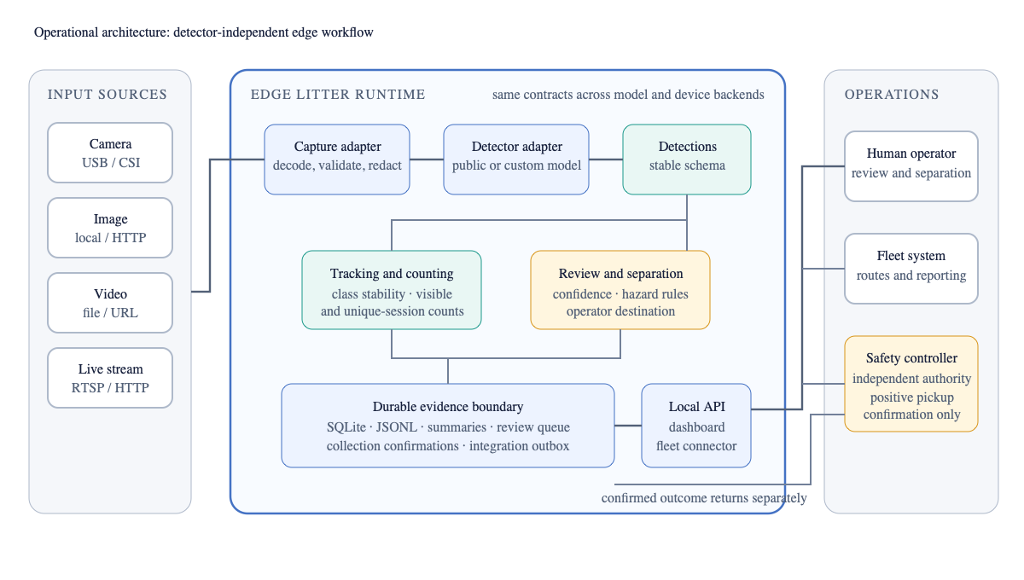
Figure 1. Detector-independent operational architecture. Capture and model adapters feed stable detection records into tracking, review, persistence, and integration components. Human and controller confirmations return as separate outcome evidence.
Capture, detection, counting, persistence, and integration are separate components. A detector adapter converts backend-specific results into a stable record containing class ID, class name, confidence, and bounding box. This allows the rest of the application to remain unchanged when a model or accelerator path is replaced.
The implementation currently includes Grounding DINO Tiny, OmDet-Turbo Tiny, and RF-DETR adapters. OmDet-Turbo Tiny is the recommended no-training path in the documented demonstration because it uses a public checkpoint and returns confidence-scored open-vocabulary detections. Grounding DINO remains a functional bootstrap and review aid. RF-DETR accepts a future project-maintained or site-specific checkpoint. No backend is described as accurate for a target site until it has passed the same frozen use-case evaluation.

4.2 Operational taxonomy
The default taxonomy contains 16 categories:
ID | Class | ID | Class
0 | plastic_bottle | 8 | cigarette_butt
1 | glass_bottle | 9 | food_waste
2 | metal_can | 10 | textile
3 | paper | 11 | tire
4 | cardboard | 12 | battery
5 | plastic_bag | 13 | electronic_waste
6 | food_wrapper | 14 | broken_glass
7 | disposable_cup | 15 | other_litter

This taxonomy balances common item types, material-separation needs, hazardous items, and an explicit ambiguous class. Public-model prompts are configurable without changing the downstream class contract. Separation destinations are kept in a different configuration because recycling policy and facility streams vary by operator and jurisdiction.
The categories were selected by three practical criteria rather than by an attempt to reproduce one dataset ontology:
Criterion | Classes or design response
Common, visually promptable containers and fibers | plastic bottle, glass bottle, metal can, paper, cardboard
Flexible packaging and disposable service items | plastic bag, food wrapper, disposable cup
Common small, organic, soft, or bulky litter | cigarette butt, food waste, textile, tire
Items requiring special handling | battery, electronic waste, broken glass
Visual or taxonomic uncertainty | other litter and mandatory/threshold-based human review

For public TACO preparation, only source labels that support a defensible operational interpretation are mapped directly—for example, Drink can to metal_can and Clear plastic bottle to plastic_bottle. Remaining source categories are retained as other_litter rather than discarded or assigned a more specific material without evidence. This is an operational starting ontology; class frequency, visual confusability, and site value must still be measured before a fixed-taxonomy model is released.
The taxonomy is not a claim that every material can be visually identified. Low-confidence, hazardous, and ambiguous observations can enter a human review queue. If a released closed-set checkpoint is trained later, every advertised class must have documented training and held-out evaluation support.

4.3 Tracking and count semantics
The system deliberately reports different quantities:
- visible_counts are detections present in the current frame;
- confirmed_visible_counts are currently visible detections whose tracks
have met a confirmation threshold;
- unique_session_counts are confirmed track identities counted once in one
run; and
- confirmed_collected_counts are physical pickups separately confirmed by a
human, collection controller, sensor-fusion service, or reviewed import.
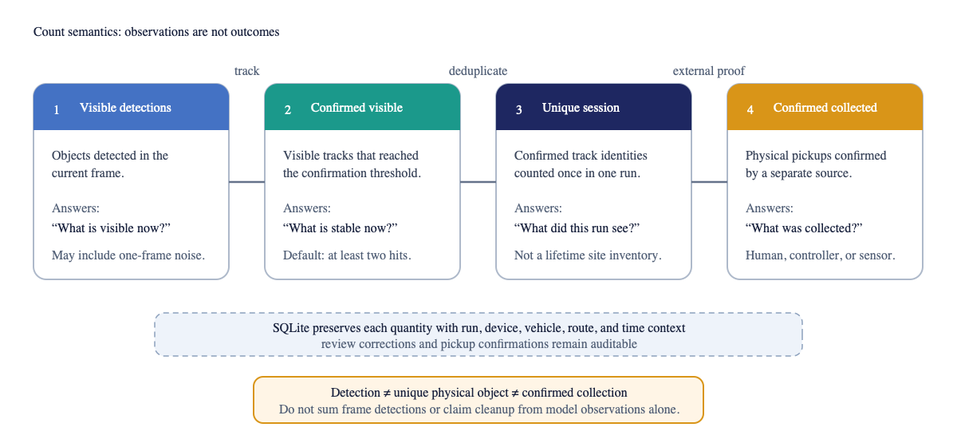
Figure 2. The four count quantities are related but not interchangeable. Only a separate human, controller, sensor, or reviewed import can establish a confirmed collection.
These quantities answer different questions. Visible counts estimate the current scene. Unique-session counts estimate how many track identities were encountered during a run. Confirmed-collected counts represent an external outcome. A detection does not prove collection, and unique counts from different runs cannot be added without accepting possible duplicate physical objects.
The default tracker associates boxes by overlap, retains a track across short missed intervals, confirms it after repeated observations, and stabilizes the class using accumulated votes. This reduces frame-by-frame overcounting and label flicker while preserving a dependency-light edge path. For fast-moving vehicle footage or crowded sorting lines, the same detection and event schema can support a stronger tracker or geospatial deduplication after separate validation.
The exact default association procedure is:
for every active track:
missed_frames += 1
for every detection-track pair with IoU >= 0.30:
score = IoU
if detection class differs from the track's modal class:
score *= 0.75
greedily assign descending scores, at most one detection per track
and one track per detection
for every matched track:
update its box, reset missed_frames, increment hits,
and add one vote for the detected class
for every unmatched detection:
create a new track with one hit and one class vote
emit the modal class accumulated by each track
confirm a track after 2 hits
delete a track after more than 30 missed frames
count each confirmed track ID once per run
There is no motion model, appearance embedding, or global assignment solver. This simplicity makes the behavior reproducible and lightweight but also explains the stated limitations under rapid motion, long occlusion, and dense overlap.
The overlap threshold gives an image-plane failure boundary. For two equal-sized boxes of width w with horizontal displacement d and no vertical displacement, their intersection over union is (w-d)/(w+d). The configured requirement of IoU at least 0.30 therefore requires d ≤ 0.538w between processed frames. A 40-pixel-wide item can move only about 21.5 pixels per processed frame before this simplified case becomes unmatchable. At 5 FPS that is approximately 108 image pixels per second. This is not responsibly convertible to vehicle speed without camera calibration, mounting geometry, depth, and object size. It does show why higher processed frame rates, motion compensation, or a stronger tracker are required for rapid vehicle motion and some conveyor conditions.

4.4 Persistence and offline operation
The application writes streaming JSON Lines events, an end-of-run JSON summary, optional annotated media, and a SQLite operational database. SQLite uses write-ahead logging and parameterized statements. The schema includes:
Table | Purpose
runs | source, device, vehicle, route, status, timing, and final counts
frame_observations | per-frame visible and cumulative unique counts
detections | optional detailed boxes and tracks
run_class_counts | query-friendly final class totals
review_queue | pending, confirmed, corrected, or rejected classifications
collection_confirmations | independently confirmed physical pickups
integration_outbox | durable events waiting for an external acknowledgement

Detailed detection rows are disabled by default to reduce long-term storage. Operators can retain counts and summaries while applying a shorter retention period to raw or annotated media. The outbox pattern permits a vehicle to continue operating without network connectivity and forward events later through an organization-controlled authenticated transport.

4.5 Human-assisted separation
Predicted classes can be mapped to site-specific material streams. A dashboard or external application can display the class, confidence, destination, and review state to a worker. Corrections are auditable and do not silently rewrite the original model observation.
The separation mapping is advisory. Composite, contaminated, hazardous, or unknown material may require a manual decision. Batteries, electronic waste, broken glass, sharps, chemicals, and pressurized containers require local safety procedures beyond a visual prediction.

4.6 Dashboard and API
The FastAPI service provides health and readiness endpoints, image detection, stream-session control, count queries, review operations, collection confirmation, and outbox acknowledgement. It also serves a dependency-free browser dashboard. A server-side session can open a camera or file on the edge computer, avoiding the false assumption that a browser camera index refers to the remote device.
The API binds to loopback by default and has no built-in multi-user identity system. Remote access should use an SSH tunnel or a mature authenticated gateway. The project does not recommend exposing the service directly to the public Internet.

4.7 Machinery-safety boundary
Perception output may inform an operator or task planner, but it must not directly move hydraulic, pneumatic, or electric equipment. A production collection arm requires an independent safety-rated controller, emergency stops, manual override, exclusion-zone and proximity sensing, arm-position and load limits, stale-signal handling, and positive pickup confirmation. If safety inputs are missing or contradictory, motion must remain inhibited.
This boundary prevents a probabilistic class or box from becoming an unreviewed actuation command. It also preserves the difference between “an object was observed” and “an object was collected.”
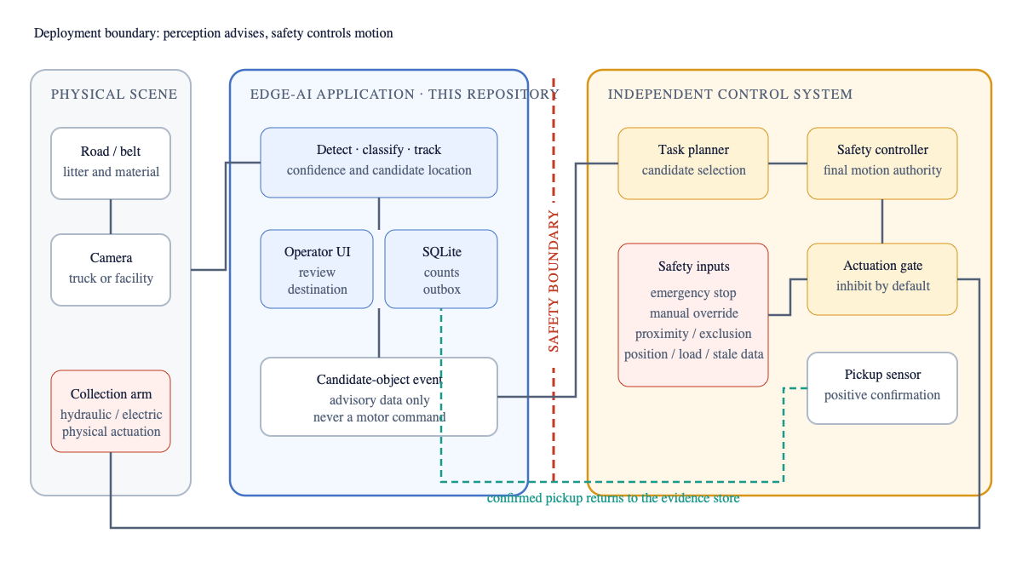
Figure 3. Edge perception produces advisory candidate events. Mechanical motion remains under an independent safety-rated controller, and positive pickup confirmation returns to the evidence store separately.

5. Implementation and Reproducibility

5.1 Software release
The implementation described in this preprint is Edge Litter Detection version 0.11.0 at Git commit 864308395b5c9515f7c8cbc55c82014d245a0e3c [7]. Code and project documentation are released under Apache License 2.0. Model checkpoints and datasets retain their own licenses and are not relicensed by the repository.
The primary clean-clone demonstration is:
git clone https://github.com/biolababs/edge-litter-detection.git
cd edge-litter-detection
./startup.sh --backend omdet_turbo --demo-video --no-display
In this paper, a clean-clone workflow means execution from a fresh source checkout on a supported host with no pre-existing project virtual environment, model cache, private checkpoint, or API credential. Internet access is allowed for public dependency, model, and attributed demonstration downloads.
The launcher creates or reuses a virtual environment, installs the selected runtime, downloads attributed demonstration media when requested, downloads a pinned public checkpoint, runs inference, and writes evidence. Cameras, network streams, the dashboard, count queries, evaluation, profiling, and security checks use the same release. Exact commands are maintained in the repository README and the accompanying supplementary reproducibility record, rather than duplicated throughout the manuscript.

5.2 Model artifact controls
Public Hugging Face model revisions are immutable in the application configuration, SafeTensors is preferred, and remote model code is disabled. Custom remote model references must be pinned to a commit and accompanied by a checksum where the download path requires it. Demonstration downloads use HTTPS, redirect validation, size limits, media-signature checks, temporary files, and SHA-256 records.
The repository keeps model selection separate from model availability. A public model makes the application immediately deployable for functional use, but only a checkpoint that passes representative accuracy and systems gates should be described as accepted for an operational site.
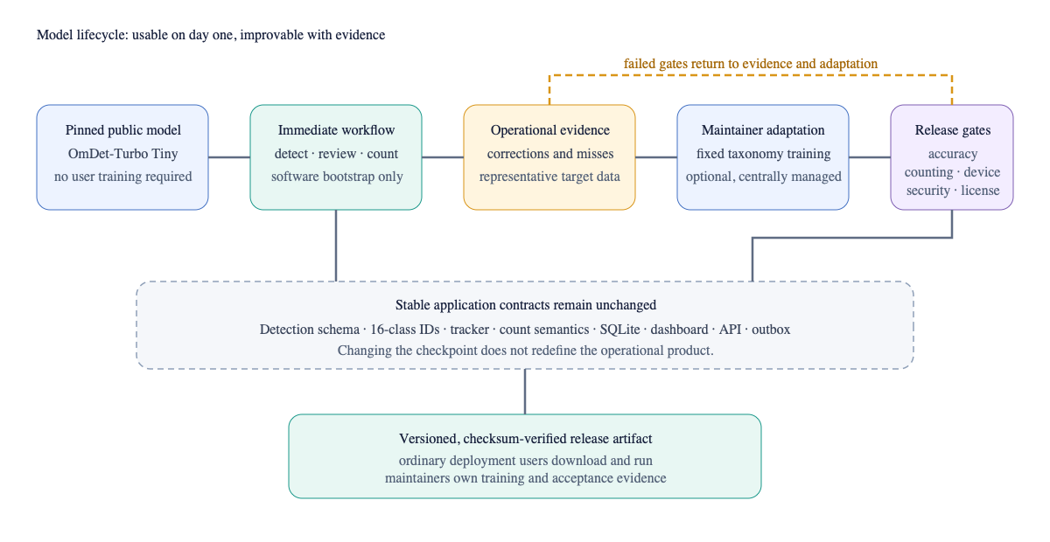
Figure 4. Ordinary users can begin with a pinned public model. Optional target-domain training remains a maintainer activity and can replace the checkpoint without changing the application’s detection, counting, storage, or integration contracts.

5.3 Hardware portability
The minimum functional baseline is a 64-bit x86_64 or ARM64 computer with four logical CPU cores, 8 GiB of memory, 10 GiB of free storage, Python 3.10–3.14, and network access for initial installation. An accelerator is optional for installation checks, still images, API integration, and low-rate processing.
The recommended real-time evaluation baseline is six or more modern logical cores, 16 GiB host memory for a discrete-GPU system, 8 GiB or more accelerator or unified memory, 20 GiB free SSD storage, and a vendor-supported CUDA, ROCm, or JetPack PyTorch environment. These values are capacity-planning baselines, not guaranteed performance.
The code exposes CPU, NVIDIA CUDA, AMD ROCm through PyTorch, Apple MPS, and Jetson-oriented paths. Each target must retain its own environment and benchmark record. Results measured on a Tesla T4 cannot be presented as Jetson, AMD, or Apple results.
The maintained public-model dependency line uses PyTorch 2.6 or newer, torchvision 0.21 or newer, and Transformers 5.20 or newer. Jetson deployments must use compatible vendor or container builds rather than replacing the device's JetPack system packages.

5.4 Software verification and secure development
At the reported revision, 86 automated tests cover configuration, model adapters, tracking, storage, streaming, benchmark output, training-data preparation, evaluation, and API security behavior. The release workflow also checks command-line help paths, shell syntax, package structure, startup regression, static correctness, dependency vulnerabilities, and Python package construction.
The security design is organized around concepts from the NIST Secure Software Development Framework and OWASP Application Security Verification Standard [20,21]. Controls include loopback network defaults, bounded media uploads, content-signature validation, browser security headers, parameterized SQL, non-root containers, pinned automation, automated dependency updates, secret scanning, CodeQL analysis, and a private vulnerability-reporting path. This is a secure-development review, not a penetration test, certification, or claim of formal compliance.

6. Evaluation Protocol

6.1 Evaluation principle
The evaluated object is one frozen solution configuration: checkpoint, taxonomy, prompts or class head, thresholds, image size, tracker settings, runtime, and Git revision. The purpose is to determine whether the complete system satisfies the use case. The study does not compare detectors for rank.
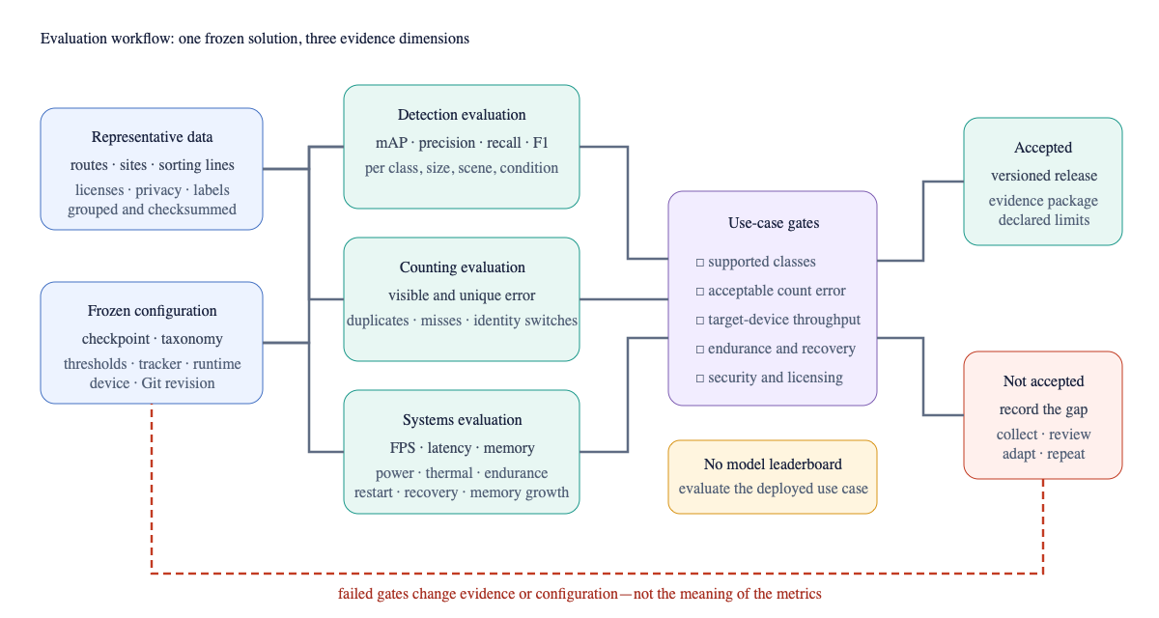
Figure 5. Detection, counting, and systems evidence are evaluated separately against use-case gates. Failed gates lead to a documented evidence or configuration change rather than an unsupported release claim.

6.2 Data acquisition and governance
Evaluation data should contain the intended truck, sorting-line, fixed-camera, or handheld viewpoint; expected object sizes; empty scenes; confusing background objects; lighting and weather variation; motion blur; occlusion; crushing; contamination; and class imbalance. Sources, licenses, collection dates, sites, sessions, and redistribution restrictions must be recorded.
Adjacent frames and repeated views from one video are strongly correlated. Random image-level splitting can place nearly identical content in development and test partitions. Entire source videos, routes, sites, or collection sessions should therefore remain in only one partition. The held-out test set must be frozen and checksummed before checkpoint, threshold, or prompt selection is finalized.
Where feasible, a quality-control subset should be labeled independently by at least two annotators. The annotation guide must define partial occlusion, truncation, minimum visible evidence, object grouping, ambiguous material, and non-litter exclusions. Identifiable people, plates, private property, and unnecessary location metadata should be removed or de-identified under the approved protocol.

6.3 Detection and classification measures
The final evaluation will report:
- precision, recall, and F1 at the frozen operational threshold;
- mAP50 and mAP50–95;
- per-class average precision and support;
- a confusion analysis;
- results by object size, lighting, weather, clutter, occlusion, distance, and
scene type; and
- human-review rate and correction rate.
No class should be advertised as supported if it lacks held-out examples. Aggregate mAP must not conceal poor recall for a hazardous or operationally important minority class.

6.4 Counting measures
Track-annotated video is required for identity-based counting claims. The final evaluation will report per-frame absolute error, visible-count mean absolute error, unique-session count error, duplicate-track rate, missed-track rate, identity switches where ground truth permits, and class reassignment within a track. Results should be stratified by camera motion, object density, occlusion, scene cuts, and looped or repeated routes.
Detection accuracy is necessary but insufficient for count accuracy. A detector can have acceptable image metrics while an unstable tracker repeatedly counts the same item.

6.5 Systems measures
Systems evaluation will separate:
- pure detector-call latency;
- preprocessing, inference, and postprocessing latency;
- observed source-to-result throughput;
- first-inference and steady-state latency;
- mean, population standard deviation, p50, p95, p99, minimum, and maximum
latency;
- process, system, and accelerator memory;
- power and energy per processed frame where supported;
- temperature, clocks, and throttling state; and
- sustained-run failures, memory growth, camera interruptions, and restart
behavior.
At least 10 detector calls must precede measured target-device samples. Principal target-device conditions must be repeated at least three times. Input resolution, precision, power mode, cooling, camera or media source, co-resident workload, software versions, and optimized artifact checksum must remain recorded with the result.

6.6 Target-device acceptance
The provisional engineering target is at least 15 source-to-result frames per second for the declared camera and coexistence condition. The preliminary public-model Jetson path reported in Section 7 did not meet this target. For the shared Jetson Orin Nano 8 GB, the preferred incremental detector memory is no more than 1.5 GiB, with a 2.0 GiB initial hard limit and at least 2.0 GiB remaining available memory. The memory-availability condition passed in the reported run, but repeated measurements and a multi-hour endurance test are still required.
An optimized FP16 or INT8 artifact must be checked against the same held-out data. INT8 requires representative calibration samples and should not be accepted merely because it is faster.

7. Preliminary Validation

7.1 Scope
Preliminary validation establishes that the software can be installed, executed, tested, and measured. The public-data result below establishes a preliminary zero-shot accuracy signal, but not target-domain detection accuracy, counting accuracy, operational benefit, environmental impact, or performance on every supported hardware family.

7.2 Functional software evidence
The clean-clone workflow has completed real OmDet-Turbo image inference through the normal launcher, produced normalized detections, written JSON and annotated output, and persisted run and count data in SQLite. The dashboard, API, tracking, review, storage, benchmark, and preparation paths are covered by 86 automated tests at the reported revision.
One TACO demonstration image produced six unique-session detections in a single-image run: three metal_can, one plastic_bag, one plastic_bottle, and one tire. These labels are reported only to demonstrate the pipeline and record schema. They are not an accuracy result because the image was not evaluated under the frozen taxonomy mapping and operating threshold, and some predictions do not match the source annotations.
Specifically, the source annotations included a cigarette, clear plastic bottle, drink can, metal bottle cap, normal paper, plastic items and wrappers, plastic utensils, and unlabeled litter. The demonstration output over-counted metal_can, proposed plastic_bag and tire where those labels were absent, and omitted several annotated small items. This concrete mismatch is why the demonstration is retained as software evidence only.

7.3 Preliminary public-data zero-shot accuracy
Version 0.11.0 adds a deterministic public evaluation path. TACO does not publish an official train/test partition, so the preparation tool assigns entire source batches or original source groups to one split using seed 42. The resulting frozen test partition contains 212 images and 680 mapped annotations. Downloaded resized images and their boxes, polygon coordinates, and areas are scaled to the actual image dimensions before evaluation.
The evaluated configuration used the public omlab/omdet-turbo-swin-tiny-hf checkpoint at pinned revision 7fe93cecfb770c4d76cf71163956221249cab566, without project fine-tuning. The confidence threshold was 0.25, non-maximum-suppression IoU was 0.45, and the maximum was 100 detections per image. Evaluation ran at Git revision 864308395b5c9515f7c8cbc55c82014d245a0e3c on Apple MPS using PyTorch 2.14.1 and Transformers 5.20.2. The annotation and evaluated-image sets are checksum-recorded in the evidence file.
The aggregate COCO bounding-box results were:
Measure | Result
mAP50–95 | 0.0765
mAP50 | 0.1016
mAP75 | 0.0916
AR at 100 detections | 0.1520
Operating-point micro precision at IoU 0.50 | 0.0721
Operating-point micro recall at IoU 0.50 | 0.0779
Operating-point micro F1 at IoU 0.50 | 0.0749

Per-class support and average precision show where the public checkpoint did and did not transfer:
Class | Test support | AP50–95 | AP50
plastic_bottle | 32 | 0.1469 | 0.1946
glass_bottle | 20 | 0.0916 | 0.1224
metal_can | 28 | 0.2259 | 0.2986
paper | 26 | 0.0403 | 0.0572
cardboard | 31 | 0.0000 | 0.0000
plastic_bag | 11 | 0.1550 | 0.1913
food_wrapper | 25 | 0.0144 | 0.0217
disposable_cup | 31 | 0.1671 | 0.2290
cigarette_butt | 129 | 0.0000 | 0.0000
food_waste | 0 | — | —
textile | 0 | — | —
tire | 0 | — | —
battery | 0 | — | —
electronic_waste | 0 | — | —
broken_glass | 4 | 0.0000 | 0.0000
other_litter | 343 | 0.0003 | 0.0033

The result is low and uneven. Metal cans, disposable cups, plastic bags, and plastic bottles show some zero-shot localization signal, while several common or safety-relevant classes show none under this mapping and threshold. other_litter contains half of the mapped annotations and remains especially difficult. Classes with no ground-truth instances are displayed rather than silently included in a macro claim.
This evaluation closes the absence of any accuracy number, but its boundary is strict: it is a project-defined grouped TACO split, a mapped operational taxonomy, one public model, and no prompt or threshold comparison. It is not roadside, vehicle, sorting-floor, or counting validation. The result supports using the checkpoint for software bring-up and data collection; it does not support production classification or automated separation decisions.

7.4 Preliminary systems measurements
Platform and measurement | Samples | Throughput | Mean detector latency | p95 latency | Additional evidence
AWS g4dn.xlarge, Tesla T4, detector benchmark | 50 repeated images after 10 warm-up calls | 16.53 FPS | 58.98 ms | 61.03 ms | 0.55 GiB peak GPU allocation
Jetson Orin Nano 8 GB, detector benchmark | 50 repeated images after 10 warm-up calls | 5.54 FPS | 174.30 ms | 175.65 ms | 0.70 GiB peak GPU allocation
Apple silicon, MPS, public-data evaluation | 212 varied images | 5.70 source-to-result FPS | 172.44 ms | 228.32 ms | 29.44 ms standard deviation; 255.48 ms p99

The T4 and Jetson measurements used a repeated image and measured the detector benchmark path rather than sustained video capture, annotation rendering, database writing, and dashboard delivery. The original T4 output was produced on the AWS instance; the public repository currently retains a transcribed evidence record and the documented values, not the original remote JSON file. The Jetson and Apple measurements are retained as repository JSON artifacts. None of these measurements evaluates accuracy.
The T4 result demonstrates that the current public-model path can exceed the provisional 15 FPS engineering target in one discrete-GPU, model-only condition. The Jetson result demonstrates compatibility and bounded steady-state detector execution, but at 5.54 FPS it did not meet that target. Neither repeated-image result establishes full-application or accuracy performance.

7.5 Jetson inventory, coexistence, and latency profile
An inventory identified the intended target as a Jetson Orin Nano Engineering Reference Developer Kit Super with Ubuntu 22.04.5, JetPack 6.2.3, L4T 36.5.2, TensorRT 10.3.0, Python 3.10.12, and 7.4 GiB physical memory. At capture time, 4.5 GiB was available, no /dev/video* camera was present, and active local LLM, application, and development services were observed.
All authorized tests used a dedicated data directory and a digest-pinned, 4 GiB-limited community L4T PyTorch container. They did not change system packages, system Python, power mode, clocks, or existing services. An initial PyTorch 2.4.0 and Transformers 4.57.6 condition established full-file functionality: after a 120-frame smoke test, the launcher processed all 3,622 frames of the 120.85-second attributed recycling demonstration in 733.54 seconds. Source-to-result throughput was 4.94 FPS and mean detector-call latency was 178.60 ms. Tracking, annotated MP4 creation, JSONL, summary output, and SQLite persistence completed.
The maintained dependency line was then moved to PyTorch 2.6+ and Transformers 5.20+ after dependency auditing. The repeated profile used PyTorch 2.7.0, torchvision 0.22.0, Transformers 5.20.2, Python 3.12.3, and TensorRT 10.7.0 inside container digest sha256:4bb7f0a3852f86629ed271aaf6c4aa000305cc4e4673b8e9f334668ee1b22bc8. At Git revision 618954e5921305addbd147ccc96ea1d78fe34c6e, three 300-frame full-pipeline repetitions were run after 10 detector warm-up calls each. The profiled path included decode, preprocessing, model forward, postprocessing, tracking and count policy, JSONL, SQLite, annotation rendering, and annotated MP4 output.
Repetition | Frames | Source-to-result FPS | Wall time | Mean detector call
1 | 300 | 5.1748 | 57.97 s | 168.60 ms
2 | 300 | 5.1881 | 57.83 s | 168.75 ms
3 | 300 | 5.2002 | 57.69 s | 168.51 ms
Mean ± population SD | 300 | 5.1877 ± 0.0104 | 57.83 ± 0.12 s | 168.62 ± 0.10 ms

The same class counts were emitted in all three repetitions on the fixed video. This is a determinism check, not counting accuracy, because the source has no track-count ground truth. Mean exclusive wall-time shares were:
Component | Mean wall-time share
model forward | 71.10%
detector preprocessing | 13.69%
annotation rendering and output | 10.59%
detector postprocessing | 2.58%
capture or decode | 0.80%
tracking, policy, and counting | 0.44%
SQLite persistence | 0.33%
JSONL serialization and write | 0.13%

The breakdown shows that model forward, preprocessing, and annotation/output are the principal optimization targets. Tracking, JSONL, and SQLite together accounted for 0.91% of wall time, so removing durable count evidence would not close the approximately threefold gap to 15 FPS.
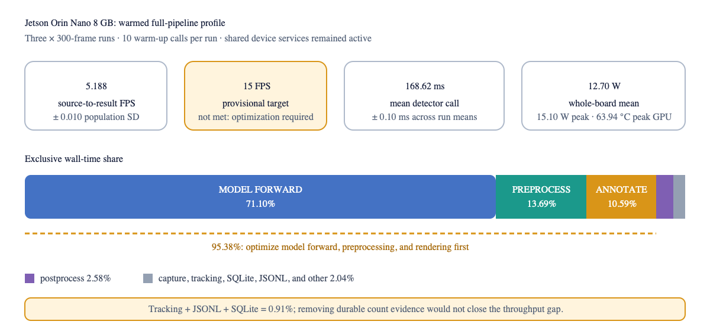
Figure 6. Mean exclusive wall-time shares across three warmed Jetson full-pipeline runs. Model forward, detector preprocessing, and annotation output account for 95.38% of measured wall time.
Across the complete three-run telemetry session—including loading, warm-up, processing, and transitions—minimum available system memory was 2,280 MiB, swap remained fixed at 243 MiB, peak GPU temperature was 63.94 °C, and whole-board input power averaged 12.70 W with a 15.10 W peak. Board power includes the full Jetson and co-resident services. The community image remains a recorded supply-chain limitation rather than an endorsed production base.
The profile initially allowed outbound HTTPS because Transformers 5.20 performed a metadata lookup for the named timm backbone. A subsequent adapter change materialized that backbone configuration locally. At Git revision 864308395b5c9515f7c8cbc55c82014d245a0e3c, an isolated Jetson smoke test with --network none, a read-only model cache, and both Hugging Face offline flags loaded the same pinned checkpoint and completed CUDA inference. This establishes cached offline startup for the tested configuration.
A separate loopback-only dashboard smoke test returned the browser interface with security headers, started and completed a 30-frame CUDA stream, served an annotated JPEG, and exposed the persisted run through the counts API. Its 1.77 FPS source-to-result result included lazy model loading and is reported only as functional UI/API evidence.
The public demonstration video does not provide labels for the project's operational taxonomy. Its detections and counts are therefore not accuracy or count-error results. The full-file run establishes bounded stability, while the three shorter warmed runs establish preliminary repeatability and a latency breakdown. Neither establishes multi-hour endurance, thermal-throttling acceptance, or production readiness.

7.6 Evidence status
Claim area | Status
Clean clone, launcher, public-model inference, SQLite, dashboard/API | implemented and functionally verified
Automated software tests and release/security workflows | verified at reported revision
Grouped TACO zero-shot detection/classification accuracy | preliminary measured evidence; low result; not target-domain acceptance
Tesla T4 OmDet-Turbo model-only execution | preliminary measured evidence
Apple MPS OmDet-Turbo model-only execution | preliminary measured evidence
Jetson Orin 8 GB detector and 3,622-frame full workflow | preliminary measured coexistence and bounded stability evidence
Jetson warmed three-run full-pipeline latency profile | preliminary measured repeatability and component evidence; 15 FPS target not met
Jetson cached offline model loading and CUDA inference | functionally verified with network disabled and read-only model cache
Target-domain detection/classification accuracy | pending representative labeled data
Video counting accuracy | pending track-annotated video
Jetson multi-hour endurance and production acceptance | pending
AMD ROCm / Strix Halo inference and sustained performance | pending target-device test
Cleanup or sorting operational benefit | pending field evaluation

8. Discussion
The implementation shows why an outcome-focused litter system should not be defined by a detector name. Public open-vocabulary detection makes the application usable before a local training project exists. The same runtime then creates review data and operational evidence that can justify—or avoid—the cost of custom training. This lowers the entry barrier for organizations that need to test the workflow but do not have an annotation team.
The adapter boundary also prevents downstream lock-in. A truck or facility integration consumes stable detections, counts, reviews, and collection confirmations rather than a backend-specific tensor. If a future checkpoint is accepted, the storage and integration contracts remain unchanged.
Explicit count semantics are a central design result. “Detected,” “uniquely tracked,” and “collected” are not synonyms. A useful operational dashboard must show which quantity it is presenting and must preserve uncertainty. Otherwise, a system can report impressive totals while repeatedly observing the same item or assuming that a proposed pickup succeeded.
The public-data evaluation changes the interpretation of “works out of the box.” The software, source handling, persistence, dashboard, and model download work without user training. The public checkpoint nevertheless achieved only 0.0765 mAP50–95 and 0.0749 micro F1 on the grouped TACO condition. Ordinary users should not need to train a model to install or explore the solution, but an operator must not treat this checkpoint as production-accepted merely because it produces detections. Representative validation, prompt and threshold freezing, and likely task-specific adaptation remain release gates.
The preliminary T4 measurement still supports systems evaluation of OmDet-Turbo as the no-training bootstrap. Its 16.53 FPS detector-only throughput in the measured condition is encouraging, but the gap between that number and a complete camera workload is material. The evaluation protocol therefore records capture, visualization, storage, thermal, and co-resident workload effects instead of treating model latency as an end-to-end result.
The Jetson run demonstrates another practical constraint: an edge device may already host valuable services. The existing workload remained active and at least 2.23 GiB system memory remained available during the three-run profile. The 5.188 ± 0.010 FPS result is stable enough to locate the current bottleneck: model forward, preprocessing, and annotation/output account for approximately 95% of measured wall time. Tracking and evidence persistence are not the dominant cost. FP16/runtime export, input-pipeline work, and optional rendering changes are therefore defensible optimization directions, but the evidence does not yet show that they will reach 15 FPS or preserve accuracy.
For human-assisted sorting, confidence and review state may be as important as the top class. The system can route ambiguous predictions to an operator instead of forcing automation. This supports a graduated deployment: visual assistance first, operational measurement second, and only then any separately safety-engineered automation.

9. Limitations and Threats to Validity
First, the public open-vocabulary checkpoint performed poorly on the grouped TACO evaluation and has not been calibrated on a representative target-domain dataset. TACO category mapping introduces additional ontology uncertainty. The result is sufficient to reject an unsupported production-accuracy claim, not to estimate truck, roadside, or sorting-floor accuracy.
Second, the model benchmarks use repeated images. They reduce source variation and do not include all full-pipeline costs. Sample counts are modest, and the remote T4 JSON artifact was not copied back into the repository before the instance output was summarized. The Jetson evidence adds a complete 3,622-frame run and three warmed 300-frame profiles, but all use one unlabelled video, one device, and one coexistence condition.
Third, the built-in tracker is intentionally compact. It may duplicate, merge, or lose identities under fast camera motion, long occlusion, dense overlap, abrupt scene cuts, or repeated routes. Counting claims require track-level ground truth and may require a stronger tracker or spatial deduplication. The simplified overlap analysis is an image-plane bound, not a validated vehicle-speed limit.
Fourth, the taxonomy contains visually ambiguous material categories. Contamination, composite packaging, transparent objects, and damage may make a single correct visual class impossible. Human review and an other_litter outcome mitigate but do not eliminate this limitation.
Fifth, the Jetson execution path has short repeated profiles but not the multi-hour, restart, camera-interruption, thermal-throttling, or optimized artifact evidence required for production acceptance. Its community container base requires a separate supply-chain decision. Cached offline startup passed after the backbone-configuration fix, but disconnected operation with a live camera and restart/recovery behavior remain untested. AMD execution remains untested.
Sixth, the author developed the system and performed the reported validation. No independent team has yet reproduced the clean-clone workflow or audited the measurements. An external reproduction log on another supported host is a required credibility milestone.
Seventh, no field study has yet measured whether the system improves route planning, worker productivity, recovery rate, separation quality, or cleanup outcomes. Those benefits remain hypotheses for later operational evaluation.
Finally, the security review is code- and configuration-oriented. A production deployment still requires environment-specific authentication, authorization, network segmentation, logging, patching, retention, privacy assessment, and safety engineering.

10. Ethics, Privacy, Security, and Sustainability
The application detects litter rather than identities. Cameras should be positioned to minimize people, private property, and license plates. Raw video retention should be limited, access controlled, and separated from public research artifacts. Public-space recording must follow the relevant consent, notice, ethics, labor, and data-protection requirements before collection.
Model performance may vary across communities, environments, seasons, and camera quality. Litter observations should not be used as an unreviewed proxy for individual behavior, neighborhood worth, or enforcement priority. Error analysis should examine locations and conditions where recall or false positives differ.
The local API is intentionally private by default. Production operators must add an authenticated access layer, restrict outbound stream access, protect credentials, and maintain supported dependencies. Model and media downloads should remain pinned and verified.
Edge processing can reduce continuous raw-video transmission but still consumes electricity and hardware. Final evaluation should report power and energy per processed frame where feasible and should select the least complex configuration that satisfies the use case. Environmental benefit should not be inferred from detection metrics alone. The preliminary Jetson test reports whole-board power, not detector-only energy. The warmed three-run telemetry session averaged 12.70 W and included loading, warm-up, measured inference, co-resident workloads, and inter-run transitions. Energy per detected object or processed frame is intentionally withheld because the session boundary does not isolate detector energy from those other loads.

11. Data, Code, and Reproducibility Availability
The software, configuration, documentation, tests, and reproduction commands are available at:
https://github.com/biolababs/edge-litter-detection
This paper describes version 0.11.0 at implementation commit:
864308395b5c9515f7c8cbc55c82014d245a0e3c
The repository includes attributed TACO demonstration preparation and a license-aware sorting-floor demonstration downloader. Downloaded media, third-party datasets, and model checkpoints retain their original terms and are not redistributed under the code license.
Preliminary evidence records accompany this manuscript under paper/evidence/, including the grouped TACO zero-shot result and predictions, three raw warmed Jetson profile summaries, their aggregate, tegrastats captures, checksums, and interpretation boundaries. The warmed Jetson profiles were executed at commit 618954e5921305addbd147ccc96ea1d78fe34c6e. The final portable TACO evaluation and offline Jetson smoke were executed at implementation commit 864308395b5c9515f7c8cbc55c82014d245a0e3c; the TACO result JSON has SHA-256 e95e4eb1cd611b871345ec6a036d6cc155aabe7692b57b30bdefa2a1de793d24. Runtime-generated records normally appear under reports/generated/, and the SQLite store appears under state/litter-edge.db. Transient media, private data, credentials, and raw device inventories are excluded from version control.

12. Conclusion and Future Work
This paper presents a reusable edge-AI system for litter detection, multiclass classification, tracking, counting, review, and integration. The main contribution is the complete operational boundary rather than a new detector. A public open-vocabulary model permits immediate clean-clone use, while the adapter design preserves a path to a centrally trained fixed-taxonomy checkpoint when representative evidence requires it.
The implementation distinguishes visible observations, unique tracked objects, and independently confirmed collections; stores durable offline evidence; supports human correction; and prevents direct perception-to-actuation coupling. Preliminary validation confirms a functioning codebase, bounded T4 and Apple-silicon measurements, a preliminary grouped TACO accuracy result, and end-to-end Jetson coexistence runs covering video, storage, dashboard, and API behavior. The public checkpoint's low TACO result means it should be treated as a bring-up and data-collection model, not a production litter classifier. The Jetson public-model path is functional but did not meet the provisional 15 FPS target. The paper does not yet support claims of target-domain accuracy, counting accuracy, endurance, AMD performance, or production readiness.
The next empirical work is to collect and annotate representative field and sorting footage, freeze grouped development and test partitions, establish inter-annotator quality, select and freeze one operating configuration, evaluate per-class detection and count error, and complete authorized sustained tests on Jetson Orin 8 GB and AMD hardware. Jetson work should first optimize model forward, preprocessing, and rendering, then complete a multi-hour endurance test. A subsequent paper revision should replace pending evidence with traceable target-domain accuracy, reliability, and operational-outcome results.

Declarations

Author contributions
Abiola A. Babsalaam conceived the use case, designed and implemented the software, prepared the preliminary validation, and authored the manuscript.

Funding
No external funding is declared for this preprint.

Competing interests
The author declares no competing interests.

Ethics statement
This preprint reports software development, public demonstration media, and technical benchmarks. It does not report a study involving recruited human participants. Any future field collection containing identifiable people, vehicles, private property, or precise locations must receive the required institutional, organizational, and legal approval before collection or publication.

Copyright and licensing
Repository code and project documentation are available under Apache License 2.0. Third-party datasets and model artifacts retain their original licenses. Copyright in this manuscript remains with the author unless a separate publication license is selected.

Use of AI tools
AI-assisted tools supported manuscript editing, code review, test generation, and document rendering. The author selected the design, executed and inspected the reported software and experiments, verified sources and evidence, and retains responsibility for the manuscript. This disclosure should be adapted to the policy of any destination venue.
⚠️ AI & Data Notice: All output is AI-generated and must be independently verified before sharing with customers or taking action.

References
[1] Kaza, S., Yao, L. C., Bhada-Tata, P., & Van Woerden, F. (2018). What a Waste 2.0: A Global Snapshot of Solid Waste Management to 2050. World Bank. https://doi.org/10.1596/978-1-4648-1329-0
[2] Jambeck, J. R., Geyer, R., Wilcox, C., Siegler, T. R., Perryman, M., Andrady, A., Narayan, R., & Law, K. L. (2015). Plastic waste inputs from land into the ocean. Science, 347(6223), 768–771. https://doi.org/10.1126/science.1260352
[3] Proença, P. F., & Simões, P. (2020). TACO: Trash Annotations in Context for Litter Detection. arXiv:2003.06975. https://doi.org/10.48550/arXiv.2003.06975
[4] Córdova, M., Pinto, A., Hellevik, C. C., Alaliyat, S. A.-A., Hameed, I. A., Pedrini, H., & Torres, R. d. S. (2022). Litter detection with deep learning: A comparative study. Sensors, 22(2), 548. https://doi.org/10.3390/s22020548
[5] Rad, M. S., von Kaenel, A., Droux, A., Tièche, F., Ouerhani, N., Ekenel, H. K., & Thiran, J.-P. (2017). A computer vision system to localize and classify wastes on the streets. In Computer Vision Systems (pp. 195–204). https://doi.org/10.1007/978-3-319-68345-4_18
[6] Bashkirova, D., Abdelfattah, M., Zhu, Z., Akl, J., Alladkani, F., Hu, P., Ablavsky, V., Calli, B., Adel Bargal, S., & Saenko, K. (2022). ZeroWaste dataset: Towards deformable object segmentation in cluttered scenes. In Proceedings of the IEEE/CVF Conference on Computer Vision and Pattern Recognition. https://doi.org/10.48550/arXiv.2106.02740
[7] Babsalaam, A. A. (2026). Edge Litter Detection, Multiclass Classification, Tracking, and Counting (Version 0.11.0) [Computer software]. GitHub. https://github.com/biolababs/edge-litter-detection
[8] Wu, T., Xu, Q., He, X., Weekes, O., Brown, J., & Duan, W. (2026). RoLID-11K: A dashcam dataset for small-object roadside litter detection. arXiv:2601.00398. https://doi.org/10.48550/arXiv.2601.00398
[9] Lin, T.-Y., Maire, M., Belongie, S., Hays, J., Perona, P., Ramanan, D., Dollár, P., & Zitnick, C. L. (2014). Microsoft COCO: Common objects in context. In Computer Vision – ECCV 2014 (pp. 740–755). https://doi.org/10.1007/978-3-319-10602-1_48
[10] Carion, N., Massa, F., Synnaeve, G., Usunier, N., Kirillov, A., & Zagoruyko, S. (2020). End-to-end object detection with transformers. In Computer Vision – ECCV 2020 (pp. 213–229). https://doi.org/10.1007/978-3-030-58452-8_13
[11] Zhang, H., Li, F., Liu, S., Zhang, L., Su, H., Zhu, J., Ni, L. M., & Shum, H.-Y. (2022). DINO: DETR with improved denoising anchor boxes for end-to-end object detection. arXiv:2203.03605. https://doi.org/10.48550/arXiv.2203.03605
[12] Liu, S., Zeng, Z., Ren, T., Li, F., Zhang, H., Yang, J., Jiang, Q., Li, C., Yang, J., Su, H., Zhu, J., & Zhang, L. (2025). Grounding DINO: Marrying DINO with grounded pre-training for open-set object detection. In Computer Vision – ECCV 2024 (pp. 38–55). https://doi.org/10.1007/978-3-031-72970-6_3
[13] Zhao, T., Liu, P., He, X., Zhang, L., & Lee, K. (2024). Real-time transformer-based open-vocabulary detection with efficient fusion head. arXiv:2403.06892. https://doi.org/10.48550/arXiv.2403.06892
[14] Robinson, I., Robicheaux, P., Popov, M., Ramanan, D., & Peri, N. (2026). RF-DETR: Neural architecture search for real-time detection transformers. In International Conference on Learning Representations (ICLR 2026). arXiv:2511.09554. https://doi.org/10.48550/arXiv.2511.09554
[15] Bewley, A., Ge, Z., Ott, L., Ramos, F., & Upcroft, B. (2016). Simple online and realtime tracking. In 2016 IEEE International Conference on Image Processing (pp. 3464–3468). https://doi.org/10.1109/ICIP.2016.7533003
[16] Zhang, Y., Sun, P., Jiang, Y., Yu, D., Weng, F., Yuan, Z., Luo, P., Liu, W., & Wang, X. (2022). ByteTrack: Multi-object tracking by associating every detection box. In Computer Vision – ECCV 2022 (pp. 1–21). https://doi.org/10.1007/978-3-031-20047-2_1
[17] Paszke, A., Gross, S., Massa, F., Lerer, A., Bradbury, J., Chanan, G., Killeen, T., Lin, Z., Gimelshein, N., Antiga, L., et al. (2019). PyTorch: An imperative style, high-performance deep learning library. In Advances in Neural Information Processing Systems 32.
[18] Wolf, T., Debut, L., Sanh, V., Chaumond, J., Delangue, C., Moi, A., Cistac, P., Rault, T., Louf, R., Funtowicz, M., et al. (2020). Transformers: State-of-the-art natural language processing. In Proceedings of the 2020 Conference on Empirical Methods in Natural Language Processing: System Demonstrations (pp. 38–45). https://doi.org/10.18653/v1/2020.emnlp-demos.6
[19] Bradski, G. (2000). The OpenCV library. Dr. Dobb’s Journal of Software Tools.
[20] National Institute of Standards and Technology. (2022). Secure Software Development Framework (SSDF) Version 1.1: Recommendations for Mitigating the Risk of Software Vulnerabilities (NIST SP 800-218). https://doi.org/10.6028/NIST.SP.800-218
[21] OWASP Foundation. (2021). Application Security Verification Standard 4.0.3. https://owasp.org/www-project-application-security-verification-standard/
[22] Litterati. (2026). Analyze: Identify litter trends and measure impact. https://www.litterati.org/analyze
[23] United States Environmental Protection Agency. (2023). EPA SBIR Supports Technology to Improve Recycling. https://www.epa.gov/sbir/epa-sbir-supports-technology-improve-recycling
[24] AMP. (2026). AMP Vision: Real-Time Material Characterization. https://ampsortation.com/vision-system
[25] Watkins, L., Bonter, D. N., Sullivan, P. J., & Walter, M. T. (2024). Methods for monitoring urban street litter: A comparison of municipal audits and an app-based citizen science approach. Environmental Science: Advances, 3, 885–896. https://doi.org/10.1039/D4VA00008K
[26] Kunwar, S. (2026). DWaste: Greener AI for waste sorting using mobile and edge devices. Journal on Artificial Intelligence, 8(1), 39–49. https://doi.org/10.32604/jai.2026.076674
[27] Arora, N. (2026). Real time detection of trash and faces for smart city environmental monitoring. Discover Cities, 3, 93. https://doi.org/10.1007/s44327-026-00276-2

Supplementary Reproducibility Materials
Exact commands for the demonstration, dashboard, counts, public-data evaluation, Jetson profiling, validation, and security audit are maintained in paper/SUPPLEMENTARY_REPRODUCIBILITY.md and the repository README. Raw and aggregate machine-readable records are retained under paper/evidence/.

