IGCSE Biology: Human Reproduction Revision Workbook
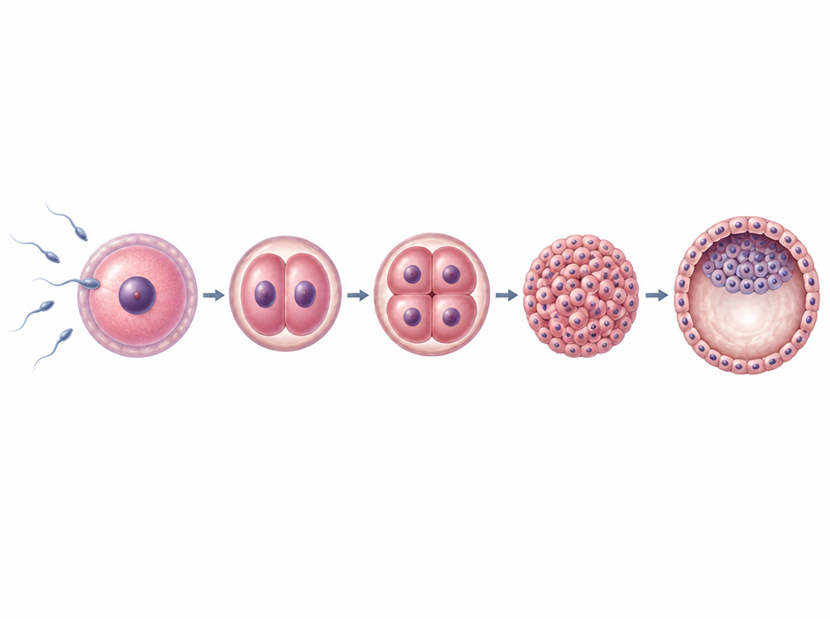

Name: __________________________________ Class: __________________
Section 1: Human Reproductive Systems
The human reproductive system consists of specialised organs that produce gametes and support development. In males, sperm are produced in the testes and transported via the sperm duct and urethra. In females, ova are released from the ovaries into the oviducts, where fertilisation occurs, before moving to the uterus.
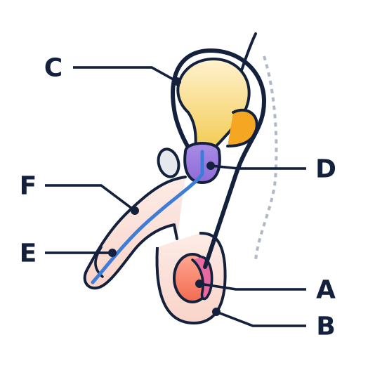 |  | 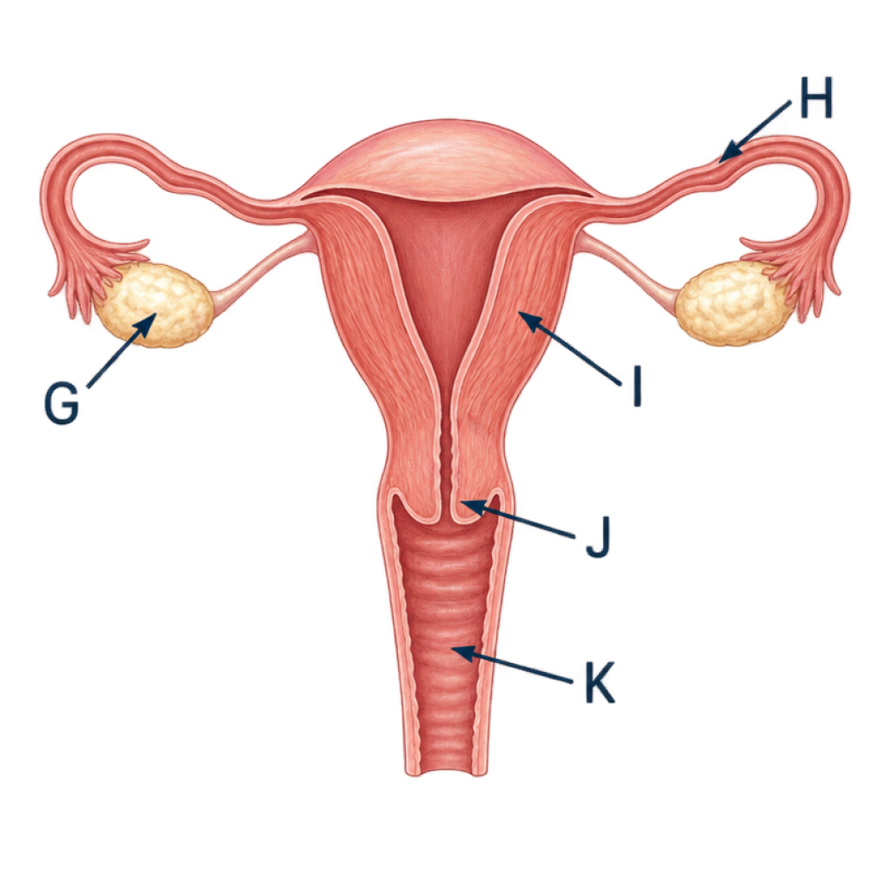

Core | 1. Identify the anatomical structures labelled on the diagrams. Write the letter matching each structure in the space provided.
Organ | Letter | Organ | Letter
Testis |  | Ovary
Scrotum |  | Oviduct
Sperm duct |  | Uterus
Prostate gland |  | Cervix
Urethra |  | Vagina
Penis

Core | 2. Complete the table below by stating the primary function for each named organ.
Word bank: carries urine and semen out of body • produces fluid to nourish sperm • site of fertilisation • holds testes outside body at lower temperature • where embryo implants and develops

Reproductive Organ | Primary Function
Scrotum
Prostate gland
Oviduct
Uterus
Urethra (male)

Section 2: Gametes and Fertilisation
Gametes are specialised sex cells adapted for reproduction. Fertilisation occurs when the nucleus of a male gamete (sperm) fuses with the nucleus of a female gamete (egg cell) to form a single diploid cell called a zygote.
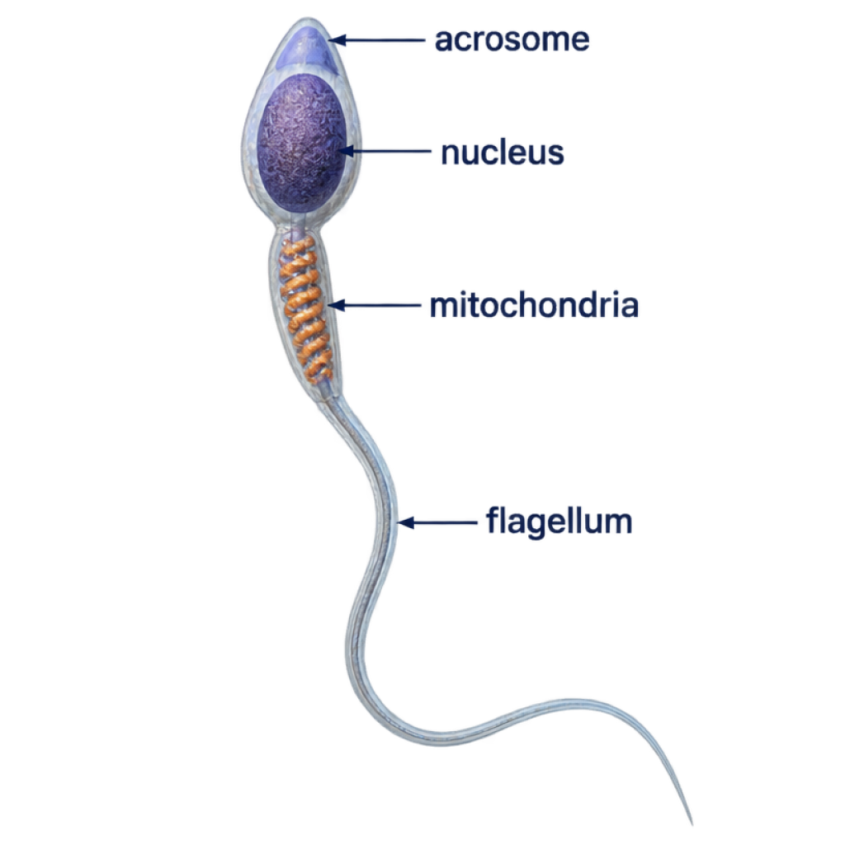 |  | 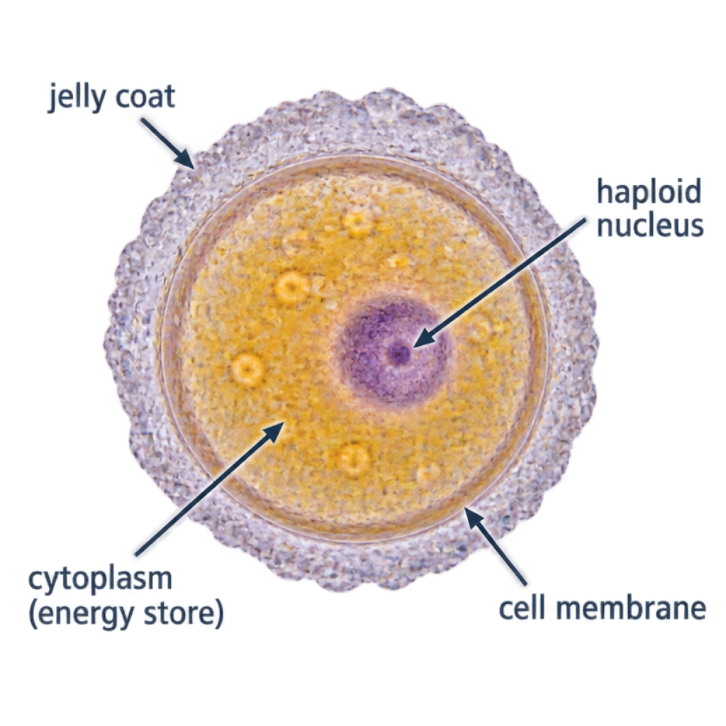

Core | 1. Compare the male gamete (sperm) and female gamete (egg cell) by completing the comparative table.
Feature | Male Gamete (Sperm) | Female Gamete (Egg Cell)
Relative size
Motility
Numbers produced
Energy stores

Core | 2. Answer the following structured questions on gamete adaptations and fertilisation.
a) State the definition of fertilisation.

b) Explain the role of the acrosome in enabling a sperm cell to reach the egg cell nucleus.

c) Explain why sperm cells contain a large number of mitochondria in their midpiece.

d) Describe what happens to the jelly coat of the egg cell immediately following the entry of a single sperm nucleus, and explain why this change is essential.

Section 3: Fetal Development and the Placenta
Following fertilisation, the zygote divides repeatedly by mitosis to form an embryo (a hollow ball of cells). This ball of cells travels into the uterus and implants into the thickened uterine lining, where specialised organs develop to sustain the growing fetus.
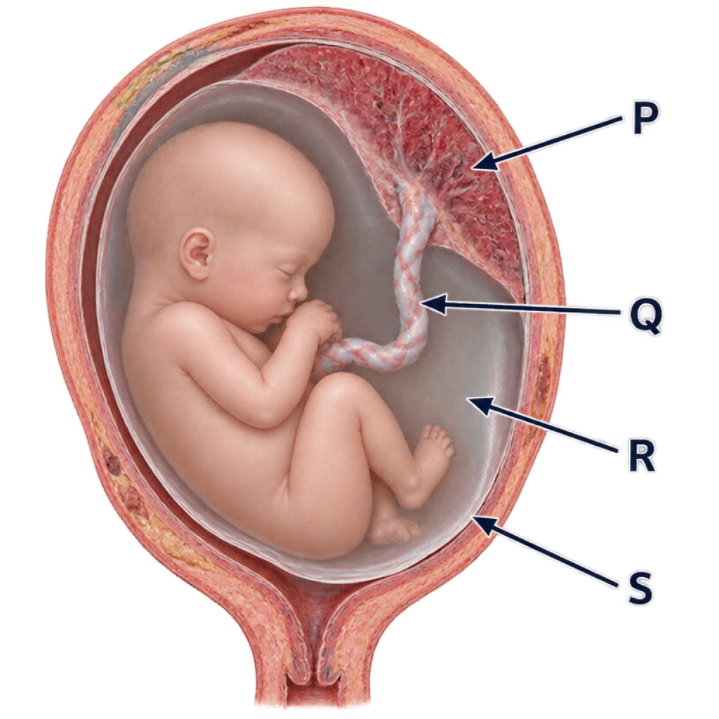 |  | Core | 1. The diagram on the left shows a developing fetus in the uterus.  a) Identify structures P, Q, R, and S:  - P: ________________________________________  - Q: ________________________________________  - R: ________________________________________  - S: ________________________________________  b) State the protective function of the amniotic fluid during pregnancy.

Extended | 2. The placenta and umbilical cord allow the exchange of dissolved substances between maternal blood and fetal blood without direct mixing.
a) Complete the table by classifying the following substances into those transferred from mother to fetus, and those transferred from fetus to mother: glucose, carbon dioxide, amino acids, urea, oxygen.
Substances Moving from Mother to Fetus | Substances Moving from Fetus to Mother

b) State why maternal blood and fetal blood do not mix directly inside the placenta.

c) Name one harmful pathogen or toxin that can cross the placenta, and describe its effect on the developing fetus.

