Name: ​ ​ Date: ​
​
IGCSE Biology Revision Guide: Sexual Reproduction in Humans
​

📢​ | Syllabus coverage: Sections marked [CORE] cover the Core syllabus. Section [EXTENDED / SUPPLEMENT] covers the Supplement syllabus.
​
1. Reproductive Systems [CORE]
​

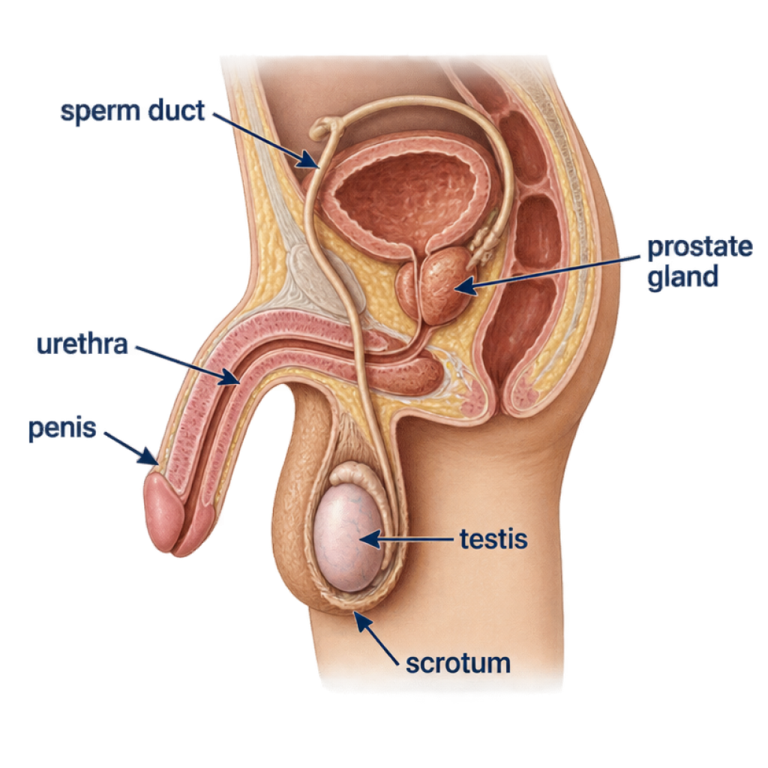 | Male Reproductive Organs & Functions:  ​
  Organ | Function
  Testes | Produce sperm cells and secrete the hormone testosterone.
  Scrotum | Sac of skin holding the testes outside the body cavity to keep them at an optimum temperature (slightly cooler than core body temperature) for sperm production.
  Sperm ducts | Muscular tubes that carry sperm from the testes towards the urethra.
  Prostate gland | Secretes a nutritive fluid that mixes with sperm to form semen.
  Urethra | Tube carrying semen (and urine, at separate times) through the penis to the outside.
  Penis | Organ that introduces semen into the vagina during sexual intercourse.

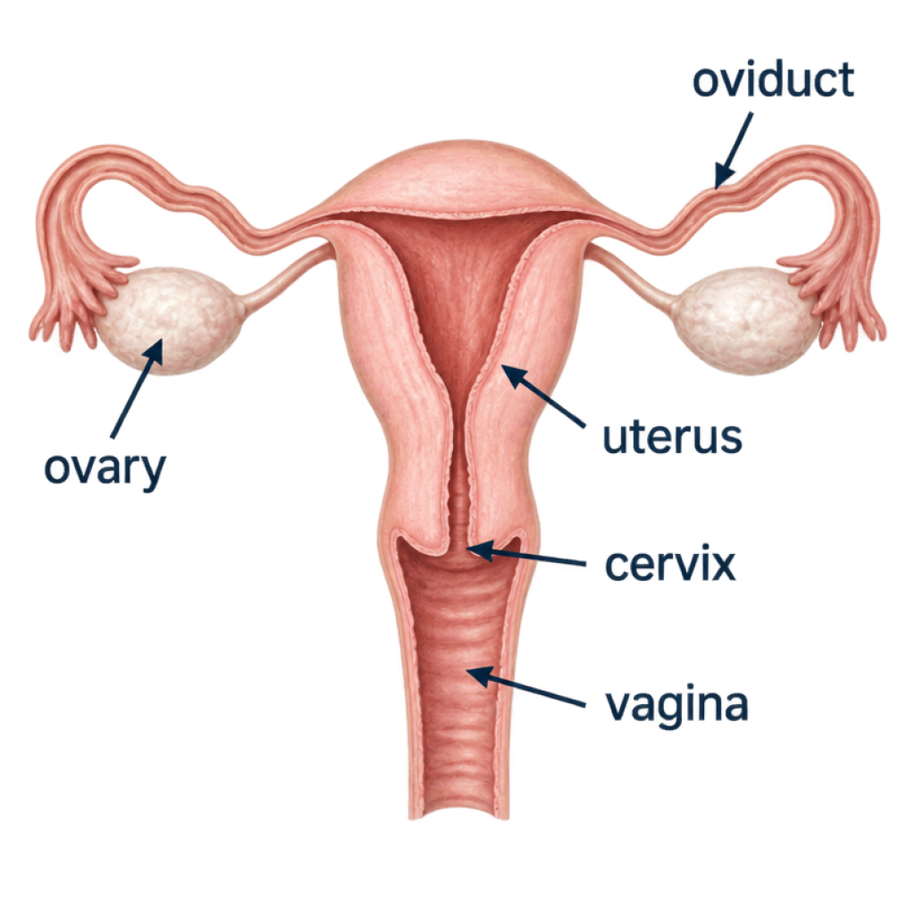 | Female Reproductive Organs & Functions:  ​
  Organ | Function
  Ovaries | Produce and release mature egg cells (ova) and secrete oestrogen and progesterone.
  Oviducts (Fallopian tubes) | Ciliated tubes linking ovaries to the uterus; site of fertilisation.
  Uterus (womb) | Muscular organ with a soft lining where the embryo implants and the fetus develops.
  Cervix | Ring of muscle at the lower neck of the uterus that holds the fetus in place during pregnancy.
  Vagina | Muscular canal leading to the outside; receives penis during intercourse and serves as the birth canal.
​
2. Gametes, Adaptations, and Fertilisation [CORE]
​

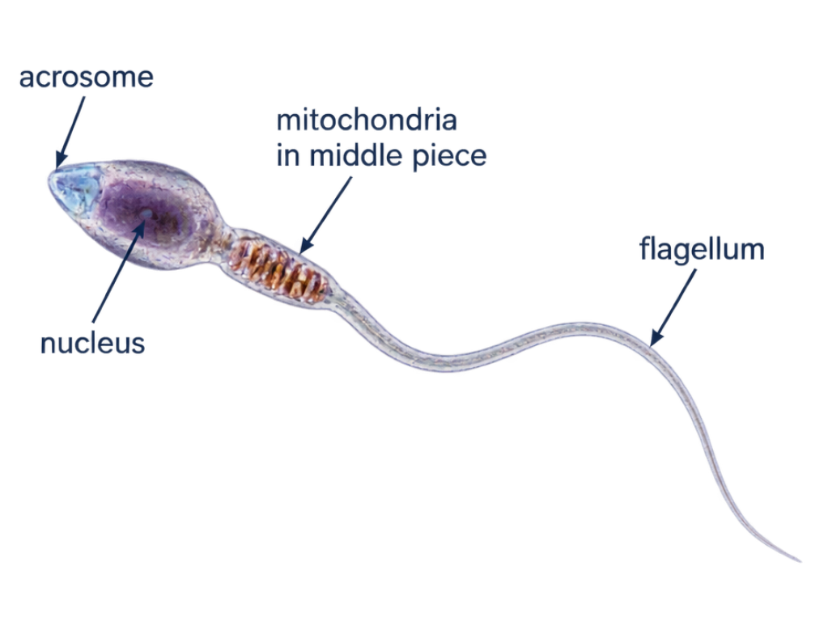 | 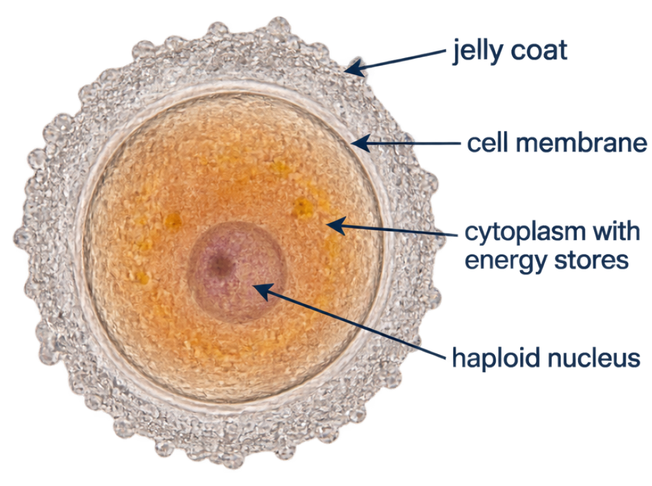

  Adaptive Features of Sperm:
  ​
  - Flagellum (tail): Whips back and forth to propel the sperm forward through fluid towards the egg.
  - Mitochondria: Concentrated in the midpiece to release energy via aerobic respiration for swimming.
  - Acrosome enzymes: Located in the tip of the head; break down the protective jelly coat of the egg to allow entry.
  Adaptive Features of Egg Cells:
  ​
  - Energy stores in cytoplasm: Provide essential nutrients to sustain the zygote and early dividing embryo before implantation.
  - Jelly coat (zona pellucida): Protective layer that hardens immediately after one sperm penetrates, preventing polyspermy (entry of additional sperm).
​

📢​ | Fertilisation [CORE]: The fusion of the nuclei of a male gamete (sperm) and a female gamete (egg cell) to form a single diploid zygote.
​
Gamete Comparison Summary [CORE]:
​

Feature | Male Gamete (Sperm) | Female Gamete (Egg / Ovum)
Size | Very small (approximately 0.05 mm long) | Very large (approximately 0.1 mm diameter; visible to naked eye)
Structure | Head with acrosome and nucleus, midpiece packed with mitochondria, long flagellum | Spherical cell containing large nutrient-rich cytoplasm, nucleus, and outer jelly coat
Motility | Highly motile; swims using flagellum | Non-motile; moved along the oviduct by ciliated cells and peristaltic contractions
Numbers | Produced continuously in huge numbers (millions per ejaculate) | Released usually one per menstrual cycle (roughly 400 throughout lifetime)
​

​

​

​

3. Early Development and Pregnancy [CORE]
​

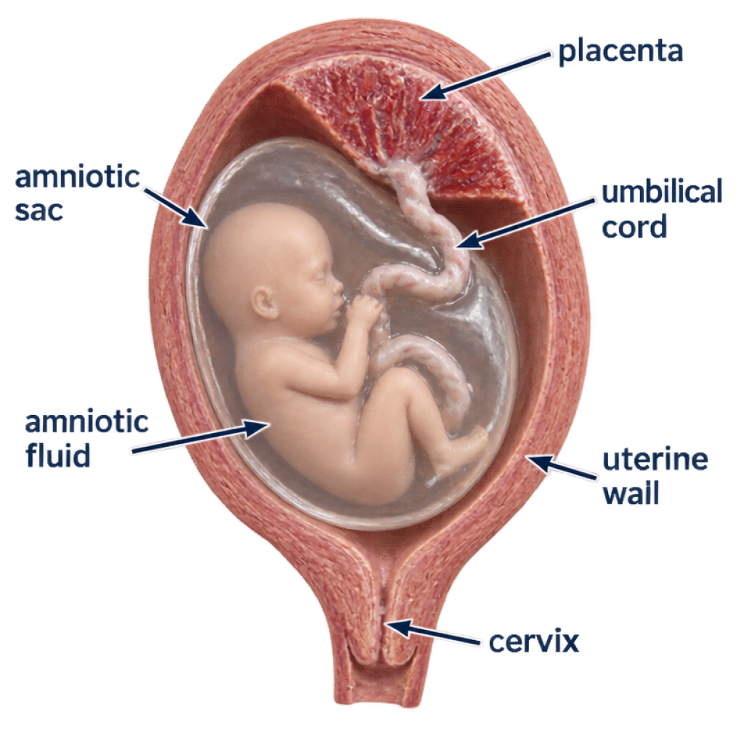 | From Zygote to Embryo:  ​  After fertilisation in the oviduct, the diploid zygote divides repeatedly as it travels towards the uterus. It forms an embryo, a ball of cells that implants into the lining of the uterus and continues to develop.  ​  Fetal Support Structures & Functions:  ​  - Amniotic sac: A tough, transparent membrane enclosing the developing embryo/fetus.  - Amniotic fluid: Liquid inside the amniotic sac that cushions and protects the fetus from physical shock, mechanical damage, and sudden temperature fluctuations.  - Placenta: Disc-shaped temporary organ embedded in the uterine wall providing a barrier and exchange surface between maternal and fetal blood.  - Umbilical cord: Connects the fetus to the placenta, carrying fetal blood vessels.
​

​

​

​

​

​

​

​

​

​

​

​

4. Placental Exchange and Fetal Health [EXTENDED / SUPPLEMENT]
​

  Placental Exchange Mechanics [EXTENDED]:
  ​
  Maternal blood and fetal blood do not mix directly. Dissolved substances cross the placenta between the two blood supplies.
  ​
  - From Mother to Fetus (via umbilical vein):
  - Oxygen (for cellular respiration)
  - Dissolved nutrients: glucose, amino acids, fatty acids, vitamins, mineral ions
  - Water and maternal antibodies (providing passive immunity)
  - From Fetus to Mother (via umbilical arteries):
  - Carbon dioxide (waste gas of respiration)
  - Urea (metabolic excretory waste)
  Transfer of Harmful Substances [EXTENDED]:
  ​
  Although the placenta acts as an effective selective barrier for many substances, some pathogens and toxins can diffuse across the placenta from the mother's blood to the fetus:
  ​
  - Pathogens: Certain viruses (e.g. rubella virus, HIV) and bacteria can cross the placenta, causing developmental defects, congenital infections, or miscarriage.
  - Toxins and Drugs: Nicotine, carbon monoxide (from cigarette smoke), alcohol, and certain prescription or illicit drugs cross the placental barrier.
  - Effects: Reduced oxygen transport (carbon monoxide binds irreversibly to maternal haemoglobin), low birth weight, premature birth, and developmental disorders (such as fetal alcohol syndrome).
​
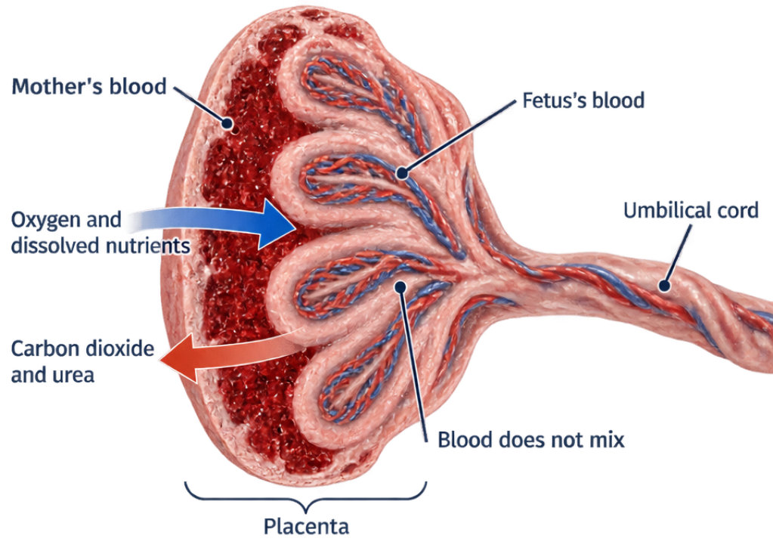

📢​ | Quick Revision Checklist: Identify the named reproductive organs and fetal support structures on diagrams, and revise their functions. Compare sperm and egg cells, explain fertilisation and their adaptations, and describe early development. For the Extended / Supplement syllabus, explain placental exchange and state that some pathogens and toxins can cross the placenta and affect the fetus.

