**Normalized data from littermates:**

> lm<-read.table("littermates.txt",header=T)

> lm

litter mut ctl

1 1 0.16884 0.24318

2 2 0.48621 0.54004

3 3 0.20224 0.30089

4 4 0.29179 0.37839

5 5 0.30845 0.40304

6 6 0.14509 0.18740

7 7 0.16128 0.29518

8 8 0.17617 0.25835

9 9 0.39746 0.46366

10 10 0.36536 0.50916

11 11 0.26722 0.40981

> attach(lm)

> names(lm)

[1] "litter" "mut" "ctl"

*# look at the data:*

> plot(lm)

> plot(mut~ctl)

> plot(mut~ctl, ylim=c(0,0.6), xlim=c(0,0.6))

> abline(0,1,lty=2)

*# abline adds a line at the specified intercepts and slope, can control line type (lty), color (col), etc.*

> var.test(mut,ctl)

F test to compare two variances

data: mut and ctl

F = 0.9515, num df = 10, denom df = 10, p-value = 0.939

alternative hypothesis: true ratio of variances is not equal to 1

95 percent confidence interval:

0.256012 3.536689

sample estimates:

ratio of variances

0.9515434

> shapiro.test(mut)

Shapiro-Wilk normality test

data: mut

W = 0.9184, p-value = 0.3052

> shapiro.test(ctl)

Shapiro-Wilk normality test

data: ctl

W = 0.9619, p-value = 0.7952

*# R will perform simple math functions on your data:*

> ctl-mut

[1] 0.07434 0.05383 0.09865 0.08660 0.09459 0.04231 0.13390 0.08218 0.06620 0.14380 0.14259

*# and perform tests on mathematical expressions from your data:*

> shapiro.test(ctl-mut)

Shapiro-Wilk normality test

data: ctl - mut

W = 0.929, p-value = 0.4013

> t.test(mut,ctl,paired=T)

Paired t-test

data: mut and ctl

t = -8.842, df = 10, p-value = 4.851e-06

alternative hypothesis: true difference in means is not equal to 0

95 percent confidence interval:

-0.11597910 -0.06929181

sample estimates:

mean of the differences

-0.09263545

> t.test(mut,ctl,paired=F)

Welch Two Sample t-test

data: mut and ctl

t = -1.9181, df = 19.988, p-value = 0.0695

alternative hypothesis: true difference in means is not equal to 0

95 percent confidence interval:

-0.19338165 0.00811074

sample estimates:

mean of x mean of y

0.2700100 0.3626455

*# Choice of test matters ; fitting the data structure allows a more powerful test!*

**Non-parametric tests for Adamts13 expression from RT-qPCR data**

*# B6 congenic data:*

> ad13b<-read.table("adamts_B6.txt",header=T)

> attach(ad13b)

> names(ad13b)

[1] "id" "nxf1" "raw" "normal" "cohort"

> shapiro.test(normal[1:6])

Shapiro-Wilk normality test

data: normal[1:6]

W = 0.6223, p-value = 0.0008452

> shapiro.test(normal[7:12])

Shapiro-Wilk normality test

data: normal[7:12]

W = 0.8574, p-value = 0.1805

> wilcox.test(normal[1:6],normal[7:12],paired=F,alternative="less")

Wilcoxon rank sum test

data: normal[1:6] and normal[7:12]

W = 6, p-value = 0.03247

alternative hypothesis: true location shift is less than 0

> plot(normal~nxf1)

> points(normal~nxf1,col="darkgreen")

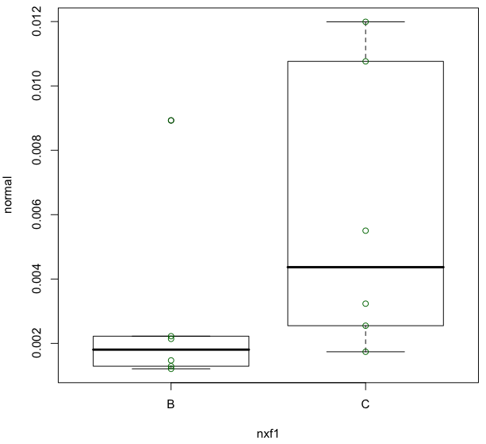

*# B6 x BALB/c F2 data:*

> ad13f2<-read.table("adamts_balbF2.txt",header=T)

> attach(ad13f2)

> names(ad13f2)

[1] "id.f2" "nxf1.f2" "raw.f2" "normal.f2" "cohort.f2"

> shapiro.test(normal.f2[1:18])

Shapiro-Wilk normality test

data: normal.f2[1:18]

W = 0.7064, p-value = 9.493e-05

> shapiro.test(normal.f2[19:30])

Shapiro-Wilk normality test

data: normal.f2[19:30]

W = 0.6201, p-value = 0.0001587

> wilcox.test(normal.f2[1:18],normal.f2[19:30],paired=F,alternative="less")

Wilcoxon rank sum test

data: normal.f2[1:18] and normal.f2[19:30]

W = 32, p-value = 0.0003972

alternative hypothesis: true location shift is less than 0

> plot(normal.f2~nxf1.f2)

> points(normal.f2~nxf1.f2, col="slateblue")

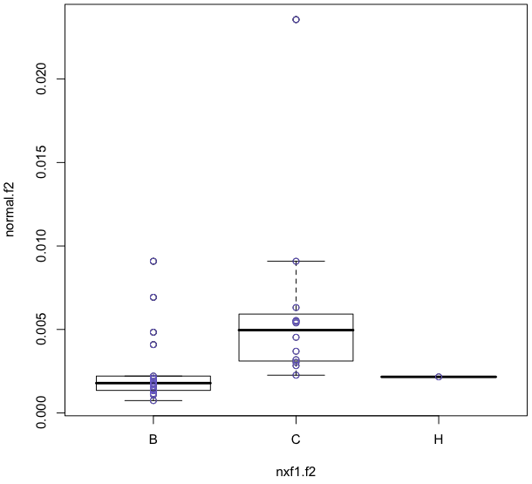

***# Combined normalized data:***

> grpB<-c(normal.f2[1:18],normal[1:6])

> grpC<-c(normal.f2[19:30],normal[7:12])

> wilcox.test(grpB,grpC,paired=F,alternative="less")

Wilcoxon rank sum test

data: grpB and grpC

W = 68, p-value = 4.013e-05

alternative hypothesis: true location shift is less than 0

> boxplot(grpB, grpC)

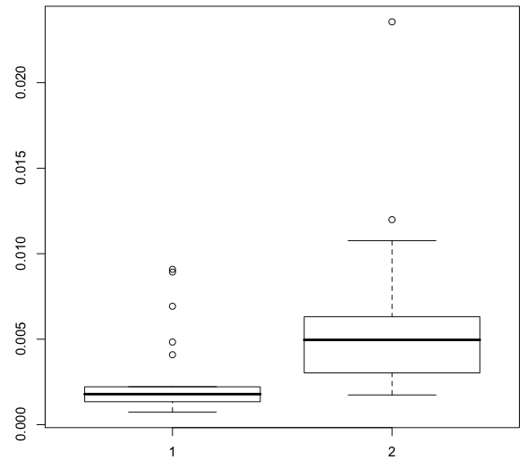

**Non-parametric tests with multiple groups:**

**Luciferase assays for intron 5 variations and deletions**

> luc<-read.table("luciferase_tests.txt",header=T)

> attach(luc)

> luc

ywc_slide ywc_number pGL4 rep Luciferase Renilla ratio nratio

1 17 1 aTAL 1 34788460 9751714 3.567420 1.0028522

2 17 1 aTAL 1 31939306 9429163 3.387290 0.9522150

3 17 1 aTAL 1 45803328 12322288 3.717112 1.0449328

4 17 2 i220_381 1 256638832 5781345 44.390852 12.4788961

…

> kruskal.test(nratio~pGL4)

Kruskal-Wallis rank sum test

data: nratio by pGL4

Kruskal-Wallis chi-squared = 88.405, df = 10, p-value = 1.109e-14