BNFO 262 / BIOM 262 / BGGN237 Winter 2026
Homework 2: RNA-seq and scRNA-seq

Name: your_name_here
PID: your_PID_here

Instructions
Answer the following questions in your own words and upload a PDF of your answers to Gradescope. This assignment is due on Thursday, 02/12/2026 at 9:00AM.

If you want to use a Jupyter notebook for answers, see this document for instructions on creating a Jupyter notebook:
https://docs.google.com/document/d/15Ux16sVp9EsBU_tJiqCMJnrqqjuBor5s/edit?usp=sharing&ouid=102134196267797631717&rtpof=true&sd=true

Part 0: (2 Points) Please make sure you select the correct pages for your answer to each question on Gradescope. You will get full points if you assign the pages correctly for all questions.

Part 1: RNA-seq (12 Points)
Q1 (4 points): For the following main steps of a full differential expression RNA-seq analysis, explain the purpose of what is done computationally and give an example of a tool you would use (if relevant). Limit 3 sentences for each step.
- QC the FASTQ files
- Align the FASTQ files
- Sort and index the aligned reads
- QC the bam file
- Count reads for every gene
- Normalize the counts
- Perform differential expression analysis
- Visualize the results

Q2 (2 points): Before loading your data into DESeq2 to perform your differential expression analysis, do you need to normalize your count matrix? If not, why not?

Q3 (3 points): Given the gene expression table below with read counts for Rep1, Rep2, and Rep3, which two samples are the most similar to one another? Make sure to show your work and final TPM values. (Hint: Calculate TPMs and sum the absolute value of TPM differences between every pair of samples. You can also use a scale factor of 10 instead of 1 million)
Gene name | Rep 1 | Rep 2 | Rep 3
A (2kb) | 15 | 3 | 30
B (4kb) | 10 | 22 | 60
C (1kb) | 5 | 10 | 15
D (10kb) | 0 | 0 | 1

Q4 (3 points): Your collaborator sent you some processed mouse data they wanted you to analyze, but you forgot to include the sample annotations, so you don’t know what type of mice the samples are from. You do know that Gene_A and Gene_B are upregulated in the knockout (KO) mice compared to the wildtype (WT) mice. Based on the heatmap below, which samples do you think are from the WT and KO groups? Briefly explain your reasoning using the genes.
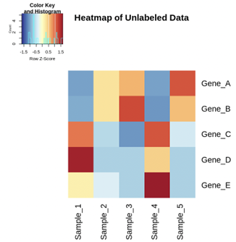

Part 2: single cell RNA-seq (9 Points)
Q1 (3 points): Describe the experimental differences between droplet-based methods and physical separation methods. Start by explaining each. Then discuss when it might be better to use one or the other. Limit 5 sentences.

Q2 (1 point): When analyzing scRNA-seq data, how do you know which cell a read comes from? Limit 5 sentences.

Q3 (3 points): When preprocessing scRNA-seq data, there are multiple metrics to perform QC on. Please list three QC metrics and explain what each control is for. Limit 5 sentences.

Q4 (2 points): Come up with an experiment in which you’d prefer to use scRNA-seq rather than RNA-seq. Justify why you believe this assay would be preferable for this experiment. Limit 5 sentences.

