**Question 1**

1. **In a few sentences, explain how the maximum moment is calculated**

The moment is calculated using the product of the muscle force and the moment arm. The torque due to the mass of the limb is then subtracted to get the maximum moment.

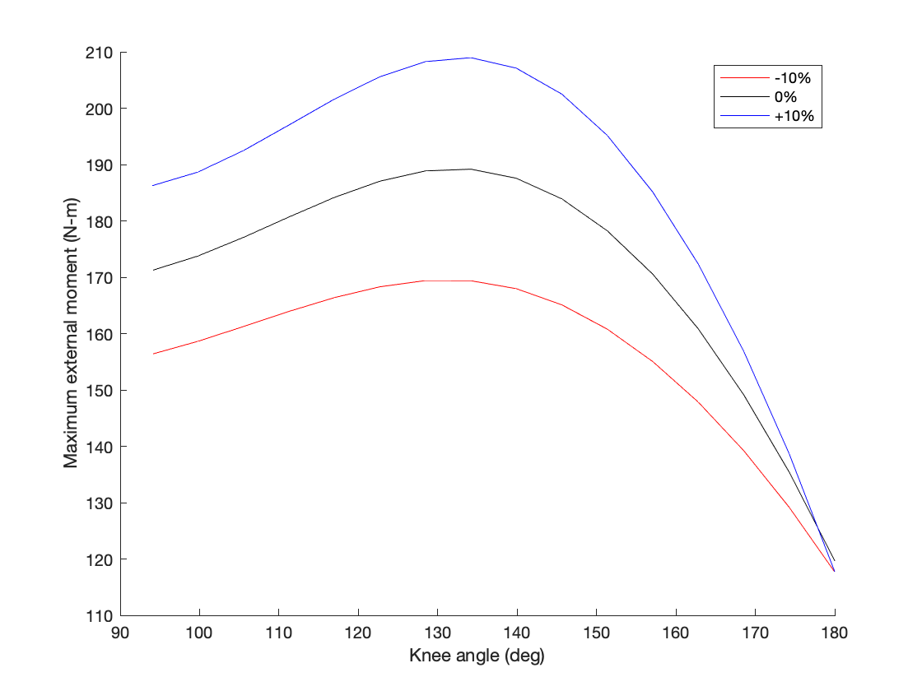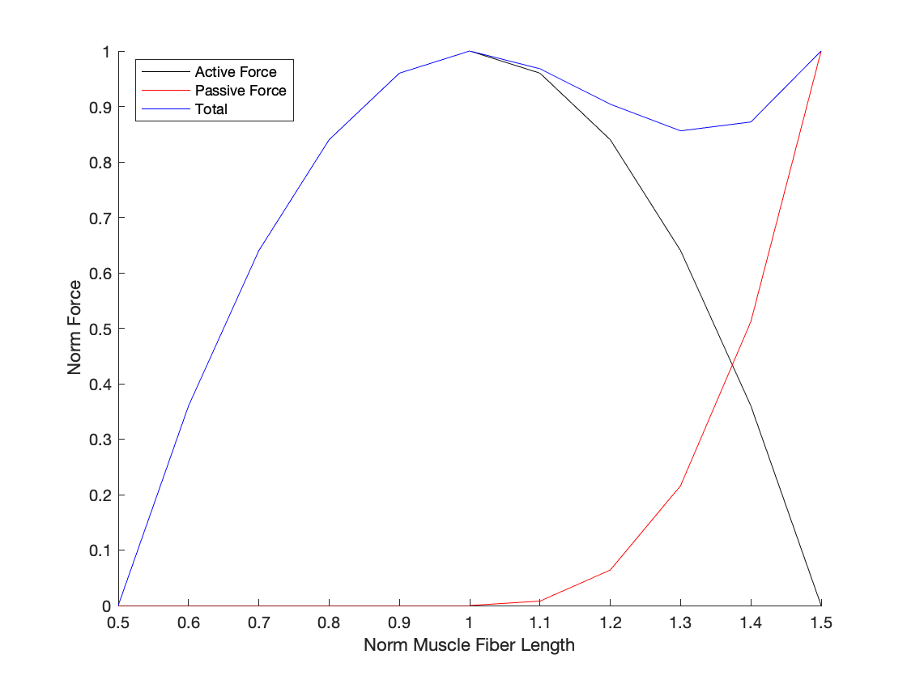

1. **Briefly explain what the curves represent.**

The curves represent the normalized muscle force as length increase. The parabolic curve is the active force as the length changes and the exponential increasing curve is the passive muscle force. This passive curve plays an important role in the total force once the muscle stretches beyond some optimal operating length.

1. **Suppose the extension moment was not quasi-static, that is, when force-velocity matters. What would you expect would happen to the maximum moment curve?**

Suppose the force-velocity relationship is one such that force decreases as velocity increases. In this situation I would expect for the total force to go down. This is true because now that force is also dependent on velocity that the muscle is moving at. As the velocity of motion will increase it will pull the force the muscle is able to generate down unlike the above curves where velocity plays no role.

1. **The model also does not include the effect of elastic tendon. What would (qualitatively) be expected to happen to the maximum moment vs. angle curve if elastic tendon were included? Explain in a sentence or two.**

If an elastic tendon was placed in parallel to the muscle, I would expect that there be a shift in the torque vs knee angle curve. The muscle would be operating at a different part of its force-length relationship as the tendon spring would absorb some of the stretch.

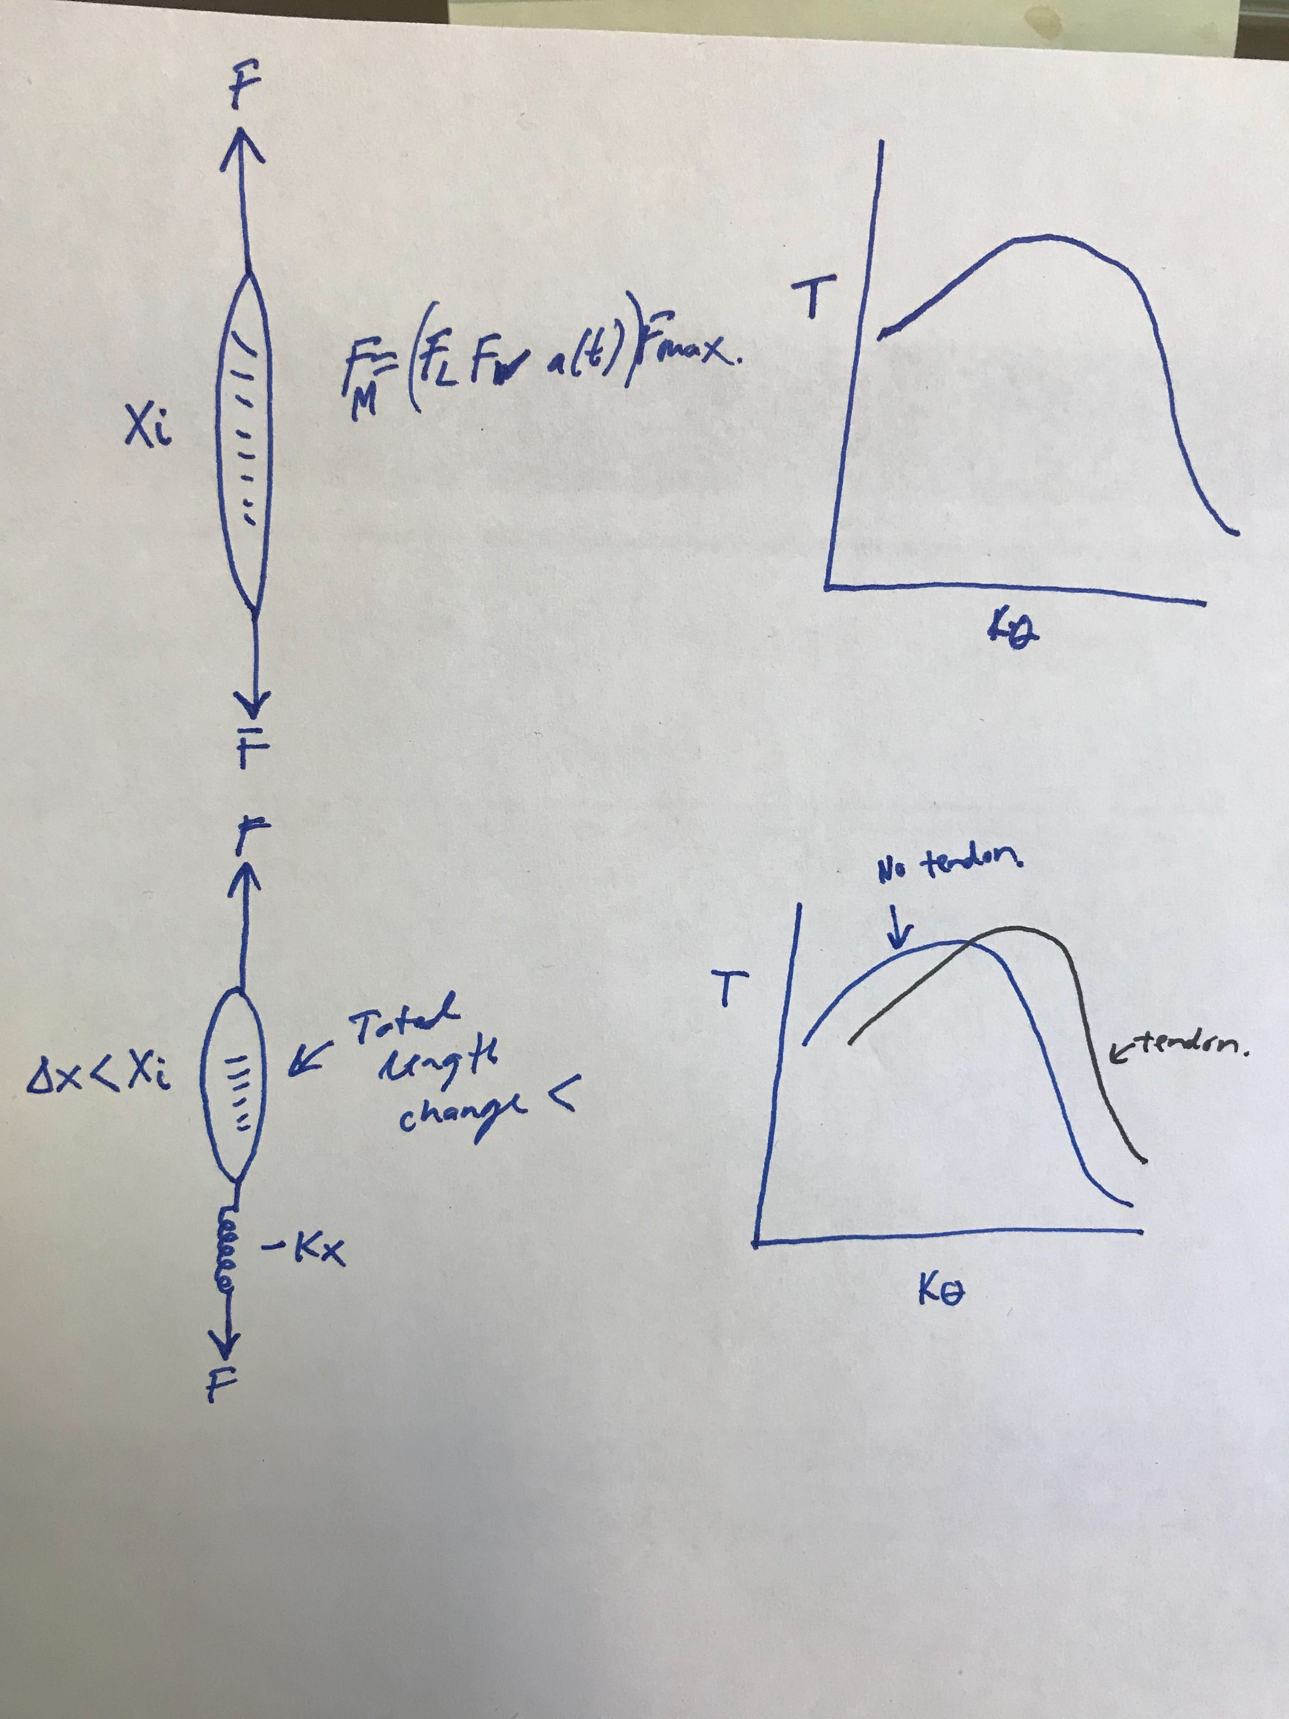

**Question 2**

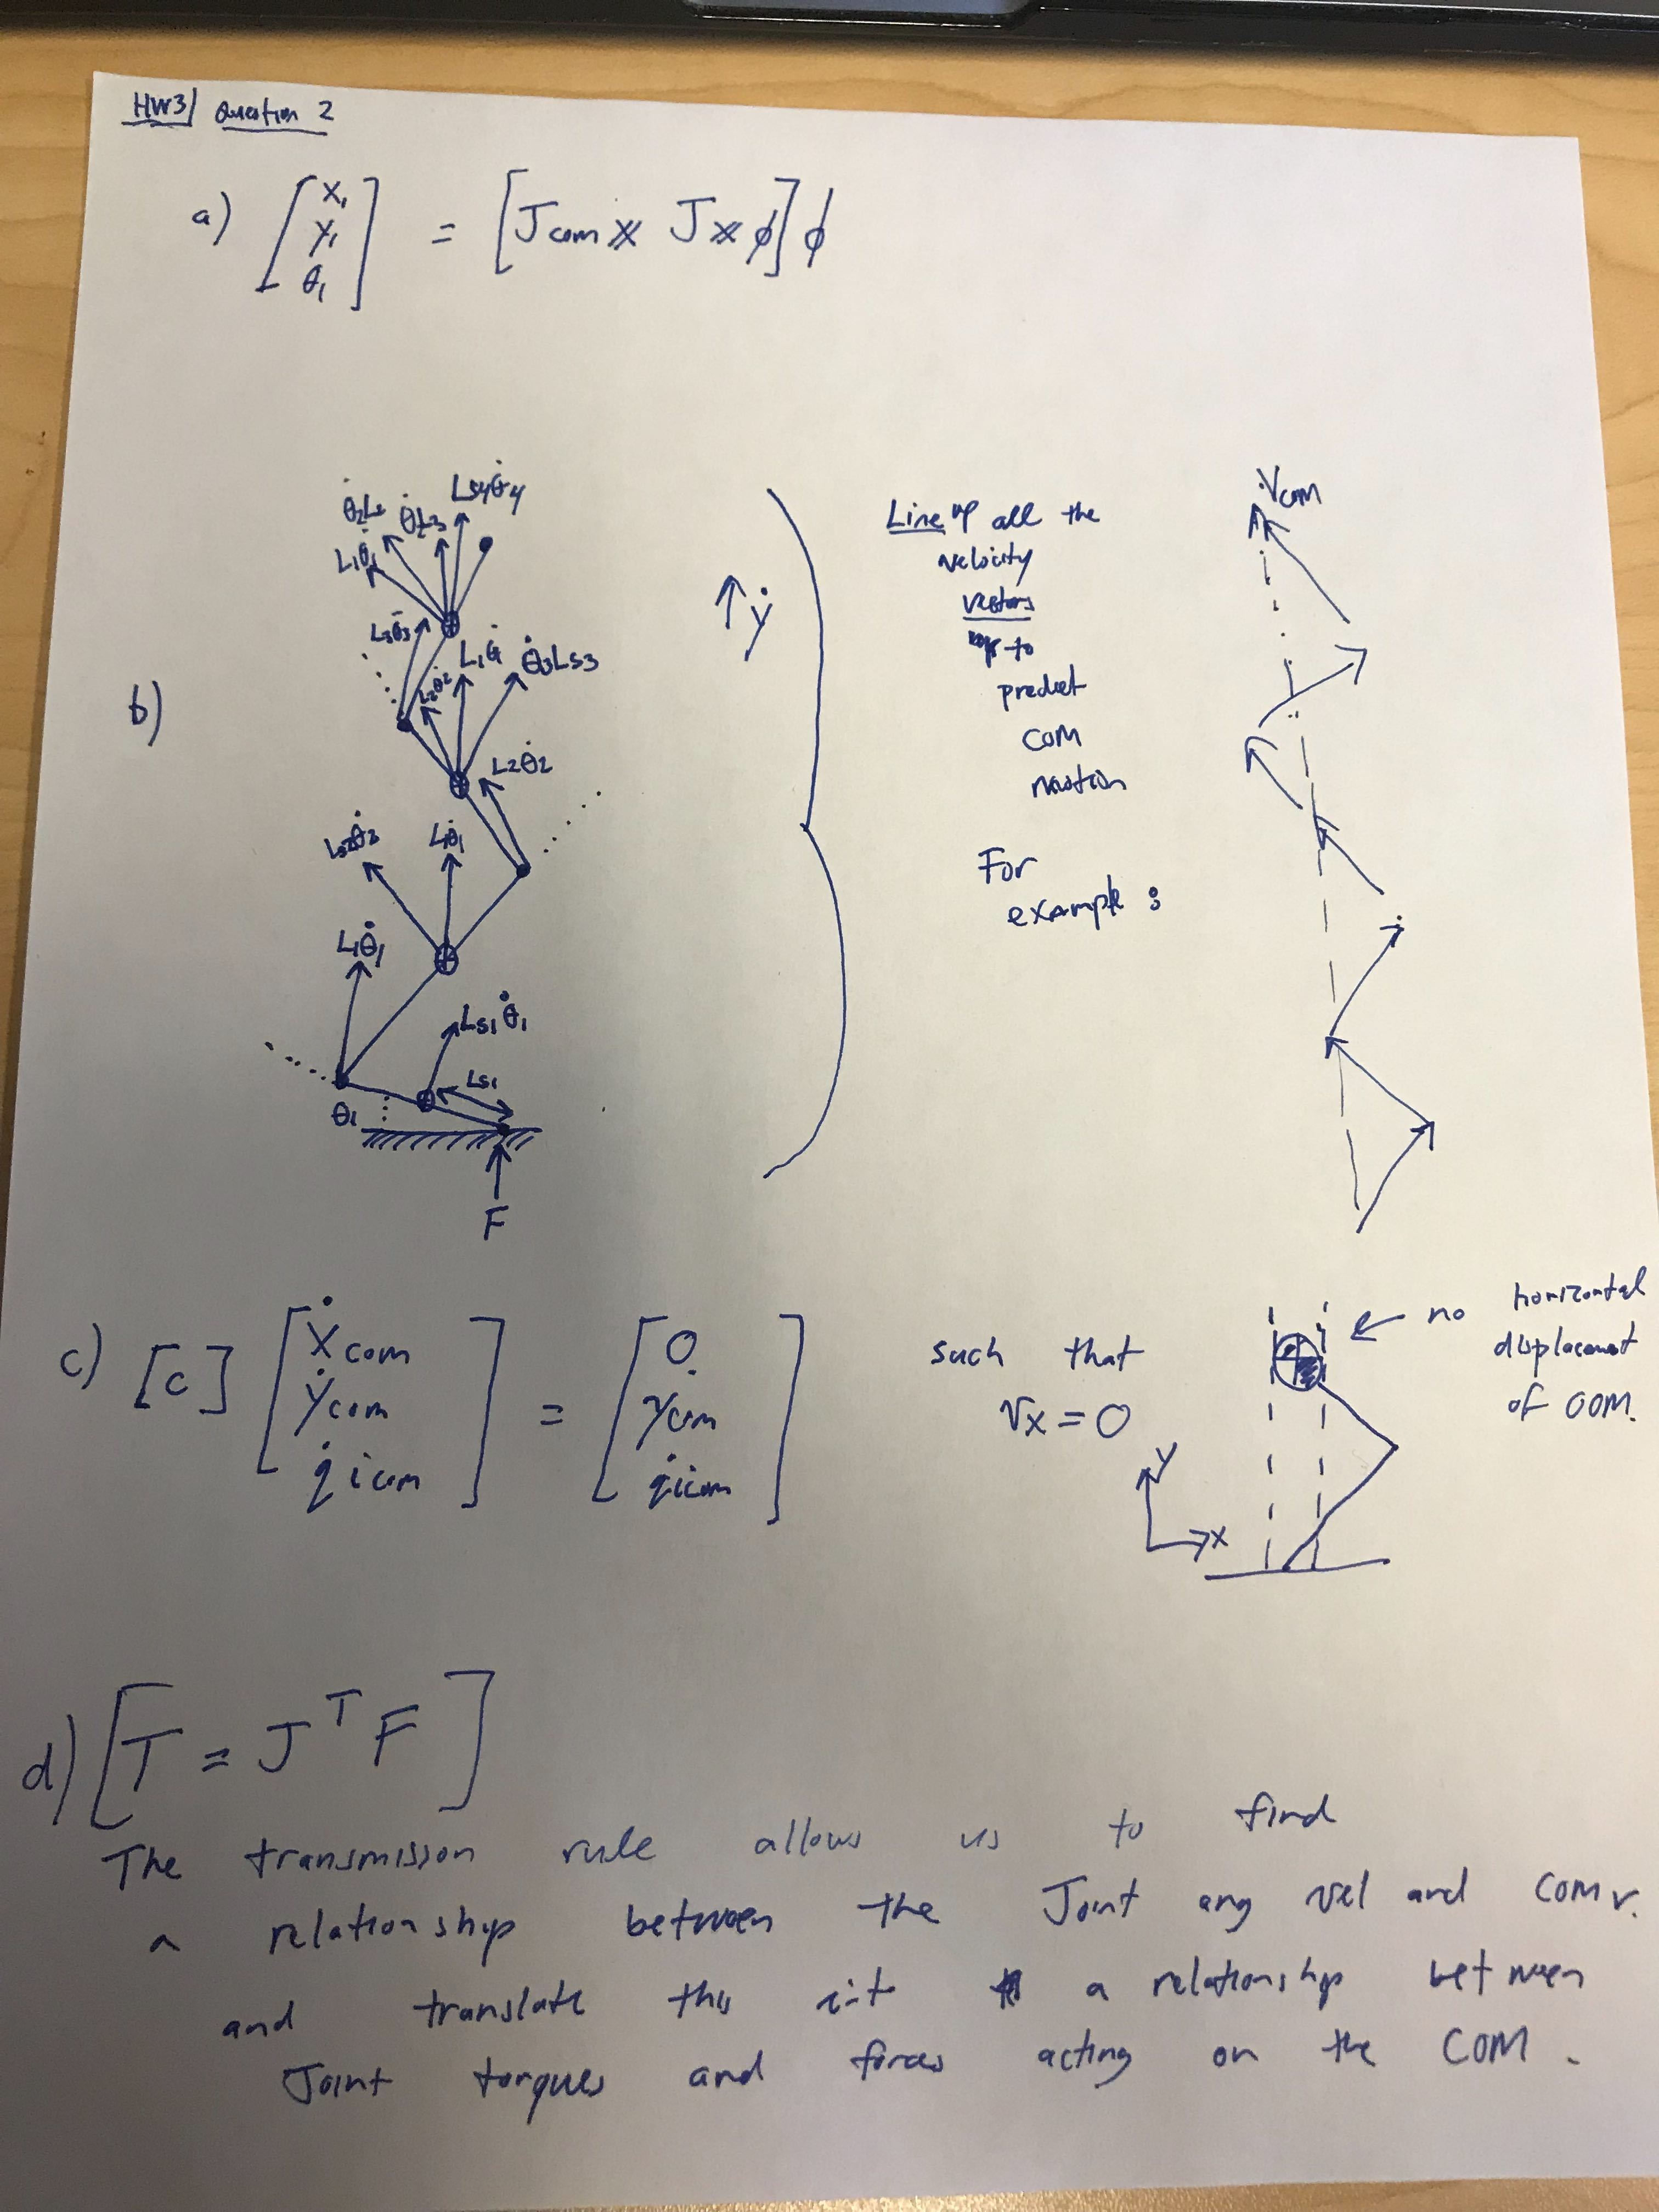

e) How the mass of each segment effects the COM velocity

f) How the angle of each segment effects the COM velocity

a ) Some additional thoughts for part a.

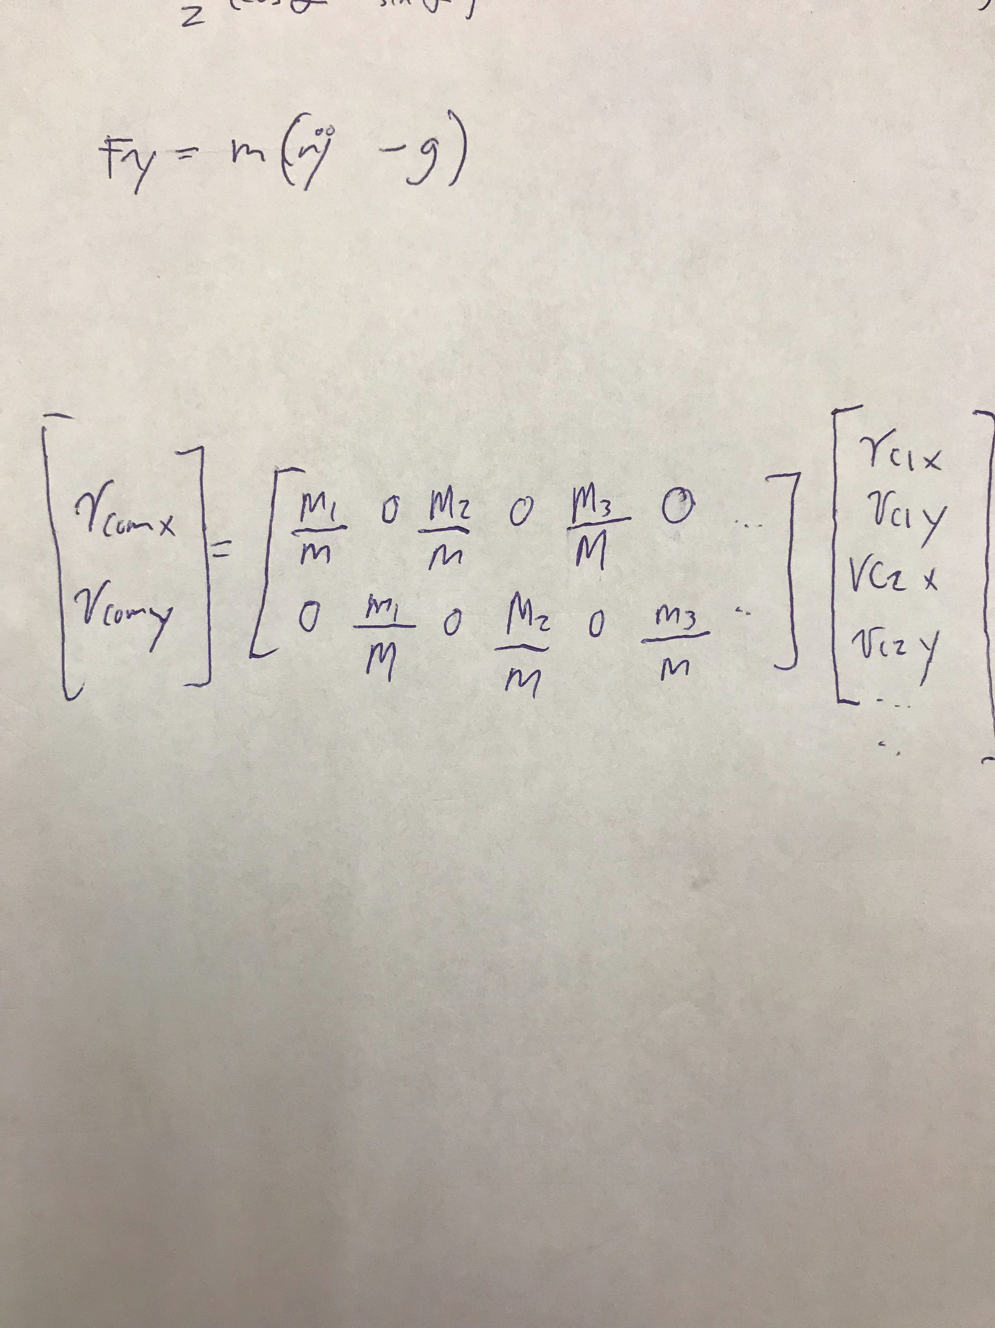

**Question 3**

Error = [(-SL-lfoot)-xtoe; 0 – ytoe];

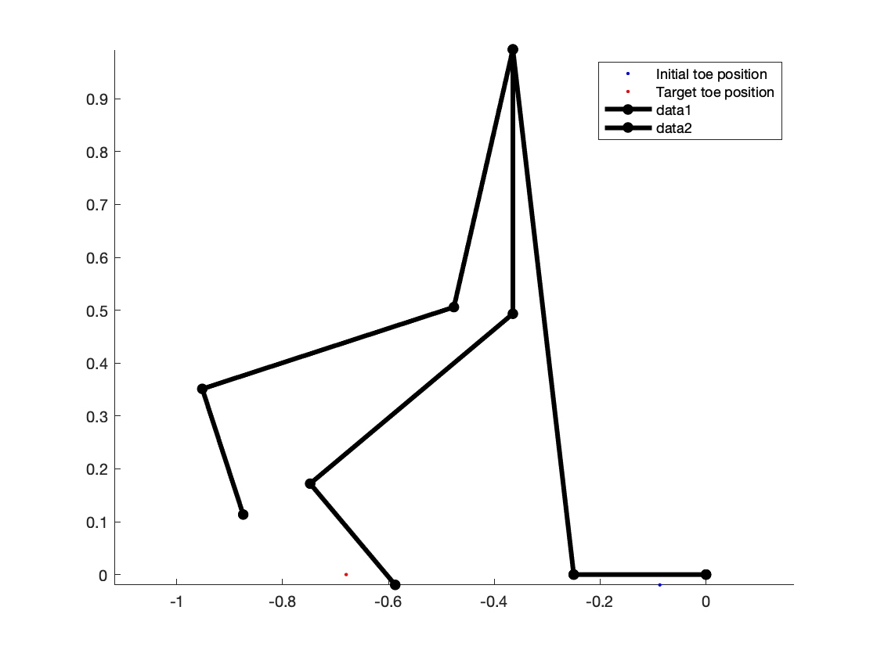

B) It is root finding to find all the initial conditions to take a full step. Since the problem is bound by right and left constraints we can use these constraints to setup our simulations to only converge on a solution that satisfies our constraints.

**Question 4**

1. The slope of the ramp versus the speed of the wheel is plotted. As the slope increases the speed increases in an almost linear way. There is a minimum slope that must be present such that enough gravitational energy is pulling the wheel to roll. Since there is a minimum amount of energy for the wheel to roll there therefore is a minimum speed at which it will roll, once the energy increases the speed will also increase.

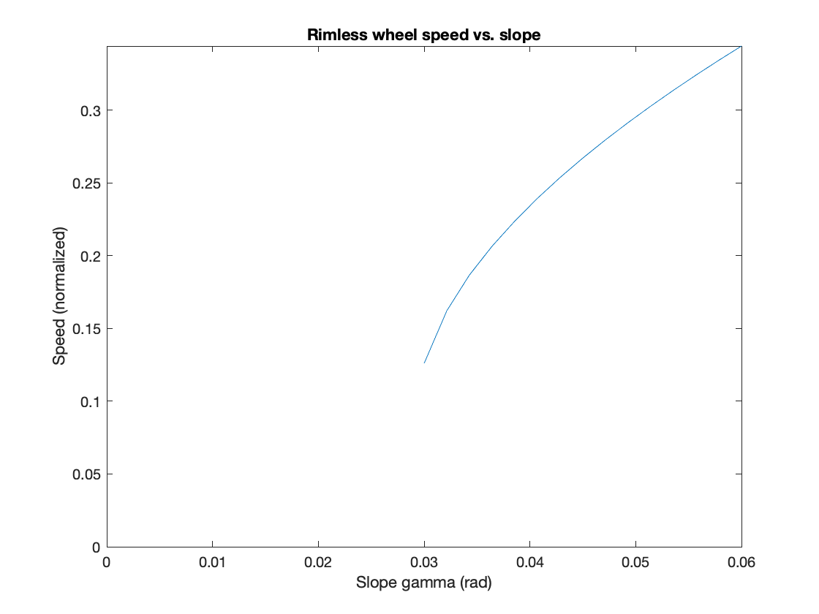

1. Plotted below is the speed of the rimless wheel as the interleg angle alpha angle changes. Three different gamma angles are also shown. What we learn from this simulation is that there appears to be a minimum alpha at around 1 degree and a maximum alpha at around 21 degrees. Outside of this region the simulations fail to yield period gait. The maximum alpha that yields a period gait is because once alpha gets too large the wheel will no longer be able to roll, it will require too much energy.
2. 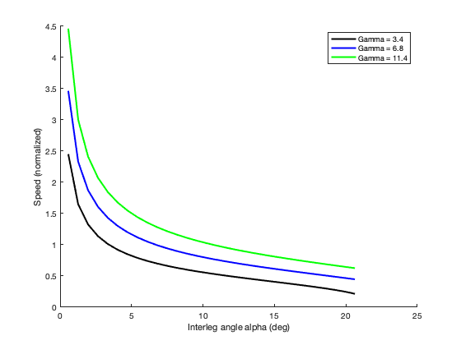

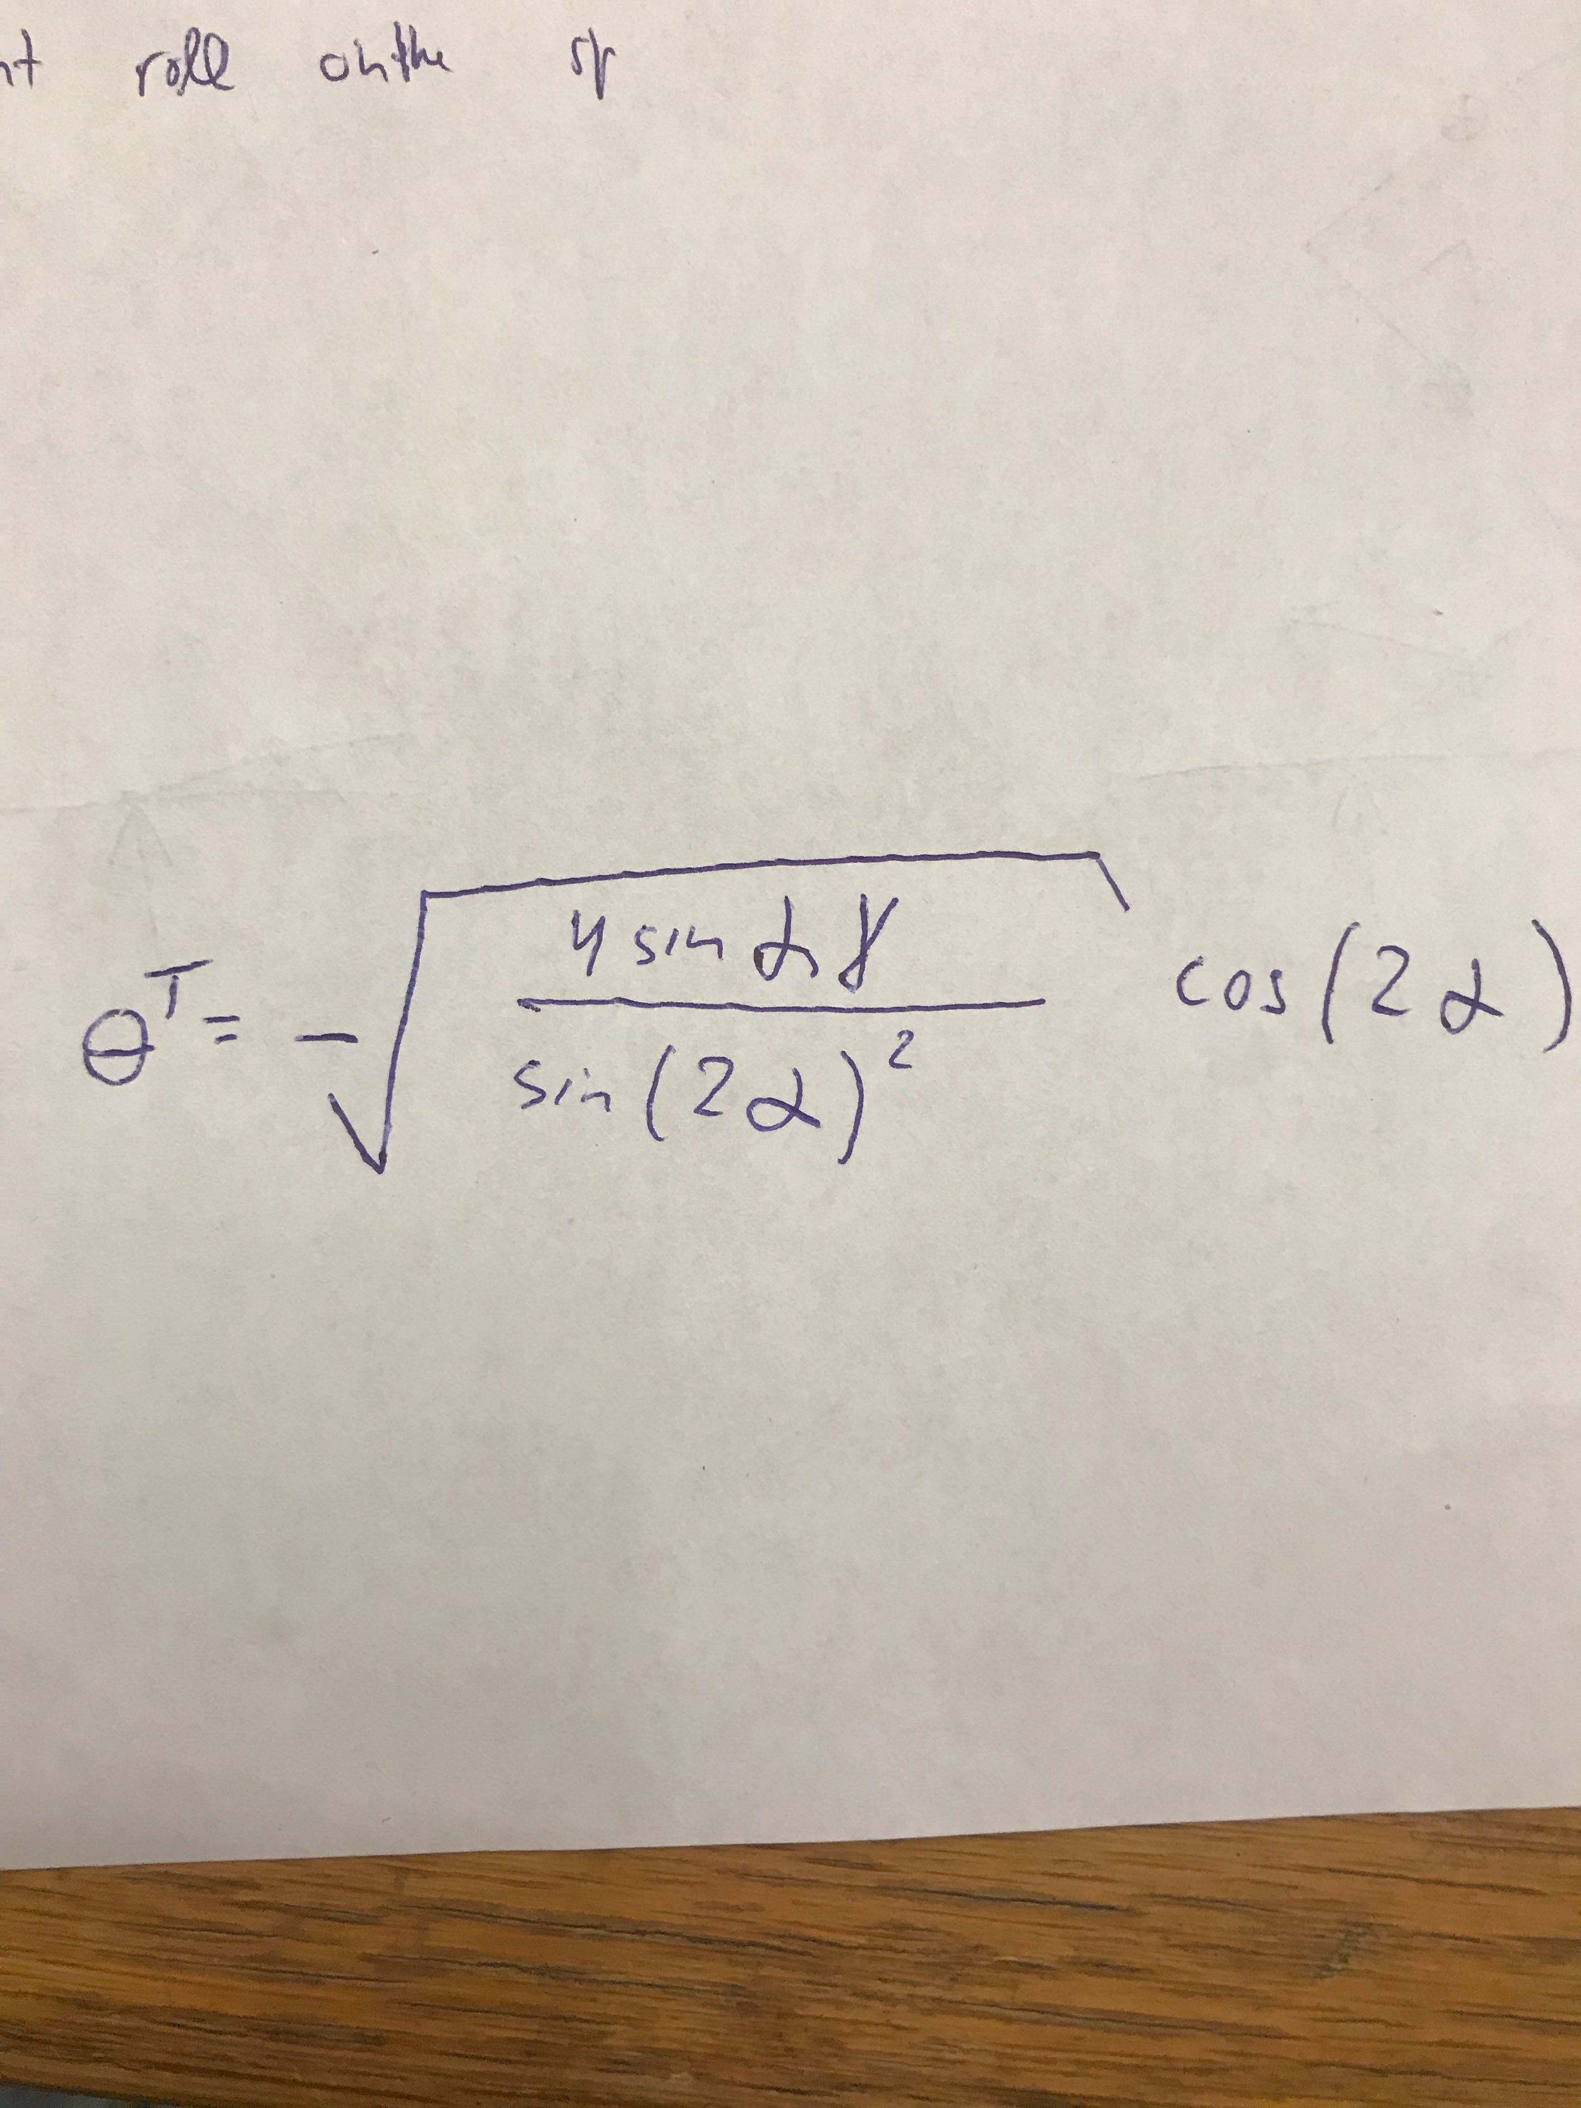

1. The case with many types of simulations is that a range of initial starting conditions will help to yield the most optimal solution to the differential equation. Many times, we do not know what the cost function landscape looks like, especially if there are many unknown parameters. Once an optimal solution is found and the parameters are varied by only small increments it is likely that the optimal parameters from the previous study will be a good guess. Since the optimal solution converged to a local (maybe global) optimum it is in this ‘basin of attraction’. The next guess with small changes to the parameters will likely also be in this basin and likely also converge.