The Journal of Obstetrics and Gynaecology Research
Manuscript Submission Check form

Title: Identification of novel genetic and epigenetic regulators of different tissue types of cervical cancer

Authors: Sanchita Chandra , Subham Sarkar, Paramita Mandal

Manuscript Number (if known):

Author(s) must read the statements below before manuscripts will be considered for publication in the Journal of Obstetrics and Gynaecology Research. All authors must agree of the term of this form and sign on. Manuscripts submitted without a signature(s) as required below will be returned immediately to the authors.
- Authorship Responsibility, Criteria and Contributions
By signing this form and checking the appropriate boxes, the Corresponding author certifies that they and any co-Contributors have met all criteria below and hereunder indicates each author’s general and specific contributions by listing his or her name next to the relevant section.

☑Please check the box
☑Author(s) carefully read and follow” instructions for author”, “JOGR document Specific Inappropriate Acts in the publication Process” to prepare this manuscript? Your manuscript does not violate the policy?
☑The manuscript represents valid and original work
☑The manuscript or portions thereof are not under consideration by another journal or electronic publication and have not been previously published except as an abstract
☑If requested Author(s) will provide raw data on which the manuscript is based for examination by the editors and reviewers
☑Author(s) agree to be responsible for indicating the source of extra-institutional funding, in particular that provided by commercial sources.
☑Author(s) require disclosing conflicts of interest or stating that they have no competing interests in the Conflict of Interest section within their manuscript.
☑Author(s) also agree to be responsible for obtaining internal review board approval of study, accuracy of the references and all statements made in the work
☑Author(s) have read and approved the final manuscript
☑Author(s)have made a substantive contribution to the information or material submitted for publication and take public responsibility

To qualify for authorship each author must have substantively contributed to a minimum of 1 task
in each of the following
Author’s name / signature
1. | Name /Signature   | 6.
2. | 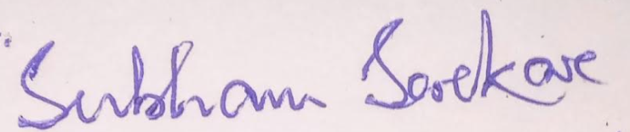 | 7.
3. | 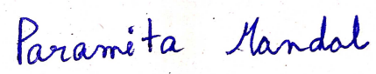 | 8.
4. |  | 9.
5. |  | 10.

Categories:
 | Conception and design | Acquisition of data | Analysis and Interpretation of data | Drafting of the manuscript | Critical revision of the manuscript for important intellectual content | Statistical analysis | Obtaining funding | Administrativetechnical or material support | Supervision
Authors
1. | SC | SC | SC | SC | SC | SC
2. | SS | SS | SS | SS |  | SS
3. | PM | PM | PM | PM | PM | PM | PM | PM | PM
4.
5.
6.
7.
8.
9.
10.
- Other (Specify if any) :
Additional Comment to Editor (optional):

- Contributor signature
Ethical approval of studies
1. By checking the appropriate boxes the Contributor certifies that a statement(s) has been included in the manuscript documenting: If the question is not relevant, please state "N/A." in the blank.
- Institutional review board, ethics committee or ethical review board study approval
- Institutional animal care and use committee approval
- In lieu of a formal ethics committee, the principles of the Helsinki Declaration were followed
- All human subjects provided written informed consent with guarantees of confidentiality
2. Ethics board approval number is N/A Registered Date N/A
3. Animal approved project number is N/A Registered Date N/A
4. Clinical Trial Number is N/A Registered Date N/A

In signing this document, the corresponding author confirms all information above.

______________Paramita Mandal_______________________ __________ _____
Corresponding Author‘s Name/Signature Date Signed: 10.05.2022

