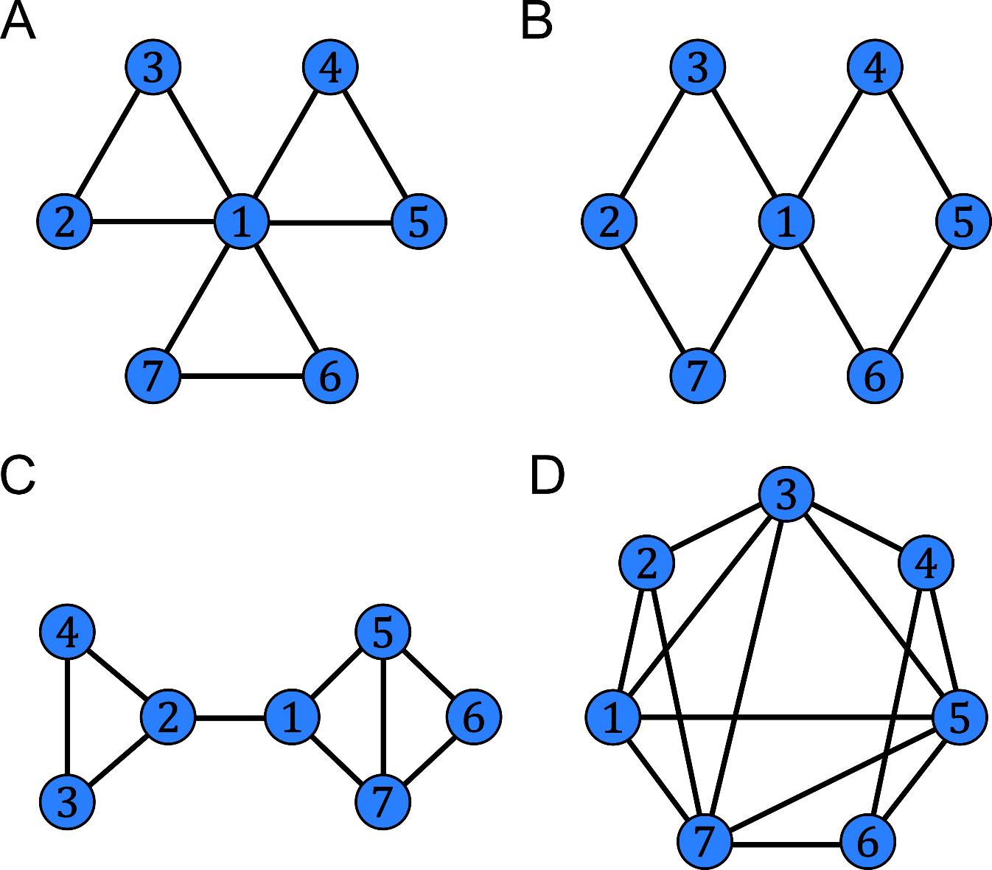

**Figure.** Toy networks for exercises

**EXERCISES**

1. Considering the toy networks A and B in the Figure, compute the average node degree, the average clustering coefficient and the characteristic path length. Which topological measure is expected to differ more between the two networks?
2. Considering the toy network C in the Figure, compute the average closeness centrality and the average edge betweenness centrality. According to these two topological measures, which are the most central node and the most central edge in the network?
3. Considering the toy network B in the Figure, compute the LCP-correlation. Is the network following LCP organization?
4. Considering the toy network D in the Figure, compute the LCP-correlation. Is the network following LCP organization?
5. Considering the structural and functional connectomes provided, write a script in order to compute for each matrix and for each threshold the average node degree, the average clustering coefficient and the characteristic path length. What is the meaning of the characteristic path length respectively in the structural and functional brain networks?

**SOLUTIONS**

Exercise 1

Network A:

D = 2.57, C = 0.89, L = 1.57.

Network B:

D = 2.29, C = 0.00, L = 1.90.

The topological measure that differs more between the two networks is the average clustering coefficient.

Exercise 2

Network C:

CL = 3.90, EBC = 4.67.

The most central node is 1 (CL1 = 4.50); the most central edge is 1-2 (EBC1-2 = 12).

Exercise 3

Network B:

LCPcorr = 0, in fact the network does not have common neighbours.

No, the network does not follow LCP organization.

Exercise 4

Network D:

LCPcorr = 0.81.

Yes, the network follows LCP organization.

Exercise 5

The EXCEL file provided reports the values of the topological measures, for each matrix and for each threshold.

In the structural connectomes, path length means combination of nodes and links resulting in physical information flow. In the functional connectomes, path length means a sequentially coherent statistical relation between subsequent regions, and might not be always supported by physical information flow through anatomical connections.