Experimental Design Seed Major Project

Due: 04/06/2021 10% of your final grade.

**Introduction**

One of the driving ideas from this course is that proper experimental design and statistical structure is NOT just for researchers. These are concepts that can be applied to the general workplace and are absolutely of benefit in agricultural fields. When you are involved in a business, three of the most important aspects, which are ubiquitous to nearly every business on the planet, are how to become more efficient, drive profit, and obtain correct information. Attempting to do any job without considering these three factors will result in negative repercussions.

This practical is designed to show you how to formulate robust statistical experimental design for simple experiments, in the hope that you will understand that the particular variables used here can be swapped out and the method is of value, not the specific circumstances here.

This practical is one that you could potentially carry out on a farm as it has direct relevance to planting one of Australia’s most valuable crops, canola. This is an example of a trial anyone could do to give them information. Two papers are given to give background information. The first by Brill et al, 2016 titled “*Optimising canola establishment and yield in south-eastern Australia with hybrids and large seed*”, and the second by Jabbari et al, 2013 titled “*Relationships between seedling establishment and soil moisture content for winter and spring rapeseed genotypes*”.

You will complete this practical in groups of 4. Let me know if you are unable to attend the planting day and I will arrange data for you. **I appreciate that I have several overseas students and arrangements will be made.**

**Factors and levels**

We are going to run a trial that will play with three factors:

1. Soil moisture at planting.
   1. Levels are 1 = full water holding capacity and 2 = half water holding capacity.
2. Planting depth.
   1. Levels are 1 = 1cm and 2 = 3cm.
3. Thickness of stubble
   1. Levels are none = 1 and present = 2.

**Response variables**

Our response variables will be:

1. Emergence at 7 days after sowing.
   1. Binary variable. Yes or No.
2. Shoot length.
   1. Continuous variable in mm.

**Covariate**

We will also include the covariate of seed size. The Biometry Hub has an in-house coded program that takes a photograph of the seeds with a standardised object of know size, and gives the sizes.

**The protocol**

This is the only job where all members of the team can participate. I need to have one piece of sticky paper with 40 seeds for each tray, so I can photograph them to create the covariate. Not everyone came to last weeks prac and hence not all are done. I have done some for you.

**For the following taks, each person will complete the chosen task across all four trays in order to avoid the confounding with treatments**

1. Put the soil in trays.
2. Add the water.
3. Weigh one of the FullCapacity trays before and after water addition.
4. Prepare sowing holes at the same depth for seeds. Remember to trace the ID of seeds when planting. Each row is an experimental unit, but individual seeds will bear the additional information about the effect of seed size.
5. Plant the seeds.
6. Add the stubble.

As there are more jobs than people some will have more than one job. Part of this practical is logistical. You will need to consider the workflow and how to best get this done and who should do which job.

* You will be provided with the experimental plan and you will be provided with the analysis instructions next week.
* You are expected to take this seriously as the data will be used for a masters project and research papers in the future.

**The experiment**

As we have learnt, a split plot design is useful when there is one factor with levels that are hard to separate spatially. In this case, it is impossible to adequately control the soil moisture of half a tray independently. The experimental design is a general split plot. This means that it is a standard split plot design, but you can choose how many factors are included.

**Student Tray**:- Refers to the tray you are working with. Each group will have 4 trays. Each group will need to number each tray at the beginning to ensure that they are able to identify which tray is which.

**Soil Moisture**:- Refers to the level of soil moisture given to each tray. The level of moisture is randomized to each tray.

**Half Tray**:- The trays are “split” into two halves. Ensure that this is an even split. A split on the shortest tray side is recommended. You will be doing 4 trays in total and your experimental plan will be larger. HalfTray = 1 is the left side and HalfTray = 2 is the right side. Make sure you know which is top and which is bottom.

Figure 1: Example of a half tray split for a single tray.

**Stubble**:- Pea straw will be made available for you to simulate stubble conditions. Half the tray will be randomized to receive no stubble, the other will be randomized to receive stubble. Stubble will be placed **AFTER** planting.

**Depth**:- There are two depths in this experiment. Each half of the tray will have one row of 1cm depth and one row of 3cm depth.

**Seeds**:- This refers to the seeds I.D from each group of 10 seeds per row. There are 10 seeds planted at Depth 1 and 10 seeds planted at Depth 2 in each half tray.

**Seed I.D.**:- The number linking the seed on your sheet to the covariate. **It is absolutely essential that you know exactly where each seed from your sheet was planted.** For those of you who do not have your seeds in neat rows you will have to use this column to link your seeds

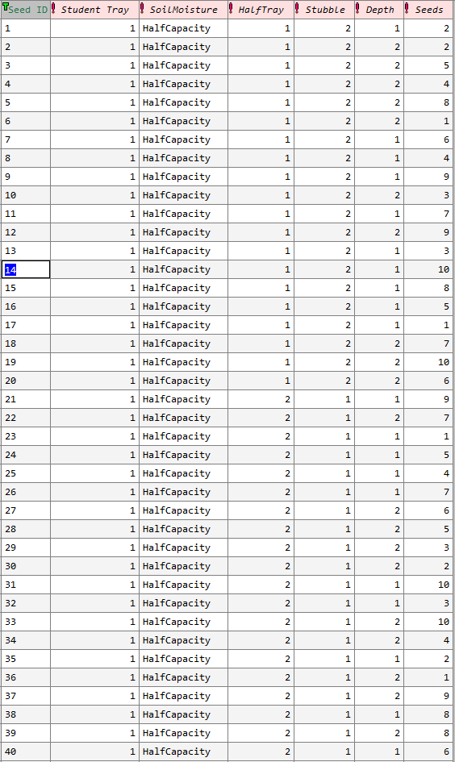

Figure 2: Example experimental plan for one tray only for canola seed RM project.

**It is of great importance that each student complete the same job for each tray. This will stop confounding of students with a particular task.**

* You will be in groups of 4.
* If you did not stick seeds on paper last week you will need to ensure that:
  + You have 4 x 40 seeds on sticky paper.
  + I have photographed them.
  + I strongly recommend you placing your seeds on the paper in 4 columns of 10 seeds.

An example is given in figure 3.

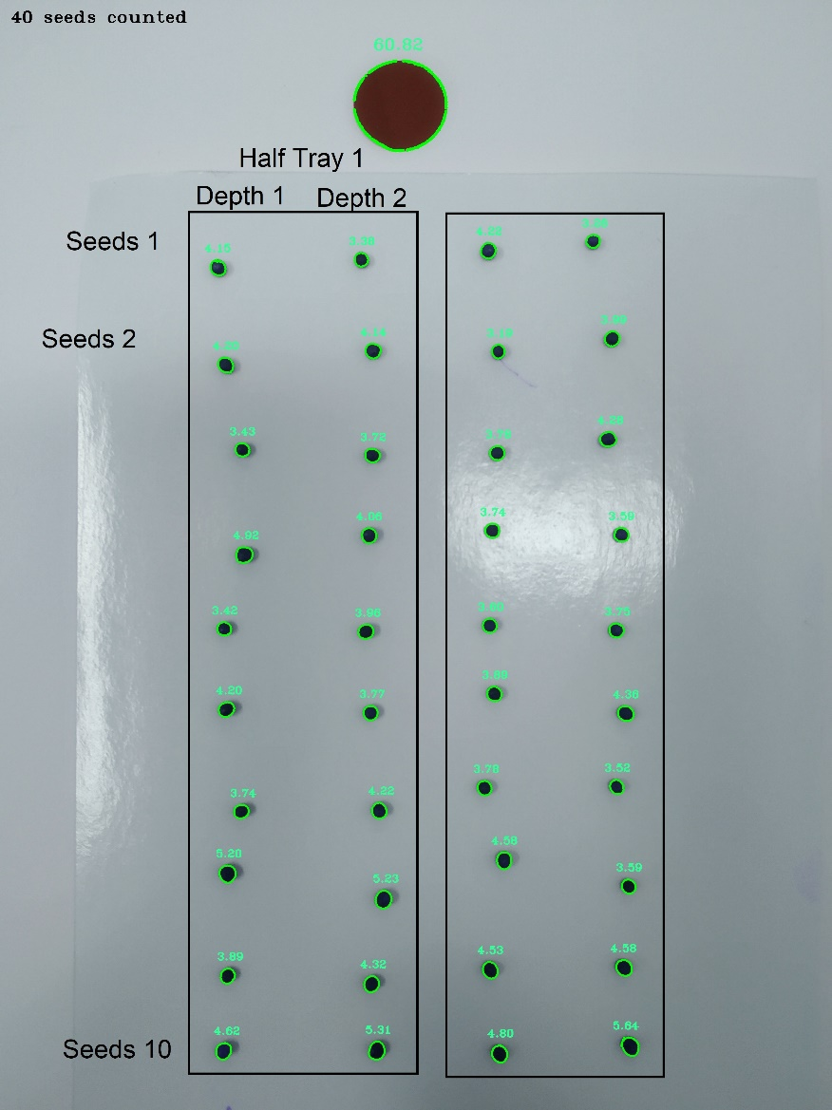

Figure 3: Example of 40 seeds in 4 rows of 10 seeds, adequately spaced for the covariate program.

**Method**

1. Gather 4 trays.
   1. Ensure they have holes in the bottom.
2. Label the trays 1, 2, 3, 4 in a manner that you can identify them later.
3. Fill each tray with soil from the large bin to a level of 1cm below the top of the tray.
   1. Do your best to make this as level as possible.
4. Identify which 2 trays will be FullCapacity and which 2 will be HalfCapacity.
   1. Ensure the scale is zeroed.
   2. Take the weight of the filled trays for the FullCapacity trays only.
   3. Record this value.
5. Using the hose or a bucket pour an excess amount of water into the FullCapacity trays only until water comes out of the holes in the bottom.
6. Let the water drain for 5 minutes (approx.) or until there are only slow drips from the bottom of the tray.
   1. Ensure the scale is zeroed.
   2. Re-weigh the FullCapacity trays to determine the amount of water added and held in the soil.
   3. Record this value.
7. Make the 4 planting rows in each tray using figure 4 as a guide.
   1. Lay out the trays as per the diagram below.
   2. The depths are 1cm (White) and 3cm (Orange)
   3. There will be 2x1cm and 2x3cm depth planting row in each tray.
   4. Ensure they are long enough to have 10 seeds at evenly spaced points.

Figure 4: Lay out of a single tray, where the white line represents 1cm depth planting row and orange line represents 3cm planting row.

1. Take the seeds from the sticky paper and plant in the rows.
   1. Ensure planting distance is as even as possible.
2. Cover the planted rows carefully with soil.
3. Identify the half of each tray that will receive stubble.
   1. Add a 0.5cm layer of stubble as evenly as possible across the appropriate half tray.
4. Place your tubs on the bench.
5. Clean up!