Module 4 – Dockerfile Instructions: Lab

# Lab Objectives

Create basic python HTTP servers

Build a container using dockerfile

1. Create python HTTP servers

1. Start by creating a new directory with an empty Dockerfile and continue the rest of this exercise in that folder.
2. Create an index.html file. This is basic webpage that our application will serve. The .html file will contain the following lines:

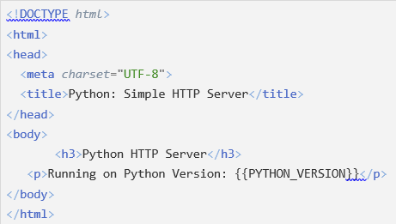

1. Create a python-server-2.7.15.py file. This is a Python script that serves the contents of the folder that it is running in on port 9000. The .py file will contain the following lines:

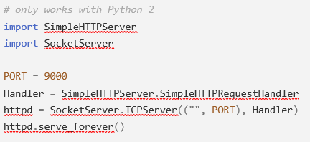

1. Create a python-server-3.6.8.pyfile. This script does the same thing as the first one but notice how the imports are different at the top of the script compared to the other script because it is only compatible with Python 3. The .py file will contain the following lines:

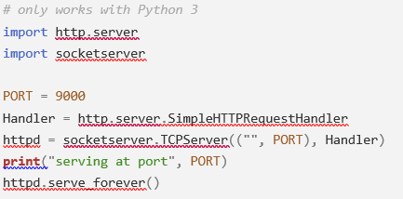

2. Building a container using dockerfile

1. Complete the Dockerfile. The file will contain the following lines:

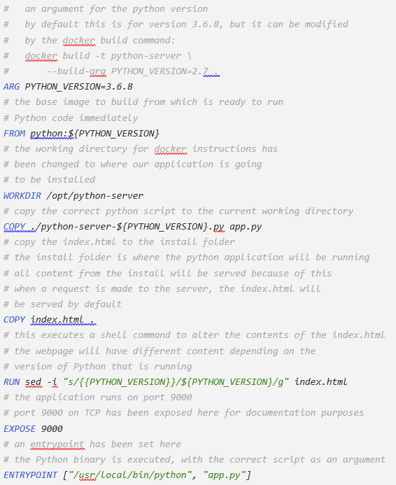

1. Your exercise folder should now look something like below. Now try building the Docker Image and running it in a container. Remember that the application runs on Port 9000 and you will need to publish that port if you want to access the application via HTTP. Try changing the PYTHON_VERSION argument to 2.7.15 with the --build-arg option.

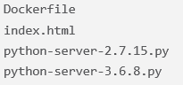

1. To clean up, stop and remove all containers and images.

3. Build your own

1. For a project that is relevant for you, try building a Docker image of it. This could be a Java project using maven, Node, Python etc.
2. Upload your created Docker image to Docker hub and see if one of your peers can get it running.