Module 7 – Multistage Builds: Lab

# Lab Objectives

Build an application through java and maven

1. Building an application though java and maven

1. Create a new folder (**~/docker/multistage_builds_exercise**) for this exercise. We’ll only need three files to get this Java project working (excluding the Dockerfile):

* pom.xml

The config file for Maven.

* src/main/java/com/example/helloworld/HelloWorldApplication.java

The Java code.

* src/main/resources/static/index.html

The static webpage that will be served.

1. Create the Java application which will run a Spring Boot server, don’t forget to put it in the correct directory.

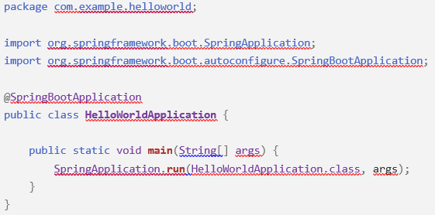

1. Just a simple static web page for the application to serve, remember not to forget the folders on this one also.

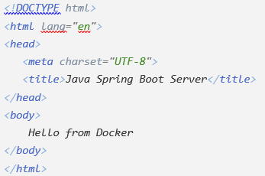

1. For Maven to understand what to compile and how to package the application (a JAR file in our case) we need to create a pom.xml file at the root of the project.

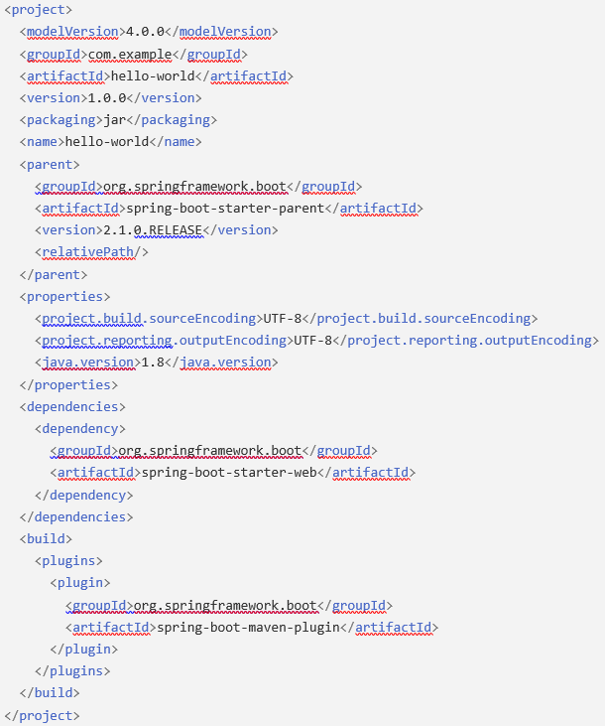

1. The Dockerfile is where we are going to be able to implement the Multistage Build, using a Maven image to compile the code and create a JAR file, then a Java image to run the code in

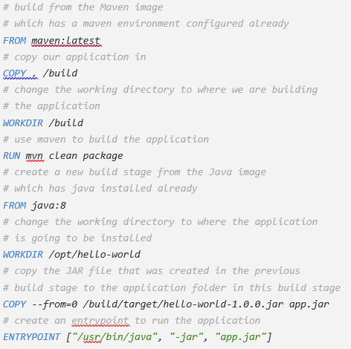

1. Make sure all the containers have been stopped and removed, delete all the images that have been created.

2. Finish up

1. Try build another project that is available to you as a multistage build, this could be another Java & Maven project, NodeJS etc.