Module 11 – Volumes: Lab

# Lab Objectives

Creating a volume

1. Create a volume

1. We are going to need a volume, whether its created separately now for while it is being mounted as well in the next step is up to you. A suggested name for the volume could be webpage.
2. Create an NGINX container with the volume mounted to /usr/share/nginx/html in the container. Make sure that you publish the port (80) so that the NGINX service is available from the host.
3. Let’s make a change to the default NGINX home page, so it is our page. You will need to connect to the container that you created and edit the index.html file, replacing the entire contents with our one. For that however we need a text editor such as vim or nano. The latest NGINX Docker image is based on Debian so you can use the apt package manager to install one of these.

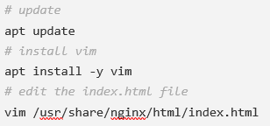

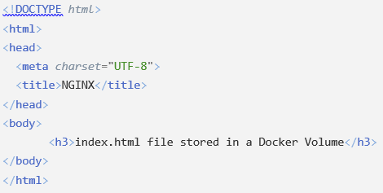

1. Once you have updated the index.html, stop and remove the NGINX container and then create it again. When you go to access NGINX with a HTTP request, you will see that your index.html is being served to you still, even though the container we created it in was destroyed.
2. Create another NGINX container using the same volume configurations and publish it to a different port on your host, when you connect to that instance of NGINX you will see your index.html there as well.
3. Connect to the second NGINX container that you created, install a text editor and make a change to the /usr/share/nginx/html/index.html file inside the <h3> tag. The changes you make should be reflected on both of the containers when you make a HTTP request to them.

2. Finish up

1. Stop and remove all containers, delete the volume that was created.
2. Try to persist all the jobs and configurations for Jenkins, so that when the container has been stopped and removed, Jenkins can pick up where it left off when you create the container again.