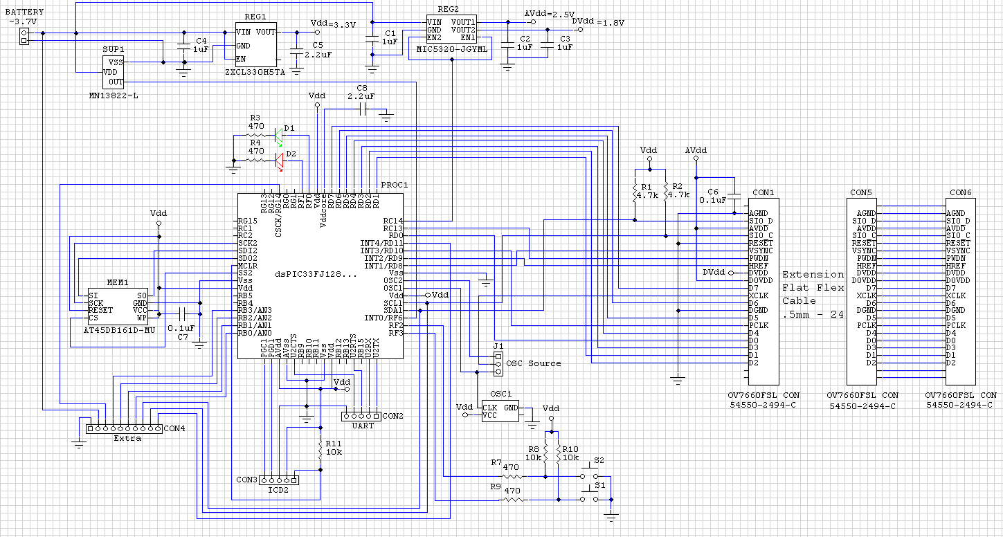

Diagram
PWR
ADC
3 2 1 0
PWM
INT4
I2C
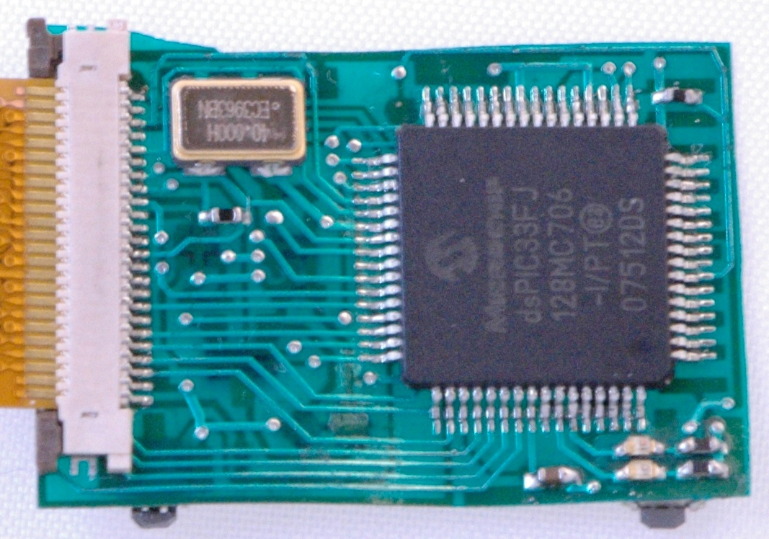
Layout (Top)
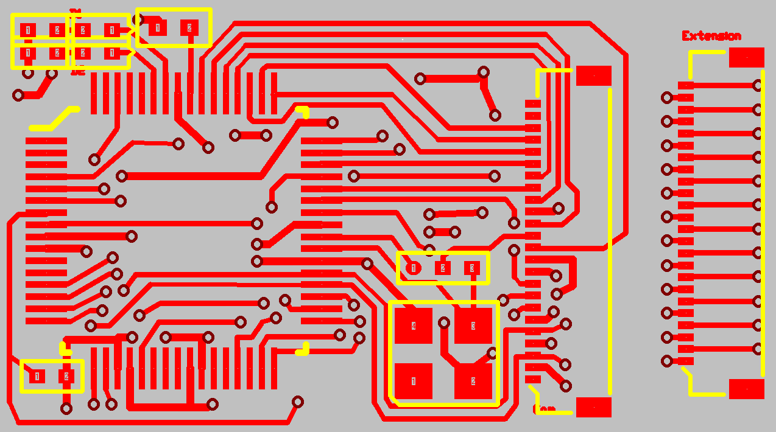
CON6
OSC1
J1
CON1
R11 10k
PROC1
R3 470
R4 470
D1 green
D2
red
C8 2.2u
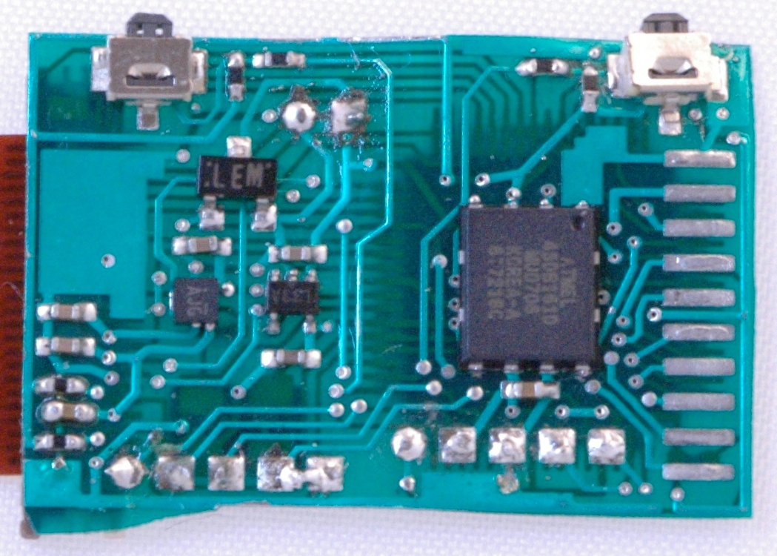
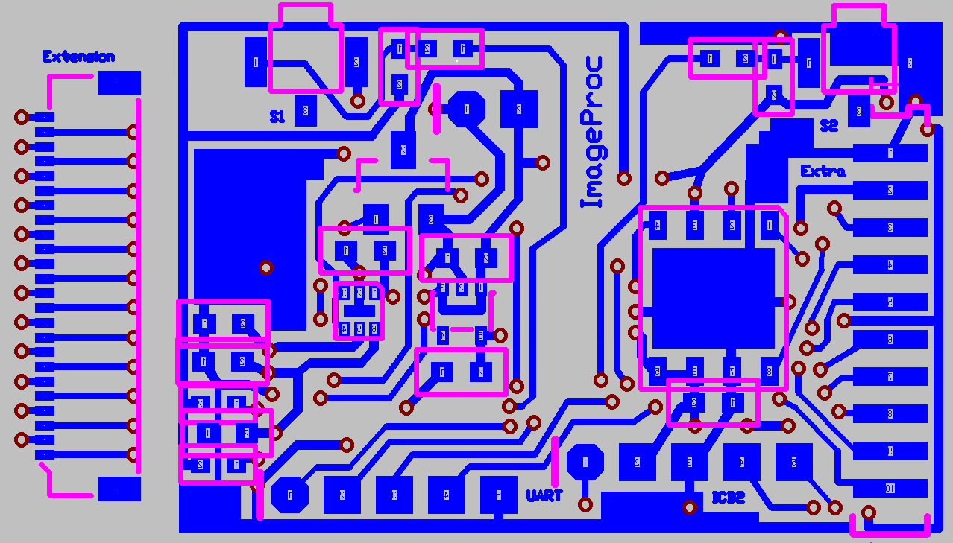
Layout (Bottom)
CON5
S2
R9 470
R7
470
R8
10k
R10 10k
S1
GND
+V
SUP1
C3
1u
C2
1u
C6
0.1u
R2
4.7k
R1
4.7k
C5 2.2u
C4
1u
C1
1u
REG1
REG2
MEM1
C7 0.1u

Bill of Materials

Item # Label-Value Attributes Designation Description

1* 1 ~3.7V pad2 BATTERY
2 4 1uF SM/C/0402 C1,C2,C3,C4
3 2 2.2uF SM/C/0402 C5,C8
4 2 0.1uF SM/C/0402 C6,C7
5 3 54550-2494-C MOLEX05FPC-24 CON1,CON5,CON6 Molex ZIF Connector for OV7660FSL
6* 1 UART pad5 CON2
7* 1 ICD2 pad5 CON3
8* 1 Extra SIP10/SM575 CON4
9 2 LED1 SM/D/0402/12 D1,D2
10* 1 OSC Source SM/JP/0402-3 J1
11 1 AT45DB161D-MU MLF-8 MEM1 16Mbit DataFlash Memory
12 1 ECS-3963-400-BN ECS3963_SMD OSC1 ECS SMD Clock Oscillator
13 1 dsPIC33FJ128... Q.50M_64A PROC1 dsPIC33FJ128MC706
14 2 4.7k SM/R/0402 R1,R2
15 4 470 SM/R/0402 R3,R4,R7,R9
16 3 10k SM/R/0402 R8,R10,R11
17 1 ZXCL330H5TA SC70-5 REG1 Micropower 150mA Low-Dropout Regulator
18 1 MIC5320-JGYML MLF-6 REG2 High Performance Dual 150mA uCap ULDO
19 2 B3U-3100P B3U-3100P S1,S2 Side-actuated Tactile Switch
20 1 MN13822-L SC59/132 SUP1 Voltage Detector/Supervisor

* These items don't need to be populated with components, but wires.

