Self-driving Car Assignment 4 Question Answer
Name: 李聖誠 Student ID: 0513336

Q1. What’s the difference between our launch (robot_pose_ekf.launch) file and original launch file?

Our launch file disabled the odom by setting the param to false because we don’t have one. This also eliminate the remap tag from odom to pr2_base_odometry/odom in the original package. In additional we add a new remap tag to remap vo topic to /zed/odom. This tag can help robot_pose_ekf node find our topic of visual odometry.

Q2. Which parts in IMU data and ZED odometry are used?

We use orientation information in IMU and pose in zed odometry.

Why choose this way?

We get the orientation from imu because it’s more reliable than orientation in vo.
And use pose to get both rotation and translation for state estimation.

Q3. Adjust the covariance in imuCallback and voCallback.
modified imu covariance:
imu_covariance:
Result: 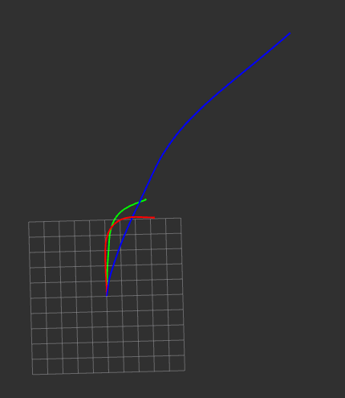

modefied vo covariance:
Result: 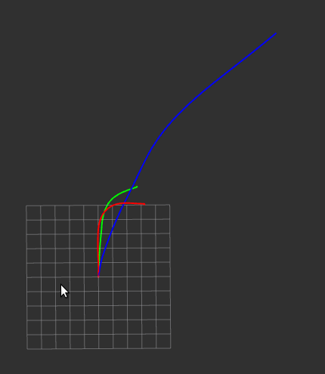

When we enlarge the covariance of imu, the combined path is moving to imu. It’s because we give a larger covariance, which represents confidence, the filter beliefs imu more.
When we decrease the covariance of vo, the combined path also moves to imu. This is because we give a smaller covariance, the filter beliefs vo less.

Q4. Comparing the resulting path and the single sensor paths, what is the difference, and why?
The result path is between two single path including imu orientation and vo positiona & orientation. It combines two path together.

