**BioNanoGenomics JBrowse Plugin**

1. **Download**

Download the BioNanoGenomics JBrowse Plugin from <Add Location>.

1. **Pre-requisite**

Installing this plugin requires a JBrowse installation on a linux server. To install JBrowse please follow directions from this link[**http://jbrowse.org/install/**](http://jbrowse.org/install/)

1. **Installation**

To install the plugin, please follow the below instructions

* Unzip the downloaded plugin file in your <jbrowse_installation> plugins directory. This will create a folder BioNanoGenomics folder.

zip -r BioNanoGenomics.zip <jbrowse_installation>/plugins/

* Make sure the following folder exists

<jbrowse_installation>/plugins/BioNanoGenomics

* Modify the jbrowse.conf to include the BioNanoGenomics plugin. Edit the jbrowse.conf file

vim <jbrowse_installation>/jbrowse.conf file.

* After adding the plugin, the jbrowse.conf shall look like this

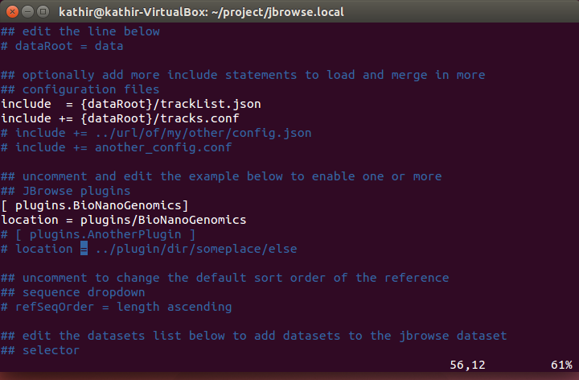

1. **Using BioNanoGenomics Plugin**

Adding the BioNanoGenomics plugin adds a new menu item to jbrowse application. Open your jbrowse application using your favorite browser. There will be new menu item under the File Menu.

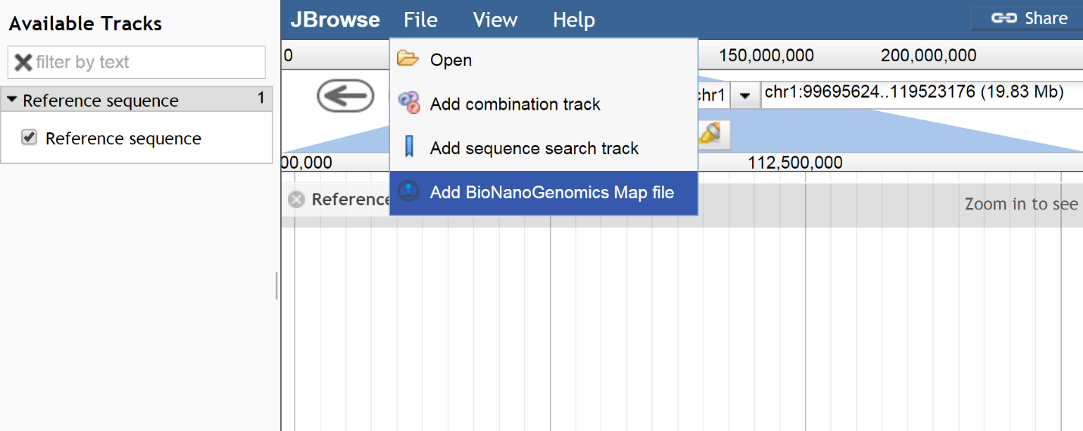

**Loading Files**

Clicking the new menu “Add BioNanoGenomics Map file” will allow you to load data files.

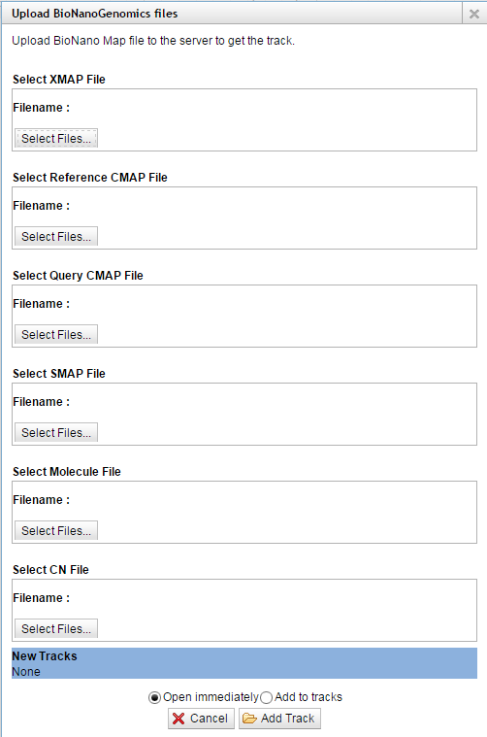

The dialog allows you to load the following file types.

* XMAP files (.xmap)
* CMAP files (_q.cmap, _r.cmap)
* SMAP files (.smap)
* CN files (.cn)
* Molecule files (.zip, all the molecule .xmap, .cmap compressed under one folder)

The user shall select the correct file in each select box. There will be success or error message at the bottom right corner of the page for each selection.

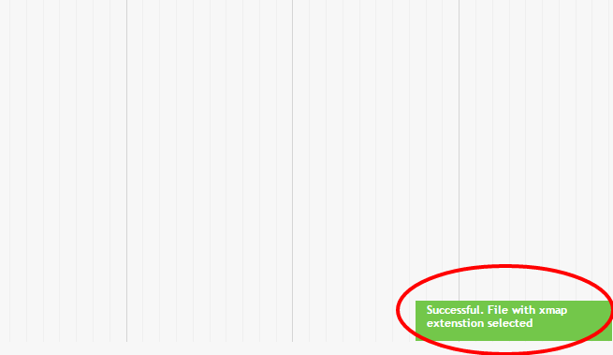

When the files are selected, track names will be displayed at the bottom of the dialog. The following tracks will be available if the user selects all the files.

* Reference Map Track
* Query Map Track ( User can view molecules if the molecule file is loaded)
* SMAP Track
* CN Track

The screenshot shows the tracks once loaded,

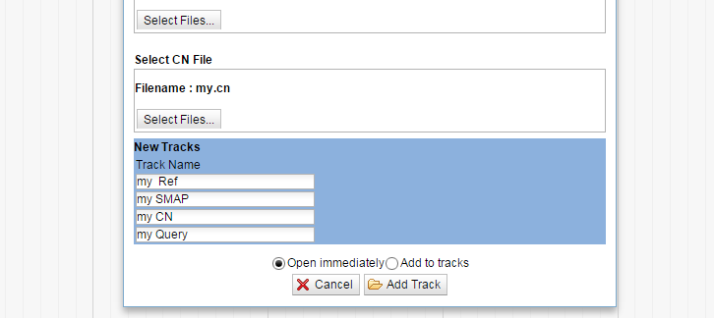

Click on “Add Track” to load the tracks into JBrowse. All the BioNanoGenomics data tracks will be loaded under a Category “BioNanoGenomics tracks”

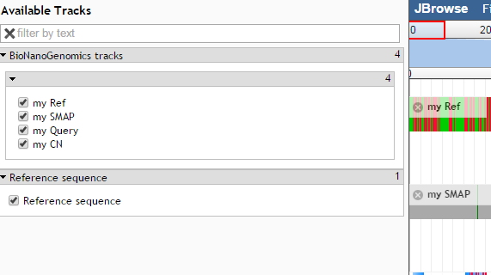

When the tracks are loaded, there will be four tracks loaded into the view. The tracks will show the data for the currently viewed chromosome. The user can now access the track as any other JBrowse track. The following screenshot shows the a sample of the tracks.

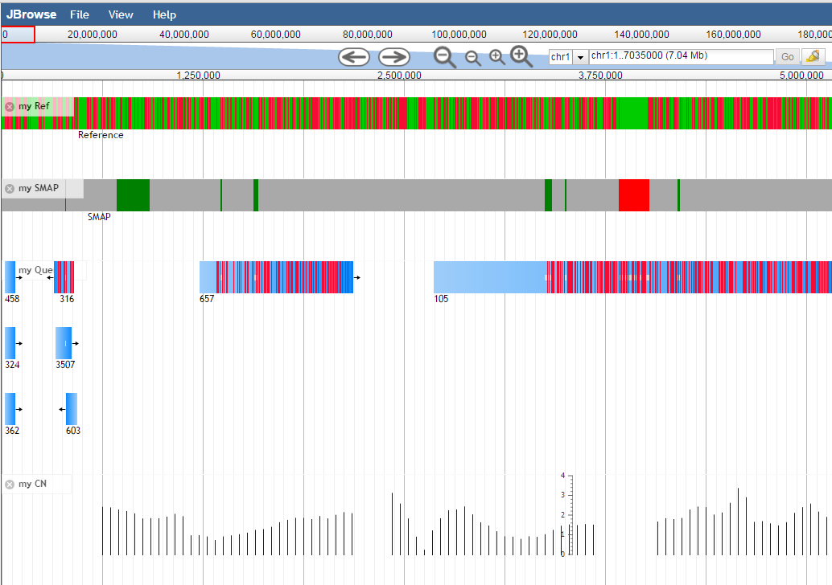

The insertions and deletions are shown in both SMAP track and also as part of the Query map tracks.

**Viewing molecules**

The molecule track can be viewed by loading them from the query track by right clicking on them. The right click option provides “View molecules” menu.

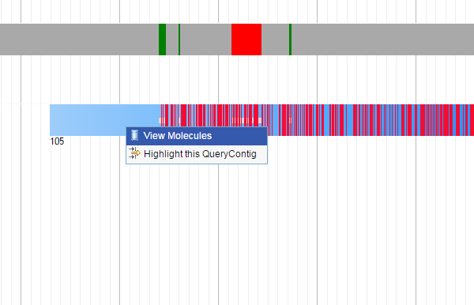

When the molecules are loaded for a query map, there will be a “Molecule Track” created with the corresponding molecule track data. This track is reused for all the query map’s molecules.

