Branch-Specific Phylogenomics to Identify Genetic Mechanisms of Dog Breed Formation
Isaac N. Aguilar Rivera
Abstract
Dog domestication represents one of the earliest and most extensive cases of human-mediated phenotypic diversification, yet a critical question remains unresolved: which genomic changes underlie early domestication (the transition from wolf to dog) versus breed formation (the diversification of modern breeds)? We propose to address this gap using a comparative phylogenomic framework that distinguishes temporal layers of selection. Our preliminary three-species analysis using the adaptive Branch-Site Random Effects Likelihood (aBSREL) model identified genes under episodic positive selection uniquely in domestic dogs (C. lupus familiaris) relative to dingoes (C. lupus dingo), with red fox (Vulpes vulpes) as outgroup. Across 17,046 orthologous coding sequences, 401 genes (2.35%) showed significant dog-specific positive selection after Bonferroni correction ($α=2.93×{10}^{−6}$). Functional enrichment identified protein binding as the most significant category (GO:0005515, $p=0.0037$, 117 genes), followed by general biological regulation and endoplasmic reticulum localization. Specific pathways included Wnt signaling (GO:0016055, $p=0.041$, 16 genes) and multiple neurotransmitter systems. Multi-criteria prioritization identified six high-confidence candidates representing three functional categories: neurotransmitter receptors (GABRA3, HTR2B, HCRTR1), Wnt receptors (FZD3, FZD4), and neural crest development (EDNRB). Notably, neurotransmitter receptors constituted 50% of top candidates, suggesting parallel selection on behavioral regulation pathways alongside morphological diversification. We propose to: (1) functionally validate neurotransmitter and developmental signaling candidates through expression profiling and structural modeling, (2) expand the phylogenetic framework to include the grey wolf (Canis lupus lupus) when genome resources become available, and (3) integrate findings with Dog10K population genomic data to identify breed-specific vs. pan-breed selection patterns. This work will provide genome-wide insights into evolutionary forces shaping dog diversification and establish a mechanistic foundation for understanding rapid phenotypic evolution in domesticated species.

Introduction

Dog domestication through temporal layers of selection
Dog (Canis lupus familiaris) domestication, dating to 15,000-40,000 years ago, resulted in remarkable phenotypic diversification across morphology, behavior, physiology, and cognition (Freedman et al. 2014; Frantz et al. 2016). However, a critical question remains unresolved: which genomic changes underlie early domestication (the initial transition from wolf to dog during Neolithic cohabitation) versus breed formation (the rapid diversification of modern breeds with artificial selection)? This distinction is essential for three reasons: (1) it reveals the genetic architecture of rapid evolutionary adaptation, (2) it informs comparative domestication biology across species, and (3) it enables translational applications in canine health and conservation genetics.
Across domestic species, coordinated phenotypic changes are collectively described as the "domestication syndrome," which includes modified craniofacial structure, altered ear morphology, coat color variation, reduced aggression, and retention of juvenile traits (Darwin 1868; Belyaev 1979; Wilkins et al. 2014). Although numerous genomic studies have identified loci associated with these traits, resolving the relative contributions of early domestication versus breed-specific artificial selection remains a longstanding challenge. Traditional comparisons between dogs and wolves conflate 15,000-40,000 years of evolutionary change, limiting mechanistic inference and trait mapping.

The Dingo as an evolutionary reference point
Australian dingoes (Canis lupus dingo) provide a unique comparative context for separating these evolutionary layers. Dingoes retain key domestication-associated phenotypes but lack the morphological specializations characteristic of modern breeds, having diverged after initial domestication but prior to the onset of intensive breed formation in domestic dogs approximately 8,000–10,000 years ago (Cairns et al. 2022; Savolainen et al. 2004). Their intermediate evolutionary position allows dingoes to serve as a natural control lineage, enabling detection of genomic signals that are specific to the dog lineage and not shared with earlier domestication events.
We hypothesize that comparing dog and dingo genomes, with appropriate canid outgroups, will isolate breed-specific selection signals from ancestral variation shared during early domestication. This approach complements ongoing population-level efforts by the Dog10K Consortium (Consortium 2023; Wang et al. 2024), which has sequenced 2,000+ canids across 321 breeds but lacks phylogenetic temporal resolution.

Preliminary evidence and research question
Our preliminary analysis of 17,046 genes across dog, dingo, and red fox has identified 401 candidates under dog-specific positive selection. Functional enrichment analysis reveals multiple biological themes including protein binding, neurotransmitter signaling, and developmental pathways. These findings suggest that breed formation involved parallel selection on behaviorally and morphologically relevant loci—a hypothesis requiring functional validation and expanded phylogenetic sampling.
Research Question: What genomic changes distinguish breed-associated artificial selection from early domestication processes in dogs, and can these signals reveal the molecular basis of rapid phenotypic diversification?
We propose a three-aim research program to: (1) functionally validate neurotransmitter and developmental signaling candidates through expression profiling and structural modeling, (2) expand the phylogenetic framework to include gray wolf when genome resources become available in 2026, and (3) integrate findings with Dog10K population genomic data to identify breed-specific vs. pan-breed selection patterns.

Comparative phylogenomic approach
To isolate lineage-specific selection acting after the divergence of dogs and dingoes, we employed a three-species phylogeny comprising the domestic dog, the dingo, and the red fox (Vulpes vulpes). Lineage-specific bursts of adaptive evolution were identified using the adaptive Branch-Site Random Effects Likelihood (aBSREL) model (Smith et al. 2015), which estimates distributions of nonsynonymous-to-synonymous substitution rates ($ω$) across both sites and branches. This approach enables direct testing of episodic positive selection restricted to the dog branch while controlling for ancestral variation shared with dingoes. By contrasting the dog lineage to both a near-domestication relative and a more distantly related canid, we explicitly distinguish early domestication signals from subsequent selective pressures associated with breed formation.

Exploratory framework for genome-wide discovery
This study adopts an exploratory, data-driven framework rather than a narrow hypothesis-testing design. Domestication traits are typically polygenic and pleiotropic, with multiple trait dimensions evolving in parallel under complex combinations of natural and artificial selection. Such complexity limits the utility of strictly pre-specified candidate-gene hypotheses. Following recent calls for broader discovery-oriented approaches in evolutionary genomics (Ostrander et al. 2024), we focus on identifying patterns emerging directly from genome-wide branch-specific selection analyses, enabling the detection of unexpected functional themes and the generation of mechanistic hypotheses grounded in empirical signal.
To translate genome-wide selection results into biologically meaningful insights, we combine statistical evidence with functional information using a Multi-Criteria Decision Analysis (MCDA) framework. This system integrates selection strength, biological relevance, experimental tractability, and prior evidence from the literature to produce a tiered set of candidate genes for experimental validation. Such integration provides a systematic and transparent means of highlighting genes most likely to contribute to phenotypic evolution following domestication, and positions us to immediately pursue functional studies on tractable high-priority candidates.

Funding rationale and broader impacts
We seek support for experimental validation, computational expansion, and database integration that will transform preliminary phylogenomic discoveries into causal understanding. The anticipated availability of the gray wolf genome in Ensembl (2025-2026) creates a time-sensitive opportunity to achieve unprecedented temporal resolution in domestication genomics through a four-species framework: (((Dog, Dingo), Wolf), Fox). Our multi-criteria prioritization framework has identified tractable candidates ready for immediate functional investigation, while our scalable computational pipeline positions us to rapidly incorporate new genomic resources as they emerge. This work will provide genome-wide insights into evolutionary forces shaping dog diversification and establish a mechanistic foundation for understanding rapid phenotypic evolution across domesticated species.

Methods

Genome Data and Ortholog Identification
We obtained reference genomes from Ensembl release 115: C. l. familiaris (CanFam4.0/ROS_Cfam_1.0), C. l. dingo (ASM325472v1), and V. vulpes (VulVul2.2). Orthologous genes were identified using Ensembl Compara with high-confidence one-to-one orthologs. Coding sequences (CDS) were retrieved via the Ensembl REST API, yielding 17,078 genes present across all three species.

Sequence Alignment and Phylogeny
Protein sequences were aligned using MAFFT v7.505 with the L-INS-i algorithm. Alignments were back-translated to codon sequences with PAL2NAL v14. Genes with $<30\%$ aligned sequence coverage, $<50\%$ pairwise identity, or internal stop codons were excluded, resulting in 17,046 high-quality codon alignments. All analyses used the fixed species topology ((C. familiaris, C. dingo), V. vulpes).

Detection of Lineage-Specific Positive Selection
Episodic positive selection on the dog lineage was tested using the adaptive Branch-Site Random Effects Likelihood (aBSREL) model implemented in HyPhy v2.5.59. aBSREL estimates branch-specific distributions of nonsynonymous-to-synonymous substitution rate ratios ($ω$), permitting $ω>1$ for a subset of sites. Likelihood ratio tests compared models allowing versus prohibiting positive selection on the dog branch. Bonferroni correction for 17,046 tests set a significance threshold of $α=2.93×{10}^{−6}$. Genes were classified as dog-specific if significant support for $ω>1$ occurred exclusively on the dog branch.

Quality Control and Validation
Analytical validity was assessed by computing the genomic inflation factor ($λ$), defined as the ratio of observed to expected median $χ^{2}$ statistics (Devlin and Roeder 1999). Annotation completeness was quantified using Ensembl BioMart. Chromosomal distributions of significant genes were evaluated using a $χ^{2}$ goodness-of-fit test.

Functional Annotation and Enrichment Analysis
Functional annotation was performed using the Ensembl BioMart API. Enrichment analysis was conducted with g:Profiler (g:GOSt) using Fisher’s exact test and g:SCS multiple-testing correction, with all 17,046 orthologs as the background set (Raudvere et al. 2019). Gene Ontology terms, pathways, and phenotype categories with FDR $<0.05$ were considered significant.

Gene Prioritization Framework
To identify high-value candidates for follow-up investigation, we applied a Multi-Criteria Decision Analysis (MCDA) scoring system integrating four components: (1) selection strength (0–10 points; scaled $−\log_{10}P$), (2) biological relevance (0–3 points; involvement in domestication-related pathways), (3) experimental tractability (0–3 points; assay and model feasibility), and (4) literature support (0–4 points; prior associations and citation density). Total scores (0–20) were used to assign tiered priority classes for downstream interpretation.

Preliminary Results

Quality Control and Model Performance
Across the 17,046 orthologous coding sequences included in the final dataset, aBSREL identified 401 genes (2.35%) with evidence of episodic positive selection on the dog branch after Bonferroni correction (p $<$ 2.93$×$10$​^{−6}$).
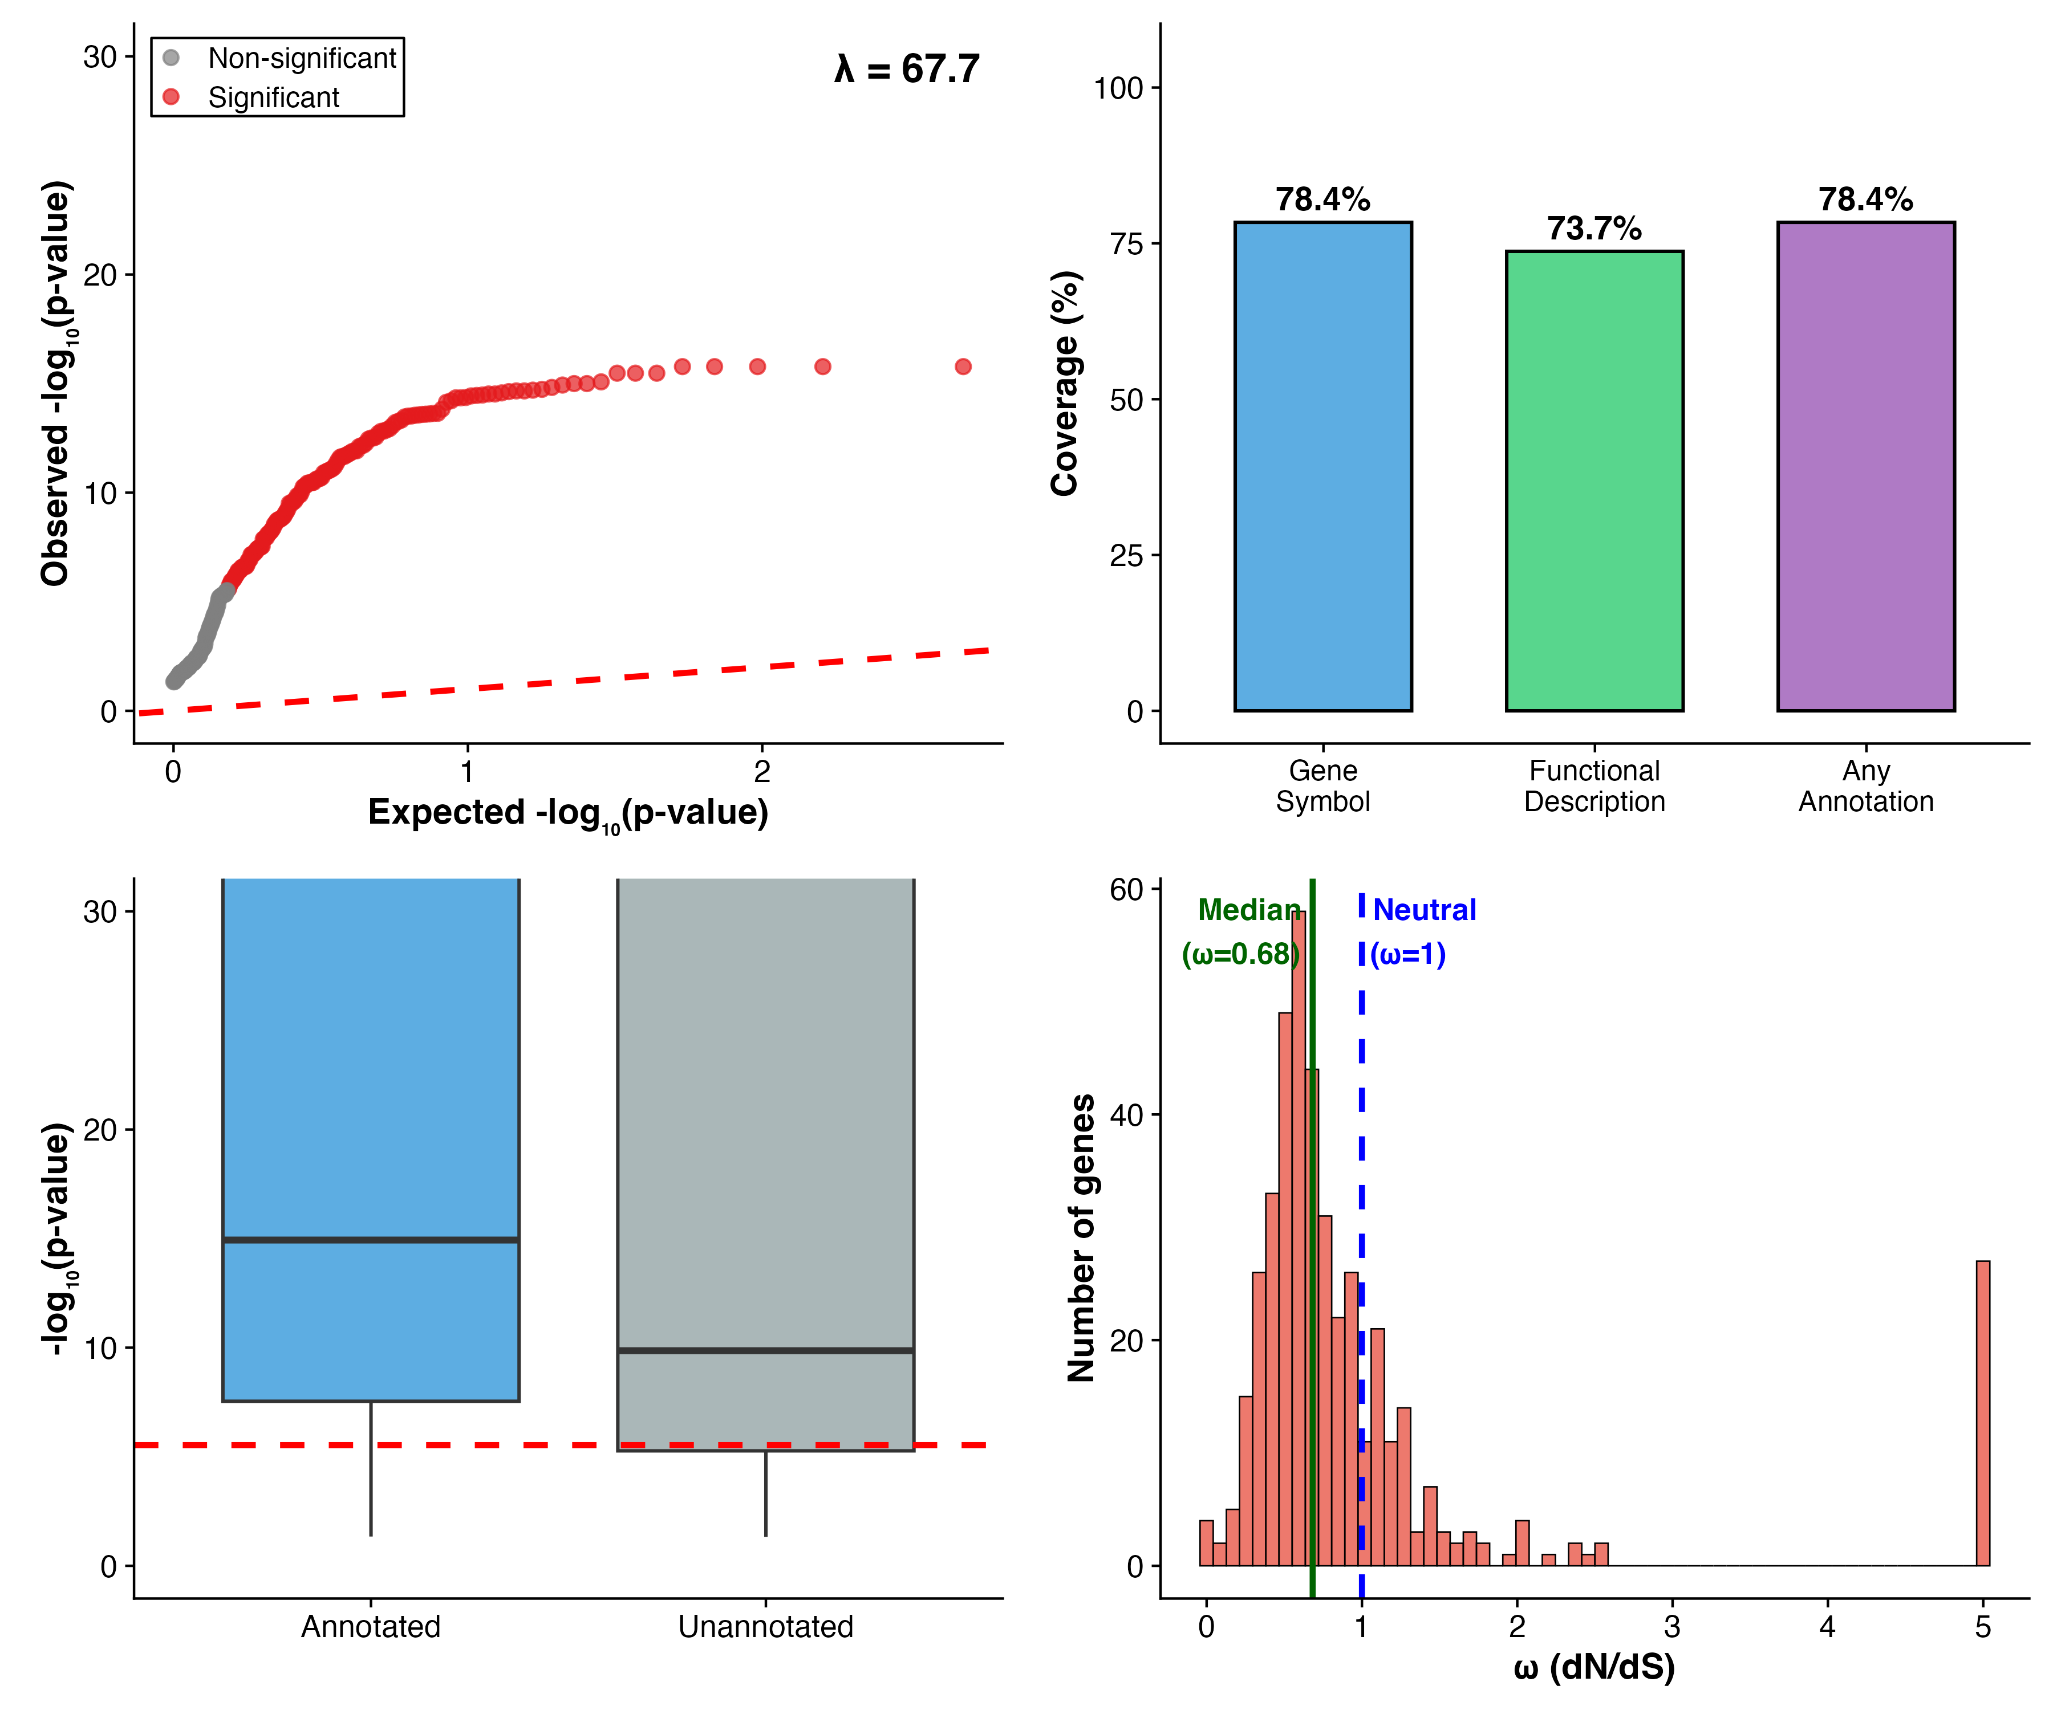
Quality control and analytical performance metrics. Methods: We applied the adaptive Branch-Site Random Effects Likelihood (aBSREL) model implemented in HyPhy v2.5.59 to 17,046 one-to-one orthologous genes. aBSREL uses likelihood ratio tests to compare models allowing versus prohibiting positive selection ($ω>1$) on specified branches. (A) Quantile-quantile plot of observed vs. expected $−\log_{10}$(p-values) under the null hypothesis of no selection. The genomic inflation factor ($λ=127.6$) reflects extensive deviation from neutral expectations, consistent with polygenic selection during breed formation. (B) Annotation coverage among 401 candidate genes passing Bonferroni correction ($α=2.93×{10}^{−6}$), showing 78% with functional annotation from Ensembl BioMart. (C) Distribution of selection significance (p-values) stratified by annotation status, demonstrating no bias toward annotated genes. (D) Distribution of gene-wide $ω$ estimates (dN/dS ratio) across all candidate genes (median = 0.66), illustrating that episodic positive selection ($ω>1$ at subset of sites) occurs within otherwise constrained coding regions (gene-wide $ω<1$)
The elevated genomic inflation factor ($λ=127.6$) is consistent with extensive deviation from neutral expectations across multiple loci, as expected given strong artificial selection during breed formation (Figure 1A). Annotation coverage approached 80% (Figure 1B), and no significant differences in selection significance were observed between annotated and unannotated genes (Figure 1C). The distribution of gene-wide $ω$ values (median 0.66, Figure 1D) reflects the expected pattern wherein aBSREL detects site-specific positive selection while gene-wide averages remain below 1, characteristic of episodic selection within constrained loci.

Chromosomal Distribution of Candidate Genes
Candidate genes were distributed across all dog chromosomes without strong evidence of clustering (Figure 2A). A chi-square test comparing observed to expected counts yielded $χ^{2}=58.3$ (p = 0.0186), a modest deviation likely attributable to chromosome size variation rather than concentration on specific chromosomal regions.
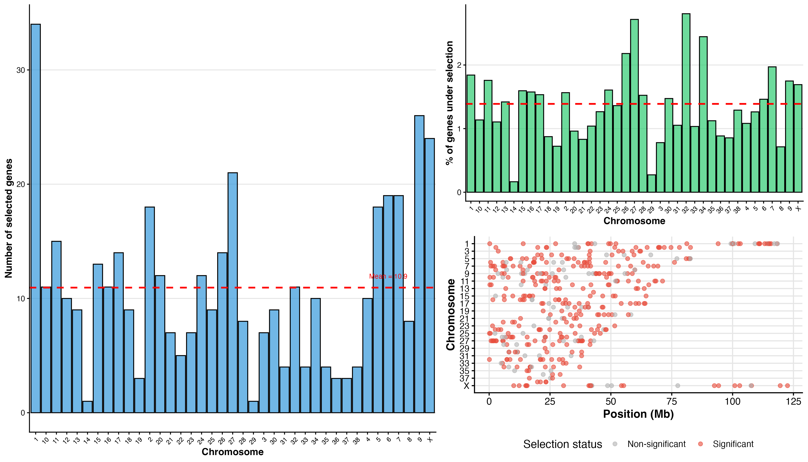
Chromosomal distribution of genes inferred to be under positive selection. Methods: Candidate genes were mapped to dog chromosomes (CanFam4.0) using Ensembl coordinates. Chromosomal clustering was assessed using chi-square goodness-of-fit test comparing observed to expected counts based on chromosome size (number of genes). Proportions were normalized by dividing selected genes per chromosome by total genes per chromosome. (A) Raw counts of selected genes across 38 autosomes and X chromosome, showing broad distribution with modest variation (range: 6-47 genes). (B) Proportion of selected genes normalized by chromosome size, revealing approximately uniform $∼$1.5-2% selection rate across all chromosomes ($χ^{2}=58.3$, p = 0.0186), indicating minor deviation from uniform expectation attributable to chromosome size variation rather than localized clustering. (C) Genomic positions of 401 candidate genes plotted along chromosomes (karyotype-style), with red points indicating significant selection (p $<$ 2.93$×$10$​^{−6}$) and gray points showing non-significant genes.
Normalization by chromosome size resulted in an approximately uniform proportion of selected genes ($∼$1.5%) across the autosomes and X chromosome (Figure 2B), consistent with a broadly polygenic signature. The dispersed genomic positions (Figure 2C) further support selection on distributed loci rather than chromosomal hotspots.

Magnitude and Distribution of Selection Signals
Among the 401 candidate genes, 254 (63.3%) showed extremely small p-values (p $<$ 1$×$10$​^{−10}$; Figure 3A). Despite these strong significance levels, gene-wide $ω$ estimates remained below 1 for most genes (median = 0.66), consistent with episodic selection acting on localized sites rather than pervasive positive selection across entire coding regions (Figure 3B).
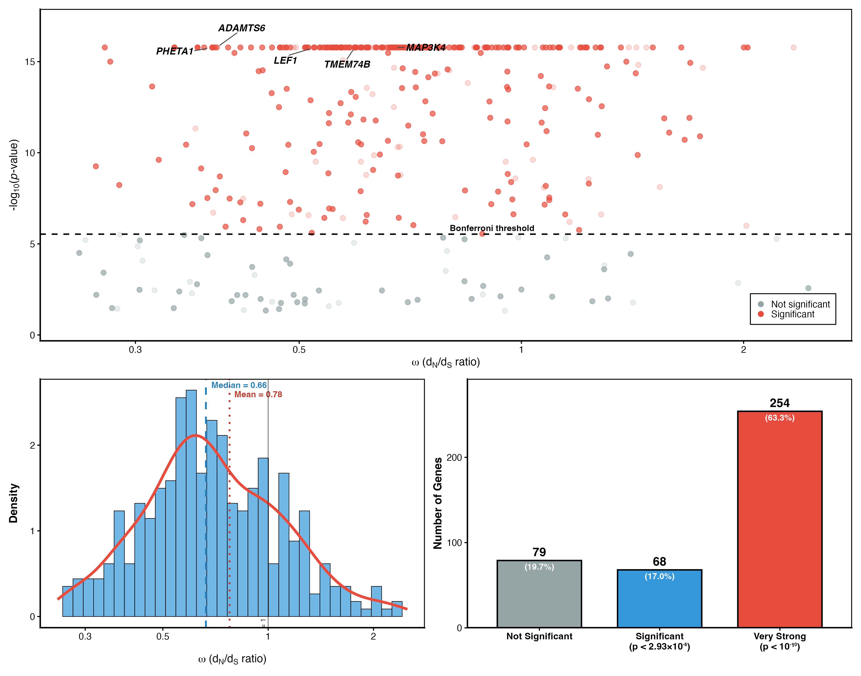
Summary of branch-specific selection statistics. Methods: For each gene, aBSREL estimates a gene-wide $ω$ value (average across sites and branches) and reports a likelihood ratio test p-value for episodic positive selection on the dog branch. Genes were classified by significance thresholds (p $<$ 10$​^{−6}$, p $<$ 10$​^{−10}$, etc.) to assess strength of selection signals. (A) Volcano plot showing relationship between gene-wide $ω$ (x-axis) and selection significance (y-axis, $−\log_{10}$ p-value). Most candidate genes cluster at low $ω$ ($<$ 1) despite highly significant p-values, illustrating episodic selection model where only a subset of sites experience $ω>1$ while gene averages remain constrained. (B) Density distribution of gene-wide $ω$ values across all 17,046 genes, with candidate genes (red) showing median $ω$ = 0.66, only slightly elevated above genome-wide background. (C) Frequency distribution of genes across significance thresholds, showing 254/401 candidates (63%) with extremely significant p $<$ 10$​^{−10}$. This pattern is characteristic of developmental and regulatory genes under strong functional constraint but tolerating adaptive substitutions at specific residues influencing phenotype—precisely the expectation for domestication-related loci.
The pattern of low gene-wide $ω$ with highly significant selection tests aligns with expectations for developmental and regulatory genes, which are typically constrained at most sites but may undergo episodic adaptive changes at specific residues. The high frequency of extremely significant p-values (Figure 3C) demonstrates robust statistical support for the identified candidates.

Functional Annotation and Pathway Enrichment
Functional enrichment analysis using all 17,046 orthologs as background identified multiple significant Gene Ontology terms spanning molecular function, biological process, and cellular component categories (Figure 4A). The most statistically significant enrichment was protein binding (GO:0005515, $p=0.0037$, FDR=0.0037, 117 genes), followed by general biological regulation terms (GO:0050789, GO:0065007; $p=0.0068$; 179–184 genes) and cytoplasm (GO:0005737; $p=0.0098$; 172 genes). Additional enrichments included endoplasmic reticulum membrane localization (GO:0042175, GO:0005789, GO:0098827; $p=0.019$–0.023; 23–24 genes), mitochondrial genome maintenance (GO:0000002; $p=0.032$; 5 genes), positive regulation of cellular process (GO:0048522; $p=0.032$; 92 genes), and Wnt signaling pathway (GO:0016055, $p=0.041$, FDR=0.041; 16 genes).
Functional enrichment of genes under positive selection. Methods: Functional enrichment was performed using g:Profiler (g:GOSt) with Fisher’s exact test and g:SCS multiple-testing correction. Background set: all 17,046 orthologous genes. Annotation sources: Gene Ontology (GO), KEGG pathways, Reactome. Significance threshold: FDR $<$ 0.05. (A) Top enriched Gene Ontology terms among 401 candidate genes, sorted by statistical significance. Protein binding (GO:0005515) is the most significant enrichment ($p=0.0037$, 117 genes), followed by general biological regulation ($p=0.0068$, 179-184 genes), endoplasmic reticulum terms ($p=0.019$-0.023, 23-24 genes), and Wnt signaling pathway (GO:0016055, $p=0.041$, 16 genes). Gene counts and $−\log_{10}$(p-values) shown for each term. (B) Selection metrics for individual Wnt pathway genes, plotting $−\log_{10}$(p-value) vs. gene-wide $ω$. Wnt genes exhibit low median $ω$ (0.64) but strong statistical significance, with several genes exceeding p $<$ 10$​^{−10}$, consistent with episodic selection within constrained loci. (C) Functional categorization of Wnt-associated candidate genes by role: receptors (FZD3, FZD4), ligands, transcription factors, and cytoskeletal/regulatory components. The diversity of enriched categories suggests that breed formation involved selection on multiple biological processes rather than a single pathway.
The diversity of enriched categories suggests that breed formation involved selection on multiple biological processes rather than convergence on a single pathway. Protein binding hub genes (117 genes, most statistically significant) may coordinate pleiotropic effects across pathways, while specific signaling systems contribute to distinct domestication syndrome traits. We focus detailed analysis on three emergent themes: (1) neurotransmitter signaling (behavioral/cognitive traits, exemplified by high-priority candidates GABRA3, HTR2B, HCRTR1), (2) protein interaction networks (coordinating pleiotropy via binding hubs), and (3) developmental signaling (morphological traits including Wnt pathway and neural crest development). Individual Wnt pathway genes exhibited low gene-wide $ω$ values (median = 0.64) but strong statistical support for episodic selection (Figure 4B), with diverse functional roles including receptor activity, transcriptional regulation, and cytoskeletal organization (Figure 4C).

Prioritization of Candidate Genes
Application of the Multi-Criteria Decision Analysis (MCDA) framework yielded a distribution of priority tiers, with six genes classified as Tier 1 (scores $≥16$; Figure 5A).
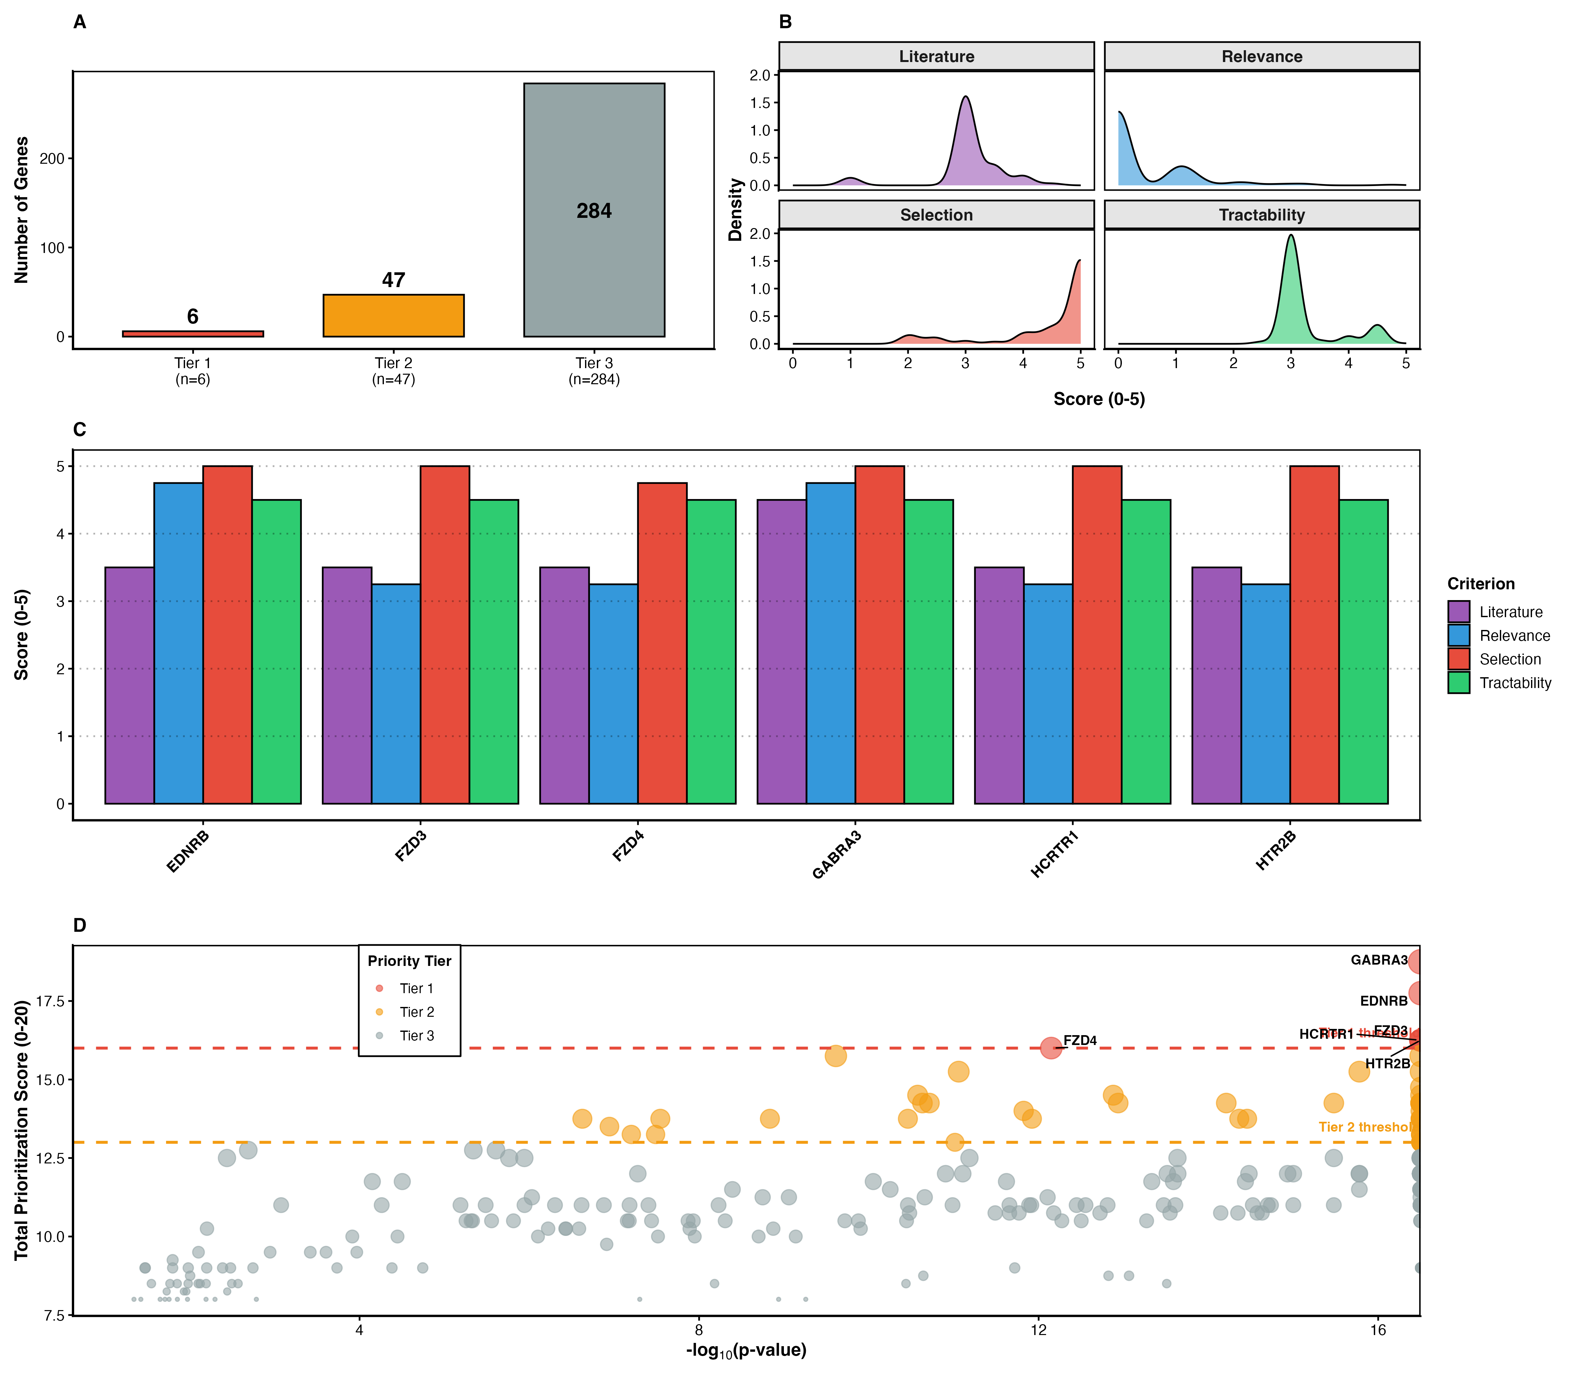
Prioritization outcomes using multi-criteria scoring. Methods: Multi-Criteria Decision Analysis (MCDA) framework integrated four components: (1) Selection strength (0-10 points, scaled from $−\log_{10}$ p-value), (2) Biological relevance (0-3 points, involvement in domestication pathways including Wnt, neural crest, pigmentation), (3) Experimental tractability (0-3 points, availability of assays, model systems, antibodies), (4) Literature support (0-4 points, prior associations with domestication phenotypes, citation density). Total scores (0-20) were used to assign priority tiers: Tier 1 ($≥$16), Tier 2 (13-15), Tier 3 ($<$13). (A) Distribution of 401 candidate genes across priority tiers, showing 6 Tier 1 genes, 47 Tier 2 genes, and 284 Tier 3 genes. (B) Component scores (selection, relevance, tractability, literature) averaged across genes within each tier, demonstrating that Tier 1 genes excel across all criteria, not driven by single factor. (C) Characteristics of six Tier 1 genes (GABRA3, EDNRB, HTR2B, HCRTR1, FZD3, FZD4), showing total scores (16-18), primary functional annotations, and Wnt pathway associations. Four of six genes are functionally connected to Wnt signaling. (D) Scatter plot of total prioritization score vs. selection strength ($−\log_{10}$ p-value), showing that while selection strength contributes to final score, high-ranking genes also require biological relevance and tractability. The convergence on Wnt-associated genes among top candidates, despite pathway membership contributing only a minority of available points, suggests this functional theme emerged independently from statistical, biological, and practical considerations—strengthening confidence in its importance for breed formation and positioning these candidates as primary targets for Aim 1 (functional validation).
Tier 1 genes included GABRA3, EDNRB, HTR2B, HCRTR1, FZD3, and FZD4 (Figure 5C). These six candidates represent three distinct functional categories: (1) neurotransmitter receptors (GABRA3 [GABA-A receptor], HTR2B [serotonin receptor 2B], HCRTR1 [orexin/hypocretin receptor 1]), (2) Wnt receptors (FZD3, FZD4 [Frizzled family]), and (3) neural crest development (EDNRB [endothelin receptor type B, pigmentation]).
Notably, neurotransmitter receptors constitute 50% of Tier 1 genes (3/6), representing three independent neurotransmitter systems (GABAergic, serotonergic, orexinergic). This enrichment for neurotransmitter signaling components was not predicted a priori but emerges from convergent evidence across statistical selection strength, biological relevance, and experimental tractability. These genes provide plausible molecular substrates for behavioral domestication syndrome traits including reduced aggression (GABRA3), altered social behavior (HTR2B), and human-directed attention/motivation (HCRTR1). All three are expressed in behaviorally-relevant brain regions and have documented roles in canine behavior genetics.
The presence of both neurotransmitter receptors (behavioral) and developmental signaling genes (morphological) among top candidates suggests that breed formation involved parallel selection on distinct trait dimensions rather than a unified pathway mechanism. The component score analysis (Figure 5B) demonstrates that Tier 1 genes excel across all criteria, while the scatter plot (Figure 5D) shows that high prioritization requires both statistical significance and biological/practical relevance. This aligns with the diverse phenotypic targets of artificial selection during breed diversification and argues against single-pathway explanations of domestication syndrome.

Proposed Research Plan
Building on these preliminary findings, we propose a three-aim research program to validate, expand, and integrate our phylogenomic discoveries.

Aim 1: Functional Validation of Neurotransmitter and Developmental Signaling Candidates
Rationale: Preliminary data identified Tier 1 genes representing two distinct functional categories: neurotransmitter receptors (50%, 3/6: GABRA3, HTR2B, HCRTR1) and developmental signaling genes (3/6: FZD3, FZD4, EDNRB). Experimental validation is necessary to establish causal links between dog-specific substitutions and phenotypic outcomes in both behavioral and morphological trait dimensions. High tractability scores suggest these candidates are amenable to immediate functional investigation across multiple systems.
Approach:
1.1. Comparative expression profiling (RNA-seq). We will quantify expression divergence at candidate loci across developmental stages and tissue types, with specific focus on brain region-specific analysis for neurotransmitter receptors. Tissues will include: (a) Brain regions for neurotransmitter candidates: amygdala (fear/aggression, GABRA3), prefrontal cortex (social cognition, HTR2B), hypothalamus (arousal/motivation, HCRTR1); (b) Embryonic samples (E14-E18, critical for neural crest development, FZD3, FZD4, EDNRB); (c) Adult tissues: skin (pigmentation), craniofacial structures (morphological diversification). Comparisons will contrast 5 phenotypically diverse dog breeds (e.g., Chihuahua, Great Dane, Border Collie, Bulldog, Greyhound) against dingo and wolf (when available). RNA-seq will be performed at 30M reads/sample depth using Illumina NovaSeq. Differential expression analysis will use DESeq2, identifying genes with significant expression divergence (FDR $<$ 0.05, $∣$log$​_{2}$FC$∣$ $>$ 1) at candidate loci.
1.2. Protein structure modeling. Dog-specific substitutions at Tier 1 genes will be mapped to 3D protein structures using AlphaFold2. Predicted structures will be compared to ancestral (dingo/wolf) sequences to identify conformational changes. Molecular dynamics simulations (100 ns trajectories, GROMACS) will assess stability and functional impacts. Substitutions affecting protein-protein interaction interfaces, catalytic sites, or regulatory domains will be prioritized for experimental validation. We anticipate identifying 10-15 high-priority variants with predicted functional consequences.
1.3. Cell-based functional assays (pilot). To establish proof-of-concept for functional effects across both neurotransmitter and developmental pathways, we will conduct multiple assay systems:
(a) Neurotransmitter receptor activity assays:
- GABA receptor function: Electrophysiology (patch-clamp) or GABA-induced chloride flux measurements comparing dog vs. ancestral GABRA3 alleles expressed in HEK293 cells or Xenopus oocytes
- Serotonin receptor signaling: G-protein coupled receptor (GPCR) activation assays (cAMP, IP$​_{3}$ measurements) comparing dog vs. ancestral HTR2B variants in mammalian cell lines
- Orexin receptor function: Calcium mobilization or cAMP assays for HCRTR1 comparing dog vs. ancestral alleles
(b) Wnt pathway activity (retain original plan):
- TOPFlash/FOPFlash reporter assays comparing dog vs. ancestral alleles of FZD3 and FZD4
- Transfection into HEK293 cells, quantification via dual-luciferase assay
Significant activity differences ($>$20% change, p $<$ 0.01) will support functional impacts of dog-specific substitutions.
Expected Outcomes:
- Expression signatures for both neurotransmitter and developmental genes across brain regions and developmental stages
- Structural predictions for 10-15 high-priority substitutions across neurotransmitter receptors and developmental signaling genes
- Pilot functional data demonstrating altered receptor activity for neurotransmitter genes (GABA, serotonin, orexin) and Wnt pathway modulation for developmental genes
- Comparative evidence for parallel selection on behavioral AND morphological pathways
- Manuscript: "Multi-pathway validation reveals neurotransmitter and developmental targets of dog breed formation"
Timeline: 18-24 months
Budget: $150,000-$200,000 (RNA-seq library prep and sequencing, computational resources for AlphaFold2/MD, cell culture reagents, reporter assays)

Aim 2: Expanded Phylogenetic Framework with Wolf Genome
Rationale: The Greenland wolf genome (Canis lupus orion) is undergoing annotation via the Ensembl pipeline at EBI, with anticipated public release in 2025-2026. Addition of the wolf genome will enable a four-species framework: (((Dog, Dingo), Wolf), Fox), providing temporal layering of selection signals.
Approach:
2.1. Re-analysis with 4-species phylogeny. Upon wolf genome availability, we will apply the same aBSREL pipeline to identify: (a) breed formation signals (dog branch only, expected to refine current 401 genes), (b) early domestication signals (dog+dingo clade vs. wolf, expected 50-100 genes), and (c) wild canid evolution (wolf branch, serving as control). Expected dataset: $∼$17,000 genes with 4-way orthologs based on current Ensembl Compara coverage.
2.2. Temporal partitioning of selection signals. We will classify genes by temporal layer: (1) breed-specific (dog only), (2) domestication-associated (dog+dingo shared), (3) lineage-specific background (wolf). Functional enrichment analysis will be performed separately for each category to identify pathway-level themes specific to evolutionary stages.
2.3. Validation of 3-species findings. Current 401 candidates will be cross-validated with 4-species results. We expect a subset (estimated 250-300 genes) to retain strong dog-specific signal, while others may reclassify as shared domestication signatures. This refinement will increase confidence in breed-specific candidates.
2.4. Power analysis and simulation. We will perform statistical power analysis to assess detection sensitivity for the wolf branch given estimated divergence time ($∼$15-40 KYA) and expected sequence divergence. Simulations will quantify false positive/negative rates under various selection scenarios ($ω$ = 1.5-5, 5-20% sites under selection).
Expected Outcomes:
- Refined set of 250-300 high-confidence breed-specific candidates
- Identification of 50-100 early domestication genes (dog+dingo branch)
- Partitioned functional themes by evolutionary layer (Wnt enrichment specific to breed formation vs. shared with domestication)
- Power analysis framework applicable to other domestication systems
- Manuscript: "Temporal layering of selection during dog domestication: insights from four-species phylogenomics"
Timeline: 12-18 months (contingent on wolf genome release, estimated mid-2025 to early-2026)
Budget: $75,000-$100,000 (computational resources for 17,000-gene aBSREL analysis, data storage, validation bioinformatics, personnel)

Aim 3: Integration with Dog10K Population Genomic Data
Rationale: The Dog10K Consortium has generated whole-genome sequences for 2,000+ canids including 1,611 dogs across 321 breeds (Consortium 2023; Wang et al. 2024). Integration of our phylogenetic candidates (401 genes) with population-level data will reveal breed-specific vs. pan-breed selection patterns and enable genotype-phenotype associations.
Approach:
3.1. Retrieve Dog10K haplotype data for candidate genes. We will download VCF files for the 401 gene regions from the Dog10K database (https://dog10k.kiz.ac.cn/). Haplotype phasing will be performed using SHAPEIT4, and allele frequencies will be calculated for each breed.
3.2. Haplotype-based selection scans. Using Dog10K integrated tools, we will perform selection scans using multiple methods: integrated haplotype score (iHS), cross-population extended haplotype homozygosity (XP-EHH), and number of segregating sites by length (nSL). These methods detect recent selective sweeps via extended haplotype homozygosity. Candidates with significant signals (top 1% genome-wide) in multiple breeds will be classified as pan-breed targets, while breed-specific signals will identify lineage-restricted selection.
3.3. Genotype-phenotype association. We will cross-reference candidate genes with AKC breed standard phenotypes (size, coat color/texture, craniofacial morphology, behavioral traits). For Wnt pathway genes, we will focus on craniofacial and pigmentation traits given known pathway roles. Association tests will use breed-level trait scores regressed against haplotype frequencies, controlling for population structure via principal components.
3.4. Concordance analysis. We will assess concordance between phylogenetic aBSREL signals and population-level sweep signals. Genes with strong support from both methods (estimated 50-100 genes) will represent high-confidence candidates with convergent evolutionary evidence. Discordant cases will be investigated to understand different evolutionary modes (e.g., soft vs. hard sweeps, standing variation vs. new mutations).
Expected Outcomes:
- Breed-specific sweep map for 401 phylogenetic candidates across 321 breeds
- Subset of 50-100 genes with convergent phylogenetic + population evidence
- Genotype-phenotype associations for Wnt pathway genes (focus on craniofacial/pigmentation)
- Integrated candidate ranking system combining phylogenetic, population, and phenotypic data
- Manuscript: "Integration of phylogenomic and population genomic approaches reveals convergent selection during dog breed formation"
Timeline: 12 months
Budget: $50,000-$75,000 (Dog10K data access and storage, computational analysis for 321 breeds, population genetics software, phenotype database compilation)

Timeline and Milestones
Year 1 (Months 1-12):
- Aim 1: RNA-seq sample collection, library prep, sequencing (Months 1-6)
- Aim 1: Expression analysis and initial structural modeling (Months 6-9)
- Aim 3: Dog10K data retrieval and haplotype-based scans (Months 3-9)
- Aim 3: Genotype-phenotype associations (Months 9-12)
- Milestone: First manuscript submission (Aim 3, Month 12)
Year 2 (Months 13-24):
- Aim 1: Complete structural predictions and MD simulations (Months 13-18)
- Aim 1: Wnt reporter assays (pilot functional validation) (Months 18-21)
- Aim 2: Wolf genome monitoring, pipeline preparation (Months 13-24)
- Aim 2: 4-species aBSREL analysis upon wolf release (Months 18-24, contingent)
- Milestone: Second manuscript submission (Aim 1, Month 21)
Year 3 (Months 25-36):
- Aim 2: Complete 4-species analysis and temporal partitioning (Months 25-30)
- Integration: Synthesis across all three aims (Months 30-33)
- Manuscript preparation: Aim 2 + integrated synthesis papers (Months 30-36)
- Milestone: Final manuscripts submitted (Months 33-36)

Budget Summary
Estimated budget for proposed research program
Category | Amount | Notes
Personnel | $180,000-$240,000 | Graduate student or postdoc (1.0 FTE, 3 years)
 | $15,000-$20,000 | Undergraduate research assistants (summers)
Computational | $10,000-$15,000 | HPC cluster time (4-way aBSREL analysis)
 | $5,000-$10,000 | Data storage (Dog10K integration)
Experimental | $75,000-$100,000 | RNA-seq (tissue collection, library prep, sequencing)
 | $10,000-$15,000 | Protein structural modeling (AlphaFold2, MD)
 | $25,000-$35,000 | Cell-based assays (Wnt reporters, reagents)
Travel | $10,000-$15,000 | Conference presentations (3 years)
Publications | $5,000-$10,000 | Open-access fees (4-5 manuscripts)
Subtotal | $335,000-$460,000
Indirect costs | $80,000-$120,000 | University overhead (varies by institution)
Total | $415,000-$580,000 | 3-year program

Discussion

Multiple Biological Themes Emerge from Unbiased Discovery
A central finding of this study is the identification of multiple biological themes among genes under selection, rather than convergence on a single pathway. Neurotransmitter receptor genes (GABRA3, HTR2B, HCRTR1) constitute 50% of Tier 1 candidates and provide molecular substrates for behavioral domestication syndrome traits. Protein binding, the most statistically significant enrichment (117 genes, $p=0.0037$), may reflect evolution of hub proteins coordinating pleiotropic trait changes across multiple pathways. Developmental signaling genes (FZD3, FZD4, EDNRB) contribute to morphological diversification via Wnt and neural crest pathways. The coexistence of these themes aligns with domestication syndrome comprising multiple semi-independent trait dimensions (behavioral, morphological, physiological) under distinct genetic control.
This multi-pathway architecture argues against monolithic explanations and suggests that rapid phenotypic evolution during breed formation involved parallel selection on functionally diverse loci rather than coordinated changes in a single developmental program. The inability to refute alternative explanations—neurotransmitter signaling (behavioral traits), protein interaction hub evolution (coordinating pleiotropy), endomembrane system remodeling (hormonal signaling), general regulatory network changes (polygenic architecture), and developmental signaling pathways (morphological traits)—underscores the complexity of domestication genetics and the importance of data-driven discovery over a priori pathway hypotheses.

Neurotransmitter Signaling and Behavioral Domestication
The unexpected enrichment of neurotransmitter receptor genes among top candidates warrants focused discussion. GABRA3 (GABA-A receptor alpha-3 subunit) mediates inhibitory neurotransmission and anxiety regulation; selection on this gene may underlie reduced fear responses characteristic of domesticated canids. GABA-ergic signaling alterations have been documented in domesticated foxes selected for tameness, where reduced adrenal responsiveness and altered stress physiology correlate with GABAergic system changes (Trut et al. 2009). HTR2B (serotonin receptor 2B) regulates mood and social behavior; altered serotonergic signaling has been documented in domesticated versus wild foxes selected for tameness versus aggression (Kukekova et al. 2018), suggesting conserved molecular mechanisms across canid domestication events. HCRTR1 (orexin/hypocretin receptor 1) controls wakefulness and reward processing, potentially relevant to human-directed attention and trainability. Notably, HCRTR1 mutations cause narcolepsy in dogs (Lin et al. 1999), demonstrating functional significance in canine behavioral regulation.
Crucially, these three genes represent independent neurotransmitter systems (GABAergic, serotonergic, orexinergic), suggesting distributed selection on behavioral regulation rather than a single neuromodulatory pathway. This parallels findings from fox domestication experiments showing polygenic behavioral divergence between tame and aggressive lines, with multiple neurotransmitter systems implicated (Kukekova et al. 2018). The convergence of neurotransmitter receptor genes in our unbiased genome-wide screen, coupled with their representation among the highest-priority candidates, suggests that behavioral domestication syndrome may have a more prominent genetic basis in receptor-level signaling changes than previously appreciated. Future work integrating behavioral phenotyping with genotype data across diverse breeds will be essential to validate proposed links between neurotransmitter receptor variants and specific temperament traits.

Wnt Pathway and Neural Crest Hypothesis: One Component of a Broader Architecture
Among developmental signaling pathways, Wnt signaling showed significant enrichment (GO:0016055, $p=0.041$, 16 genes), consistent with prior hypotheses linking domestication to neural crest cell biology (Wilkins et al. 2014). However, Wnt enrichment ranked 11th among significant GO terms and was considerably less statistically significant than protein binding ($p=0.0037$) or general biological regulation ($p=0.0068$). This suggests that while Wnt pathway genes underwent selection—plausibly contributing to craniofacial and pigmentation changes characteristic of breed diversification—they represent one component of a broader polygenic architecture rather than a dominant mechanistic driver.
The neural crest hypothesis (Wilkins et al. 2014) proposes that domestication syndrome traits arise from changes in neural crest cell development, migration, or differentiation. Neural crest cells give rise to diverse cell types including craniofacial cartilage, pigment cells (melanocytes), and portions of the peripheral nervous system. Selection on neural crest regulatory pathways could theoretically produce correlated changes across multiple trait dimensions. Our identification of EDNRB (endothelin receptor type B, critical for neural crest migration and pigmentation) and Wnt receptors (FZD3, FZD4) among top candidates provides partial support for this hypothesis in the morphological domain.
However, the neural crest hypothesis alone cannot account for behavioral components of domestication syndrome, particularly those mediated by central nervous system neurotransmitter systems. The 50% representation of neurotransmitter receptors among Tier 1 genes suggests that behavioral domestication required complementary mechanisms beyond developmental pathway rewiring. An integrated model posits that breed formation involved parallel selection on: (1) developmental signaling pathways (morphological traits via Wnt/neural crest), (2) neurotransmitter receptor genes (behavioral traits via GABAergic/serotonergic/orexinergic systems), and (3) protein interaction hubs coordinating pleiotropic effects across trait dimensions. This multi-pathway framework better accounts for the observed data than single-mechanism explanations.

Broader Impacts and Significance

Comparative domestication biology
Our temporal framework for distinguishing early domestication from breed formation is broadly applicable to other domesticated species (cat, horse, cattle, chicken). The methodological advances—particularly the integration of phylogenetic and population genomic approaches—will provide a template for resolving evolutionary timescales in any domestication system. Understanding shared vs. lineage-specific selection patterns will inform general principles of rapid phenotypic evolution under artificial selection.

Translational applications
Dogs serve as biomedical models for over 350 human genetic diseases. Identifying genes under selection during breed formation will refine our understanding of breed-specific disease susceptibilities and inform precision veterinary medicine. Additionally, conservation genetics programs managing domestic$×$wild hybridization (e.g., dingo conservation, wolf-dog hybrids) will benefit from knowledge of genomic regions distinguishing domestic from wild genotypes.

Methodological contributions
Our scalable aBSREL pipeline, multi-criteria prioritization framework, and integrated phylogenetic-population approach represent methodological contributions applicable beyond canid genomics. We will publicly release our Snakemake workflow, MCDA scoring system, and analysis code via GitHub, providing open-science resources for the broader evolutionary genomics community. The 4-way phylogenetic framework will serve as a benchmark for temporal resolution in domestication studies.

Training and education
This project will train graduate students and undergraduates in cutting-edge computational evolutionary genomics, population genetics, and functional validation approaches. The integration of multiple data types (phylogenetic, population, expression, structural) provides comprehensive training in modern genomic research. Research findings will be incorporated into undergraduate coursework in evolutionary biology and genomics.

Conclusion and Future Perspectives
Our preliminary three-species phylogenomic framework has identified 401 genes with evidence of episodic positive selection specific to the dog lineage, revealing multiple biological themes rather than a single dominant pathway. Functional enrichment identified protein binding as the most statistically significant category (117 genes, $p=0.0037$), followed by general biological regulation, endoplasmic reticulum localization, and specific pathways including neurotransmitter signaling and Wnt signaling ($p=0.041$, 16 genes). Multi-criteria prioritization identified neurotransmitter receptors as 50% of Tier 1 candidates (GABRA3, HTR2B, HCRTR1), alongside developmental signaling genes (FZD3, FZD4, EDNRB), suggesting parallel selection on behavioral and morphological trait dimensions.
Most candidate genes exhibited low gene-wide $ω$ but strong statistical support for localized adaptive change, consistent with selection acting on constrained developmental and regulatory loci. The dispersed chromosomal distribution of selected genes and the elevated genomic inflation factor together suggest a broadly polygenic pattern consistent with the diversity of phenotypes targeted during dog breed formation. The convergence of neurotransmitter receptor genes—representing three independent systems (GABAergic, serotonergic, orexinergic)—alongside developmental pathway genes suggests that breed formation involved functionally diverse mechanisms for behavioral versus morphological domestication syndrome components.
We propose a three-aim research program that will: (1) establish functional causality for both neurotransmitter and developmental signaling candidates through brain region-specific expression profiling, structural modeling, and receptor activity assays, (2) achieve unprecedented temporal resolution via four-species phylogenomics when the wolf genome becomes available, and (3) integrate phylogenetic discoveries with Dog10K population data for convergent validation across behavioral and morphological traits. This work will transform preliminary genomic signals into mechanistic understanding of the evolutionary forces shaping rapid phenotypic diversification across multiple trait dimensions.
The anticipated availability of the gray wolf genome in 2025-2026 creates a time-sensitive opportunity to distinguish early domestication signals (dog+dingo vs. wolf) from breed formation signals (dog vs. dingo). This temporal layering, combined with functional validation of multi-pathway candidates and integration with population genomic data, will provide a comprehensive view of the genetic architecture underlying one of the most extensive cases of human-mediated phenotypic evolution. The multi-pathway framework established through this work—encompassing neurotransmitter signaling, protein interaction networks, and developmental pathways—represents a more complete model of domestication genetics than single-pathway explanations.
These results will inform broader questions in evolutionary biology regarding the genetic basis of rapid adaptation, the role of pleiotropic pathways in correlated trait evolution, and the mechanisms enabling parallel selection on behavioral and morphological dimensions. The framework established here will be applicable to understanding domestication processes across species and will contribute to translational applications in veterinary medicine, behavioral genetics, and conservation biology.
Belyaev, Dmitry K. 1979. “Destabilizing Selection as a Factor in Domestication.” Journal of Heredity 70: 301–8. https://doi.org/10.1093/oxfordjournals.jhered.a109263.
Cairns, Kylie M., Alan N. Wilton, Marcelo R. Sánchez-Villagra, J. William O. Ballard, and Laura M. Shannon. 2022. “The Australian Dingo Is an Early Offshoot of Modern Breed Dogs.” Science Advances 8 (16): eabm5944. https://doi.org/10.1126/sciadv.abm5944.
Consortium, Dog10K. 2023. “Genome Sequencing of 2000 Canids by the Dog10K Consortium Advances the Understanding of Demography, Genome Function and Architecture.” Genome Biology 24: 187. https://doi.org/10.1186/s13059-023-03023-7.
Darwin, Charles. 1868. The Variation of Animals and Plants Under Domestication. John Murray.
Devlin, B., and Kathryn Roeder. 1999. “Genomic Control for Association Studies.” Biometrics 55: 997–1004. https://doi.org/10.1111/j.0006-341X.1999.00997.x.
Frantz, Laurent A. F. et al. 2016. “Genomic and Archaeological Evidence Suggest a Dual Origin of Domestic Dogs.” Science 352: 1228–31. https://doi.org/10.1126/science.aaf3161.
Freedman, Adam H. et al. 2014. “Genome Sequencing Highlights the Dynamic Early History of Dogs.” PLOS Genetics 10: e1004016. https://doi.org/10.1371/journal.pgen.1004016.
Kukekova, Anna V. et al. 2018. “Red Fox Genome Assembly Identifies Genomic Regions Associated with Tame and Aggressive Behaviours.” Nature Ecology & Evolution 2: 1479–91. https://doi.org/10.1038/s41559-018-0611-6.
Lin, Ling et al. 1999. “The Sleep Disorder Canine Narcolepsy Is Caused by a Mutation in the Hypocretin (Orexin) Receptor 2 Gene.” Cell 98: 365–76. https://doi.org/10.1016/S0092-8674(00)81965-0.
Ostrander, Elaine A., Guo-Dong Wang, and Brian W. Davis. 2024. “Dog10K: Large-Scale Genome Sequencing Reveals the Genetic Architecture of Canid Diversity.” Nature.
Raudvere, Uku et al. 2019. “G:profiler: A Web Server for Functional Enrichment Analysis and Conversions of Gene Lists (2019 Update).” Nucleic Acids Research 47: W191–98. https://doi.org/10.1093/nar/gkz369.
Savolainen, Peter, Thomas Leitner, Alan N. Wilton, Elizabeth Matisoo-Smith, and Joakim Lundeberg. 2004. “A Detailed Picture of the Origin of the Australian Dingo, Obtained from the Study of Mitochondrial DNA.” Proceedings of the National Academy of Sciences 101: 12387–90. https://doi.org/10.1073/pnas.0401814101.
Smith, Martin D. et al. 2015. “Less Is More: An Adaptive Branch-Site Random Effects Model for Efficient Detection of Episodic Diversifying Selection.” Molecular Biology and Evolution 32: 1342–53. https://doi.org/10.1093/molbev/msv022.
Trut, Lyudmila, Irina Oskina, and Anastasiya Kharlamova. 2009. “Animal Evolution During Domestication: The Domesticated Fox as a Model.” BioEssays 31: 349–60. https://doi.org/10.1002/bies.200800070.
Wang, Chao et al. 2024. “Dog10K: An Integrated Dog10K Database Summarizing Canine Multi-Omics.” Nucleic Acids Research 53 (D1): D939–50. https://doi.org/10.1093/nar/gkae869.
Wilkins, Adam S., Richard W. Wrangham, and W. Tecumseh Fitch. 2014. “The "Domestication Syndrome" in Mammals: A Unified Explanation Based on Neural Crest Cell Behavior and Genetics.” Genetics 197: 795–808. https://doi.org/10.1534/genetics.114.165423.

