**Robobulls Installation Guide**

This document details installation for Robobulls, its dependencies (grSim/SSL-Refbox/SSL-Vision), and solutions for common installation issues.

**Obtaining the software/Installation (in-lab)**

Before installing the software, you must have git installed. Install git if not already present on the lab machine. After acquiring git, clone the robobulls repository, then run the included installation script. Compile the software using make or Qt.

sudo apt-get install git

git clone [https://github.com/biorobaw/roboBulls.git](https://github.com/biorobaw/RoboBulls.git)

cd robobulls/

./documents/scripts/install_robobulls.sh

make

Next, install and build the ssl-vision camera system

git clone <https://github.com/RoboCup-SSL/ssl-vision.git>

cd ssl-vision/

make

**Obtaining the software/Installation (Outside the lab)**

**Note:** Robobulls & grSim have been successfully tested on some builds, but this process is not guaranteed for all distros and environments.

Tested environments: Xubuntu 18.04, Mint 18.3

**Installing Robobulls**

Update the distribution with the following commands.

sudo apt-get update

sudo apt-get upgrade

Before installing the software, you must have git installed. Install git through your distribution's package manager. After acquiring git, clone the robobulls repository and run the included installation script.

sudo apt-get install git

git clone [https://github.com/biorobaw/roboBulls.git](https://github.com/biorobaw/RoboBulls.git)

./robobulls/documents/scripts/install_robobulls.sh

Robobulls is compiled with protobuf version 2.6.1. On a modern distribution, you will typically be running version 3.0.0 or later. Resolve the version mismatch by installing version 2.6.1, acquired from google’s github located [here](https://github.com/google/protobuf/releases?after=v3.0.0-alpha-1), unpacking the tarball and following all the installation instructions. The installation will take approximately a half hour. Update the robobull’s makefile located in the robobull’s main directory to link against this protobuf installation.



*Example of modified makefile to link against new protobuf installation. Take note that your protoc installation may not be in /usr/local/lib, as in this image.*

Once the git repository cloned, the installation script has been run, protoc 2.6.1 installed and the Robobulls makefile linked against protobuf 2.6.1 correctly, run make from the terminal or compile from Qt in the Robobulls directory to compile the project.

**Resolving Robobulls Installation issues**

**-’Old version of protobuf’ error**

Protobuf 2.6.1 is missing or uninstalled. Refer to this step to acquire, install, and link against the correct version of protobuf.

**-Undefined reference to google::protobuf::internal…..compilation errors**



Edit the makefile to link against the protobuf 2.6.1 library. Refer to this image for an example of linking against proto 2.6.1.

**-Makefile fails with ‘posedge and negedge macro expansion’ compilation error**

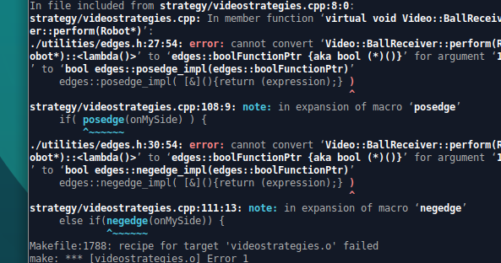

Comment out or remove the videostrategies source and header files in the Robobulls.pro file located in the robobulls main directory.

**-Attempting to run Robobulls triggers a ‘shared object not found’ error**

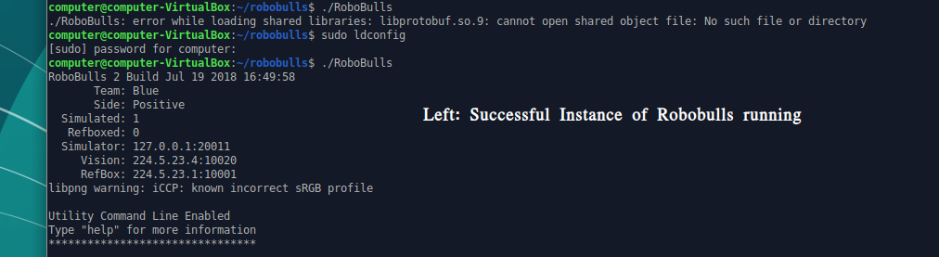

After installing protobuf 2.6.1, run the command

sudo ldconfig

**2) Checking Dependencies (grSim, SSL-Refbox)**

If the installation script reported no issues installing grSim, you may skip this section.

Run make in grSim’s directory to compile. See below for known issues.

**Resolving grSim installation issues**

**-Missing QGLWidget error**



Acquire the full Qt-sdk by running the following command:

sudo apt-get install qt-sdk

**-Missing VARTYPES dependency during grSim compilation**

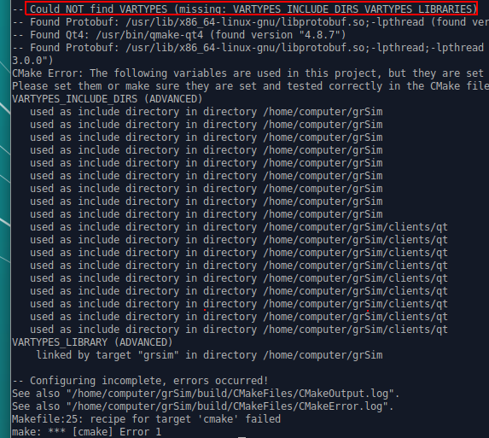

See grSim’s installation guide [here](https://github.com/RoboCup-SSL/grSim/blob/master/INSTALL.md) to compile & install vartypes from source. Depending on your environment (missing boost header when building vartypes, see below), you may need to build boost from source as well.

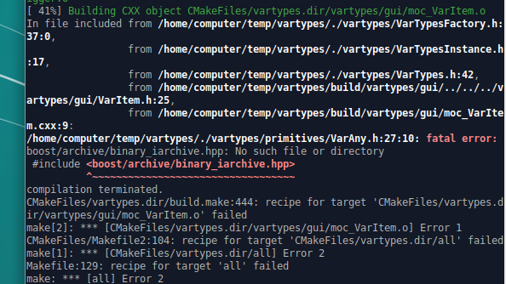

See Boost’s installation guide [here](https://www.boost.org/doc/libs/1_67_0/more/getting_started/unix-variants.html).

After building and installing both Boost and Vartypes, remove the existing grSim directory. Then run the following commands to complete compilation.

git clone <http://www.github.com/mani-monaj/grSim.git>

cd grSim/

make

**SSL_Refbox installation issues**

If the install script reported no issues installing SSL-Refbox, you may skip this section. Run make in SSL-Refbox’s directory to compile. See below for known issues.

**-No known issues.**

**Additional Resources**

[Robobulls Readme](https://github.com/biorobaw/RoboBulls/blob/ssl-league-fixed/documents/readme.docx)

[Robobulls Installation Guide](https://github.com/biorobaw/RoboBulls/blob/ssl-league-fixed/documents/InstallInstructions.pdf)

[Robobulls Operation Guide](https://github.com/biorobaw/RoboBulls/blob/ssl-league-fixed/documents/RunInstructions.pdf)

[Robobulls Development Goals](https://github.com/biorobaw/RoboBulls/blob/ssl-league-fixed/documents/Robobulls_Development_Goals.pdf)

[SSL-Robocup Ruleset](http://wiki.robocup.org/Small_Size_League/Rules)

[SSL-Refbox Documentation](http://robocupssl.cpe.ku.ac.th/referee:start)

[SSL-Vision Official Documentation](https://github.com/RoboCup-SSL/ssl-vision/wiki)

[SSL-Vision Robobulls Operation Guide](https://github.com/biorobaw/RoboBulls/tree/ssl-league-fixed/documents/SSL_Vision_Operation_Guide.pdf)

[Yisibot Manual](https://github.com/biorobaw/RoboBulls/tree/ssl-league-fixed/documents/Yisibot_Manual.pdf)

[Robobulls GUI Honors Thesis (Overview of Robobulls)](https://github.com/biorobaw/RoboBulls/tree/ssl-league-fixed/documents/RobobullsGUIHonorsThesis.pdf)

[Robobulls Software Presentation Complete](https://github.com/biorobaw/RoboBulls/tree/ssl-league-fixed/documents/Robobulls Software Presentation Complete.pdf) (warning, lots of incorrect info here)

Also, see the Robobulls pre-2016 Doxygen HTML documentation, found by opening the Documentation.html file located in documents of the main project folder.

**Contact Info**

After reading all of the above documentation, if you need additional clarification on an issue detailed above and the current lab admins are not available or are unfamiliar with your problem, you can contact one of the previous team members for more information.

May-Aug 2018 Team Members:

nherbert2@mail.usf.edu

* Familiar with Yisirobot movement code, out-of-lab installation. Authored readme, devgoals, installation guide, operation guide, architecture guide. (8/03/18)

kellerc@mail.usf.edu