**Robobulls Operation Guide**

This document details how to run the Robobulls software for running simulated or physical games, as well as resolutions for common issues with both the simulator and Yisibots.

**Running a Simulated 2-Team Game**

There are 3 programs necessary to run a simulated game: grSim, SSL-Refbox, and the Robobulls dashboard.

To run a fully simulated game you must have **two** instances of the robobulls software installed, one of which must be in the team-blue-config branch, and the other in team-yellow-config branch (Note: This is an improper use of branches, and should to be changed to avoid the need for branch switching).

Make sure each instance of the software is installed in a different location. Both will need to be run, so that each team is represented. Before running Robobulls, change the simulated VISION_ADDRESS IP in [communication.h](https://github.com/biorobaw/RoboBulls/blob/master/include/config/communication.h) to point at the IP reported in grSim’s control panel (see image below).

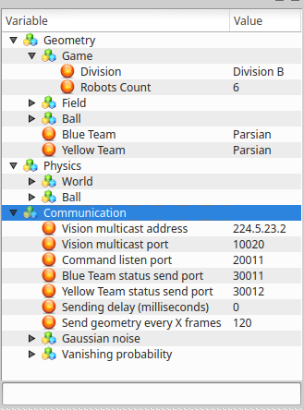

*Above: grSim control panel. Target the IP listed as Vision multicast address in Robobull’s communication.h. Also note the division & robot count parameters.*

In the grSim folder, run the following command to start grSim’s simulator:

./bin/grsim

In the SSL-Refbox folder, run the following command to start the referee program:

./sslrefbox

Next, open qtcreator, open the Robobulls project, and run the Robobulls dashboard.

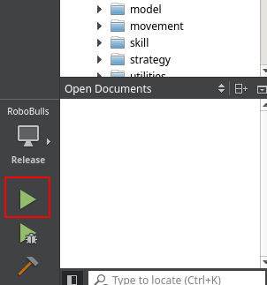

*Above: QtCreator. Click the green arrow to compile & run the Robobulls dashboard.*

Alternatively, run the following command in the team-blue-config Robobulls directory:

./Robobulls

Open a second Robobulls dashboard by repeating the steps above in the team-yellow-config directory.

In Refbox’s program, and give a name to both teams then hit ‘stop game’. Enter the goalie robots number for each team, then select a side to perform the kick off and hit ‘start game’. The simulated game should then be viewable from either grSim or either of the robobulls dashboards GUI windows.

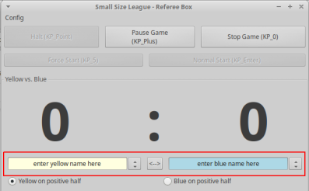

*Above: SSL-Refbox. See the team name text boxes outlined in red. Note that the simulation will not function correctly unless both teams are named.*

**Running a Game with Robots**

There are 3 programs necessary to run a game: ssl-refbox, robobulls dashboard, and ssl-vision. The details on preparing and running the SSL-Vision cameras is detailed in the SSL-Vision documentation.

In the SSL-Refbox folder, run the following command to start the referee program:

./sslrefbox

In the Robobulls folder, run the following command

git checkout ssl-league-fixed

Run the following commands to compile, and run:

make

./Robobulls

Alternatively, compile and run the project from QtCreator (see above image).

In Refbox’s program, give a name to both teams then hit ‘stop game’. Enter the goalie robots number for each team, then select a side to perform the kick off and hit ‘start game’. The simulated game should then be viewable from either gr sim or either of the robobulls dashboards GUI windows.



*Above: SSL-Refbox. See the team name text boxes outlined in red. Note that the simulation will not function correctly unless both teams are named.*

If at anytime you need to halt the play of the game inside the robobulls dashboard, hit the stop game button inside refbox to bring the robots into a stand-by mode or halt to force stoppage. Alternatively, you can either hit the override checkbox of any robot to disable it. You can override the entire team by using the hotkey CTRL+o or the disable button along the top of the robobulls dashboard.

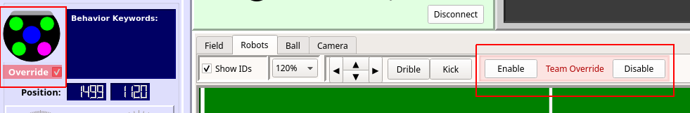

*Above: Robobulls Dashboard. See the override checkbox (left) for individual bots, or the full-team override option (right). An overridden bot will not move autonomously.*

**Warning**: If, for any reason, the camera fails to track a robot (insufficient color calibration in ssl-vision, robot exits camera field of view, etc), it will drive erratically, continually picking up speed until it is moving dangerously fast. The robot will need to be turned off manually by hitting the power switch located on the rear-left side of the robot’s chassis, overridden in the Robobulls GUI, or issued a Halt command from the refbox. For this reason, we suggest lowering the robot’s ACCEL_MULT in [include/config/move_parameters.h](https://github.com/biorobaw/RoboBulls/blob/ssl-league-fixed/include/config/move_parameters.h) if you are not absolutely confident in the camera’s calibration & responsiveness.

**Known Issues & Workarounds**

**-Compilation issue when trying to compile from qtcreator**

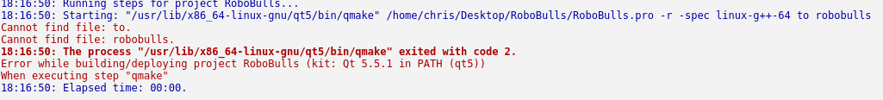

If you receive the above error message while trying to compile from qtcreator, to resolve this issue open the projects tab on the left hand side of qt creator. Then, under the build steps tab hit the details button and delete anything in the additional arguments field. The project should then compile normally.

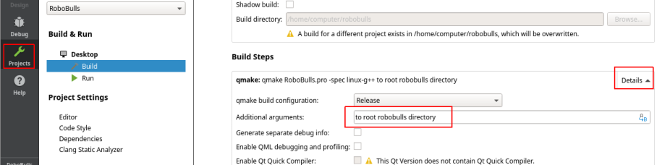

*Above: QtCreator build settings. Open the menu with the projects button (left), expand the build details (right), and remove any invalid additional arguments (center)*

**-Connectivity problems when attempting to connect robots to the yisibot transmitter for non-simulated games.**

Ensure that the serial port name in [communication/yisirobcomm.cpp](https://github.com/biorobaw/RoboBulls/blob/ssl-league-fixed/communication/yisirobcomm.cpp) matches the USB device name used for the transmitter, found by looking in the file system’s /dev/ folder under the name ttyUSB#, where # is a number assigned to the transmitter. Ex: “/dev/ttyUSB1”

Turn on the robot and allow it some time (if the robot’s faceplace shows eyes, it is ready) to fully boot. Then, plug the yisi transmitter into the computer. Afterwards, run the robobulls dashboard. The yisi transmitter will blink left and right, then blink both lights simultaneously, then both lights will stop blinking and stay on, indicating successful connection to the bots (see unexpected behavior on connection issue below). At this point you should be able to manually move an overridden bot through the robobulls software by selecting it and using the WASD keys.

If this fails, repeat the process. The robots don’t need to be powered off/on again. If the lights on the transmitter never transition from left/right blink to double blink on starting robobulls software, restart the machine. This may take many attempts.

**-Robots frequently collide during pathing**

Unresolved. Robubulls uses FPPA pathing (fast path planning algorithm), the details of which can be found [here](http://fei.edu.br/rcs/2014/RegularPapers/robocupsymposium2014_submission_55.pdf), and the implementation of which is found in [movement/pathing/fppa_pathplanning](https://github.com/biorobaw/RoboBulls/tree/ssl-league-fixed/movement/pathfinding) files. Special note to commit [56bba26](https://github.com/biorobaw/RoboBulls/commit/56bba26d66e4e5a3f5f8290fcb6279cfde8487e5), where a ‘personal bubble’ was added around each bot, in which obstacles are ignored, as well as commit [08b6f67](https://github.com/biorobaw/RoboBulls/commit/08b6f6755fa137d15b04db9217844edb66959346), which runs that algorithm as much as possible. Together, these changes seem to introduce behavior that results in bots immediately disregarding any obstacle that ever comes too close - further investigation required.

**-Normalize speed function is** [**implemented**](https://github.com/biorobaw/RoboBulls/blob/982301e1381631f17590bb692b101535ebf395c8/movement/four_wheel_omni/four_wheel_omni_pilot.h) **but not used**

Currently this means robots increase in velocity indefinitely until they reach their target. Use of this function should set a hard cap for how fast they can move which is specified inside the robot soccer ruleset (1.5 m/s).

**Additional Resources**

[Robobulls Readme](https://github.com/biorobaw/RoboBulls/blob/ssl-league-fixed/documents/readme.docx)

[Robobulls Installation Guide](https://github.com/biorobaw/RoboBulls/blob/ssl-league-fixed/documents/InstallInstructions.pdf)

[Robobulls Operation Guide](https://github.com/biorobaw/RoboBulls/blob/ssl-league-fixed/documents/RunInstructions.pdf)

[Robobulls Development Goals](https://github.com/biorobaw/RoboBulls/blob/ssl-league-fixed/documents/Robobulls_Development_Goals.pdf)

[SSL-Robocup Ruleset](http://wiki.robocup.org/Small_Size_League/Rules)

[SSL-Refbox Documentation](http://robocupssl.cpe.ku.ac.th/referee:start)

[SSL-Vision Official Documentation](https://github.com/RoboCup-SSL/ssl-vision/wiki)

[SSL-Vision Robobulls Operation Guide](https://github.com/biorobaw/RoboBulls/tree/ssl-league-fixed/documents/SSL_Vision_Operation_Guide.pdf)

[Yisibot Manual](https://github.com/biorobaw/RoboBulls/tree/ssl-league-fixed/documents/Yisibot_Manual.pdf)

[Robobulls GUI Honors Thesis (Overview of Robobulls)](https://github.com/biorobaw/RoboBulls/tree/ssl-league-fixed/documents/RobobullsGUIHonorsThesis.pdf)

[Robobulls Software Presentation Complete](https://github.com/biorobaw/RoboBulls/tree/ssl-league-fixed/documents/Robobulls Software Presentation Complete.pdf) (warning, lots of incorrect info here)

Also, see the Robobulls pre-2016 Doxygen HTML documentation, found by opening the Documentation.html file located in documents of the main project folder.

**Contact Info**

After reading all of the above documentation, if you need additional clarification on an issue detailed above and the current lab admins are not available or are unfamiliar with your problem, you can contact one of the previous team members for more information.

May-Aug 2018 Team Members:

nherbert2@mail.usf.edu

* Familiar with Yisirobot movement code, out-of-lab installation. Authored readme, devgoals, installation guide, operation guide, architecture guide. (8/03/18)

kellerc@mail.usf.edu