Yu-Ting Chung

**Visual SLAM Run Instructions**

1. **Description**

This project is to develop a SLAM algorithm running on Raspberry Pi with camera. The SLAM algorithm does both mapping and localization (location and orientation) at the same time using only a camera. In addition, colored landmarks can be recognized during navigation.

1. **Environment**

Linux Ubuntu 18.04

g++ 7.3.0

OpenCV 2.4.13.6 (Required at least 2.4.3)

Eigen 3.3.4 (Required at least 3.1.0)

1. **Camera Calibration**

Need a Chessboard.

Modify the following values in default.xml (config/default.xml) before running the camera calibration:

* Board size
* Square size
* Input (camera ID)

Running the calibration:

cd build

./camera-calibration

Pressing g to start the calibration. “camera_data.xml” will be generated.

Using the camera matrix and distortion coefficients information in the generated xml file after calibration.

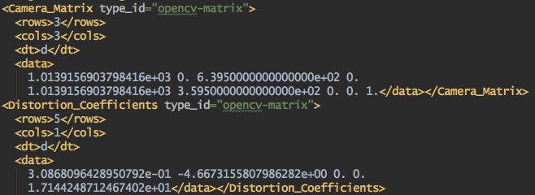

The corresponding variables are as below:

* Camera matrix = [fx, 0, cx, 0, fy, cy, 0, 0, 1]
* Distortion coefficients = [k1, k2, p1, p2, k3]

Now, we need to adjust the parameters in webcam.yaml (config/webcam.yaml) according to the calibration.

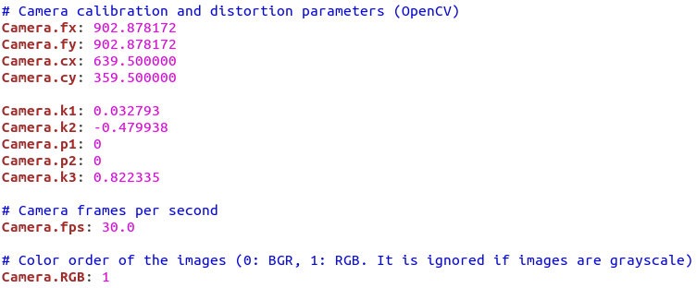

1. **Visual SLAM**

After the camera calibration, adjusting the parameters for the camera, and unzipping the vocabulary file, we can simply run the following command to start the program:

cd build

./main