Running Drone Alpha-Beta Algorithm using ROS

Bishop Clark

University of South Florida

# Introduction

This walkthrough explains how to run the alpha-beta program for the AR Drone 2.0 using the ROS software. It is assumed at this point that the reader has the necessary amount of operable Ubuntu Linux devices with ROS installed properly on them. As well as have already cloned the ‘ardrone’ repository from the USF GitHub Bio robotics page.

* Ubuntu Linux 16.04 Xenial (tutorials.ubuntu.com)
* ROS Kinetic version (wiki.ros.org)
* Files (github.com/biorobaw)
* AR Drone 2.0
* If not already in the bash file, add the line “source /opt/ros/kinetic/setup.bash” to enable ROS commands within the terminal; you can open this file by inputting “gedit /.bashrc”

## Initial Configuration

1. AR Drone 2.0
   1. Verify a fully charged lithium ion battery and equip it to the AR Drones
   2. Equip the wing propeller hull to each AR Drone for safety
2. Linux Machines
   1. Open the AlphaBeta.py file on each Linux device and configure the colors for that drone to follow
   2. The objective pink HSV color used in the tests is lower bound: (90, 90, 200) and upper bound: (180, 255, 255)
   3. The objective neon green HSV color used in the tests is lower bound: (10, 110, 100) and upper bound: (100, 255, 255)
   4. Save each file
   5. Open network connection interface
   6. Connect to the desired AR Drone network
   7. Open a terminal and input the command “roscore” on each machine this will connect to the ROS Master node (do not close)
   8. Open a second terminal and navigate to the directory in which the ‘drone.launch’ file is held on each machine, input command “roslaunch drone.launch”, this file determines what initialized parameters to set when running the program. It returns to the machine various data on the current state of the drone as well, such as battery power, camera usability, etc.

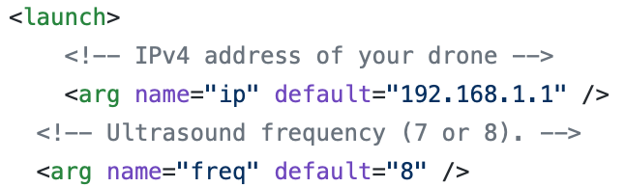

* 1. Note: If “roscore” does not successfully connect, change the IP address in the launch file to “192.168.1.2” instead, if it still does not connect you must change your hostname to this.

## Running AlphaBeta Program

1. Verify the above steps are functional
2. On a third terminal, navigate to the directory where ‘AlphaBeta.py’ is held on each machine
   1. Place each drone in a safe location away from each other in a large environment
   2. To begin flying, run the command “python AlphaBeta.py” on the command line on each machine terminal

Warning: the drones will takeoff approximately two seconds after the command is entered. If for any reason the drones have malfunctioned, stop the program using CTRL+C.

1. If any drone has red lights among any rotors, disconnect and reconnect the battery, the launch file will reconnect with the drone and repeat steps starting with Running AlphaBeta Program step 1.