Self-Supervised Object Recognition and Manipulation for Sorting Electronics Waste

Matt Travers & Howie Choset, Carnegie Mellon

Recycling and reclamation have grown in relative importance in recent years, as we begin to realize the limitations of natural resources and the impact certain materials, if not properly disposed, can have on the environment. For both processes, a critical task involves physically extracting raw materials. This is complicated as raw materials with any real value are typically processed, productized, or otherwise difficult to access in whatever bulk loads of material arrive at a recycling or reclamation facility on a given day. To help address this complexity and better facilitate the long-term goal to retrieve raw materials with higher efficiency and quality across a broad spectrum of markets, this work focuses on developing a novel automated system that addresses a critical first step in the retrieval processes: sorting at an industrial scale.

To this day, industrial-scale sorting is a time-consuming job, with a high turn-over rate, that requires human intervention to achieve highly accuracy separations. This is due mostly to the fact that there is a large amount of variability in the type, shape, condition, etc. of potential materials to be sorted. Because of these and many other reasons, conventional sorting falls short of serving society’s needs. Therefore, this work turns to artificial intelligence, machine learning and automation to assist people in sorting recyclable and potentially dangerous materials. Specifically, this work continues an ongoing collaboration between Apple and CMU whose near-term goal is to prototype a self-contained parts-sorting system that learns, without supervision, to robustly recognize and reliably manipulate a diverse set of changing items or materials over time.

In the initial portion of this collaboration, the current work focused on the first of these two key functionalities: robustly recognizing previously unknown items, with a specific focus on electronics waste. Our approach builds upon conventional machine learning algorithms that have recently gained notoriety in a variety of application domains. One of the challenges in adopting machine learning approaches is the availability of data (especially labeled data), on which the system can learn. Despite the availability of images of cell phones and other electronics on-line, finding “enough” images of a particular make and model of item to, e.g., train a visual classifier is challenging, if not impossible, to this day. Furthermore, many of the images of a given item, which would be available online, would picture the item when new, and not in the myriad of different conditions the same item will be, when a recycling facility receives them. In our current work, we have been able to show that by starting with a just physical cell phone, whose class is not known to a visual classifier, we can generate synthetic image data that can be used to retrain the classifier to recognize, with confidence, the same make and model of phone should it appear again regardless of what it might be in, i.e., scratched, dented, broken, etc.

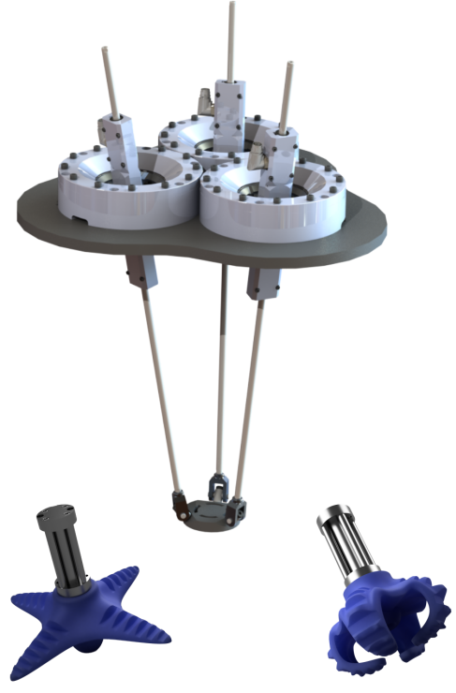
This work proposes i) to further evaluate and refine our automated visual classification system, and ii) to focus on addressing the second of the key functionalities we strongly believe is necessary to create a truly self-contained sorting system: developing a manipulation system that reliably sorts a large variety of different items across a spectrum of physical sizes and geometries, including those that may not have ever been seen before. To this end, this work intends to pursue three inter-related, but individual technical thrusts:

T1: System Quantification and Manipulator Refinement: We seek to advance and quantify the performance of the existing baseline Apple-CMU automated visual classification system to determine expected throughput, to gauge its accuracy, and to find out how well the system works when used in conjunction with an autonomous pick-and-place robot. At its core, this portion of the proposed work looks to compose and rigorously evaluate the performance of a composite classification-manipulation system. All too-often, researchers develop component concepts and technologies in isolation, without any consideration to the integrated system. Our goal is to develop a better understanding of how well the system works when its components are indeed fully integrated, and we task it with running in a fully autonomous mode.
Figure 1: Manipulator and end-effector concept designs

As a starting point for the manipulation, we intend to design and build a novel robotic arm with an innovative end-effector constructed out of soft material (Fig. 1). We are currently in the process of building a prototype of this initial concept and are eager to start experimenting with it. Note that the prototype pictured in Fig. 1 was designed to manipulate cell phones. However, in addition to speed and accuracy, a sorting system must be able to reliably manipulate items across a diverse physical spectrum of electronic products, including cell phones, laptops, tablets, monitors, etc. Therefore, in addition to further evaluating the automated visual classification system that was the focus of the initial portion of this work, this proposed effort also looks to evaluate and quantify manipulation performance, especially as it relates to manipulating never-seen-before items across a broad scale of size and weight. To this end, we propose to:

- Prototype different modular end-effector models using soft materials and novel actuation;
- Evaluate prototypes using high-speed manipulator to establish performance baselines;
- Revisit design of manipulator “arm” and build second evaluation unit, considering different power and physical configurations;
- Evaluate and quantify (% successful grasps, speed, etc.) different manipulator and end-effector combinations over items with wide range of physical characteristics.

The primary questions to be answered in this investigation are:

- Can a single manipulator with a single end-effector manipulate all items?
- Does a single manipulator with heterogeneous end-effectors suffice?
- Is there some fixed subset of manipulators and end-effectors that “cover” the full spectrum of items to be manipulated?

T2: Learning Self-Supervised Manipulation Policies for New Object Classes: The hardware-centric technical thrust described above focuses on what is physically possible in terms of manipulating different items across physical scales given and with different potential manipulator designs. This technical thrust aims one-level deeper: if a manipulator design is theoretically capable of physically manipulating a given item (e.g., item’s weight is within payload bounds, force closure “should” be possible, etc.), what is the best, or most reliable way to do so? Especially if the item to be manipulated has never been seen before. To this end, we intend to apply a similar set of underlying principles to that we are currently using to recognize never-before-seen object classes to learn object manipulation policies using a self-supervised approach.

Specifically, the novelty of this portion of the proposed work is to employ and advance dynamics randomization to learn in a self-supervised manner manipulation policies for robotic manipulators using only (or primarily) simulated data, i.e., a policy is trained in simulation and deployed on hardware. Dynamics randomization functions similarly to the concept of domain randomization, the idea that served as the basis for self-training object our recognition system. In both approaches the idea is the same: if there is enough “variation” in a simulated data set, we can train a network (e.g., a recognition network, a policy network, etc.) based almost entirely on the synthetic data, then deploy it in the real world and expect reasonable behavior. In a sense, the “parameters of the real world” end up looking like just another variation in the data; if a system can be trained to be robust to these variations, we can expect reasonable behaviors to emerge, even when deployed in the real world.

In dynamics randomization, the primary idea is to vary the physical parameters that define an underlying simulation environment (frictional properties, inertias, etc.). A manipulation policy is then trained to optimize performance across these variations, i.e., to produce a policy that is robust across a wide variety of different “physical” conditions. The policy is then deployed on hardware. Prior works have shown dynamics randomization is effective in training robotic manipulators to perform a variety of different manipulation tasks. This work proposes to use dynamics randomization as the basis for automatically teaching our manipulation system to robustly manipulate different fixed object classes as well as new object classes should they appear over time.

The specific sequence of steps we imagine executing in the dynamics randomization pipeline is:
- A new object class (e.g., a new type of cell phone) that is not currently recognized by a pre-trained classifier (e.g., a phone-type classifier) is identified;
- A 3D scanning system makes a full scan of the unknown object;
- A 3D mesh for the object is generated from the point cloud data;
- The mesh is sent to a rendering engine for domain randomization, and Gazebo, or an equivalent open source physics simulator for dynamics randomization;
- A pick-and-place policy is trained to manipulate the model of the unknown item in the randomized physical worlds using model free reinforcement learning (e.g., using the recurrent deterministic policy gradients method);
- The policy is deployed on the physical robot and its performance evaluated.

T3: Integration of Visual and Manipulation Learning: The primary practical objective of this work is to demonstrate an integrated prototype system that:
- Uses the visual classifier to be developed to view cell phones moving by the sensor at an operational tempo;
- Let’s pass classes of phones that it recognizes;
- Physically isolates any phones that are not recognized by the classifier;
- Generates a full, three-dimensional scan of the outside of any unknown phones using an RGB-D sensor;
- Creates a mesh from the scan that is sent to a rendering engine to be used in domain randomization to generate synthetic data that is used to retrain the visual classifier;
- Sends the mesh to a physics engine to be used in dynamics randomization, wherein a manipulation policy will be learned; and,
- Uses a prototype manipulator, with novel end-effector to physically grasp the phone and place it in a desired location.

Milestones:

Tasks | Thrust | Month
Tasks | Thrust | 1 | 2 | 3 | 4 | 5 | 6 | 7 | 8 | 9 | 10 | 11 | 12
Finalize initial manipulation arm and end-effector | T1
Quantify integrated, automated classification system performance (e.g., % correct classifications, sorting speed, etc.) | T1
Prototype and experiment with different arm and end-effector configurations | T1
Finalize and experiment with manipulation hardware | T1
Develop system that reliably creates 3D models of electronics items with various physical sizes | T2
Train manipulation policies in simulated worlds with randomized dynamics using model-free reinforcement learning | T2
Deploy manipulation policies on manipulation hardware and experiment | T2
Integrate self-contained object recognition and manipulation subsystems | T1 & T2
Prepare for final integrated demo | T3

Budget:

Total Personnel Costs 234,524
Total Hardware Costs 40,000
Total Travel Expense 3,548
Total Direct Cost 281,478
Facilities & Administration 123,135
Total Project Cost $404,612

