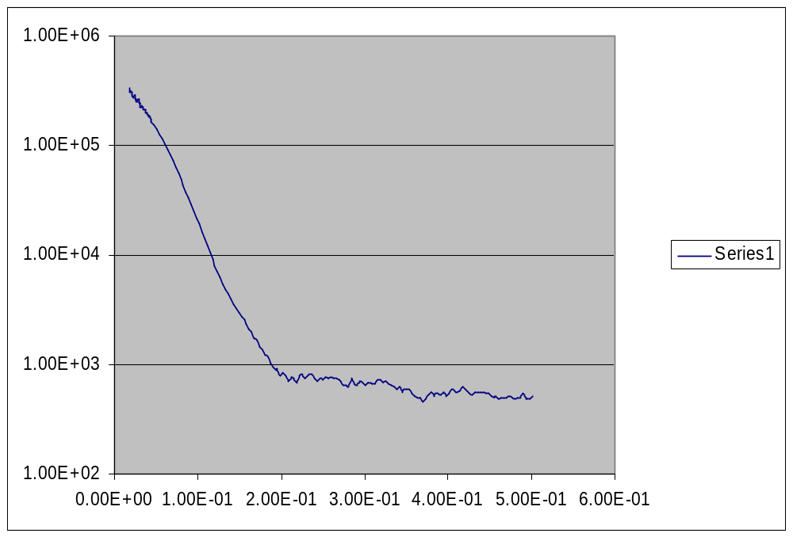

Experimental data in .fit file of an early run (above) and same expt data after several independent runs of EOM.

