**Shapes On Keys**

Team Members:-

Chaitanya Karadkhedkar (31)

Krishna Bisoi (32)

**IN PARTIAL FULFILMENT OF UNDER GRADUATE**

**PROGRAM IN SCIENCE**

**IN COMPUTER SCIENCE**

**P.V.G's COLLEGE OF SCIENCE**

**PUNE**

**(2017 - 18)**

**ACKNOWLEDGEMENT**

It has been a great opportunity to gain a lot of experience in real time project, followed by knowledge of actually implementing various ideas in the project and testing them.

We want to thank all the people who helped and supported us in completing this project. We would like to extend a special gratitude to our principal Mrs. Surekha Deshmukh ma'am , and our project guide, Mrs. Shilpa Pawale ma'am, for their patience and guidance along the semester.

At last we would like to thank all the people who encouraged us to successfully complete the Computer Graphics project.

**Computer Graphics Concepts Used in Project**

* Key Handling
* Interactive Screen
* 2-D Display

**OpenGL Library and Methods Used in Project**

**Libraries**:

• glut.h

• gl.h

• glu.h

• math.h

**Methods:**

• glutInit(): glutInit is used to initialize the GLUT library.

• glutInitDisplayMode(): glutInitDisplayMode sets the initial display mode.

* glutInitWindowPosition() : glutInitWindowPosition sets Window position

• glutInitWindowSize(): glutInitWindowSize sets the initial window size.

• glutCreateWindow(): glutCreateWindow creates a top-level window.

• glutDisplayFunc() : glutDisplayFunc sets the display callback for the current window.

* glRasterPos2f() :Specifies the raster position for pixel operations.

• glutPassiveMouseFunc(): glutPassiveMouseFunc sets the mouse callback for the current window.

• glutKeyboardFunc(): glutKeyboardFunc sets the keyboard callback for the current window.

• glutMainLoop(): glutMainLoop enters the GLUT event processing loop.

• glBegin(): delimit the vertices of a primitive or a group of like primitives.

• glVertex2f(): Specifies a vertex.

• glEnd(): deliit the vertices that define a primitive or a group of like primitives.

• glFlush(): force execution of GL commands in finite time.

* glViewport(): The glViewport function sets the viewport.

• glMatrixMode(): specify which matrix is the current matrix.

• glLoadIdentity(): The glLoadIdentity function replaces the current matrix withthe identity matrix.

• glColor3f(): Sets the current color.

• glClear(): clear buffers to preset values.

* GlutBitmapCharacter():Without using any display lists, glutBitmapCharacter renders the character in the named bitmap font.
* glutPostRedisplay():Mark the normal plane of current window as needing to be redisplayed.
* glutCreateMenu() : create a menu .
* glutAddMenuEntry() : To add menu item in a menu.
* glutAttachMenu(): attaches a mouse button for the current window to the identifier of the current menu.

Source Code:-

Screen Shots

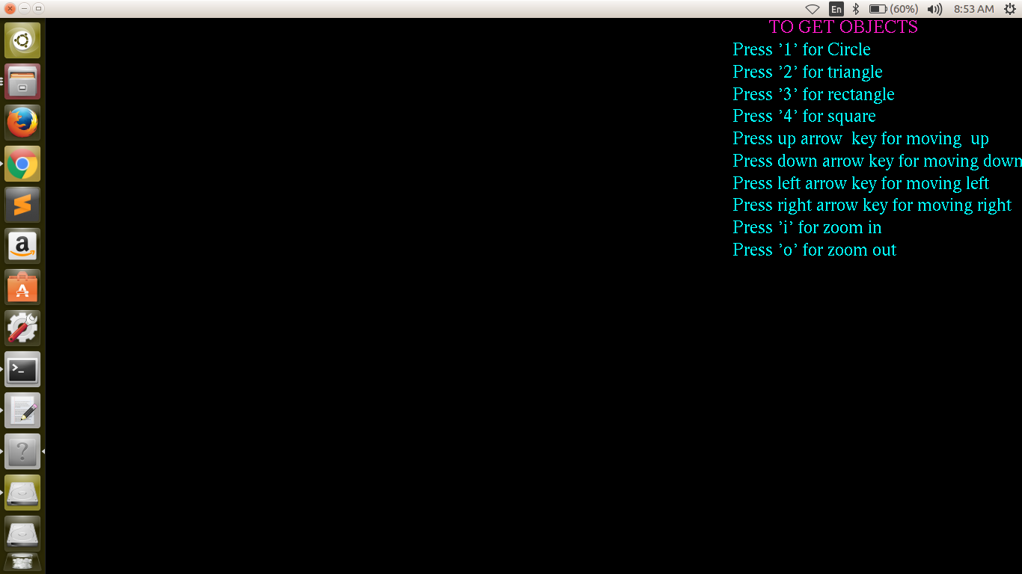

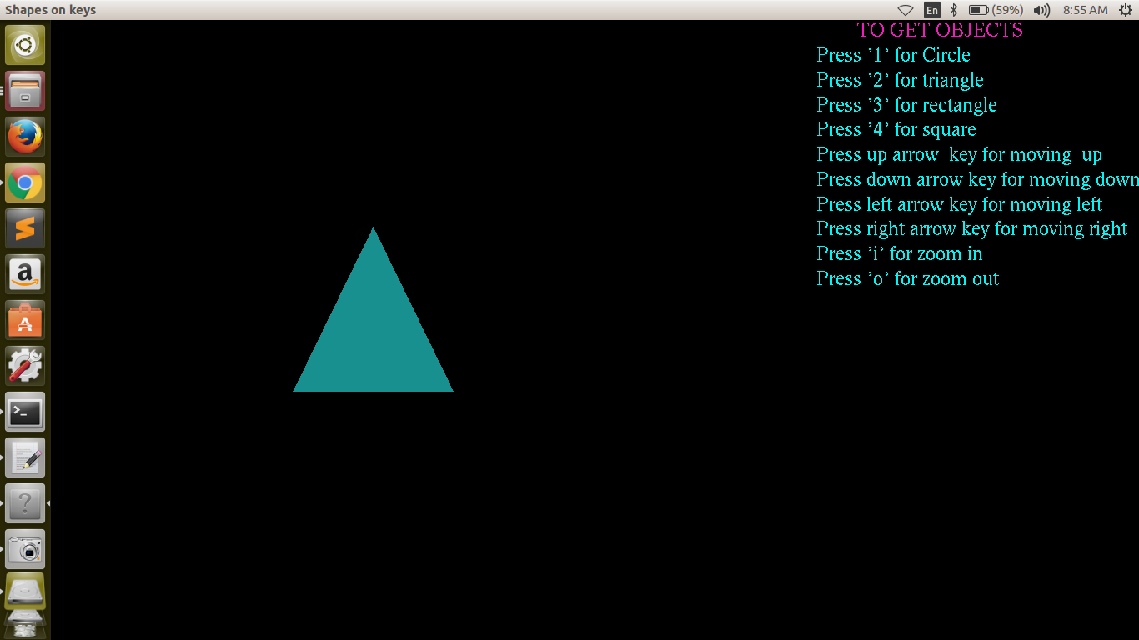

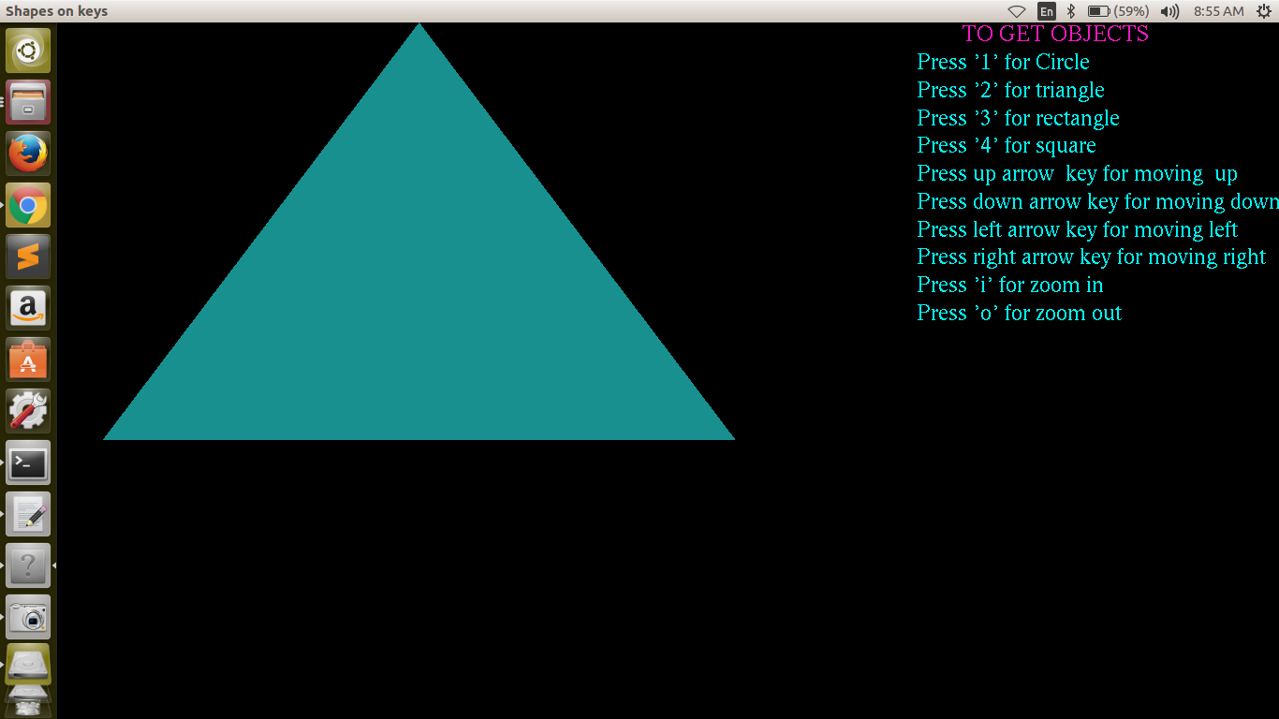

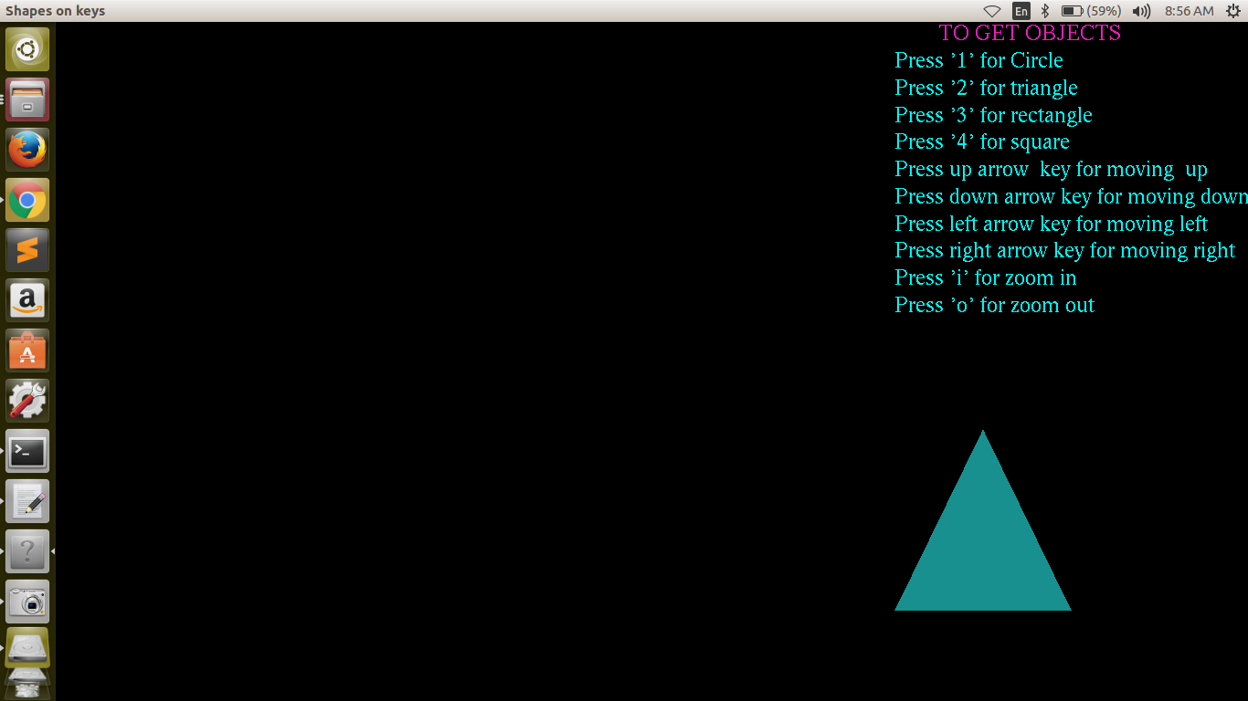

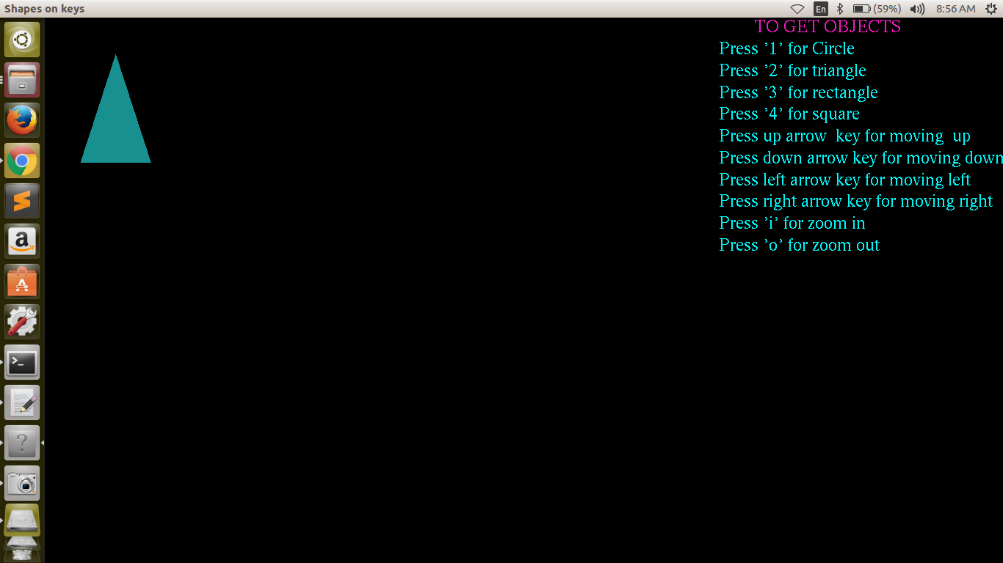

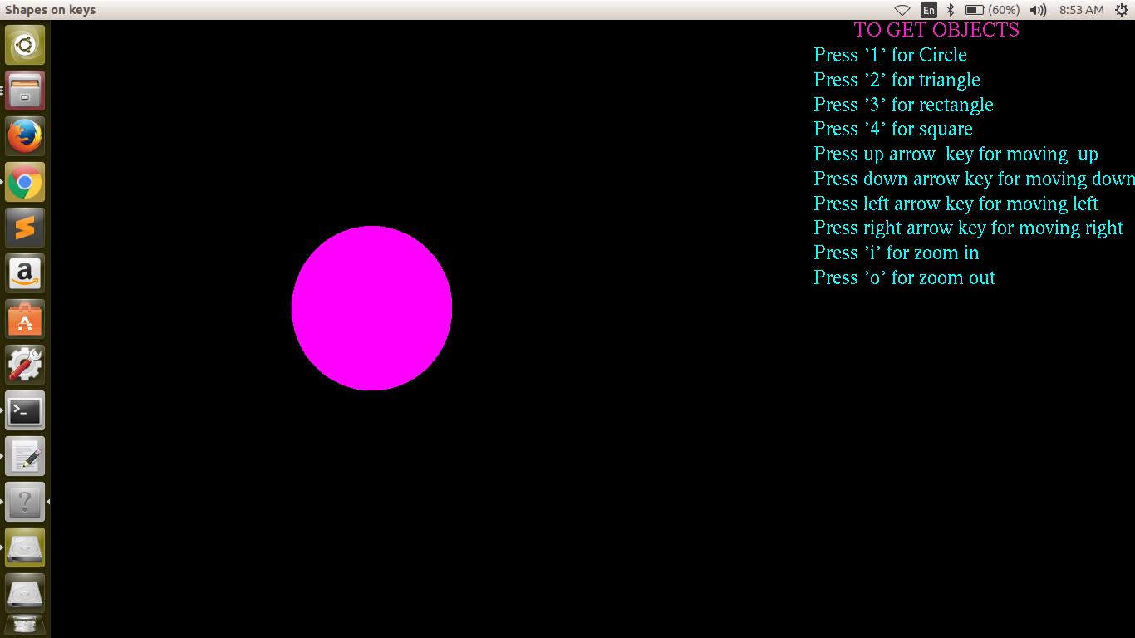

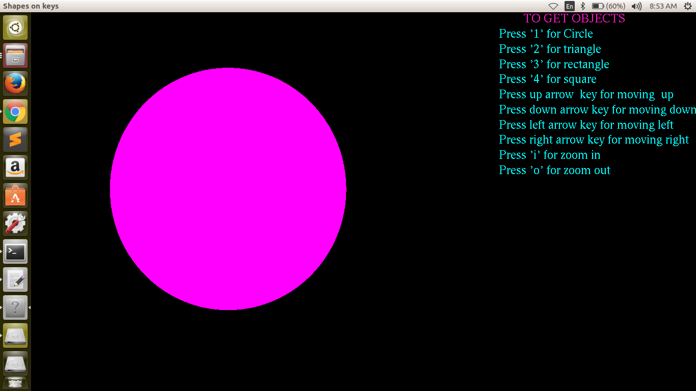

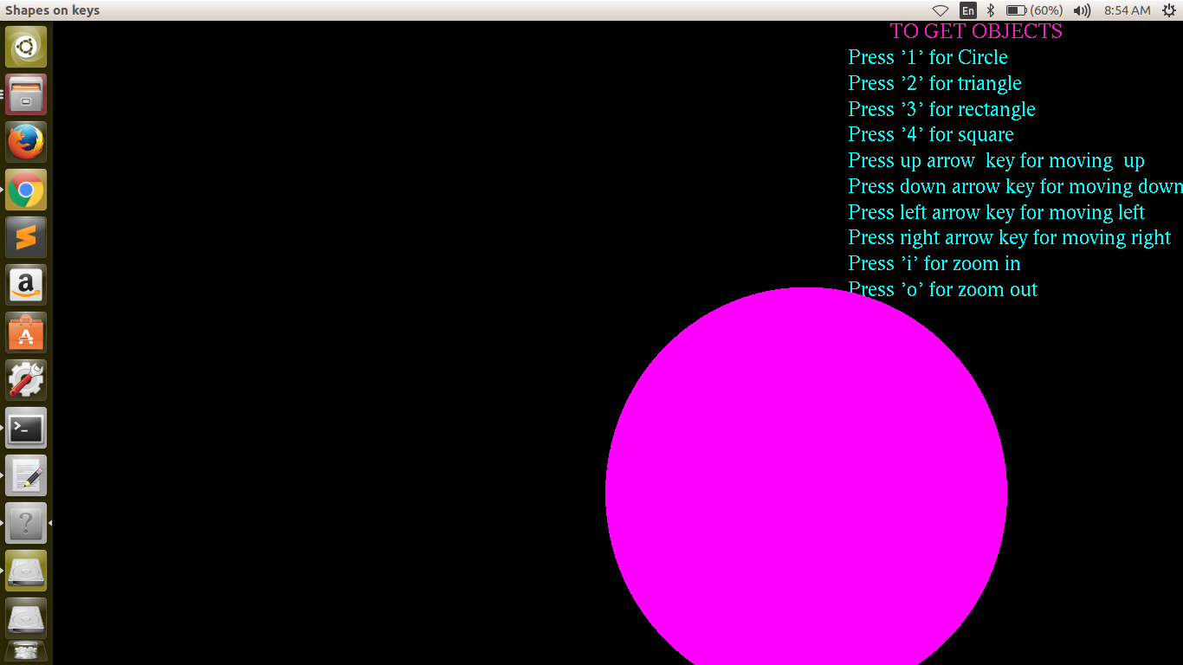

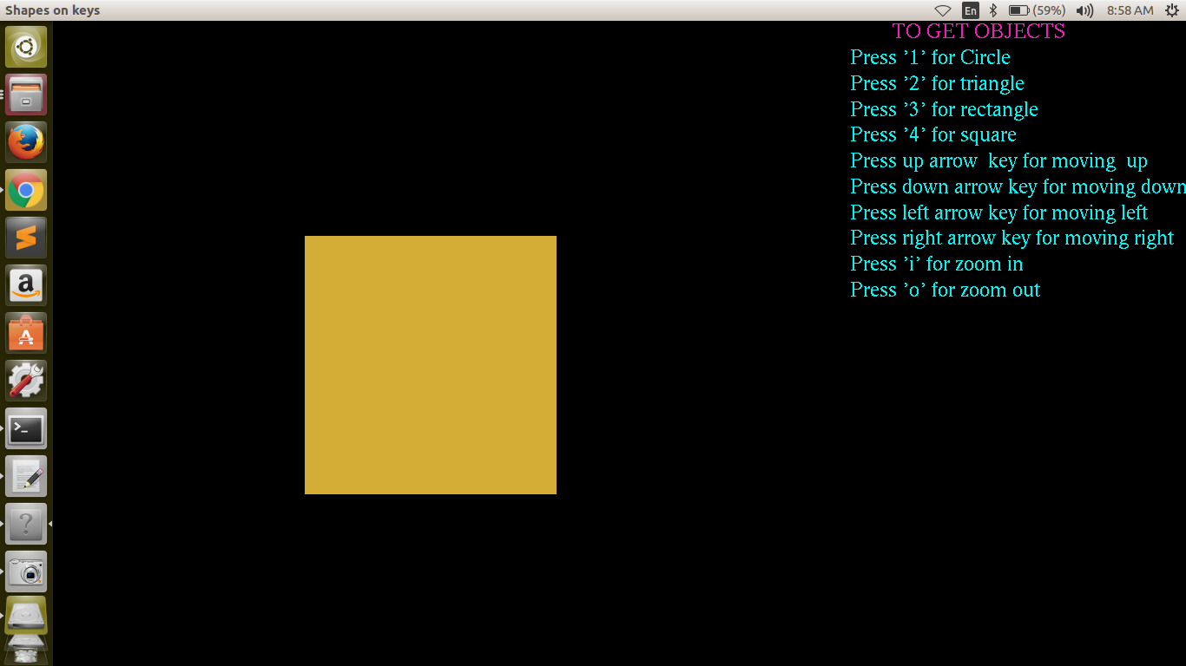

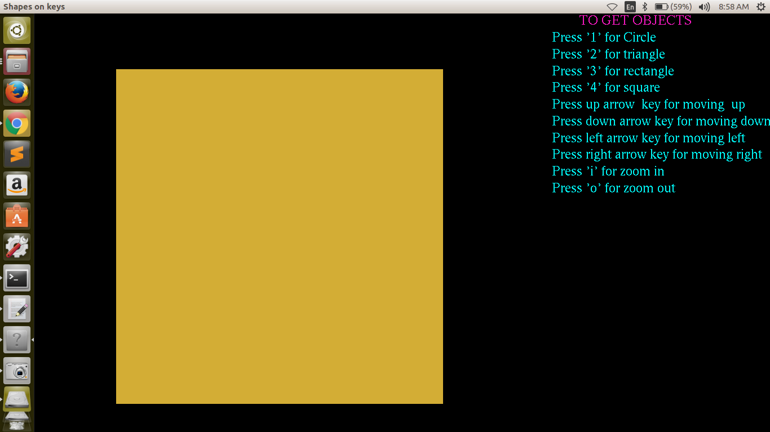

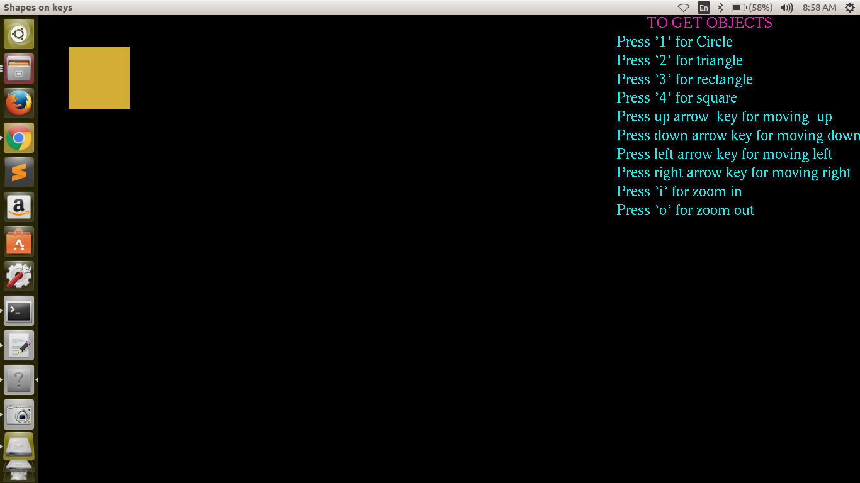

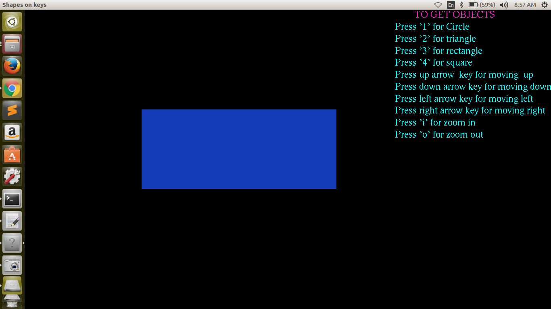

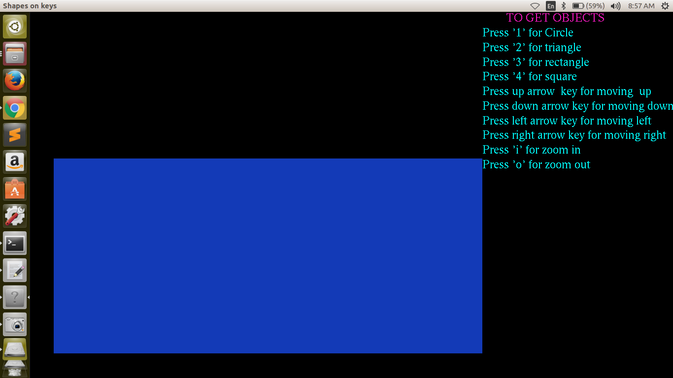

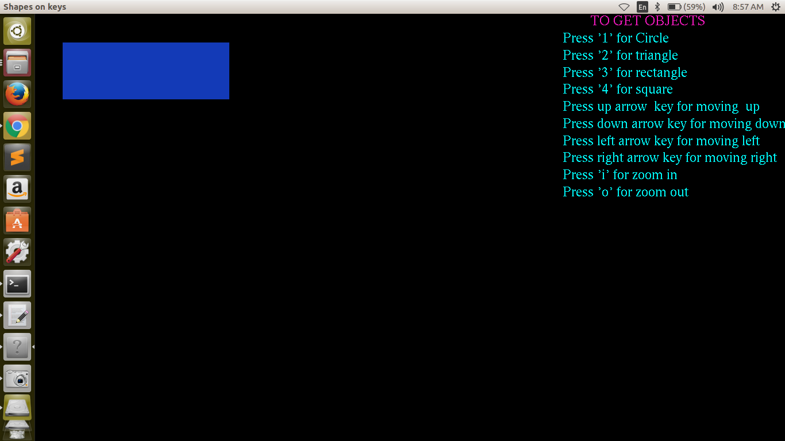

**Bibliography**

[http://www.coders-hub.com](http://www.coders-hub.com/)

[www.opengl.org](http://www.opengl.org/)

[www.opengl-tutorial.org](http://www.opengl-tutorial.org/)