# People Counting with Radar and ML

## Scope and purpose

The goal of the document is to explain our approach for solving the problem proposed in the hackathon. In particular, we created a model able to count the number of people in a room (from 0 to 3 people) within a range of 3 m using the data collected by means of the Infineon’s FMCW Radar.

## Intended audience

The document is intended to Infineon’s company which provided us the FMCW radar.

## Data Collection

Data were collected with radar sensor BGT60TR13C at the height of 0.95 m from the floor. The acquisition was brought on in three different environments with different indoor office scenarios as suggested by the task presentation.

For every scenario the four cases were reproduced: 0 person, 1 person, 2 and 3 people.

## Pre-processing

Pre-processing consists of two steps: signal processing with *Preprocessing_rangeDopplerData* which already performs mean subtraction form the signal and the FFT and data transformation into a 2D format in order to get better performances from the DNN model.

Data coming from the 3 different environments where subsequently concatenated

## ML approach

The problem was set as a multi-classification task and for the model generation transfer learning was used.

## Train and Validation

The model was trained with the 80% of the data (28800 samples) using the train_test_split function which already performs data random shuffling. The validation was carried on the remaining 20% of the data corresponding to 7200 samples.

The model used was EfficientNetV2L and was trained on the subsequent 700 layers.

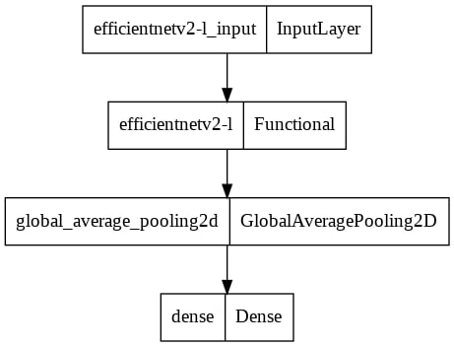

## Achieved results

To evaluate the results we have taken a look at the confusion matrix which shouws the percentage of classification for each class

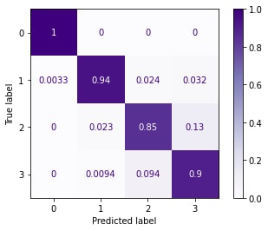

## Algorithm complexity

