This is a tutorial for CellML emphasising the modularity, reuse, and exchange features that are available when developing models in a CellML 1.1 framework. The focus of this tutorial is the application of a CellML based modelling framework in the area of cardiac cellular electrophysiology.
The reference description can be browsed from the models.cellml.org a1 workspace...
There are two parts to the tutorial. The first is a detailed guide to the modification of an exisiting “published” model which is available on the internet. The example used is modifying the original Hodgkin & Huxley 1952 squid axon model to produce action potentials closer to those found in cardiac cells.
The second part applies the same techniques to a more realistic scenario, namely that of modifying the stimulus protocol being applied to a model of human cardiac myocytes.

Modifying Hodgkin & Huxley toward Noble 1962
This section of the tutorial illustrates the modularity and reuse aspects of CellML. An accurate representation of the original Hodgkin & Huxley 1952 squid axon model has previously been published and made available on a web server at NUS in Singapore. In this task we first validate this implementation of the model and then modify it through the replacement of the potassium current for a model available in the CellML model repository and the slight modification of some parameters. These modifications are sufficient to turn the short duration nerve action potential into a long lasting action potential similar to the Noble 1962 cardiac Purkinje fibre action potential.
The basic premise of this example is based on the first biophysical cardiac cellular electrophysiology model, published by Denis Noble in 1962, which defines a modification of the Hodgkin-Huxley 1952 squid axon model capable of reproducing the action and pacemaker potentials observed in Purkinje fibres. In this tutorial we start with a CellML description of the Hodgkin-Huxley model and modify it to reproduce some of the key features of the Noble 1962 model.

HH model structure
The structure of the NUS implementation of the HH model is illustrated in the figure below.
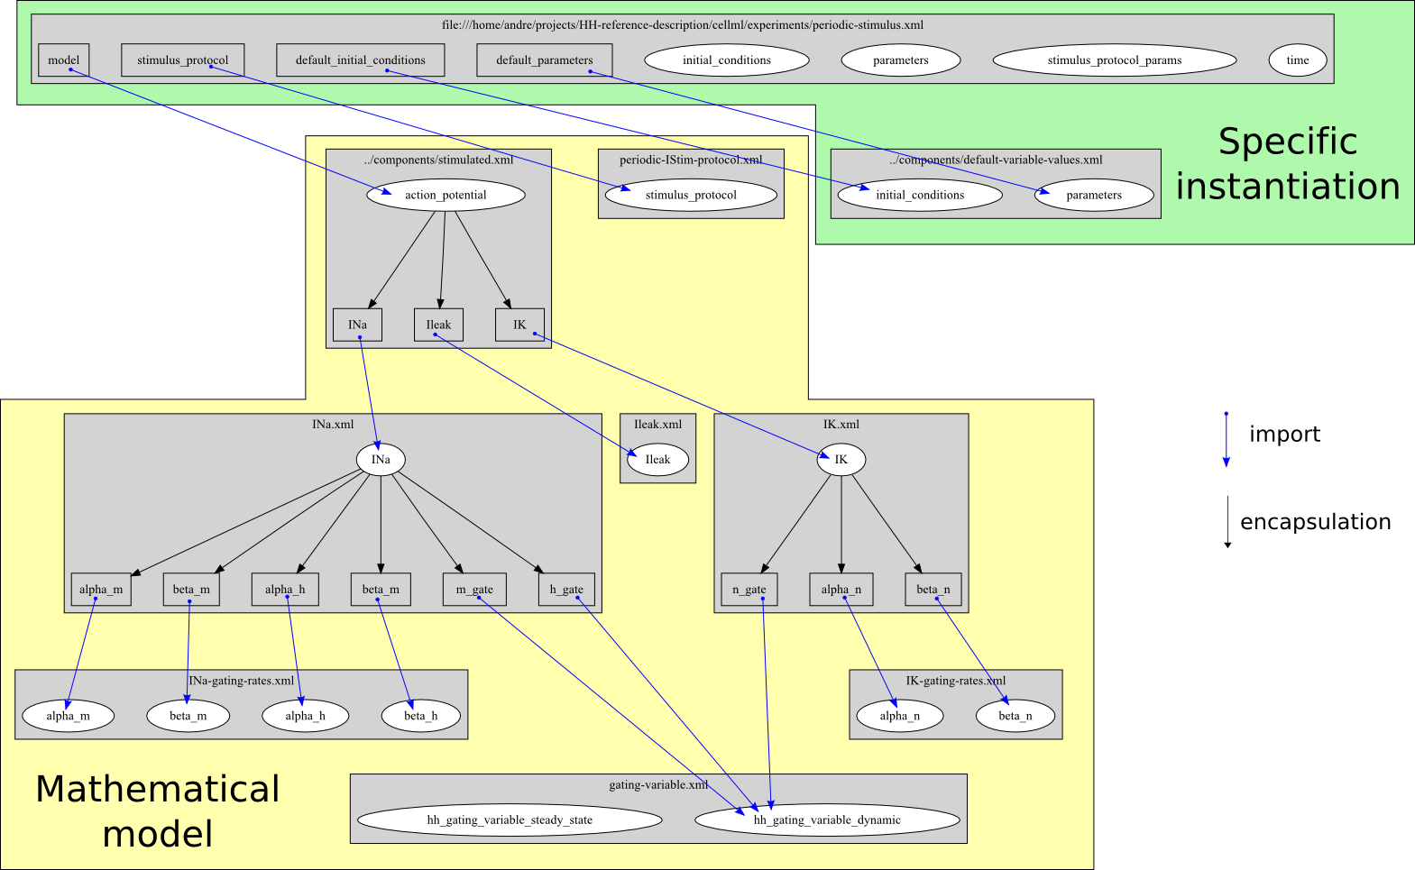
This diagram emphasises the modular definition of the model using CellML 1.1. The mathematical model is separated from the specific instantiation in to a specific simulation experiment. Reuse is illustrated by the use of a single definition of the standard Hodgkin-Huxley gating kinetics being reused for each of the m, h, and n gating variables.

HH Model Validation
The HH model used here has been previously implemented and is available online from the Computational Bioengineering Laboratory at the National University of Singapore. The original source of these models is http://www.bioeng.nus.edu.sg/compbiolab/p3/. All the graphs illustrated here are simulated directly from the data described on the NUS server. The following simulations serve to validate this implementation by showing simulation observations which correspond directly to those published by Hodgkin & Huxley (1952).
All references to files loaded in OpenCell are relative to the IUPS-2009-CellML-tutorial-models folder extracted from the model archive (ROOT). Just including a few examples from the complete “reference description” as I don't think we need to do them all here... The steps I describe are from using PCEnv 0.6 under a Windows Vista virtual machine.

Potassium Channel Kinetics Validation
Validation study investigating the kinetics of the potassium channel of the base implementation of the Hodgkin & Huxley model. Open OpenCell and load the model ROOT/NUS-HodgkinHuxley-Implementation/experiments/IK-gating-kinetics.xml. The simulation metadata gets parsed so you can just click integrate.
plot alpha_n and beta_n against membrane potential. alpha_n = alpha_n/alpha; beta_n = beta_n/beta; membrane potential = ramp/y [its described in the model mathematically as a linear ramp with a generic name, although imported as V]. This reproduces figure 4 from the Hodgkin & Huxley (1952) article.
plot n_infinity against membrane potential. [membrane potential as above; n_infinity = hh_gating_variable_steady_state/gate_inf (generic gating kinetics imported for each gate)]. This reproduces Figure 5 from the HH (1952) article.

Action Potential Validation
Validation study investigating the dynamic response of the base implementation of the Hodgkin & Huxley model to an applied electrical stimulus current. Load ROOT/NUS-HodgkinHuxley-Implementation/experiments/periodic-stimulus.xml into OpenCell. The simulation metadata gets parsed and you can just click integrate.
Plot action potentials [action_potential/minus_V vs time/time].
Plot currents [INa/INa vs time; IK/IK vs time; Ileak/Ileak vs time]
Plot gating variables [random hh_gating_variable_dynamic/gate vs time] – not sure how to work out which is which...
Any way to zoom in on a single AP in each of the above?

Modification toward Noble 1962 model
This task defines the modifications made to the base HH implementation in order to approximate the action potential shape of the Noble 1962 model. The figure below illustrates the model structure that we want to develop.
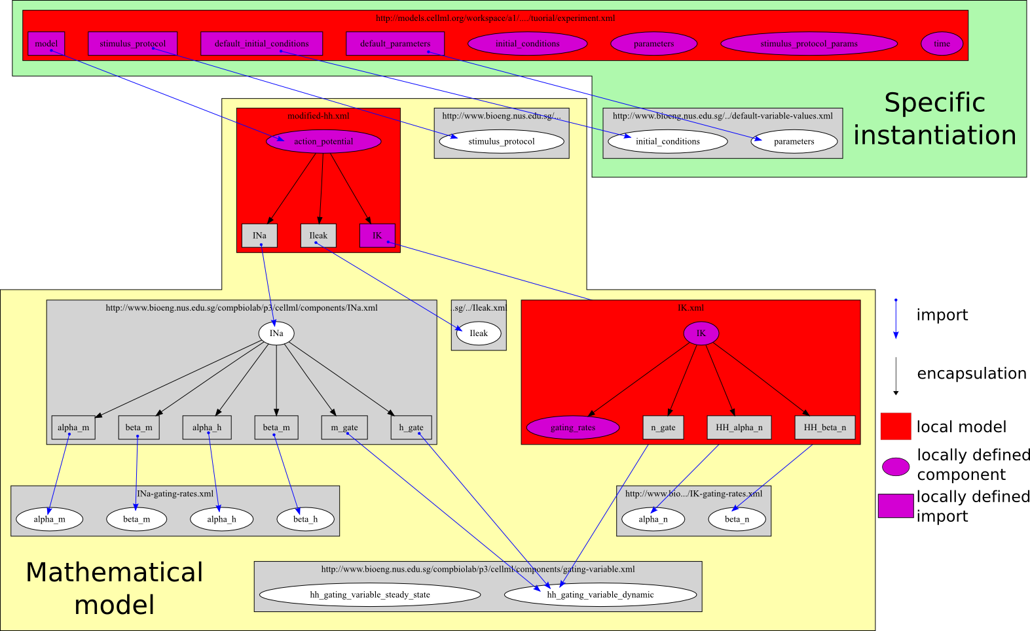
In this figure, all the red models are defined “locally” and the rest come from the base implementation from NUS described above. Within the local models, some of the components are imported from the base NUS model and some are newly defined. All units are imported from the base NUS model implementation.
The major change to the mathematical model is to replace the Hodgkin & Huxley potassium channel with one based on that described by Noble (1962). The Noble IK description has to be altered to reflect the modelling conventions used by Hodgkin & Huxley. If you load ROOT/models.cellml.org/workspace/a1/tutorial/modified-hh.xml into OpenCell you can see the structure of the actual mathematical model (at least, if you ignore the error message and go to the full tree view). Not really sure what specifics we might want to point out looking at this model? Essentially just shows the sodium and leakage current being imported from “NUS” and the potassium current being imported locally.
Now load ROOT/models.cellml.org/workspace/a1/tutorial/experiment-start.xml into OpenCell. In this model, the modified mathematical model is imported into a specific experiment model and all the default parameter values and initial conditions are imported from the NUS model implementation. The stimulus protocol parameters are defined locally to define a suitable stimulus protocol. Integrating this model and plotting [action_potential/minus_V vs time] shows the altered action potentials due to changing the potassium current formulation.
The other changes required to get the plateau-like phase in the action potential are to change the parameters Cm and gK_max to reflect the differences described by Noble (1962). This is done by [[creating a parameters component]] and then creating the [[Cm]] and [[gK_max]] variables. They both should have public_interface=out and Cm is units uF_per_cmsq and value 12.0 while gK_max has units mS_per_cmsq and initial_value 12.0. Then remove Cm and gK_max from the default_parameters connection to model [[always first 2 variable mappings?]]. The create connection between model and parameters component and connect Cm and gK_max.
Now graph the new action potentials to compare to the old ones. And everyone goes whoo hooo!
Not really sure what else to take out of experiment-start.xml that wouldn't be too time consuming to add back in. Feel free to play around and get something a bit more exciting to put together.

TNNP stimuli
Here we make use of an exisiting encoding of the ten Tusscher et al (2004) human ventricular myocyte model which has a periodic stimulus current applied. We replace this stimulus protocol with one suited for restitution analysis.
Nickerson & Buist (2008) (PBMB, Practical applicaiton of CellML 1.1...) published a study investigating the practical application of CellML 1.1 based on the ten Tusscher et al (2004) human ventricular myocyte electrophysiology model. The online supplement for this study is available at: http://www.bioeng.nus.edu.sg/compbiolab/papers/nickerson-PBMB-2008/, which includes all the simulation experiment descriptions presented in that study. As for the Hodgkin-Huxley example above, we first check that the base implementation available from the NUS server is correct and then modify it with a new stimulus protocol.

Periodic
Presentation of the results obtained from the default periodic stimulus simulation experiment from the experiment description provided on the NUS server (http://www.bioeng.nus.edu.sg/compbiolab/papers/nickerson-PBMB-2008/).
Load ROOT/NUS-TNNP-Implementation/papers/nickerson-PBMB-2008/experiments/TNNP-periodic.xml into OpenCell. Change the end time point to 10000 and turn on tabulation control with a tabulation interval of 1ms (why do I have to clone the model every time I click on anything!?!?!). Integrate. Plot the action potentials [[membrane_potential/V vs time/time]] – this is why you need the tabulation control to get action potentials that all look the same.

S1-S2 restitution
The Nickerson & Buist (2008) implementation of the ten Tusscher et al (2004) model includes the description of the model with an applied S1-S2 stimulus protocol (10 stimuli with a fixed period followed by a single stimulus at some interval after the 10th periodic stimulus. As this is a published and “fixed” set of CellML encoded models we are not able to change them directly, but we would really like to use that model with our own stimulus protocol description. Due to the modular nature of the model implementation available from NUS this is straightforward to achieve.
- Create a new model in OpenCell [[CellML 1.1 model; name = S1S2]]
- Save the model to ROOT/my-S1S2.xml
- Create a new import
  - URL: NUS-TNNP-Implementation/papers/nickerson-PBMB-2008/experiments/TNNP-S1S2.xml
  - Create a new component [[model => interface]]
- Create a new import
  - URL: NUS-TNNP-Implementation/cellml/models/common/units.xml
  - Create a new units [[ ms => ms]]
- Save it :)
- Create a new component in the top level model
  - name: parameters
  - Create variable:
    - name: basicCycleLength
    - value: 750
    - units: ms
    - public_interface: out
  - Create variable:
    - name: S2Interval
    - value: 500
    - units: ms
    - public_interface: out
- Save it :)
- Create new connection
  - Component 1: parameters
  - Component 2: model
  - Create new variable mapping
    - Variable 1: basicCycleLength
    - Variable 2: basicCycleLength
  - Create new variable mapping
    - Variable 1: S2Interval
    - Variable 2: S2Interval
- Save it!
- Randomly click around until the integrate panel comes up and lets you simulate the model
  - set tabulation control on with a tabulation interval of 1ms
  - end time of 10000ms
  - maximum step size of 0.1ms
  - integrate model
    - plot action potentials (membrane_potential/V vs time/time)
- Clone model
  - randomly see if you can edit the S2Interval parameter and change it to 800 and run simulation with same integration parameters as above
  - plot new action potentials along side the original one
- repeat 11 for several different values and plot them together
Not really sure how well this will work, I seem to get lots of random clones showing up and the model contents appears and disappears all over the place. Maybe you can find out a reliable way to do it? Steps 1-9 seem to work OK, but 10 was a bit strange....but the integration seemed to work fine once it decided I was allowed to integrate the model. 11 and 12 haven't worked for me yet...

