reportRx Demo

27 May, 2021

Table of Contents

# Introduction

This is an rMarkdown document to produce Word and PDF files from the reportRx package [@R-reportRx] in the R statistical programming language [@R-base].

First, make some changes to the lung data.

data(lung)  
lung <- lung %>%  
 mutate(  
 Status=factor(status-1),  
 Sex = factor(sex,labels = c('Male','Female')),  
 AgeGroup = cut(age, breaks=seq(0,100,10)),  
 OneLevelFactor = factor(x='one level')  
 ) %>%  
 arrange(Status)  
  
lung$x_null = rnorm(nrow(lung))  
lung$x_pred = c(rnorm(sum(lung$Status==0),0,1),  
 rnorm(sum(lung$Status==1),1,1))  
set.seed(1)  
test_data = tibble(  
 y= rnorm(1000),  
 x0= geoR::rboxcox(1000, lambda=.5, mean=10, sd=2),  
 x1= x0+y  
)

# 1 Numbered Heading

## 1.1 Test covsum

rm_covsum(data=lung,  
 covs=c('Status','Sex','age','AgeGroup','meal.cal','OneLevelFactor')  
)

Summary sample statistics.

|  |  |
| --- | --- |
| Covariate | n=228 |
| Status |  |
| 0 | 63 (28) |
| 1 | 165 (72) |
| Sex |  |
| Male | 138 (61) |
| Female | 90 (39) |
| age |  |
| Mean (sd) | 62.4 (9.1) |
| Median (Min,Max) | 63 (39,82) |
| AgeGroup |  |
| (0,10] | 0 (0) |
| (10,20] | 0 (0) |
| (20,30] | 0 (0) |
| (30,40] | 3 (1) |
| (40,50] | 23 (10) |
| (50,60] | 68 (30) |
| (60,70] | 88 (39) |
| (70,80] | 44 (19) |
| (80,90] | 2 (1) |
| (90,100] | 0 (0) |
| meal cal |  |
| Mean (sd) | 928.8 (402.2) |
| Median (Min,Max) | 975 (96,2600) |
| Missing | 47 |
| OneLevelFactor |  |
| one level | 228 (100) |

rm_covsum(data=lung,  
 covs=c('Status','age','AgeGroup','meal.cal','OneLevelFactor'),  
 maincov = 'Sex')

Summary sample statistics by Sex.

|  |  |  |  |  |
| --- | --- | --- | --- | --- |
| Covariate | Full Sample (n=228) | Male (n=138) | Female (n=90) | p-value |
| **Status** |  |  |  | **<0.001** |
| 0 | 63 (28) | 26 (19) | 37 (41) |  |
| 1 | 165 (72) | 112 (81) | 53 (59) |  |
| age |  |  |  | 0.057 |
| Mean (sd) | 62.4 (9.1) | 63.3 (9.1) | 61.1 (8.8) |  |
| Median (Min,Max) | 63 (39,82) | 64 (39,82) | 61 (41,77) |  |
| AgeGroup |  |  |  | 0.13 |
| (0,10] | 0 (0) | 0 (0) | 0 (0) |  |
| (10,20] | 0 (0) | 0 (0) | 0 (0) |  |
| (20,30] | 0 (0) | 0 (0) | 0 (0) |  |
| (30,40] | 3 (1) | 3 (2) | 0 (0) |  |
| (40,50] | 23 (10) | 11 (8) | 12 (13) |  |
| (50,60] | 68 (30) | 35 (25) | 33 (37) |  |
| (60,70] | 88 (39) | 58 (42) | 30 (33) |  |
| (70,80] | 44 (19) | 29 (21) | 15 (17) |  |
| (80,90] | 2 (1) | 2 (1) | 0 (0) |  |
| (90,100] | 0 (0) | 0 (0) | 0 (0) |  |
| **meal cal** |  |  |  | **0.022** |
| Mean (sd) | 928.8 (402.2) | 980.5 (413.3) | 840.7 (369.1) |  |
| Median (Min,Max) | 975 (96,2600) | 1025 (169,2600) | 925 (96,2450) |  |
| Missing | 47 | 24 | 23 |  |
| OneLevelFactor |  |  |  |  |
| one level | 228 (100) | 138 (100) | 90 (100) |  |

If you need to run an rm_ function in a loop, you need to use this structure: Unfortunately, this produces a NULL after each table, which is on the todo list!

pander::panderOptions('knitr.auto.asis', FALSE)  
  
for (v in names(lung)[1:2]){  
 cat("\n")  
 print(rm_covsum(data=lung,covs=v))  
 cat("\n")  
}

Summary sample statistics.

|  |  |
| --- | --- |
| Covariate | n=228 |
| inst |  |
| Mean (sd) | 11.1 (8.3) |
| Median (Min,Max) | 11 (1,33) |
| Missing | 1 |

NULL

Summary sample statistics.

|  |  |
| --- | --- |
| Covariate | n=228 |
| time |  |
| Mean (sd) | 305.2 (210.6) |
| Median (Min,Max) | 255.5 (5.0,1022.0) |

NULL

pander::panderOptions('knitr.auto.asis', TRUE)

## 1.2 Test plotunivariate

Figure 1.1 shows the bivariate relationships between the response and covariates. Figure referencing works only when a figure caption is provided in the chunk options. Note that underscores and not allowed in the chunk names, only hyphens.

plotuv(data=lung,  
 covs=c('Sex','age','AgeGroup','meal.cal','OneLevelFactor'),  
 response = 'Status',  
 response_title = 'Test Response Title',  
 showN=T  
)

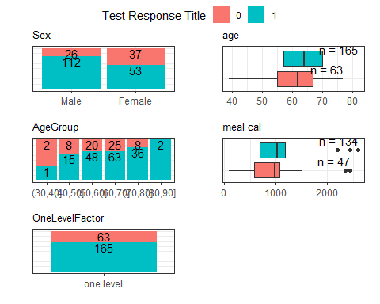

Figure 1.1: Associations between status and covariates in the lung data.

## 1.3 Tests for uvsum

### 1.3.1 Test logistic

Tables 1.1, 1.2 and 1.3 display the logistic regression results with different confidence interval widths. If the document in knit to pdf, the chank-lable option will not be used, instead the name of the chunk will be used in cross-referening. For Word tables the chunk label needs to be added into the function call.

rm_uvsum(response = 'Status',  
 covs=c('age','Sex','wt.loss'),  
 data=lung,  
 type='logistic',  
 chunk_label = 'test-uv-logistic-1' )

Table 1.1: Univariate analysis of predictors of Status.

|  |  |  |  |
| --- | --- | --- | --- |
| Covariate | OR(95%CI) | p-value | N |
| **age** | **1.04 (1.00,1.07)** | **0.025** | **228** |
| **Sex** |  | **<0.001** | **228** |
| Male | Reference |  | 138 |
| Female | 0.33 (0.18,0.61) |  | 90 |
| wt loss | 1.01 (0.98,1.03) | 0.61 | 214 |

rm_uvsum(response = 'Status',  
 covs=c('age'),  
 data=lung,  
 type='logistic',  
 CIwidth=.9,  
 chunk_label='test-uv-logistic-2')

Table 1.2: Univariate analysis of predictors of Status.

|  |  |  |  |
| --- | --- | --- | --- |
| Covariate | OR(90%CI) | p-value | N |
| **age** | **1.04 (1.01,1.07)** | **0.025** | **228** |

rm_uvsum(response = 'Status',  
 covs=c('age'),  
 data=lung,  
 type='logistic',  
 CIwidth=.99,  
 chunk_label='test-uv-logistic-3')

Table 1.3: Univariate analysis of predictors of Status.

|  |  |  |  |
| --- | --- | --- | --- |
| Covariate | OR(99%CI) | p-value | N |
| **age** | **1.04 (0.99,1.08)** | **0.025** | **228** |

### 1.3.2 Test Linear

rm_uvsum(response = 'wt.loss',  
 covs=c('Status','Sex','ph.ecog','meal.cal','age'),  
 data=lung,  
 CIwidth=.95)

Univariate analysis of predictors of wt loss.

|  |  |  |  |
| --- | --- | --- | --- |
| Covariate | Estimate(95%CI) | p-value | N |
| Status |  | 0.61 | 214 |
| 0 | Reference |  | 62 |
| 1 | 1.01 (-2.90,4.92) |  | 152 |
| Sex |  | 0.058 | 214 |
| Male | Reference |  | 128 |
| Female | -3.45 (-7.04,0.14) |  | 86 |
| **ph ecog** | **3.42 (0.99,5.85)** | **0.0055** | **213** |
| meal cal | -3.3e-03 (-8.3e-03,1.6e-03) | 0.18 | 171 |
| age | 0.05 (-0.14,0.25) | 0.58 | 214 |

rm_uvsum(response = 'wt.loss',  
 covs=c('age'),  
 data=lung,  
 CIwidth=.90)

Univariate analysis of predictors of wt loss.

|  |  |  |  |
| --- | --- | --- | --- |
| Covariate | Estimate(90%CI) | p-value | N |
| age | 0.05 (-0.11,0.22) | 0.58 | 214 |

### 1.3.3 Test coxph & ggsurv

rm_uvsum(response = c('time','status'),  
 covs=c('Sex','ph.ecog','meal.cal','age'),  
 data=lung,  
 CIwidth=.99)

Univariate analysis of predictors of survival.

|  |  |  |  |
| --- | --- | --- | --- |
| Covariate | HR(99%CI) | p-value | N |
| **Sex** |  | **0.0015** | **228** |
| Male | Reference |  | 138 |
| Female | 0.59 (0.38,0.90) |  | 90 |
| **ph ecog** | **1.61 (1.20,2.16)** | **<0.001** | **227** |
| meal cal | 1.00 (1.00,1.00) | 0.59 | 181 |
| **age** | **1.02 (1.00,1.04)** | **0.042** | **228** |

ggkmcif(c("time","status"),"Sex", data=lung,fsize=8,nsize=3)

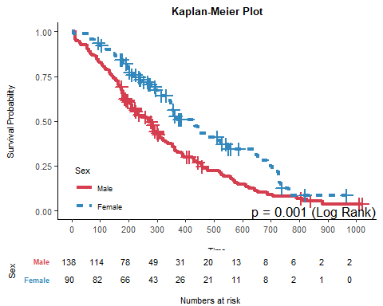

# Unnumbered Heading

## 1.4 Test mvsum & forestplot2

m = glm(Status~wt.loss+Sex,  
 data=lung,  
 family='binomial')  
rm_mvsum(m)

|  |  |  |
| --- | --- | --- |
| Covariate | OR(95%CI) | Global p-value |
| wt loss | 1.00 (0.98,1.02) | 0.97 |
| **Sex** |  | **<0.001** |
| Male | reference |  |
| Female | 0.32 (0.17,0.60) |  |

forestplot2(m)

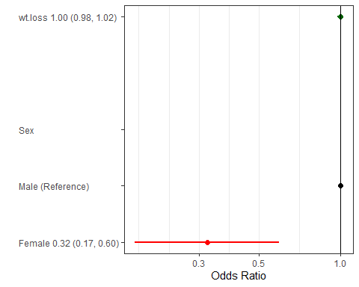

# 2 References

# 3 Appendix

Other results can go here.

### 3.0.1 Test crr

rm_uvsum(response = c('time','status'),  
 covs=c('Sex','ph.ecog','meal.cal','age'),  
 data=lung,  
 type='crr',  
 CIwidth=.90)

Univariate analysis of predictors of survival.

|  |  |  |  |
| --- | --- | --- | --- |
| Covariate | HR(90%CI) | p-value | N |
| **Sex** |  | **<0.001** | **228** |
| Male | Reference |  | 138 |
| Female | 2.49 (1.64,3.79) |  | 90 |
| **ph ecog** | **0.54 (0.40,0.72)** | **<0.001** | **227** |
| meal cal | 1.00 (1.00,1.00) | 0.9 | 181 |
| **age** | **0.97 (0.95,0.99)** | **0.028** | **228** |

rm_uvsum(response = c('time','status'),  
 covs=c('age'),  
 data=lung,  
 type='crr')

Univariate analysis of predictors of survival.

|  |  |  |  |
| --- | --- | --- | --- |
| Covariate | HR(95%CI) | p-value | N |
| **age** | **0.97 (0.94,1.00)** | **0.028** | **228** |

### 3.0.2 Test boxcox

rm_uvsum(response = 'y',  
 covs=c('x0','x1'),  
 data=test_data,  
 type='boxcox',  
 CIwidth=.90)

Univariate analysis of predictors of y.

|  |  |  |  |
| --- | --- | --- | --- |
| Covariate | Estimate(90%CI) | p-value | N |
| x0 | 6.2e-04 (-3.5e-03,4.8e-03) | 0.81 | 1000 |
| **x1** | **7.1e-03 (3e-03,0.01)** | **0.0043** | **1000** |