ggkmcif2
library(reportRmd)
data("pembrolizumab")

Figure Height = 5

ggkmcif2
ggkmcif2(response = c('os_time','os_status'),
cov='cohort', times = seq(0,36,6),xlim=c(0,25),
data=pembrolizumab)
Warning: Vectorized input to `element_text()` is not officially supported.
ℹ Results may be unexpected or may change in future versions of ggplot2.
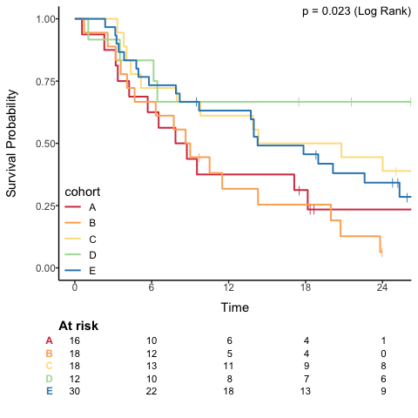

ggkmcif2
titleStr="myTitle"
ggkmcif2(response = c('os_time','os_status'),
#type="CIF",
cov='cohort', times = seq(0,36,6),xlim=c(0,25),
legend.pos=c(.25,0),
pval.pos=c(18,0),
main=titleStr,
data=pembrolizumab)
Warning: Vectorized input to `element_text()` is not officially supported.
ℹ Results may be unexpected or may change in future versions of ggplot2.
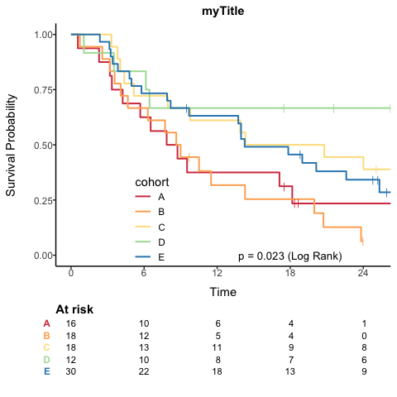

Figure Height = 4

ggkmcif2
ggkmcif2(response = c('os_time','os_status'),
cov='sex',
data=pembrolizumab)
Warning: Vectorized input to `element_text()` is not officially supported.
ℹ Results may be unexpected or may change in future versions of ggplot2.
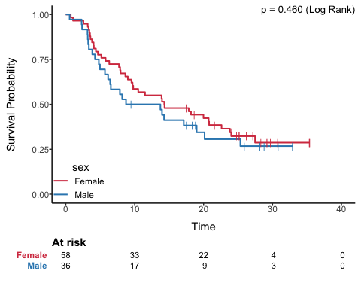

ggkmcif2
ggkmcif2(response = c('os_time','os_status'),
cov='sex',
data=pembrolizumab)
Warning: Vectorized input to `element_text()` is not officially supported.
ℹ Results may be unexpected or may change in future versions of ggplot2.

Figure Height = 3

ggkmcif2
ggkmcif2(response = c('os_time','os_status'),
cov='sex',
data=pembrolizumab)
Warning: Vectorized input to `element_text()` is not officially supported.
ℹ Results may be unexpected or may change in future versions of ggplot2.
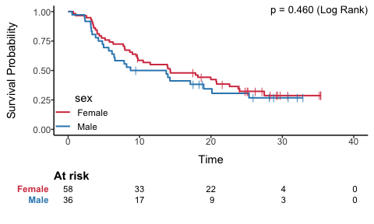

ggkmcif2
ggkmcif2(response = c('os_time','os_status'),
cov='sex',
data=pembrolizumab)
Warning: Vectorized input to `element_text()` is not officially supported.
ℹ Results may be unexpected or may change in future versions of ggplot2.

Figure Height = 2

ggkmcif2
ggkmcif2(response = c('os_time','os_status'),
cov='sex',
data=pembrolizumab)
Warning: Vectorized input to `element_text()` is not officially supported.
ℹ Results may be unexpected or may change in future versions of ggplot2.
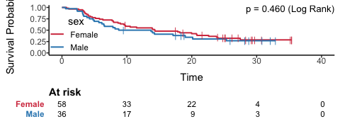

ggkmcif2
ggkmcif2(response = c('os_time','os_status'),
cov='sex',
data=pembrolizumab)
Warning: Vectorized input to `element_text()` is not officially supported.
ℹ Results may be unexpected or may change in future versions of ggplot2.

Testing rm_compactsum
data("pembrolizumab")
rm_compactsum(data = pembrolizumab,
xvars = c("age",
"change_ctdna_group", "l_size", "pdl1"), grp = "sex", use_mean = "age",
digits = c("age" = 2, "l_size" = 3), digits.cat = 1, iqr = TRUE,
show.tests = TRUE)
 | Full Sample (n=94) | Female (n=58) | Male (n=36) | p-value | Missing | pTest
Age at study entry | 57.86 (12.75) | 56.95 (12.59) | 59.32 (13.05) | 0.39 | 0 | t-test
Did ctDNA increase or decrease from baseline to cycle 3 - Increase from baseline | 40 (54.8%) | 21 (52.5%) | 19 (57.6%) | 0.84 | 21 | ChiSq
Target lesion size at baseline | 73.500 (49.250-108.750) | 68.000 (44.250-97.750) | 93.000 (65.500-121.000) | 0.066 | 0 | Wilcoxon Rank Sum
PD L1 percent | 0.0 (0.0-10.0) | 0.5 (0.0-13.8) | 0.0 (0.0-4.5) | 0.76 | 1 | Wilcoxon Rank Sum
rm_compactsum(data = pembrolizumab,
xvars = c("age",
"change_ctdna_group", "l_size", "pdl1"), grp = "sex", use_mean = "age",
digits = c("age" = 2, "l_size" = 3), digits.cat = 1, iqr = TRUE,
show.tests = TRUE)
 | Full Sample (n=94) | Female (n=58) | Male (n=36) | p-value | Missing | pTest
Age at study entry | 57.86 (12.75) | 56.95 (12.59) | 59.32 (13.05) | 0.39 | 0 | t-test
Did ctDNA increase or decrease from baseline to cycle 3 - Increase from baseline | 40 (54.8%) | 21 (52.5%) | 19 (57.6%) | 0.84 | 21 | ChiSq
Target lesion size at baseline | 73.500 (49.250-108.750) | 68.000 (44.250-97.750) | 93.000 (65.500-121.000) | 0.066 | 0 | Wilcoxon Rank Sum
PD L1 percent | 0.0 (0.0-10.0) | 0.5 (0.0-13.8) | 0.0 (0.0-4.5) | 0.76 | 1 | Wilcoxon Rank Sum
# Other Examples (not run)
# Include the summary statistic in the variable column
rm_compactsum(data = pembrolizumab, xvars = c("age",
"change_ctdna_group"), grp = "sex", use_mean = "age", show.sumstats=TRUE)
 | Full Sample (n=94) | Female (n=58) | Male (n=36) | p-value | Missing
Age at study entry Mean (sd) | 57.9 (12.8) | 56.9 (12.6) | 59.3 (13.1) | 0.39 | 0
Did ctDNA increase or decrease from baseline to cycle 3 - Increase from baselinen (%) | 40 (55%) | 21 (52%) | 19 (58%) | 0.84 | 21
rm_compactsum(data = pembrolizumab, xvars = c("age",
"change_ctdna_group"), grp = "sex", use_mean = "age", show.sumstats=TRUE)
 | Full Sample (n=94) | Female (n=58) | Male (n=36) | p-value | Missing
Age at study entry Mean (sd) | 57.9 (12.8) | 56.9 (12.6) | 59.3 (13.1) | 0.39 | 0
Did ctDNA increase or decrease from baseline to cycle 3 - Increase from baselinen (%) | 40 (55%) | 21 (52%) | 19 (58%) | 0.84 | 21
# To show effect sizes
rm_compactsum(data = pembrolizumab, xvars = c("age",
"change_ctdna_group"), grp = "sex", use_mean = "age", digits = 2,
effSize = TRUE, show.tests = TRUE)
 | Full Sample (n=94) | Female (n=58) | Male (n=36) | p-value | Effect Size (95% CI) | Missing | pTest | effStat
Age at study entry | 57.86 (12.75) | 56.95 (12.59) | 59.32 (13.05) | 0.39 | 0.18 (-0.29, 0.36) | 0 | t-test | Cohen’s d
Did ctDNA increase or decrease from baseline to cycle 3 - Increase from baseline | 40 (55%) | 21 (52%) | 19 (58%) | 0.84 | 0.02 (-0.20, 0.05) | 21 | ChiSq | Cramer’s V
rm_compactsum(data = pembrolizumab, xvars = c("age",
"change_ctdna_group"), grp = "sex", use_mean = "age", digits = 2,
effSize = TRUE, show.tests = TRUE)
 | Full Sample (n=94) | Female (n=58) | Male (n=36) | p-value | Effect Size (95% CI) | Missing | pTest | effStat
Age at study entry | 57.86 (12.75) | 56.95 (12.59) | 59.32 (13.05) | 0.39 | 0.18 (-0.31, 0.35) | 0 | t-test | Cohen’s d
Did ctDNA increase or decrease from baseline to cycle 3 - Increase from baseline | 40 (55%) | 21 (52%) | 19 (58%) | 0.84 | 0.02 (-0.20, 0.05) | 21 | ChiSq | Cramer’s V
rm_compactsum(data = pembrolizumab, xvars = c("age",
"change_ctdna_group"), grp = "cohort", use_mean = "age", digits = 2,
effSize = TRUE, show.tests = TRUE)
 | Full Sample (n=94) | A (n=16) | B (n=18) | C (n=18) | D (n=12) | E (n=30) | p-value | Effect Size (95% CI) | Missing | pTest | effStat
Age at study entry | 57.86 (12.75) | 62.88 (6.08) | 56.29 (13.99) | 57.89 (10.83) | 63.84 (9.98) | 53.70 (15.26) | 0.069 | 0.05 (-0.12, 0.11) | 0 | ANOVA | Omega Sq
Did ctDNA increase or decrease from baseline to cycle 3 - Increase from baseline | 40 (55%) | 8 (57%) | 7 (64%) | 5 (50%) | 2 (20%) | 18 (64%) | 0.18 | 0.30 (0.21, 0.50) | 21 | Fisher Exact | Cramer’s V
rm_compactsum(data = pembrolizumab, xvars = c("age","l_size",
"change_ctdna_group"), grp = "cohort", use_mean = c("age","l_size"), digits = 2,
effSize = TRUE, show.tests = TRUE)
 | Full Sample (n=94) | A (n=16) | B (n=18) | C (n=18) | D (n=12) | E (n=30) | p-value | Effect Size (95% CI) | Missing | pTest | effStat
Age at study entry | 57.86 (12.75) | 62.88 (6.08) | 56.29 (13.99) | 57.89 (10.83) | 63.84 (9.98) | 53.70 (15.26) | 0.069 | 0.05 (-0.12, 0.11) | 0 | ANOVA | Omega Sq
Target lesion size at baseline | 87.94 (59.56) | 84.38 (39.80) | 46.33 (20.17) | 104.72 (54.95) | 59.58 (38.37) | 116.07 (74.73) | <0.001 | 0.17 (0.02, 0.25) | 0 | ANOVA | Omega Sq
Did ctDNA increase or decrease from baseline to cycle 3 - Increase from baseline | 40 (55%) | 8 (57%) | 7 (64%) | 5 (50%) | 2 (20%) | 18 (64%) | 0.18 | 0.30 (0.19, 0.50) | 21 | Fisher Exact | Cramer’s V
rm_compactsum(data = pembrolizumab, xvars = c("age",
"change_ctdna_group"), grp = "cohort", digits = 2,
effSize = TRUE, show.tests = TRUE)
 | Full Sample (n=94) | A (n=16) | B (n=18) | C (n=18) | D (n=12) | E (n=30) | p-value | Effect Size (95% CI) | Missing | pTest | effStat
Age at study entry | 59.12 (49.54-68.71) | 62.15 (58.65-68.84) | 56.64 (43.47-68.46) | 53.88 (51.20-67.78) | 64.64 (57.08-71.08) | 51.83 (43.10-65.69) | 0.12 | 0.08 (-0.09, 0.13) | 0 | Kruskal Wallis | Epsilon sq
Did ctDNA increase or decrease from baseline to cycle 3 - Increase from baseline | 40 (55%) | 8 (57%) | 7 (64%) | 5 (50%) | 2 (20%) | 18 (64%) | 0.18 | 0.30 (0.21, 0.50) | 21 | Fisher Exact | Cramer’s V
# To return unformatted p-values
rm_compactsum(data = pembrolizumab, xvars = c("l_size",
"change_ctdna_group"), grp = "cohort", effSize = TRUE, unformattedp = TRUE)
 | Full Sample (n=94) | A (n=16) | B (n=18) | C (n=18) | D (n=12) | E (n=30) | p-value | Effect Size (95% CI) | Missing
Target lesion size at baseline | 73.5 (49.2-108.8) | 90.5 (61.8-108.2) | 45.5 (34.0-58.8) | 90.0 (72.8-129.2) | 54.5 (32.8-64.0) | 97.0 (69.2-140.5) | 8.856061925021e-06 | 0.31 (0.12, 0.42) | 0
Did ctDNA increase or decrease from baseline to cycle 3 - Increase from baseline | 40 (55%) | 8 (57%) | 7 (64%) | 5 (50%) | 2 (20%) | 18 (64%) | 0.178191111645594 | 0.30 (0.19, 0.50) | 21
rm_compactsum(data = pembrolizumab, xvars = c("l_size",
"change_ctdna_group"), grp = "cohort", effSize = TRUE, unformattedp = TRUE,covTitle = "my left foot")
my left foot | Full Sample (n=94) | A (n=16) | B (n=18) | C (n=18) | D (n=12) | E (n=30) | p-value | Effect Size (95% CI) | Missing
Target lesion size at baseline | 73.5 (49.2-108.8) | 90.5 (61.8-108.2) | 45.5 (34.0-58.8) | 90.0 (72.8-129.2) | 54.5 (32.8-64.0) | 97.0 (69.2-140.5) | 8.856061925021e-06 | 0.31 (0.13, 0.42) | 0
Did ctDNA increase or decrease from baseline to cycle 3 - Increase from baseline | 40 (55%) | 8 (57%) | 7 (64%) | 5 (50%) | 2 (20%) | 18 (64%) | 0.178191111645594 | 0.30 (0.20, 0.50) | 21
# Using tidyselect
pembrolizumab |> rm_compactsum(xvars = c(age, sex, pdl1), grp = cohort,
effSize = TRUE)
 | Full Sample (n=94) | A (n=16) | B (n=18) | C (n=18) | D (n=12) | E (n=30) | p-value | Effect Size (95% CI) | Missing
Age at study entry | 59.1 (49.5-68.7) | 62.1 (58.7-68.8) | 56.6 (43.5-68.5) | 53.9 (51.2-67.8) | 64.6 (57.1-71.1) | 51.8 (43.1-65.7) | 0.12 | 0.08 (-0.07, 0.13) | 0
Patient Sex - Male | 36 (38%) | 13 (81%) | 0 (0%) | 0 (0%) | 5 (42%) | 18 (60%) | <0.001 | 0.66 (0.98, 1.25) | 0
PD L1 percent | 0.0 (0.0-10.0) | 2.0 (0.5-67.5) | 0.0 (0.0-2.5) | 2.5 (0.0-13.8) | 1.0 (0.0-37.5) | 0.0 (0.0-1.0) | 0.019 | 0.13 (-0.06, 0.21) | 1
pembrolizumab |> rm_compactsum(xvars = c(age, sex, pdl1), grp = cohort,
effSize = TRUE)
 | Full Sample (n=94) | A (n=16) | B (n=18) | C (n=18) | D (n=12) | E (n=30) | p-value | Effect Size (95% CI) | Missing
Age at study entry | 59.1 (49.5-68.7) | 62.1 (58.7-68.8) | 56.6 (43.5-68.5) | 53.9 (51.2-67.8) | 64.6 (57.1-71.1) | 51.8 (43.1-65.7) | 0.12 | 0.08 (-0.09, 0.13) | 0
Patient Sex - Male | 36 (38%) | 13 (81%) | 0 (0%) | 0 (0%) | 5 (42%) | 18 (60%) | <0.001 | 0.66 (0.96, 1.24) | 0
PD L1 percent | 0.0 (0.0-10.0) | 2.0 (0.5-67.5) | 0.0 (0.0-2.5) | 2.5 (0.0-13.8) | 1.0 (0.0-37.5) | 0.0 (0.0-1.0) | 0.019 | 0.13 (-0.07, 0.21) | 1

Testing header above
data(pembrolizumab)
tab <- rm_covsum(data = pembrolizumab,
covs = c("age", "sex"),
maincov = "cohort",
tableOnly = TRUE)
# row.names = NULL;
# to_indent = numeric(0);
# bold_headers = TRUE;
# rows_bold = numeric(0);
# bold_cells = NULL;
# caption = NULL;
# digits = 2
# applyAttributes = TRUE;
# keep.rownames = FALSE;
# nicenames = TRUE;
# format = NULL;
# header_above = c(" " = 2, "Cohort" = 5, " " = 1)
outTable(tab,
header_above = c(" " = 2, "Cohort" = 5, " " = 1),format = "doc")
 |  | Cohort
Covariate | Full Sample (n=94) | A (n=16) | B (n=18) | C (n=18) | D (n=12) | E (n=30) | p-value
Age at study entry |  |  |  |  |  |  | 0.12
Mean (sd) | 57.9 (12.8) | 62.9 (6.1) | 56.3 (14.0) | 57.9 (10.8) | 63.8 (10.0) | 53.7 (15.3)
Median (Min,Max) | 59.1 (21.1, 81.8) | 62.1 (51.0, 70.9) | 56.6 (35.5, 74.8) | 53.9 (36.5, 74.0) | 64.6 (45.0, 78.2) | 51.8 (21.1, 81.8)
Patient Sex |  |  |  |  |  |  | <0.001
Female | 58 (62) | 3 (19) | 18 (100) | 18 (100) | 7 (58) | 12 (40)
Male | 36 (38) | 13 (81) | 0 (0) | 0 (0) | 5 (42) | 18 (60)

