reportRx Demo

21 June, 2021

Table of Contents

# 1 11 Jun 2021

## 1.1 Comments from Katherine to fix

## 1.2 Reproducible example:

rm(list=ls())  
library(reportRx) #development version  
library(survival)  
library(dplyr)  
  
data(lung)  
  
# create variable with empty levels:  
lung$Sex <- recode(lung$sex, `1`="Male",`2`="Female")  
lung$Sex <- factor(lung$Sex, levels=c("","Empty level","Male","Female"))  
  
#linear model: no issue  
summary(lm(time~Sex, data=lung))

##   
## Call:  
## lm(formula = time ~ Sex, data = lung)  
##   
## Residuals:  
## Min 1Q Median 3Q Max   
## -333.97 -140.28 -56.23 104.08 738.77   
##   
## Coefficients:  
## Estimate Std. Error t value Pr(>|t|)   
## (Intercept) 283.23 17.82 15.895 <2e-16 ***  
## SexFemale 55.73 28.36 1.965 0.0506 .   
## ---  
## Signif. codes: 0 '***' 0.001 '**' 0.01 '*' 0.05 '.' 0.1 ' ' 1  
##   
## Residual standard error: 209.3 on 226 degrees of freedom  
## Multiple R-squared: 0.0168, Adjusted R-squared: 0.01245   
## F-statistic: 3.862 on 1 and 226 DF, p-value: 0.05063

rm_uvsum(response="time",covs="Sex",data=lung)

Univariate analysis of predictors of time.

|  |  |  |  |
| --- | --- | --- | --- |
| Covariate | Estimate(95%CI) | p-value | N |
| **Sex** |  | **0.049** | **228** |
| Male | Reference |  | 138 |
| Female | 55.73 (-0.15,111.62) |  | 90 |

# survival model: rm_uvsum duplicates variable levels in tables  
coxph(Surv(time, status)~Sex, data=lung)

## Call:  
## coxph(formula = Surv(time, status) ~ Sex, data = lung)  
##   
## coef exp(coef) se(coef) z p  
## SexEmpty level NA NA 0.0000 NA NA  
## SexMale 0.5310 1.7007 0.1672 3.176 0.00149  
## SexFemale NA NA 0.0000 NA NA  
##   
## Likelihood ratio test=10.63 on 1 df, p=0.001111  
## n= 228, number of events= 165

rm_uvsum(data=lung, response=c("time","status"),covs="Sex")

Univariate analysis of predictors of survival.

|  |  |  |  |
| --- | --- | --- | --- |
| Covariate | HR(95%CI) | p-value | N |
| **Sex** |  | **0.0015** | **228** |
| Male | Reference |  | 138 |
| Female | 0.59 (0.42,0.82) |  | 90 |

##   
## Call:  
## glm(formula = binaryvar ~ Sex, family = binomial(link = "logit"),   
## data = lung)  
##   
## Deviance Residuals:   
## Min 1Q Median 3Q Max   
## -1.215 -1.165 1.140 1.190 1.190   
##   
## Coefficients:  
## Estimate Std. Error z value Pr(>|z|)  
## (Intercept) -0.02899 0.17027 -0.170 0.865  
## SexFemale 0.11794 0.27115 0.435 0.664  
##   
## (Dispersion parameter for binomial family taken to be 1)  
##   
## Null deviance: 316.06 on 227 degrees of freedom  
## Residual deviance: 315.87 on 226 degrees of freedom  
## AIC: 319.87  
##   
## Number of Fisher Scoring iterations: 3

Univariate analysis of predictors of binaryvar.

|  |  |  |  |
| --- | --- | --- | --- |
| Covariate | OR(95%CI) | p-value | N |
| Sex |  | 0.66 | 228 |
| Male | Reference |  | 138 |
| Female | 1.13 (0.66,1.91) |  | 90 |

## 1.3 Comment from Osvaldo

rm_covsum and pcovsum throw an error if maincov=NULL and full=FALSE

**fixed**

Summary sample statistics.

|  |  |
| --- | --- |
| Covariate | n=228 |
| Sex |  |
|  | 0 (0) |
| Empty level | 0 (0) |
| Male | 138 (61) |
| Female | 90 (39) |
| age |  |
| Mean (sd) | 62.4 (9.1) |
| Median (Min,Max) | 63 (39,82) |

# Introduction

This is an rMarkdown document to produce Word and PDF files from the reportRx package (Bel and Xu 2013) in the R statistical programming language (R Core Team 2020).

First, make some changes to the lung data.

data(lung)  
lung <- lung %>%  
 mutate(  
 Status=factor(status-1),  
 Sex = factor(sex,labels = c('Male','Female')),  
 AgeGroup = cut(age, breaks=seq(0,100,10)),  
 OneLevelFactor = factor(x='one level')  
 ) %>%  
 arrange(Status)  
  
lung$x_null = rnorm(nrow(lung))  
lung$x_pred = c(rnorm(sum(lung$Status==0),0,1),  
 rnorm(sum(lung$Status==1),1,1))  
set.seed(1)  
test_data = tibble(  
 y= rnorm(1000),  
 x0= geoR::rboxcox(1000, lambda=.5, mean=10, sd=2),  
 x1= x0+y  
)

# 2 Numbered Heading

## 2.1 Test covsum

Summary sample statistics.

|  |  |
| --- | --- |
| Covariate | n=228 |
| Status |  |
| 0 | 63 (28) |
| 1 | 165 (72) |
| Sex |  |
| Male | 138 (61) |
| Female | 90 (39) |
| age |  |
| Mean (sd) | 62.4 (9.1) |
| Median (Min,Max) | 63 (39,82) |
| AgeGroup |  |
| (0,10] | 0 (0) |
| (10,20] | 0 (0) |
| (20,30] | 0 (0) |
| (30,40] | 3 (1) |
| (40,50] | 23 (10) |
| (50,60] | 68 (30) |
| (60,70] | 88 (39) |
| (70,80] | 44 (19) |
| (80,90] | 2 (1) |
| (90,100] | 0 (0) |
| meal cal |  |
| Mean (sd) | 928.8 (402.2) |
| Median (Min,Max) | 975 (96,2600) |
| Missing | 47 |
| OneLevelFactor |  |
| one level | 228 (100) |

Summary sample statistics by Sex.

|  |  |  |  |  |
| --- | --- | --- | --- | --- |
| Covariate | Full Sample (n=228) | Male (n=138) | Female (n=90) | p-value |
| **Status** |  |  |  | **<0.001** |
| 0 | 63 (28) | 26 (19) | 37 (41) |  |
| 1 | 165 (72) | 112 (81) | 53 (59) |  |
| age |  |  |  | 0.057 |
| Mean (sd) | 62.4 (9.1) | 63.3 (9.1) | 61.1 (8.8) |  |
| Median (Min,Max) | 63 (39,82) | 64 (39,82) | 61 (41,77) |  |
| AgeGroup |  |  |  | 0.13 |
| (0,10] | 0 (0) | 0 (0) | 0 (0) |  |
| (10,20] | 0 (0) | 0 (0) | 0 (0) |  |
| (20,30] | 0 (0) | 0 (0) | 0 (0) |  |
| (30,40] | 3 (1) | 3 (2) | 0 (0) |  |
| (40,50] | 23 (10) | 11 (8) | 12 (13) |  |
| (50,60] | 68 (30) | 35 (25) | 33 (37) |  |
| (60,70] | 88 (39) | 58 (42) | 30 (33) |  |
| (70,80] | 44 (19) | 29 (21) | 15 (17) |  |
| (80,90] | 2 (1) | 2 (1) | 0 (0) |  |
| (90,100] | 0 (0) | 0 (0) | 0 (0) |  |
| **meal cal** |  |  |  | **0.022** |
| Mean (sd) | 928.8 (402.2) | 980.5 (413.3) | 840.7 (369.1) |  |
| Median (Min,Max) | 975 (96,2600) | 1025 (169,2600) | 925 (96,2450) |  |
| Missing | 47 | 24 | 23 |  |
| OneLevelFactor |  |  |  |  |
| one level | 228 (100) | 138 (100) | 90 (100) |  |

If you need to run an rm_ function in a loop, you need to use this structure: Unfortunately, this produces a NULL after each table, which is on the todo list!

pander::panderOptions('knitr.auto.asis', FALSE)  
  
for (v in names(lung)[1:2]){  
 cat("\n")  
 print(rm_covsum(data=lung,covs=v))  
 cat("\n")  
}

Summary sample statistics.

|  |  |
| --- | --- |
| Covariate | n=228 |
| inst |  |
| Mean (sd) | 11.1 (8.3) |
| Median (Min,Max) | 11 (1,33) |
| Missing | 1 |

NULL

Summary sample statistics.

|  |  |
| --- | --- |
| Covariate | n=228 |
| time |  |
| Mean (sd) | 305.2 (210.6) |
| Median (Min,Max) | 255.5 (5.0,1022.0) |

NULL

pander::panderOptions('knitr.auto.asis', TRUE)

## 2.2 Test plotuv

Figure 2.1 shows the bivariate relationships between the response and covariates. Figure referencing works only when a figure caption is provided in the chunk options. Note that underscores and not allowed in the chunk names, only hyphens.

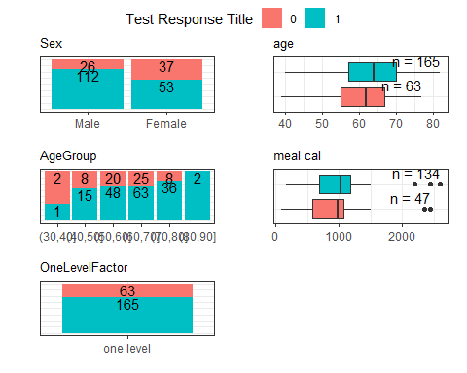

Figure 2.1: Associations between status and covariates in the lung data.

## 2.3 Tests for uvsum

### 2.3.1 Test logistic

Tables 2.1, 2.2 and 2.3 display the logistic regression results with different confidence interval widths. If the document in knit to pdf, the chank-lable option will not be used, instead the name of the chunk will be used in cross-referening. For Word tables the chunk label needs to be added into the function call.

Table 2.1: Univariate analysis of predictors of Status.

|  |  |  |  |
| --- | --- | --- | --- |
| Covariate | OR(95%CI) | p-value | N |
| **age** | **1.04 (1.00,1.07)** | **0.025** | **228** |
| **Sex** |  | **<0.001** | **228** |
| Male | Reference |  | 138 |
| Female | 0.33 (0.18,0.61) |  | 90 |
| wt loss | 1.01 (0.98,1.03) | 0.61 | 214 |

Table 2.2: Univariate analysis of predictors of Status.

|  |  |  |  |
| --- | --- | --- | --- |
| Covariate | OR(90%CI) | p-value | N |
| **age** | **1.04 (1.01,1.07)** | **0.025** | **228** |

Table 2.3: Univariate analysis of predictors of Status.

|  |  |  |  |
| --- | --- | --- | --- |
| Covariate | OR(99%CI) | p-value | N |
| **age** | **1.04 (0.99,1.08)** | **0.025** | **228** |

### 2.3.2 Test Linear

Univariate analysis of predictors of wt loss.

|  |  |  |  |
| --- | --- | --- | --- |
| Covariate | Estimate(95%CI) | p-value | N |
| Status |  | 0.61 | 214 |
| 0 | Reference |  | 62 |
| 1 | 1.01 (-2.90,4.92) |  | 152 |
| Sex |  | 0.058 | 214 |
| Male | Reference |  | 128 |
| Female | -3.45 (-7.04,0.14) |  | 86 |
| **ph ecog** | **3.42 (0.99,5.85)** | **0.0055** | **213** |
| meal cal | -3.3e-03 (-8.3e-03,1.6e-03) | 0.18 | 171 |
| age | 0.05 (-0.14,0.25) | 0.58 | 214 |

Univariate analysis of predictors of wt loss.

|  |  |  |  |
| --- | --- | --- | --- |
| Covariate | Estimate(90%CI) | p-value | N |
| age | 0.05 (-0.11,0.22) | 0.58 | 214 |

### 2.3.3 Test coxph & ggsurv

Univariate analysis of predictors of survival.

|  |  |  |  |
| --- | --- | --- | --- |
| Covariate | HR(99%CI) | p-value | N |
| **Sex** |  | **0.0015** | **228** |
| Male | Reference |  | 138 |
| Female | 0.59 (0.38,0.90) |  | 90 |
| **ph ecog** | **1.61 (1.20,2.16)** | **<0.001** | **227** |
| meal cal | 1.00 (1.00,1.00) | 0.59 | 181 |
| **age** | **1.02 (1.00,1.04)** | **0.042** | **228** |

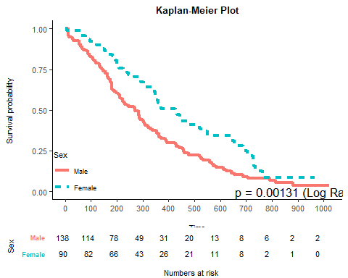

# Unnumbered Heading

## 2.4 Test mvsum & forestplot2

|  |  |  |  |  |
| --- | --- | --- | --- | --- |
| Covariate | OR(95%CI) | p-value | Global p-value | Holm Adj p |
| wt loss | 1.00 (0.97,1.02) |  | 0.83 | 0.83 |
| **Sex** |  |  | **<0.001** | **<0.001** |
| Male | reference |  |  |  |
| Female | 0.31 (0.16,0.58) |  |  |  |
| AgeGroup |  |  | 0.41 | 0.83 |
| (0,10] | reference |  |  |  |
| (40,50] | 7.23 (0.53,98.89) | 0.14 |  |  |
| (50,60] | 8.52 (0.68,106.08) | 0.096 |  |  |
| (60,70] | 7.93 (0.66,95.39) | 0.1 |  |  |
| (70,80] | 14.77 (1.13,192.73) | 0.04 |  |  |
| (80,90] | 1.2e+07 (0e+00,Inf) | 0.99 |  |  |

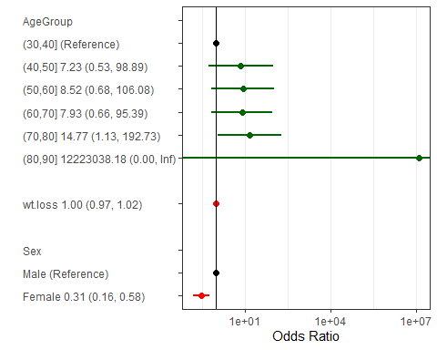

# 3 References

Bel, Ryan Del, and Wei Xu. 2013. *reportRx: Tools for Automatically Generating Reproducible Clinical Report*. <https://CRAN.R-project.org/package=reportRx>.

R Core Team. 2020. *R: A Language and Environment for Statistical Computing*. Vienna, Austria: R Foundation for Statistical Computing. <https://www.R-project.org/>.

# 4 Appendix

Other results can go here.

### 4.0.1 Test crr

Univariate analysis of predictors of survival.

|  |  |  |  |
| --- | --- | --- | --- |
| Covariate | HR(90%CI) | p-value | N |
| **Sex** |  | **<0.001** | **228** |
| Male | Reference |  | 138 |
| Female | 2.49 (1.64,3.79) |  | 90 |
| **ph ecog** | **0.54 (0.40,0.72)** | **<0.001** | **227** |
| meal cal | 1.00 (1.00,1.00) | 0.9 | 181 |
| **age** | **0.97 (0.95,0.99)** | **0.028** | **228** |

Univariate analysis of predictors of survival.

|  |  |  |  |
| --- | --- | --- | --- |
| Covariate | HR(95%CI) | p-value | N |
| **age** | **0.97 (0.94,1.00)** | **0.028** | **228** |

### 4.0.2 Test boxcox

Univariate analysis of predictors of y.

|  |  |  |  |
| --- | --- | --- | --- |
| Covariate | Estimate(90%CI) | p-value | N |
| x0 | 6.2e-04 (-3.5e-03,4.8e-03) | 0.81 | 1000 |
| **x1** | **7.1e-03 (3e-03,0.01)** | **0.0043** | **1000** |