BIOSZEN User Manual (English)
A practical guide to run BIOSZEN from raw files to reproducible outputs.
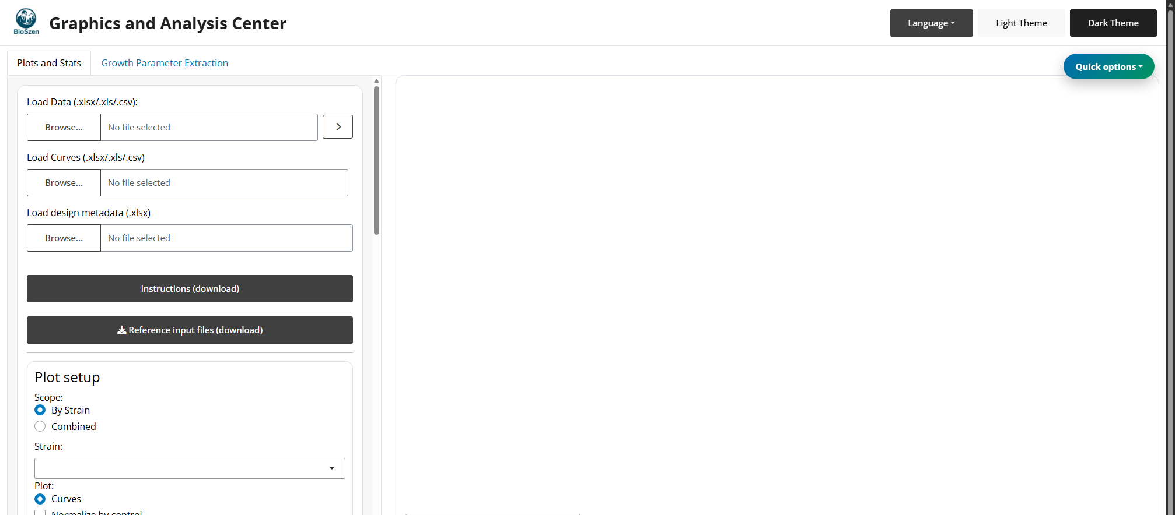
IMPORTANT: If possible, use Platemap + Curves mode. It gives the best support for statistics, replicate QC, and complete exports.
TIP: Keep this manual open while working. Each section includes both quick actions and deeper technical reference.

Manual Map
- 1. Before You Start
- 2. Fast Start by Scenario
- 3. Choose an Input Mode
- 4. Input Specifications
- 5. Standard Workflow
- 6. Plot Types and Controls
- 7. Normalization
- 8. Statistics
- 9. Significance Annotations
- 10. QC and Replicate Management
- 11. Metadata and Reproducibility
- 12. Downloads
- 13. Growth Module
- 14. Troubleshooting Playbook
- 15. Support

1. Before You Start
Requirements:
- R >= 4.1.
- BIOSZEN launched from app.R, BIOSZEN::BIOSZEN(), or BIOSZEN::run_app().
- Data file for Load Data in Excel (.xlsx, .xls) or CSV (.csv).
- Curves file for Load Curves in Excel (.xlsx, .xls) or CSV (.csv) when curves are not embedded in the main workbook.
Install the stable R package from R-universe with:
install.packages(
"BIOSZEN",
repos = c(
"https://bioszen.r-universe.dev",
"https://cloud.r-project.org"
)
)
BIOSZEN::BIOSZEN()
The standalone App.R and bundle launch methods remain available for users who prefer not to install BIOSZEN from a package repository.
Reference templates available in-app (Reference input files (download)) and in:
- inst/app/www/reference_files/
Template files:
- Ejemplo_platemap_parametros.xlsx
- Ejemplo_curvas.xlsx
- Ejemplo_parametros_agrupados.xlsx
- Ejemplo_input_summary_mean_sd.xlsx
NOTE: First launch may install packages into local R_libs. Keep that folder to avoid reinstalling dependencies.

2. Fast Start by Scenario

Scenario A: I have raw plate data and curves (recommended)
- Load platemap in Load Data.
- Load curves file in Load Curves.
- Select scope and plot type.
- Apply filters and replicate QC.
- Run stats and annotations.
- Export plot, tables, metadata, and ZIP bundle.

Scenario B: I only have grouped or summary data
- Load grouped/summary workbook in Load Data.
- Configure plots and filters.
- Run available stats for that mode.
- Export plots and metadata.

Scenario C: I need performance on larger datasets
- Start with .csv in Load Data.
- Keep selected parameters small while iterating.
- Add overlays/advanced layers only near final export.

Scenario D: I need a reproducible R script
- Launch the same app with BIOSZEN::BIOSZEN(); BIOSZEN::run_app() remains supported.
- Use BIOSZEN::growth_parameters() to obtain the same growth parameters as the Growth tab without opening the visual interface.
- growth_parameters() accepts wide/tidy data frames, one or more .xlsx/.xls/.csv files, or a directory. It writes nothing unless output_dir is supplied.
- Use BIOSZEN::bioszen_update_available() to check for an update and BIOSZEN::bioszen_update() to install one after confirmation and after closing the app.
- Use BIOSZEN::bioszen_citation() or citation("BIOSZEN") for the official citation.
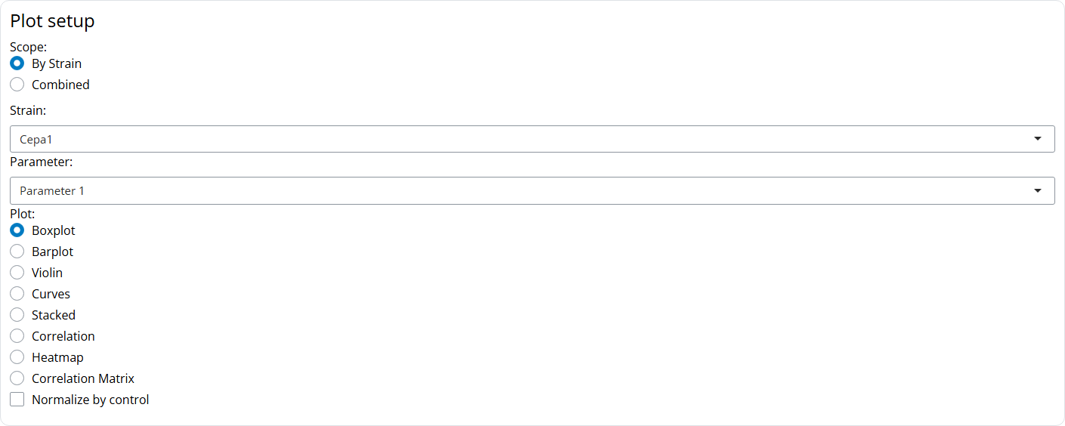

3. Choose an Input Mode
- Platemap + Curves
Best when: You want full workflow depth.
Main limitations: Requires strict well mapping and sheet structure.
- Grouped parameters
Best when: Parameter-only analysis.
Main limitations: Curves require embedded Curves_Summary-type sheets (or a separate file in Load Curves).
- Summary (Mean/SD/N)
Best when: Raw replicate rows are unavailable.
Main limitations: Some normality/non-parametric routes may be limited.
- CSV mode
Best when: High-volume data and faster IO.
Main limitations: Metadata roundtrip still uses .xlsx.

4. Input Specifications

4.1 Platemap workbook
Required sheets:
- Datos: metadata + parameters.
- PlotSettings: default axis settings by parameter.
Datos expected columns:
- Well: well ID (A1, B3, etc.), required for curves linking.
- Strain: strain or biological group.
- Media: condition/treatment (Control, Drug A, etc.).
- BiologicalReplicate: biological replicate ID (1, 2, 3, ...).
- TechnicalReplicate: technical replicate within each biological replicate (A, B, C or 1, 2, 3).
- Replicate (compatibility): legacy alternate biological replicate field.
- Orden: integer used for plotting/export ordering.
- Parameter columns: one or more numeric analytes/metrics.
Practical consistency rule:
- Strain + Media + BiologicalReplicate + TechnicalReplicate should identify each experimental row consistently.
PlotSettings expected columns:
- Parameter
- Y_Max
- Interval
- Y_Title

4.2 Curves file
Excel (.xlsx, .xls):
- Sheet1: first column Time, remaining columns by well (A1, A2, ...).
- Sheet2: X_Max, Interval_X, Y_Max, Interval_Y, X_Title, Y_Title.
CSV (.csv):
- First column Time, remaining columns by well (A1, A2, ...).
- Axis settings are auto-generated:
  - X_Max and Y_Max: observed maxima.
  - Interval_X and Interval_Y: max/4.
  - X_Title and Y_Title: blank by default.
WARNING: Curves merge failures are usually caused by inconsistent well names between platemap and curves (Well vs curve headers).

4.3 Grouped parameters mode
- Load grouped workbook in Load Data.
- Designed for parameter plots/statistics from grouped sheets (for example Parametro_1, Parametro_2, ...).
- Optional embedded curves are supported via summary-curve sheets in the same workbook.
- Keep using Load Data for grouped workbooks (do not upload grouped files in Load Curves).

4.4 Summary mode
- Load summary workbook in Load Data.
- BIOSZEN detects parameter summaries from any of these sheet names:
  - Parameters_Summary
  - Parametros_Summary
  - Summary_Parameters
  - Resumen_Parametros
- BIOSZEN detects embedded curve summaries from any of these sheet names:
  - Curves_Summary
  - Curvas_Summary
  - Summary_Curves
  - Resumen_Curvas
- Useful when row-level raw replicates are unavailable.
- Curves plots require either a valid Load Curves file or an embedded curve-summary sheet.

4.5 CSV mode
- Load Data accepts .csv and auto-detects delimiter (,, ;, tab, |).
- BIOSZEN attempts profile conversion when CSV is not already platemap-ready.
- Load Curves also accepts .csv (Time + wells).

4.6 Optional AI skill for input preparation
The GitHub/source repository includes an optional AI-agent skill in the skills/bioszen-platemap-curves/ GitHub folder. To use it, give that GitHub folder URL to the corresponding AI tool or agent so it can read or acquire the skill. If the agent needs local files, download the repository ZIP from https://github.com/bioszen/BIOSZEN/archive/refs/heads/main.zip and copy the skills/bioszen-platemap-curves/ folder into your agent's skill system.
Use this skill from Codex, Claude, Antigravity, or similar agentic tools when you need to generate a Datos + PlotSettings platemap from any readable data file, correct an existing platemap, repair parameter-name typing mistakes between Datos columns and PlotSettings$Parameter, prepare a separate curves workbook, or validate that Datos$Well exactly matches curve headers before uploading files to BIOSZEN.
The skill is a documentation/tooling extra. It does not modify the BIOSZEN app and does not assume fixed parameter names, fixed experiment labels, or a specific measurement type.

5. Standard Workflow
- Load main data file.
- Optionally load/merge curves.
- Optionally load metadata.
- Choose scope (By Strain or Combined).
- Select plot type.
- Apply filters and replicate selections.
- Optionally normalize by control.
- Run statistics.
- Add significance annotations.
- Export outputs.
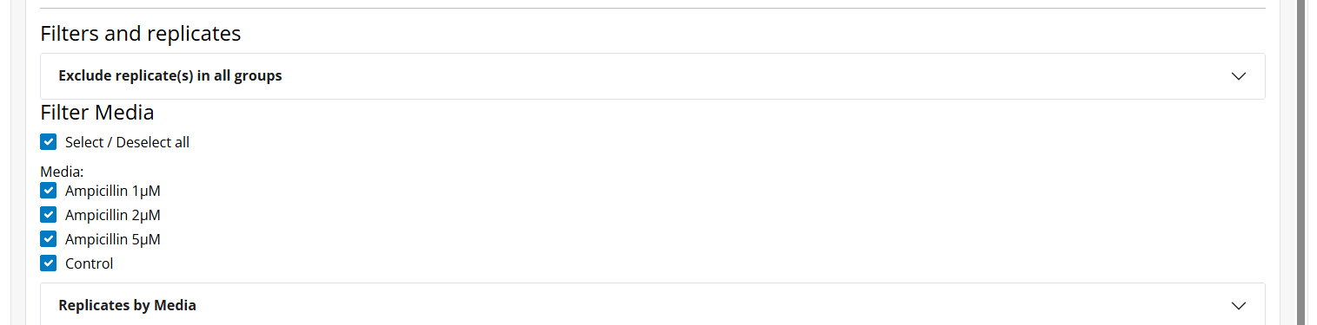

6. Plot Types and Controls

Boxplot
- Best for raw replicate distributions.
- Controls: jitter, box width, point size.
- Supports manual/automatic significance annotations.
- Flip orientation (horizontal) improves readability for long group labels.

Barplot
- Best for summarized group comparisons.
- Supports error bars and optional raw points.
- Horizontal orientation available.

Violin
- Best for showing distribution shape with replicate overlays.
- Uses the same annotation workflow as Boxplot/Barplot.
- Horizontal orientation available.

Stacked
- Parameter selector + parameter ordering controls.
- Configurable deviation bars and color behavior.
- Statistics and auto-generated significance are available per included parameter. Comparisons are made within each parameter, so Parameter A - Group 1 is compared with Parameter A - Group 2, not with another stacked segment.
- Significance labels can be added over the selected target group for the selected parameter; the results table includes a Parameter column.
- Annotation labels are recommended for stacked plots.
- Horizontal orientation available; legends, text styles, error bars, and significance labels are preserved when the plot is flipped.

Correlation
- Select X/Y parameters.
- Methods: Pearson, Spearman, Kendall.
- Optional overlays: regression line, r, p, R2, equation.
- Advanced panel supports one-vs-all style screening and Excel export.

Heatmap
- Parameter subset selection.
- Scale options: none, row, column.
- Optional clustering and dendrograms.
- Optional in-cell value labels.

Correlation Matrix
- Multi-select parameters.
- Correlation method + p-value correction.
- Optional significant labels only.

Curves
- Configure axes, labels, line width, and curve point size.
- Choose line geometry and confidence interval style.
- Optional raw replicate trajectories.
- Curve point size controls the visible markers when the line-and-points geometry is selected. It changes marker size only; curve values, line geometry, and statistical results are not altered.

Shared plot appearance controls
- The Error bar statistic selector controls deviation bars where available:
  - SD: mean +/- standard deviation.
  - SEM: mean +/- standard error.
  - Min-Max: observed minimum to maximum; available only for Boxplot.
- The collapsible Text styling section is available for individual plots.
- Font family applies to all text in the current graph. Available choices include common publication and system fonts such as Helvetica, Arial, Calibri, Cambria, Segoe UI, Times New Roman, Georgia, Verdana, and related variants.
- Bold, italic, and underline are applied independently by text part: plot title, axis titles, axis tick labels, legend, data labels, and significance text.
- Axis-title styling is applied to both X and Y axis titles when those titles are visible. Axis tick-label styling applies to the labels shown along the axes, whether they are numeric ticks or category labels.
- Legend controls include whether the legend is shown on the right when applicable, plus legend text size and bold/italic/underline styling.
- Each text part can use its own combination of styles; selecting underline for significance text, for example, does not force underline on the title or legend.
- Flip orientation (horizontal), when available, is a visual orientation change only. It preserves the same plotted values, legends, font family, bold/italic/underline settings, error bars, and significance annotations.
- These choices are applied to the plot preview and included in exported PNG and PDF files.
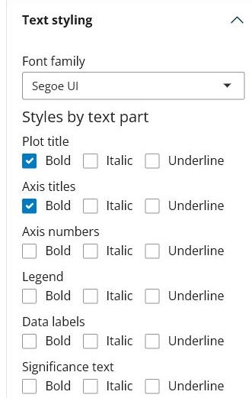

Composition Panel
Recommended workflow:
- Build and edit each source graph, then click Add to panel.
- Open Composition Panel and use the plot picker to include, exclude, and order plots. Deselecting a plot removes it from the active composition without deleting the source graph.
- Set rows and columns. For non-rectangular or repeated-cell layouts, enter the layout grid; column widths and row heights control relative sizing and positioning.
- Set composition width and height in pixels. These values define the preview canvas and the composition aspect ratio; they are independent of export DPI and PowerPoint slide size.
- Configure style, shared legends, typography, palette, rich text, and optional per-plot overrides. Apply composition typography to every plot changes tick-label sizes, X/Y angles and alignment, font family, and text styles across every included graph while preserving its data geometry.
- Configure the PowerPoint slide preset (4:3, 16:9, or custom), width, height, orientation, and edge margin.
- Review the preview and export PNG, PPTX, PDF, or composition metadata.

DPI and physical dimensions
- The default export resolution is 300 DPI. The supported range is 72 to 600 DPI, and the value remains editable.
- DPI applies to raster output, including PNG, raster clipboard output, and the raster fallback used only when editable PowerPoint vector rendering is unavailable.
- PDF and the normal editable PPTX path are vector-based, so DPI does not alter their vector elements. A selected DPI is still stored in metadata for reproducibility and for any raster fallback.
- The browser preview uses screen/CSS pixel density. Changing export DPI does not resize or reposition the preview.
- Increasing DPI increases raster pixel count, rendering time, memory use, and file size. It does not change composition width/height, graph proportions, layout positions, or PowerPoint slide dimensions.
- Composition width/height control the logical canvas. PowerPoint width/height control the physical slide. DPI controls raster sampling quality. These are separate settings.
- Metadata stores the effective DPI and restores it when loaded. Legacy metadata without a DPI field uses 300 DPI. Missing, non-numeric, zero, negative, or out-of-range DPI values safely fall back to 300 DPI; other valid metadata fields are still restored.
Composition style controls apply in parallel to all selected plots. The composition Text styling section mirrors the individual plot controls: the font family is applied across all plot text, while bold/italic/underline can be selected separately for titles, axes, legends, data labels, and significance text. Composition metadata also preserves layout, dimensions, slide settings, DPI, typography, legend configuration, palette, rich text, and per-plot overrides.
The PowerPoint export always creates one slide and proportionally fits the preview layout within the selected margins. If a slide is too small, BIOSZEN scales the composition down and warns the user rather than overlapping or clipping plots. Very dense layouts, long labels, large fonts, and small portrait slides may require a larger slide, fewer plots, shorter labels, or wider margins. Preview and PowerPoint text can differ slightly because browser and PowerPoint font metrics are not identical; BIOSZEN applies a proportional safety adjustment when shrinking the layout.
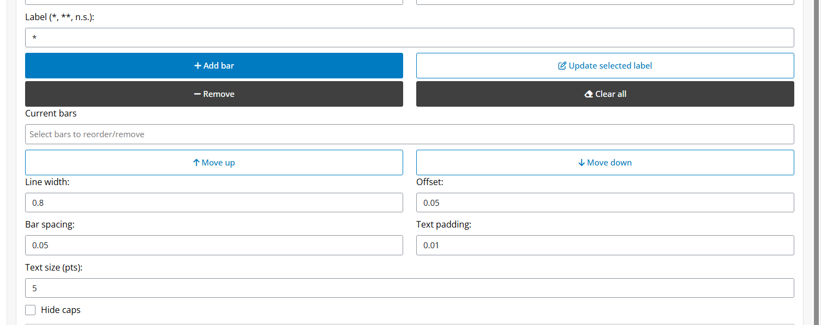

7. Normalization
Enable Normalize by control and pick a control medium.
- BIOSZEN creates normalized columns with _Norm suffix.
- Correlation supports axis-specific normalization (both, X only, Y only).
- Fallback logic is applied when strict control pairing is not available.

8. Statistics

Main statistical tools
- Shapiro-Wilk: stats::shapiro.test
- Kolmogorov-Smirnov: stats::ks.test
- Anderson-Darling: nortest::ad.test
- ANOVA: stats::aov
- Kruskal-Wallis: stats::kruskal.test
- t-test routes: rstatix::t_test, rstatix::pairwise_t_test
- Wilcoxon routes: rstatix::wilcox_test
- Multiple-testing correction: stats::p.adjust
Post hoc routes by selection:
- Tukey / Games-Howell: rstatix
- Dunn: rstatix::dunn_test
- Dunnett: DescTools::DunnettTest
- Scheffe, Conover, Nemenyi, DSCF: PMCMRplus
Curve statistics (S1-S4):
The Curve Statistics accordion appears for Curves plots. Select one or more methods, then click Run curve statistics to generate the results table.
- S1: stats::lm + splines::ns + stats::anova
- S2: stats::pnorm + stats::pchisq
- S3: stats::pnorm
- S4: gcplyr::auc + normality-driven comparisons (stats::t.test, stats::wilcox.test, stats::aov, stats::kruskal.test)
Comparison modes:
- All vs all
- Control vs all
- Pair
P-value correction options:
- Holm
- FDR
- Bonferroni
- None
For Stacked plots, normality and significance are calculated separately for each included parameter. The output table includes Parameter, and each parameter-level comparison should match the same comparison run from the corresponding single-parameter plot.
CAUTION: In Summary mode, normality may be NA and some non-parametric paths that require raw observations are disabled.

9. Significance Annotations
Manual workflow:
- Select Group 1 and Group 2.
- Enter label (*, **, ***, ns, custom text).
- Add/reorder/edit/remove annotations.
Automatic workflow:
- Run significance tests.
- Open auto-annotation options.
- Choose inclusion (significant only or all).
- Choose label mode (stars or p-value).
- Replace or append annotations.
For Stacked plots, choose the parameter before adding a label. Automatic labels keep the parameter identity and place the annotation over the selected target group for that parameter.

10. QC and Replicate Management
Use QC panels to monitor:
- Missing values.
- Outliers by group.
- Sample size and replicate coverage.

Biological replicates
- Manual include/exclude controls.
- Automatic IQR filtering.
- Keep-N reproducibility selection.
Keep-N behavior:
- Ranks replicates by distance to the group median across selected parameters.
- Keeps lowest-score (most reproducible) replicates.

Technical replicates
Available when technical replicates are valid:
- Dedicated technical QC tab.
- Group and biological-replicate selectors.
- Global select/deselect controls.
- Automatic IQR technical outlier detection.
- Technical Keep-N per subgroup.
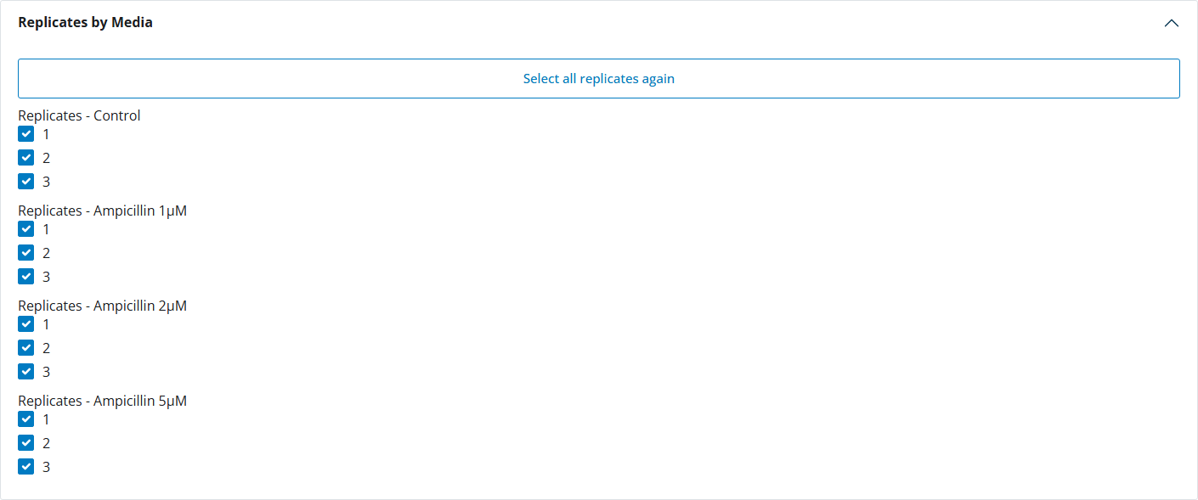

11. Metadata and Reproducibility
Metadata flow:
- Download metadata to save current state.
- Re-import metadata in future sessions.
- Orientation flip state persists across metadata roundtrip.
- Plot typography choices persist across metadata roundtrip, including font family, text sizes, and normal/bold/italic/underline state for plot titles, X/Y axis titles, axis tick labels, legend text, data labels, and significance text.
- Legend visibility/placement, including right-side legend selection where applicable, is stored in metadata and reapplied when metadata are loaded.
- Curve point size is stored in curve design metadata and restored when that metadata is loaded. Design metadata do not restore group/sample order, scope, or strain selection.
- Error-bar statistic and curve-statistics method selection persist across metadata roundtrip.
Reproducibility bundle:
- Save plot versions in-session.
- Export ZIP with plot assets + metadata.
- Reopen workflows with consistent configuration.
Regression coverage includes:
- Orientation flip applied only to Boxplot/Barplot/Violin/Stacked.
- Metadata roundtrip persistence checks.
- Final builder orientation checks.

12. Downloads
Main outputs:
- Plot image (PNG, PDF, depending on chart).
- Data export.
- Metadata export.
- Statistics export.
- Bundle ZIP.
- Advanced correlation tables.
- Merged platemap/curves exports (if merge tools were used).
Plot exports preserve the active visual configuration, including font family, per-text-part bold/italic/underline choices, selected error-bar statistic, significance labels, and axis/legend settings. Composition exports preserve the same typography controls across all plots in the layout.
Raster exports use 300 DPI by default and accept supported user values from 72 to 600 DPI. The selected effective DPI is included in metadata and bundle versions. Vector PDF/PPTX elements do not use DPI; graph width, height, and slide dimensions are configured separately.

13. Growth Module
Growth tab file support:
- Accepted file type: Excel (.xlsx).
- Auto-detected structures:
  - Reader/Tecan-like raw layout (typically later-row data in Sheet1).
  - Processed A1 table layout (first column time, following columns as wells/curves).
Extracted parameters:
- uMax: maximum exponential-phase slope.
- max_percap_time: time window of max per-capita growth.
- doub_time: doubling time (ln(2) / uMax).
- lag_time: pre-exponential transition time.
- ODmax: maximum measured OD/signal.
- max_time: time at ODmax.
- AUC: area under the curve.
- OD0: initial OD/signal at the first measured point of each curve.
Typical flow:
- Upload one or more growth files.
- Set max time and interval.
- Run extraction.
- Download ZIP outputs.
- Reuse extracted outputs in main plotting workflows.
Autosave and interruption handling:
- The optional Autosave output folder can be typed manually or selected with Browse....
- If you do not want autosave, leave this folder blank and download the ZIP with Download results at the end.
- If you type a folder, it must already exist. If the path does not exist, BIOSZEN shows a correction message and does not start that run until the path is fixed or cleared.
- When an autosave folder is set, final Curves_*.xlsx / Parameters_*.xlsx files are copied there automatically while the regular Download results ZIP remains available.
- During long runs, BIOSZEN writes per-well checkpoints under a temporary BIOSZEN_growth_checkpoints folder inside the selected autosave folder. These checkpoints allow an interrupted run to resume from completed wells instead of starting from zero.
- Checkpoints are deleted automatically after a successful completion or successful resume. They are kept only when processing is interrupted before completion.
- Stop process requests a safe cancellation. The app may finish the current well/checkpoint before releasing the run so partial files stay usable and the growth-parameter calculations are not changed.
R command equivalent:
parameters <- BIOSZEN::growth_parameters("Curves.xlsx")
parameters <- BIOSZEN::growth_parameters(
"Curves.xlsx",
output_dir = "growth_results",
overwrite = FALSE
)
The command runs the same robust detector first and uses the same permissive fallback only for values the robust method could not calculate. Its returned columns and numerical results match the Growth tab. Without output_dir, it returns the result in R and does not create files.
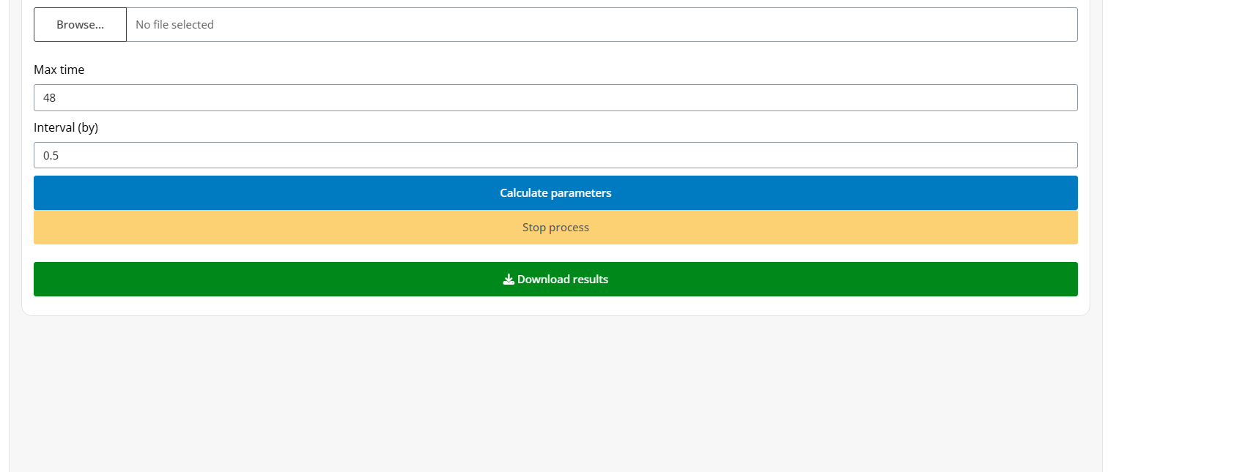

14. Troubleshooting Playbook
- Upload error
Likely cause: Missing sheet/column names.
What to do: Validate workbook structure and exact headers.
- No plot generated
Likely cause: Selected parameter/group absent after filtering.
What to do: Reset filters and verify parameter availability.
- Only Curves appears in plot type selector
Likely cause: No valid parameter columns were parsed from the uploaded data file.
What to do: Verify grouped/summary sheet structure and parameter headers, then re-upload.
- Normalization unavailable
Likely cause: Missing control medium in current scope.
What to do: Confirm control group exists in active subset.
- Stats disabled
Likely cause: Mode/test mismatch.
What to do: Switch test or use a mode with raw-compatible data.
- Curves merge fails
Likely cause: Well ID mismatch.
What to do: Match platemap Well values to curves columns.
- Grouped/Summary workbook loads but Curves has no data
Likely cause: Missing embedded curves summary sheet.
What to do: Add Curves_Summary (or alias) to the workbook, or upload curves separately in Load Curves.
- CSV not recognized
Likely cause: Wrong delimiter or missing required headers.
What to do: Check delimiter consistency and required columns.
- Slow performance
Likely cause: Too many parameters/overlays at once.
What to do: Reduce active parameters and heavy layers.

15. Support
For support and bug reports: bioszenf@gmail.com

