CSDA 5210 Databases and Data Warehousing

Project Paper on “Webster University Center
Resource Management: A Centralized Database for Operational Excellence”

Submitted To: Shawn Higginbotham
Submitted by: Bipana Gurung
12/08/2024

CONTEXT

This database project aims to address the operational challenges faced by the Webster university center in managing its facilities, equipment, and reservation processes. As a student building manager, I have first-hand experience with the inefficiencies of the current manual systems, which result in double-bookings, underutilized spaces, and limited visibility into usage patterns. By developing a centralized database system, we can transform these issues into opportunities for improved resource management and data-driven decision making. So, I am personally super excited for this paper work. And, I will try my best to gain a valuable decision and conclusion from this database system.
The database will serve as a comprehensive solution for tracking and managing:
- Multiple facilities (gymnasiums, pools, meeting rooms, fitness center)
- Equipment inventory and maintenance
- Reservation system for users
It’s about to one year that I am working as a SBM of Webster University Center and I have experienced inconvenience in its management system. Hence, this project is driven by the pressing need to modernize the university center's facility management operations and provide a scalable, efficient, and user-friendly system to meet the growing demands of the campus community.

CONTENTS

This project paper outlines the development of a centralized database system to manage the operational and analytical needs of the Webster University Center. The database system consists of two operational databases and one analytical database:

- Operational Databases:
- Facilities Database
- Equipment Inventory Database

- Analytical Database:
- Resource Utilization and Analytics Database

For the operational databases, the paper first details the specific requirements for each one. It then presents the conceptual models, depicted through Entity Relationship Diagrams (ERDs), and the implementation models, showcasing the detailed database schemas.
Next, the paper describes the requirements, conceptual model, and implementation model for the analytical database, which combines data from the two operational databases.
Finally, the paper provides the complete SQL code used to construct the tables, constraints, relationships, and populate the data for the entire database system. This SQL code accurately represents the requirements, ERDs, and database schemas outlined earlier in the paper.

GOALS

The main purpose of this centralized database system is to transform the operational efficiency and data-driven decision-making capabilities of the Webster University Center.
By bringing together the management of facilities, equipment, and reservations into a single integrated platform, the university center aims to achieve several key goals:

- Optimize Facility Utilization: The database will provide real-time visibility into facility reservations, occupancy, and availability, allowing staff to maximize the use of limited campus resources and accommodate the growing demands of the student body.

- Streamline Reservation Management: A user-friendly reservation system will eliminate manual errors, prevent double-bookings, and simplify the booking process for students, faculty, and staff, enhancing the overall user experience.

- Enhance Equipment Tracking: Maintaining a comprehensive equipment inventory and maintenance records will enable the university center to better manage its assets, reduce the risk of lost or damaged items, and ensure equipment is always available when needed.

- Enable Data-Driven Decisions: By collecting and analyzing facility usage, reservation patterns, and equipment utilization data, the university center will gain valuable insights to guide future planning, budgeting, and resource allocation decisions, driving continuous improvement in its operations.

- Achieve Operational Excellence: Overall, the centralized database system will transform the university center's operations, transitioning it from a manually intensive, reactive environment to a proactive, data-driven organization, resulting in cost savings, improved service delivery, and a stronger campus experience.

By implementing this integrated database solution, the Webster University Center will be well-equipped and welcomed location to meet the evolving needs of its community while maintaining a high level of operational efficiency and data-informed decision-making.

DESIGN
  - Requirements & Dataset Description
Primary Entities and Their Attributes:
    - Facility Dataset
      - FacilityID (Unique identifier)
      - FacilityName (Name of room/space)
      - Type (Gym, Pool, Meeting Room, etc.)
      - Capacity (Maximum occupancy)
      - Location (Building/floor/room number)
      - Status (Available, Under Maintenance, Reserved)
      - OperatingHours (Daily schedule)
      - LastModifiedBy: Tracks who last updated facility details.

    - Equipment Dataset
- EquipmentID (Unique identifier)
- Name (Equipment name)
- Category (Sports, AV, Furniture)
- PurchaseDate
- CurrentLocation (FacilityID where item is located)
- Status (Available, In Use, Maintenance)
- LastMaintenance (Date)
- LastModifiedBy: Tracks who updated equipment details.
- ChangeTimestamp: Records when equipment details were updated.
    - User Dataset
- UserID (Unique identifier)
- FirstName
- LastName
- Type (Student, Faculty, Staff)
- Email
- Phone
- Status (Active/Inactive)
    - Reservation Dataset
- ReservationID (Unique identifier)
- UserID (Who made the reservation)
- FacilityID (What was reserved)
- StartTime (When reservation begins)
- EndTime (When reservation ends)
- Purpose (Event description)
- Status (Confirmed, Cancelled, Completed)
- LastModifiedBy: Tracks who modified or canceled a reservation.
- CancellationReason: Logs the reason if a reservation is canceled.

    - Involve Dataset
- ReservationID (Unique identifier)
- EquipmentID (Unique identifier)
- Quantity : Tracks how many units of each piece of equipment are involved in a given reservation

  - Entity Relationship Diagram (ERD)

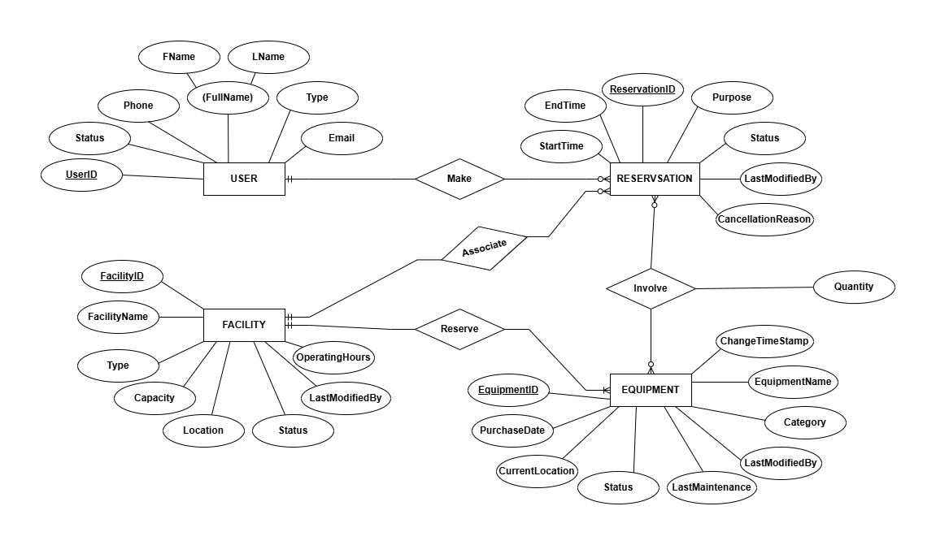

- Schema

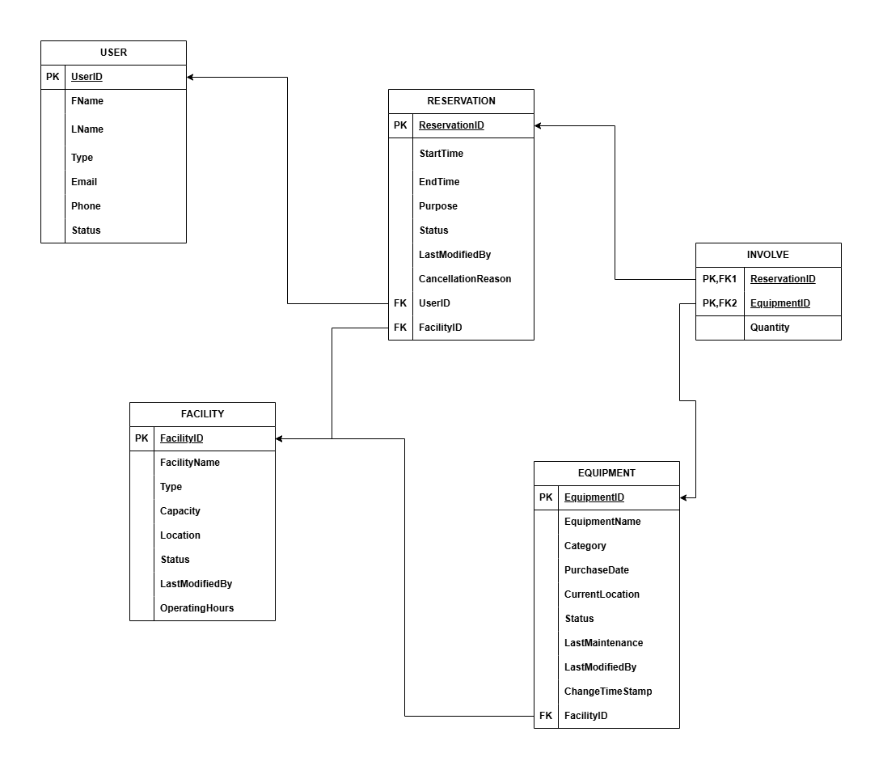

Implementation
To achieve the objectives of my project, I have designed and created a comprehensive database that includes key entities such as USER, RESERVATION, FACILITY, EQUIPMENT, and INVOLVE. These entities were carefully selected to represent the main components of the reservation and resource management system at the Webster University Center.
I designed tables for each entity with relevant attributes and populated them with sample data to test the system’s functionality and relationships. Below, I provide the SQL code used to create and populate these tables
- To create Users table, the SQL code are:
CREATE TABLE Users (
UserID VARCHAR2(10) PRIMARY KEY,
FirstName VARCHAR2(50) NOT NULL,
LastName VARCHAR2(50) NOT NULL,
Type VARCHAR2(20) NOT NULL,
Email VARCHAR2(100) NOT NULL,
Phone VARCHAR2(20) NOT NULL,
Status VARCHAR2(20) NOT NULL
) ;
- To insert data into Users Table, the SQL codes are:
INSERT INTO Users (UserID, FirstName, LastName, Type, Email, Phone, Status)
VALUES ('U001', 'Emily', 'Johnson', 'Student', 'emily.j@webster.edu', '314-555-1234', 'Active');

INSERT INTO Users (UserID, FirstName, LastName, Type, Email, Phone, Status)
VALUES ('U002', 'Michael', 'Rodriguez', 'Faculty', 'm.rodriguez@webster.edu', '314-555-5678', 'Active');

INSERT INTO Users (UserID, FirstName, LastName, Type, Email, Phone, Status)
VALUES ('U003', 'Sarah', 'Kim', 'Staff', 'sarah.kim@webster.edu', '314-555-9012', 'Active');

INSERT INTO Users (UserID, FirstName, LastName, Type, Email, Phone, Status)
VALUES ('U004', 'David', 'Patel', 'Student', 'david@webster.edu', '314-555-3456', 'Active');

INSERT INTO Users (UserID, FirstName, LastName, Type, Email, Phone, Status)
VALUES ('U005', 'Jessica', 'Thompson', 'Faculty', 'j.thompson@webster.edu', '314-358-7890', 'Inactive');

INSERT INTO Users (UserID, FirstName, LastName, Type, Email, Phone, Status)
VALUES ('U006', 'Robert', 'Garcia', 'Student', 'robert.g@webster.edu', '314-555-2345', 'Active');

INSERT INTO Users (UserID, FirstName, LastName, Type, Email, Phone, Status)
VALUES ('U007', 'Amanda', 'Wong', 'Staff', 'amandawong@webster.edu', '314-358-8901', 'Active');

INSERT INTO Users (UserID, FirstName, LastName, Type, Email, Phone, Status)
VALUES ('U008', 'Thomas', 'Brown', 'Faculty', 'thomasbrown@webster.edu', '314-555-3210', 'Active');

INSERT INTO Users (UserID, FirstName, LastName, Type, Email, Phone, Status)
VALUES ('U009', 'Jennifer', 'Lee', 'Student', 'jenniferlee@webster.edu', '314-358-0685', 'Inactive');

INSERT INTO Users (UserID, FirstName, LastName, Type, Email, Phone, Status)
VALUES ('U010', 'Carlos', 'Martinez', 'Staff', 'carlosmartinez@webster.edu', '314-358-7654', 'Active');

INSERT INTO Users (UserID, FirstName, LastName, Type, Email, Phone, Status)
VALUES ('U011', 'Sophia', 'Davis', 'Student', 'sophiadavid@webster.edu', '314-555-9876', 'Active');

INSERT INTO Users (UserID, FirstName, LastName, Type, Email, Phone, Status)
VALUES ('U012', 'Kevin', 'Nguyen', 'Student', 'kevinnguyd@webster.edu', '314-555-6789', 'Active');

INSERT INTO Users (UserID, FirstName, LastName, Type, Email, Phone, Status)
VALUES ('U013', 'Daniel', 'Taylor', 'Staff', 'danieltayld@webster.edu', '314-555-5540', 'Active');

INSERT INTO Users (UserID, FirstName, LastName, Type, Email, Phone, Status)
VALUES ('U014', 'Rachel', 'Kim', 'Student', 'rachelkid@webster.edu', '314-358-0688', 'Active');

INSERT INTO Users (UserID, FirstName, LastName, Type, Email, Phone, Status)
VALUES ('U015', 'Maria', 'Lopez', 'Student', 'marialoped@webster.edu', '314-555-0147', 'Active');

- The screenshot below shows the created Users table in Oracle, which includes all the inserted data rows and columns. Although only rows up to row 13 are captured in the image for demonstration purposes, the table in Oracle contains the complete set of data as inserted by the SQL code INSERT statements.

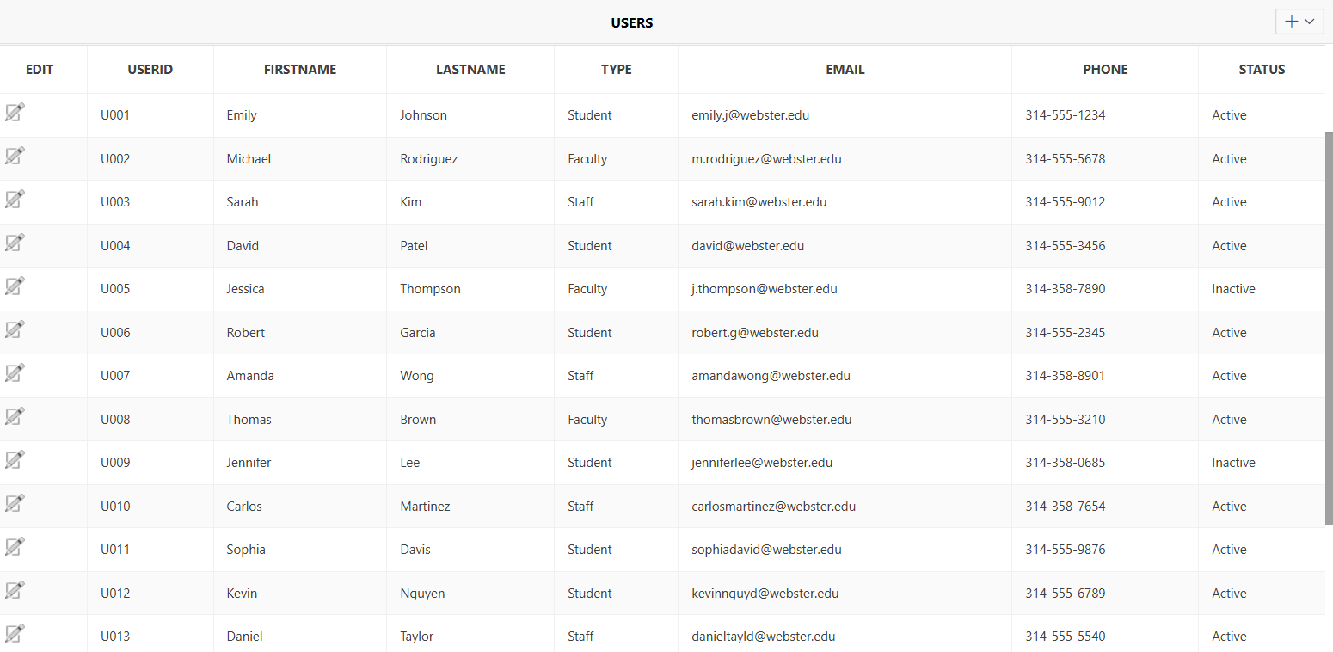

- To create Facilities Table, the SQL code are:
CREATE TABLE Facilities (
FacilityID VARCHAR2(10) PRIMARY KEY,
FacilityName VARCHAR2(100) NOT NULL,
Type VARCHAR2(50) NOT NULL,
Capacity NUMBER NOT NULL,
Location VARCHAR2(100) NOT NULL,
Status VARCHAR2(50) NOT NULL,
OperatingHours VARCHAR2(50) NOT NULL,
LastModifiedBy VARCHAR2(100) NOT NULL
);
- To insert the data into ‘Facilities’ table, the SQL codes are:
INSERT INTO Facilities VALUES ('F001', 'Main Gymnasium', 'Gym', 150, 'University Center Ground Floor', 'Available', '06:00-22:30', 'John@webster.edu') ;
INSERT INTO Facilities VALUES ('F002', 'Olympic Pool', 'Pool', 50, 'University Center Ground Floor', 'Available', '06:00-21:00', 'Sarah@webster.edu') ;
INSERT INTO Facilities VALUES ('F003', 'Conference Room', 'Meeting Room', 20, 'University Center Ground Floor', 'Available', '06:00-22:30', 'Mike@webster.edu') ;
INSERT INTO Facilities VALUES ('F004', 'Fitness Center', 'Fitness', 75, 'University Center Ground Floor', 'Available', '06:00-22:30', 'Lisa@webster.edu') ;
INSERT INTO Facilities VALUES ('F005', 'Presentation Room', 'Meeting Room', 15, 'University Center 1st Floor', 'Under Maintenance', '06:00-22:30', 'Riley@webster.edu') ;
INSERT INTO Facilities VALUES ('F006', 'Sunnen Lounge', 'Meeting Room', 100, 'University Center 1st Floor', 'Available', '06:00-22:30', 'Bipana@webster.edu') ;
INSERT INTO Facilities VALUES ('F007', 'Basketball Court', 'Sports', 30, 'University Center Ground Floor', 'Available', '06:00-22:30', 'Steven@webster.edu') ;
INSERT INTO Facilities VALUES ('F008', 'Multipurpose Dance Studio', 'Meeting Room', 25, 'University Center 1st Floor', 'Available', '06:00-22:30', 'Annamaria@webster.edu') ;
INSERT INTO Facilities VALUES ('F009', 'Basketball Training', 'Gym', 60, 'University Center Ground Floor', 'Reserved', '06:00-22:30', 'Dangol@webster.edu') ;
INSERT INTO Facilities VALUES ('F010', 'Swimming Training', 'Pool', 40, 'University Center Ground Floor', 'Available', '06:00-21:00', 'Sugat@webster.edu') ;
INSERT INTO Facilities VALUES ('F011', 'Production Room', 'Meeting Room', 12, 'University Center 1st Floor', 'Reserved', '06:00-22:30', 'Pradip@webster.edu') ;
INSERT INTO Facilities VALUES ('F012', 'Weight Training Area', 'Fitness', 50, 'University Center Ground Floor', 'Reserved', '06:00-22:30', 'Dusa@webster.edu') ;
INSERT INTO Facilities VALUES ('F013', 'Volleyball Training', 'Sports', 25, 'University Center Ground Floor', 'Under Maintenance', '06:00-22:30', 'Adip@webster.edu') ;
INSERT INTO Facilities VALUES ('F014', 'Racquetball Court', 'Sports', 20, 'University Center Ground Floor', 'Available', '06:00-22:30', 'Mike@webster.edu') ;
INSERT INTO Facilities VALUES ('F015', 'Cardio Room', 'Fitness', 55, 'University Center Ground Floor', 'Available', '06:00-22:30', 'Emma.er@webster.edu') ;

- For Demonstration Purpose as mentioned above:

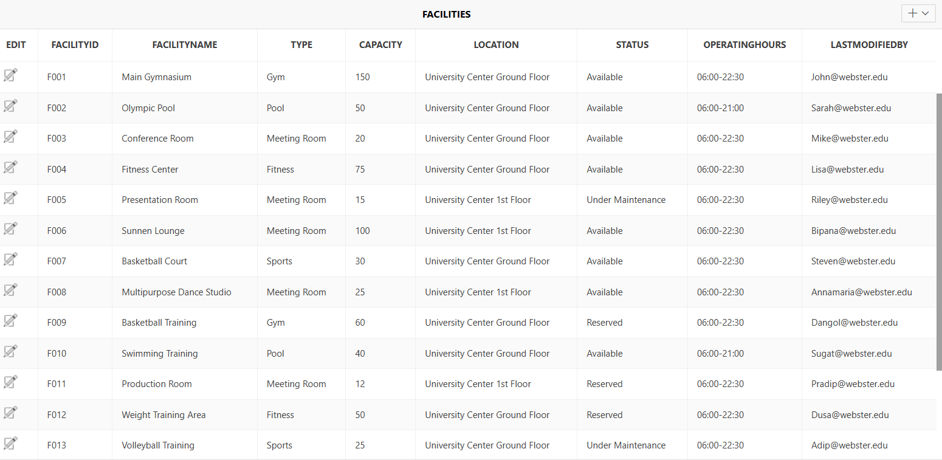

- To Create Equipment table, the SQL codes are:
CREATE TABLE Equipment (
EquipmentID VARCHAR2(10) PRIMARY KEY,
Name VARCHAR2(100) NOT NULL,
Category VARCHAR2(50) NOT NULL,
PurchaseDate DATE NOT NULL,
CurrentLocation VARCHAR2(10) NOT NULL,
Status VARCHAR2(50) NOT NULL,
LastMaintenance DATE,
LastModifiedBy VARCHAR2(100) NOT NULL,
ChangeTimestamp TIMESTAMP NOT NULL
);
- To insert the data into ‘Equipment’ table, the SQL codes are:

INSERT INTO Equipment VALUES ('E001', 'Basketballs', 'Sports', TO_DATE('3/15/2023', 'MM/DD/YYYY'), 'F002', 'Available', TO_DATE('1/10/2024', 'MM/DD/YYYY'), 'Riley@webster.edu', TO_DATE('1/10/2024 12:30', 'MM/DD/YYYY HH24:MI'));
INSERT INTO Equipment VALUES ('E002', 'Swimming Lanes Marker', 'Sports', TO_DATE('11/20/2022', 'MM/DD/YYYY'), 'F001', 'Available', TO_DATE('10/3/2023', 'MM/DD/YYYY'), 'Pradip@webster.edu', TO_DATE('1/15/2024 9:45', 'MM/DD/YYYY HH24:MI'));
INSERT INTO Equipment VALUES ('E003', 'Yoga Mats (10 set)', 'Furniture', TO_DATE('8/1/2023', 'MM/DD/YYYY'), 'F009', 'In Use', TO_DATE('2/17/2024', 'MM/DD/YYYY'), 'Katie@webster.edu', TO_DATE('3/20/2024 1:30', 'MM/DD/YYYY HH24:MI'));
INSERT INTO Equipment VALUES ('E004', 'Projector', 'AV', TO_DATE('1/20/1900', 'MM/DD/YYYY'), 'F005', 'Available', TO_DATE('11/6/2023', 'MM/DD/YYYY'), 'Justin@webster.edu', TO_DATE('2/9/2024 11:45', 'MM/DD/YYYY HH24:MI'));
INSERT INTO Equipment VALUES ('E005', 'Treadmill', 'Sports', TO_DATE('6/30/2022', 'MM/DD/YYYY'), 'F007', 'In Use', TO_DATE('12/8/2022', 'MM/DD/YYYY'), 'Bipana@webster.edu', TO_DATE('3/18/2023 8:30', 'MM/DD/YYYY HH24:MI'));
INSERT INTO Equipment VALUES ('E006', 'UC Laptop (2)', 'AV', TO_DATE('1/10/2023', 'MM/DD/YYYY'), 'F010', 'Available', TO_DATE('10/16/2023', 'MM/DD/YYYY'), 'Billy@webster.edu', TO_DATE('5/19/2024 22:00', 'MM/DD/YYYY HH24:MI'));
INSERT INTO Equipment VALUES ('E007', 'Bose Sound System', 'AV', TO_DATE('5/15/2021', 'MM/DD/YYYY'), 'F013', 'Available', TO_DATE('6/14/2024', 'MM/DD/YYYY'), 'Jeniffer@webster.edu', TO_DATE('6/14/2024 21:00', 'MM/DD/YYYY HH24:MI'));
INSERT INTO Equipment VALUES ('E008', 'Weight Set', 'Sports', TO_DATE('12/1/2022', 'MM/DD/YYYY'), 'F012', 'In Use', TO_DATE('2/14/2024', 'MM/DD/YYYY'), 'Katie@webster.edu', TO_DATE('2/14/2024 22:00', 'MM/DD/YYYY HH24:MI'));
INSERT INTO Equipment VALUES ('E009', 'Sunnen Handheld Microphone', 'AV', TO_DATE('7/20/2020', 'MM/DD/YYYY'), 'F002', 'Available', TO_DATE('6/17/2023', 'MM/DD/YYYY'), 'JoshParreteu@webster.edu', TO_DATE('1/9/2024 1:30', 'MM/DD/YYYY HH24:MI'));
INSERT INTO Equipment VALUES ('E010', 'Racquetball Equipment Set', 'Sports', TO_DATE('8/15/2022', 'MM/DD/YYYY'), 'F004', 'Available', TO_DATE('9/17/2024', 'MM/DD/YYYY'), 'Jeniffer@webster.edu', TO_DATE('10/25/2024 4:45', 'MM/DD/YYYY HH24:MI'));
INSERT INTO Equipment VALUES ('E011', 'Conference Table', 'Furniture', TO_DATE('2/28/2020', 'MM/DD/YYYY'), 'F011', 'In Maintenance', TO_DATE('10/4/2024', 'MM/DD/YYYY'), 'Katie@webster.edu', TO_DATE('12/2/2024 12:45', 'MM/DD/YYYY HH24:MI'));
INSERT INTO Equipment VALUES ('E012', 'UC Bikes', 'Sports', TO_DATE('10/5/2022', 'MM/DD/YYYY'), 'F012', 'In Maintenance', TO_DATE('12/3/2023', 'MM/DD/YYYY'), 'Jeniffer@webster.edu', TO_DATE('12/3/2023 10:00', 'MM/DD/YYYY HH24:MI'));
INSERT INTO Equipment VALUES ('E013', 'Multimedia Projector', 'AV', TO_DATE('6/18/2023', 'MM/DD/YYYY'), 'F007', 'In Use', TO_DATE('12/1/2022', 'MM/DD/YYYY'), 'Jeniffer@webster.edu', TO_DATE('4/4/2023 1:30', 'MM/DD/YYYY HH24:MI'));
INSERT INTO Equipment VALUES ('E014', 'Swimming Training Boards', 'Sports', TO_DATE('7/17/2021', 'MM/DD/YYYY'), 'F003', 'Available', TO_DATE('11/14/2022', 'MM/DD/YYYY'), 'JoshParreteu@webster.edu', TO_DATE('10/2/2024 8:30', 'MM/DD/YYYY HH24:MI'));
INSERT INTO Equipment VALUES ('E015', 'Fitness Training Machines', 'Sports', TO_DATE('4/22/2023', 'MM/DD/YYYY'), 'F005', 'In Use', TO_DATE('2/29/2024', 'MM/DD/YYYY'), 'JoshParreteu@webster.edu', TO_DATE('5/25/2024 9:00', 'MM/DD/YYYY HH24:MI'));

- Demonstration:
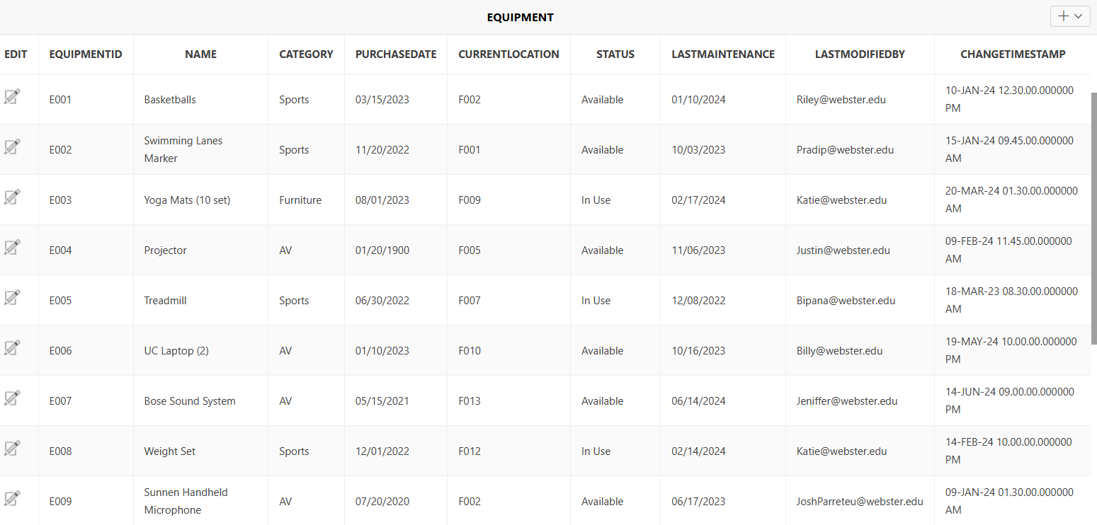
- To create Reservations table, the SQL codes are:
CREATE TABLE Reservations (
ReservationID VARCHAR2(10) PRIMARY KEY,
UserID VARCHAR2(10) NOT NULL,
FacilityID VARCHAR2(10) NOT NULL,
StartTime TIMESTAMP NOT NULL,
EndTime TIMESTAMP NOT NULL,
Purpose VARCHAR2(200) NOT NULL,
Status VARCHAR2(20) NOT NULL,
LastModifiedBy VARCHAR2(100) NOT NULL,
CancellationReason VARCHAR2(200),
CONSTRAINT fk_reservations_users FOREIGN KEY (UserID) REFERENCES Users(UserID),
CONSTRAINT fk_reservations_facilities FOREIGN KEY (FacilityID) REFERENCES Facilities(FacilityID)
);

- To insert data into ‘Reservations’ table, the SQL codes are:
INSERT INTO Reservations VALUES ('R001', 'U001', 'F004', TO_TIMESTAMP('2/15/2024 8:30', 'MM/DD/YYYY HH24:MI'), TO_TIMESTAMP('2/15/2024 12:00', 'MM/DD/YYYY HH24:MI'), 'Basketball Practice', 'Confirmed', 'U001', NULL);
INSERT INTO Reservations VALUES ('R002', 'U002', 'F006', TO_TIMESTAMP('2/16/2024 11:30', 'MM/DD/YYYY HH24:MI'), TO_TIMESTAMP('2/16/2024 16:45', 'MM/DD/YYYY HH24:MI'), 'Research Meeting', 'Confirmed', 'U010', NULL);
INSERT INTO Reservations VALUES ('R003', 'U003', 'F003', TO_TIMESTAMP('3/4/2024 10:00', 'MM/DD/YYYY HH24:MI'), TO_TIMESTAMP('3/4/2024 12:00', 'MM/DD/YYYY HH24:MI'), 'Morning Swimming Training', 'Confirmed', 'U003', NULL);
INSERT INTO Reservations VALUES ('R004', 'U004', 'F001', TO_TIMESTAMP('5/9/2024 8:00', 'MM/DD/YYYY HH24:MI'), TO_TIMESTAMP('5/9/2024 10:30', 'MM/DD/YYYY HH24:MI'), 'Facilities Safety Meeting', 'Cancelled', 'U006', 'Insufficient Attendance');
INSERT INTO Reservations VALUES ('R005', 'U005', 'F005', TO_TIMESTAMP('1/14/2024 12:00', 'MM/DD/YYYY HH24:MI'), TO_TIMESTAMP('1/14/2024 14:45', 'MM/DD/YYYY HH24:MI'), 'SGA Interview', 'Completed', 'U012', NULL);
INSERT INTO Reservations VALUES ('R006', 'U006', 'F010', TO_TIMESTAMP('5/10/2024 8:30', 'MM/DD/YYYY HH24:MI'), TO_TIMESTAMP('5/10/2024 9:30', 'MM/DD/YYYY HH24:MI'), 'Yoga Session', 'Confirmed', 'U008', NULL);
INSERT INTO Reservations VALUES ('R007', 'U007', 'F007', TO_TIMESTAMP('3/17/2024 10:30', 'MM/DD/YYYY HH24:MI'), TO_TIMESTAMP('3/17/2024 17:00', 'MM/DD/YYYY HH24:MI'), 'SGA Meeting', 'Confirmed', 'U011', NULL);
INSERT INTO Reservations VALUES ('R008', 'U008', 'F015', TO_TIMESTAMP('6/12/2024 13:30', 'MM/DD/YYYY HH24:MI'), TO_TIMESTAMP('6/12/2024 19:00', 'MM/DD/YYYY HH24:MI'), 'Welcome Party', 'Confirmed', 'U013', NULL);
INSERT INTO Reservations VALUES ('R009', 'U009', 'F009', TO_TIMESTAMP('7/13/2024 12:00', 'MM/DD/YYYY HH24:MI'), TO_TIMESTAMP('7/13/2024 22:45', 'MM/DD/YYYY HH24:MI'), 'Gorloks Aware Interviews', 'Confirmed', 'U009', NULL);
INSERT INTO Reservations VALUES ('R010', 'U010', 'F010', TO_TIMESTAMP('5/14/2024 8:45', 'MM/DD/YYYY HH24:MI'), TO_TIMESTAMP('5/14/2024 13:15', 'MM/DD/YYYY HH24:MI'), 'Swimming Lesson', 'Confirmed', 'U015', NULL);
INSERT INTO Reservations VALUES ('R011', 'U011', 'F014', TO_TIMESTAMP('5/29/2024 8:30', 'MM/DD/YYYY HH24:MI'), TO_TIMESTAMP('5/29/2024 16:30', 'MM/DD/YYYY HH24:MI'), 'Media Projector', 'Cancelled', 'U014', 'Equipment Unavailability');
INSERT INTO Reservations VALUES ('R012', 'U012', 'F012', TO_TIMESTAMP('8/16/2024 11:45', 'MM/DD/YYYY HH24:MI'), TO_TIMESTAMP('8/16/2024 13:45', 'MM/DD/YYYY HH24:MI'), 'Sports Department Meeting', 'Completed', 'U002', NULL);

INSERT INTO Reservations VALUES ('R014', 'U014', 'F011', TO_TIMESTAMP('11/18/2024 19:30', 'MM/DD/YYYY HH24:MI'), TO_TIMESTAMP('11/18/2024 23:30', 'MM/DD/YYYY HH24:MI'), 'Fitness Workout', 'Confirmed', 'U007', NULL);
INSERT INTO Reservations VALUES ('R015', 'U015', 'F009', TO_TIMESTAMP('10/19/2024 20:00', 'MM/DD/YYYY HH24:MI'), TO_TIMESTAMP('10/20/2024 0:30', 'MM/DD/YYYY HH24:MI'), 'Winter Holiday Party', 'Completed', 'U004', NULL);

INSERT INTO Reservations (
ReservationID, UserID, FacilityID, StartTime, EndTime, Purpose, Status, LastModifiedBy, CancellationReason
) VALUES (
'R013',
'U013',
'F013',
TO_TIMESTAMP('9/17/2024 22:00', 'MM/DD/YYYY HH24:MI'),
TO_TIMESTAMP('9/18/2024 2:00', 'MM/DD/YYYY HH24:MI'),
'Women''s Basketball Training',
'Confirmed',
'U005',
NULL
);
- For Demonstration Purpose as mentioned above:
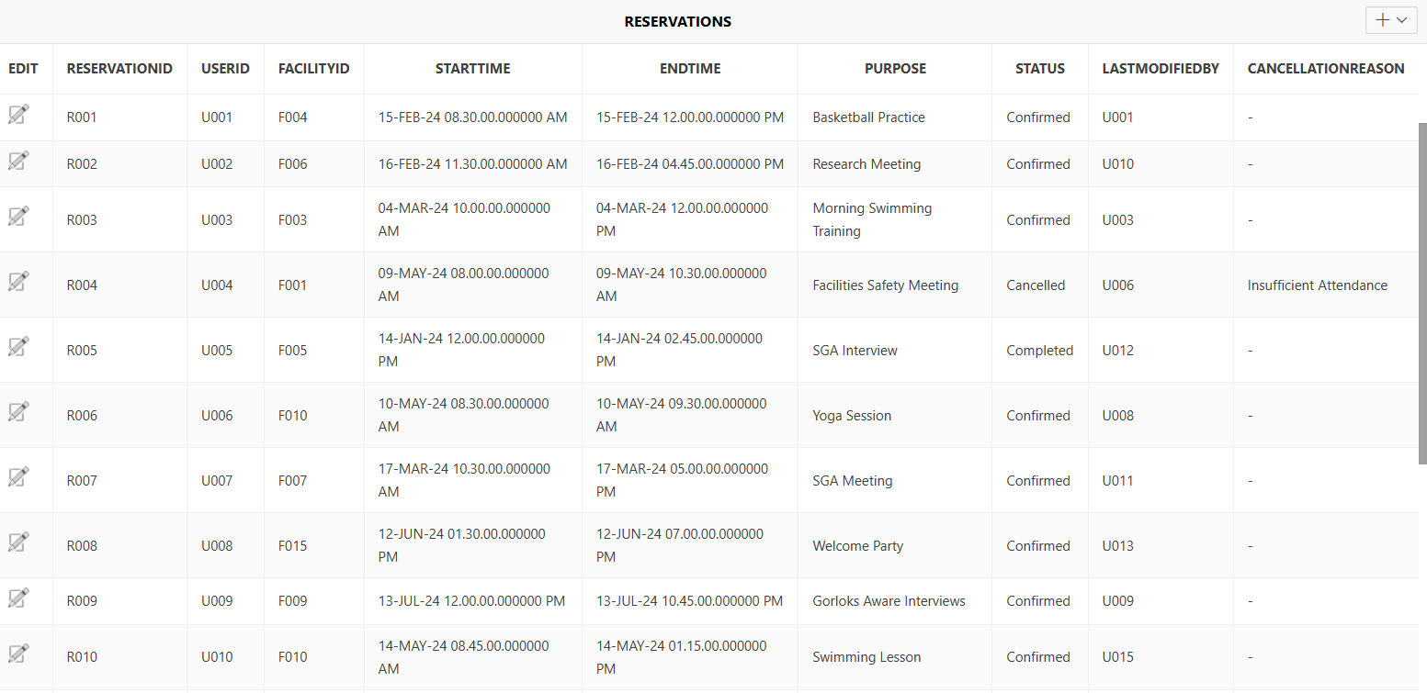

- To create Involve table and insert data, the SQL codes are:
CREATE TABLE Involve (
ReservationID VARCHAR2(10),
EquipmentID VARCHAR2(10),
Quantity NUMBER,
CONSTRAINT PK_Involve PRIMARY KEY (ReservationID, EquipmentID)
);

INSERT INTO Involve (ReservationID, EquipmentID, Quantity)
VALUES ('R002', 'E006', 5);

INSERT INTO Involve (ReservationID, EquipmentID, Quantity)
VALUES ('R005', 'E001', 6);

INSERT INTO Involve (ReservationID, EquipmentID, Quantity)
VALUES ('R009', 'E004', 2);

INSERT INTO Involve (ReservationID, EquipmentID, Quantity)
VALUES ('R010', 'E009', 7);

INSERT INTO Involve (ReservationID, EquipmentID, Quantity)
VALUES ('R001', 'E010', 3);

INSERT INTO Involve (ReservationID, EquipmentID, Quantity)
VALUES ('R002', 'E015', 1);

INSERT INTO Involve (ReservationID, EquipmentID, Quantity)
VALUES ('R008', 'E013', 4);

INSERT INTO Involve (ReservationID, EquipmentID, Quantity)
VALUES ('R011', 'E011', 9);

INSERT INTO Involve (ReservationID, EquipmentID, Quantity)
VALUES ('R015', 'E014', 11);

INSERT INTO Involve (ReservationID, EquipmentID, Quantity)
VALUES ('R003', 'E003', 5);

INSERT INTO Involve (ReservationID, EquipmentID, Quantity)
VALUES ('R006', 'E005', 3);

INSERT INTO Involve (ReservationID, EquipmentID, Quantity)
VALUES ('R007', 'E007', 4);

INSERT INTO Involve (ReservationID, EquipmentID, Quantity)
VALUES ('R013', 'E012', 6);

INSERT INTO Involve (ReservationID, EquipmentID, Quantity)
VALUES ('R009', 'E008', 8);

INSERT INTO Involve (ReservationID, EquipmentID, Quantity)
VALUES ('R013', 'E011', 2);

- For Demonstration Purpose as mentioned above:
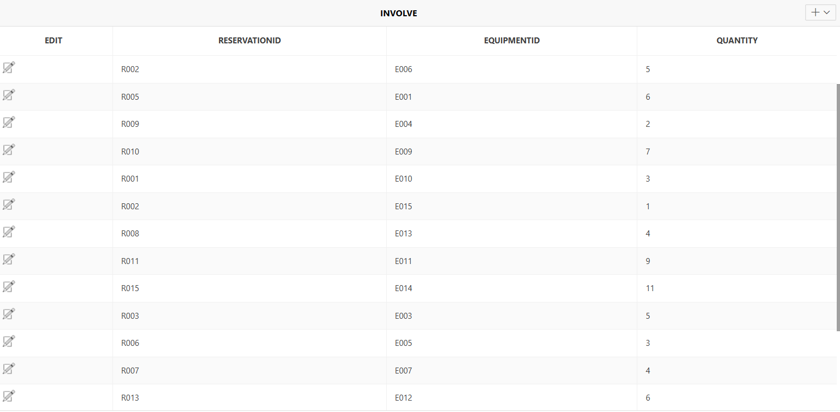

Deployment
To enhance the operational efficiency of Webster University Center resources, to showcase the practical utility of the centralized database system for Webster University Center, I have developed a series of targeted SQL queries that address key operational challenges and provide valuable insights into resource management.

- Resource Utilization Optimization Query
This query helps identify the most and least utilized facilities, enabling strategic resource allocation and planning:

SELECT f.FacilityName, COUNT(r.ReservationID) AS ReservationCount, ROUND(COUNT(r.ReservationID) / (SELECT COUNT(*) FROM Reservations) * 100, 2) AS UtilizationPercentage FROM Facilities f LEFT JOIN Reservations r ON f.FacilityID = r.FacilityID GROUP BY f.FacilityName ORDER BY ReservationCount DESC;

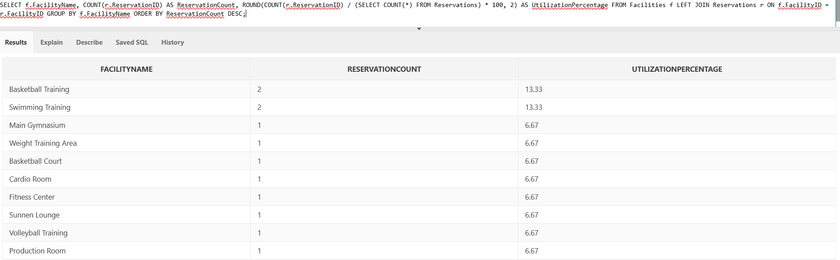

This query provides a comprehensive view of facility usage, helping management:
- Identify high-demand and underutilized spaces
- Make informed decisions about resource allocation
- Plan potential facility expansions or restructuring

- Equipment Tracking and Maintenance Efficiency A critical query to monitor equipment status and maintenance cycles:
SELECT e.EquipmentID, e.Name, e.Status, e.LastMaintenance, ROUND(MONTHS_BETWEEN(SYSDATE, e.LastMaintenance), 1) AS MonthsSinceLastMaintenance FROM Equipment e WHERE MONTHS_BETWEEN(SYSDATE, e.LastMaintenance) > 12 OR e.Status = 'In Maintenance' ORDER BY MonthsSinceLastMaintenance DESC;

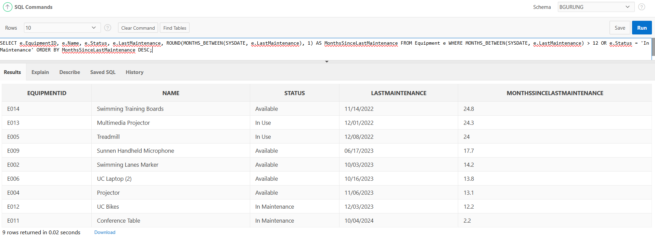
Key Benefits:
- Proactively identifies equipment needing maintenance
- Tracks equipment that has exceeded recommended maintenance intervals
- Helps prevent equipment failure and unexpected downtime

- User Reservation Patterns Analysis A query to understand reservation behaviors across different user types:
SELECT u.Type AS UserCategory, COUNT(r.ReservationID) AS TotalReservations, ROUND(AVG(EXTRACT(HOUR FROM (r.EndTime - r.StartTime)) * 60 + EXTRACT(MINUTE FROM (r.EndTime - r.StartTime))), 2) AS AverageReservationDuration FROM Users u JOIN Reservations r ON u.UserID = r.UserID GROUP BY u.Type ORDER BY TotalReservations DESC;
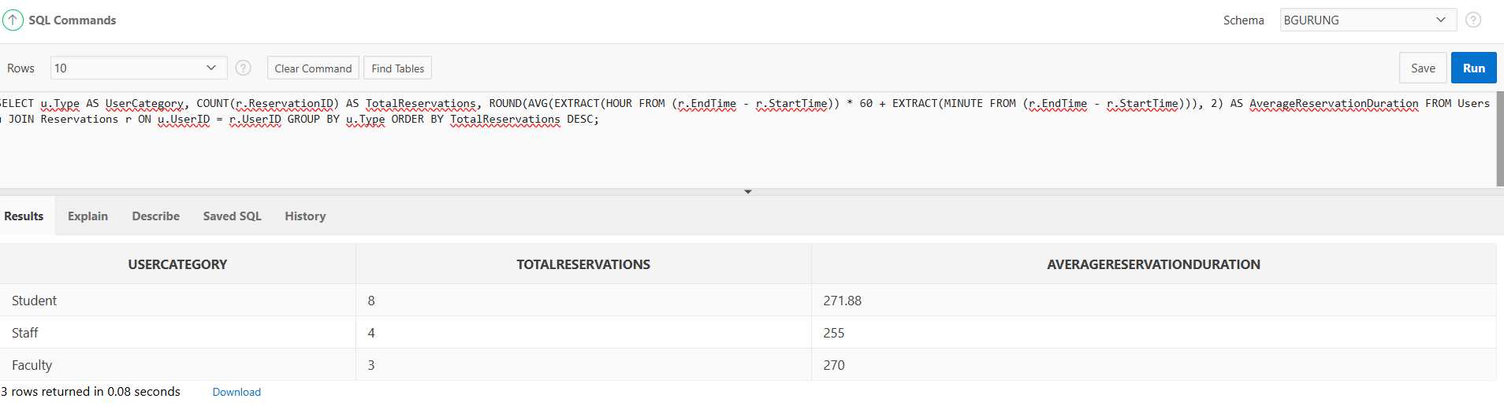
Insights Provided:
- Reservation patterns across student, faculty, and staff categories
- Average reservation duration for each user type
- Helps in understanding space and resource needs for different user groups

- Double Booking Prevention: The double booking check query helps prevent scheduling conflicts, ensuring smooth and organized use of university resources.
This stored procedure checks for overlapping reservations by comparing the proposed start and end times with the existing reservations. It uses the BETWEEN clause to handle various scenarios where the proposed reservation may overlap with an existing one.

To check for double booking directly:
SELECT COUNT(*) AS ConflictCount
FROM Reservations
WHERE FacilityID = 'F001'
AND StartTime <= TO_DATE('2024-12-15 12:00', 'YYYY-MM-DD HH24:MI')
AND EndTime >= TO_DATE('2024-12-15 10:00', 'YYYY-MM-DD HH24:MI');
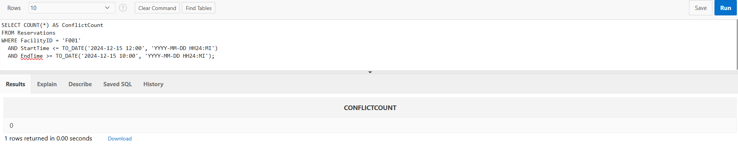

- Emergency Maintenance and Equipment Availability Tracker
SELECT e.EquipmentID, e.Name, e.Status, i.ReservationID, r.StartTime, r.EndTime FROM Equipment e LEFT JOIN Involve i ON e.EquipmentID = i.EquipmentID LEFT JOIN Reservations r ON i.ReservationID = r.ReservationID WHERE e.Status IN ('In Maintenance', 'In Use') ORDER BY r.StartTime;
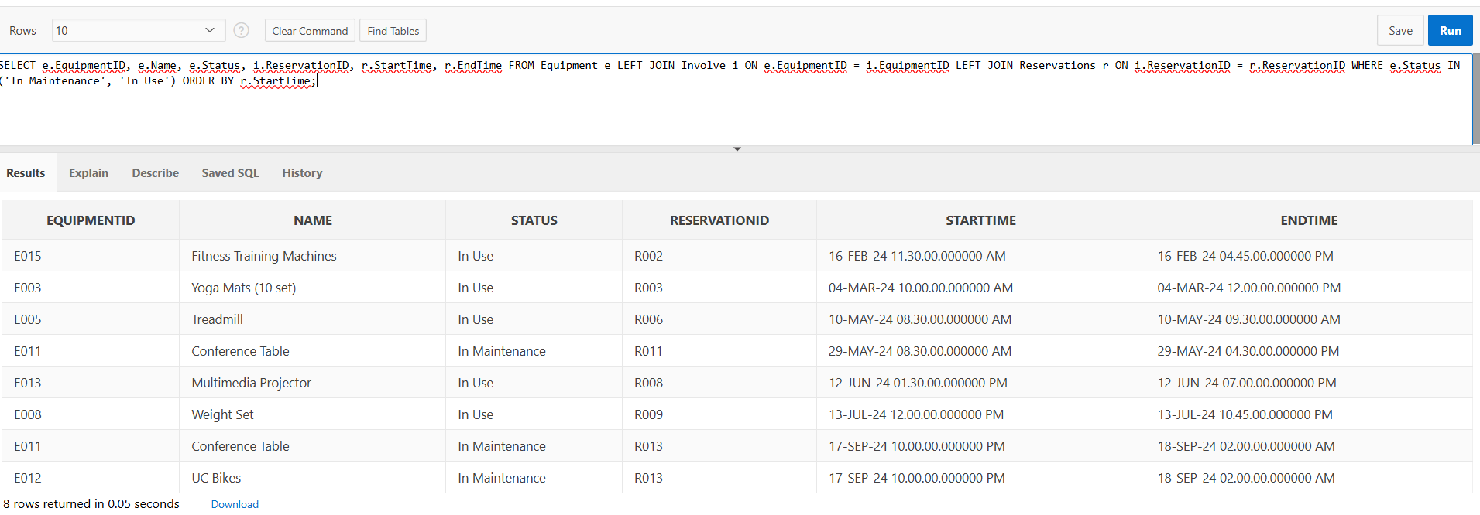
Key Features:
- Tracks equipment currently unavailable
- Links unavailable equipment to specific reservations
- Helps in real-time resource management and planning

- To find the top facilities by the number of reservations: This query only considers confirmed reservations, as those are the ones that have actually been booked. It limits the output to the top 5 facilities with the most reservations, which should provide a good overview of the most popular facilities.
SELECT FacilityID, COUNT(*) AS TotalReservations
FROM Reservations
GROUP BY FacilityID
ORDER BY TotalReservations DESC;
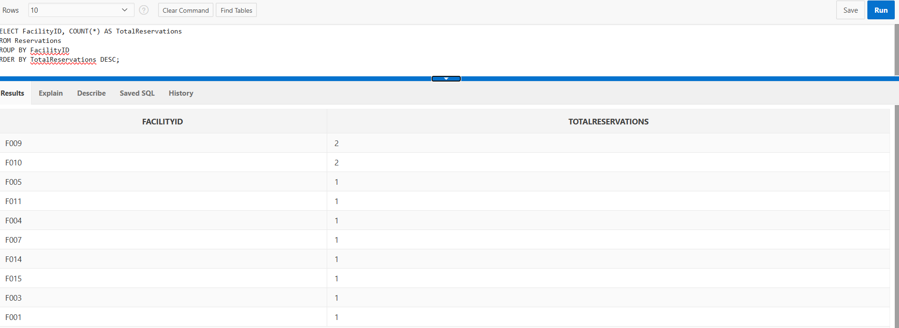
- To retrieve cancelled reservations with reasons: This query also remains the same as the previous example, as it effectively retrieves the cancelled reservations and their associated cancellation reasons.

SELECT r.ReservationID, r.FacilityID, r.StartTime, r.EndTime, r.CancellationReason
FROM Reservations r
WHERE r.Status = 'Cancelled'
ORDER BY r.StartTime DESC;

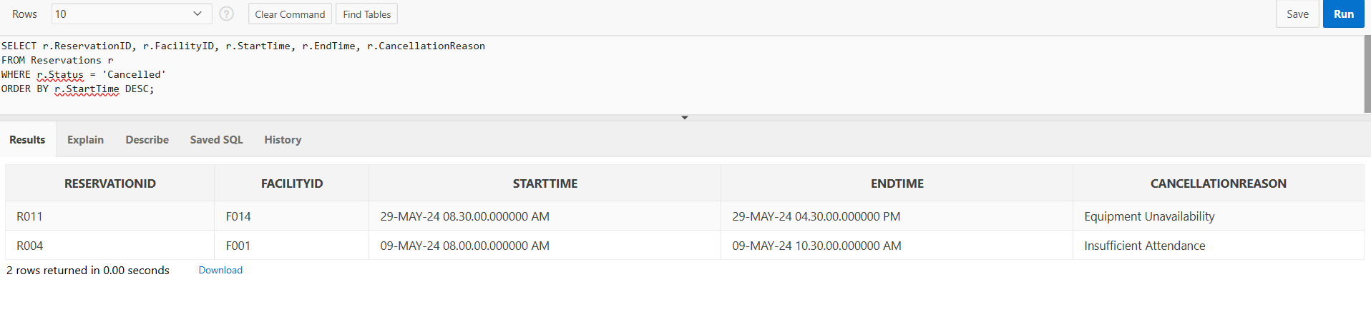

- To retrieve the maintenance history of equipment: Query to get a list of equipment that has been maintained. It provides more valuable information about the equipment's maintenance history, including when the last changes were made.
SELECT e.EquipmentID, e.Name, e.LastMaintenance, e.LastModifiedBy
FROM Equipment e
ORDER BY e.LastMaintenance DESC;
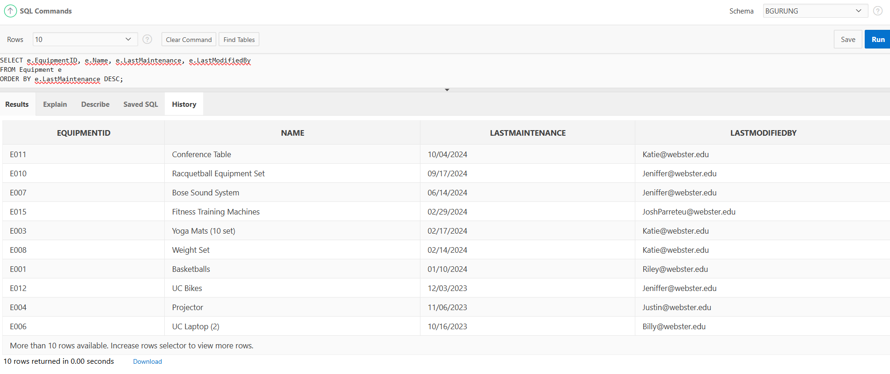

- To retrieve the facilities under maintenance: This query retrieves a list of facilities from the Facilities table that are currently under maintenance. It selects the FacilityID, FacilityName, and Status columns and filters the results to include only facilities with a status of 'Under Maintenance'. The output will show which facilities are not available for use at the moment.
SELECT f.FacilityID, f.FacilityName, f.Status
FROM Facilities f
WHERE f.Status = 'Under Maintenance'
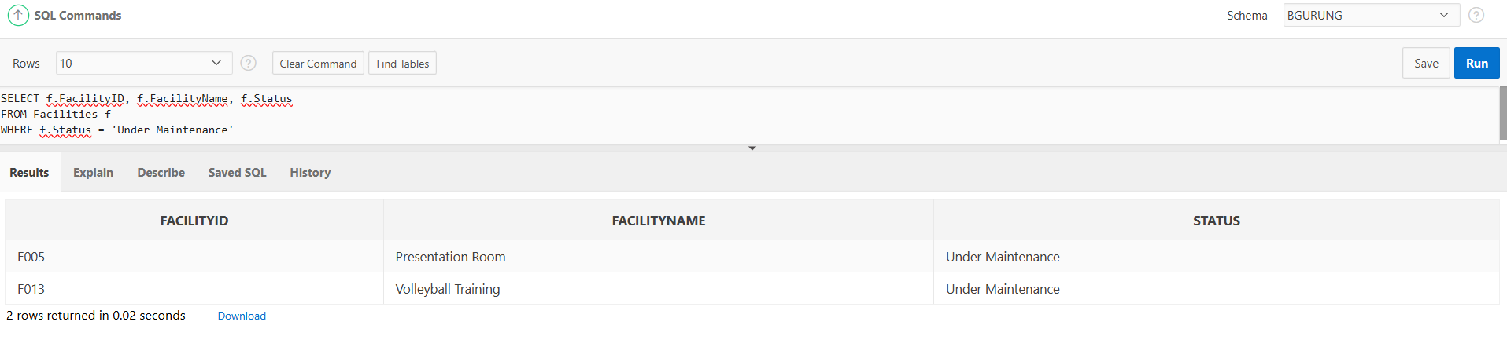

What Was Built and Accomplished
Built:
A comprehensive database system for Webster University Center was developed to streamline the management of facilities, equipment, users, and reservations. The system includes well-structured tables such as Users, Facilities, Equipment, Involve and Reservations, capturing detailed attributes and relationships essential for efficient resource management and reservation processes.

Accomplished:
- Implemented various SQL queries to support critical operations such as Emergency maintenance and equipment availability tracker, to retrieve the facilities under maintenance, user reservation patterns analysis, a query to understand reservation behaviors across different user types, double booking prevention, listing active reservations, identifying facility availability, and generating equipment usage reports and so on. These queries enable efficient resource utilization, better planning, and improved decision-making for operational excellence at the University Center.

Learnings and Challenges
Learnings:
- Gained hands-on experience in SQL, particularly in creating and inserting data, designing tables, and constructing relational databases.
- Learned how to query and manage datasets to produce actionable insights for improving operations.
- Improved understanding of concepts like normalization, primary and foreign keys, schema design, and entity-relationship modeling (ERD).
Challenges:
- Difficulty and time-consuming nature of constructing the ERD (Entity Relationship Diagram).
- Identifying the correct SQL code to achieve desired results was challenging and required multiple revisions.

Suggestions for Improvement
- User-Friendly Interface: Developing a user-friendly interface for non-technical users would make it easier for staff to interact with the database and generate reports independently, improving accessibility.
- Automation and Scheduled Updates: Implementing automated processes for data updates and maintenance would enhance efficiency, reduce manual workload, and minimize the risk of errors.
- Performance Optimization: Applying more advanced performance optimization techniques, such as indexing and query caching, could further improve data retrieval times and system responsiveness.

Impact on Understanding of Concepts
This project deepened my practical understanding of database concepts such as ERD, Schema, normalization, and query optimization. I specifically learned how to write SQL code for creating, inserting, and querying data in tables. I also gained strong familiarity with designing ERDs and understanding database schema structures. This project highlighted the importance of data integrity and demonstrated how well-organized databases can support effective decision-making and resource management.

Future Career Relevance
Interest:
The project sparked an interest in database design and management, particularly in applying these skills to real-world organizational challenges.

Future Goals:
Motivated to explore advanced concepts like predictive analytics, which could predict resource demand patterns or improve reservation processes using historical data trends.

Additional Reflections
Project Concept:
This project concept came from my own workplace, where I work as a Student Building Manager at Webster University Center. Experiencing the inefficient operations in my own building sparked the idea for this project. This challenge felt very personal and exciting to me, as it allowed me to apply my academic learning to a real-world issue I am familiar with. Using a real-world scenario like resource and reservation management provided valuable insight into the practical application of database systems and how they can effectively support operational processes.

Project Process:
The process was challenging but deeply rewarding. It provided a hands-on learning experience that kept me engaged and motivated, much more so than traditional exam-based assessments. Navigating through the design and implementation phases felt personal, as I was applying my knowledge to solve a real problem at my workplace. The use of sample data allowed me to create a conceptual functional system that demonstrated how the database could enhance resource and reservation management. This approach required problem-solving and critical thinking, which helped me build confidence in my technical skills and strengthened my understanding of database management. It was fulfilling to see my project evolve from an idea to a system that, in theory, could improve operations at Webster University Center.

Recommendation for Curriculum:
I am personally highly recommending this project-based learning approach as it provides practical skills and a deeper understanding of database management. It offers a more engaging and meaningful learning experience.

Conclusion

The database system I developed for the Webster University Center has been a meaningful step toward modernizing resource management. By streamlining the handling of reservations, tracking equipment, and optimizing facility utilization, it has created a comprehensive overview of resource status and user activity. This has empowered data-driven decision-making and improved overall operational efficiency.

Through this project, I gained valuable insights into database design and SQL functionality, enabling me to implement optimized queries and structured views for faster and more reliable data retrieval. This was essential for timely reporting and effective resource allocation, as well as supporting better scheduling and enhancing user experience.

This project not only reinforced my technical skills but also showed me firsthand how a well-designed database can transform organizational processes. It was rewarding to see how my work could contribute to improving resource management and strategic decision-making at Webster University Center. This experience has deepened my understanding of data management's potential to make a real difference, and I'm excited to apply these insights in future endeavors.

