1. Introduction
GourmetHub is a specialty food retailer which sells its products to customers through three different channels: catalog, web, and physical store. This project will analyze consumer behavior through the use of analytics on a database of 2,240 customers enrolled over the period from September 2012 to June 2014. The database contains information about demographics, household composition, product spending, channel activity, and responses to five marketing campaigns.

This study intends to assist GourmetHub in transitioning from uniform, intuition-based campaign outreach to evidence-based, segment-differentiated marketing decisions. The shift is warranted due to three main issues. Firstly, spending differs by a factor of six across household lifecycle stages; however, there is no indication that campaigns are structured around this aspect. Secondly, catalog engagement (the strongest behavioral predictor of spending) is on a decline with each new enrollment cohort while the business does not have any tool to distinguish which consumers are likely to generate high value. Finally, the two major channel metrics in the data provide opposite indications: catalog purchases strongly predict high spending whereas frequent web visits strongly predict low spending, which raises a resource allocation question that the business has not yet addressed.

Specific analytical methods have been used to deal with each of the above problems. Lifecycle segmentation has been done through k-means clustering. Logistic regression, classification tree, and naive Bayes models have been used to identify high-value consumers along with catalog engagement trend being analyzed through time series. Channel attribution has been done through multiple regression with income as a control variable. Further, the combination of these methods informs decisions about campaign strategy and investments.

2. Business Problems and Goals

2.1 Business Problem 1: Lifecycle Spending Disparity
The consumer profile of GourmetHub has four lifecycle stages of households with a divergence of six times on their spending profiles. The average empty nester has a total spend of $1,105 but comprise 28.5% of the enrolled base but produces 52% of all revenue. Young families average $186. The important point to note here is that the income difference between these two groups is not 5.9x but merely 1.9x, whereas the spending difference is 5.9x. Lifecycle stage reduces expenditure by almost three times the amount that would have been anticipated by the income factor alone, and it implies that income-based targeting fails to cover this difference.

It is a retention issue masquerading as a targeting issue. Young families do not necessarily remain low-value consumers. They are would-be empty nesters going through a limited stage. By putting the same campaign pressure on them that GourmetHub puts on its highest spending segments, GourmetHub will gather low response, make incorrect conclusions, and lose these consumers before they get to their optimum value. One approach that treats every consumer as one is working against revenue in the long term.

Business Goal 1: Segment the consumer base by household lifecycle stage and measure the difference between the spending, channel behavior, and income of different segments, such that campaigns can be target-marked by lifecycle stage and GourmetHub can retain the young families through their low-spend phase rather than losing them before they become high-value.

2.2 Business Problem 2: Declining Catalog Engagement Across Cohorts
The correlation between catalog purchasing and total spend is r = 0.778, so catalog purchasing is the only behavioral predictor of consumer value in this data set that is stronger than income. This notwithstanding, the catalog participation in new enrollees has been in a downward trend in every cohort year. The 2012 group had 3.01 average purchases on the catalog. The 2014 cohort averaged 2.29, a 24% decline. Spend was also on the same path: $745, $602, $491 during the three cohort years.

Every new generation of consumers is coming in less interested in the most valuable channel, and spending less because of it. GourmetHub does not have a model to determine enrolling consumers who are on a high-value trajectory. In its absence, the low-engagement trend that defines more recent cohorts is fixed before anything can be done about it. This would amount to about $92,500 in annual revenue that the business is not taking in 2014 alone, out of 556 consumers enrolled, not because consumers are dropping out, but because the behavioral base to spend was not created.

Business Goal 2: Develop a model that predicts the probability that a new consumer will become a high-value consumer at enrollment, using catalog engagement, channel breadth, and household structure as signals, so GourmetHub can provide the right onboarding experience before low-engagement behavior sets in.

2.3 Business Problem 3: Misread Channel Signals
Two-channel metrics dominate this dataset, and they point in opposite directions. The lowest quintile of web visits has an average of $1,121 in spending by consumers. High quintile consumers have an average of $334. The relationship is monotonic across all five quintiles, and the correlation is r = -0.50. In the meantime, the catalog users have an average of $801 as compared to non-catalog consumers of $57, a 14:1 ratio, with a correlation of r = 0.778.

When GourmetHub is measuring consumer engagement or campaign effectiveness by web traffic volume, it follows a signal that is moving in the wrong direction in comparison with revenue. The business may be optimizing the channel that predicts the least while the channel that predicts the most quietly declines. The question is, does this pattern persist when income is conditioned, or are web visits and catalog use merely a proxy of income variations among segments.

Business Goal 3: Determine whether catalog engagement is a predictor of total spending that is independent of income, and whether web visit frequency is a true behavioral driver or a proxy of income that is confounded, such that channel investment decisions are made based on evidence rather than assumption.

2.4 Analytics Goals
Goal | Analytical Objective | How It Serves the Business Goal
Analytics Goal 1 | Apply k-means clustering on behavioral and demographic variables to identify natural consumer segments. Validate clusters against LifeStage to confirm lifecycle structure emerges from the data. | Produces actionable segment profiles with spending levels, channel preferences, and household composition differences that directly support differentiated campaign design for Business Goal 1.
Analytics Goal 2 | Build and compare logistic regression, classification tree, and naive Bayes models to predict the binary high-value target. Evaluate on accuracy, sensitivity, and specificity. Fit a time series trend model on catalog engagement. | Provides an enrollment-time classifier and verifies whether catalog engagement and household structure are the most important predictors. The trend model measures the urgency of Business Goal 2.
Analytics Goal 3 | Build a multiple regression model to total spending, incorporating catalog purchases, web visits, and income. Test the independent predictive power of channel variables, controlling income. Test EnrollYear to quality decline in cohort. | Addresses Business Goal 3 channel attribution question with evidence on the coefficient level. Distinguishes true behavioral drivers and income-confounded signals and supports or rejects the hypothesis of a cohort decline.

3. Data Preprocessing

3.1 Data Understanding and Attribute Definitions
The data set includes 2,240 consumers' records with 29 variables in total. The variables are divided into four categories. Demographics consist of variables such as Year_Birth Education Marital_Status, and Income that reveal the consumers' characteristics. The Household structure variables, Kidhome and Teenhome, indicate the presence of children in the household and play a key role in the lifecycle segmentation in Business Goal 1. Behavioral variables are comprised of six product spending columns (MntWines through MntGoldProds), four channel purchase counts (web catalog store, deals), web visit frequency, and recency, all combined describing the consumers' engagement with GourmetHub. The Campaign outcome variables, AcceptedCmp1 through AcceptedCmp5 and Response, represent which marketing efforts each consumer was responsive to. Two administrative constants, Z_CostContact and Z_Revenue, were respectively 3 and 11 throughout all 2,240 records and thus contain no analytical information.
The six Mnt columns denote monetary amounts spent on each product category. The four Num purchase columns count transactions through each channel. The AcceptedCmp columns are binary indicators where 1 mark that the consumer accepted the campaign and 0 means they did not. Familiarity with these groupings is vital for determining how variables are combined during feature engineering and which ones are included in each model.

Variable | Type | Definition
ID | Identifier | Unique consumer record key; no analytical value
Year_Birth | Demographic | Consumer year of birth; converted to Age in feature engineering
Education | Demographic | Highest education level: Basic, 2n Cycle, Graduation, Master, PhD
Marital_Status | Demographic | Marital status: contained invalid entries corrected during cleaning
Income | Demographic | Annual household income in dollars; 24 values missing
Kidhome | Household | Number of young children in the household: 0, 1, or 2
Teenhome | Household | Number of teenagers in the household: 0, 1, or 2
Dt_Customer | Enrollment | Date of consumer enrollment; converted to Tenure_Days and EnrollYear
Recency | Behavioral | Days since the consumer's most recent purchase
MntWines to MntGoldProds | Behavioral | Dollar amount spent on each of six product categories
NumWebPurchases | Behavioral | Number of purchases completed through the website
NumCatalogPurchases | Behavioral | Number of purchases made through the catalog
NumStorePurchases | Behavioral | Number of purchases made in physical stores
NumDealsPurchases | Behavioral | Number of purchases made using promotional deals
NumWebVisitsMonth | Behavioral | Number of website visits in the past month
AcceptedCmp1 to AcceptedCmp5 | Campaign | Binary: 1 if consumer accepted the respective campaign
Response | Campaign | Binary: 1 if consumer accepted the most recent campaign offer
Complain | Campaign | Binary: 1 if consumer filed a complaint in the past two years
Z_CostContact / Z_Revenue | Administrative | Constants across all records; dropped from analysis

3.2 Missing Values and Zero Value Check
A column-level missing value scan across all 29 variables found that Income was the only field with missing entries, totaling 24 records. These were spread among Education groups: 11 in Graduation, 5 in Master, 5 in PhD and 3 in 2n Cycle. Due to the significant differences in income based on education level, missing values were filled in with the median income within each Education group instead of the global median, which would have added systematic bias for both lower and higher-educated consumers.
Zero values in product spending columns were reviewed separately. MntFruits (400 records), MntFishProducts (384 records), and MntSweetProducts (419 records) have analytically valid zeros. In fact, these consumers did not really buy those categories, and this is considered actual purchase behavior, and is stored as such. Zero catalog purchases in 586 records (26% of the base) define the non-catalog segment that is central to Business Goal 3. These are not errors. They form the comparison group such that the catalog effect can be measured.
An additional consistency check confirmed that the acceptance rates of the campaigns are low in all the five campaigns with campaign 2 having the lowest rate of 1.3% and campaign 4 having the highest rate of 7.5%. The rate of complaints was 0.9%. Both variables were flagged during predictor relevance analysis.

3.3 Outlier Identification and Removal
Year_Birth values of 1893, 1899, and 1900 produced computed ages of 124, 125, and 131. These three entries are data entry errors and were eliminated. Among the income values, seven records were above $150,000, all of which showed behavioral and demographic patterns consistent with high earners and were retained. There was one different record: consumer ID 9432 earned more than $666,666, and the record was 28 standard deviations higher than the average, but its total spend amounted to only $62. This value was not even close to other records. It was eliminated as an individual outlier. There are 2,236 records in the cleaned dataset.

3.4 Categorical Recoding
Marital_Status had seven invalid values (Alone (3), Absurd (2), and YOLO (2)) recoded to Single as single-person households. Together (580 records) was coded to Married since cohabiting couples are in the same household spending environment as those who are married. The final valid categories were Divorced (231), Married (1,442), Single (486), and Widow (77). To reflect the true educational hierarchy and provide the capability to make the contrasts of the polygons in regression, education was coded as an ordered variable as five levels (Basic, 2n Cycle, Graduation, Master, PhD). The variable of Marital_Status was coded as unordered nominal.

3.5 Feature Engineering
The original variables needed to be consolidated and transformed, then modeled. Three composite measures were formed with six product spending columns. The result of the regression and the target of classification is TotalSpend, the sum of the six Mnt columns. PremiumSpend clusters wines and meat, the two most valuable categories, to use in clustering. The remaining four categories are lumped together in EverydaySpend.

Date of enrollment was broken down into Tenure Days-the number of days of enrollment to June 30, 2014, and Enroll Year, the calendar year of enrolment. The regression model also includes EnrollYear to directly examine the hypothesis of whether more recent cohorts spend less regardless of individual consumer characteristics. Age was obtained as a transformation of Year_Birth.

ChannelCount is the number of times a consumer utilized at least once each of the three primary channels of purchases, web, catalog, and store. It captures channel breadth as a signal of behavioral engagement. BasketSize = TotalSpend/number of transactions and undefined with the six consumers who did not make any purchases. Using the values of Kidhome and Teenhome, LifeStage assigns each consumer one of the four household stage labels, EmptyNester, TeenFamily, MixedFamily or YoungFamily. Only profiling and visualization are done; Kidhome and Teenhome are entered with models separately since the impacts on their spending are not the same in magnitude.

Lastly, the binary HighValue target was created by comparing each consumer TotalSpend to the median of the dataset of $396. HighValue = 1 was assigned to values with high value above median; otherwise HighValue = 0. This resulted in a very convenient 1,118 consumers per class, which does not need oversampling. Since TotalSpend is not a predictor of any model, there is no leakage of data between the target and the predictor set.

After the feature engineering, thirteen original variables were dropped: the six individual Mnt columns were replaced by their composites, Year_Birth and Dt_Customer were replaced by the derived time variables, ID and the two administrative constants, Complain due to its 0.9% rate and near-zero correlation with any outcome and Response due to a separate campaign acceptance outcome falling out of the scope of this project. The last dataset has 2,236 rows and 27 columns.

4. Data Exploration and Summary Statistics

4.1 Descriptive Summary
Variable | Min | Q1 | Median | Mean | Q3 | Max | Notes
Age (years) | 28 | 47 | 54 | 55.1 | 65 | 84 | 3 errors removed
Income ($) | 1,730 | 35,503 | 51,446 | 51,957 | 68,276 | 162,397 | 24 imputed
TotalSpend ($) | 5 | 69 | 397 | 606 | 1,046 | 2,525 | Right-skewed
Recency (days) | 0 | 24 | 49 | 49.1 | 74 | 99 | Near uniform
NumCatalogPurchases | 0 | 0 | 2 | 2.66 | 4 | 28 | 26% zero
NumStorePurchases | 0 | 3 | 5 | 5.80 | 8 | 13
NumWebPurchases | 0 | 2 | 4 | 4.09 | 6 | 27
NumWebVisitsMonth | 0 | 3 | 6 | 5.32 | 7 | 20
BasketSize ($/tr.) | 2.67 | 13.00 | 29.84 | 38.20 | 49.17 | 1,679 | 6 undefined

TotalSpend average is $606 while the midpoint is $397. This supports the fact that more of the distribution is on the left and the small portion of spenders on the right are very high. Income is fairly spread out and after removing the $666,666 outlier, there is no evidence of skew. Recency is almost uniform, which implies that there is no particular pattern of purchase timing. Catalog purchases have a median of 2 but a mean of 2.66, which signifies a long right tail stemming from heavy catalog users. The 26% zero rate in catalog purchases corresponds to the non-catalog segment.

In the case of categorical variables, Graduation has the highest representation (50.4%) as an education level, and Married is the most common marital status (64.5%) after the recoding. LifeStage indicates that TeenFamily is the collection with the greatest number of people (29.2%), later comes EmptyNester (28.5%), YoungFamily (23.2%) and MixedFamily (19.1%). The HighValue target is exactly balanced with both classes having 1,118 consumers.

4.2 Lifecycle Stage: Where the Revenue Comes From
Spending rises consistently as children age and leave the household. EmptyNester consumers average $1,105, TeenFamily average $703, MixedFamily average $223, and YoungFamily average $186. More telling is the high-value rate: 79.3% of EmptyNester consumers exceed the spend median, against 13.1% of YoungFamily consumers. The income gap between these groups is 1.9x. The spending gap is 5.9x. Lifecycle stage is doing most of the work.

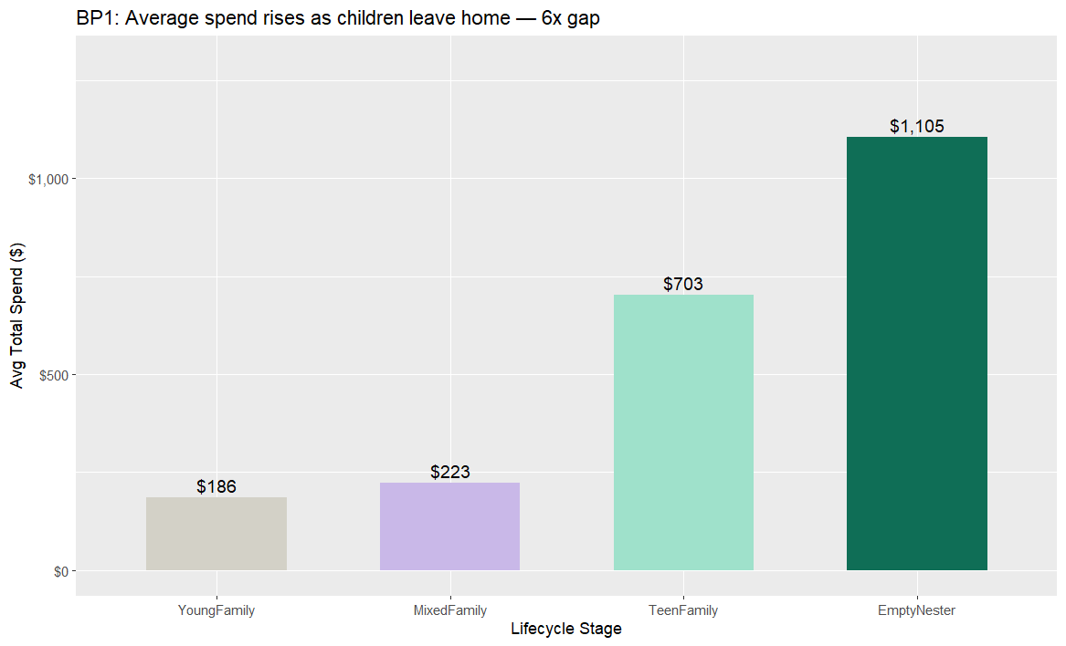
Figure 1. Average total spend by lifecycle stage. Spending recovers as children age out of the household, from $186 for YoungFamily to $1,105 for EmptyNester.

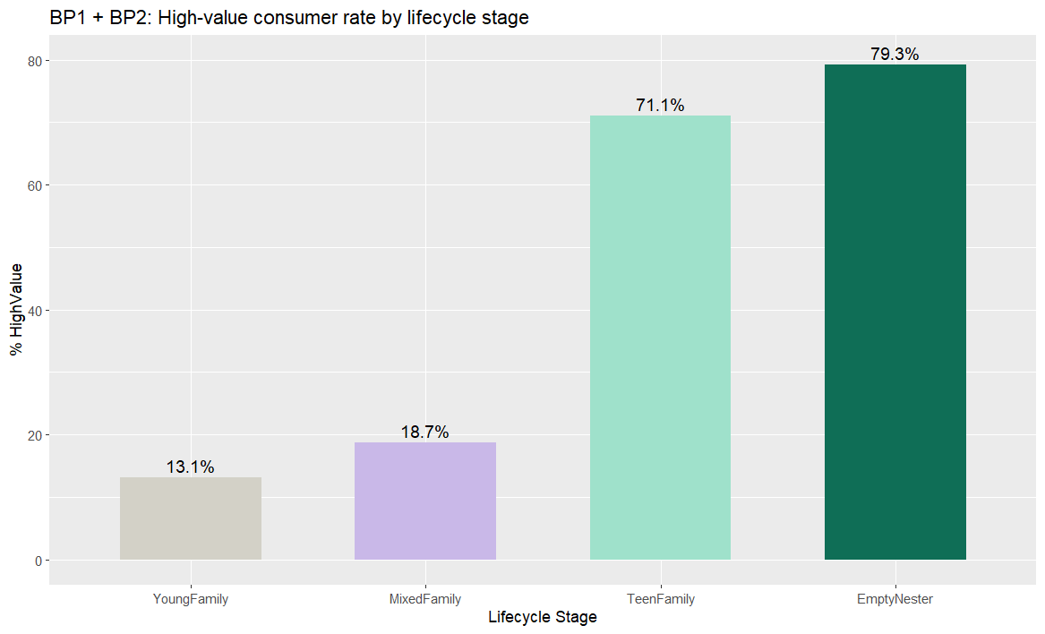
Figure 2. Percentage of high-value consumers by lifecycle stage. EmptyNester consumers are six times more likely to exceed the spend median than YoungFamily consumers.
The boxplots below confirm that even a single young child in the household drives median spend close to zero. Two young children barely changes that picture. Teenagers show a far smaller suppression effect, which explains why TeenFamily consumers recover to $703 in average spend and why this lifecycle stage is already approaching high-value territory.

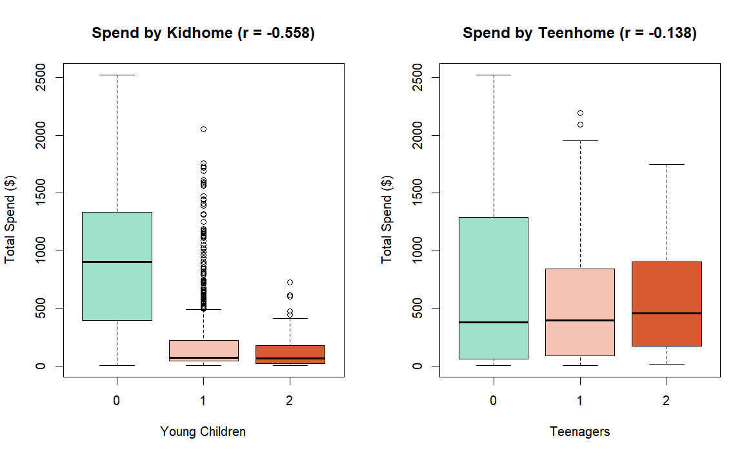
Figure 3. Total spend by number of young children (left) and teenagers (right). Young children suppress spending far more sharply than teenagers, confirming that the lifecycle suppression mechanism operates differently by child age.

4.3 Cohort Quality: A Measurable and Worsening Trend
Both spend and catalog engagement decline monotonically across enrollment cohorts. The 2012 cohort averaged $745 in spend and 3.01 catalog purchases. By 2014 those figures were $491 and 2.29. The two metrics move together because catalog use drives spending, so cohorts that arrive less engaged with the catalog spend less across their entire relationship with GourmetHub.

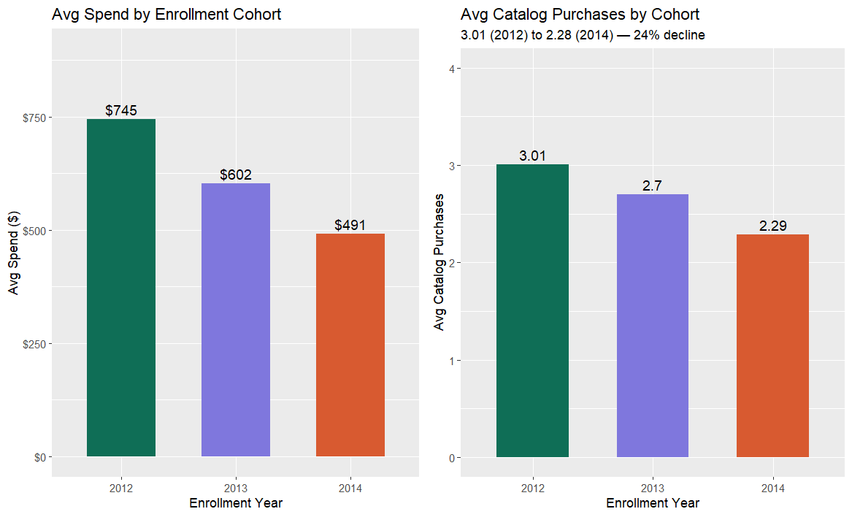
Figure 4. Average spend (left) and average catalog purchases (right) by enrollment year. Both measures decline consistently with each successive cohort, confirming a structural quality problem, not a random fluctuation.

The monthly enrollment trend below shows that new consumer volume is relatively stable, with a mild decline. The problem is not how many consumers are arriving. It is how engaged they are when they do.
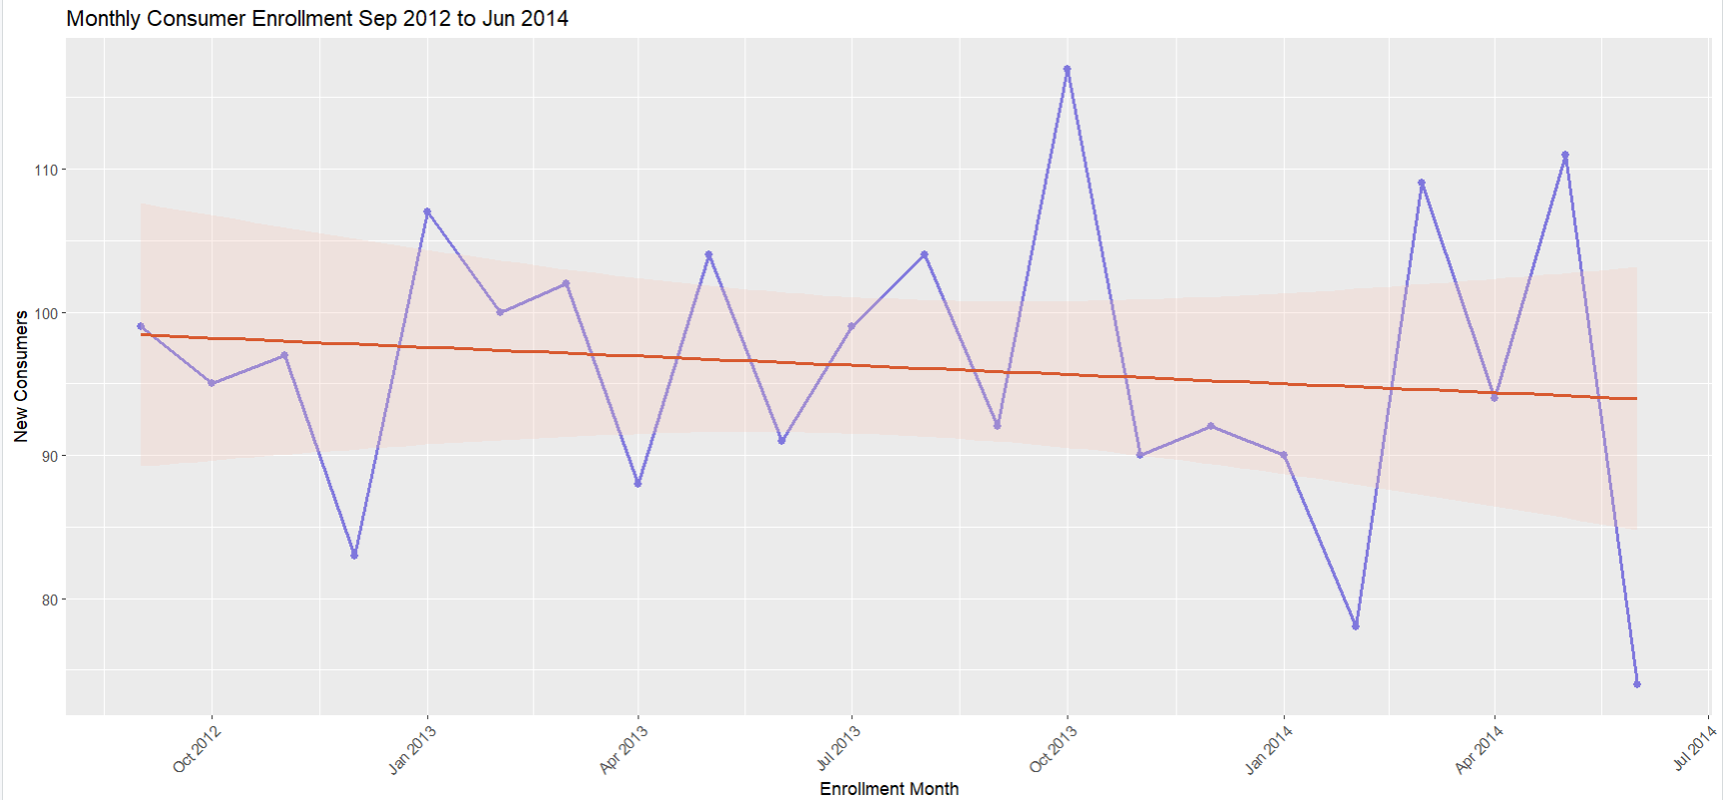

Figure 5. Monthly consumer enrollment from September 2012 to June 2014. Volume is broadly stable, which confirms that the catalog decline is a behavioral engagement problem, not an acquisition volume problem.

4.4 Campaign Effectiveness Across Segments
Campaign acceptance rates are low across all five historical campaigns, ranging from 1.3% for Campaign 2 to 7.5% for Campaign 4. The campaigns are not all equally effective, and there are direct links between campaign effectiveness and the consumer segments identified in this study. The most strongly correlated campaigns with total spend are Campaigns 1 (r = 0.38) and Campaign 5 (r = 0.47), and they have significantly higher acceptance rates among HighValue than among Standard consumers. Campaign 5 is particularly successful at targeting the EmptyNester and high-catalog segments that drive most of the revenue. Campaigns 2 and 3 have correlations close to zero with spend, showing that they are reaching a general audience, rather than the high-value segment. This is shown in Figure 7: the gap between HighValue and Standard consumers in campaign acceptance is largest for Campaign 5, and not visible for Campaigns 2 and 3. This confirms that the most effective campaign for GourmetHub is reaching the consumers they want to reach, while the least effective campaigns are wasting money on the least valuable consumers.

4.5 Revenue Concentration
The highest spending 20% of consumers generate 52% of revenue. This means that correctly identifying and retaining high-value consumers right at the time of enrollment is not a marginal improvement. It is the most important variable for revenue. Losing a small share of the top segment causes disproportionate revenue damage that cannot easily be offset by acquiring more Standard consumers.
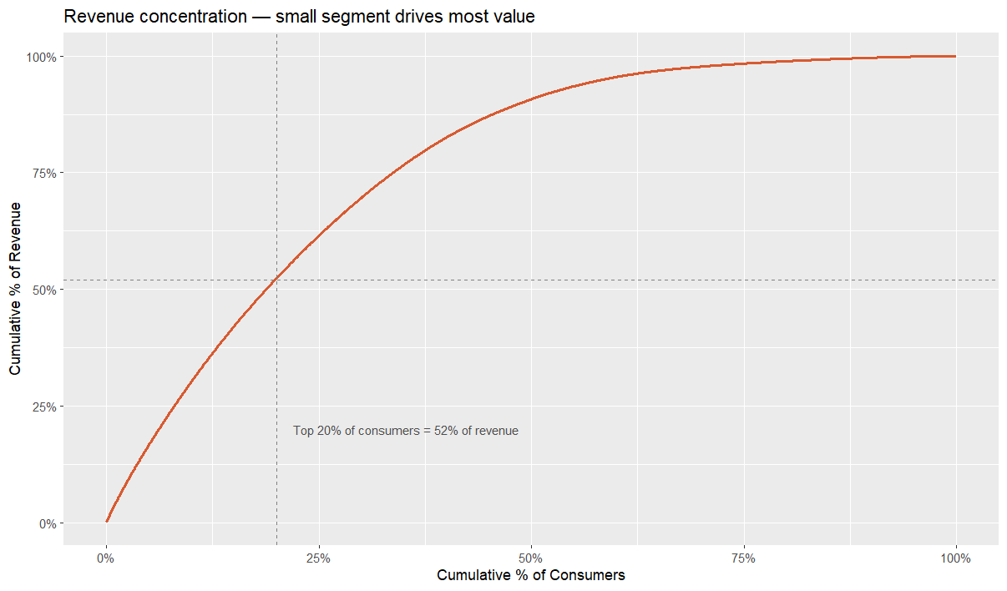
Figure 6. Cumulative revenue by consumer percentile. The top 20% of consumers generate more than half of all revenue.

4.6 High-Value versus Standard Consumer Profile
The six-panel comparison below illustrates the differences between HighValue and Standard consumers on predictor variables. HighValue consumers have higher incomes, purchase more from the catalog and in stores, and visit the website less. The differences in income and catalog are most dramatic. Recency is almost the same (50 days for HighValue and 49 for Standard), showing that recent buyers aren't necessarily HighValue consumers. A Standard consumer can be as recently active as a HighValue consumer. What distinguishes them is channel behavior.
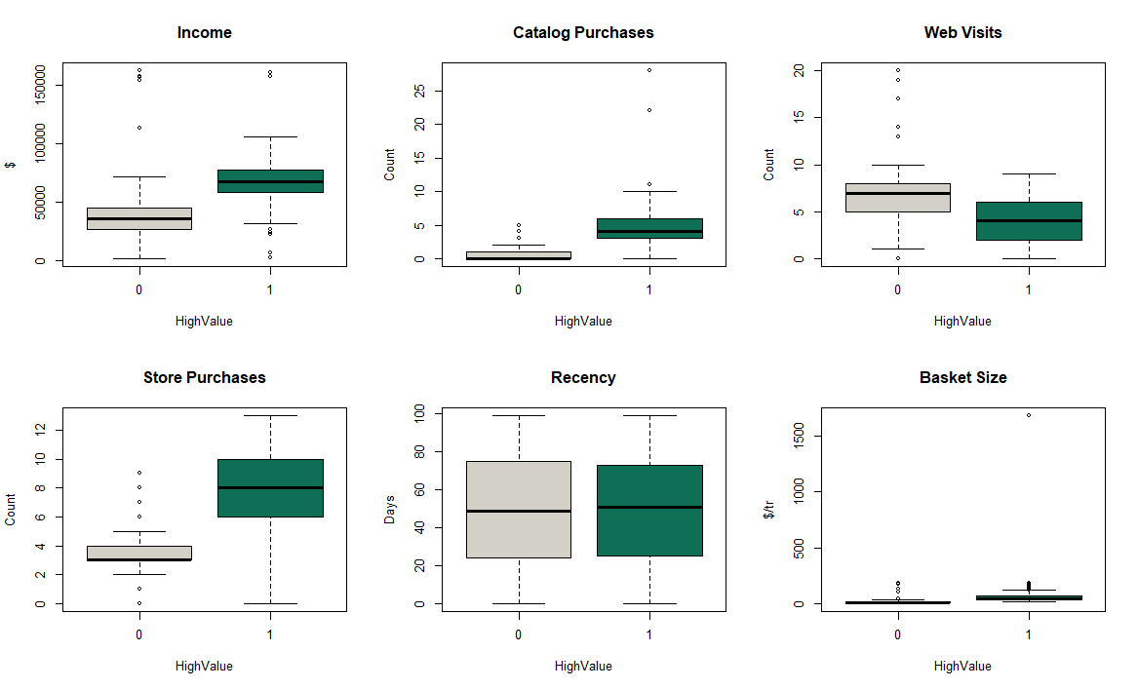
Figure 7. Six key predictor variables split by HighValue status. Catalog purchases, income, and store purchases show the clearest separation. Web visit frequency is higher among Standard consumers, and recency is nearly identical across both groups.

The income versus spend scatter below makes the structural separation visible. Standard consumers are concentrated at low spend across all income levels. HighValue consumers are in the upper-right corner and in the $40,000 to $100,000 range. High income alone does not guarantee HighValue status, but the combination of higher income and catalog use does.

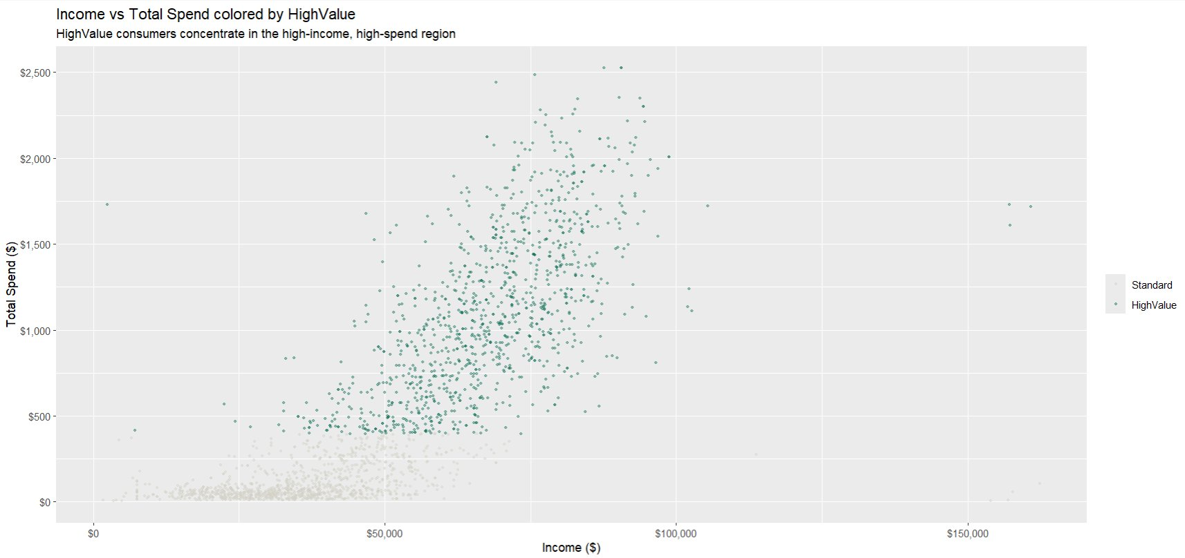
Figure 8. Income versus total spend colored by HighValue status. Standard consumers cluster near zero spend across all income levels. High-value consumers are concentrated in the high-income, high-spend region.

4.7 Correlation Structure
The correlation matrix shows the associations between all continuous variables. Catalog use, income and store purchases are positively associated with TotalSpend. The number of web visits has one of the strongest negative correlations. Kidhome is negatively correlated with income, catalog use and spend at the same time, and confirms that lifecycle suppression is multi-dimensional and cannot be attributed to any single variable. The strong correlation between NumWebVisitsMonth and Kidhome (r = 0.45) suggests that the negative web visit effect is partly a result of the browsing behavior of low-income households with many children rather than an independent behavioral pattern.

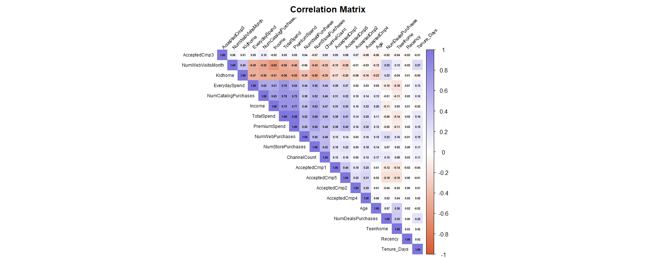
Figure 9. Correlation matrix across all continuous variables. Warm tones indicate positive correlation; cool tones indicate negative. The catalog and income clusters dominate the spend relationship.

5. Predictor Analysis and Relevance

5.1 Correlation-Based Relevance Ranking
Pearson correlations were computed between each candidate predictor and both analytical targets. This ranking determines which variables carry genuine predictive signal and which are candidates for exclusion.

Predictor | r with HighValue | r with TotalSpend | Interpretation | Decision
NumStorePurchases | +0.747 | +0.675 | Consistent, strong positive signal in both models | Retain
Income | +0.735 | +0.789 | Strongest predictor of TotalSpend; essential control variable | Retain
NumCatalogPurchases | +0.704 | +0.778 | Dominant behavioral predictor; core to Business Goals 2 and 3 | Retain
NumWebPurchases | +0.636 | +0.520 | Transactional web use; distinct from browsing | Retain
ChannelCount | +0.552 | +0.503 | Channel breadth signals deeper engagement | Retain
Kidhome | -0.566 | -0.557 | Strong negative; young children suppress spending independently of income | Retain
NumWebVisitsMonth | -0.442 | -0.500 | Bivariate negative; tested for income confounding in regression | Retain
AcceptedCmp5 | +0.279 | +0.468 | Campaign 5 reaches high-value consumers effectively | Retain
AcceptedCmp1 | +0.251 | +0.382 | Moderate positive; included as candidate | Retain
Teenhome | +0.017 | -0.138 | Near zero for HighValue; moderate negative for spend | Retain in regression
Recency | +0.009 | +0.021 | Near zero for both targets; no predictive signal | Retain supervised; drop clustering
AcceptedCmp3 | +0.026 | +0.053 | Near zero for both targets | Drop all models

5.2 Predictor Selection Decisions
AcceptedCmp3 is excluded from all models. Its correlations with both targets are less than 0.06 and it has no cluster discriminating power. Education and Marital_Status are included in the supervised models because tree and regression models handle ordinal and nominal variables, and the education spending gradient is analytically meaningful: average spend ranges from $82 for Basic-educated consumers to $670 for PhDs, which is a significant difference.
In clustering, all AcceptedCmp binary variables are removed. The distributions of acceptance rates of 1 to 7% have almost no variance in Euclidean distance space, and contribute noise rather than signal to cluster separation. Education and Marital_Status are also excluded from clustering because k-means calculates distances between points as the sum of the differences of the variables, assuming they are continuous numeric variables with equal-interval spacing. TotalSpend is excluded from the clustering because it is correlated with PremiumSpend (r = 0.982). Both would include the same signal, which would destroy the cluster geometry.

6. Dimension Reduction
Principal component analysis and similar transformation techniques were evaluated and rejected. The output needs to be interpretable at the level of the variables for all three business goals. Business Goal 1 requires a segment description in terms of spending and family structure. Business Goal 2 needs assurance that the high-value status is driven by catalog-related and household variables. Business Goal 3 needs a coefficient for catalog purchases in dollars that is understandable by business decision makers. Abstracting predictors to components would remove this interpretability with no gain in model accuracy on this data set.

Reduction in the number of predictors was done by explicit removal based on the correlation analysis in Section 5. The only predictor removed due to negligible predictive power across both targets was AcceptedCmp3. The final predictor sets are as follows.

Model | Final Predictor Set
Classification | Income, Education, Marital_Status, NumCatalogPurchases, NumWebVisitsMonth, NumStorePurchases, NumWebPurchases, Kidhome, Teenhome, Recency, Age, ChannelCount, Tenure_Days, AcceptedCmp1, AcceptedCmp2, AcceptedCmp4, AcceptedCmp5 (17 predictors)
Regression | Same as classification with EnrollYear replacing Tenure_Days, to test cohort quality decline directly after individual consumer controls are applied (17 predictors)
Clustering | Income, PremiumSpend, EverydaySpend, Recency, NumCatalogPurchases, NumWebVisitsMonth, NumDealsPurchases, Kidhome, Teenhome, Age, ChannelCount (11 variables)

7. Data Engineering and Transformation

7.1 Standardization for K-Means
K-means assigns observations to clusters based on Euclidean distance. Income ranges in value from $1,730 to $162,397, would dominate that calculation over Kidhome, which ranges from 0 to 2. All 11 clustering variables were standardized to z-scores with R's scale() function. After scaling, the new column means were verified as zeroes and the column standard deviations as ones, contributing equally. Scaling was done only for the clustering data. Tree and regression models are not sensitive to the scale of the variable and use the original data.

7.2 Factor Encoding
Education was encoded as an ordered factor with five levels so that the regression model can fit polynomial contrasts to reflect the genuine hierarchy from Basic through PhD. Marital_Status was encoded as an unordered nominal factor, with a separate estimate for the effect of each level, compared to Divorced as the reference level .

7.3 Classification Target
HighValue was defined as 1 for consumers with TotalSpend higher than the median $396 of the total dataset and 0 otherwise. This achieves a perfectly balanced 50/50 class split with 1,118 consumers in each class, and there is no need for oversampling or class-weighting. The usual accuracy measures can be applied. TotalSpend is not used as a predictor in any model, so the target definition does not create data leakage.

8. Data Partitioning
The supervised classification and regression models were trained, compared, and tested on a stratified 60/20/20 split. Stratification on the binary HighValue variable preserved the 50/50 class balance in all three sets, ensuring that the validation and test model comparisons reflect the same population distribution as training. A fixed seed of 2026 was applied throughout for reproducibility.
Set | Records | HighValue % | Purpose
Training | 1,342 | 50.0% | Fitting all supervised models
Validation | 448 | 50.0% | Comparing models and selecting the best
Test | 446 | 50.0% | Final held-out evaluation of selected models

The k-means clustering model trained on all 2,236 records because unsupervised learning does not predict a held-out variable and data partition is not necessary. The time series model used the complete monthly series of data from August 2012 to June 2014, since time is necessary for trend prediction and future forecasting.

9. Model Selection

9.1 Clustering: K-Means with k=4
For the segmentation problem, k-means was chosen as it results in hard clustering, where a consumer is assigned to a single segment. This is needed to develop tailored campaign strategies. A consumer must be assigned to one segment for the business to act on it. The elbow method was used to select the number of clusters.
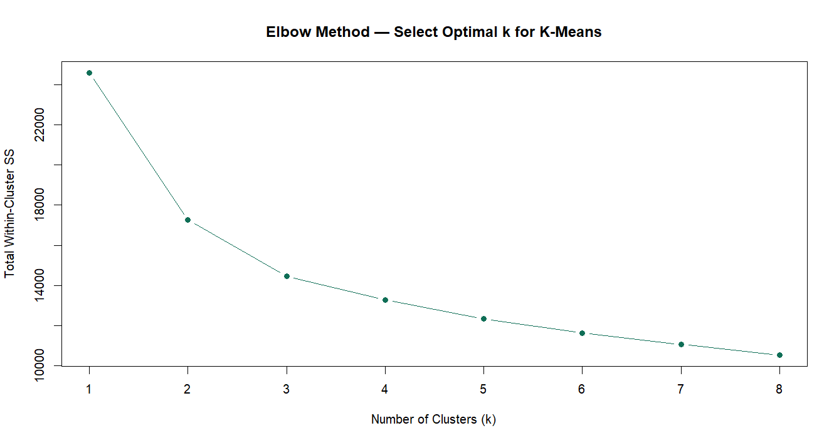
Figure 10. Elbow method for k selection. The largest marginal gain occurs at k=2 with a secondary inflection between k=3 and k=4.

The elbow curve flattens after k=4. Four clusters were chosen because they correspond to the four household lifecycle stages motivating Business Goal 1; and because k=4 retains sufficient granularity to differentiate the mid-value TeenFamily group from both the high-value EmptyNester and low-value YoungFamily groups. Reducing to three clusters would lump groups with distinct needs for spending and campaign targeting.

9.2 Classification: Three Candidate Models
Three algorithms were fitted and compared: logistic regression, a classification tree, and naive Bayes. Logistic regression was the priority candidate because its regression coefficients measure the independent effect of each predictor on the log-odds scale, and directly verify the hypothesis that catalog engagement is important for classification beyond what income alone explains. The classification tree was included because its rules can easily be understood by non-technical stakeholders without any statistical interpretation. Naive Bayes was included as a baseline probabilistic model.

Sensitivity was the primary selection criterion because missing a HighValue consumer is the more costly error type. A false negative sends a high-spend consumer through a generic experience, risking disengagement and lost future revenue. A false positive sends a personalised message to a Standard consumer, which is less costly by comparison.

9.3 Regression: Three Candidate Models
Three regression models were fitted: multiple linear regression, a regression tree, and a random forest. The priority choice was multiple linear regression because Business Goal 3 requires a coefficient for NumCatalogPurchases that can be interpreted as dollars spent per additional catalog purchase, and a coefficient for NumWebVisitsMonth that can be interpreted as dollars spent per additional web visit, holding income constant. These can only be answered by a parametric model with coefficients. The regression tree was included for easy-to-interpret consumer spending segments. The random forest was included as a high-accuracy benchmark and for variable importance confirmation.
Validation RMSE was the selection criterion. When RMSE was comparable, model interpretability was the selection criterion. The multiple linear regression was chosen over the random forest despite a higher RMSE because the coefficient estimates are the primary analytical output and a validation R-squared of 0.851 is sufficient for confident inference.

9.4 Time Series: Linear Trend Model
A linear trend model was applied to the monthly time series of the average number of catalog purchases per new enrollee to test whether the downward trend is statistically significant and to forecast the trend. Tests of the residuals showed no significant autocorrelation (up to five lags, Breusch-Godfrey p = 0.110), so a simple linear model without ARIMA adjustment was justified.

10. Model Fitting and Validation Performance

10.1 K-Means Clustering: Segment Profiles
K-means was run with k=4, 25 random starts, and seed 2026. The four clusters produced distinct and interpretable profiles on the original unstandardized scale.

Cluster | n | Avg Spend | Avg Income | Avg Catalog | Avg Kid | HighValue % | Profile Label
1 | 615 | $685 | $57,861 | 3.5 | 0.42 | 65% | Mid-Value Catalog Engaged
2 | 557 | $1,393 | $76,515 | 6.1 | 0.04 | 98% | Premium High-Value
3 | 589 | $56 | $32,651 | 0.2 | 0.84 | 6% | Low-Value Constrained
4 | 475 | $263 | $39,454 | 1.3 | 0.79 | 26% | Emerging / Young Family

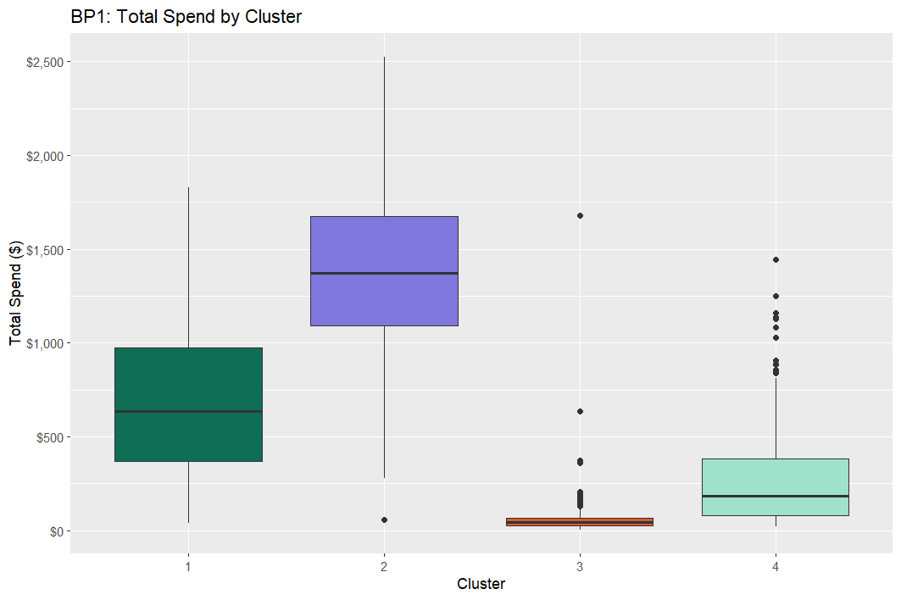
Figure 11. Total spend by cluster. Cluster 2 is the premium segment averaging $1,393; Cluster 3 averages $56 with high child presence and near-zero catalog use.

Cluster 2 is the premium segment. This group has 557 consumers who spend an average of $1,393, earn $76,515, and purchase 6.1 catalogs, and have no young kids (Kidhome = 0.04). Almost all are HighValue (98%). Cluster 3 is the "needier" group: 589 consumers who spend an average of $56, having low incomes, high numbers of children and almost no catalog purchases. Cluster 1 is the middle value, catalog active, TeenFamily group. Cluster 4 is a young family with some catalog activity and some spend potential.

A cross-tabulation of cluster by LifeStage confirmed that the lifecycle structure is not imposed on the data. Cluster 2 is dominated by EmptyNester (471 of 557). Cluster 3 is dominated by YoungFamily (285) and MixedFamily (186). Cluster 1 is dominated by TeenFamily (533 of 615). This is a check on the cluster solution and Business Goal 1 is confirmed by the four clusters.

10.2 Classification: Validation Comparison
Model | Accuracy | Sensitivity | Specificity
Logistic Regression | 96.7% | 96.9% | 96.4%
Classification Tree | 95.1% | 96.0% | 94.2%
Naive Bayes | 87.3% | 77.2% | 97.3%

Logistic regression has the highest accuracy and sensitivity and was chosen as the best classifier. Naive Bayes has the highest specificity but 51 of 224 HighValue consumers on the validation set were missed, the real cost to the business. The classification tree is competitive on both metrics and its rule structure provides direct business utility.
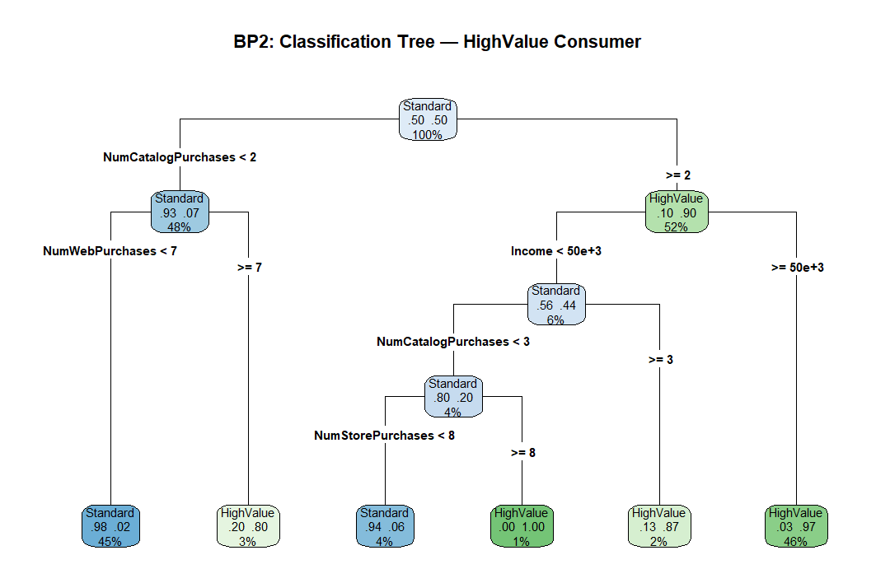
Figure 12. Classification tree for the HighValue outcome. The first split on catalog purchases and the second on income correctly classify the majority of the consumer base with two interpretable rules.

The tree makes the classification logic usable without a statistician. Anyone with less than 2 catalog purchases is classified as Standard with 93% confidence and accounts for 48% of the base. Of those with 2 or more catalog purchases, income greater than $50,000 routes 46% of the base to a HighValue prediction with 97% confidence. These two rules handle the vast majority of enrollment decisions with high reliability.

10.3 Regression: Validation Comparison
Model | Validation RMSE | Validation R-squared | Notes
Random Forest | $188.74 | 0.907 | Highest accuracy; no coefficients
Linear Regression (selected) | $231.94 | 0.851 | Selected for interpretability
Regression Tree | $253.28 | 0.820 | Useful for spend segmentation

The random forest has the smallest RMSE, but no coefficients. Given Business Goal 3 requires estimating the catalog and web visit effects after controlling for income, linear regression was chosen. With a validation R-squared of 0.851, it is strong enough to support confident inference, and its test R-squared of 0.800 confirms generalization.

10.4 Time Series: Catalog Trend and Forecast
The linear trend model for monthly average catalog purchases by new enrollees had a slope of -0.041 catalog purchases per month, significant at p < 0.001, with R-squared of 0.43. The model predicts that the number of catalog purchases per enrollee will shrink from an estimated 3.14 in August 2012 to 2.15 in July 2014. The 95% forecast interval for July through December 2014 ranges from 1.40 to 2.91.
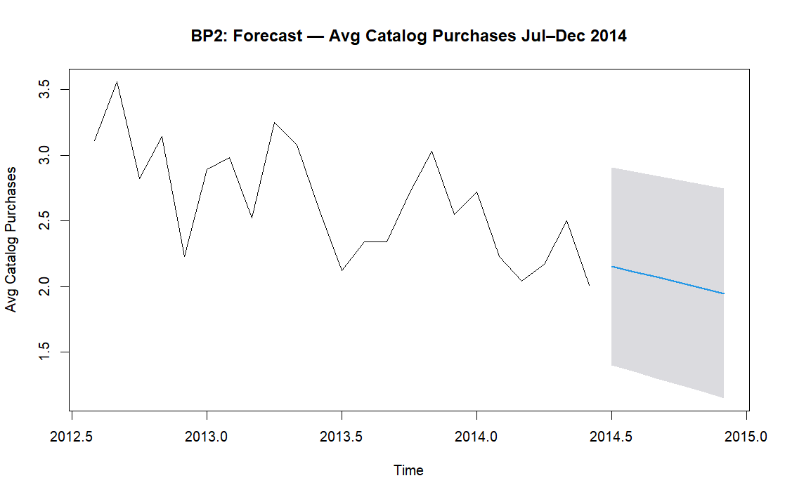
Figure 13. Forecast of average catalog purchases among new enrollees through December 2014. The confirmed downward trend projects continued decline without intervention, reaching approximately 1.95 by year-end.

11. Model Evaluation

11.1 Logistic Regression: Test Set Performance
The selected logistic regression model tested at 97.5% accuracy, 96.9% sensitivity and 98.2% specificity on the 446-test set consumers. Test set results are slightly better than validation set results, indicating that model selection didn't result in overfitting. The model classifies 216 of 223 HighValue consumers and 219 of 223 Standard consumers.

 | Actual: Standard | Actual: HighValue
Predicted: Standard | 219 (TN) | 7 (FN)
Predicted: HighValue | 4 (FP) | 216 (TP)

The 7 false negatives are HighValue consumers scored as Standard. This is the critical error for the business because a high-value consumer who was not identified may get a standard onboarding and may not engage before the company makes a profit from the consumer. At a 96.9% true positive rate, the model is ready to be deployed as an enrollment-time scoring tool.

11.2 Key Coefficient Results: Logistic Regression
Predictor | Estimate | p-value | Business Interpretation
NumCatalogPurchases | +2.926 | < 0.001 | Each additional catalog purchase strongly increases the odds of being HighValue, independent of income
NumStorePurchases | +2.232 | < 0.001 | In-store purchasing is an independent positive signal for high-value status
NumWebPurchases | +1.992 | < 0.001 | Web transactions, distinct from web visits, positively predict value
Income | +0.000135 | 0.002 | Higher income raises HighValue probability even after channel behavior is controlled
Kidhome | -1.636 | 0.020 | Each young child independently reduces HighValue odds
Teenhome | -1.720 | 0.007 | Each teenager also reduces odds; the effect reverses as the lifecycle progresses

11.3 Key Coefficient Results: Linear Regression
Predictor | Estimate | p-value | Business Interpretation
NumCatalogPurchases | +$65.86 | < 0.001 | Each additional catalog purchase adds $65.86 to total spend after income is held constant. Catalog use is a genuine behavioral driver.
Income (per $1) | +$0.0079 | < 0.001 | Each $1,000 of additional income adds approximately $7.90 in spend, controlling for all other variables
NumStorePurchases | +$37.59 | < 0.001 | Each store visit adds $37.59 independently
NumWebPurchases | +$25.15 | < 0.001 | Web transactions add $25.15 each, distinct from browsing
Teenhome | -$129.40 | < 0.001 | Each teenager reduces average spend by $129; effect reverses as teens leave home
Kidhome | -$76.41 | < 0.001 | Each young child reduces spend by $76 on average
AcceptedCmp5 | +$274.10 | < 0.001 | Campaign 5 acceptors spend $274 more; the strongest campaign effect in the model
AcceptedCmp1 | +$103.40 | 0.002 | Campaign 1 acceptors spend $103 more on average
EnrollYear | -$56.50 | < 0.001 | Each later enrollment year reduces spending by $56.50 after individual controls, confirming structural cohort quality decline
NumWebVisitsMonth | +$10.14 | 0.029 | Positive after income control. The bivariate negative correlation is explained entirely by income confounding.

Web visits are the most significant diagnostic regression result. The r = -0.50 bivariate correlation between web visits and spend suggests that web users are less valuable customers. The regression tells a different story. Controlling for income, web visits have a small positive coefficient. The bivariate result is completely accounted for by income: the lower the income, the more the web visits, the more the deal browsing, and the lower the spending, not because the web visits lead to less spending, but because all three are outcomes of lower income. Web visits are not a negative predictor of spending. It represents a low-income consumer who is looking for a deal and would respond to catalogs.

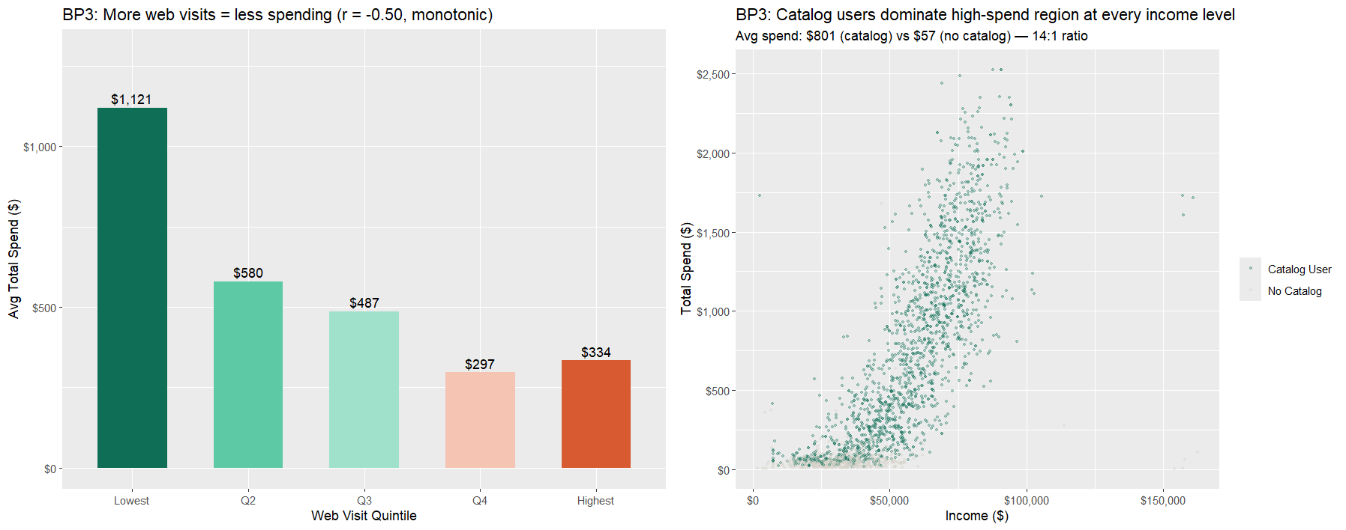

Figure 14. Left: Average spend decreases monotonically across web visit quintiles ($1,121 lowest to $334 highest). Right: Catalog users dominate the high-spend region at every income level. The 14:1 spend ratio between catalog and non-catalog consumers confirms catalog as the reliable value signal.

11.4 Variable Importance: Random Forest Cross-Check
The random forest variable importance is a non-parametric confirmation of the predictor rankings. The top two predictors according to both percentage increase in mean squared error and increase in node purity are NumCatalogPurchases and Income, in agreement with the correlation analysis and the linear regression coefficients. NumStorePurchases ranks third. The consistency between correlation analysis, logistic regression, linear regression, and random forest importance confirms the catalog effect is real.
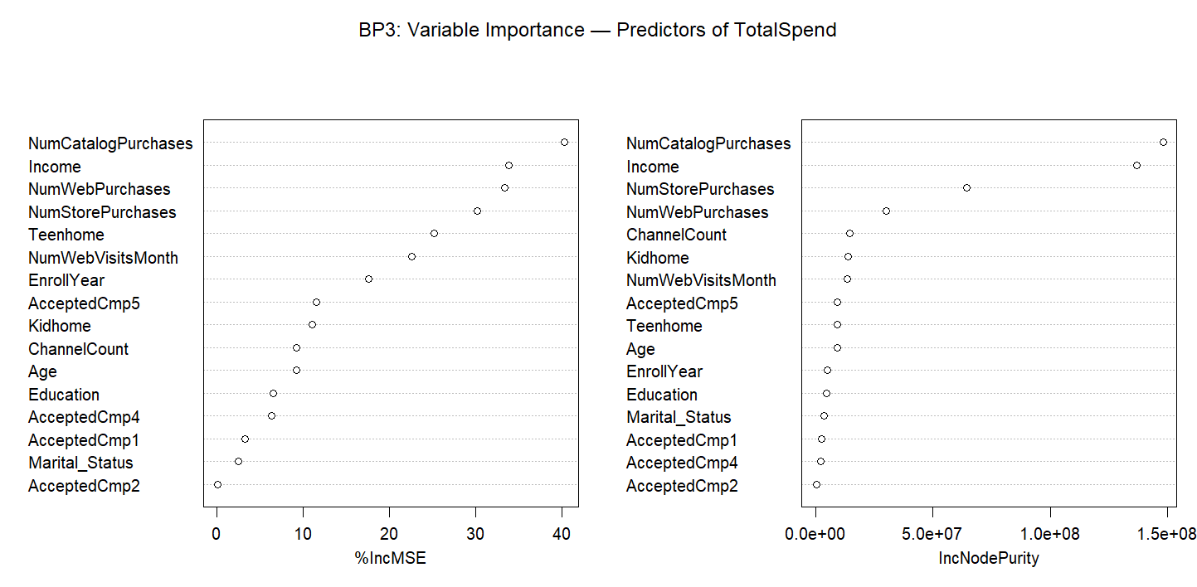
Figure 15. Variable importance from the random forest. NumCatalogPurchases and Income dominate both measures, confirming the predictor ranking from correlation analysis and regression.

11.5 Regression Diagnostics
The residual vs. fitted plot has a fan shape and the Q-Q plot has fat tails. These are expected given the right skew of TotalSpend, and the structural gap between the near-zero spenders (Cluster 3) and the high spenders (Cluster 2). Three high-leverage cases were identified, but were real high spenders and so were not excluded. The 0.800 R-squared for the fully withheld set indicates the model's excellent fit generalizes. The directions and significance of the key predictors remain consistent, which is more important stability check.
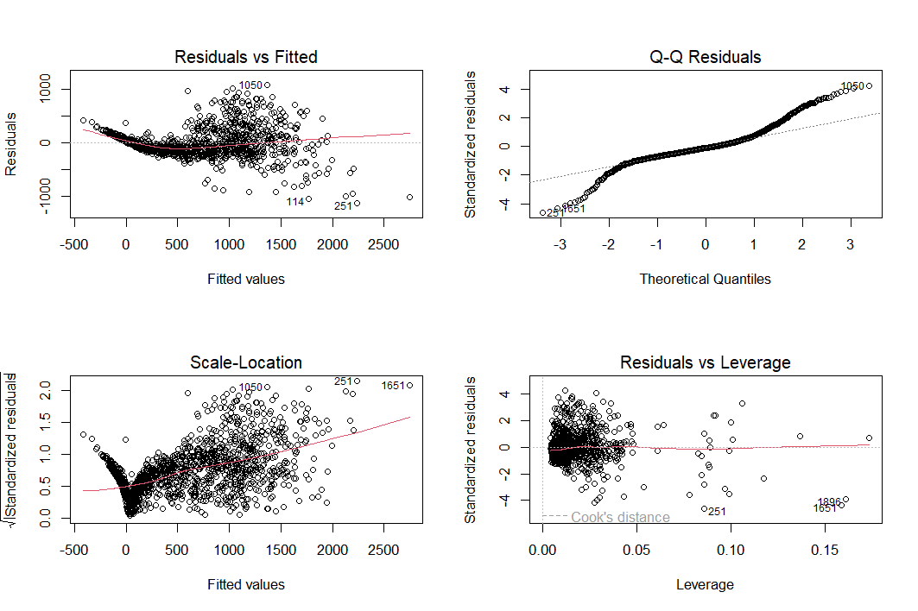
Figure 16. Linear regression diagnostic plots. Heteroscedasticity and non-normal tails are present and are consistent with the right-skewed TotalSpend distribution across structurally different consumer segments.

12. Observations and Conclusions

12.1 What the Analysis Found
GourmetHub's customers are quite diverse, and the warning signs tell that they are indeed pretty straightforward and not at all cryptic. For instance, there are up to 6-fold differences in spending across lifecycle stages, the primary behavior signal correlated with spending is trending down for each new cohort, and two of the key channel performance metrics are moving in opposite directions. There are no minor remarks. These are the key operational problems that a one-size-fits-all campaign approach cannot address.
In the k-means results, it is clear that lifecycle stage is the primary consumer cohort characteristic. Indeed, the four clusters match the four lifecycle stages, despite the fact that they were not imposed. The amount spent by the premium cluster (Cluster 2, $1,393) is 25 times the amount spent by the constrained cluster (Cluster 3, $56). Only about one-third of this gap can be explained by income. The remaining difference is due to lifecycle stage affecting household composition, channel behavior, and catalog engagement all at once. So, a targeting strategy based solely on income would miss this completely.

The classification model confirms that it is possible to predict who is of high value at the time of enrollment with 97.5% accuracy using only the data GourmetHub currently has. The two important predictors are catalog purchases and income. A classification tree reduces this to two rules that are easily understood by non-statisticians: fewer than 2 catalog purchases predict Standard with 93% confidence; 2 or more catalog purchases with income greater than $50,000 predict HighValue with 97% confidence. Therefore, it can be used immediately.

The regression model answers the channel question. Purchases made via the catalog increase total spending per purchase by $65.86 after income is held constant. This is not an income correlation. It's a behavioral mechanism that is independent. Web visit frequency, which appear to be a very strong negative signal bivariate, is positive once income is taken into account. The bivariate correlation is a confounding effect of income. GourmetHub does not have a problem that web visit frequency is suppressing sales. It has a problem that low-income consumers are heavy viewers and low buyers, and the business may be misinterpreting that pattern as a sign of web channel effectiveness.
The time series result provides a structural explanation for the classification result. The negative trend in monthly catalog activity by the new enrollees is statistically significant, at -0.041 purchases per month. The regression coefficient for EnrollYear is -$56.50 per year after all the other individual controls. The quality issue of the cohort is real, can be measured at the individual level, and it is increasing with each new wave of consumers.

12.2 Recommendations and Targeted Marketing Strategy
To summarise, the findings of the study support three very specific and implementable marketing decisions.
Firstly, for lifecycle-based campaign differentiation, it is recommended that GourmetHub discontinue the practice of using the same campaign intensity for all segments. YoungFamily and MixedFamily consumers together account for 42.3% of the enrolled base and currently generate a very small portion of revenue. These segments should be subject to a longer-term retention campaign strategy: a reduced campaign frequency focused on providing value through content related to discovery of premium products, and introductions of catalogs that help form the behavioral patterns required for high-value status. TeenFamily and EmptyNester consumers should be given the full intensity of GourmetHub's promotional expenditure as their return on campaign spend is both rapid and substantial.

Secondly, in terms of intervention at the time of enrollment, the logistic regression model can be used to score new consumers at the time they enroll. The consumers who, according to their early catalog engagement and household structure, score as likely-Standard should be targeted with a catalog-engagement program in anticipation of their spending behavior being established. The cost of this first intervention is worth it. However, the expenditure on allowing a high-potential consumer to adopt a low-engagement pattern is not.

Finally, for channel investment reallocation, GourmetHub should consider catalog engagement as the primary channel that delivers ROI and reallocate accordingly. The number of web visits should be dropped as a KPI for consumer value. High web visit frequency is actually more of a sign of catalog engagement need: they are interested enough to visit but haven't been allowed to engage via the more valuable channel. Campaign 5 should continue to be the most effective campaign for engaging high-value consumers, as evidenced by its correlation of 0.47 with TotalSpend and a $274 spend premium for acceptors.

12.3 How the Analytics Supports the Business Goals
Business Goal | Analytical Outcome | Strategic Recommendation
Business Goal 1 | K-means clustering confirmed four segments aligned with lifecycle stages. Spending varies 6x across segments. Income explains only 1.9x of that gap. Lifecycle stage independently suppresses spending through household composition and channel behavior. | Differentiate campaigns by lifecycle stage. Invest in YoungFamily retention now. Reserve high-intensity outreach for TeenFamily and EmptyNester segments where campaign ROI is immediate.
Business Goal 2 | Logistic regression classifies HighValue consumers at 97.5% accuracy using catalog purchases, store purchases, and household variables. Catalog engagement is declining at -0.041 purchases per month with a statistically confirmed trend. EnrollYear is significant at -$56.50 per year. | Deploy the classifier at enrollment. Launch a catalog engagement program for new consumers scoring as likely-Standard. Treat the cohort decline as an urgent, quantified revenue problem requiring immediate intervention.
Business Goal 3 | Catalog adds $65.86 per purchase independently of income. Web visit frequency is an income-confounded proxy, not an independent behavioral driver. Its bivariate negative correlation disappears after income control. | Reallocate channel investment toward catalog. Retire web visit volume as a consumer value KPI. Use high web visit frequency as a trigger for catalog outreach rather than a measure of engagement success.

