1. Project Introduction
A regional bank's consumer credit division is facing a serious and increasing challenge. Over the past few years, loan volumes have gone up steadily, but so have delinquency rates, and the variability of charge-offs has become even more difficult to control. As a result, the bank is feeling competitive pressure from fintech lenders who offer near-instant automated credit decisions, something the bank's current manual approval process cannot address. Under the existing scheme, home equity loan decisions are made based on written underwriting guidelines, but the loan officer's individual judgment also plays a significant role in borderline cases. Consequently, the approval process ends up being inconsistent across different teams, slow to scale, and difficult to justify to regulators.

To help eliminate these issues, the bank gave 5,960 records of home equity loans with 12 borrower and property characteristics recorded at origination and a binary result variable that indicated whether each loan was eventually repaid or went into default. ECOA expects any credit denial to be supported by certain identifiable variable-level reasons that can be made available to the applicant and checked by regulators. All the modeling decisions in this project consider that constraint.

This project delivers three analytical tools to support those decisions directly. The first score is each applicant's default probability before a loan is approved. The second approximates the debt-to-income ratio among the 21 percent of the applicants who do not report it. The third divides the current portfolio into risk-based areas that could be tracked over time. Each tool was evaluated on data it never saw during development, ensuring the results are according to the actual lending conditions and not controlled experiments.

2. Business and Analytics Goals

2.1 Business Problem
The core problem is that the bank lacks a consistent, data-driven way to identify high-risk applicants before approval, leading to avoidable losses, inconsistent decisions, and regulatory risk.
Currently, loan approval depends partly on individual judgment, which means similar applicants may be treated differently across underwriting teams. Over time, shifting priorities between risk control and loan growth have further weakened consistency. As a result, the bank cannot clearly connect borrower characteristics at the time of application to future loan performance, making it difficult to manage risk and justify decisions when questioned.

Default Risk:
The bank needs a reliable way to determine whether an applicant is likely to default before approving the loan. Without a scoring model, approval decisions depend on which loan officer reviews the file and what criteria they apply that day - two officers can look at the same application and reach opposite conclusions. That inconsistency is not just operationally inefficient; it creates legal exposure when decisions are challenged.

Missing Financial Information:
A significant portion of applicants do not disclose their debt-to-income ratio, which is an important indicator of repayment ability. This creates uncertainty and increases the risk of making decisions based on incomplete information. Currently, there is no structured way to handle these applications - they are either rejected outright, losing potentially good borrowers, or approved without adequate information, absorbing hidden risk. Neither outcome is defensible under regulatory scrutiny.
Borrower Segmentation:
The bank does not have a structured way to group borrowers based on their financial profiles and risk patterns. Without segmentation, every borrower is managed as an individual case. Portfolio-level shifts, a gradual rise in high-risk approvals, for instance, remain invisible until delinquency rates have already climbed.

These problems cannot be solved effectively through manual review alone. Loan outcomes depend on multiple factors at the same time, and these relationships are not always obvious. Relying on intuition leads to two costly outcomes: approving applicants who are likely to default and rejecting those who would have repaid. A structured, data-driven approach is needed to improve consistency and support better decisions.

2.2 Business Goals
- Reduce charge-off losses by identifying high-risk applicants before approval, replacing inconsistent manual review with a consistent scoring process
- Ensure regulatory compliance by generating variable-level denial reasons for every adverse decision so that you meet the requirements of ECOA without any extra tools
- Monitor portfolio risk over time by maintaining a structured view of borrower segments that signals deteriorating quality before it appears in delinquency data

2.3 Analytics Goals
Three analytical outputs are produced in this project, each connected to a specific decision the bank needs to make:
- Classification produces a default probability score for every applicant. This score allows the bank to rank applicants by risk before approval and provides the variable-level explanation ECOA requires for any denial.
- Regression produces an estimated debt-to-income ratio for the 21% of applicants who do not disclose it. This estimate is used to flag incomplete applications for additional documentation rather than approving or rejecting them without adequate information.
- Clustering produces four borrower segments based on financial profile and documentation behavior. These segments give the bank a quarterly monitoring lens - tracking shifts in new originations across segments provides an early warning of portfolio quality changes before outcomes are known.

All outputs are evaluated on a separate test dataset to ensure they reflect real-world performance and can be trusted in practice.

3. Data Preprocessing

3.1 Attribute Definitions
The HMEQ dataset contains 5,960 records with 12 predictor variables and one binary outcome variable. The table below defines each attribute, its data type, and its role in the analysis.

Variable | Type | Description | Role
BAD | Binary | 1 = defaulted or seriously delinquent; 0 = remained current | Target
LOAN | Continuous | Requested loan amount in dollars | Predictor
MORTDUE | Continuous | Amount owed on existing mortgage | Predictor
VALUE | Continuous | Estimated property value at origination | Predictor
REASON | Categorical | DebtCon = debt consolidation; HomeImp = home improvement | Predictor
JOB | Categorical | Occupational category of the applicant | Predictor
YOJ | Continuous | Years employed at current job | Predictor
DEROG | Discrete | Number of major derogatory credit reports | Predictor
DELINQ | Discrete | Number of delinquent credit lines at origination | Predictor
CLAGE | Continuous | Age of oldest credit line in months | Predictor
NINQ | Discrete | Number of recent credit inquiries | Predictor
CLNO | Discrete | Total number of open credit lines | Predictor
DEBTINC | Continuous | Total debt-to-income ratio | Predictor + Regression Target
Table 1. HMEQ variable definitions, data types, and analytical roles.

3.2 Data Exploration
Before we even thought about preprocessing the data, we compared the main variables across different groups according to the outcome to see where the data naturally separates. These observed differences directly informed which variables were prioritized and how missing values were treated.
Table 1a presents descriptive statistics for every numeric variable in the raw dataset, before any cleaning or imputation. Three patterns stand out immediately. Missing values in DEBTINC appear in 21.3% of cases, which is too many for a simple average to handle, so MICE imputation is necessary. Six variables have skewness over 1.0; DEROG and DELINQ stand out with +4.71 and +4.60, respectively, both show a median of zero, yet peak at 10 and 15, pushing risk into extreme outliers. CLAGE hits 1,168 months, almost 97 years - far beyond the 99th percentile at 400 months. That gap justifies the winsorization limit set in section 3.4. The distribution is heavily skewed toward high values, mainly in risk indicators. And the upper tail holds most of the variation, not the center.

Variable | N Valid | Missing | Min | Q1 | Median | Mean | Q3 | Max | Std Dev | Skewness
LOAN | 5,960 | 0% | 1,100 | 11,100 | 16,300 | 18,608 | 23,300 | 89,900 | 11,207 | +1.87
MORTDUE | 5,442 | 8.7% | 2,063 | 46,276 | 65,019 | 73,761 | 91,488 | 399,550 | 44,457 | +1.72
VALUE | 5,848 | 1.9% | 8,000 | 66,076 | 89,236 | 101,776 | 119,824 | 855,909 | 57,384 | +3.04
DEBTINC | 4,693 | 21.3% | 0.52 | 29.14 | 34.82 | 33.78 | 39.00 | 203.3 | 8.60 | +2.41
CLAGE | 5,652 | 5.2% | 0 | 115.1 | 173.5 | 179.8 | 231.6 | 1,168 | 85.1 | +1.42
YOJ | 5,445 | 8.6% | 0 | 3.0 | 7.0 | 8.9 | 13.0 | 41.0 | 7.7 | +1.07
DEROG | 5,252 | 11.9% | 0 | 0 | 0 | 0.25 | 0 | 10 | 0.85 | +4.71
DELINQ | 5,380 | 9.7% | 0 | 0 | 0 | 0.45 | 0 | 15 | 1.13 | +4.60
NINQ | 5,450 | 8.6% | 0 | 0 | 1 | 1.19 | 2 | 17 | 1.73 | +2.96
CLNO | 5,738 | 3.7% | 0 | 15 | 20 | 21.3 | 26 | 71 | 10.1 | +0.98
BAD | 5,960 | 0% | 0 | 0 | 0 | 0.20 | 0 | 1 | 0.40 | N/A
Table 1a. Summary statistics for all numeric variables - raw data before cleaning or imputation. Missing rates shown as a percentage of 5,960 total records.

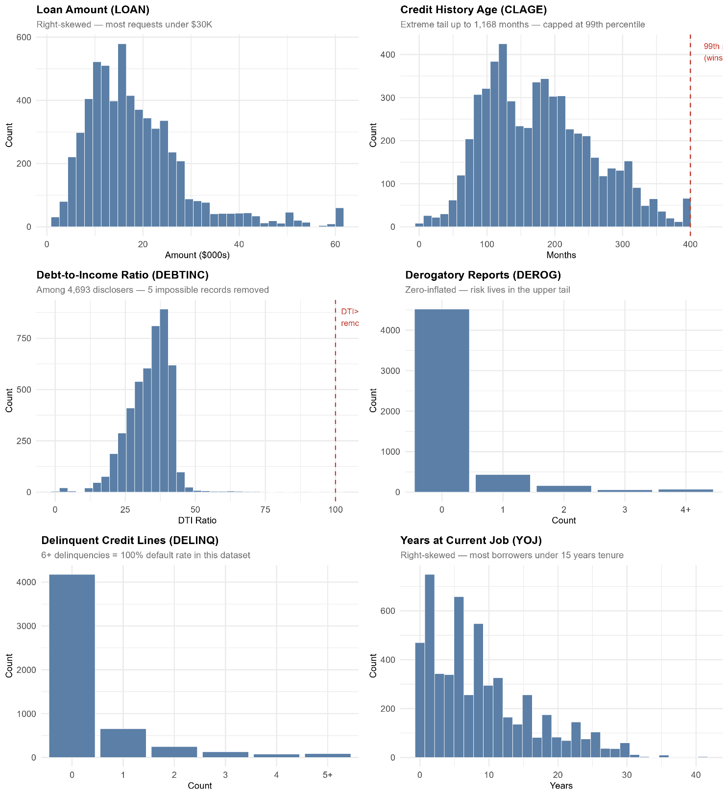
Figure 1a. Distribution histograms for six key predictors - raw data before imputation or outlier treatment. Red dashed lines mark removal or capping thresholds where applied.

Variable | Good Borrowers | Defaulters | Gap
DEBTINC - median debt-to-income ratio | 34.80 | 38.24 | +3.44 pts
CLAGE - median age of the oldest credit line | 182 months | 132 months | - 50 months
VALUE - median property value | $94,488 | $86,191 | - $8,297
LOAN - median requested loan amount | $17,100 | $16,150 | -$950
MORTDUE - median existing mortgage balance | $67,180 | $61,837 | -$5,343
Table 1b. Median values by loan outcome - raw data before cleaning or imputation.

CLAGE shows the widest separation at 50 months. DEBTINC separates moderately. Financial size variables show minimal difference, confirming they are weaker predictors of default. DELINQ and DEROG both show a median of 0 across groups - their signal lives in the upper tail and is shown in Figure 4.
The first thing the data exploration revealed is a class imbalance problem that must be addressed before any model is trained.

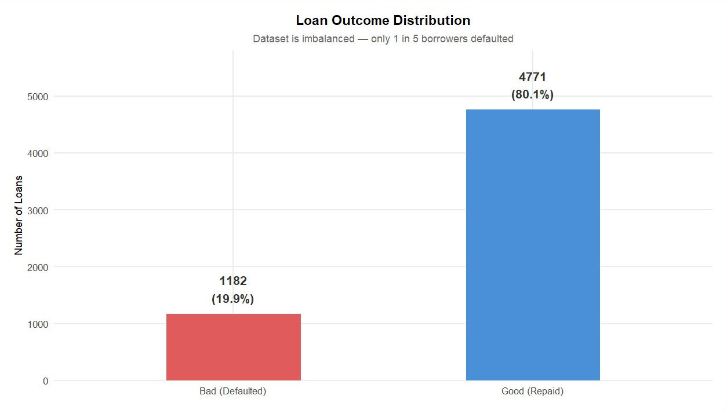
Figure 1. Loan outcome distribution - 4,771 repaid (80.1%) versus 1,182 defaulted (19.9%). A naive classifier that predicts every applicant as good achieves 80% accuracy without identifying a single defaulter.

The 4:1 class imbalance means raw accuracy is meaningless as a performance measure. A model that classifies every applicant as good would score 80% accuracy while failing completely at the bank's actual objective. To address this, model performance is evaluated using more meaningful measures. Sensitivity (the proportion of actual defaulters correctly identified) reflects how well the model captures risk, while AUC-ROC (a score from 0 to 1 indicating how well the model separates risky and safe borrowers) provides an overall measure of discrimination. Kappa is also used to measure how much better the model performs compared to random guessing.
The second major finding from data exploration was the pattern of missing values, not just how much was missing, but why.

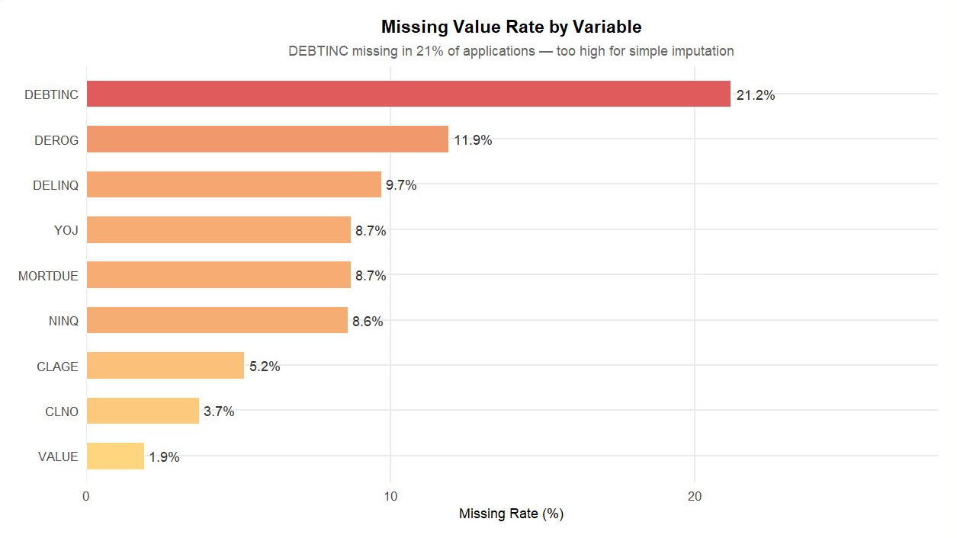
Figure 2. Missing value rate by variable – DEBTINC, absent in 21.2% of applications, far above the threshold where simple mean imputation distorts model inputs.
Ten of the 12 predictor variables had missing values. DEBTINC at 21.2% missing was the most problematic: at that rate, replacing missing values with the variable mean would visibly compress the distribution and understate model uncertainty. But the more important question was why so many DEBTINC values were absent. The chart below answers that directly.

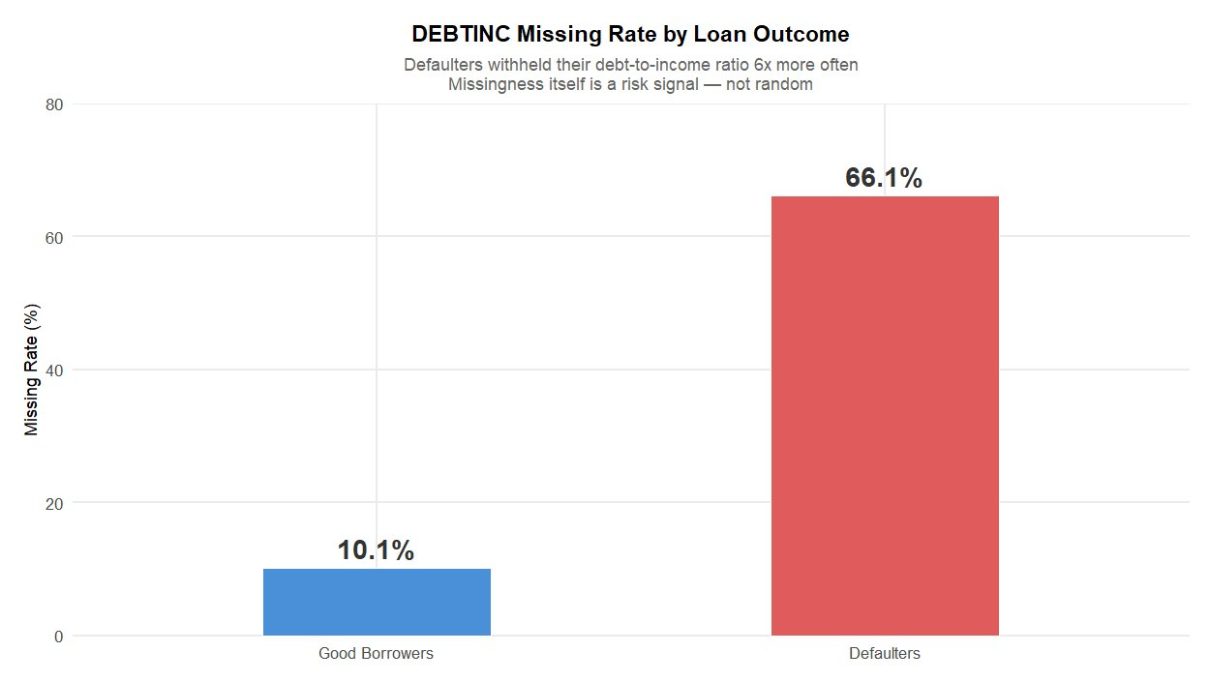
Figure 3. DEBTINC missing rate by loan outcome - 66.1% of defaulters withheld their debt-to-income ratio versus 10.1% of good borrowers. A 56-point gap that proves the missingness is informative, not random.
This chart is the most important single finding in the preprocessing stage. A 56 % point gap in the missing rate between defaulters and good borrowers means DEBTINC is Not Missing at Random (NMAR). Borrowers who already knew their financial situation was too weak to support a loan had an incentive not to disclose it. The same pattern appeared for VALUE (8.7% point gap) and DEROG (reversed pattern, selective non-disclosure of derogatory history). For all three variables, a binary indicator flag was created before any imputation, DEBTINC_MISSING, VALUE_MISSING, DEROG_MISSING - preserving the signal that the act of withholding information carries. These flags turned out to be the two most important predictors in the entire classification model.

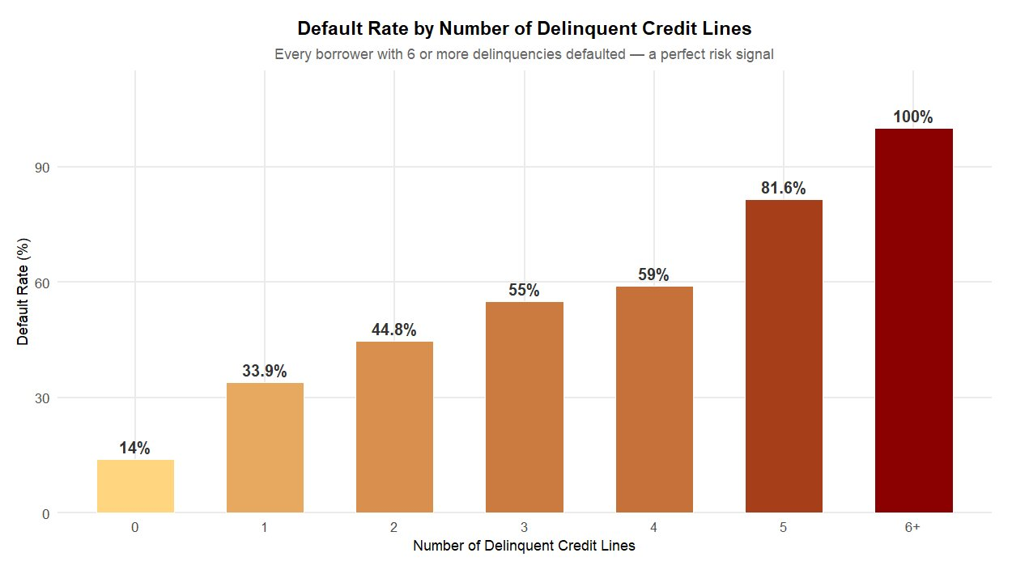
Figure 4. Default rate by delinquent credit line count - a perfect monotonic escalation from 14% at zero delinquencies to 100% at six or more.
Another strong pattern emerged in delinquency history. Figure 4 shows a clear increase in default rates as the number of delinquent credit lines rises. Borrowers with six or more delinquencies had a 100% default rate in this dataset. This is a direct observation from the data and highlights a potential threshold for identifying extremely high-risk applicants.
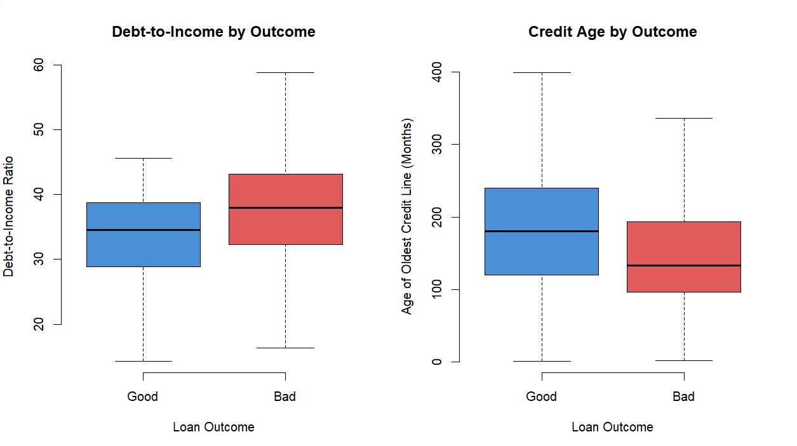
Figure 5. DEBTINC (left) and credit age CLAGE (right) distributions by loan outcome - defaulters carry higher debt loads and have significantly shorter credit histories.
Finally, Figure 5 compares financial characteristics between defaulters and non-defaulters. Borrowers who defaulted generally had higher debt-to-income ratios and shorter credit histories. While the difference in debt burden is moderate, the gap in credit history is more pronounced, suggesting that experience in managing credit plays an important role in repayment behavior.

3.3 Missing Value Classification and Treatment
Variables were classified as MCAR (Missing Completely at Random), MAR (Missing at Random), or NMAR (Not Missing at Random) based on differential missing rates between defaulters and good borrowers. Variables identified as NMAR were treated carefully because the act of not reporting a value carries important information. For these variables, indicator flags were created before imputation to preserve this signal.
Numeric variables were then imputed using MICE (Multiple Imputation by Chained Equations), a method that fills in missing values by learning patterns from other variables in the dataset. To avoid introducing bias, imputation was performed separately on the training and test sets after the data split.
For categorical variables such as REASON and JOB, missing values were assigned to an “Unknown” category rather than being estimated. This allows the model to treat non-disclosure as a meaningful group rather than as random noise. This distinction is significant for each model employed in this project. Logistic Regression, Decision Tree, and Random Forest in R all naturally work with factor variables - they consider each category as a separate, unordered group. Changing them to codes like 1, 2, 3 would create a false numerical distance between job categories that is meaningless in the real world and would lead to incorrect model estimates. Factor encoding eliminates this problem while keeping the categories interpretable.

Variable | Overall Missing | Defaulters | Good Borrowers | Classification | Treatment
DEBTINC | 21.3% | 66.1% | 10.1% | NMAR | Binary flag + MICE imputation
VALUE | 1.9% | 8.8% | 0.1% | NMAR | Binary flag + MICE imputation
DEROG | 11.9% | 7.3% | 13.0% | NMAR | Binary flag + MICE imputation
MORTDUE | 8.7% | 8.9% | 8.6% | MCAR | MICE imputation
DELINQ | 9.7% | 6.1% | 10.6% | MAR | MICE imputation
YOJ | 8.6% | 5.5% | 9.4% | MAR | MICE imputation
NINQ | 8.6% | 6.3% | 9.1% | MAR | MICE imputation
CLAGE | 5.2% | 6.6% | 4.8% | MCAR | MICE imputation
CLNO | 3.7% | 4.5% | 3.5% | MCAR | MICE imputation
REASON / JOB | 4.2–4.7% | Similar | Similar | MCAR/MAR | Unknown category
Table 2. Missing value classification and treatment by variable.

3.4 Anomaly Removal, Outlier Treatment, and Class Imbalance
Seven records were deleted because a thorough check revealed that their values could not possibly belong to actual borrowers. Five of them had a debt-to-income ratio (DTI) higher than 100, which implies that total debt obligations exceeded income - a situation that cannot happen in a living household and most likely indicates a data entry mistake. Two showed a credit age of zero months, meaning no credit history at the time of application. A home equity loan implies that the borrower owns a property, which in turn requires prior credit activity; therefore, a credit age of zero is inconsistent with the loan type and cannot be a real applicant. No records were deleted due to having extreme values but still financially plausible ones; these were treated by winsorization, which keeps every record but reduces the effect of outliers on model estimates. The working dataset after removal contained 5,953 records. Four continuous variables - CLAGE, VALUE, MORTDUE, and LOAN - were capped at their 99th percentile values (winsorization, meaning extreme values are limited so they do not distort results). CLAGE's longest credit history was 1,168 months, which is about 97 years of credit history, which compare to a 99th percentile of 400 months. Anyone with a credit history that long is hardly someone who is currently looking for a home equity loan, so the right thing to do is to cap at the 99th percentile rather than treat it as a very high but valid figure. VALUE did the same, hitting $855,909 against a 99th percentile of $289,991 and was treated the same way. Capping preserves the whole dataset while stopping these extreme values from influencing model coefficients and clustering distances in a way that doesn't typify a normal borrower.
After cleaning and imputation, the training set contained 3,340 good records and 828 default records. Class imbalance in the training data was addressed using ROSE (Random Over-Sampling Examples), a method that generates synthetic examples of the minority class to create a more balanced dataset. This helps the model learn patterns for both defaulters and non-defaulters more effectively.
Importantly, the test dataset was left unchanged and retained the original 80:20 class distribution. This ensures that model evaluation reflects real-world conditions rather than artificially balanced data.

4. Predictor Analysis and Variable Relevance
Predictor importance was measured in terms of how well the observed data patterns pointed to the variables that most strongly signal default risk. Predictors were prioritized according to how strongly they were correlated with loan default as measured by changes in default rates and the extent of separation in the distributions of the outcome groups.
The strongest predictors were the three NMAR missingness flags. DEBTINC MISSING represents the difference in the percentage of defaulters and non-defaulters at 56 percentage points whereas VALUE MISSING also represents an evident gap. These variables take into consideration the behavior of the borrowers and this means that an applicant who fails to disclose financial information has a high probability of default.
The second tier consists of DELINQ, DEROG, and CLAGE. DELINQ escalates from 14% to 100% default rate with a monotonically increasing pattern as shown in Figure 4. DEROG follows a similar but slightly less extreme escalation. CLAGE separates groups by approximately 47 months (four years) of median credit history. DELINQ, as well as DEROG, are indicators that a borrower has, either through their actions or their credit history, shown that they are incapable or not willing to keep financial promises to a lender, making them directly relevant to the bank's core question of whether a new loan will be repaid. Longer credit history (CLAGE), on the contrary, is a sign of reduced risk of default.
The third tier - NINQ, JOB, YOJ, MORTDUE, LOAN, VALUE - showed weak to moderate associations individually. JOB showed the widest categorical spread (13.2% for office workers versus 34.9% for sales professionals). Although the differences in these variables allow moderate separation, they add more information in combination with stronger predictors.
Altogether, the most reliable risk indicators are the borrower behavior and credit history whereas the financial variables are supporting in decision making.

Variable | Direction | Evidence from HMEQ Data
DEBTINC_MISSING | Very strong positive | 66.1% missing among defaulters vs 10.1% good borrowers - 56pt gap
VALUE_MISSING | Strong positive | 8.8% missing among defaulters vs 0.1% good borrowers
DELINQ | Strong positive | 14% (0 lines) → 33.9% → 44.8% → 55% → 59% → 81.6% → 100% (6+)
DEROG | Strong positive | 16.7% (0 marks) → 38.9% → 51.2% → 75%+ (3+ marks)
CLAGE | Negative | Good: median ~180 mo vs Defaulters: median ~133 mo
DEBTINC | Moderate positive | Defaulters: median 38.0 vs Good: median 34.5 (among those who disclosed)
NINQ | Moderate positive | Higher inquiry count linked to elevated default rate
JOB | Categorical | Sales: 34.9% vs Office: 13.2% vs ProfExe: 16.6% default rate
YOJ / MORTDUE / LOAN | Weak | Small directional differences, no strong separation
CLNO | Negligible | Near-zero correlation with loan outcome
Table 3. Predictor relevance ranked by strength of observed relationship with loan default.

5. Dimension Reduction
Dimension reduction was evaluated and deliberately excluded from this project for two reasons.

The reason for regulation is the main one. ECOA requires all unfavorable credit decisions to be justified by certain, distinguishable attributes of the borrowers. PCA results in linear combinations of the original variables that cannot be interpreted directly. A bank cannot explain to an applicant that his or her credit was denied because his/her first principal component score exceeded a threshold, as that is meaningless to the applicant and will not pass the test of a regulator. Given that there is no bargaining on ECOA compliance in such a deployment setting, PCA is not an option more or less, it may offer a marginal improvement in accuracy.

The second reason is practical. Fifteen variables are not enough to dig into heavy computations, not to mention that there is not so much of a risk of overfitting, which leads to dimension reduction in large-feature tasks. The 12 original predictors plus 3 NMAR flags are 15 variables that do not pose computational or overfitting problems that would prompt the application of dimension reduction in high-feature problems. CLNO had the poorest individual association with the outcome and was to be excluded, but the total number of variables of 15 makes the cost of retaining a low-signal predictor insignificant. The models assign CLNO near-zero importance during training without any manual exclusion needed - confirming the data's own judgment that it adds nothing.

6. Data Engineering and Transformation
Transformations were applied in a specific sequence to maintain data integrity and prevent leakage between the training and test sets.

Step 1: NMAR indicator flags created. The three binary flags DEBTINC_MISSING, VALUE_MISSING, and DEROG_MISSING were added to the dataset before any imputation. This ordering is essential; if flags were created after MICE filled in the missing values, the signal that a value was absent would be permanently lost. These flags became the two strongest predictors in the final classification model.
Step 2: REASON and JOB missing records were set to unknown and kept as factor variables. Logistic Regression, Decision Tree, and Random Forest all handle factor variables as separate, unordered categories without needing numeric recoding. The Unknown level stayed in its own category so models could learn from cases where data was missing, not just ignore them as noise.

Step 3: Outlier capping. CLAGE, VALUE, MORTDUE, and LOAN were winsorized at the 99th percentile. This maintains all 5953 records and ensures that a few extreme values do not have a disproportionate effect on the model coefficients or splits in the trees.

Step 4: Clustering standardization. All numerical variables were brought to zero mean and unit variance and then k-means was applied. K-means calculates Euclidean distance, which is unscaled so that MORTDUE scores in the tens of thousands would entirely dominate DELINQ scores between 0 and 15, giving it clusters based on financial size and not risk profile.

7. Data Partitioning
The dataset was split 70/30 into training and test sets using stratified random sampling via createDataPartition in caret. Stratification on BAD ensures both sets preserve the original 80:20 class distribution. Training set comprises 4,168 records, and the test set - 1,785 records, both with default rates close to 19.9%.
The split was done after cleaning but before imputation which, in that order, keeps the rule of no data leakage: if MICE were done on the whole data then splitting, test set records would help in the imputation of train records, thus giving an unrealistic enhancement of the performance of the model on data that it has not been used for training, in other words the model was not really trained on it. MICE was done separately on each of the partitions. ROSE was applied only to the training set after imputation. The test set was never touched at all during the whole modeling process. A fixed random seed of 2026 was applied to all steps — the data split, imputation, ROSE balancing, model training, and clustering, so that every result in this document can be reproduced exactly.

Set | Records | Good | Defaulted | Default Rate | ROSE Applied
Training (before ROSE) | 4,168 | 3,340 (80.1%) | 828 (19.9%) | 19.9% | No
Training (after ROSE) | ~4,168 | 2,081 (49.9%) | 2,087 (50.1%) | 50.1% | Yes
Test (hold-out) | 1,785 | 1,431 (80.2%) | 354 (19.8%) | 19.8% | No - unchanged
Table 4. Data partitioning summary. Test set retained at real-world 80:20 for honest performance evaluation.

8. Model Selection and Justification

8.1 Classification Models
The first interpretability model was Logistic Regression, which is also the industry standard in credit scoring because its coefficients can easily explain each variable's impact on the likelihood of default.
For instance, if the coefficient of DELINQ is positive, it implies that each additional delinquent credit line increases the estimated default probability by a specific, reportable amount. This is precisely what ECOA requires for adverse action notices.

The second interpretable model was a decision tree. Since it is a visual flowchart, a loan officer can easily find out which combination of characteristics led to the application being flagged, which is why it is the most effective tool for producing denial explanations that a borrower can comprehend.

Random Forest has been chosen as the performance reference point. It creates 500 trees on random samples of the training data, and the prediction results are combined by majority voting. Apart from accuracy, its main benefit is the output of variable importance, which is capable of providing an objective verification of whether the NMAR preprocessing hypothesis was valid - a model that has no information at all about the preprocessing decisions should indicate the same ranking of predictors if the analysis was correct.

8.2 Regression Models
Linear Regression was used as a very understandable baseline. It can show you at the level of coefficients which financial characteristics lead people to have higher debt levels. Regression Tree used the rpart method to estimate a continuous result. It splits loan applicants into different groups that have similar DEBTINC values predicted by the model. Gradient Boosting was chosen to be the complex model. It creates a series of trees step by step with each new one fixing the errors of the last - the strongest method capable of modeling the non-linear financial connections in this data. Regression models were trained on the imputed training set directly, without ROSE balancing. Class balancing applies only to classification problems - DEBTINC is a continuous outcome, so there is no minority class to oversample.

8.3 Clustering
K-means was selected since it was able to form distinct and non-overlapping segments of borrowers, which could be profiled, named, and followed over a period. The two methods used concurrently helped in determining the number of clusters. The elbow method is a method that examines the tightness of the clusters as you add more of them. Adding another cluster no longer adds significant improvement, so that is the correct point to stop. Silhouette analysis is a question that gauges the fit of each borrower to the cluster to which it is assigned with respect to other options - a high score indicates that the groupings are more pronounced and, therefore, meaningful. The two approaches identified four clusters as the best way to solve this portfolio.
Each classification and regression model was tested using repeated cross-validation - 10 repetitions of 10-fold cross-validation - giving 30 unique performance estimates per model before the held-out test set was ever touched. This method tries out every single model on numerous different slices of the training data before the use of the held-out test set and provides an accurate view of the actual stability of the performance of each model.

9. Model Fitting and Performance Evaluation

9.1 Classification Models
All three models were trained on the ROSE-balanced training set using repeated 10-fold cross-validation with 3 repeats. The cross-validation comparison below shows performance distributions across all 30 folds before the test set was touched.

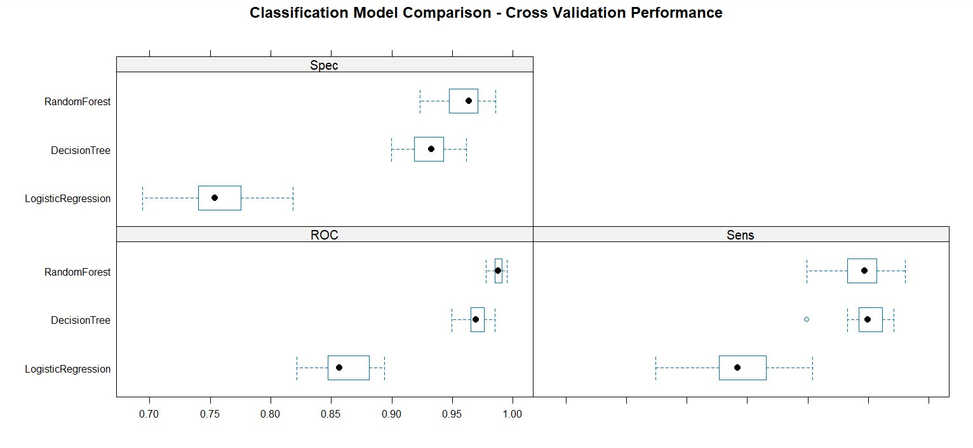
Figure 6. Classification model cross-validation performance - ROC, Sensitivity, and Specificity across 30 folds. Random Forest and Decision Tree show tighter, higher-positioned boxes; Logistic Regression shows wider spread and lower mean ROC during training.
During cross-validation on the training set, Random Forest achieved a mean ROC of 0.988, Decision Tree 0.970, and Logistic Regression 0.860. The Random Forest and Decision Tree distributions are compact and positioned near the top of the scale. Logistic Regression shows wider variability during CV, which raises the question of whether this holds on the true held-out test set. The answer from the test set is more nuanced.

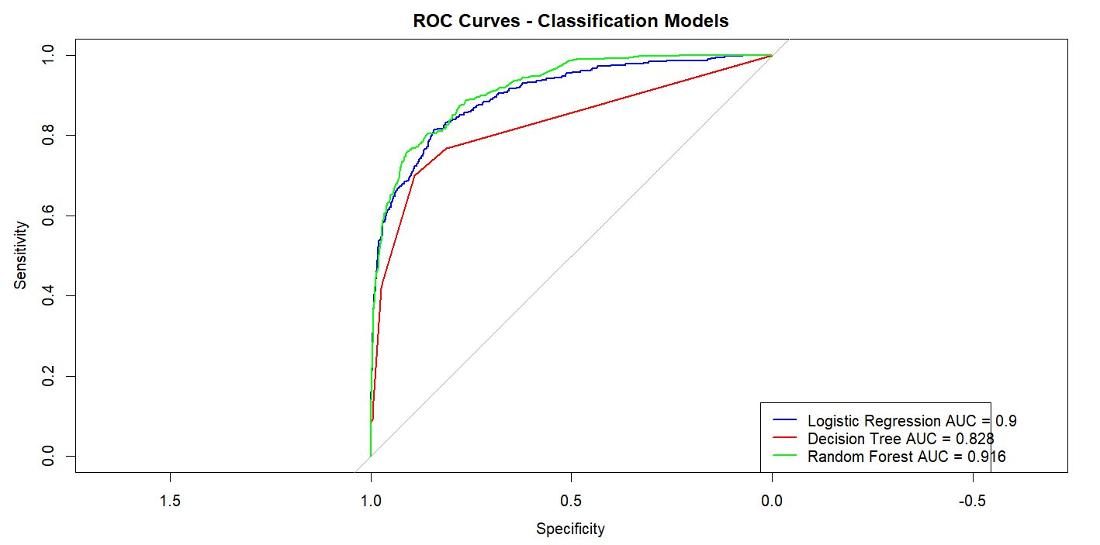
Figure 7. ROC curves on the held-out test set - Logistic Regression AUC = 0.900, Decision Tree AUC = 0.828, Random Forest AUC = 0.916. The gap between Logistic Regression and Random Forest narrows to 0.016 on real-world data.
Random Forest and Logistic Regression give almost the same ROC curves in the entire range of thresholds in the test set. The gap in the 0.016 AUC is most significant in the classification analysis: this implies that the fully interpretable model is just as effective as the complicated ensemble when used on the real deployment condition data. Decision Tree lags significantly behind the two, especially in the high sensitivity segment, where the pre-emption of the defaulters is of greatest importance.

Metric | Logistic Regression | Decision Tree | Random Forest
Accuracy | 0.8471 | 0.8633 | 0.8863
Kappa | 0.5640 | 0.4766 | 0.5835
Sensitivity (Recall) | 0.7514 | 0.4181 | 0.5254
Specificity | 0.8707 | 0.9734 | 0.9755
Precision | 0.5898 | 0.7957 | 0.8416
F1 Score | 0.6609 | 0.5481 | 0.6470
AUC-ROC | 0.9001 | 0.8282 | 0.9164
Table 5. Classification model test set performance - 1,785 held-out records at real-world 80:20 class distribution.

The sensitivity of the Logistic Regression was the highest (75.1%), correctly flagging three out of four actual defaulters. The essential measure of this business issue is sensitivity: each defaulter that defaults at the approval point is a charge-off in the future. The accuracy (88.6%) and the precision (84.2%) of the random Forest were higher, but the sensitivity was only 52.5% i.e., it would allow almost half of the true defaulters to pass based on its sensitivity. The sensitivity of the Decision Tree of 41.8% indicates that it would miss more defaulters than it catches. Kappa - how much better the model performs compared to pure random guessing, where 0 means the model is no better than chance and 1 means the model is as good as it is possible - supports this conclusion. The Kappa of Logistic Regression of 0.564 is confirmation that it is actually drawing useful distinctions, rather than the distinction being helped by the fact that 80 percent of the applicants are already good borrowers.
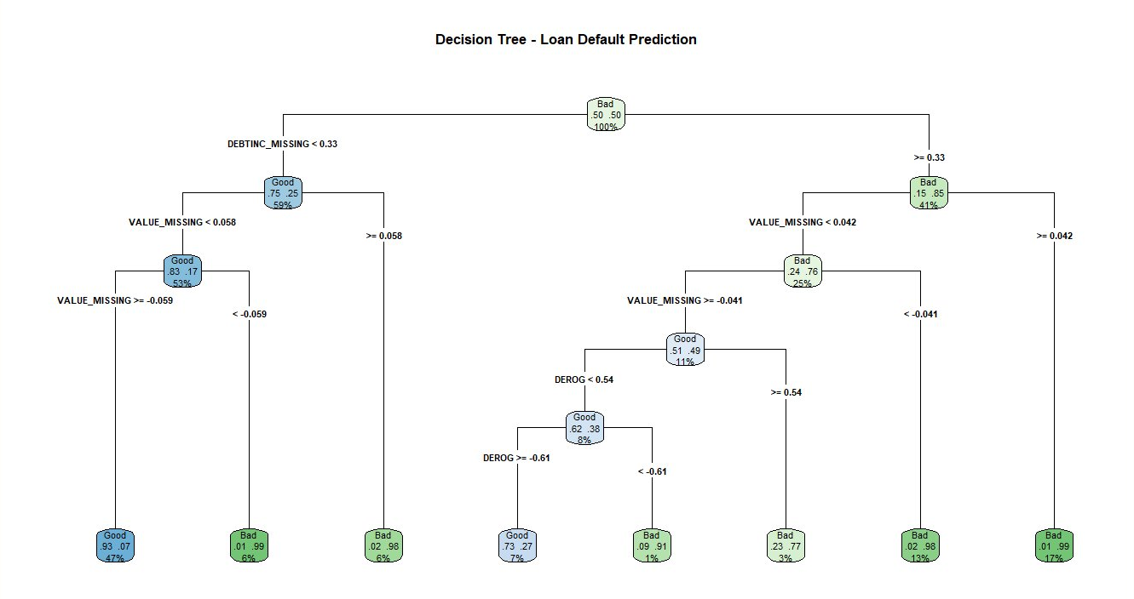
Figure 8. Decision tree structure - the first split is on DEBTINC_MISSING and the second on VALUE_MISSING. Both NMAR flags appear before any financial variable anywhere in the tree.
The decision tree visualization directly confirms the NMAR hypothesis. The model's first split places every borrower with DEBTINC_MISSING >= 0.33 into a branch where 85% are classified as high-risk, before any financial variable is checked. The second level uses VALUE_MISSING on both branches. DEROG appears only at the fourth level. The model independently discovered - with no knowledge of how the preprocessing was designed - that documentation behavior dominates financial figures as a default predictor.

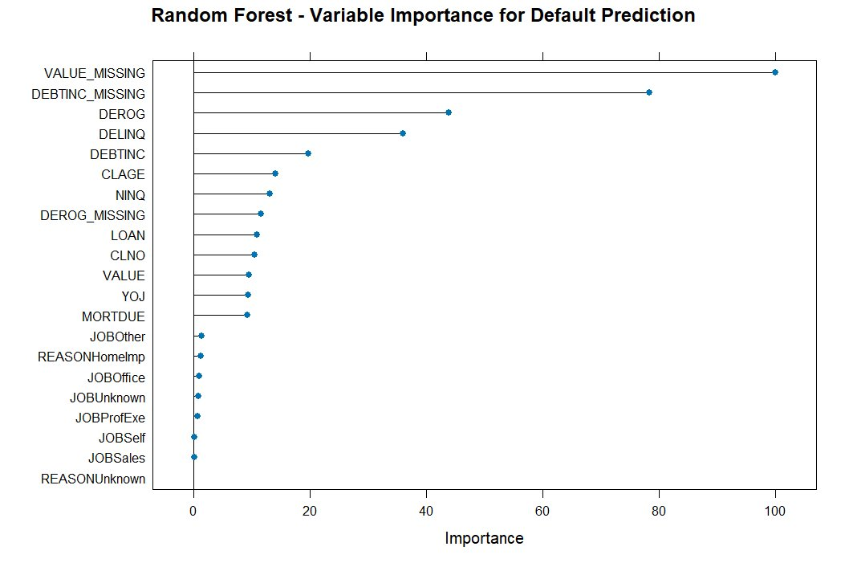
Figure 9. Random Forest variable importance - VALUE_MISSING scores 100 (maximum), DEBTINC_MISSING scores 79. Both NMAR flags outrank every financial variable. DEROG ranks third at 44, DELINQ fourth at 36.

Random Forest variable importance provides the third and final independent confirmation of the same finding. VALUE_MISSING at 100 and DEBTINC_MISSING at 79 sit above DEROG (44), DELINQ (36), DEBTINC (21), CLAGE (15), and every other financial variable in the dataset. No loan amount, property value, mortgage balance, or credit line count scored above 15. Three entirely different analytical approaches - the NMAR pre-analysis, the decision tree structure, and the Random Forest importance ranking - all agree: what a borrower chooses not to disclose at application is more predictive of default than any figure they do provide.
Business Problem 1 is addressed. The bank, at this point, knows how to rate each applicant's risk of default even before a decision is made. For regular work, Logistic Regression is recommended to be used. It correctly flags three out of four people who are going to default in the future. On top of that, its decisions can be related to the individual characteristics of the borrower. So, each rejected application can be fully justified in writing, satisfying the Equal Credit Opportunity Act requirement that applicants are informed of the specific, factual reasons for any detrimental decision. Alongside Logistic Regression, Random Forest is kept as a backup to check if the model's quality remains unchanged as new applications come in over time.

9.2 Regression Models
Three models were trained to estimate DEBTINC for applicants who did not disclose it. BAD and DEBTINC_MISSING were excluded from the predictor set. Test set results are below.
Model | MAE | RMSE | R-Squared
Linear Regression | 5.9745 | 8.0996 | 0.1152
Regression Tree | 5.9494 | 8.2045 | 0.0922
Gradient Boosting | 5.5553 | 7.7304 | 0.1941
Table 6. Regression model test set performance - estimating DEBTINC from 13 financial and employment predictors.
Gradient Boosting produced the best result on every metric: lowest MAE (5.56), lowest RMSE (7.73), and highest R-squared (0.194). The advantage held consistently across all 30 cross-validation folds, confirming it reflects a genuine modeling difference. The R-squared values for the three models - 0.09 to 0.19 - are generally low. R-squared is the proportion of the data variance that the model can explain, where 1.0 stands for a perfect explanation and 0 for the model explaining nothing. A score in the range 0.09-0.19 means that the models are explaining only about 9-19% of the variation in the debt-to-income ratios based on the available information. This is an honest result that reflects the data, not a modeling failure. Income is not present in the HMEQ dataset. DEBTINC is determined by the ratio of total debt obligations to total income, and the income side is unobservable from the available predictors. The models explain approximately 19% of DEBTINC variance from financial profile and employment data alone.
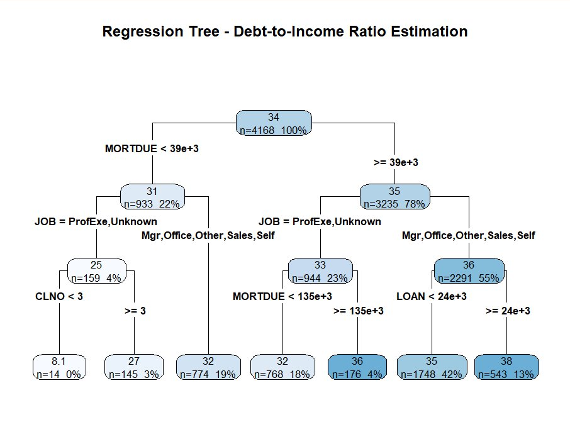
Figure 10. Regression tree for DEBTINC estimation - MORTDUE is the primary split, with JOB category and LOAN amount providing secondary refinement.
According to the regression tree, MORTDUE is the dominant driver of the calculated debt-to-income ratio. Consumers who have previous mortgage balances of less than $39000 are expected to possess DEBTINC at approximately 31. Beyond that threshold, JOB category divides professional and executive jobs from all others, and LOAN amount further separates. It is projected that borrowers who are professionally categorized have high current mortgage balances, and with new loan requests of large sizes, will have the highest debt load (around 37-38). The gradient boosting model indicates that MORTDUE attains an importance of 100, followed by CLNO (59), CLAGE (47), and LOAN (46).

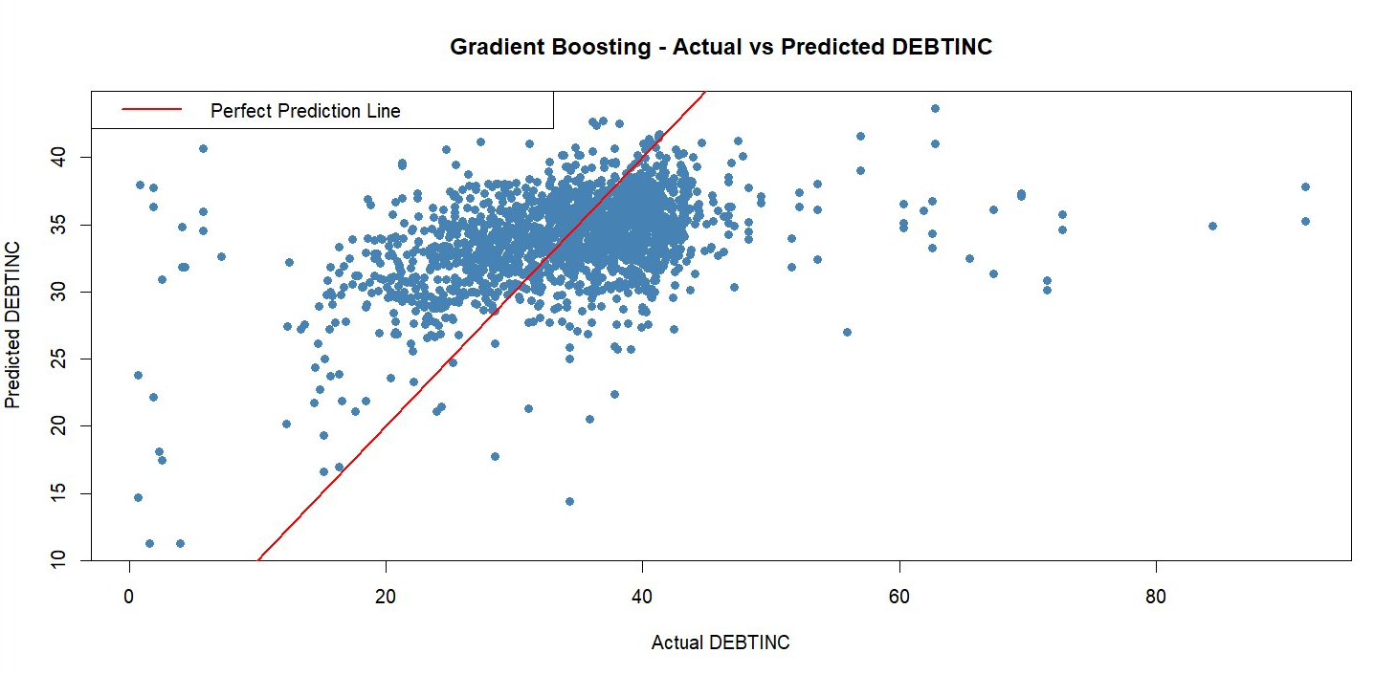
Figure 11. Gradient Boosting actual vs predicted DEBTINC - predictions cluster around the center of the distribution; extreme low and high values are pulled toward the mean, consistent with an R-squared of 0.194.

The actual versus predicted scatter plot demonstrates the regression-to-mean effect, which is expected to happen with R-squared of about 0.19. Both the highest and lowest values of the actual ones are closely concentrated in the range of 28 to 40. Systematic over-prediction is made of borrowers having very low actual DEBTINC (below 15), and under-prediction of borrowers having very high DEBTINC (above 60). This trend indicates that the model is most accurate among applicants in the middle point and least predictable at the ends, where a risk indicator would be most effective, as well as where a request for verification makes most sense.
Business Problem 2 is addressed. The bank is no longer faced with a dilemma of either rejecting incomplete applications straightaway or approving them without quite enough information. Gradient Boosting offers an effective method to estimate the creditworthiness of any applicant who refuses to reveal their debt-to-income ratio - and since 66.1% of non-disclosers have defaulted according to this dataset, this group has a large concentration of risk that was invisible at the approval stage. If the estimated ratio goes beyond a certain limit, the application is immediately flagged for submission of further documents before making any decision. This allows the bank to have a reasonable, regular method of dealing with 21% of applications that come incomplete, instead of leaving this decision to individual loan officers. The estimates serve as a cautionary marker for risks, not a certified figure of income, hence they should never be used as a replacement for the information actually provided by the applicant.

9.3 Clustering - Business Problem 3 Results
K-means clustering was applied to the training data set with 13 variables: the ten main financial factors plus the three NMAR missingness flags - DEBTINC_MISSING VALUE_MISSING DEROG_MISSING. Using the missingness flags in addition to the core financial variables implies that the clustering will reveal not only financial profile but also documentation behavior, which makes the classification model result a similar type of combination as that of the clustering model. Before clustering, all the 13 variables were standardized to have a mean of zero and a variance of one so that the distance computations were not influenced by any single variable. Two diagnostic tools both pointed to four clusters as the right number. The elbow method, which tracks how much tighter the groupings get as more clusters are added, showed the biggest improvement going from three to four clusters, with little gain beyond that. Silhouette analysis which scores how cleanly each borrower fits its assigned group compared to the others - confirmed this, with k=4 producing the highest score of 0.176 on a scale where higher means more distinct, meaningful groups.
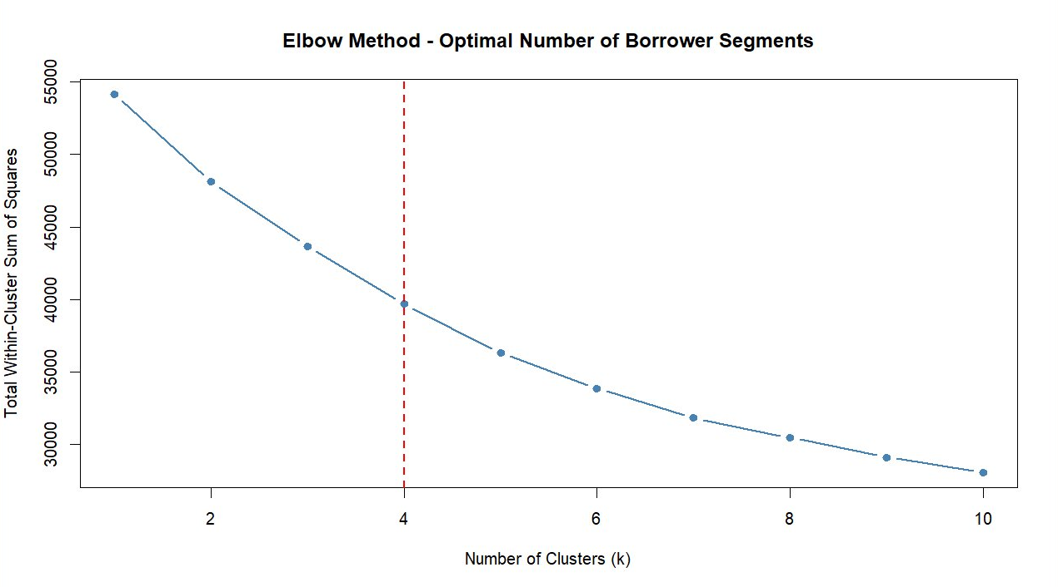
Figure 12. Elbow method - within-cluster sum of squares drops steeply to k=4, then flattens. Silhouette scores: k=2 (0.150), k=3 (0.161), k=4 (0.176), k=5 (0.134). K=4 is optimal by both criteria.

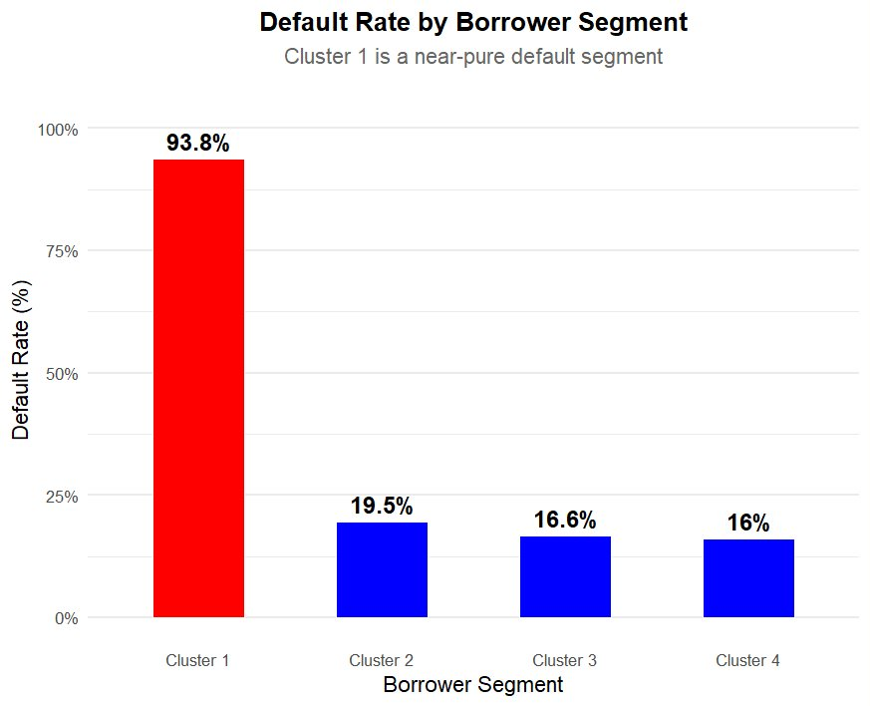
Figure 13. Default rate by borrower segment - Cluster 1 at 93.8% is separated from Clusters 2-4 (16–19.5%) by a factor of nearly five. Identified from financial profile variables alone with no knowledge of loan outcomes.
The default rate plot indicates that k-means - acting simply on the variables of financial profile, having no access whatsoever to loan performance chosen at training - alone recognized as an almost pure default group. The default rate of Cluster 1 was 93.8 percent which is almost five times more than any other cluster. This is the best possible confirmation of the clustering output: the algorithm discovered the same high-risk group that the classification models discover, with entirely different input and an entirely different procedure.
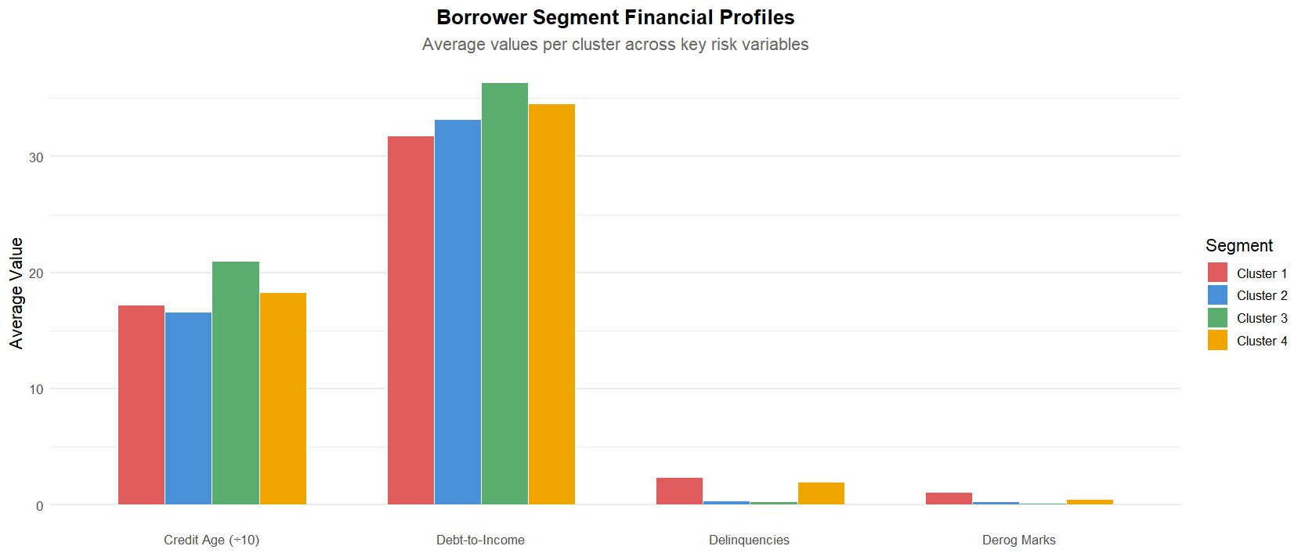
Figure 14. Borrower segment financial profiles - Cluster 1 (red) shows extreme delinquency and derogatory marks relative to all other segments. Cluster 3 (green) has the longest credit age and highest property values.
The profile chart indicates the differentiators of each segment. Cluster 1 (red) records delinquency and derogatory mark averages very high in comparison with the other three clusters, whereas its debt to income and age of credit are not noteworthy. Cluster 1 risk is purely behavioral. Cluster 3 (green) includes the longest credit history and property values, so it has the lowest default rate of 16.6 below average although it has the highest debt-income ratio. The elevated delinquency in Cluster 4 (orange) is in contrast to Cluster 2 (blue), which indicates a moderate but watch-list level of risk.

Cluster | Size | Default Rate | Avg DELINQ | Avg DEROG | Avg DEBTINC | Avg CLAGE | Avg Value | Segment
1 | 80 (1.9%) | 93.8% | 2.38 | 1.09 | 31.77 | 172 mo | $96,855 | Critical Risk
2 | 2,677 (64.2%) | 19.5% | 0.33 | 0.24 | 33.18 | 166 mo | $79,560 | Standard Borrowers
3 | 911 (21.8%) | 16.6% | 0.27 | 0.16 | 36.38 | 210 mo | $168,440 | Established Borrowers
4 | 500 (12.0%) | 16.0% | 1.93 | 0.47 | 34.52 | 183 mo | $93,083 | Emerging Risk
Table 7. Cluster financial profiles and segment labels - k=4, based on standardized financial profile variables.

Business Problem 3 is resolved. The bank's portfolio is not a single risk pool - it consists of four distinct borrower groups, each with a different financial profile. Cluster 1 makes up less than 2% of the borrowers but has a 93.8% default rate; therefore, denying loan approvals to individuals who fit this profile would eliminate a large share of charge-off losses while hardly affecting any overall decisions. Cluster 3 stands for the bank's most financially strong borrowers - experienced credit histories, high property values, and they deserve the most favorable treatment. Clusters 2 and 4 are in the middle of the portfolio, with Cluster 4 manifesting signs of deterioration leading to early warning indicators. Measuring what portion of new applications are like each cluster over time provides the bank with a preemptive indication of whether portfolio quality is changing, even before any of it appears in delinquency data.

10. Model Evaluation and Comparison

10.1 Classification
The 0.016 AUC gap sounds important, but it really is not. What the bank cannot afford is a model that goes silent when a denied applicant wants to know why. Random Forest does exactly that. It reads the portfolio well, but cannot justify one specific decision, which is exactly what ECOA requires. Logistic Regression does not have that problem. Its coefficients explain each decision automatically. Combined with 75.1% sensitivity, three out of four future defaulters were called before being approved, making it the obvious production choice.
The sensitivity of the Random Forest of 52.5 percent would allow almost half of the future charge-offs to pass through this, which is directly against the aim of Business Problem 1 of minimizing unnecessary losses. It is involved in this area, in the capacity of monitoring, checking that the same predictors are dominant as more applications are made as time goes on. Decision Tree tracks on each metric but can do only one thing that none of the other models can do - the step-by-step structure of the decision tree provides a loan officer with a plain-language foundation on which to compose denial notices that could be comprehended by a borrower.

10.2 Regression
Gradient Boosting won on every metric and held that advantage across all 30 cross-validation rounds. Linear Regression remains useful alongside it - its coefficients name which financial variables drive debt load higher, thus equipping the bank with an interpretable rationale why one incomplete application could be considered riskier than another. The common conclusion among the three models is, in fact, more important than the individual winner. The 0.09-0.19 range of R-squared simply points to a data limitation rather than a failure of the model - income is missing from the data set, and the debt-to-income ratio cannot be reasonably calculated without it. These results are sufficiently accurate to serve as a trigger for requesting that applicants provide additional documentation when the predicted ratio appears concerning. However, they are not trustworthy enough to serve as a replacement for the income that a borrower actually declares and considering them as such would expose the bank to unfair lending accusations that it would not be able to justify.

10.3 Clustering
The four-cluster solution is validated statistically by the highest silhouette score among all options tested, and operationally by Cluster 1's 93.8% default rate - identified using only application-time variables, with no knowledge of which loans actually defaulted. That second point is the more meaningful one: the clustering confirmed the same high-risk population the classification model finds, through an entirely independent method.
What makes this result genuinely valuable beyond the classification framework is timing. A classification model has to wait - it learns from loans that have already defaulted, which means the danger has already materialized by the time the signal exists. The borrower segments work differently. They are built from application characteristics alone, which means the bank can use them on day one with any new applicant. Watching how the mix of incoming applications shifts across the four segments from one quarter to the next gives the bank an early warning system - a way to see the portfolio drifting toward riskier borrowers while there is still time to act, rather than after the charge-offs have already landed. That's the gap this project was asked to close, and the clustering output closes it.

11. Observations and Conclusions

11.1 Key Findings
The biggest finding in this project is not what borrowers provided - it is what they chose to withhold. DEBTINC_MISSING and VALUE_MISSING ranked as the top two predictors, ahead of every financial variable in the dataset. The decision tree checked DEBTINC_MISSING before looking at a single dollar figure. The NMAR analysis caught this before any model was built. Three separate methods landed at the same conclusion. Borrowers who withheld their debt-to-income ratio defaulted at 66.1% - 6.5 times the 10.1% rate among those who disclosed it. The bank currently has no structured way to act on that signal. This project gives it one.
Delinquency history draws a line that the data justifies on its own. Every borrower with six or more delinquent credit lines defaulted - 100%, no exceptions, across 5,953 records. That is a direct observation, not a model output, and it is enough to support a hard screening rule without anything else backing it up.
On the held-out test set, Logistic Regression achieved an AUC of 0.900 against Random Forest's 0.916 - a gap of just 0.016. That difference is negligible in practice. What is not negligible is that Random Forest cannot produce the variable-level denial reasons ECOA requires, and Logistic Regression can. When compliance is non-negotiable, interpretability and performance point to the same model.
Gradient Boosting explained 19.4% of DEBTINC variance with a mean error of 5.56 percentage points. The modest R-squared reflects a genuine data limitation; income is simply not in this dataset. What the model does reliably is flag which incomplete applications carry a concerning debt profile, which is exactly what it was built to do.
Cluster 1 covers just 1.9% of borrowers but carries a 93.8% default rate, identified using only application-time information with no knowledge of actual loan outcomes. Cluster 3 sits at the other end - longest credit histories, highest property values, and below-average default rate. Neither group shows up in portfolio averages. The segmentation makes both visible.

Recommendations
Business Problem 1 (Default Risk): Deploy Logistic Regression as the primary scoring model. With a sensitivity of 75.1% it picks up on three out of four future defaulters before their loan is approved and its coefficients can be used as is for adverse actions under ECOA. The Decision Tree can help generate denial reasons in easy-to-understand language that loan officers can deliver without the need for interpretation. Run Random Forest in parallel to monitor whether the same predictors stay dominant as the approved population evolves under the new framework.

Business Problem 2 (Missing Debt-to-Income): Deploy Gradient Boosting to score every incomplete application. If the model's imputed DEBTINC exceeds an acceptable threshold, hold the application for additional documentation rather than approving or rejecting it without enough information. The model's output is only a risk indicator - it never substitutes for what the applicant actually provides.

Business Problem 3 (Portfolio Monitoring): Check the portion of new originations that each quarter is coming from each of the four borrower segments. A rising proportion of Cluster 1 - profile applications signals portfolio quality getting worse before it shows up in delinquency rates or charge-off data. This directly addresses the monitoring gap identified in Section 2.

Two rules that require no model to implement: Any application with DEBTINC missing should receive automatic elevated scrutiny - those who don't disclose the ratio have been found to default 6.5 times more than those who do, making non-disclosure even more discriminating than most financial variables in the dataset. Any applicant with six or more delinquent credit lines should be submitted for mandatory senior review. Not one borrower with that profile repaid their loan across 5,953 records.

Model maintenance: These models were trained on loans approved under a partially discretionary process. As the scoring framework changes who gets approved, the patterns learned from the old population may not hold the same strength. Track performance on each new cohort and schedule retraining before any drift starts affecting decisions.

This framework gives the bank something the current process cannot - a way to make credit decisions that are consistent, explainable, and grounded in evidence rather than individual judgment. Every finding came from the data. Every model was tested on records it never saw during development. Every recommendation was shaped by the requirement that decisions must be justifiable to applicants and regulators alike. The bank does not have to choose between managing risk and defending its decisions. This framework does both.

