unit detailed design
SAP ECC/6.0
GLIMS INTERFACE
PROCESS COA DATA REPLY

Table of contents

1. FORMAL DETAILS 3
1.1. Development / Document details 3
1.2. Roles and responsibilities 4
2. Functional Description 5
2.1. Overview about main and sub functions 5
2.2. Detailed description 5
2.3. Translation 5
2.4. High level test scenario 5
3. Unit INPUT / OUTPUT & Settings 6
4. Standards 6
4.1. Usage of ZXX_DEVELOPMENTS TABLE 6
5. Security and access 6
6. RelatIonships with other uDD 7
7. Implementation and development specifications 7
7.1. Summary 7
7.2. System Components 7
7.3. Data Description 10
7.3.1. Input 10
7.3.2. Selection Parameters 10
7.3.3. Data Source 11
7.3.4. Data Selection Criteria 12
7.3.5. Interfaces 12
7.4. Processing and Algorithm 12
7.4.1. Process Map 13
7.4.2. Processing logic 14
7.4.3. Unit or Sub-Routine Triggering 17
7.4.4. Output 18
7.5. Translation 18
7.6. Error handling 18
7.7. Technical Constraints 18
7.8. Performance, Volume and Frequency 19
7.9. Usage of ZXX_DEVELOPMENTS TABLE 19
7.10. Authorization Considerations 19
7.11. Help Functionality 19
8. References 19
9. Appendix 19
Appendix 1: Revision Log 20

FORMAL DETAILS

Development / Document details

Document title | UDD-SAPECC-QM-1609-04
UDD Creation date | 25-May-2022
Development type | Enhancement
Function | S-FU-300-QMIDI

Roles and responsibilities

UDD

 | FUNCTION | NAME  (plus User ID)
AUTHOR (FC) | Functional | Neeraj Singh(E630399)
CO-AUTHOR (DEV) | Developer | Christian Khouri (E631475)
MODULE OWNER | Guardian | Maciej Otreba (E620884)
REVIEWED BY (CO) | Reviewer | Shamik Das (E633074)

CRR
 | FUNCTION | NAME  (plus User ID)
AUTHOR (Peer Review) | Reviewer | Shamik Das (E633074)
CO-AUTHOR (Expert Review) | Can be N/A for low and medium complexity developments

Functional Description
Context : Print a CoA for an inspection lot from SAP. (UDD-SAPECC-QM-1412)
SAP automatically receives the characteristic data to be printed on the CoA from GLIMS for all applied grades, including the internal spec aka Super Spec. The master data which determines which inspection results need to be printed on the CoA are maintained in GLIMS.
A CoA Data Request is sent to GLIMS which is returned as a CoA Data Reply.
This document concerns the design of the inbound flow :
Process a CoA Data Reply from GLIMS
Scope :
- Organizational Bulle and Braine plants
- Materials in principle any FG, BULK, API or RM that is inspected in SAP

{Start CRQ 246287
Report to convert xml files placed in AL11 to SAP inbound idocs. This is relevant for GLIMS and OptiMU interface. The AL11 folder path, system name and port details should be controlled via development table. This report will be handled via background job.
End of CRQ 246287}

Start CRQ 322074
It is required fix the background job Z_COA_GLIMS_IB_XML_IDOC_PROC failure when the incoming GLIMS XML file stuck in the AL11 file folder ZDIR_INTERFACES /interfaces/glims. The received XML details processed by the ZQM_WE16_JOB program variant & later the idoc in status 64 is processed to 53 by RBDAPP01 program eventually the data is updated in ZQM_LIMS_COA_DAT after this processing.
Sometimes the XML file is stuck AL11 file path which result in job Z_COA_GLIMS_IB_XML_IDOC_PROC failure due to duplicate file in the folder path. The change is requested to fix the issue. (Refer - Note 18273 - DELETE DATASET returns SY-SUBRC = 4). If the file is processed by the program and if it is stuck in the AL11 file path, it will skip that file and process the other file which are in the queue. The file which is stuck can be seen in table EDFI2. If the xml format is in wrong, then it will lead to job failure.
A new user status YCOA is configured to update in IL, when the GLIMS analytical result received in the ZQM_LIMS_COA_DAT table. YCOA user status should be updated in the inspection lot.
Also, an Inbound idoc for the message type ZQMCOAREPLAY which is created for the COA data result xml processed from GLIMS should be update in inspection lot service of object. - relationship.
End CRQ 322074

Overview about main and sub functions

Process a CoA Data Reply
- When a CoA Data Reply is returned from GLIMS, we import it into a holding table from which the CoA can be created in UDD 1412
- The iDoc in question contains quality characteristics, specifications and results for all the grades that were applied in GLIMS for the requested inspection lot (including the internal spec aka Super Spec)
- It contains references to
  - the inspection lot (plant, matl, batch) for which the CoA Data was requested
  - the inspection lot number from GLIMS
Start of CRQ000010003494
CoA Data reply will have additional data of below fields –
- Test Type (U_TEST_TYPE is 50 Char Long )
- Stage description (STAGE_DESC Stage description is a 254 Char long field)
- Above mentioned fields to be added in Idoc (Basic type ZQM_COAREPLY01)
Program to update table ZQM_LIMS_COA_DAT need to be changed to
- Read new Idoc structure (with 2 additional fields)
- Update 2 new fields ( test type and Stage description ) in table ZQM_LIMS_COA_DAT
- Consider SAP Inspection Lot number and GLIMS Lot number for updating table ZQM_LIMS_COA_DAT
End of CRQ00001000

Detailed description

Process a CoA Data Reply
This interface requires no user interaction : it is executed automatically in the background.
Processing mode : batch
Frequency : for every CoA Data Request sent from SAP (see UDD 1608)
The data from the iDoc is stored in table ZQM_LIMS_COA_DATA

Flow
1. Read the iDoc

2. Delete any lines in ZQM_LIMS_COA_DATA
Where COA_INSP_LOT = iDoc CoA Inspection Lot

3. For every LINE in iDoc COA Data Reply, add a line
to table ZQM_LIMS_COA_DATA

Start of CRQ000010003494

XML Structure of Basic Type ZQM_COAREPLY01 is changed. 2 new field added in the inbound xml for ZQM_COAREPLY01.
- U_TEST_TYPE ( 50 Char)
- STAGE_DESC ( 254 char)
Revised Xml Structure as below;

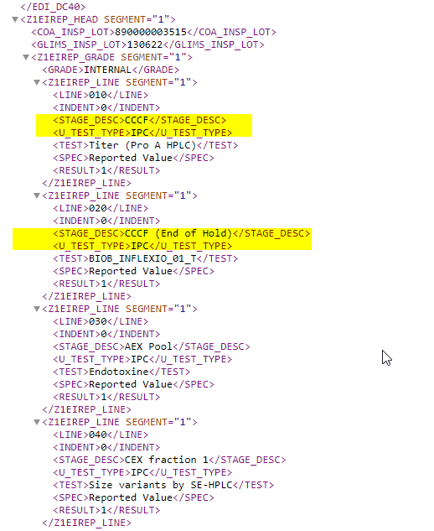

- Idoc Structure updated with TEST TYPE and STAGE DESC
Segment |  |  | Field
Z1EIREP_HEAD |  |  | COA_INSP_LOT
 |  |  | GLIMS_INSP_LOT
 | Z1EIREP_GRADE |  | GRADE
 |  | Z1EIREP_LINE | LINE
 |  |  | INDENT
 |  |  | TESTGROUP
 |  |  | TEST
 |  |  | U_TEST_TYPE
 |  |  | STAGE_DESC
 |  |  | SPEC
 |  |  | RESULT
 |  |  | METHOD

- Delete any lines in ZQM_LIMS_COA_DATA, Where COA_INSP_LOT = IDoc CoA Inspection Lot and ZGLIMS_INSP_LOT = Idoc ZGLIMS_INSP_LOT

End of CRQ000010003494

Translation
N/A

High level test scenario
- Process an inbound iDoC Coa Data Reply
  - Verify the CoA data table is correctly populated

Start of CRQ000010003494

- Verify CoA data table populated correctly with Test Type and Stage description field values
End of CRQ000010003494

Unit INPUT / OUTPUT & Settings
N/A

Process a CoA Reply

Input
iDoc CoA Data Reply
CoA Inspection lot NUMC 12
GLIMS Inspection lot NUMC 12
GRADE CHAR 16
LINES
LINE NUMC 3
INDENT NUMC 3
TESTGROUP CHAR 100
TEST CHAR 100
SPEC CHAR 400
RESULT CHAR 100
METHOD CHAR 100
…
…

GRADE External or internal specification from Labware
LINE Sort sequence of line to be printed
INDENT meaning :
0 print TEST Bold, SPEC, RESULT + newline
1 Print TESTGROUP Bold + new line
2 Tab Print TEST not Bold, SPEC, RESULT + new line

Start of CRQ000010003494

CoA Inspection lot NUMC 12
GLIMS Inspection lot NUMC 12
GRADE CHAR 16
STAGE_DESC CHAR 254
LINES
LINE NUMC 3
INDENT NUMC 3
TESTGROUP CHAR 100
TEST CHAR 100
TEST_TYPE CHAR 50
SPEC CHAR 400
RESULT CHAR 100
METHOD CHAR 100

End of CRQ000010003494

Output
Table ZQM_LIMS_COA_DATA (see UDD 0986)

Standards
SOP-011365

Usage of ZXX_DEVELOPMENTS TABLE
UDD | Parameter name | Parameter 1 | Parameter 2 | Long Parameter | Long description
1609 | PORT_RELATED_TO_INTERFACE_DIR | GLIMS_IB | DE1 | /import/sapbatchde1V2/TIBCO/glims/Inbounds | PORT and AL11 folder for GLIMS in DE1 system
1609 | PORT_RELATED_TO_INTERFACE_DIR | GLIMS_IB | AE1 | /import/sapbatchae1V2/TIBCO/glims/Inbounds | PORT and AL11 folder for GLIMS in AE1 system
1609 | PORT_RELATED_TO_INTERFACE_DIR | GLIMS_IB | PE1 | /import/sapbatchpe1V2/TIBCO/glims/Inbounds | PORT and AL11 folder for GLIMS in PE1 system
1609 | PORT_RELATED_TO_INTERFACE_DIR | MET_EQ_IB | DE1 |  | PORT and AL11 folder for METROLOGY equipment in DE1 system
1609 | PORT_RELATED_TO_INTERFACE_DIR | MET_EQ_IB | AE1 |  | PORT and AL11 folder for METROLOGY Equipment in AE1 system
1609 | PORT_RELATED_TO_INTERFACE_DIR | MET_EQ_IB | PE1 |  | PORT and AL11 folder for METROLOGY Equipment in PE1 system
1609 | PORT_RELATED_TO_INTERFACE_DIR | MET_WO_IB | DE1 |  | PORT and AL11 folder for METROLOGY Work Order in DE1 system
1609 | PORT_RELATED_TO_INTERFACE_DIR | MET_WO_IB | AE1 |  | PORT and AL11 folder for METROLOGY Work Order in AE1 system
1609 | PORT_RELATED_TO_INTERFACE_DIR | MET_WO_IB | PE1 |  | PORT and AL11 folder for METROLOGY Work Order in PE1 system

Security and access
N/A

RelatIonships with other uDD
This UDD is related to
- it’s interface counterpart UDD 1608 GLIMS Interface : Create CoA Data Request
- UDD 0986 QM Z Tables (ZQM_LIMS_COA_DATA)

Implementation and development specifications

Summary

System Components
R/3 Version: | SAP ECC 6.0
Source System: | DE1/500
Legacy System: | N/A

App Components & Objects | Name | Existing | New | Upgrade Implications
Module / Package | ZUQM | Y
Report | ZQM_WE16_JOB | Y
Function Group | ZQM_COA_DATA_REPLAY | Y
Structure | Z1EIREP_GRADE  Z1EIREP_HEAD  Z1EIREP_LINE | Y  Y  Y |  | CRQ10003494  CRQ10003494
Basic type | ZQM_COAREPLY01 | Y |  | CRQ10003494
Function Module | Z_QM_1609_PROC_COA_DATA_REPLY | Y |  | CRQ10003494
Include | LZQM_COA_DATA_REPLAYF01  LZQM_COA_DATA_REPLAYTOP  SAPLZQM_COA_DATA_REPLAY | Y  Y  Y

Data Description
N/A

Input
N/A

Selection Parameters
- Report - ZQM_WE16_JOB

Data Source
N/A

Data Selection Criteria
N/A

Interfaces
N/A

Processing and Algorithm

Process Map
N/A

Processing logic
1. Read the IDOC and Delete any lines in ZQM_LIMS_COA_DATA Where COA_INSP_LOT = IDOC CoA Inspection Lot
2. For every LINE in IDOC COA Data Reply, add a line to table ZQM322_LIMS_COA_DATA

Report - ZQM_WE16_JOB
{ CRQ256287 – Start }
- Fetch the development table entries based on UDD = '1608', Step = '6' , Parametername = 'PORT_GLIMS_IB' into LT_DEV.
- Fetch the maintained development table entries for the UDD 1609 and fill the internal table LT_DEV.
- Read the table LT_DEV to get the port maintained for the given directory in the selection screen and the system ID.
{ CRQ256287 – End }
- Get the development table entry zzparameter1 into port(g_port).
Begin of Change CRQ322074
- Create a range table(LR_PATH) for the path given path LV_PATH.
- Get all the files which are processed but not deleted in the table EDFI2 for the given path LR_PATH into table LT_EDFI2.
End of Change CRQ322074
- Call FM to 'EPS2_GET_DIRECTORY_LISTING' importing parameters are selection screen = LV_DIR_NAME.
- Based on the FM sy-subrc value to pass error message.
- Loop all the files and process by calling FM EDI_DATA_INCOMING.
Begin of Change CRQ322074
- While looping check if the file is in table LT_EDFI2 with deletion Flag (DELETEFLAG) equal to ABAP_TRUE by passing file path G_PATH then skip the Processing of that file.
End of Change CRQ322074

Function module Z_QM_1609_PROC_COA_DATA_REPLY
Begin of Change CRQ322074
- Perform F_GET_DEV is called to get the development table entries.
- Get the status maintained in the development table at ZZPARAMETER2 with step = 2 and parameter name UPDATE_USER_STATUS_IL_YCOA into LV_STAT.
End of Change CRQ322074
- Loop all the IDOC data and table ZQM_LIMS_COA_DAT is updated with the details in the IDOC.
Begin of Change CRQ 10003494
- Updated 2 new fields in table ZQM_LIMS_COA_DAT(zstage_desc, ztest_type) with the data from IDOC
End of Change CRQ10003494
Begin of Change CRQ322074

- Check if the status LV_STAT is having value then create an object number LV_OBJNR for the inspection lot in the head segment of the IDOC(LS_SEG_HEAD-COA_INSP_LOT).
- FM I_CHANGE_STATUS is called to update the status of the inspection lot by passing object number LV_OBJNR and status to be changed LV_STAT.

Include LZQM_COA_DATA_REPLAYF01
- From F_GET_DEV, FM Z_QM_XXXX_DEV_GET_PARAMETER is called to get the development entries maintained for UDD 1609 into table GT_DEV.
End of Change CRQ322074

Unit or Sub-Routine Triggering
N/A

Output
N/A

Error handling
N/A

Technical Constraints
N/A

Performance, Volume and Frequency
N/A

Usage of ZXX_DEVELOPMENTS TABLE
{ CRQ246287 – Start }
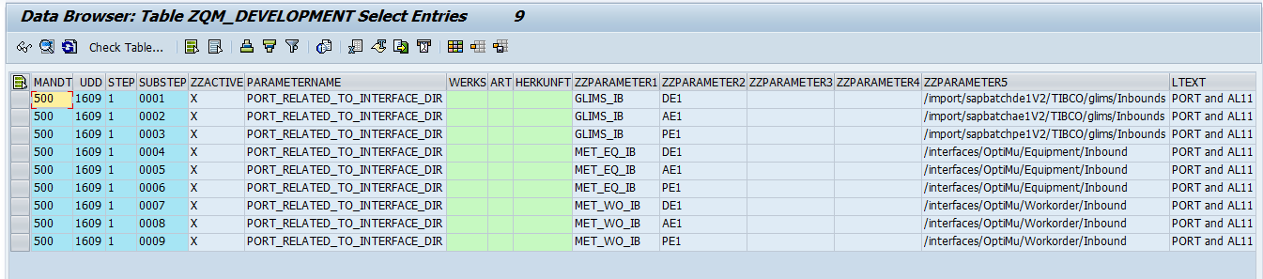
The port maintained with the parameter name PORT_RELATED_TO_INTERFACE_DIR corresponding to the maintained system related to the corresponding AL11 folder will be considered to create the inbound IDocs.
{ CRQ246287 – End }
Begin of Change CRQ322074
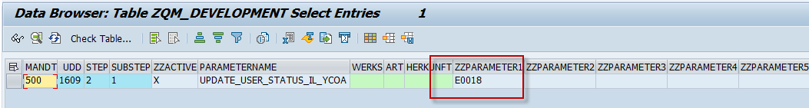
- The user status YCOA to be updated when the IDOC is processed to the Inspection lot.
- The user status YCOS(E0018) is maintained in the development table with parameter name UPDATE_USER_STATUS_IL_YCOA and step 2 at ZZPARAMETER2.
End of Change CRQ322074

Authorization Considerations
N/A

Code Review
Overall Review Status? | Accepted | X | Rejected

Comments or Recommendations:
SAP PE1: InfleXio (INFL_QM_42) - GLIMS Additional Fields mapping to SAP
CRQ000010003494

All the changes are OK and accepted.

References
- Project Framework Glossary – PFR-ISIT-1000
- SAP development standards SOP-011365

Appendix
- Revision Log

Appendix 1: Revision Log
DOCUMENT VERSION | DATE OF THE CHANGE | REASONS OF THE CHANGE | Transport Request
01 | 26-Jun-2016 | CoA Harmonization CRQ110605  Kernel release  Initial creation of functional specification by Vladimir Ploegaerts | DE1K973389/ DE1K977149
 | 30-Jun-2016 | UDD FS ready
 | 28-Oct-2017 | TS updated by E610641
02 | 8-Oct-2018 | Metrology: CRQ000000246287  SAP IDOC Instrument Processing | DE1K990645
 | 11-Oct-2018 | FS updated by E614860
 | 11-Oct-2018 | TS Updated by E608075
03 | 21-MAY-2020 | UCB_RUN  CRQ000000322074  SAP PE1-Rectify Job failure Z_COA_GLIMS_IB_XML_IDOC_PROC & new user status YCOA | DE1K999062  DE1K999027  DE1K998978
 | 16-07-2020 | FS Updated by E619164
 | 02-June-2020 | TS updated by E615966  (Meghana Siddappa)
 | 09-Jun-2020 | Formal Adjustments by E610641
04 | 25-MAY-2022 | SAP PE1: InfleXio (INFL_QM_42) - GLIMS Additional Fields mapping to SAP  CRQ000010003494  SAP PE1: InfleXio (INFL_QM_42) - GLIMS Additional Fields mapping to SAP | DE1K9A07RV
 | 26-May-2022 | FS Updated by E630399
 | 20-Jun-2022 | TS Updated by E631475

