unit detailed design
SAP ECC / 6.0
System performance during goods RECIPT, good issue and tr confirmation

Table of contents

1. FORMAL DETAILS 3
1.1. Development / Document details 3
1.2. Roles and responsibilities 4
2. Functional Description 5
2.1. Overview about main and sub functions 5
2.2. Detailed description 5
2.3. Translation 5
2.4. High level test scenario 5
3. Unit INPUT / OUTPUT & Settings 5
4. Standards 5
4.1. Usage of ZXX_DEVELOPMENTS TABLE 5
5. Security and access 6
6. RelatIonships with other uDD 7
7. Implementation and development specifications 7
7.1. Summary 7
7.2. System Components 7
7.3. Data Description 7
7.3.1. Input 7
7.3.2. Selection Parameters 7
7.3.3. Data Source 7
7.3.4. Data Selection Criteria 7
7.3.5. Interfaces 7
7.4. Processing and Algorithm 8
7.4.1. Process Map 8
7.4.2. Processing logic 8
7.4.3. Unit or Sub-Routine Triggering 8
7.4.4. Output 8
7.5. Translation 8
7.6. Error handling 8
7.7. Technical Constraints 8
7.8. Performance, Volume and Frequency 9
7.9. Usage of ZXX_DEVELOPMENTS TABLE 9
7.10. Authorization Considerations 9
7.11. Help Functionality 9
8. References 9
9. Appendix 9
Appendix 1: Revision Log 10

FORMAL DETAILS

Development / Document details

Document title | UDD-SAP-ECC-WM-1690-01
UDD Creation date | 15-Jun-2017
Development type | Creation of secondary index for SAP standard table

Roles and responsibilities

 | FUNCTION | NAME  (plus User ID)
AUTHOR (FC) | Functional Consultant | Avinash Khambalkar
CO-AUTHOR (DEV) | Developer | Swarup Banerjee  ( E156103 )
MODULE OWNER | WM-IM Guardian | Alain Moreels
REVIEWED BY (CO) | Reviewer | Jayaram Mahadevan

Functional Description
The purpose of this UDD is to fix the system performance (slowness issue) occurring in various transactions of goods receipt, goods issue and transfer order confirmation.

Overview about main and sub functions
The system performance issue is because of the standard program SAPLV05I which is taking long time to execute a ‘Delete’ operation on the standard table VLPMA based on the delivery number (VBELN).

Detailed description
In the inbound delivery when user is doing packing and then clicked on “Save” button system is taking long time around 30 mins. to save the delivery. When try to change delivery user is getting error message such as “This delivery (180321700) is currently being processed by another user (E150459)” Message no. VL046.
To be able to fix this issue, as per the recommendation of OSS note 1878333, to have a secondary index created on the table VLPMA with the fields MANDT and VBELN.

Translation
NA

High level test scenario
Goods receipt against Purchase Order
- Create standard Purchase Order
- Release Purchase Order
- Create inbound delivery using VL32N against Purchase Order, assign batch and MPN material under “UCB Data” tab and “Save” delivery.
- Run VL32N and do the packing and “Save” delivery.
- Run VL32N after few seconds and fill the delivery number and click “Enter” and check
system should not display error message “This delivery is currently processed by another user”
- Run VL32N and post the delivery.

Unit INPUT / OUTPUT & Settings
NA

Standards
SAP development standards IT-WIN-PE-225
SAP development standards SOP-011365

Usage of ZXX_DEVELOPMENTS TABLE
NA.

Security and access
NA

RelatIonships with other uDD
NA

Implementation and development specifications

Summary
NA

System Components

R/3 Version: | ECC 6.0
Source System: | DE1 500
Legacy System: | NA

App Components & Objects | Name | Existing | New | Upgrade Implications
Module/SubModule Area | WM | Y
Development Class | ZUWM | Y
Secondary Index | VLPMA~ZVL |  | Y

Data Description
NA

Input
NA

Selection Parameters
NA

Data Source
NA

Data Selection Criteria
NA

Interfaces
NA

Processing and Algorithm

Process Map
NA

Processing logic
A secondary index VLPMA~ZVL (on VBELN) is created for the SAP table VLPMA.

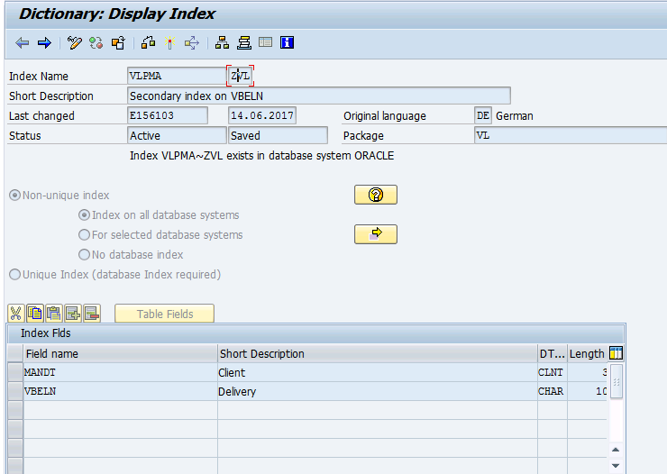

Unit or Sub-Routine Triggering
NA

Output
NA

Translation
NA

Error handling
NA

Technical Constraints
NA

Performance, Volume and Frequency
NA

Usage of ZXX_DEVELOPMENTS TABLE
NA

Authorization Considerations
NA

Help Functionality
NA

References
- SAP-ABAP IV Development Conventions, sop-ai-011365
- UCB Glossary, gov-000314

Appendix
- Revision Log

Appendix 1: Revision Log

DOCUMENT VERSION | DATE OF THE CHANGE | REASONS OF THE CHANGE | Transport Request
01 | 15-Jun-2017 | UCB_RUN  INC000000899997 & INC00000088365_Slowness issue  CRQ000000175469 - System performance issue in inbound delivery - VL32N | DE1K980898
 | 16-Jun-2017 | FS added by E150459
 | 19-Jun-2017 | TS Updated by E156103

