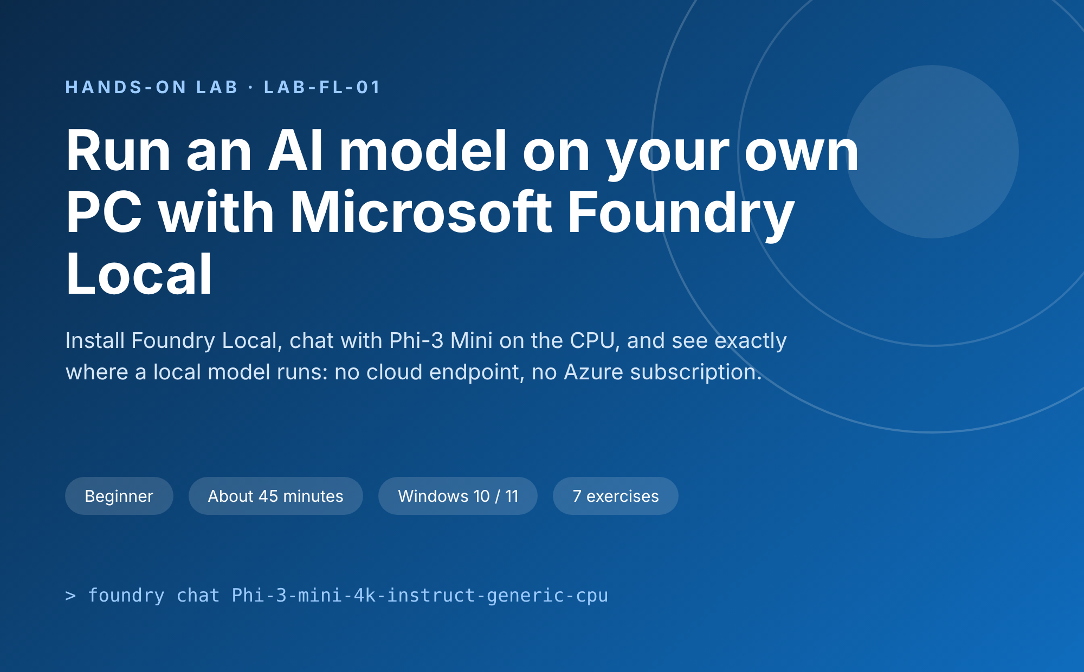
Lab details
Item | Detail
Lab ID | LAB-FL-01
Level | Beginner: no prior AI or cloud experience needed
Duration | About 45 minutes (plus model download time)
Platform | Windows 10 or 11 with PowerShell or Windows Terminal
Tools | Microsoft Foundry Local CLI (version 0.11.0 used in this lab)
Model | Phi-3-mini-4k-instruct, CPU variant (2.5 GB)
Internet | Needed only to install Foundry Local and download the model
Cost | Free: no Azure subscription or cloud AI endpoint required
Lab author: Shruti Sinha · Version 1.0 · October 2026

1. Lab overview
In this lab you install Microsoft Foundry Local, download a small language model and chat with it entirely on your own Windows computer. Nothing you type is sent to a cloud AI service: the model runs on your CPU, and the internet is used only to install the tool and download the model once.
You will work in the command line first. Once this works, the same local model can be called from a Python application or a web dashboard in a follow-on lab.

Learning objectives
- Install and verify the Foundry Local command-line tool
- Explore the local model catalog and understand model variants
- Run Phi-3 Mini on the CPU and hold a chat with it
- Recognise a hallucination and explain why small local models produce them
- Inspect the model cache and the local server that Foundry Local runs

Prerequisites
- A Windows 10 or 11 computer where you can install software
- winget (Windows Package Manager), included in current Windows versions
- At least 3 GB of free disk space for the Phi-3 Mini CPU model; larger models need more
- An internet connection for the install and the first model download
- Basic familiarity with opening PowerShell or Windows Terminal

Key concepts
Term | What it means in this lab
Foundry Local | A Microsoft tool that downloads AI models and runs them on your own device, with a local server and a command-line interface
Small language model (SLM) | A compact model such as Phi-3 Mini that is small enough to run on a laptop CPU
Model alias | The friendly name in the catalog, for example phi-3-mini-4k
Model variant | A build of the model for specific hardware, for example Phi-3-mini-4k-instruct-generic-cpu
Execution provider | The ONNX Runtime engine that runs the model on CPU, GPU (WebGPU) or Intel hardware (OpenVINO)
Model cache | The folder on disk where downloaded models are kept so later runs start without downloading
Local endpoint | The address http://127.0.0.1:<port> where the Foundry Local server listens on your PC

2. Architecture: what runs where
Everything in the blue box runs on your computer. The only external connection is the one-time download of a model from the Foundry catalog.
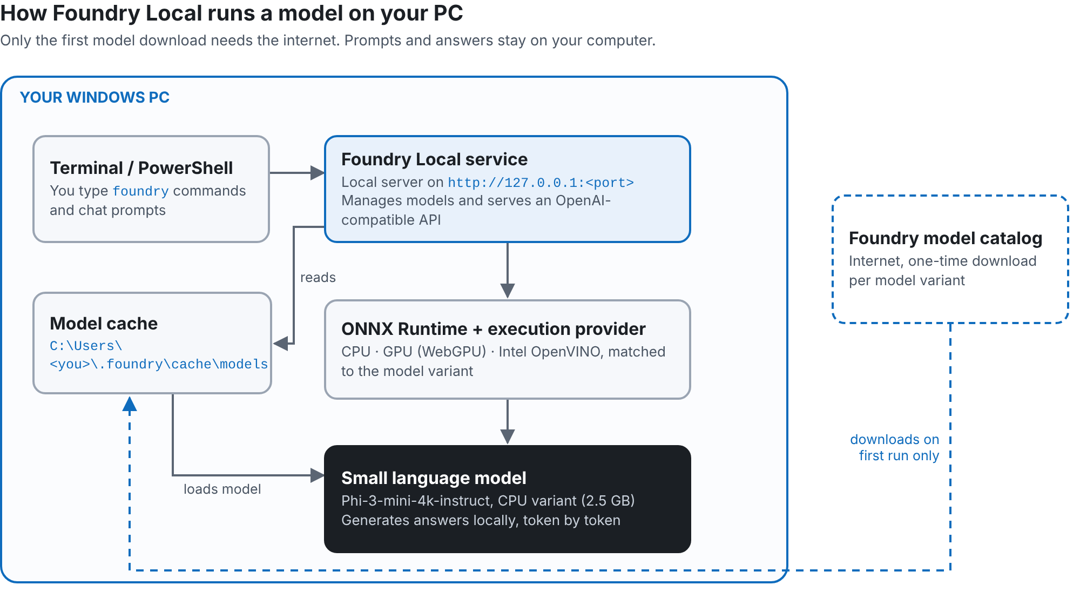
Figure 1. Foundry Local components on a Windows PC

How the parts work together
- Terminal / PowerShell. You type foundry commands here, and later your chat prompts.
- Foundry Local service. A local server that the CLI starts automatically. It manages models and exposes an OpenAI-compatible API on 127.0.0.1.
- Model cache. Downloaded models are stored in your user profile, so each model is downloaded only once.
- ONNX Runtime + execution provider. Runs the model on the hardware that matches the variant you chose: CPU, GPU or Intel OpenVINO.
- Small language model. Phi-3 Mini generates the answer token by token, locally.
NOTE
Because inference happens on your device, there is no per-token cloud cost and prompts stay private. The trade-off is that a small local model is less capable than large cloud models such as GPT-5.

Lab flow
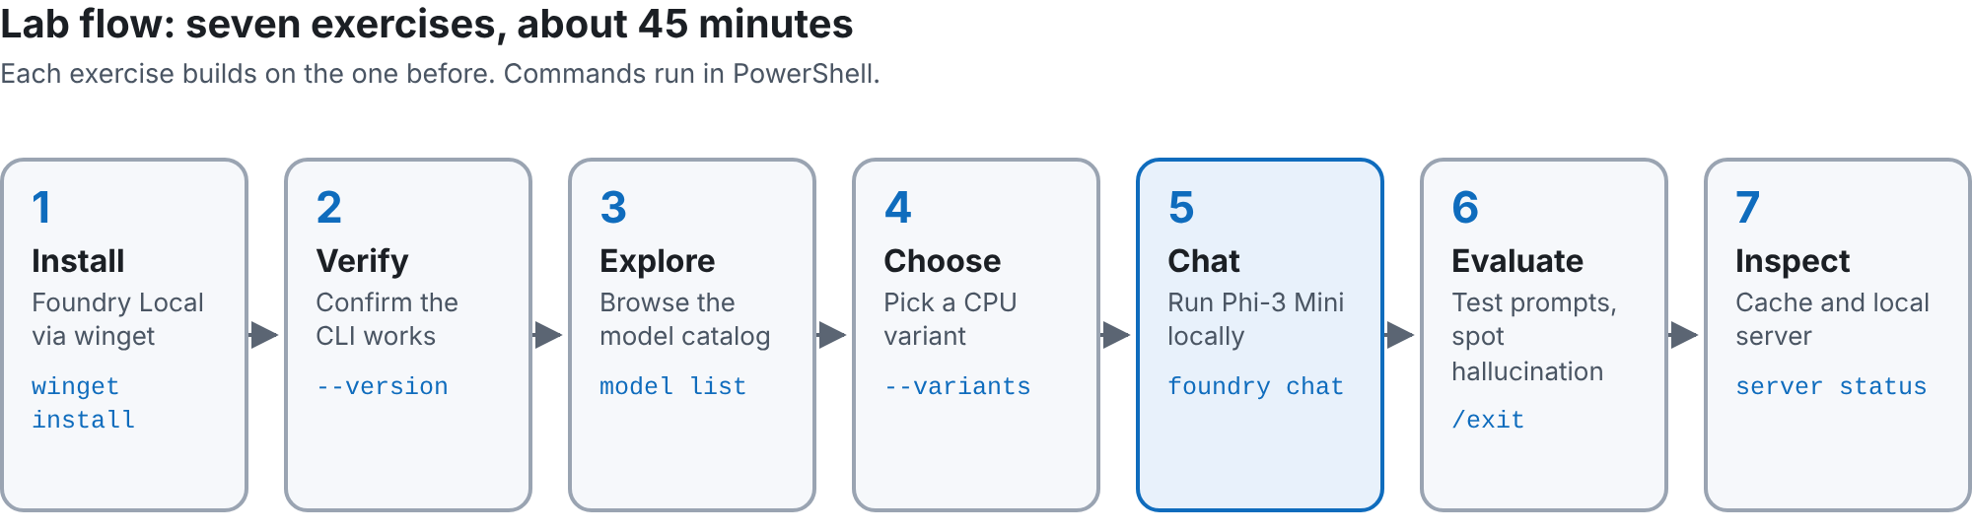
Figure 2. The seven exercises in this lab

Exercise 1 · Install Foundry Local
Goal: install the Foundry Local command-line tool with the Windows Package Manager.
- Open Windows Terminal or PowerShell.
- Run the following command:
PS> winget install Microsoft.FoundryLocal
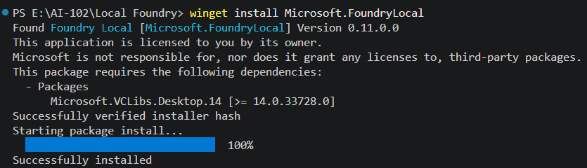
Figure 3. winget installs Foundry Local 0.11.0 and its dependency
EXPECTED RESULT
The installer finishes with Successfully installed.

WHAT JUST HAPPENED
winget found the Foundry Local package, installed its dependency (Microsoft.VCLibs) and added the foundry command to your system.

Exercise 2 · Verify the installation
Goal: confirm that the foundry command is available.
- Close PowerShell and open it again, so it picks up the new command.
- Run:
PS> foundry --version
Figure 4. The installed version is shown
EXPECTED RESULT
A version number such as 0.11.0 appears.

WARNING
Type two hyphens: --version. Word and some editors turn -- into a single dash (–), which the command will not recognise. Copy commands as plain text.

Exercise 3 · Explore the model catalog
Goal: see which models Foundry Local can run on your computer.
PS> foundry model list
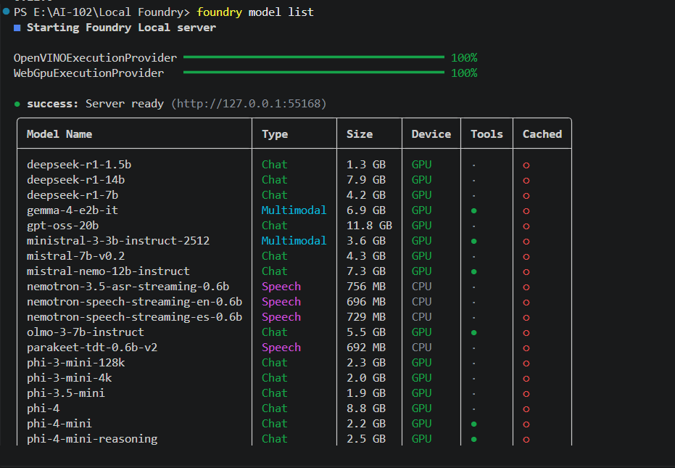
Figure 5. First run starts the local server and lists the catalog
WHAT JUST HAPPENED
The first command started the Foundry Local server on a local address and downloaded the execution providers it needs (OpenVINO and WebGPU here). It then listed the models in the catalog.

Reading the catalog
Column | Meaning
Model Name | The model alias, for example phi-3-mini-4k
Type | Chat, Multimodal (text and images) or Speech
Size | Download size of the default variant
Device | Hardware the default variant runs on (CPU or GPU)
Tools | A dot means the model supports tool (function) calling
Cached | A filled dot means the model is already downloaded

Exercise 4 · Choose a CPU model variant
Goal: list every hardware variant of the chat models and pick one that runs on any laptop CPU.
PS> foundry model list --variants --type chat
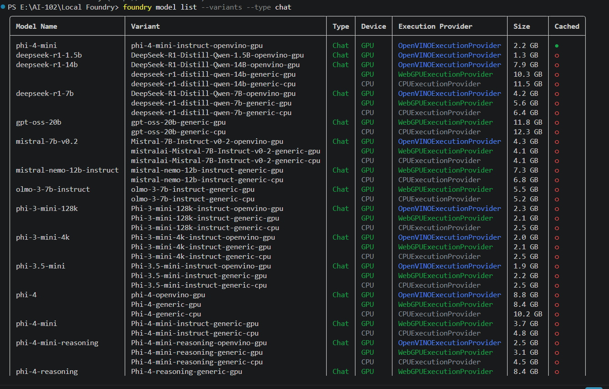
Figure 6. Each model comes in several variants for different hardware

How to read a variant name
Variant suffix | Runs on | Execution provider
-openvino-gpu | Intel GPUs | OpenVINOExecutionProvider
-generic-gpu | Most GPUs | WebGPUExecutionProvider
-generic-cpu | Any CPU | CPUExecutionProvider

This lab uses Phi-3-mini-4k-instruct-generic-cpu (2.5 GB). The CPU variant works on any laptop without special GPU drivers. It answers more slowly than a GPU variant, but it is the most reliable starting point.
TIP
Copy the variant ID exactly as shown in your list, including capital letters. If phi-4-mini has a CPU variant on your machine (Phi-4-mini-instruct-generic-cpu), you can use it instead.

Exercise 5 · Chat with Phi-3 Mini on the CPU
Goal: download the model, load it and hold a conversation, all on your PC.
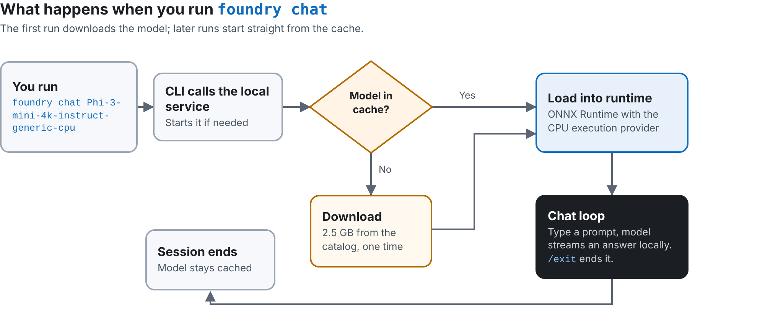
Figure 7. What happens when you run foundry chat
- Start a chat with the CPU variant:
PS> foundry chat Phi-3-mini-4k-instruct-generic-cpu
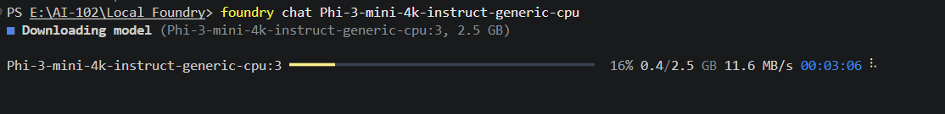
Figure 8. The first run downloads the 2.5 GB model
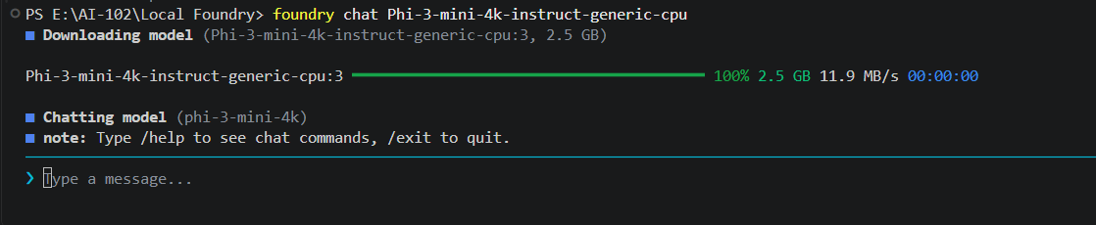
Figure 9. Download complete; the chat prompt appears
- At the prompt, ask a general question:
Prompt Explain cloud computing in simple words.
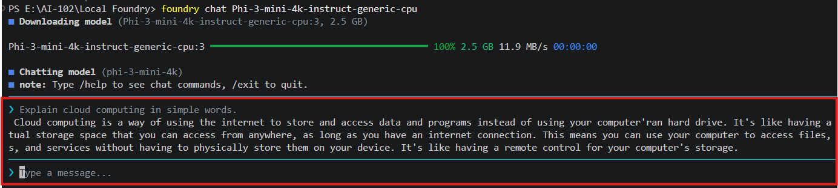
Figure 10. The model answers locally
- Ask for some code:
Prompt Write a Python program to check whether a number is even or odd.
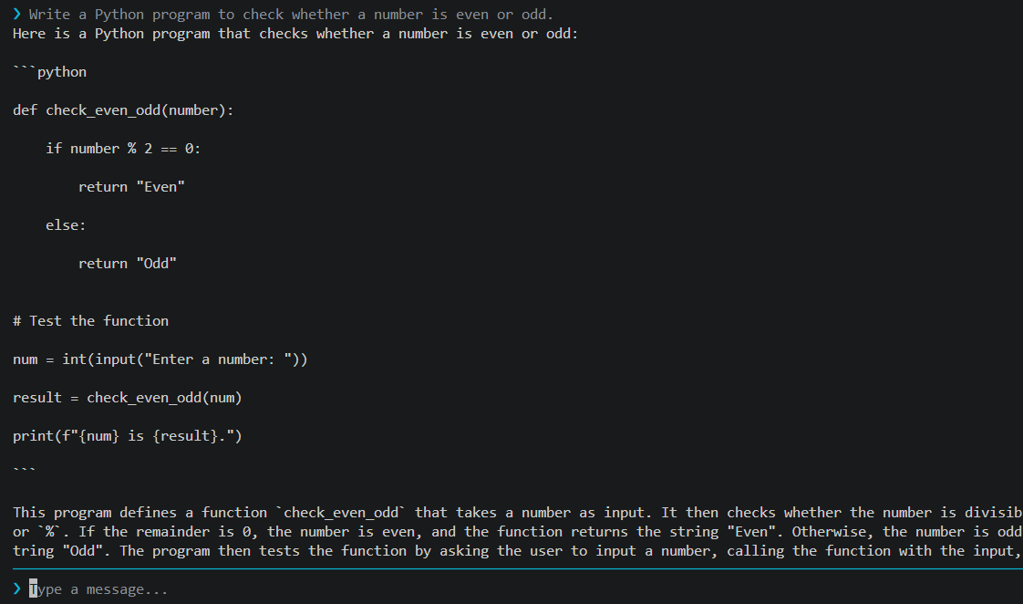
Figure 11. A correct, working Python answer
EXPECTED RESULT
Both answers are generated on your computer. Watch Task Manager while the model answers: CPU usage rises because the model runs locally.

Exercise 6 · Evaluate the answers and spot a hallucination
Goal: see the limits of a small local model by asking about something it cannot know.
- Ask about a specific person:
Prompt Who is Bipeen Sinha, AIML expert?
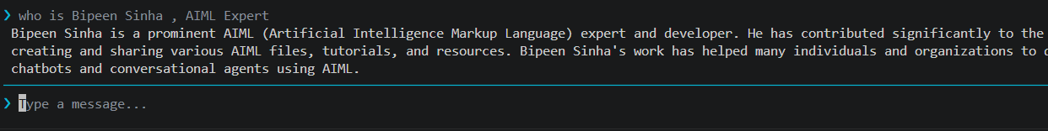
Figure 12. A confident but unreliable answer

What went wrong
The model read AIML as *Artificial Intelligence Markup Language* instead of AI/ML, then produced details that sound plausible but that it cannot verify. This is a hallucination: the model predicts likely-sounding text rather than looking anything up.
Why it happens | How to reduce it
Small model with limited knowledge | Use a larger model for open-ended factual questions
Fixed training data, no internet access | Ground answers in trusted documents (retrieval-augmented generation)
Ambiguous terms such as "AIML" | Write precise prompts and give context
Models are trained to answer, not to say "I don’t know" | Instruct the model to admit uncertainty and to cite sources
- End the chat session:
Prompt /exit
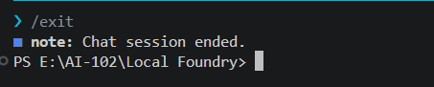
Figure 13. The chat session ends; the model stays cached
NOTE
Never treat a local model’s answer about people, prices or recent events as fact without checking a trusted source.

Exercise 7 · Inspect the cache and the local server
Goal: confirm that the model is stored and served from your own computer.
- List the cached models:
PS> foundry cache ls
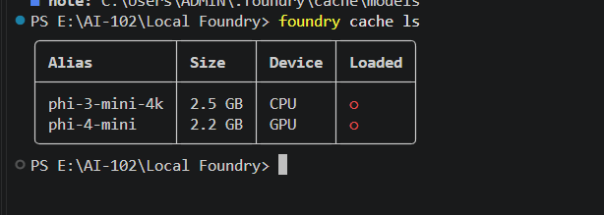
Figure 14. Two models are cached on this PC
- Show where the cache lives on disk:
PS> foundry cache location
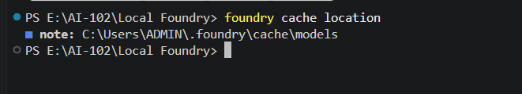
Figure 15. Models are stored in your user profile
- Check the local server:
PS> foundry server status
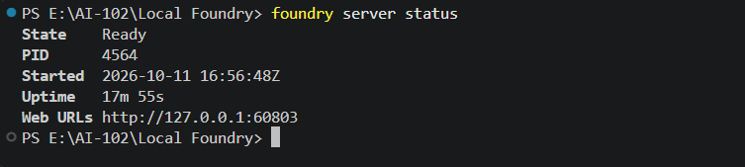
Figure 16. The server is Ready on a local address
WHAT JUST HAPPENED
The cache holds phi-3-mini-4k (CPU, 2.5 GB) and phi-4-mini (GPU, 2.2 GB). Neither is loaded in memory after you exit the chat.
The server listens only on 127.0.0.1, your own machine. Its port changes each time it starts (55168 earlier, 60803 here), so always read it from foundry server status.

Troubleshooting
Symptom | Likely cause | Fix
foundry is not recognised | The terminal was opened before the install | Close and reopen PowerShell
winget is not recognised | App Installer is missing or outdated | Install or update App Installer from the Microsoft Store
Unknown option –version | A long dash replaced the two hyphens | Retype the command as --version
Model not found | The variant ID was mistyped | Copy the exact ID from foundry model list --variants
Download stalls or fails | Network interruption or proxy | Check the connection and run the command again
Answers are very slow | CPU variant on a busy or low-memory PC | Close other apps, or use a smaller model or a GPU variant

Knowledge check
# | Question | Answer
1 | Which part of this lab needs the internet? | Installing Foundry Local and the first download of each model
2 | What does generic-cpu in a variant name mean? | The model runs on any CPU through the CPU execution provider
3 | Where are downloaded models stored? | In the model cache, shown by foundry cache location
4 | Why did the model describe AIML as a markup language? | It is a small model without lookup or grounding, so it guessed a plausible meaning: a hallucination
5 | How do you find the local server address? | Run foundry server status and read the Web URL

Summary and next steps
You installed Foundry Local, chose a CPU variant of Phi-3 Mini, chatted with it entirely on your own PC and inspected where the model and server live. You also saw why small local models need grounding before their answers can be trusted.

Command reference
Command | Purpose
winget install Microsoft.FoundryLocal | Install Foundry Local
foundry --version | Check the installed version
foundry model list | List the model catalog (starts the server)
foundry model list --variants --type chat | List hardware variants of chat models
foundry chat <variant-id> | Download (first time), load and chat with a model
/exit | Leave the chat session
foundry cache ls | List downloaded models
foundry cache location | Show the cache folder
foundry server status | Show the local server state and address

Next steps
- Call the local model from a Python application through its OpenAI-compatible endpoint
- Build a simple web chat dashboard on top of the local server
- Compare answers from a CPU and a GPU variant of the same model
- Add retrieval over your own documents to reduce hallucinations

Clean up (optional)
To remove Foundry Local, run winget uninstall Microsoft.FoundryLocal. Cached models are kept in the folder shown by foundry cache location; delete them there if you need the disk space back.

