AI Solutions Architect Discovery Questionnaire
Oct 11, 2026 · @Shruti
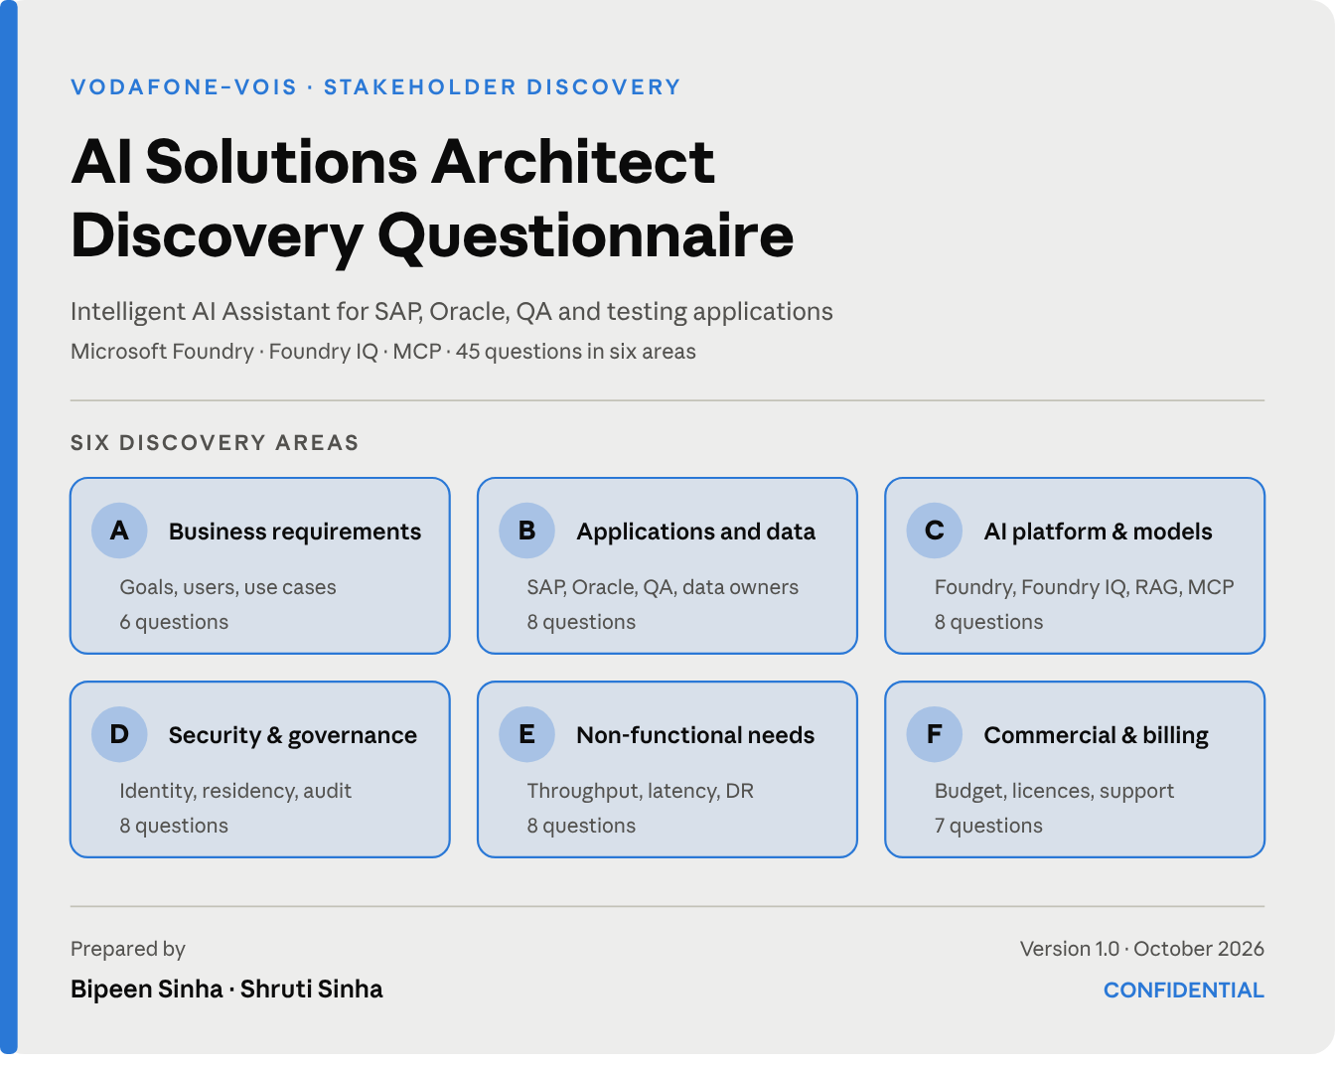
A structured discovery for the Vodafone–VOIS Intelligent AI Assistant, completed with stakeholders in Month 1 before the architecture is signed off.

Document control
Complete one copy of this questionnaire for each stakeholder interview. The interviewer fills in the details below before the session starts.
Item | Detail
Engagement | Vodafone–VOIS Intelligent AI Assistant (Pilot)
Project code | VOIS-GENAI-2026-014
Document | AI Solutions Architect Discovery Questionnaire, v1.0
Classification | Confidential: client and delivery team only
Engagement leads | Bipeen Sinha (Engagement Director) · Shruti Sinha (Project Lead)
Discovery window | Month 1, Weeks 1–4
Respondent details
Field | Response
Respondent name
Role and team
Sections covered (A–F)
Interview date
Interviewer
Follow-up owner

Purpose and how to use this questionnaire
This questionnaire collects the facts we need to design a secure, scalable and cost-effective assistant before any architecture is fixed. It covers the SAP, Oracle, QA and testing applications, built on Microsoft Foundry, Foundry IQ and MCP. Choosing a model or an SDK comes after these answers, not before.
The five questions it must answer
- What business problem are we solving?
- What data and applications must the AI access?
- Which AI models and integration patterns do we need?
- What security, performance, residency and compliance requirements apply?
- How will we measure success and control costs?
The six discovery areas
Section | Area | Covers | Main audience
A | Business requirements | Goals, users, use cases, outcomes | Business owner, product owner
B | Applications and data | SAP, Oracle, QA tools, documents, APIs, data ownership | Application and data owners
C | AI platform and models | Foundry, model selection, Foundry IQ, RAG, MCP | AI platform team, FinOps
D | Security and governance | Identity, access, residency, audit, AI safety | Security, IAM, privacy
E | Non-functional requirements | Throughput, latency, availability, DR, scale | Enterprise architect, SRE
F | Commercial and operational | Billing, provider agreements, licensing, support | Procurement, finance
How to complete it
- Ask only the sections that match the respondent's role.
- Record answers in the Response column, with numbers wherever possible: users, requests per minute, seconds, rupees.
- Set Status for every question. Mark it Follow-up when the answer depends on someone else, and name that person.
- Do not guess targets. An unknown answer is recorded as unknown and goes to the risk register.

Section A · Business requirements
Audience: business owner, product owner, application support leads. Outcome: MVP scope and success criteria.
# | Question | Why we ask | Response | Status
A1 | What business problem should the AI assistant solve? | Sets scope and business value
A2 | Who will use it: employees, developers, testers or support teams? | Shapes user experience and permissions
A3 | Which use cases are mandatory for the first release? | Defines the MVP
A4 | Should the assistant only answer questions, or also carry out actions? | Separates knowledge retrieval from agentic workflows
A5 | Which languages must it support? | Affects model choice and testing
A6 | How will success be measured? | Sets acceptance criteria and KPIs
Example answer. The business owner says: “Initially, employees should find SAP troubleshooting procedures and QA test results without searching five different applications.” That gives a clear first release: knowledge retrieval, citations and access control per application. Automated SAP changes stay out of scope until explicitly approved.

Section B · Applications and data
Audience: SAP and Oracle owners, QA leads, data owners, application architects. Outcome: an application inventory.
# | Question | Why we ask | Response | Status
B1 | Which SAP modules and Oracle applications are in scope? | Identifies source systems
B2 | Which QA and testing platforms must be integrated? | Determines connectors and APIs
B3 | Is the information in databases, APIs, documents, tickets or logs? | Sets retrieval and integration patterns
B4 | Do the applications expose REST, OData, SQL or other interfaces? | Confirms technical feasibility
B5 | Is the data structured, unstructured, or both? | Guides indexing and retrieval strategy
B6 | How often does the source data change? | Sets synchronisation frequency
B7 | Does the data include confidential, personal, financial or regulated information? | Drives classification and protection
B8 | Who owns each source and approves access? | Establishes accountability
Architect's output. An application inventory listing, for each source: owner, integration method, data classification, refresh frequency and access restrictions.

Section C · AI platform and models
Audience: AI platform team, cloud architect, procurement, FinOps. Outcome: an AI model decision matrix.
# | Question | Why we ask | Response | Status
C1 | Is Microsoft Foundry already provisioned? | Identifies existing platform resources
C2 | Which models are approved and available in the required regions? | Determines feasible model choices
C3 | Is a general-purpose model enough, or do we need specialised models? | Supports model routing and selection
C4 | Do we need text, image, audio or multimodal processing? | Sets model capabilities
C5 | Will Foundry IQ be used for enterprise knowledge retrieval? | Sets the grounding approach
C6 | Which data sources will feed the knowledge layer? | Drives indexing, permissions and ingestion
C7 | Do we need MCP tools to read application information or run operations? | Defines agent and tool integration
C8 | Are third-party models permitted, and how must they be procured and billed? | Clarifies commercial and governance terms
Example decision. Use a text model for SAP troubleshooting, retrieval over approved internal documentation, and MCP tools for live application status where needed. Add image processing only when a real use case requires it.

Section D · Security, identity and governance
Audience: security architect, IAM team, privacy and compliance teams. Outcome: the security architecture and data classification matrix.
# | Question | Why we ask | Response | Status
D1 | Is Microsoft Entra ID the approved identity provider? | Sets the authentication design
D2 | Must the assistant enforce each user's existing source-system permissions? | Prevents unauthorised disclosure
D3 | Which data must stay within specific countries or regions? | Defines residency boundaries
D4 | May third-party model providers process the data? | Determines acceptable model deployments
D5 | What are the requirements for encryption, secrets and network isolation? | Drives the security architecture
D6 | Must prompts, responses, tool calls and decisions be audited? | Defines logging and audit controls
D7 | What are the retention and deletion rules for conversation history? | Shapes session and storage design
D8 | Which actions require human approval? | Controls agentic risk and privileged operations
Critical question. If a user cannot open a document in SAP or SharePoint, can the AI assistant still reveal its contents? The answer must be no. Retrieval and tool access must enforce authorisation themselves, rather than relying on the model to decide what a user may see.

Section E · Non-functional requirements
Audience: enterprise architect, infrastructure team, SRE and operations. Outcome: the NFR specification.
# | Question | Why we ask | Response | Status
E1 | How many users will use the system? | Sizes the service
E2 | What are the average and peak concurrent users? | Sets concurrency requirements
E3 | What request volume is expected per second or minute? | Defines throughput (and tokens per minute)
E4 | What is the maximum acceptable response time? | Defines latency targets
E5 | What availability target is required? | Drives redundancy and deployment design
E6 | What are the recovery time and recovery point objectives (RTO and RPO)? | Defines disaster recovery
E7 | Which regions must be served, and from where? | Shapes regional deployment and routing
E8 | What monitoring, alerting and operational support are required? | Defines production operations
Rule. Do not guess these values. Ask stakeholders for measurable targets, then validate them with load testing.

Section F · Commercial, billing and licensing
Audience: procurement, finance, FinOps, cloud platform owner. Outcome: the cost estimate and ownership model.
# | Question | Why we ask | Response | Status
F1 | What is the approved monthly and annual budget? | Sets cost boundaries
F2 | Which model deployments are billed through Azure? | Clarifies billing routes
F3 | Do any third-party models need separate licences or agreements? | Avoids commercial surprises
F4 | What input and output token volumes are expected? | Enables usage-cost estimates
F5 | Are Foundry, search, networking, storage and monitoring costs included? | Captures costs beyond inference
F6 | Are budgets, alerts, quotas and per-team cost allocation required? | Supports cost governance
F7 | Who owns model procurement, vendor support and renewals? | Establishes operational ownership
Note. For third-party models, confirm the exact deployment offer and contract. Finding a model in the Foundry catalog does not by itself prove that its licensing and support terms match first-party models.

Expected outputs
The answers must turn into concrete architecture decisions, not just meeting notes. Each deliverable below is produced in Month 1 from the sections shown.
Deliverable | What it contains | Fed by
Business requirements document | Use cases, MVP scope, success criteria | A
Application inventory | SAP, Oracle, QA and testing systems, owners, interfaces | B
Data classification matrix | Sensitivity, residency, access and retention | B, D
AI model decision matrix | Models, endpoints, regions, licensing, cost | C, F
Integration design | Foundry IQ, MCP tools, APIs and retrieval flows | B, C
Security architecture | Identity, authorisation, secrets, network and audit | D
NFR specification | Throughput, latency, availability, RTO and RPO | E
Cost estimate | Inference, retrieval, infrastructure and support | C, F
Risk register | Unknowns, dependencies, owners and mitigations | All
Acceptance test plan | Quality, security, performance and user acceptance | A, D, E

Discovery readiness checklist
Tick each topic once it is confirmed. Whatever stays unticked becomes the agenda for the next discovery meeting.
Critical priority
- ☐ Business use cases and MVP scope
- ☐ SAP, Oracle and QA application inventory
- ☐ Data classification and residency
- ☐ User identity and source-system authorisation
- ☐ Approved AI models and provider agreements
High priority
- ☐ Foundry IQ knowledge sources and ingestion
- ☐ MCP tools and permitted actions
- ☐ Peak load, throughput and latency targets
- ☐ Availability, disaster recovery and monitoring
- ☐ Budget, billing and cost controls
- ☐ Testing, acceptance criteria and support ownership
The five answers to get first
Complete discovery and the architecture decisions in Month 1, before committing to detailed implementation. These five answers shape the architecture far more than the choice of SDK:
- Which business use cases must the pilot deliver?
- Which SAP, Oracle, QA and testing systems can we reach, and through which interfaces?
- What data may the assistant retrieve, and what must stay within specific regions?
- Which models, Foundry capabilities and MCP tools are approved?
- Which measurable targets define acceptable quality, latency, security and cost?

Validation and sign-off
By signing, the respondent confirms that the answers recorded above are accurate to the best of their knowledge. Any answer marked Follow-up has a named owner.
Role | Name | Signature | Date
Respondent
Interviewer
Engagement Director | Bipeen Sinha
Project Lead & Delivery Manager | Shruti Sinha

