HANDS-ON LAB MANUAL
AI Employee Expense Assistant
Custom Function Calling with GPT-5 on Microsoft Foundry
Item | Detail
Lab ID | Lab 01: Use a Custom Function in an AI Agent
Level | Beginner to intermediate
Duration | About 60 minutes
Platform | Microsoft Foundry (Azure), VS Code, Python 3.10+
Model | OpenAI gpt-5, GlobalStandard deployment
Key concept | Function calling (tool use)
Deliverables | expense_agent.py, expense_Agent_with_AI.py, .env, requirements.txt

Contents

1. Lab Overview
In this lab you build an Employee Expense Assistant: a GPT-5 agent on Microsoft Foundry that answers expense questions by calling your own Python function, check_expense_policy().
The key idea: the AI does not do the business calculation itself; it decides when to call your application's function, passes it parameters, and turns the result into a friendly answer.
Example: an employee asks "I spent ₹3,500 on a hotel. Can I claim it?" The agent extracts hotel and 3500, calls the function, receives APPROVED with a ₹5,000 limit, and replies in plain language.

1.1 Objectives
By the end of this lab you will be able to:
- Explain what a custom function (tool) is and why an AI agent needs one.
- Set up a Microsoft Foundry project and deploy a GPT-5 model from VS Code.
- Write and test a business-logic function in plain Python, without AI.
- Describe a function to the model as a tool with a JSON schema.
- Show how the agent decides to call the function and passes parameters to it.
- Execute the function in your application and return the result to the AI.
- Observe the AI generating the final response from the function result.

1.2 Prerequisites
- An Azure subscription or lab sandbox account with permission to create Foundry projects
- Visual Studio Code (1.140 or later) with the Python extension
- Python 3.10 or later installed and on your PATH
- Basic Python knowledge: functions, dictionaries, if statements

1.3 Business Scenario
Your company keeps its expense policy inside your application, not inside the AI model. The policy for this lab is:
Expense type | Maximum allowed
Hotel | ₹5,000 per day
Taxi | ₹2,000 per day
Meals | ₹1,500 per day
Flight | ₹15,000

Employees will ask questions such as "I spent ₹1,200 on a taxi. Is that allowed?" or "What is the maximum hotel reimbursement?"

1.4 Lab Tasks at a Glance
Part | Tasks | Time
A. Set up Foundry | Install toolkit, sign in, create project, deploy gpt-5, copy key and endpoint | 15 min
B. Build the agent | Virtual environment, custom function, test without AI, .env, packages, AI agent file | 25 min
C. Run and verify | Start the assistant, run five test questions, read the console trace | 15 min
Wrap-up | Troubleshooting, cleanup, review questions | 5 min

2. Architecture and Flow
Two parts work together: your Python application holds the policy and runs the function, and the gpt-5 deployment in Microsoft Foundry decides when to ask for it.

2.1 Architecture Diagram
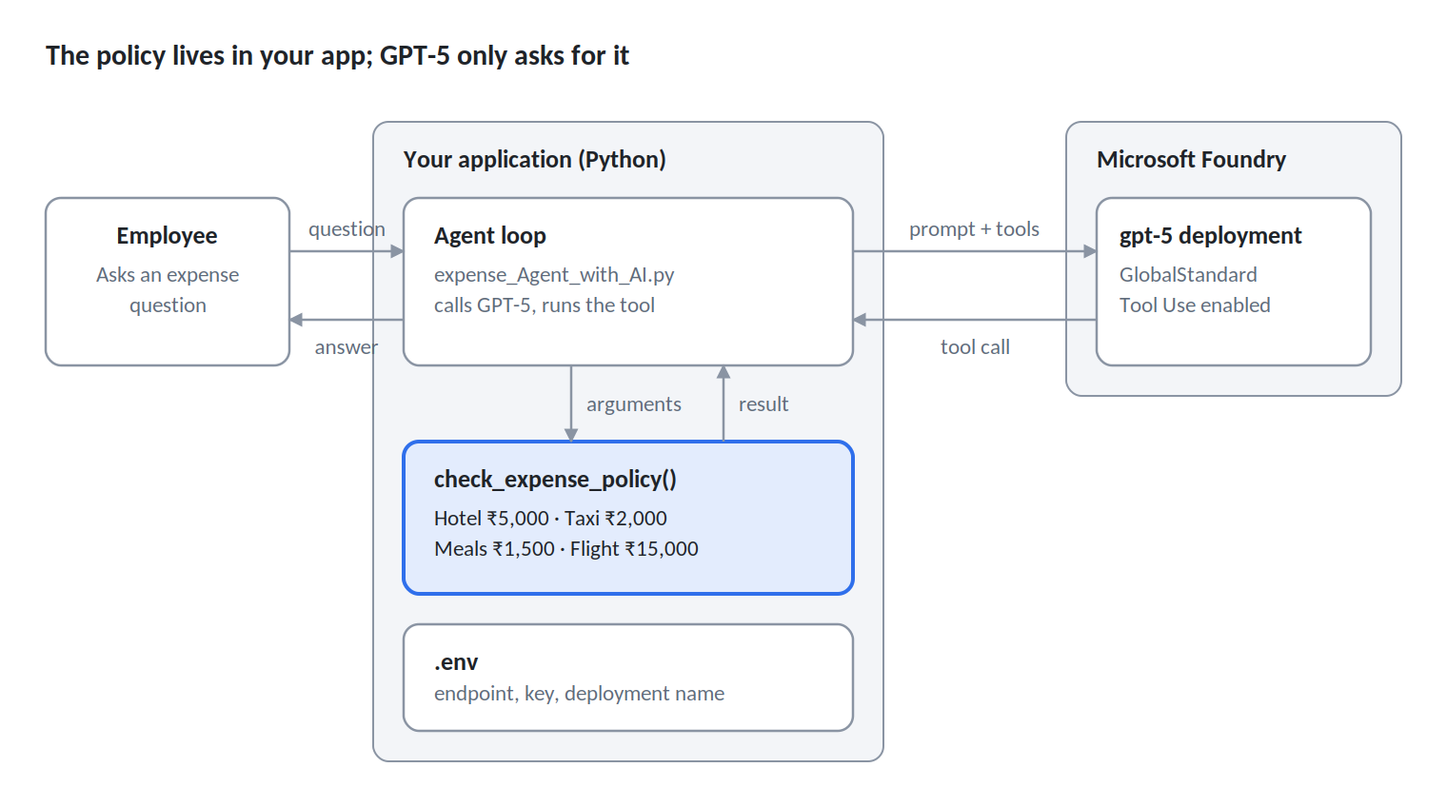
Figure 1: Lab architecture: employee, Python application and Microsoft Foundry
The employee only talks to your application. GPT-5 never sees the policy table; it sees the tool description and, later, the function's result.

2.2 Function-Calling Flow Chart
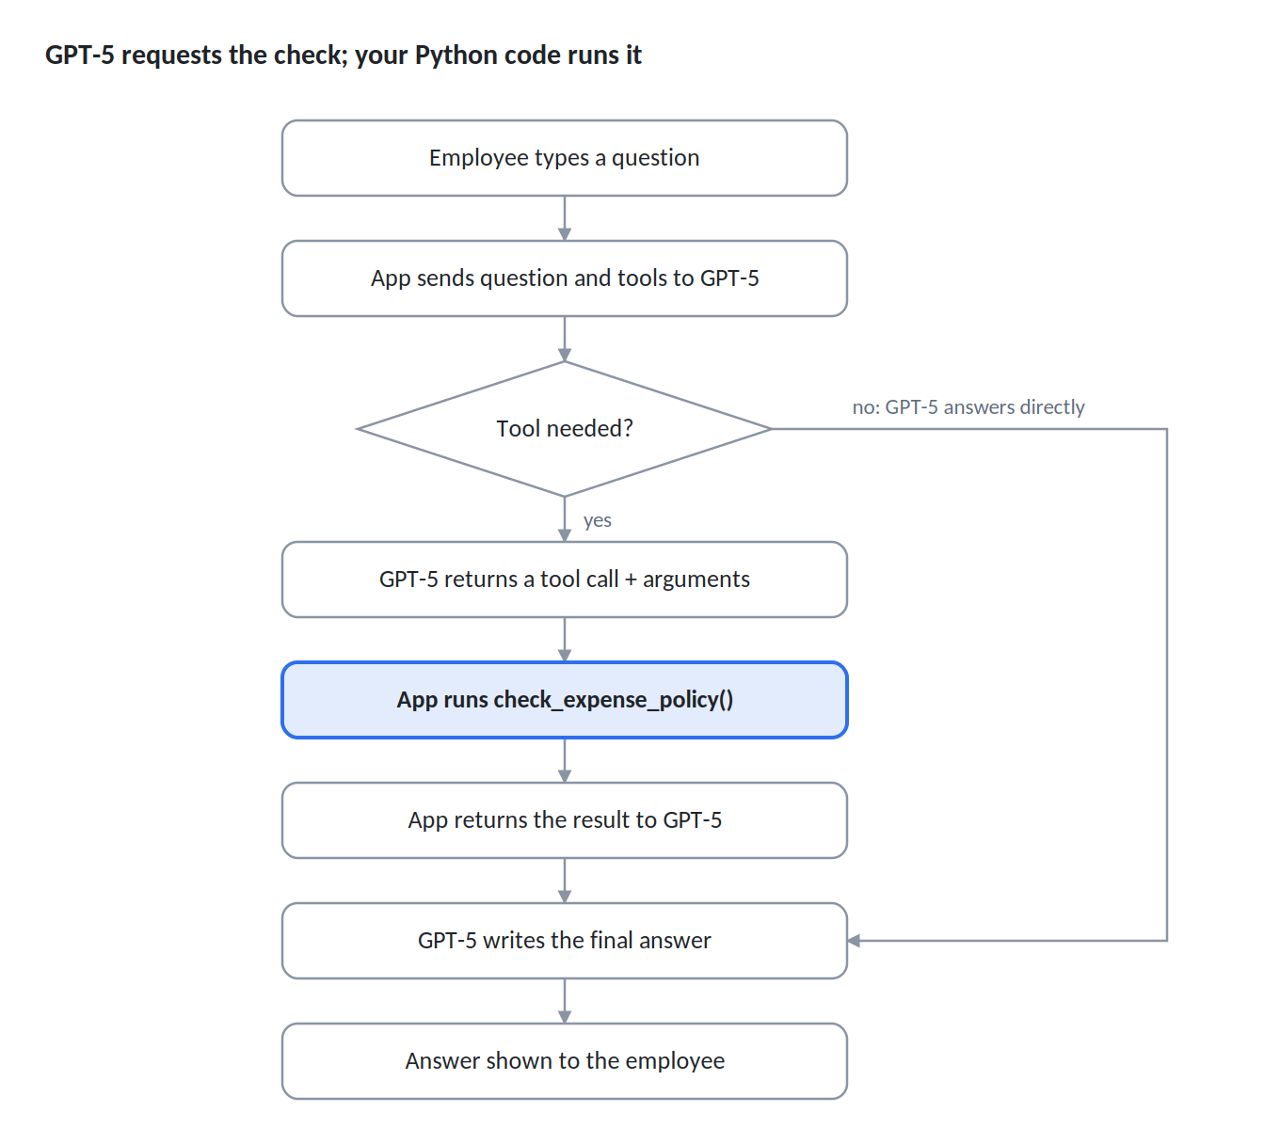
Figure 2: Function-calling flow: 8 steps, 1 decision
The app calls GPT-5 twice: once to get the tool call, once to turn the result into an answer. If no tool is needed, the first call already returns the answer.

3. Part A: Set Up Microsoft Foundry and Deploy GPT-5
In Part A you connect VS Code to Azure, create a Foundry project and deploy the gpt-5 model the agent will use. Allow about 15 minutes.

Task A1: Install the Foundry Toolkit Extension
- Open VS Code and select Extensions in the Activity Bar (or press Ctrl+Shift+X).
- Search for foundry.
- Select Foundry Toolkit for VS Code by Microsoft and click Install.
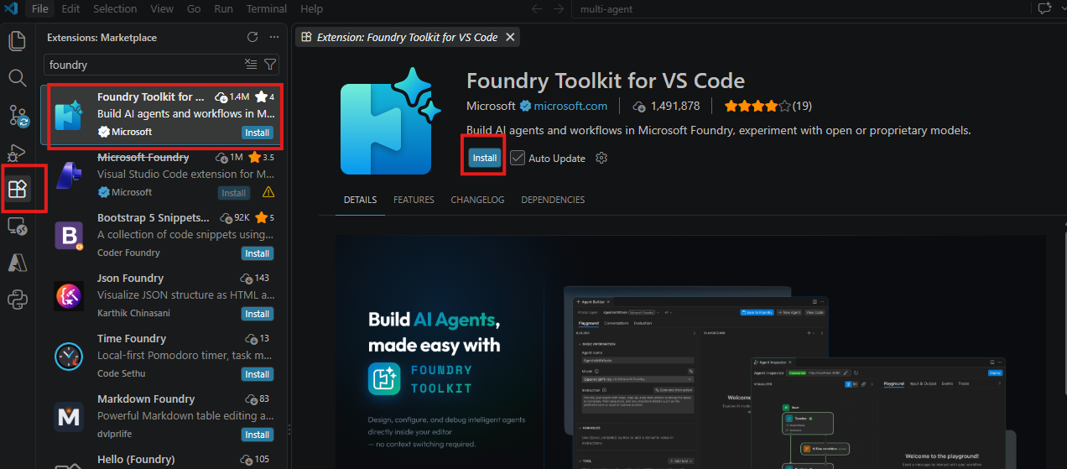
Figure 3: Install the Foundry Toolkit extension
- When installation finishes, the Foundry Toolkit icon appears in the Activity Bar. Click it to open My Resources, which shows Set Foundry Project.
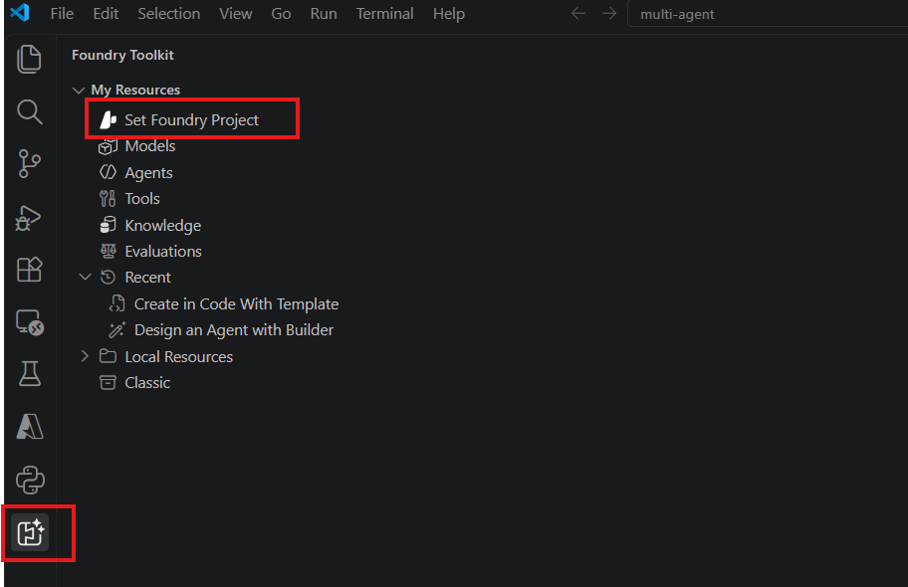
Figure 4: Foundry Toolkit icon and Set Foundry Project

Task A2: Sign In to Azure
- Select the Azure icon in the Activity Bar.
- Under Resources, click Sign in to Azure...
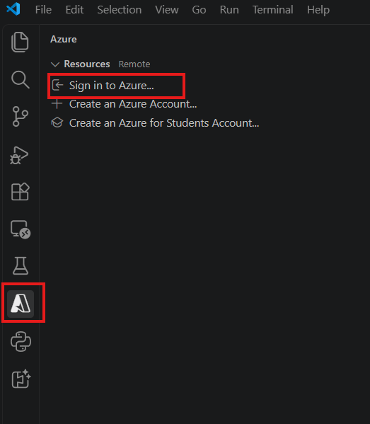
Figure 5: Sign in to Azure from VS Code
- In the Microsoft sign-in window, enter the lab username from your lab environment, click Next, then enter the password.
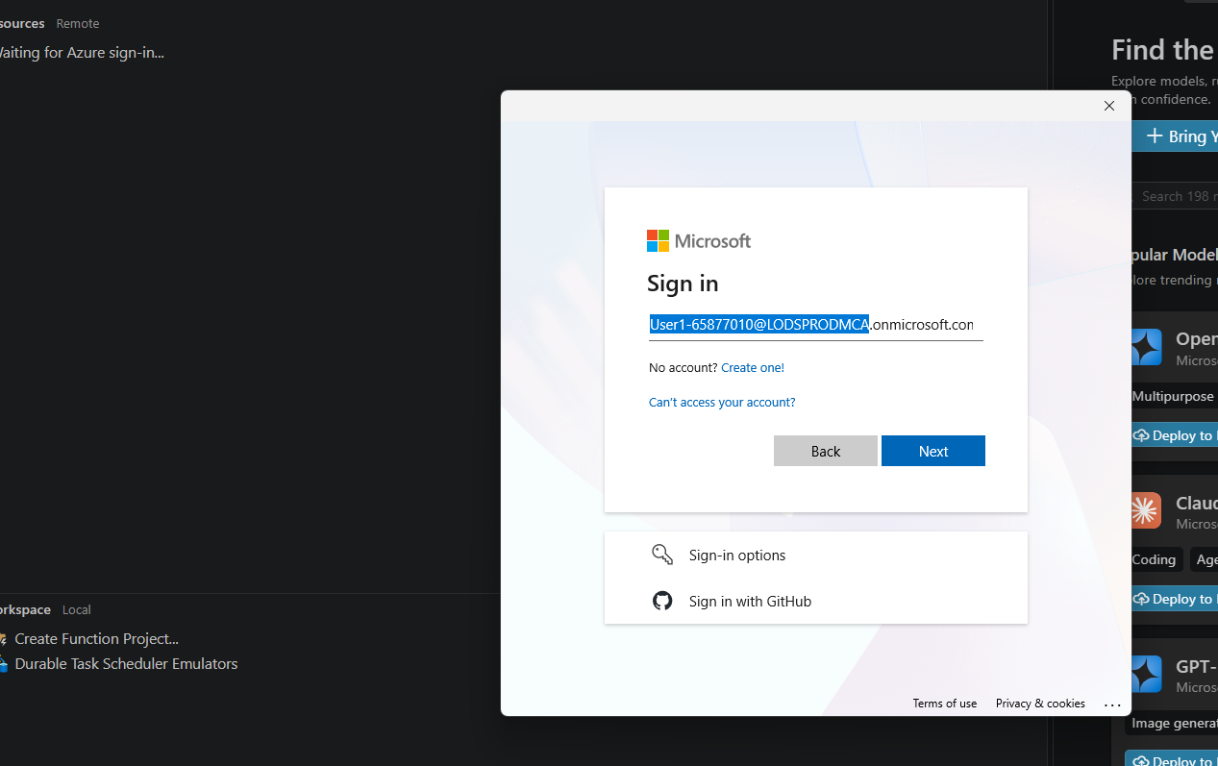
Figure 6: Microsoft sign-in window
- When asked "Sign in to all apps and websites on this device?", click No, this app only. This keeps the lab account from being registered on a shared machine.
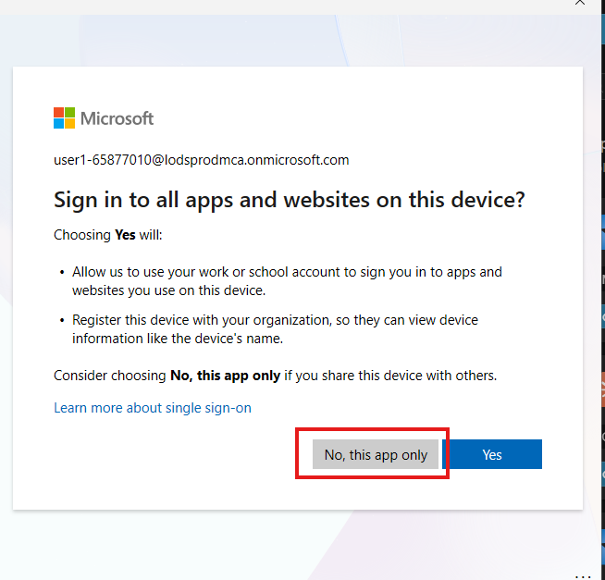
Figure 7: Choose No, this app only
Note: Sandbox credentials are temporary. Use only the username and password shown in your lab instructions panel.

Task A3: Create a Foundry Project
- Return to Foundry Toolkit and click Set Foundry Project under My Resources.
- In the action list, choose Create project (Create a new project and set as default).
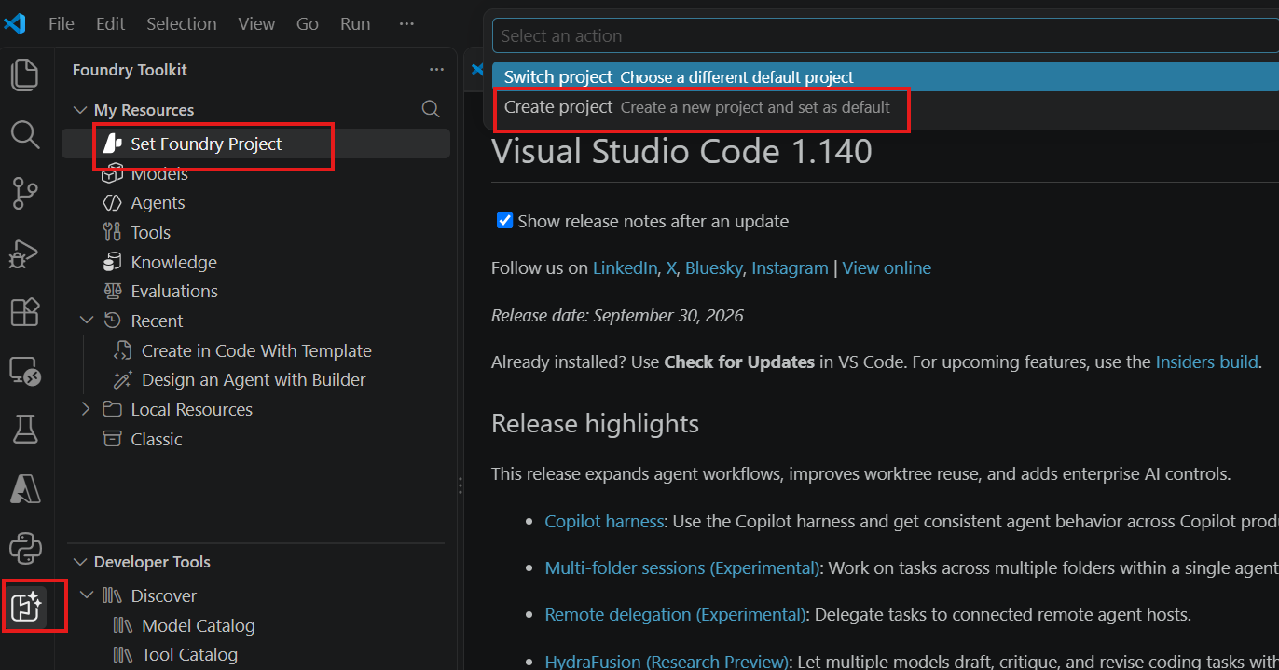
Figure 8: Create a new Foundry project
- When prompted to choose a resource group, select the existing lab resource group, for example ResourceGroup1 (westeurope). Do not create a new one in a sandbox.
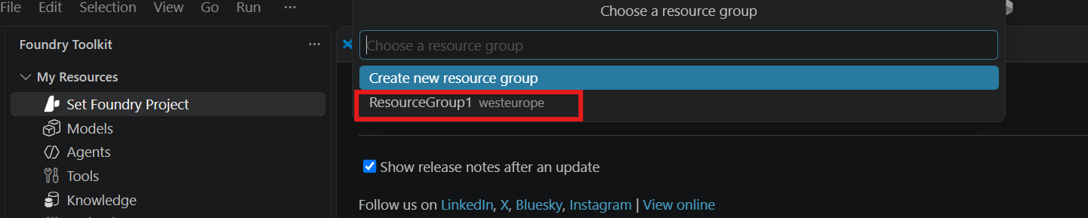
Figure 9: Choose the existing resource group
- Accept the suggested project name (for example ai-agents-project65877010) or type your own, then press Enter.
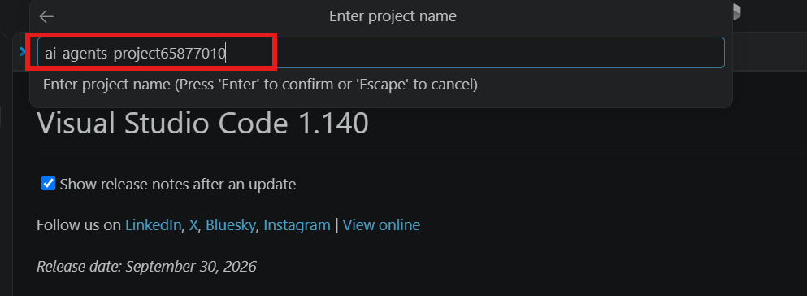
Figure 10: Enter the project name
- Wait for the notification Microsoft Foundry Project ... Deployed successfully. The project name now appears under My Resources.
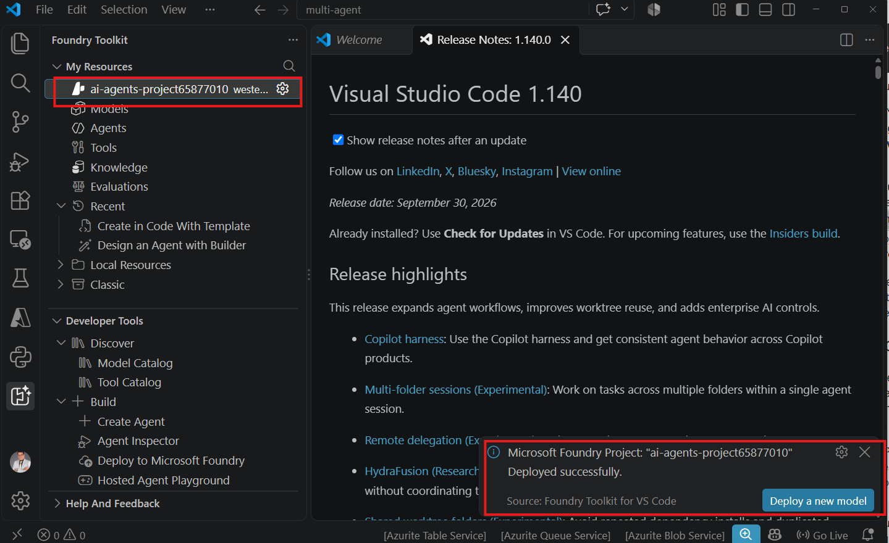
Figure 11: Project created successfully

Task A4: Deploy the gpt-5 Model
- Under your project, click Models, then open the Catalog tab.
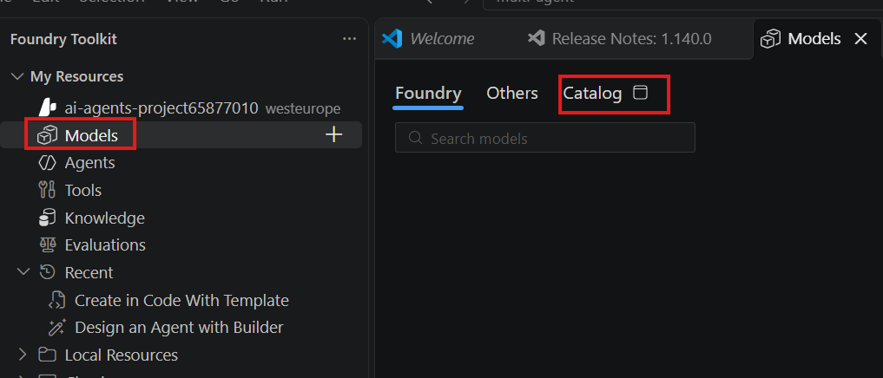
Figure 12: Open Models and the Catalog tab
- In the catalog search box, type gpt-5. Locate OpenAI gpt-5 (Foundry), which supports Structured Outputs and Tool Use.
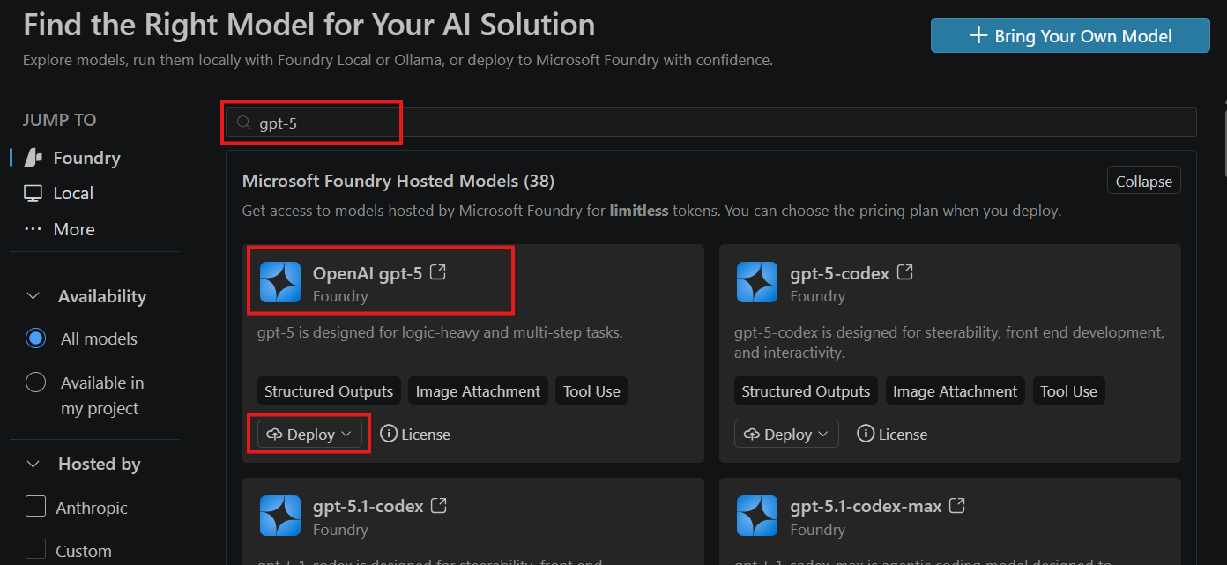
Figure 13: Search for gpt-5 in the model catalog
- Open the Deploy drop-down on the OpenAI gpt-5 card and select Deploy with default settings.
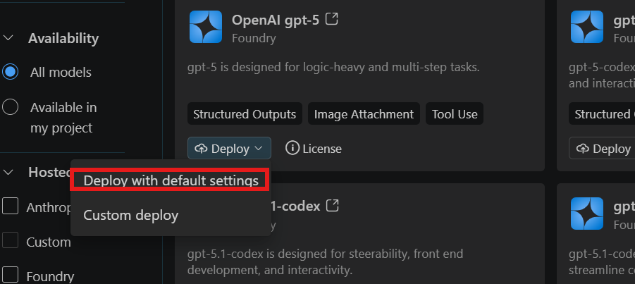
Figure 14: Deploy with default settings
- Wait for the notification Model deployed successfully.
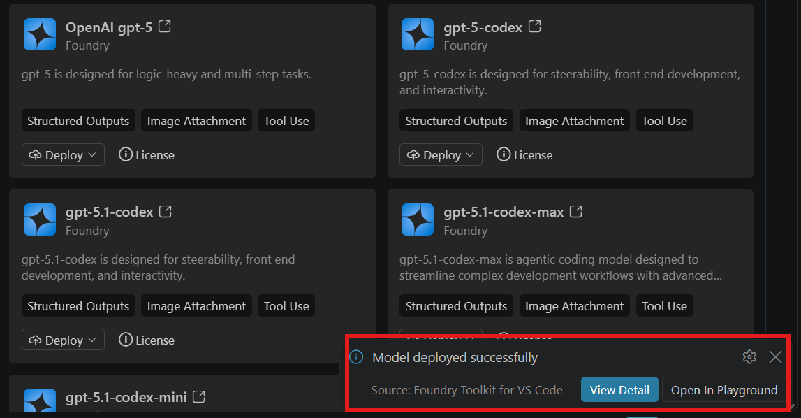
Figure 15: Model deployed successfully
Why gpt-5? The model must support Tool Use (function calling). Check for that tag on any model you pick.

Task A5: Verify the Project in the Foundry Portal (Optional)
- In a browser, go to ai.azure.com and sign in with the same lab account.
- Open All resources and confirm your project is listed with type Project and the expected region.
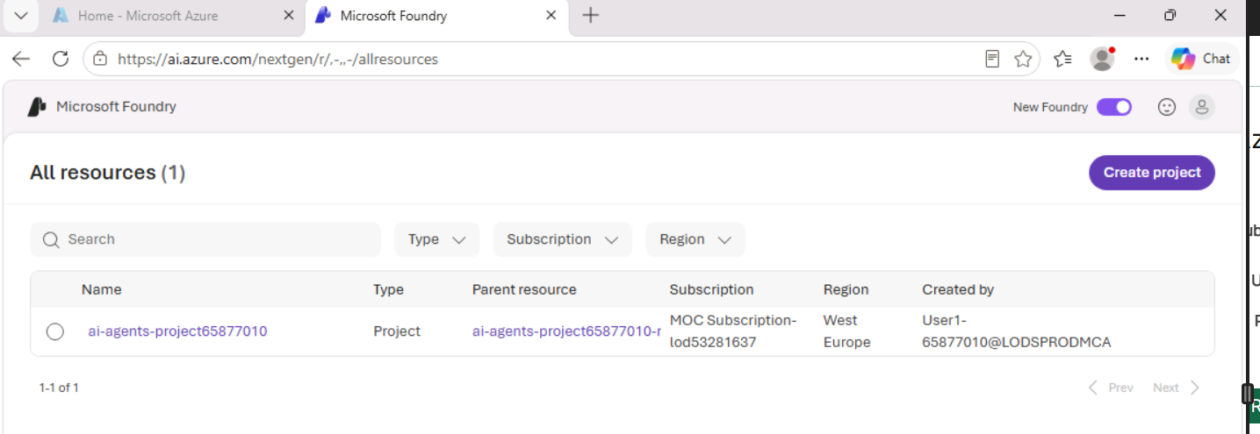
Figure 16: Verify the project in the Foundry portal

Task A6: Copy the API Key and Endpoint
- In Foundry Toolkit, open Models under your project. Confirm the gpt-5 deployment shows status Success and deployment type GlobalStandard.
- Click the ... menu on the gpt-5 row and choose Copy API Key. Paste it into a temporary note.
- Open the same menu again and choose Copy Endpoint. Paste it beside the key.
- Note the deployment Name (here gpt-5). You need all three values in Part B.
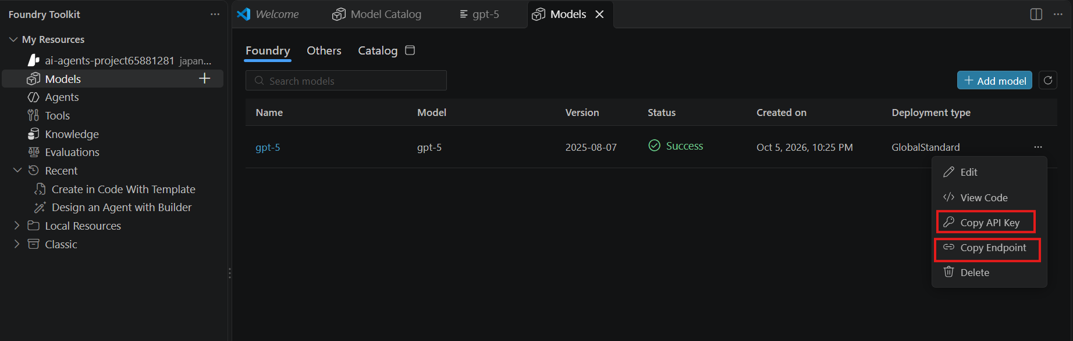
Figure 17: Copy the API key and endpoint
Security: Treat the API key like a password. Never paste it into code, screenshots or chat; it belongs only in the .env file.

Checkpoint: You have a Foundry project, a gpt-5 deployment with status Success, and its endpoint, API key and deployment name.

4. Part B: Build the Expense Agent in Python
In Part B you first write the business rule as ordinary Python, prove it works without AI, then hand it to GPT-5 as a tool. Allow about 25 minutes.

Task B1: Create the Project Folder and Virtual Environment
- In VS Code, open a new folder named Custom-function.
- Open a terminal (Ctrl+`) and create and activate a virtual environment:
python -m venv .venv
.\.venv\Scripts\Activate.ps1

On macOS or Linux, run source .venv/bin/activate instead. Your prompt should now start with (.venv).

Task B2: Write the Custom Function
- Create a file named expense_agent.py.
- Add the function below. It holds the company policy and returns a structured result.
def check_expense_policy(expense_type: str, amount: float):
policy = {
"hotel": 5000,
"taxi": 2000,
"meals": 1500,
"flight": 15000
}

expense_type = expense_type.lower()

if expense_type not in policy:
return {
"status": "UNKNOWN",
"message": f"No policy found for {expense_type}"
}

limit = policy[expense_type]
status = "APPROVED" if amount <= limit else "REJECTED"

return {
"expense_type": expense_type,
"amount": amount,
"maximum_allowed": limit,
"status": status
}

Task B3: Test the Function Without AI
- Add these lines at the bottom of expense_agent.py:
result = check_expense_policy("hotel", 2500)
print(result)

- Run it:
python expense_agent.py

- Confirm the output matches:
{'expense_type': 'hotel', 'amount': 2500, 'maximum_allowed': 5000, 'status': 'APPROVED'}
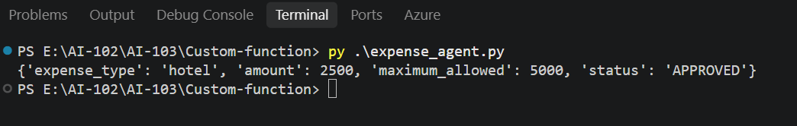
Figure 18: Function test output without AI
Trainer point: We have not used AI yet. The function is ordinary Python. The agent will simply gain the ability to ask our application to run it when it needs the information.

Task B4: Store the Connection Settings in .env
- Create a file named .env in the project folder.
- Paste the three values you copied in Task A6:
AZURE_OPENAI_ENDPOINT=https://YOUR-RESOURCE.openai.azure.com
AZURE_OPENAI_API_KEY=YOUR_API_KEY
AZURE_OPENAI_DEPLOYMENT=gpt-5
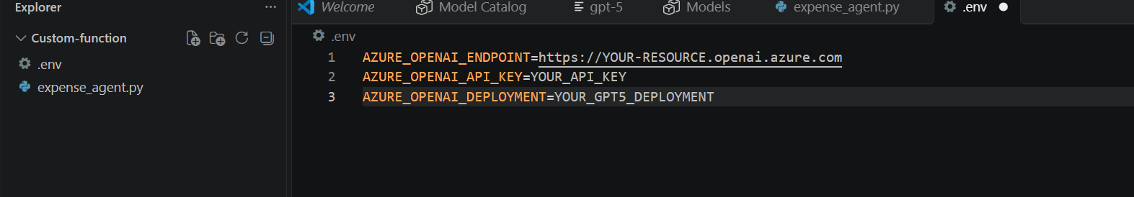
Figure 19: The .env file
Important: Use the resource base URL only (ending in .openai.azure.com or .cognitiveservices.azure.com). The code adds /openai/v1/ itself. If you share this folder through Git, add .env to .gitignore.

Task B5: Install the Required Packages
- Create requirements.txt with two lines:
openai
python-dotenv
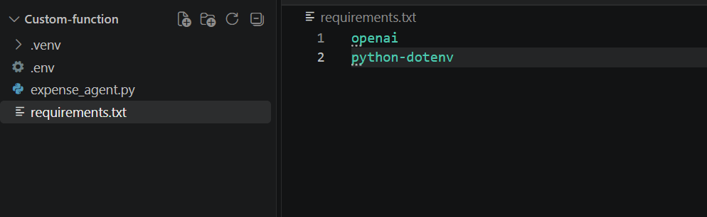
Figure 20: requirements.txt
- Install them inside the virtual environment:
pip install -r requirements.txt
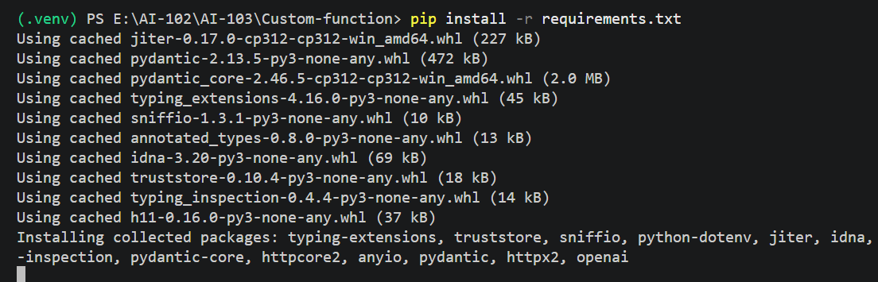
Figure 21: pip install output

Task B6: Create the AI Agent File
- Create a second file named expense_Agent_with_AI.py.
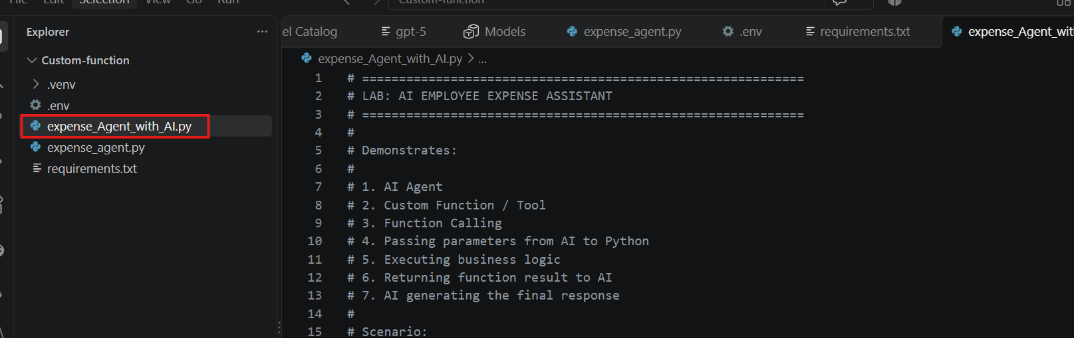
Figure 22: Create expense_Agent_with_AI.py
- Paste the complete code below. Each numbered comment block maps to one step of the function-calling loop.
# ============================================================
# LAB: AI EMPLOYEE EXPENSE ASSISTANT
# Demonstrates: AI agent, custom function (tool), function calling,
# passing parameters from AI to Python, running business logic,
# returning the result to AI, and the AI's final response.
# ============================================================

# 1. IMPORT LIBRARIES
import json
import os

from dotenv import load_dotenv
from openai import OpenAI

# 2. LOAD ENVIRONMENT VARIABLES
load_dotenv()
AZURE_OPENAI_ENDPOINT = os.getenv("AZURE_OPENAI_ENDPOINT")
AZURE_OPENAI_API_KEY = os.getenv("AZURE_OPENAI_API_KEY")
AZURE_OPENAI_DEPLOYMENT = os.getenv("AZURE_OPENAI_DEPLOYMENT")

# 3. CREATE THE CLIENT (Azure OpenAI v1 endpoint)
client = OpenAI(
base_url=f"{AZURE_OPENAI_ENDPOINT.rstrip('/')}/openai/v1/",
api_key=AZURE_OPENAI_API_KEY,
)

# 4. COMPANY POLICY (lives in your application, not in the model)
EXPENSE_POLICY = {"hotel": 5000, "taxi": 2000, "meals": 1500, "flight": 15000}

# 5. THE CUSTOM FUNCTION
def check_expense_policy(expense_type: str, amount: float) -> dict:
expense_type = expense_type.lower().strip()
if expense_type not in EXPENSE_POLICY:
return {"status": "UNKNOWN_EXPENSE_TYPE", "expense_type": expense_type,
"amount": amount,
"message": "This expense type is not defined in the company policy."}
limit = EXPENSE_POLICY[expense_type]
if amount <= limit:
return {"status": "APPROVED", "expense_type": expense_type, "amount": amount,
"maximum_allowed": limit,
"message": f"The expense is within the company policy. The maximum allowed amount for {expense_type} is ₹{limit}."}
return {"status": "EXCEEDS_LIMIT", "expense_type": expense_type, "amount": amount,
"maximum_allowed": limit,
"message": f"The expense exceeds the company policy. The maximum allowed amount for {expense_type} is ₹{limit}."}

# 6. DESCRIBE THE FUNCTION TO THE MODEL (tool definition)
tools = [{
"type": "function",
"function": {
"name": "check_expense_policy",
"description": "Check whether an employee expense is within the company expense policy.",
"parameters": {
"type": "object",
"properties": {
"expense_type": {"type": "string",
"description": "Type of expense, e.g. hotel, taxi, meals, flight."},
"amount": {"type": "number", "description": "Expense amount in Indian rupees."},
},
"required": ["expense_type", "amount"],
},
},
}]

SYSTEM_PROMPT = (
"You are an Employee Expense Assistant. Always call check_expense_policy to check "
"an expense; never guess the policy. Explain the result clearly and politely."
)

def banner(title):
print("\n" + "=" * 60 + f"\n{title}\n" + "=" * 60)

# 7. THE FUNCTION-CALLING LOOP
def ask_agent(question: str) -> str:
messages = [{"role": "system", "content": SYSTEM_PROMPT},
{"role": "user", "content": question}]
banner("USER"); print(question)

# 7a. First call: the model decides whether it needs the tool
response = client.chat.completions.create(
model=AZURE_OPENAI_DEPLOYMENT, messages=messages, tools=tools, tool_choice="auto")
message = response.choices[0].message

if not message.tool_calls:
return message.content

messages.append(message)
for tool_call in message.tool_calls:
# 7b. Read the parameters the AI chose
args = json.loads(tool_call.function.arguments)
banner("AI AGENT → CUSTOM FUNCTION")
print(f"Function: {tool_call.function.name}")
print(f"Arguments: {json.dumps(args, indent=2)}")

# 7c. Your application executes the business logic
result = check_expense_policy(**args)
banner("CUSTOM FUNCTION RESULT")
print(json.dumps(result, indent=4, ensure_ascii=False))

# 7d. Return the result to the AI
messages.append({"role": "tool", "tool_call_id": tool_call.id,
"content": json.dumps(result, ensure_ascii=False)})
banner("CUSTOM FUNCTION → AI AGENT")

# 7e. Second call: the AI writes the final answer from the result
final = client.chat.completions.create(model=AZURE_OPENAI_DEPLOYMENT, messages=messages)
return final.choices[0].message.content

# 8. INTERACTIVE CONSOLE
if __name__ == "__main__":
print("\nEMPLOYEE EXPENSE AI ASSISTANT\n")
print("Company Expense Policy:\n" + "-" * 23)
for k, v in EXPENSE_POLICY.items():
print(f"{k.title():<7}: ₹{v:,}")
print("\nType your expense question.\nType 'exit' to quit.")
while True:
q = input("\nYou: ").strip()
if q.lower() in ("exit", "quit"):
break
if q:
answer = ask_agent(q)
banner("FINAL AI RESPONSE"); print(answer)

How the Code Maps to Function Calling
Code block | What happens | Who does it
6. tools | The function's name, purpose and parameters are described as JSON schema | Your application
7a. first call | The model reads the question and decides to request check_expense_policy | GPT-5
7b. arguments | The model supplies expense_type and amount extracted from the question | GPT-5
7c. execute | Python runs the policy check | Your application
7d. tool message | The result is sent back with the matching tool_call_id | Your application
7e. second call | The model turns the result into a friendly answer | GPT-5

Checkpoint: Your folder contains .venv, .env, expense_agent.py, expense_Agent_with_AI.py and requirements.txt, and Task B3 printed APPROVED.

5. Part C: Run, Test and Verify
In Part C you run the agent and watch every hop of the function-calling loop in the console. Allow about 15 minutes.

Task C1: Start the Assistant
- With the virtual environment active, run:
python expense_Agent_with_AI.py

On Windows you can also use py .\expense_Agent_with_AI.py.
- The assistant prints the company policy and waits for your question.
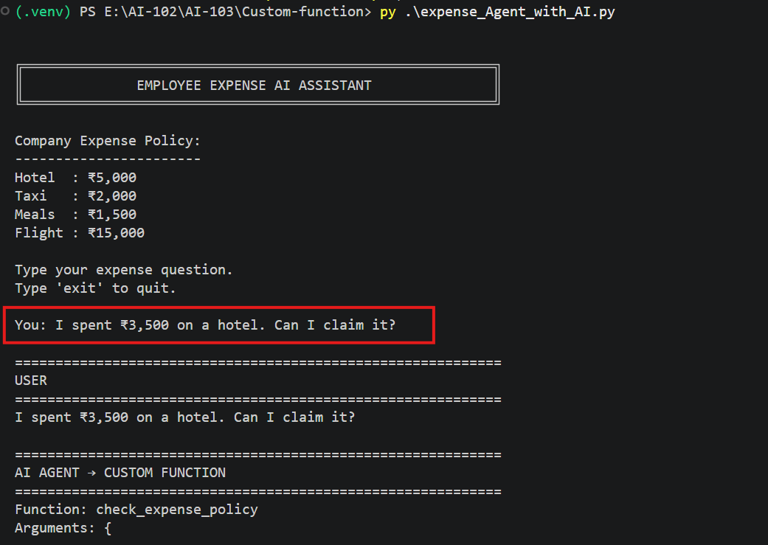
Figure 23: The assistant starts and shows the policy

Task C2: Run the Five Test Questions
Type each question at the You: prompt. For each one, confirm the arguments the AI chose and the status the function returned.
# | Test question | Expected arguments | Expected status
1 | I spent ₹3,500 on a hotel. Can I claim it? | hotel, 3500 | APPROVED (limit ₹5,000)
2 | I spent ₹2,800 on a taxi. Is this expense reimbursable? | taxi, 2800 | EXCEEDS_LIMIT (limit ₹2,000)
3 | I had a business meal that cost ₹1,200. Can I claim it? | meals, 1200 | APPROVED (limit ₹1,500)
4 | My flight ticket cost ₹18,000. Can I claim the full amount? | flight, 18000 | EXCEEDS_LIMIT (limit ₹15,000)
5 | I spent ₹1,000 on parking. Can I claim it? | parking, 1000 | UNKNOWN_EXPENSE_TYPE

Type exit when you are done.

Reading the Console Output
Each answer prints five labelled blocks, one per stage of the loop:
- USER: the question as typed.
- AI AGENT → CUSTOM FUNCTION: the function name and the JSON arguments GPT-5 extracted.
- CUSTOM FUNCTION RESULT: the dictionary your Python code returned.
- CUSTOM FUNCTION → AI AGENT: the result is sent back to the model.
- FINAL AI RESPONSE: the model's plain-language answer.

Sample Results
Test 1, hotel within limit. The AI passes hotel and 3500; the function returns APPROVED and the AI confirms the claim.
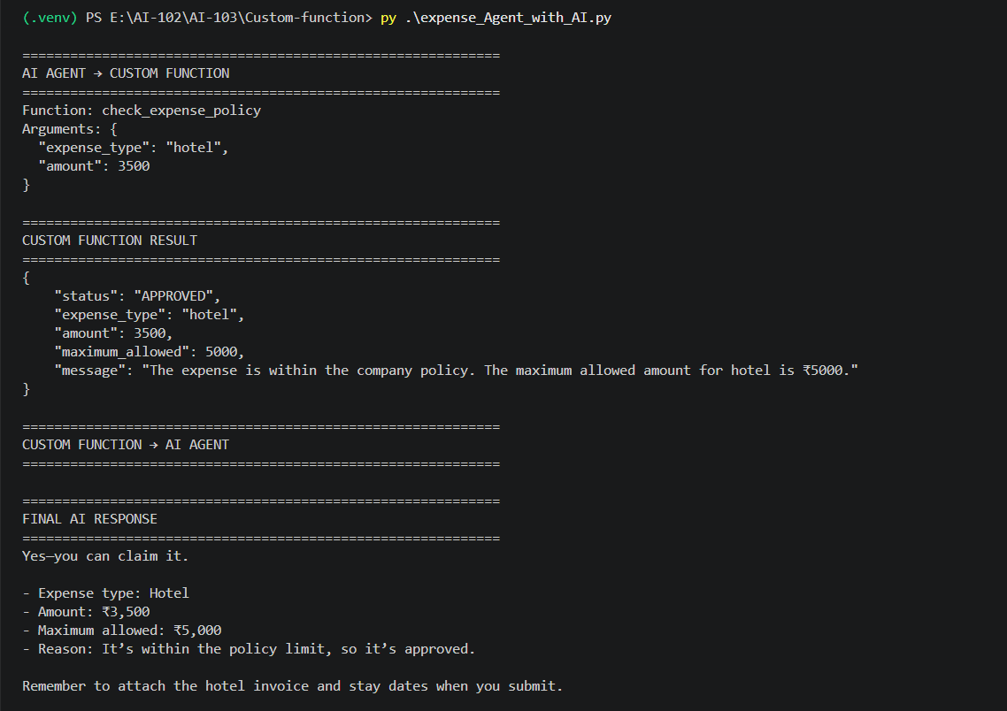
Figure 24: Test 1: hotel within limit
Test 2, taxi over limit. The function returns EXCEEDS_LIMIT with a ₹2,000 maximum; the AI explains why it is not reimbursable as submitted.
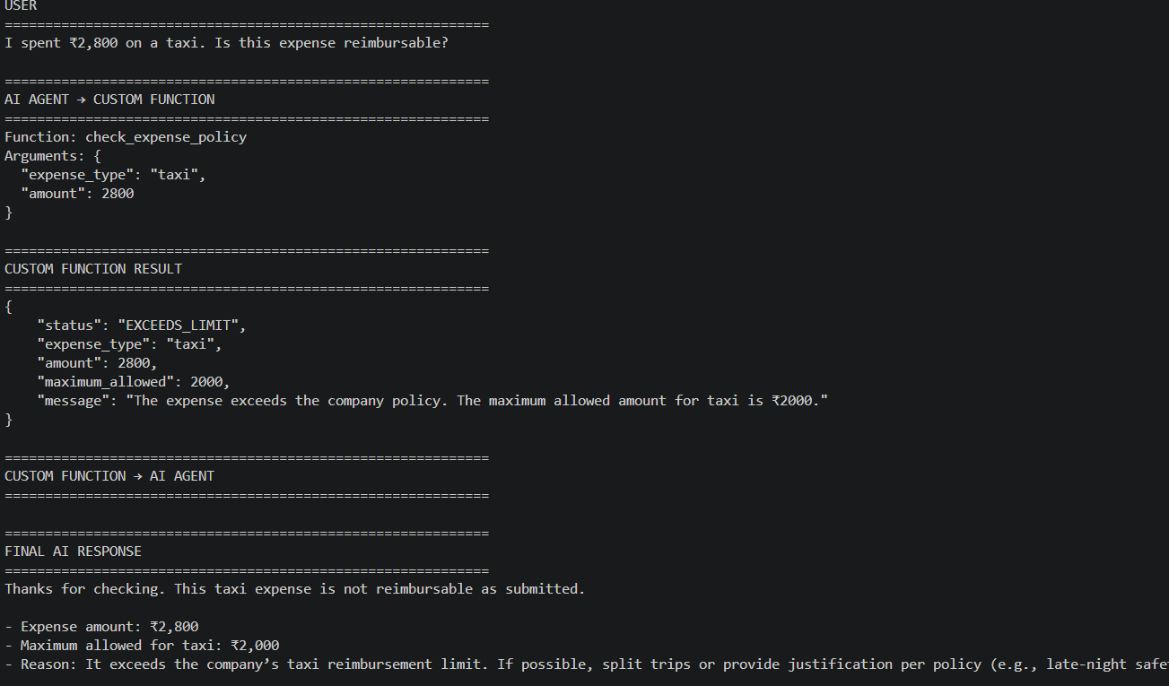
Figure 25: Test 2: taxi exceeds limit
Test 4, flight over limit. The AI works out that ₹15,000 is reimbursable and the ₹3,000 overage needs an exception.
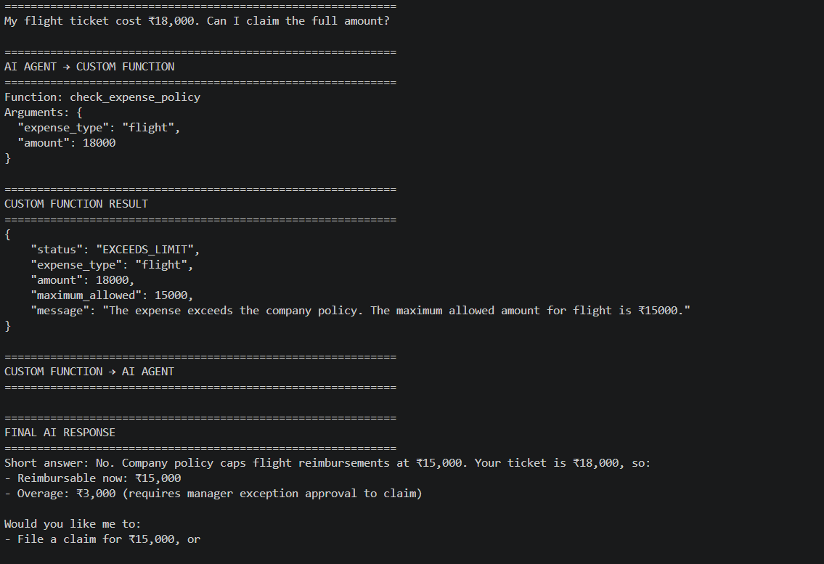
Figure 26: Test 4: flight exceeds limit
Test 5, unknown expense type. The function cannot find parking in the policy; the AI says so and asks for details instead of guessing.
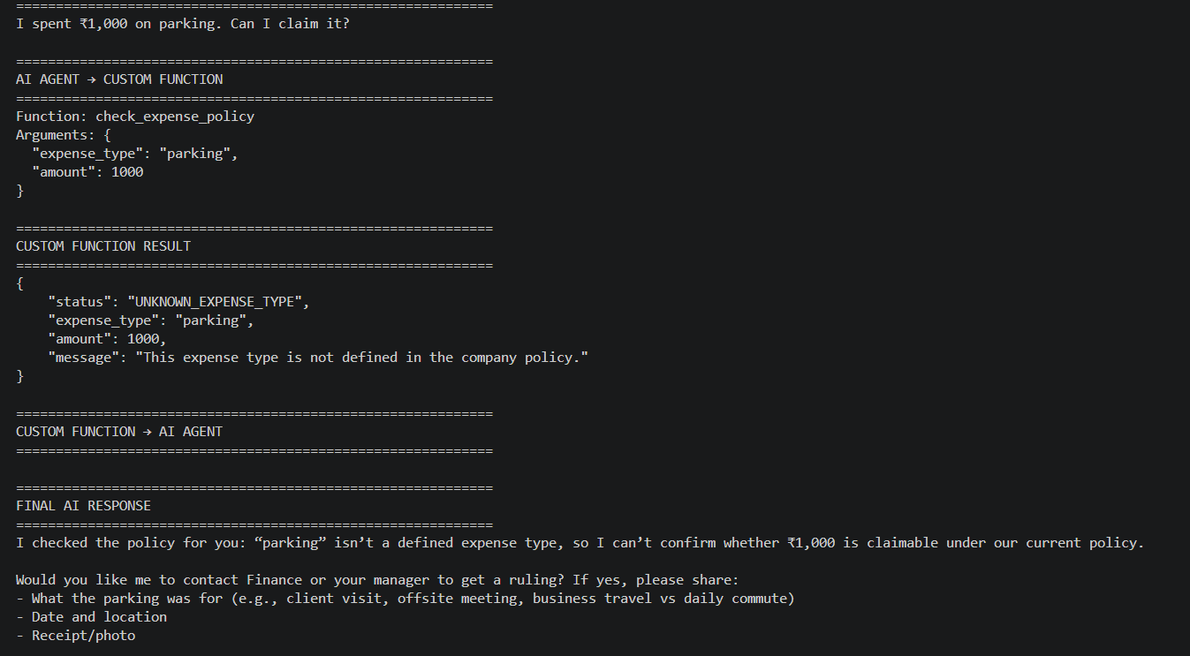
Figure 27: Test 5: unknown expense type
Note: The final wording changes from run to run because the model writes it. The arguments and the status must not change: they come from your function.

Task C3: Explore Further (Optional)
- Ask a question with no amount, such as "What is the maximum hotel reimbursement?" Observe whether the model calls the tool or asks for an amount.
- Ask something unrelated, such as "What is the capital of France?" The model should answer without calling the function.
- Add "training": 10000 to EXPENSE_POLICY and re-run the assistant with a training expense.
Checkpoint: All five tests show the expected arguments and status, and the final AI response agrees with the function result.

6. Troubleshooting, Cleanup and Review

6.1 Troubleshooting
Symptom | Likely cause | Fix
401 Unauthorized or Access denied | Wrong or expired API key | Copy the key again from Models > ... > Copy API Key and update .env
404 Resource not found or DeploymentNotFound | Deployment name or endpoint path is wrong | Set AZURE_OPENAI_DEPLOYMENT to the exact Name in the Models list; use the base endpoint only
AttributeError: 'NoneType' object has no attribute 'rstrip' | .env not found or variable misspelled | Run from the project folder; check the three variable names exactly
ModuleNotFoundError: No module named 'openai' | Packages installed outside the venv | Activate .venv, then run pip install -r requirements.txt again
Activate.ps1 cannot be loaded | PowerShell execution policy | Run Set-ExecutionPolicy -Scope Process -ExecutionPolicy Bypass, then activate again
Unsupported parameter: temperature | GPT-5 rejects some sampling settings | Remove temperature and similar parameters from the API call
Model answers without calling the function | Prompt or tool description too vague | Keep the system prompt instruction to always call check_expense_policy
429 Too Many Requests | Deployment rate limit reached | Wait a few seconds and retry
Deploy fails or model missing from catalog | Model not offered in the region | Create the project in a region that lists gpt-5

6.2 Cleanup
- Type exit to stop the assistant, then run deactivate to leave the virtual environment.
- Delete .env, or at least remove the API key, before sharing the folder.
- In Foundry Toolkit > Models, open the ... menu on gpt-5 and choose Delete if you will not reuse it.
- In a personal subscription, delete the project and its resource group in the Azure portal to stop charges. In a lab sandbox, the environment is removed when the lab ends.

6.3 Review Questions
- Why does the expense policy live in your Python code rather than in the model's prompt?
- Which part of the code tells GPT-5 that the function exists and what parameters it takes?
- Who actually executes check_expense_policy(): the model or your application?
- What links the function result back to the model's request?
- Why does the final answer wording vary between runs while the status does not?
- What happens when the employee asks about an expense type not in the policy, and why is that the right behaviour?

6.4 Answer Key (for Trainers)
- Business rules change and must be exact; code is auditable and the model cannot invent limits.
- The tools list (block 6): name, description and a JSON schema for expense_type and amount.
- Your application. The model only requests the call with arguments.
- The tool_call_id on the role: tool message.
- The model writes the prose, which is non-deterministic; the status comes from deterministic Python.
- The function returns UNKNOWN_EXPENSE_TYPE and the agent asks for details instead of guessing.

6.5 Summary
You deployed GPT-5 on Microsoft Foundry, wrote a business function in plain Python, and gave it to the model as a tool. The agent understood each question, chose to call your function with the right parameters, and turned the result into a clear answer. This define, request, execute, return, respond loop is the same pattern behind every tool-using AI agent.

6.6 Reference
Function calling in Microsoft Foundry Agent Service (Microsoft Learn)

