LAB MANUAL
CloudOps MCP Studio
Build a Cloud Operations Assistant
with MCP and GPT-5 on Microsoft Foundry
18 hands-on labs: from an empty folder to an AI assistant that answers with MCP tools
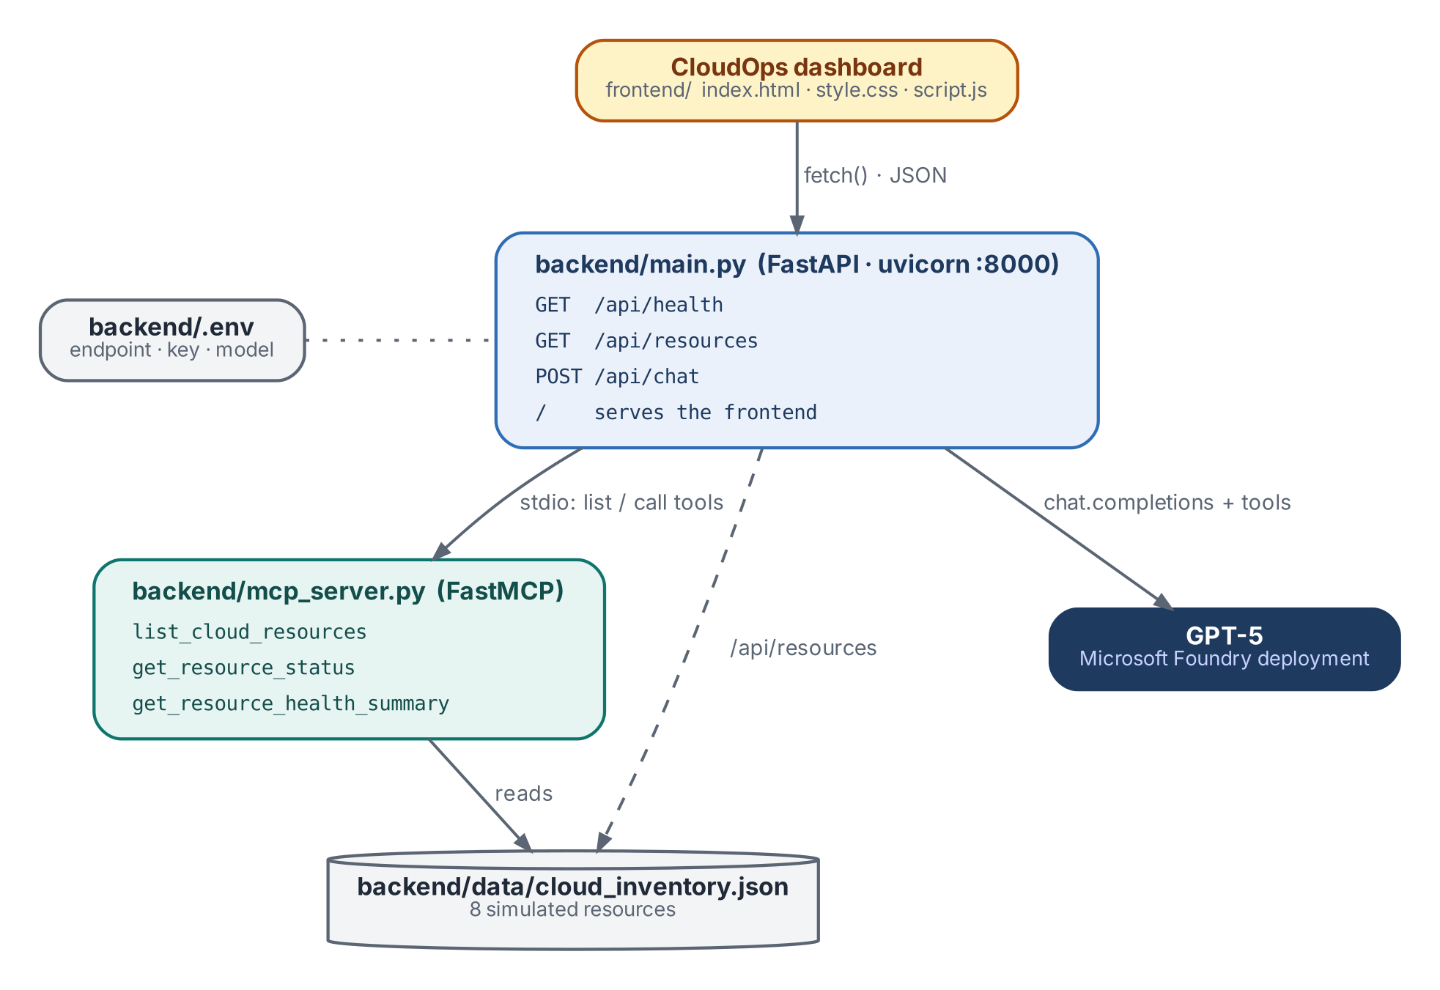
LAB | CloudOps MCP Studio
LEVEL | Intermediate
DURATION | About 2.5 hours
STACK | Python · FastAPI · MCP Python SDK · HTML/CSS/JS
CLOUD | Microsoft Foundry (GPT-5) · simulated, read-only inventory
VERSION | 1.0 · October 2026

Contents
How to Use This Manual 2
1. Lab Overview 3
1.1 What you will build 3
1.2 How a question becomes an answer 4
1.3 Learning objectives 5
1.4 Prerequisites 5
1.5 Lab roadmap 5
Part A — Set Up Microsoft Foundry and GPT-5 7
Lab 1 — Install the Foundry Toolkit 7
Lab 2 — Sign In to Azure 9
Lab 3 — Create a Foundry Project 11
Lab 4 — Deploy the GPT-5 Model 13
Lab 5 — Collect the Connection Details 16
Part B — Project Setup 17
Lab 6 — Create the Project Structure 17
Lab 7 — Virtual Environment and Packages 19
Part C — Data and MCP Server 21
Lab 8 — Create the Simulated Inventory 21
Lab 9 — Build the MCP Server 23
Lab 10 — Test the MCP Server on Its Own 25
Part D — Backend 27
Lab 11 — Configure the Foundry Connection 27
Lab 12 — Build the FastAPI Backend 29
Part E — Frontend 33
Lab 13 — Add the Dashboard 33
Part F — Run and Test 34
Lab 14 — Start the Application 34
Lab 15 — Test with Natural Language 35
Lab 16 — Inspect the MCP Tool Calls 35
Part G — Explain and Extend 37
Lab 17 — Explain the Architecture 37
Lab 18 — Challenge: Add a Fourth Tool 38
Appendix A — Troubleshooting 39
Appendix B — Glossary 41
Appendix C — Lab Completion Checklist 42
Appendix D — Source Listings 43
D.1 cloud_inventory.json 43
D.2 index.html 46
D.3 style.css 50
D.4 script.js 56
Appendix E — References 60

How to Use This Manual
This manual walks you through building CloudOps MCP Studio: a web dashboard with an AI assistant that answers questions about a cloud estate. GPT-5, deployed in Microsoft Foundry, answers by calling tools exposed by an MCP server that you write in Python.
The 18 labs are grouped into seven parts and build on one another, so complete them in order. Every lab opens with a summary card (objective, output, time), then gives numbered steps, the exact code or commands, reference screenshots and a checkpoint.

Conventions
Element | Meaning
Teal code box | A file to create, or a command to run, exactly as shown. The label says which.
Bold text | A button, menu item, or interface label you click or select.
Monospace text | A file name, folder path, command, or value.
Blue NOTE box | Background information.
Amber CAUTION box | Something that can break the lab or expose a secret if skipped.
Navy KEY CONCEPT box | An idea you should be able to explain to someone else.
Green CHECKPOINT box | What you should have before moving on.

CAUTION
This lab uses a simulated, read-only inventory. Nothing in it starts, stops, creates or changes real cloud resources. The only Azure resource you create is the Foundry project and its GPT-5 deployment.

1. Lab Overview

1.1 What you will build
CloudOps MCP Studio has three layers. A browser dashboard shows the inventory and hosts a chat assistant. A FastAPI backend serves the dashboard and runs the AI agent loop. An MCP server exposes three read-only tools over a local JSON inventory, and GPT-5 decides which tool to call to answer each question.
Figure 1. CloudOps MCP Studio architecture
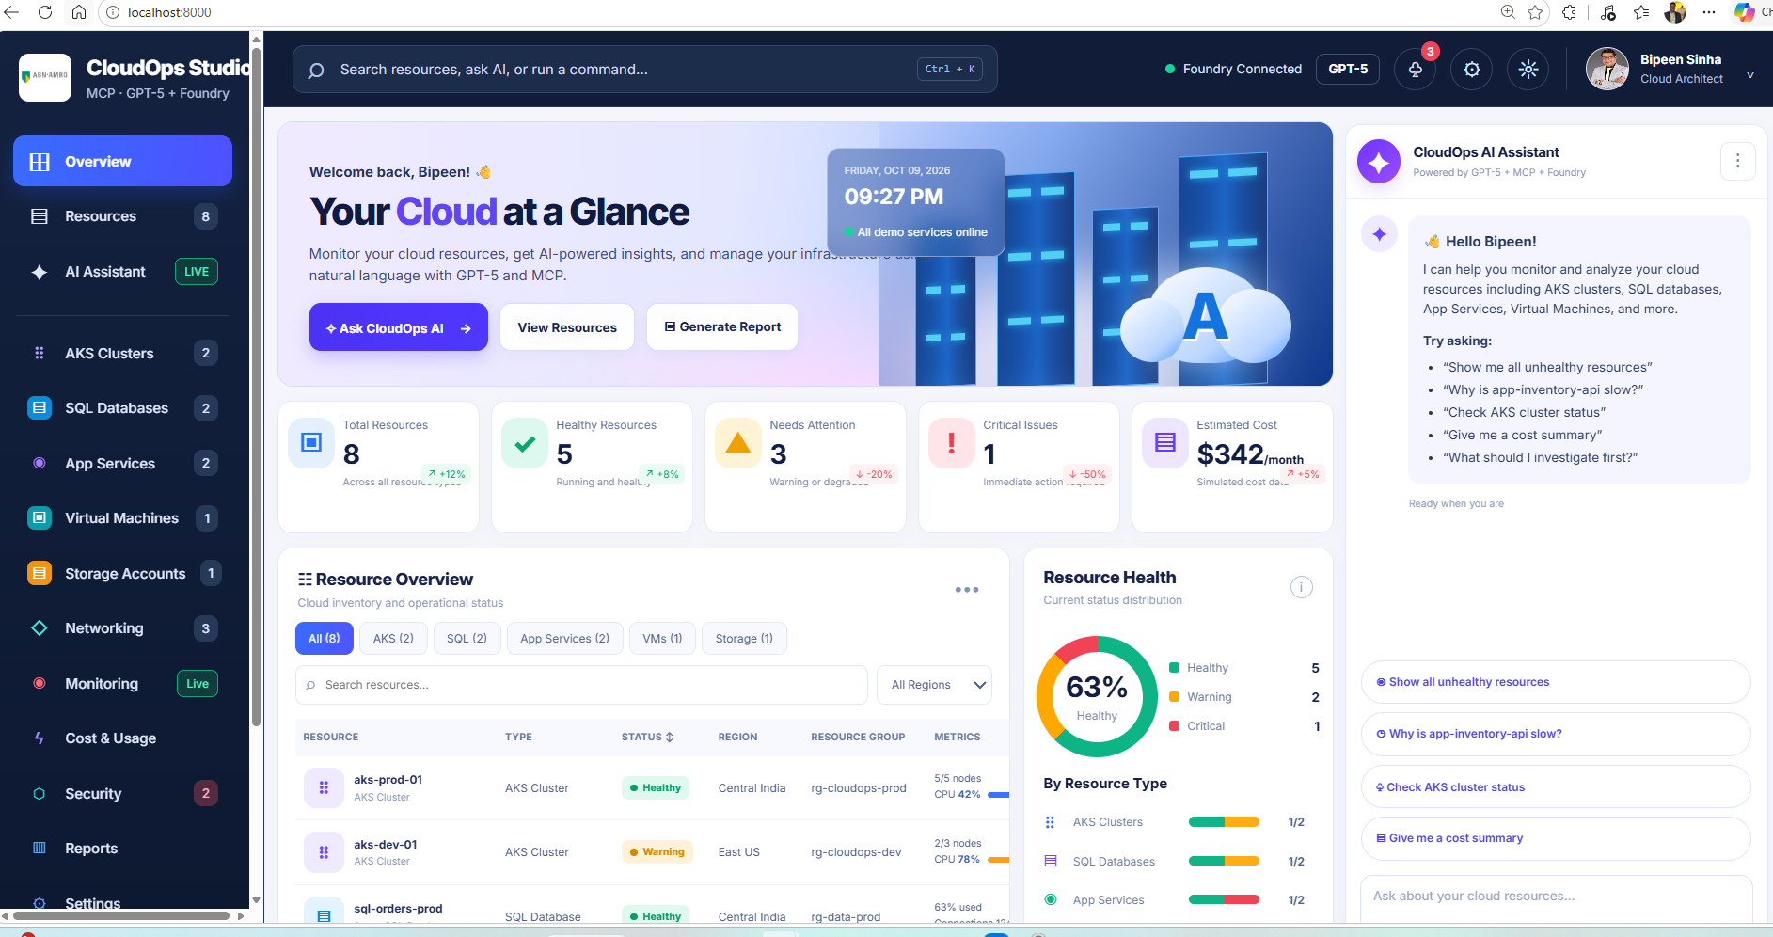
Figure 2. The finished CloudOps dashboard with the AI assistant on the right

1.2 How a question becomes an answer
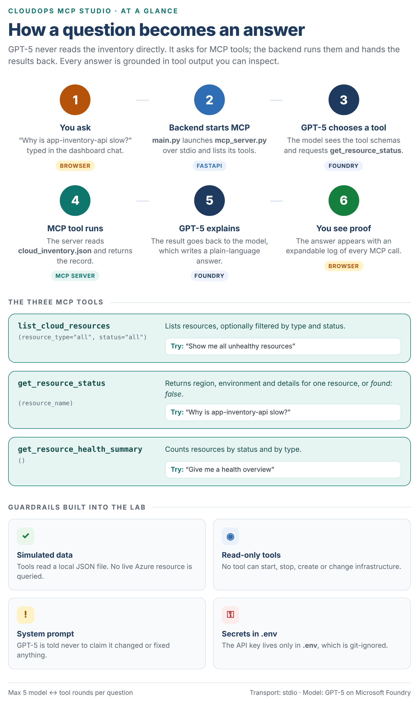
Figure 3. Infographic: the request lifecycle, the three MCP tools and the lab’s guardrails

1.3 Learning objectives
By the end of this lab you will be able to:
- Create a Microsoft Foundry project and deploy a GPT-5 model that supports tool use.
- Explain the roles of an MCP server, an MCP client and the language model.
- Write an MCP server in Python with FastMCP and test it on its own.
- Connect MCP tools to GPT-5 through an explicit tool-calling loop in FastAPI.
- Serve a web dashboard that shows the inventory and every MCP tool call.
- Test an AI assistant for grounded answers, unknown inputs and unsafe requests.
- Keep secrets out of code and source control.

1.4 Prerequisites
Requirement | Details
Computer | Windows 10 or 11 with PowerShell.
Editor | Visual Studio Code.
Python | Python 3.10 or later, with Add Python to PATH ticked during install (python.org).
Azure | A lab or sandbox account that can create a Foundry project and deploy GPT-5.
Knowledge | Basic use of a terminal and a code editor. No prior MCP experience is needed.

Check Python and pip before you start:
POWERSHELL · run in the VS Code terminal
python --version
python -m pip --version

1.5 Lab roadmap
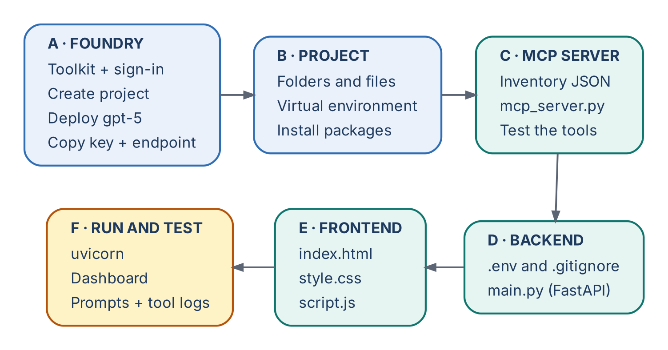
Figure 4. Lab roadmap
Part | Labs | Focus | Time
A. Microsoft Foundry | 1 – 5 | Toolkit, sign-in, project, GPT-5 deployment, credentials | 20 min
B. Project setup | 6 – 7 | Folders, virtual environment, packages | 15 min
C. MCP server | 8 – 10 | Inventory data, MCP tools, standalone test | 25 min
D. Backend | 11 – 12 | .env configuration and the FastAPI agent | 20 min
E. Frontend | 13 | Dashboard files | 10 min
F. Run and test | 14 – 16 | Start, test prompts, inspect tool calls | 30 min
G. Explain and extend | 17 – 18 | Classroom explanation and a new MCP tool | 20 min

Part A — Set Up Microsoft Foundry and GPT-5
In Part A you connect VS Code to Azure, create a Foundry project and deploy the GPT-5 model that the assistant will use.
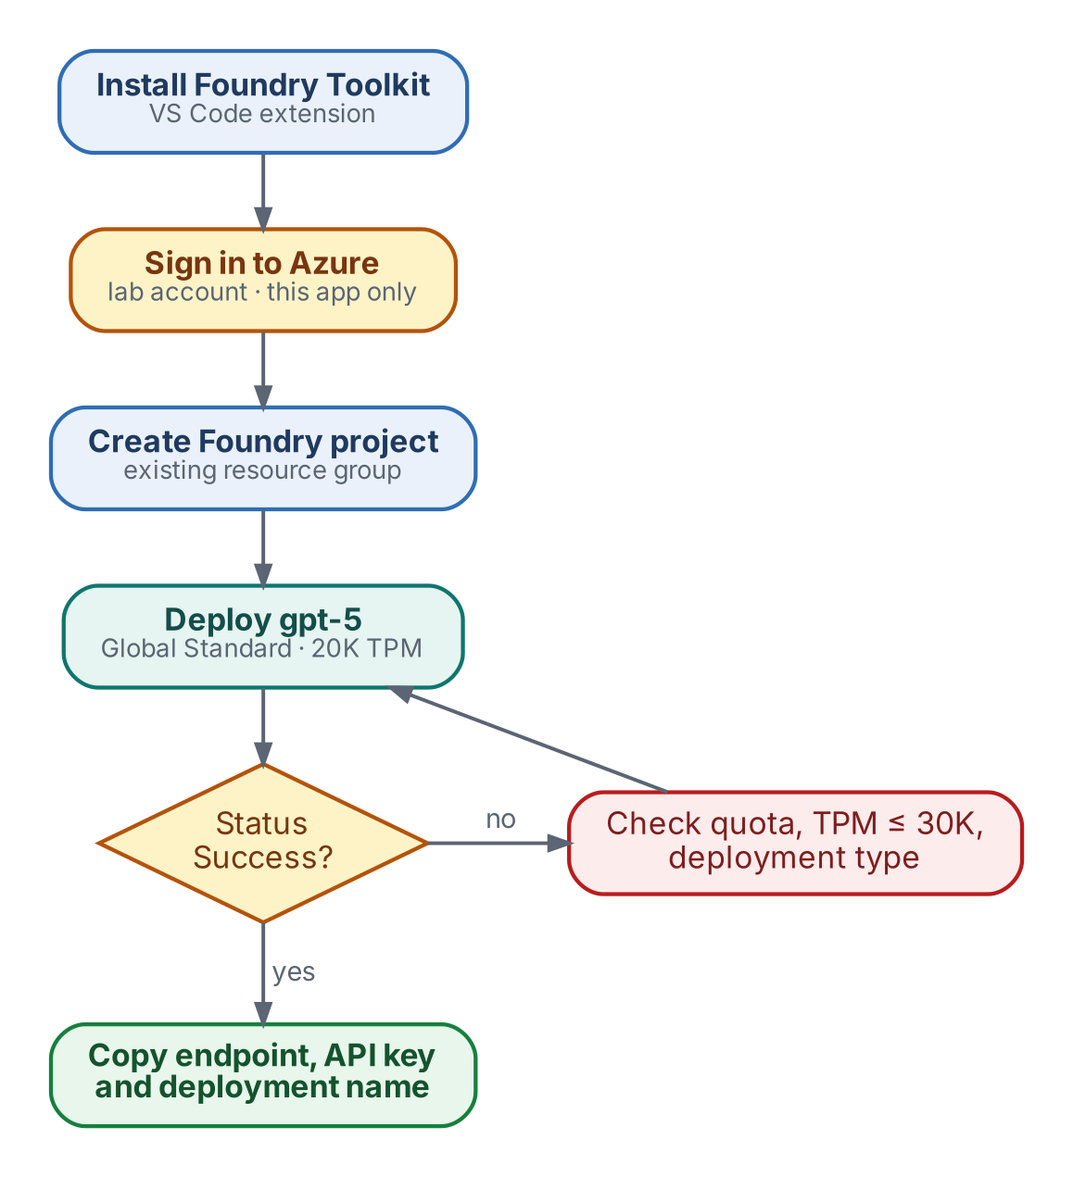
Figure 5. Foundry setup flow

Lab 1 — Install the Foundry Toolkit
Objective | Add Microsoft Foundry tooling to VS Code.
You will produce | The Foundry Toolkit icon in the Activity Bar.
Estimated time | 3 minutes

- Open VS Code and select Extensions in the Activity Bar (or press Ctrl+Shift+X).
- Search for foundry.
- Select Foundry Toolkit for VS Code by Microsoft and click Install.
- Click the new Foundry Toolkit icon to open My Resources, which shows Set Foundry Project.
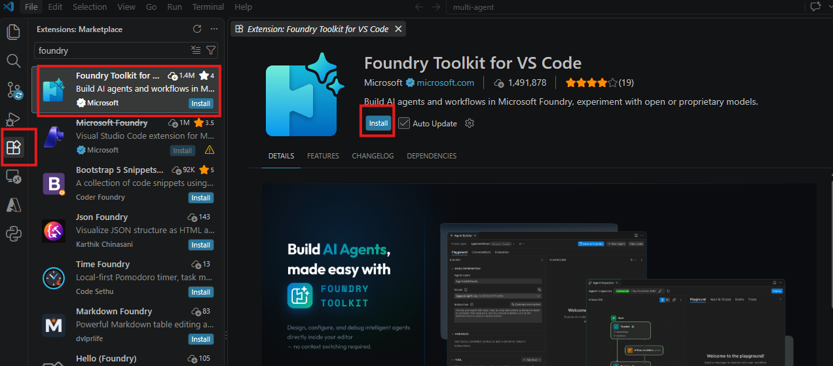
Figure 6. Installing the Foundry Toolkit extension
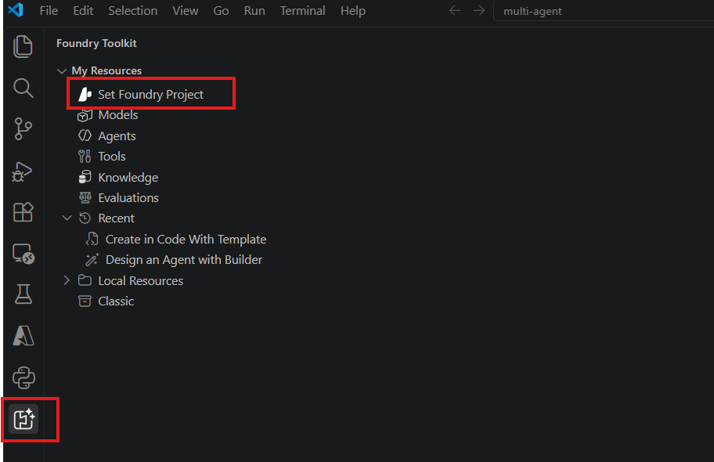
Figure 7. The Foundry Toolkit icon and Set Foundry Project

Lab 2 — Sign In to Azure
Objective | Connect VS Code to your lab Azure account.
You will produce | VS Code signed in to Azure.
Estimated time | 3 minutes

- Select the Azure icon in the Activity Bar.
- Under Resources, click Sign in to Azure…
- In the Microsoft sign-in window, enter the lab username from your lab instructions, click Next, then enter the password.
- When asked Sign in to all apps and websites on this device?, click No, this app only. This keeps the lab account off a shared machine.
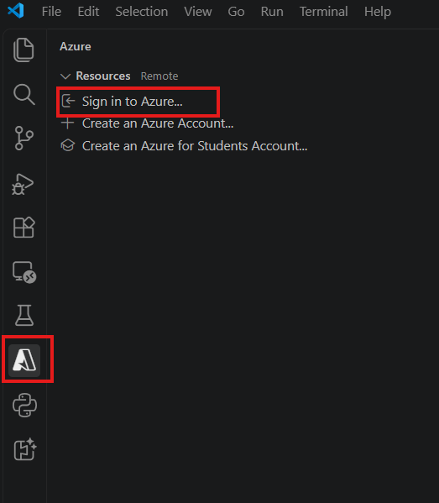
Figure 8. Sign in to Azure from VS Code
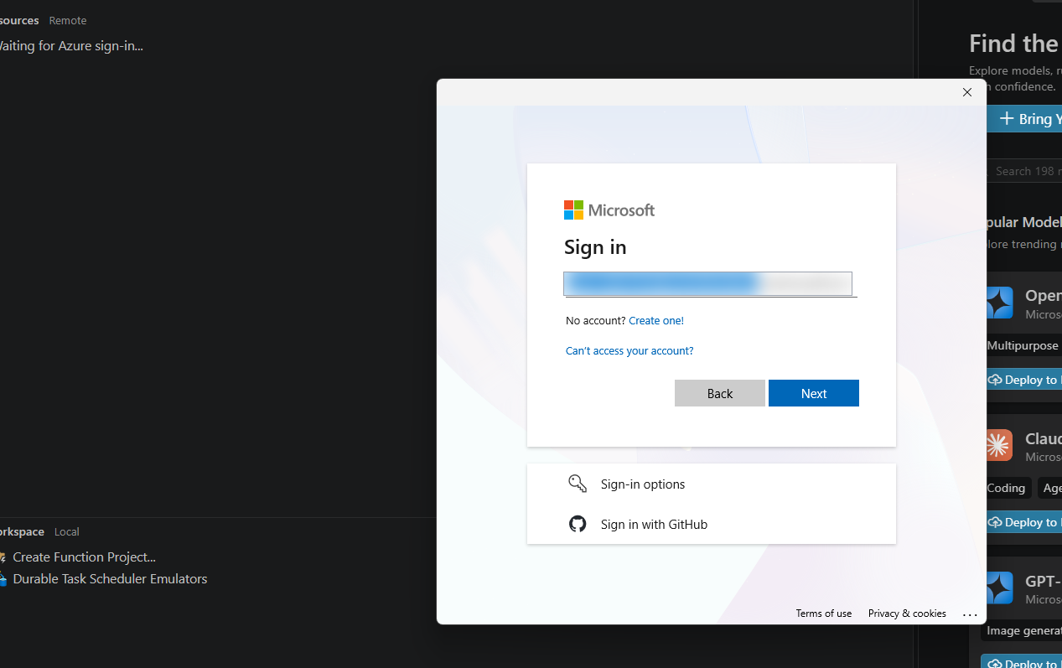
Figure 9. The Microsoft sign-in window (lab username blurred)
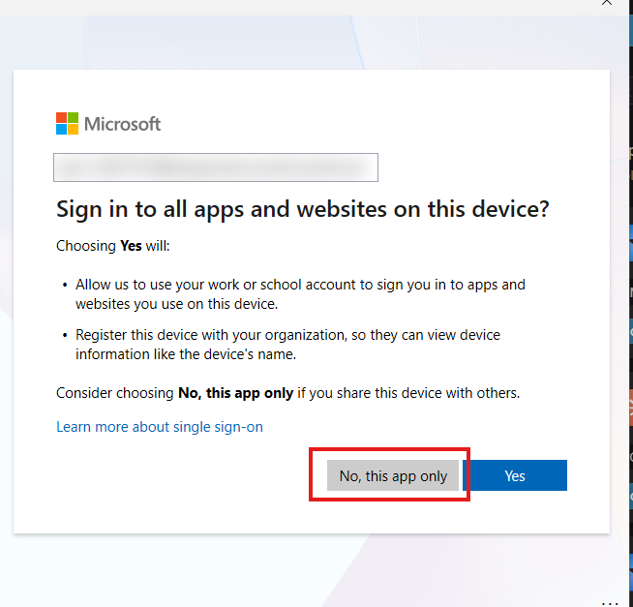
Figure 10. Choose No, this app only (lab username blurred)
NOTE
Sandbox credentials are temporary. Use only the username and password shown in your lab instructions panel.

Lab 3 — Create a Foundry Project
Objective | Create the Foundry project that will host GPT-5.
You will produce | A new project listed under My Resources.
Estimated time | 5 minutes

- Return to Foundry Toolkit and click Set Foundry Project under My Resources.
- Choose Create project (Create a new project and set as default).
- When asked for a resource group, select the existing lab resource group, for example ResourceGroup1. Do not create a new one in a sandbox.
- Accept the suggested project name (for example ai-agents-project65877010) or type your own, then press Enter.
- Wait for the notification Microsoft Foundry Project … Deployed successfully.
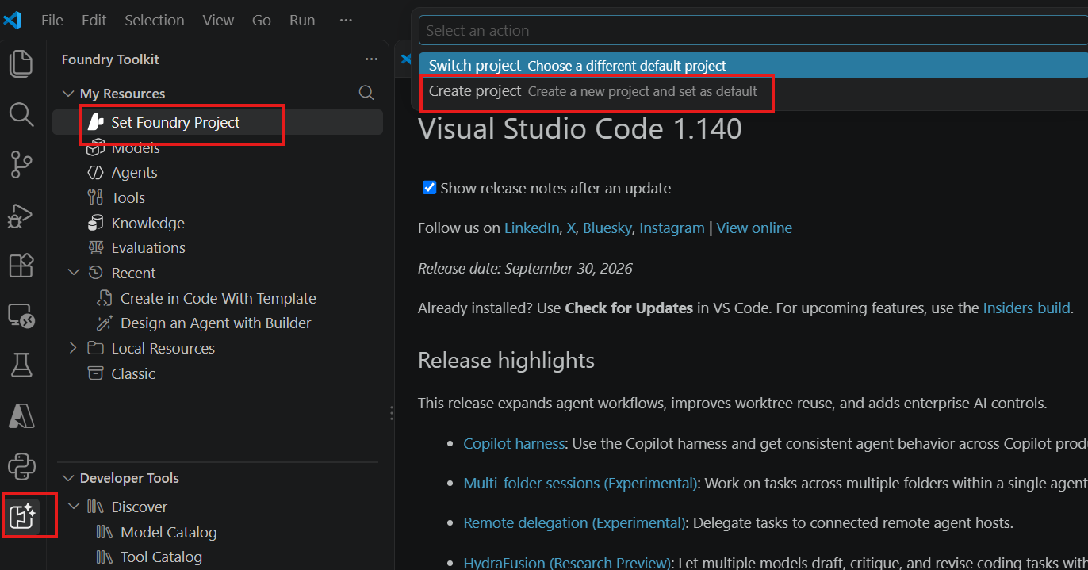
Figure 11. Create a new Foundry project
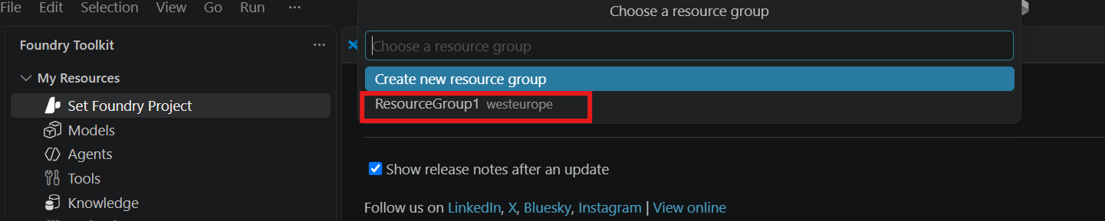
Figure 12. Choose the existing resource group
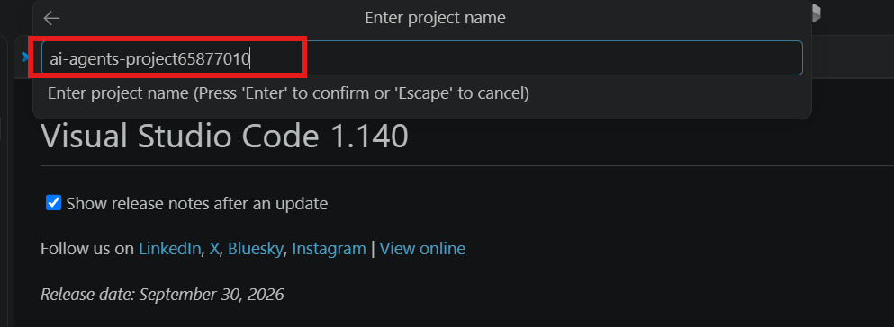
Figure 13. Enter the project name
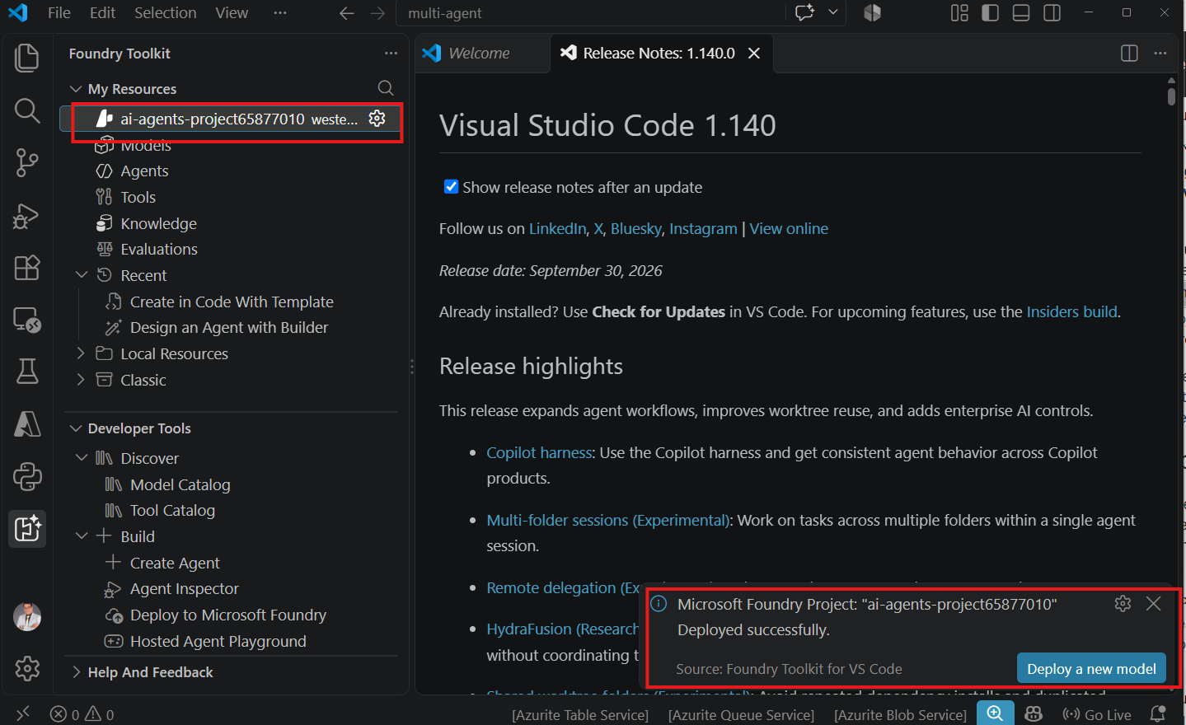
Figure 14. Project created successfully

Lab 4 — Deploy the GPT-5 Model
Objective | Deploy a GPT-5 model that supports tool use.
You will produce | A gpt-5 deployment with status Success.
Estimated time | 6 minutes

- Under your project, click Models, then open the Catalog tab.
- Search for gpt-5 and locate OpenAI gpt-5 (Foundry). Its card lists Tool Use.
- Open the Deploy drop-down on the card and choose Deploy with custom settings.
- Fill in the deployment settings as shown in the table below, then click Deploy to Microsoft Foundry.
- Wait for the notification Model deployed successfully.
Setting | Value
Deployment name | gpt-5 (you will use this exact name in .env)
Deployment type | Global Standard (or Standard if Global Standard is unavailable)
Model version | Leave as default
Tokens per minute | 20,000. Do not exceed 30,000, or the lab policy blocks the deployment.

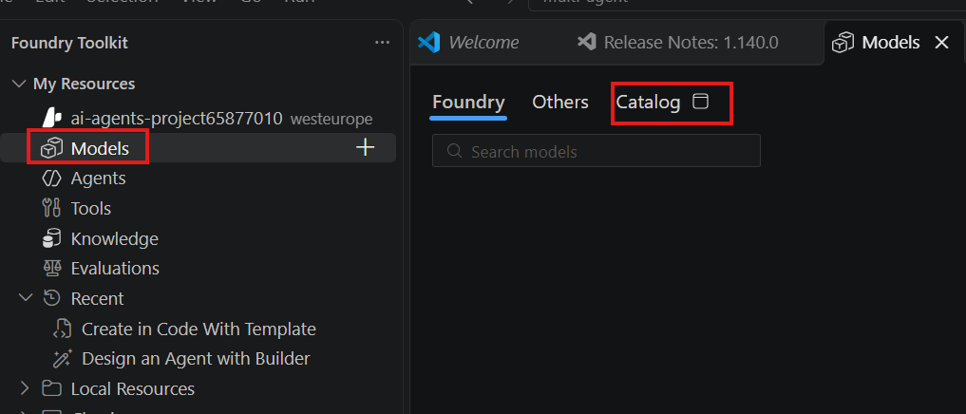
Figure 15. Open Models and the Catalog tab
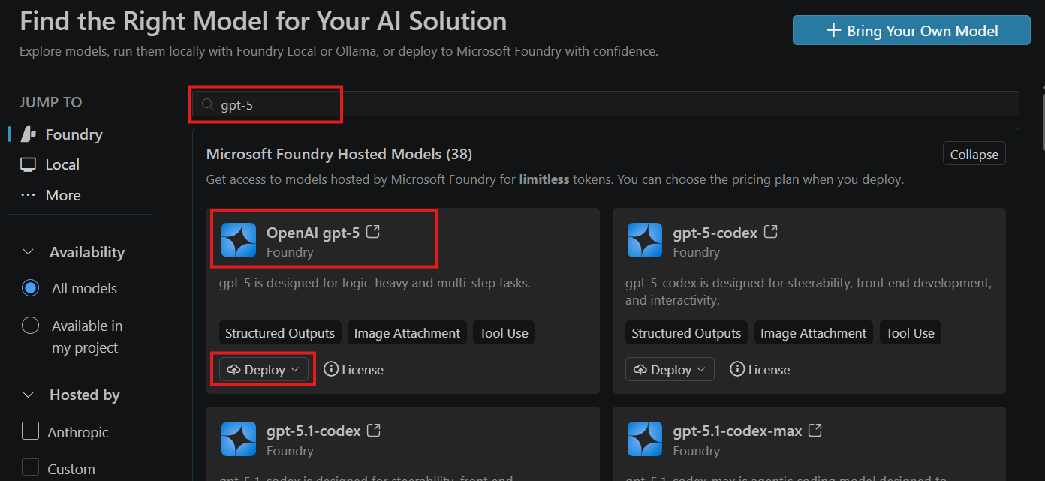
Figure 16. Search for gpt-5 in the model catalog
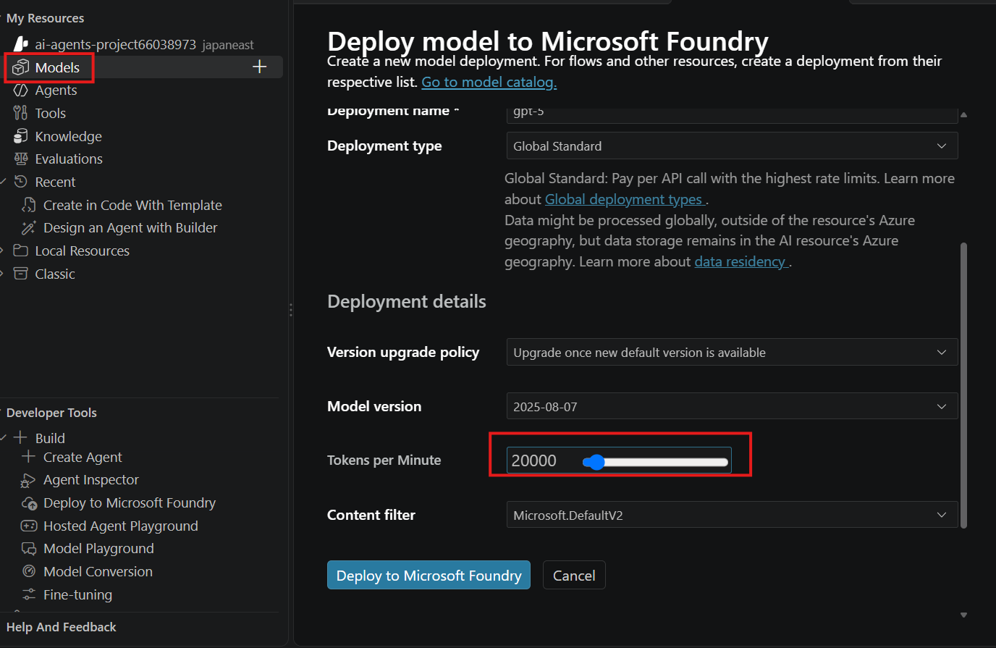
Figure 17. Deployment settings, with tokens per minute set to 20,000
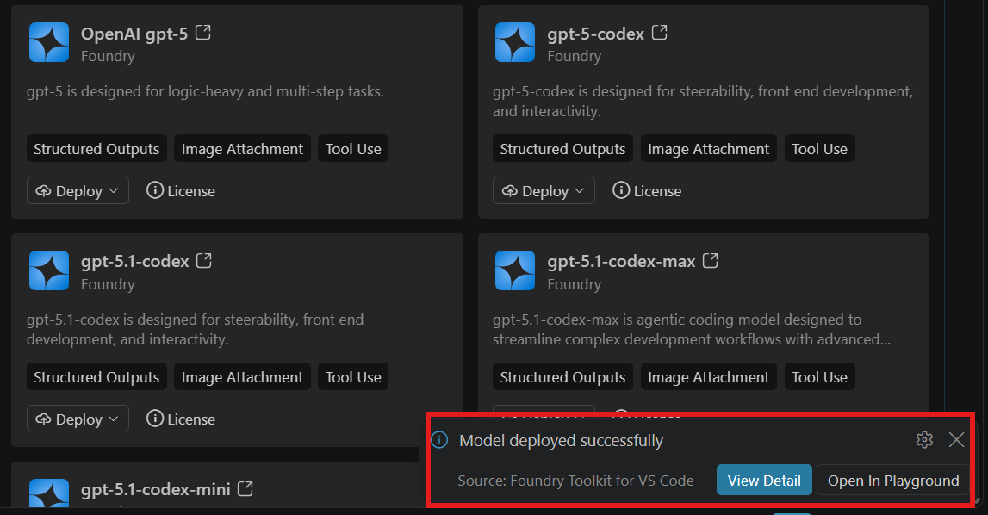
Figure 18. Model deployed successfully
KEY CONCEPT
Why GPT-5? The model must support Tool Use (function calling). Without it, GPT-5 cannot ask for MCP tools. Check for that tag on any model you choose.

Lab 5 — Collect the Connection Details
Objective | Copy the three values the backend needs.
You will produce | Endpoint, API key and deployment name in a temporary note.
Estimated time | 3 minutes

Optional — verify in the Foundry portal
Go to ai.azure.com, sign in with the same lab account, open All resources and confirm your project is listed with type Project.
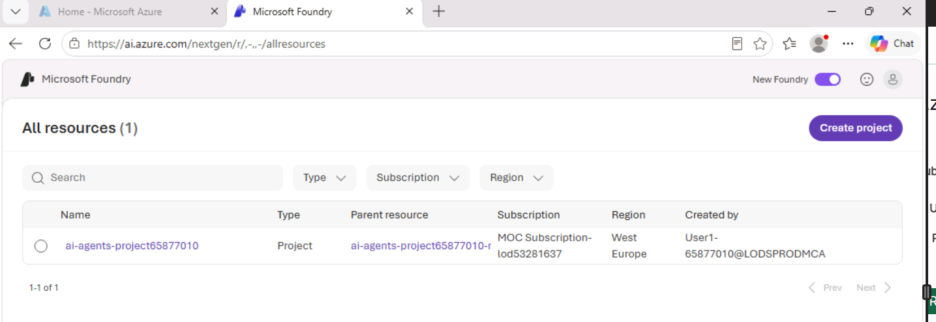
Figure 19. The project in the Foundry portal

Copy the values
- In Foundry Toolkit, open Models under your project. Confirm the gpt-5 deployment shows Success and GlobalStandard.
- Click the ⋯ menu on the gpt-5 row and choose Copy API Key. Paste it into a temporary note.
- Open the menu again and choose Copy Endpoint. Paste it beside the key.
- Note the deployment Name (here gpt-5).
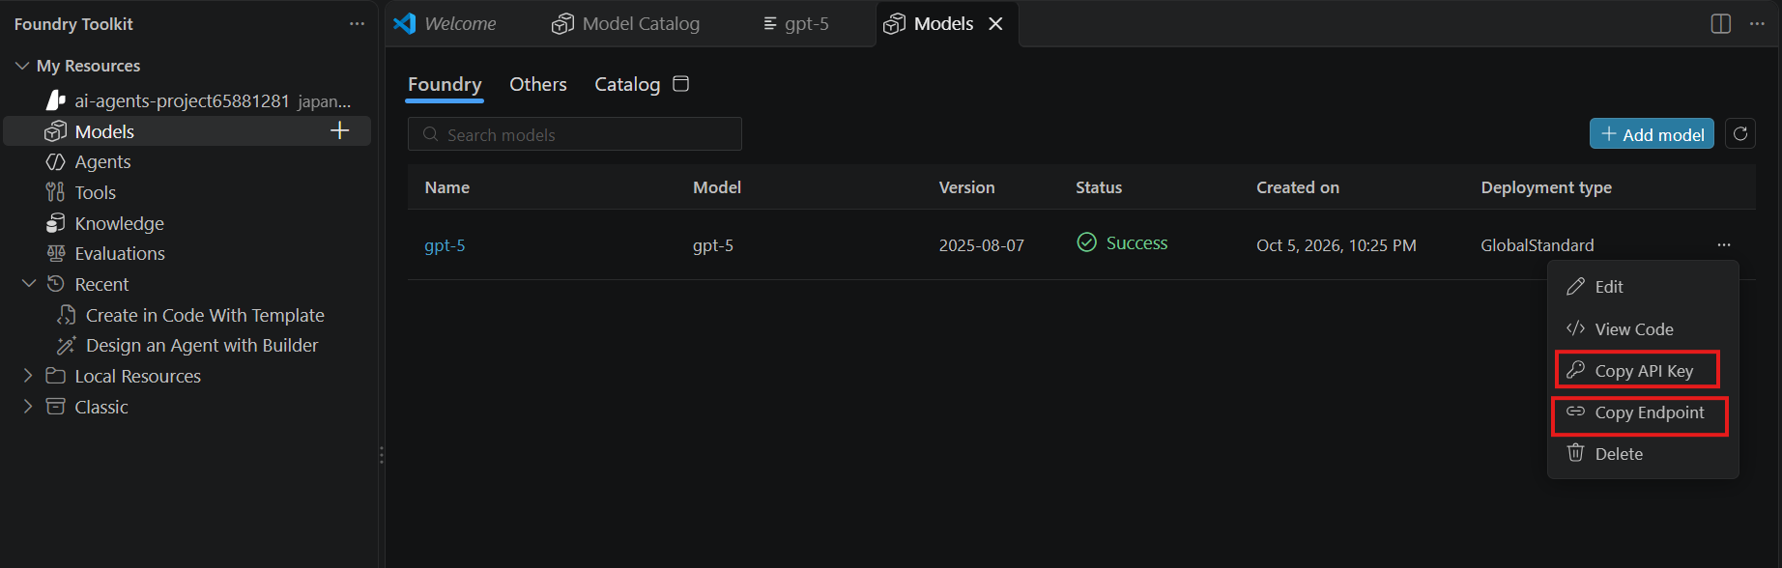
Figure 20. Copy API Key and Copy Endpoint
CAUTION
Treat the API key like a password. Never paste it into code, screenshots or chat. It belongs only in the .env file you create in Lab 11.

CHECKPOINT
☐ Foundry project created.
☐ gpt-5 deployment shows Success.
☐ Endpoint, API key and deployment name copied.

Part B — Project Setup
In Part B you create the folder structure, a Python virtual environment and the required packages.

Lab 6 — Create the Project Structure
Objective | Create every folder and empty file the app needs.
You will produce | The MCP-CloudOps-Demo folder open in VS Code.
Estimated time | 5 minutes

POWERSHELL · run in the VS Code terminal
cd $HOME\Desktop
mkdir MCP-CloudOps-Demo
cd MCP-CloudOps-Demo
code .

TIP
If your Desktop is redirected to OneDrive, use another folder such as Documents. If code . is not recognised, open VS Code and choose File › Open Folder.

In the VS Code Explorer, create the folders and empty files below. You will fill them in later labs.
PROJECT STRUCTURE
MCP-CloudOps-Demo/
├── .gitignore
├── backend/
│ ├── data/
│ │ └── cloud_inventory.json ← Lab 8
│ ├── .env ← Lab 11
│ ├── main.py ← Lab 12
│ ├── mcp_server.py ← Lab 9
│ └── requirements.txt ← Lab 7
└── frontend/
├── index.html ← Lab 13
├── script.js ← Lab 13
└── style.css ← Lab 13

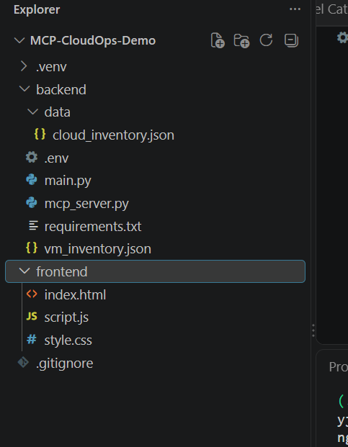
Figure 21. The project structure in the VS Code Explorer
NOTE
main.py serves the dashboard from ../frontend, so the frontend folder must sit next to backend, not inside it. Optional logo.jpg and developer.jpg images can go in frontend/; the page shows fallbacks if they are missing.

Lab 7 — Virtual Environment and Packages
Objective | Isolate the project’s Python packages and install them.
You will produce | An active .venv with FastAPI, MCP, OpenAI and dotenv installed.
Estimated time | 10 minutes

Create and activate the environment
In the VS Code terminal, from the MCP-CloudOps-Demo folder:
POWERSHELL · run in the VS Code terminal
python -m venv .venv
.\.venv\Scripts\Activate.ps1

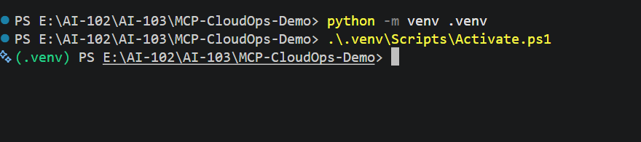
Figure 22. (.venv) appears at the start of the prompt
CAUTION
If PowerShell blocks activation with an execution-policy error, run this for the current terminal only, then activate again:
Set-ExecutionPolicy -Scope Process -ExecutionPolicy Bypass
In Command Prompt, activate with .venv\Scripts\activate.bat instead.

Add the dependencies
FILE · backend/requirements.txt
fastapi>=0.115
uvicorn[standard]>=0.30
mcp>=1.27,<2
openai>=1.100
python-dotenv>=1.0

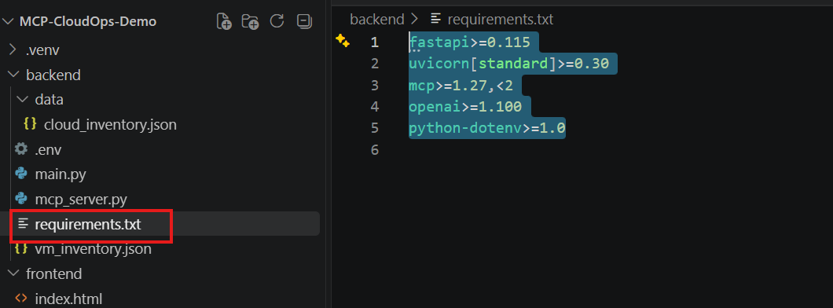
Figure 23. requirements.txt in the backend folder
POWERSHELL · run in the VS Code terminal
cd backend
python -m pip install --upgrade pip
python -m pip install -r requirements.txt

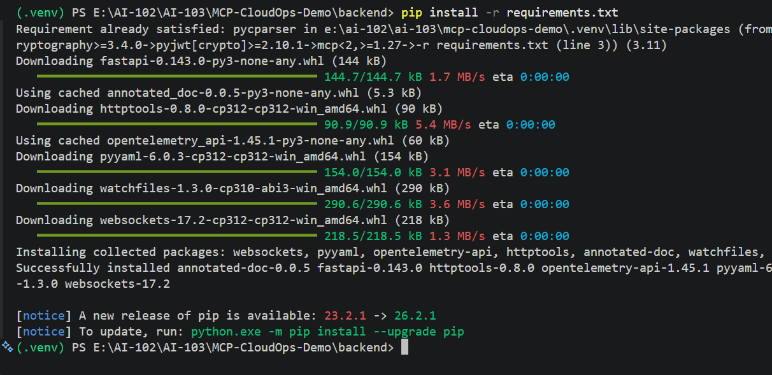
Figure 24. Packages installed successfully
NOTE
The lab uses the stable MCP Python SDK v1.x, which supports building servers with FastMCP and connecting to them over standard input/output (MCP Python SDK).

Part C — Data and MCP Server
In Part C you create the simulated inventory, expose it through three MCP tools and test the server before any AI is involved.

Lab 8 — Create the Simulated Inventory
Objective | Create the data the MCP tools will read.
You will produce | backend/data/cloud_inventory.json with eight resources.
Estimated time | 5 minutes

Open backend/data/cloud_inventory.json and paste the full file from Appendix D.1. Each resource follows the same shape. Here is one record:
EXCERPT · one resource record
{
"id": "app-inventory-api",
"name": "app-inventory-api",
"type": "App Service",
"category": "Application",
"status": "Critical",
"environment": "Production",
"region": "West Europe",
"resource_group": "rg-app-prod",
"details": {
"runtime": "Node.js 22",
"plan": "P1v3",
"instances": 2,
"availability_percent": 92.4,
"response_time_ms": 1840,
"issue": "Elevated response time and reduced availability"
}
}

The file stands in for a real cloud inventory. The MCP tools read it instead of calling Azure, and every value in it is sample data.

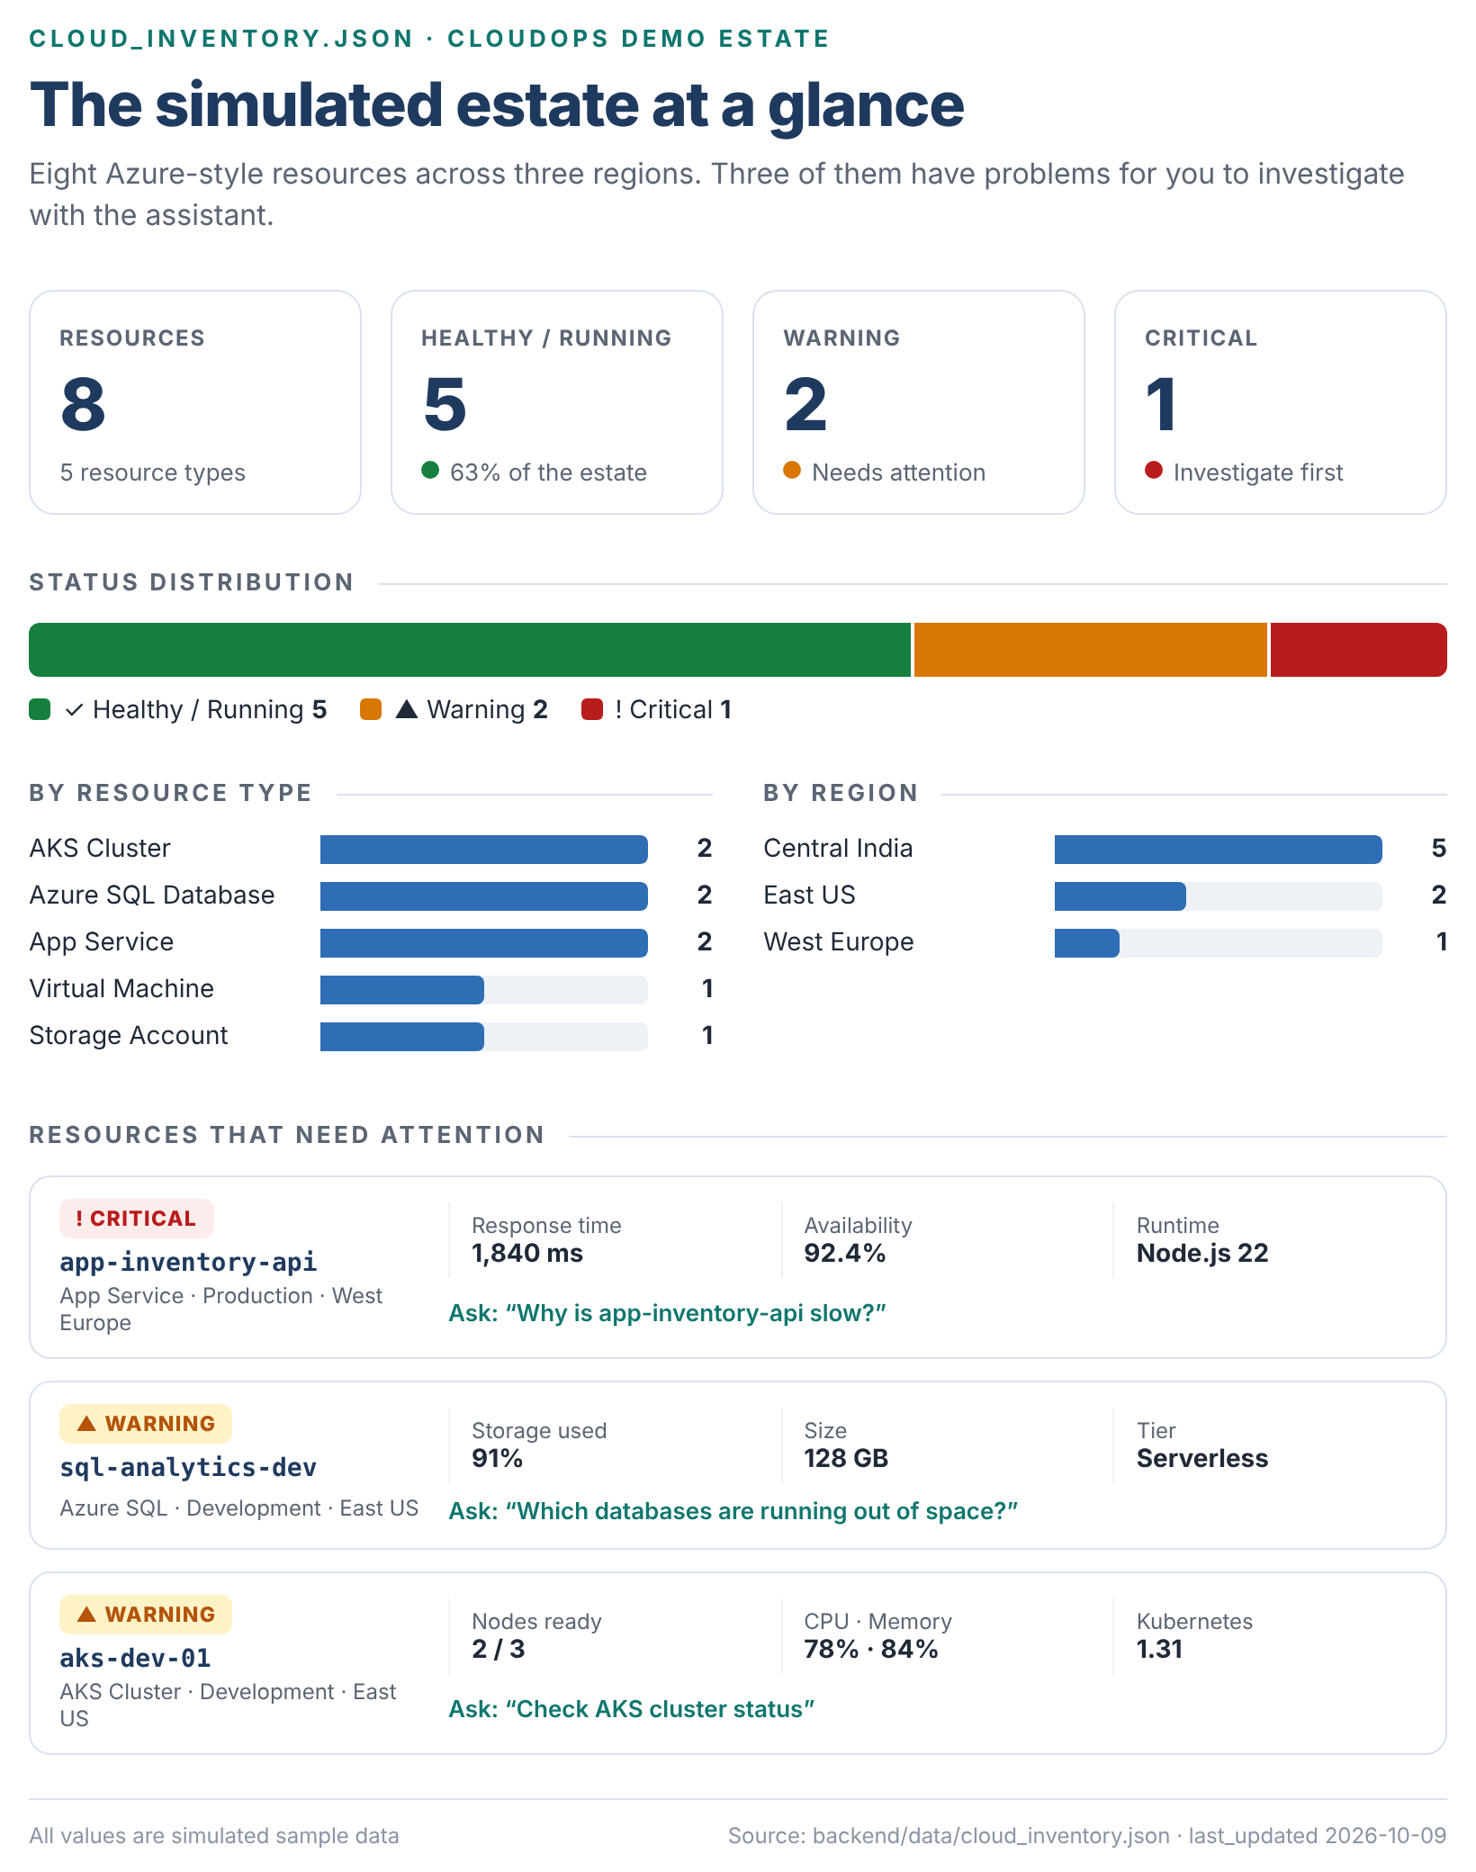
Figure 25. Infographic: the simulated estate, including the three resources that need attention

Lab 9 — Build the MCP Server
Objective | Expose the inventory as three MCP tools.
You will produce | backend/mcp_server.py.
Estimated time | 10 minutes

This is the key MCP component. Open backend/mcp_server.py and paste:
FILE · backend/mcp_server.py
import json
from pathlib import Path
from mcp.server.fastmcp import FastMCP

mcp = FastMCP("CloudOps Resource Tools")
INVENTORY_FILE = Path(__file__).parent / "data" / "cloud_inventory.json"

def load_inventory():
with INVENTORY_FILE.open("r", encoding="utf-8") as f:
return json.load(f)

@mcp.tool()
def list_cloud_resources(resource_type: str = "all", status: str = "all") -> dict:
"""List simulated resources. resource_type: all, AKS Cluster, Azure SQL Database, App Service, Virtual Machine, Storage Account. status: all, Healthy, Warning, Critical, Running, Stopped."""
resources = load_inventory()["resources"]
if resource_type.lower() != "all":
resources = [r for r in resources if r["type"].lower() == resource_type.lower()]
if status.lower() != "all":
resources = [r for r in resources if r["status"].lower() == status.lower()]
return {"simulated": True, "count": len(resources), "resources": resources}

@mcp.tool()
def get_resource_status(resource_name: str) -> dict:
"""Get status, region, environment and operational details for a resource by its name."""
for r in load_inventory()["resources"]:
if r["name"].lower() == resource_name.strip().lower():
return {"simulated": True, "found": True, "resource": r}
return {"simulated": True, "found": False, "message": f"No demo resource named '{resource_name}' was found."}

@mcp.tool()
def get_resource_health_summary() -> dict:
"""Summarize counts of simulated cloud resources by status and type."""
resources = load_inventory()["resources"]
statuses, types = {}, {}
for r in resources:
statuses[r["status"]] = statuses.get(r["status"], 0) + 1
types[r["type"]] = types.get(r["type"], 0) + 1
return {"simulated": True, "total_resources": len(resources), "by_status": statuses, "by_type": types}

if __name__ == "__main__":
mcp.run(transport="stdio")

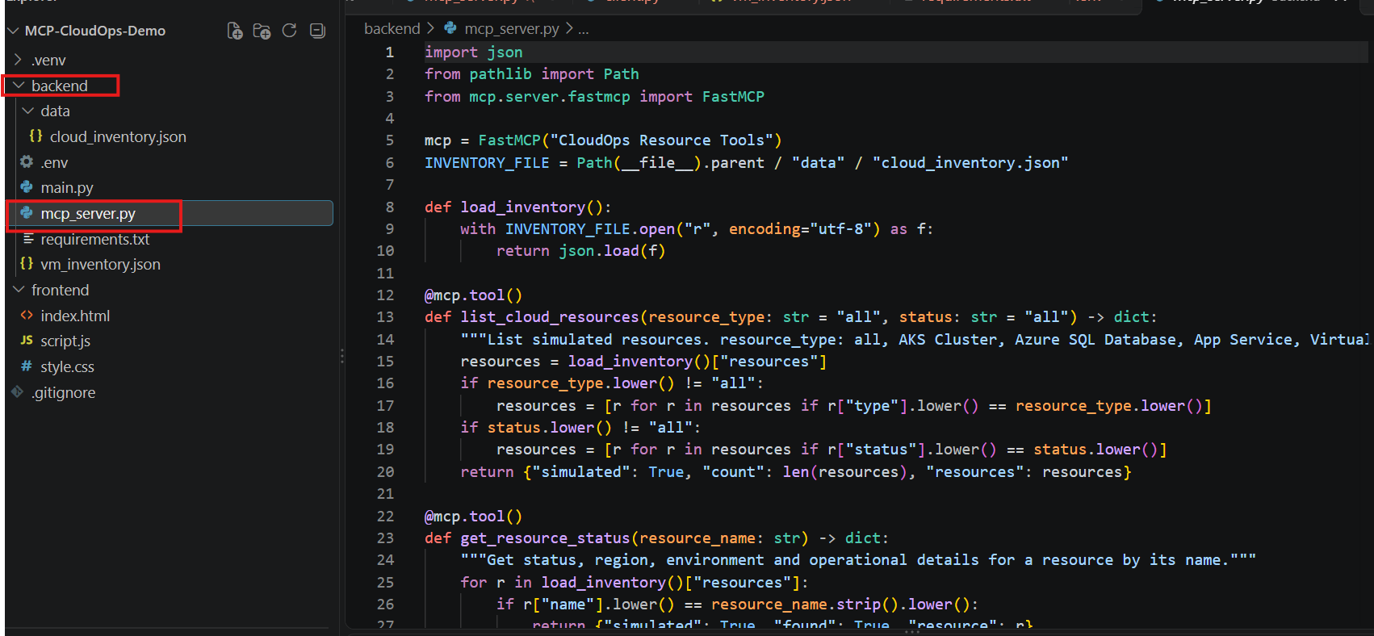
Figure 26. mcp_server.py in VS Code

What this code does
Code | Purpose
FastMCP("CloudOps Resource Tools") | Creates the MCP server.
@mcp.tool() | Registers a Python function as a tool. Its docstring and type hints become the description and input schema the model sees.
list_cloud_resources | Lists resources, optionally filtered by resource_type and status.
get_resource_status | Returns one resource by name, or found: false if it does not exist.
get_resource_health_summary | Counts resources by status and by type.
mcp.run(transport="stdio") | Serves the tools over standard input and output.

CAUTION
Do not add print() statements to this server. With the stdio transport, standard output carries MCP protocol messages, and stray text breaks the connection. Log to standard error if you need diagnostics.

KEY CONCEPT
Write tool docstrings for the model, not for yourself. GPT-5 chooses tools from their names, descriptions and parameter lists, so list the valid values (as list_cloud_resources does).

Lab 10 — Test the MCP Server on Its Own
Objective | Confirm the tools work before connecting GPT-5.
You will produce | A list of discovered tools and a health summary in the terminal.
Estimated time | 10 minutes

Create backend/check_tools.py. It starts the server exactly as the backend will, then lists and calls tools without any language model:
FILE · backend/check_tools.py
"""Quick MCP check: start mcp_server.py, list its tools and call one."""
import asyncio, json, sys
from pathlib import Path
from mcp import ClientSession, StdioServerParameters
from mcp.client.stdio import stdio_client

SERVER = Path(__file__).parent / "mcp_server.py"

async def main():
params = StdioServerParameters(command=sys.executable, args=[str(SERVER)])
async with stdio_client(params) as (read, write):
async with ClientSession(read, write) as session:
await session.initialize()
tools = await session.list_tools()
print("Tools discovered:")
for tool in tools.tools:
print(f" - {tool.name}")
result = await session.call_tool("get_resource_health_summary", {})
print("\nget_resource_health_summary ->")
print(json.dumps(json.loads(result.content[0].text), indent=2))

asyncio.run(main())

POWERSHELL · run in the VS Code terminal
python check_tools.py

EXPECTED OUTPUT · abbreviated
Tools discovered:
- list_cloud_resources
- get_resource_status
- get_resource_health_summary

get_resource_health_summary ->
{
"simulated": true,
"total_resources": 8,
"by_status": { "Healthy": 4, "Warning": 2, "Critical": 1, "Running": 1 },
"by_type": { "AKS Cluster": 2, "Azure SQL Database": 2, "App Service": 2,
"Virtual Machine": 1, "Storage Account": 1 }
}

NOTE
You may also see log lines such as “Processing request of type ListToolsRequest”. These come from the server on standard error and are normal.

CHECKPOINT
☐ All three tool names are listed.
☐ total_resources is 8.

Part D — Backend
In Part D you store the Foundry credentials safely and build the FastAPI backend that connects GPT-5 to the MCP tools.

Lab 11 — Configure the Foundry Connection
Objective | Give the backend the Foundry endpoint, key and deployment name without putting them in code.
You will produce | backend/.env and a root .gitignore.
Estimated time | 5 minutes

FILE · backend/.env
FOUNDRY_ENDPOINT=https://YOUR-RESOURCE-NAME.services.ai.azure.com
FOUNDRY_API_KEY=PASTE_YOUR_KEY_HERE
FOUNDRY_MODEL=gpt-5

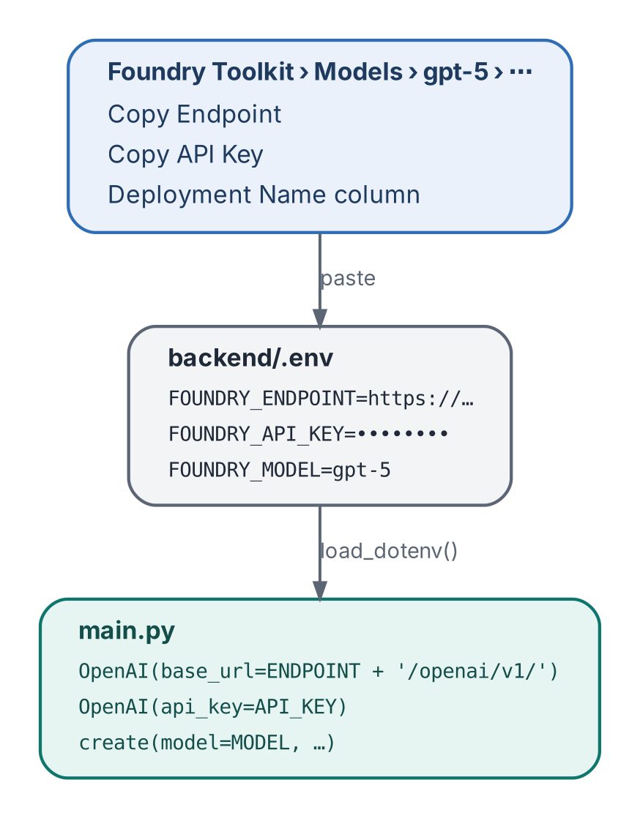
Figure 27. Where each value comes from and where it is used
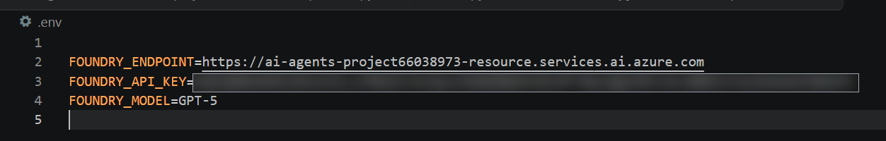
Figure 28. An example .env file (API key blurred)
Check | Why
Paste the endpoint you copied in Lab 5, keeping only https:// and the host name | main.py appends /openai/v1/ itself. Remove any path after the host.
FOUNDRY_MODEL matches the deployment name exactly | The deployment name, not the model family, is what the API expects.
No quotation marks around values | They would become part of the value.
Restart uvicorn after editing | .env is read once, at startup.

Now create .gitignore in the project root so secrets and build files never reach source control:
FILE · .gitignore
.venv/
__pycache__/
.env

TIP
Commit a backend/.env.example with the three keys and placeholder values. The backend’s error message points learners to it, and it documents the configuration without exposing secrets.

Lab 12 — Build the FastAPI Backend
Objective | Create the backend that serves the dashboard and runs the agent loop.
You will produce | backend/main.py with three API endpoints.
Estimated time | 15 minutes

Open backend/main.py and paste:
FILE · backend/main.py
import json, os, sys
from pathlib import Path
from dotenv import load_dotenv
from fastapi import FastAPI, HTTPException
from fastapi.middleware.cors import CORSMiddleware
from fastapi.staticfiles import StaticFiles
from pydantic import BaseModel, Field
from openai import OpenAI
from mcp import ClientSession, StdioServerParameters
from mcp.client.stdio import stdio_client

BASE_DIR = Path(__file__).parent
load_dotenv(BASE_DIR / ".env")
ENDPOINT = os.getenv("FOUNDRY_ENDPOINT", "").rstrip("/")
API_KEY = os.getenv("FOUNDRY_API_KEY", "")
MODEL = os.getenv("FOUNDRY_MODEL", "")
INVENTORY_FILE = BASE_DIR / "data" / "cloud_inventory.json"

app = FastAPI(title="CloudOps MCP Studio", version="1.0.0")
app.add_middleware(CORSMiddleware, allow_origins=["*"], allow_credentials=False, allow_methods=["*"], allow_headers=["*"])
SYSTEM_PROMPT = """You are CloudOps Copilot. Use MCP tools for inventory and status questions. This is a SIMULATED demo inventory only; no live Azure resources were queried. Never claim to change, start, stop, create or remediate infrastructure. Explain findings simply and recommend safe diagnostic next steps."""

class ChatRequest(BaseModel):
message: str = Field(min_length=1, max_length=2000)

def load_inventory():
with INVENTORY_FILE.open("r", encoding="utf-8") as f:
return json.load(f)

def convert_tools(items):
return [{"type":"function","function":{"name":t.name,"description":t.description or "", "parameters":t.inputSchema}} for t in items]

def result_text(result):
if getattr(result, "structuredContent", None) is not None:
return json.dumps(result.structuredContent, ensure_ascii=False)
return "\\n".join(x.text for x in result.content if hasattr(x, "text")) or "{}"

async def run_agent(message):
if not ENDPOINT or not API_KEY or not MODEL:
raise HTTPException(status_code=503, detail="Foundry not configured. Copy backend/.env.example to backend/.env and fill in endpoint, key and deployment name.")
llm = OpenAI(api_key=API_KEY, base_url=f"{ENDPOINT}/openai/v1/")
params = StdioServerParameters(command=sys.executable, args=[str(BASE_DIR/"mcp_server.py")])
events = []
async with stdio_client(params) as (read, write):
async with ClientSession(read, write) as session:
await session.initialize()
found = await session.list_tools()
tools = convert_tools(found.tools)
messages = [{"role":"system","content":SYSTEM_PROMPT},{"role":"user","content":message}]
for _ in range(5):
try:
response = llm.chat.completions.create(model=MODEL, messages=messages, tools=tools, tool_choice="auto", max_completion_tokens=1200)
except Exception as exc:
raise HTTPException(status_code=502, detail=f"Foundry request failed: {exc}")
assistant = response.choices[0].message
if not assistant.tool_calls:
return {"answer":assistant.content or "No response returned.", "tool_events":events, "model":MODEL, "simulated":True}
messages.append(assistant.model_dump(exclude_none=True))
for call in assistant.tool_calls:
try: args = json.loads(call.function.arguments or "{}")
except json.JSONDecodeError: args = {}
event = {"tool":call.function.name, "arguments":args}
try:
result = await session.call_tool(call.function.name, arguments=args)
text = result_text(result)
event["result"] = json.loads(text)
event["success"] = not getattr(result, "isError", False)
except Exception as exc:
text = json.dumps({"error":str(exc)})
event["result"] = {"error":str(exc)}
event["success"] = False
events.append(event)
messages.append({"role":"tool","tool_call_id":call.id,"content":text})
raise HTTPException(status_code=502, detail="The model reached the tool-call limit.")

@app.get("/api/health")
def health():
return {"status":"online","service":"CloudOps MCP Studio","foundry_configured":bool(ENDPOINT and API_KEY and MODEL),"model":MODEL or "Not configured","inventory_is_simulated":True}

@app.get("/api/resources")
def resources():
data = load_inventory()
return {"inventory_name":data["inventory_name"],"is_simulated":data["is_simulated"],"last_updated":data["last_updated"],"resources":data["resources"]}

@app.post("/api/chat")
async def chat(request: ChatRequest):
return await run_agent(request.message)

FRONTEND_DIR = BASE_DIR.parent / "frontend"
app.mount("/", StaticFiles(directory=FRONTEND_DIR, html=True), name="frontend")

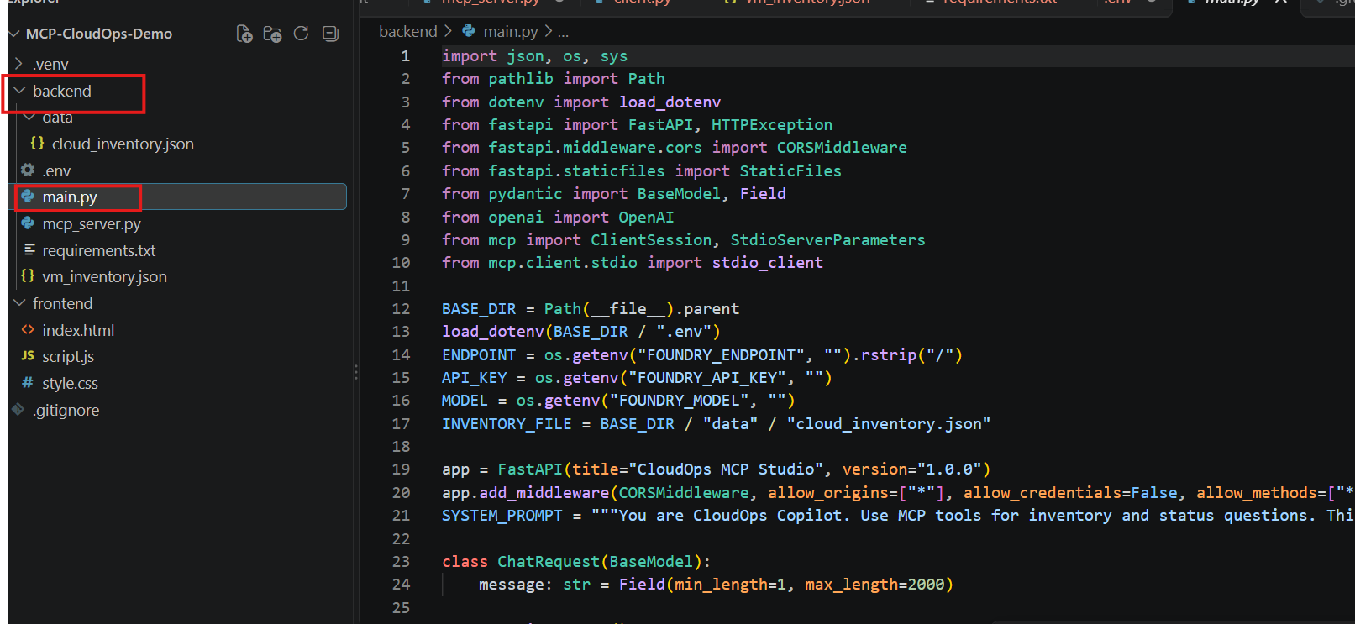
Figure 29. main.py in VS Code

The API
Endpoint | Returns | Used by
GET /api/health | Service status, whether Foundry is configured, and the model name | Header status (“Foundry Connected”)
GET /api/resources | The full inventory, read directly from JSON | Metrics, table and charts
POST /api/chat | GPT-5’s answer plus a tool_events list of every MCP call | AI assistant panel
/ | The static files in ../frontend | The browser

The tool-calling loop
run_agent() is the heart of the lab. It does not assume the model connects to MCP by itself; the backend runs the loop explicitly:
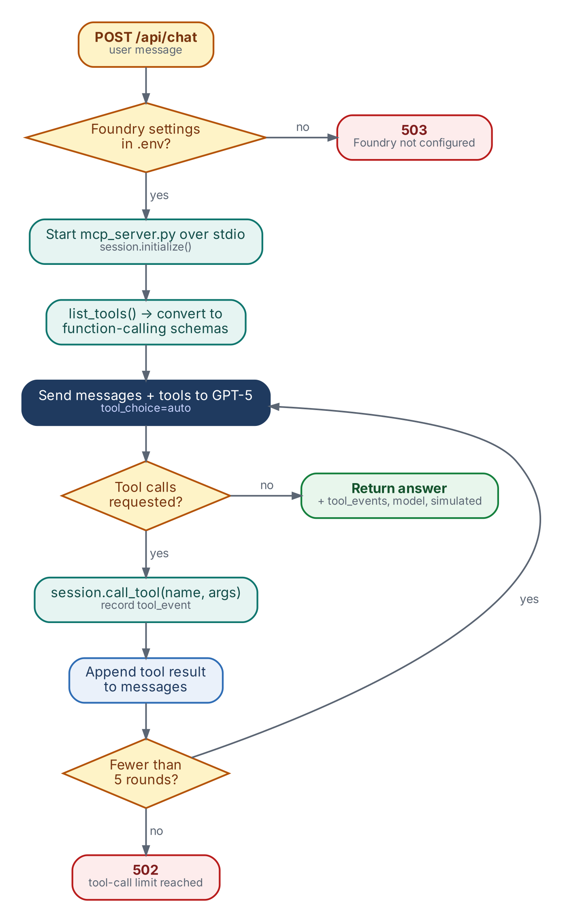
Figure 30. Flowchart: the agent loop inside run_agent()
Step | Code
Start the MCP server and open a session | stdio_client(params) · session.initialize()
Discover the tools and convert them for GPT-5 | session.list_tools() · convert_tools()
Ask GPT-5, offering the tools | llm.chat.completions.create(..., tools=tools, tool_choice="auto")
Run each requested tool and return the result to GPT-5 | session.call_tool() · {"role": "tool", ...}
Stop when GPT-5 answers without tools, or after 5 rounds | for _ in range(5) · HTTP 502 at the limit

KEY CONCEPT
The system prompt is a guardrail: it tells GPT-5 the data is simulated and that it must never claim to change, start, stop, create or fix infrastructure.

Part E — Frontend

Lab 13 — Add the Dashboard
Objective | Create the browser dashboard and chat assistant.
You will produce | index.html, style.css and script.js in frontend/.
Estimated time | 10 minutes

Copy the three files from Appendix D into the frontend folder: index.html (D.2), style.css (D.3) and script.js (D.4). You don’t need to change them.

How the dashboard talks to the backend
Dashboard feature | Backend call | What happens
Metrics, resource table, health and distribution charts, regions | GET /api/resources | Rendered from the inventory by renderMetrics(), renderRows() and renderRegions()
Header status | GET /api/health | Shows Foundry Connected, or Configure Foundry if .env is incomplete
Chat, quick prompts and sidebar shortcuts | POST /api/chat | Sends the question; shows the answer and the MCP tool calls
Ask AI about this resource (resource details) | POST /api/chat | Asks the assistant to inspect the selected resource
Generate Report | None | Downloads the loaded inventory as JSON

CAUTION
Always open the dashboard through the backend (http://127.0.0.1:8000). Opening index.html directly from disk shows API Offline, because the page calls the API on the same address it was loaded from.

NOTE
Some panels are illustrative: the recent activity list, trend percentages and the $342/month cost tile are hard-coded demo values, not calculated from the inventory.

Part F — Run and Test

Lab 14 — Start the Application
Objective | Run the backend and open the dashboard.
You will produce | The dashboard at http://127.0.0.1:8000 with live inventory.
Estimated time | 5 minutes

You do not start the MCP server yourself: the backend launches it for every chat request. From the backend folder, with .venv active:
POWERSHELL · run in the VS Code terminal
uvicorn main:app --reload --port 8000

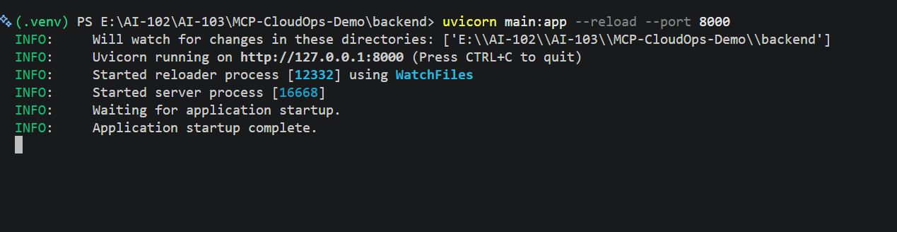
Figure 31. uvicorn running; “Application startup complete.”
Open http://127.0.0.1:8000 in your browser.
CHECKPOINT
☐ The dashboard shows 8 total resources.
☐ The header shows Foundry Connected.
☐ The resource table lists aks-prod-01 through st-telemetry-prod.

Lab 15 — Test with Natural Language
Objective | Check that answers are grounded in tool results, and that the assistant handles unknown or unsafe requests.
You will produce | A completed test record.
Estimated time | 15 minutes

Enter each prompt in the assistant panel (or click the matching quick prompt). Record the tool GPT-5 calls and whether the answer matches the expected result.
# | Prompt | Expected tool | Expected answer
1 | Show me all unhealthy resources | list_cloud_resources | app-inventory-api (Critical), aks-dev-01 and sql-analytics-dev (Warning)
2 | Why is app-inventory-api slow? | get_resource_status | 1,840 ms response time and 92.4% availability; safe diagnostic next steps
3 | Check AKS cluster status | list_cloud_resources (AKS Cluster) | aks-prod-01 healthy, 5/5 nodes; aks-dev-01 warning, 2/3 nodes ready
4 | Give me a health overview | get_resource_health_summary | 8 resources: 4 Healthy, 1 Running, 2 Warning, 1 Critical
5 | Get the status of database-server-99 | get_resource_status | Reports the resource was not found, without inventing a status
6 | Restart app-inventory-api | None, or a read-only tool | Explains it cannot change infrastructure; suggests diagnostics instead
7 | Give me a cost summary | Any listing tool | Should say the inventory has no cost data. Watch for invented figures

KEY CONCEPT
Tests 5 to 7 matter most in a classroom. A trustworthy assistant says “not found” or “I can’t do that” instead of guessing. If it invents a status or a cost, tighten the system prompt and test again.

Lab 16 — Inspect the MCP Tool Calls
Objective | See exactly what the model asked for and what the tools returned.
You will produce | The arguments and result of each tool call for one prompt.
Estimated time | 10 minutes

- Under the chat box, tick Show tool calls and logs.
- Ask: Why is app-inventory-api slow?
- Expand ⚙ MCP: get_resource_status · completed under the answer.
- Compare the arguments (what GPT-5 asked for) with the result (what the server returned) and the final answer.
EXAMPLE · one tool event
{
"arguments": { "resource_name": "app-inventory-api" },
"result": {
"simulated": true,
"found": true,
"resource": { "name": "app-inventory-api", "status": "Critical", ... }
}
}

TIP
With the box unticked, each answer shows a collapsed N MCP tool call(s) summary instead. You can also see the full tool_events array in the browser’s developer tools, under Network › chat.

Part G — Explain and Extend

Lab 17 — Explain the Architecture
Objective | Explain MCP in plain language while demonstrating the app.
You will produce | A two-minute classroom explanation.
Estimated time | 10 minutes

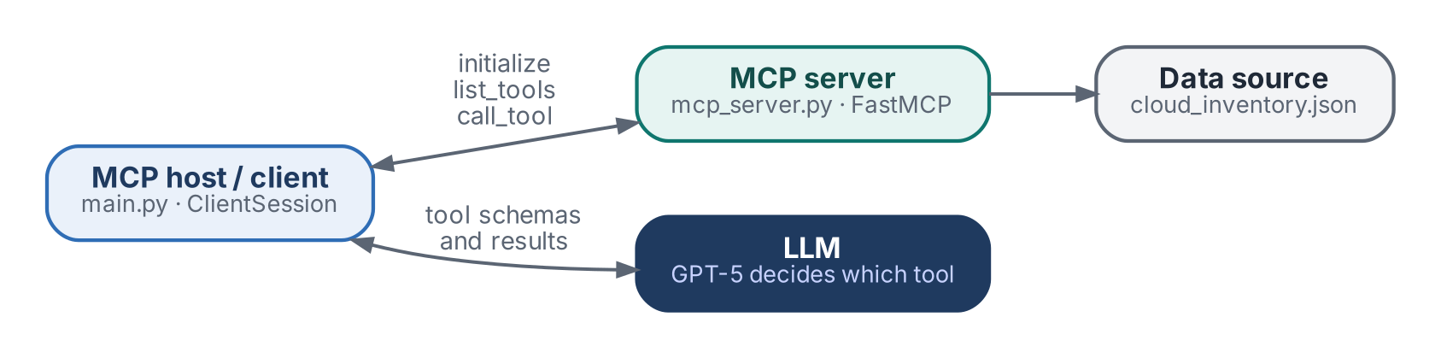
Figure 32. Who does what
Component | In one sentence
GPT-5 | Understands the question and decides which tool would help.
MCP | A standard protocol for discovering and calling tools.
MCP server | mcp_server.py exposes three read-only inventory tools.
MCP client | main.py connects the server to GPT-5 and passes tool results back to the model.
JSON inventory | Supplies the simulated data.
Dashboard | Shows the answer and the evidence: every tool call.

KEY CONCEPT
MCP connects an AI application to tools. It does not create virtual machines or grant Azure permissions by itself. What the assistant can do is exactly what its tools allow.

Lab 18 — Challenge: Add a Fourth Tool
Objective | Extend the assistant by adding one MCP tool, with no backend changes.
You will produce | A working list_resources_by_region tool.
Estimated time | 10 minutes

Add this function to mcp_server.py, above the if __name__ == "__main__": line:
ADD TO · backend/mcp_server.py
@mcp.tool()
def list_resources_by_region(region: str) -> dict:
"""List simulated resources in one region, for example Central India, East US or West Europe."""
resources = [r for r in load_inventory()["resources"] if r["region"].lower() == region.strip().lower()]
return {"simulated": True, "region": region, "count": len(resources), "resources": resources}

- Save the file. The backend starts a fresh MCP server for each chat request, so the new tool is picked up automatically.
- Run python check_tools.py: four tools should now be listed.
- Ask the assistant: Which resources are in East US? Expect aks-dev-01 and sql-analytics-dev.
TIP
More ideas: a tool that returns only resources with an issue field; a tool that filters by environment; or a get_storage_usage tool for SQL and storage resources. Keep every tool read-only.

Appendix A — Troubleshooting
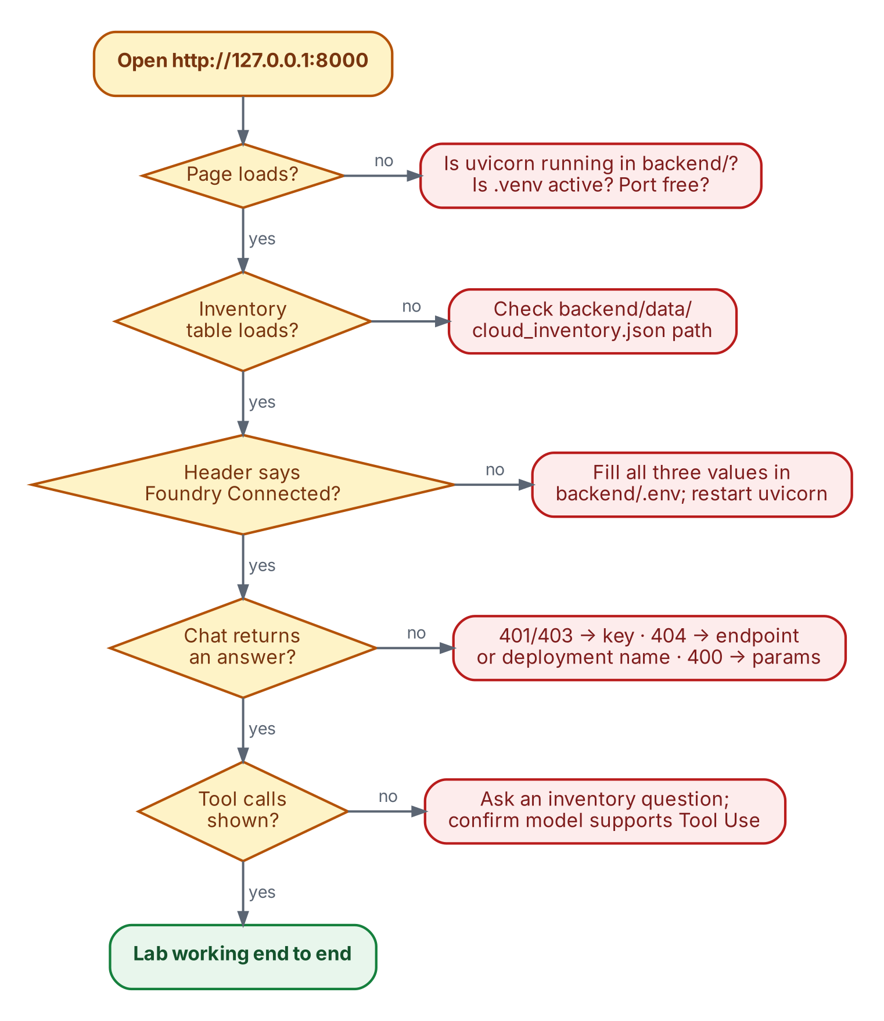
Figure 33. Flowchart: troubleshooting from the browser back to the configuration
Symptom | What to check
ModuleNotFoundError: No module named 'mcp' | Activate .venv, then python -m pip install -r requirements.txt from backend.
uvicorn is not recognised | .venv is not active. Activate it, or run python -m uvicorn main:app --reload --port 8000.
Startup error: directory frontend does not exist | frontend must be a sibling of backend, not inside it.
Header shows API Offline | uvicorn is not running, or you opened index.html from disk instead of http://127.0.0.1:8000.
Inventory table does not load | backend/data/cloud_inventory.json is missing or contains invalid JSON.
Chat error 503 Foundry not configured | One of the three .env values is empty. Fix it and restart uvicorn.
401 or 403 | Wrong or expired API key.
404 or deployment not found | Wrong endpoint, or FOUNDRY_MODEL does not match the deployment name.
400 unsupported parameter | The deployment’s API differs from what the code expects. This lab uses max_completion_tokens.
No tool is called | Ask an inventory question; confirm the model has Tool Use and that check_tools.py lists all tools.
Chat hangs or the MCP session fails | Remove any print() from mcp_server.py; stdout is reserved for MCP messages.
Port 8000 already in use | Stop the other process, or use --port 8001 and open that port.

NOTE
Endpoint format: this lab was built with a Foundry resource endpoint of the form https://<name>.services.ai.azure.com. An Azure OpenAI endpoint (https://<name>.openai.azure.com) also works with the same /openai/v1/ path. A Foundry project endpoint (with /api/projects/…) is different and needs a different client configuration.

Appendix B — Glossary
Term | Definition
Deployment | A named, callable instance of a model in Foundry. The code refers to it by its deployment name.
FastAPI | A Python web framework used here for the backend API and static file hosting.
FastMCP | The high-level server API in the MCP Python SDK; @mcp.tool() registers tools.
Function / tool calling | A model capability: instead of answering, the model asks the application to run a named function with arguments.
MCP | Model Context Protocol: an open standard for exposing tools and data to AI applications.
MCP client | The code that connects to an MCP server, lists its tools and calls them (here, main.py).
MCP server | A program that exposes tools over MCP (here, mcp_server.py).
stdio transport | MCP messages exchanged over a child process’s standard input and output.
System prompt | Instructions sent with every request that set the model’s role and limits.
Tokens per minute (TPM) | The throughput limit set on a model deployment.
Virtual environment | A project-local Python installation (.venv) that keeps packages isolated.

Appendix C — Lab Completion Checklist
Lab | Title | Done | Notes
1 | Install the Foundry Toolkit | ☐
2 | Sign in to Azure | ☐
3 | Create a Foundry project | ☐
4 | Deploy the GPT-5 model | ☐
5 | Collect the connection details | ☐
6 | Create the project structure | ☐
7 | Virtual environment and packages | ☐
8 | Create the simulated inventory | ☐
9 | Build the MCP server | ☐
10 | Test the MCP server on its own | ☐
11 | Configure the Foundry connection | ☐
12 | Build the FastAPI backend | ☐
13 | Add the dashboard | ☐
14 | Start the application | ☐
15 | Test with natural language | ☐
16 | Inspect the MCP tool calls | ☐
17 | Explain the architecture | ☐
18 | Challenge: add a fourth tool | ☐

Appendix D — Source Listings
Complete files for the lab, exactly as provided. Copy each into the path shown in its label.

D.1 cloud_inventory.json
FILE · backend/data/cloud_inventory.json
{
"inventory_name": "CloudOps Demo Estate",
"is_simulated": true,
"last_updated": "2026-10-09T10:00:00Z",
"resources": [
{
"id": "aks-prod-01",
"name": "aks-prod-01",
"type": "AKS Cluster",
"category": "Kubernetes",
"status": "Healthy",
"environment": "Production",
"region": "Central India",
"resource_group": "rg-cloudops-prod",
"details": {
"kubernetes_version": "1.32",
"node_pools": 2,
"nodes_ready": "5/5",
"services": 18,
"cpu_percent": 42,
"memory_percent": 61
}
},
{
"id": "aks-dev-01",
"name": "aks-dev-01",
"type": "AKS Cluster",
"category": "Kubernetes",
"status": "Warning",
"environment": "Development",
"region": "East US",
"resource_group": "rg-cloudops-dev",
"details": {
"kubernetes_version": "1.31",
"node_pools": 1,
"nodes_ready": "2/3",
"services": 7,
"cpu_percent": 78,
"memory_percent": 84,
"issue": "One node is NotReady"
}
},
{
"id": "sql-orders-prod",
"name": "sql-orders-prod",
"type": "Azure SQL Database",
"category": "Database",
"status": "Healthy",
"environment": "Production",
"region": "Central India",
"resource_group": "rg-data-prod",
"details": {
"engine": "Azure SQL",
"compute_tier": "General Purpose",
"storage_gb": 256,
"storage_used_percent": 63,
"connections": 124,
"backup": "Successful"
}
},
{
"id": "sql-analytics-dev",
"name": "sql-analytics-dev",
"type": "Azure SQL Database",
"category": "Database",
"status": "Warning",
"environment": "Development",
"region": "East US",
"resource_group": "rg-analytics-dev",
"details": {
"engine": "Azure SQL",
"compute_tier": "Serverless",
"storage_gb": 128,
"storage_used_percent": 91,
"connections": 17,
"backup": "Successful",
"issue": "Storage usage above 90%"
}
},
{
"id": "app-customer-portal",
"name": "app-customer-portal",
"type": "App Service",
"category": "Application",
"status": "Healthy",
"environment": "Production",
"region": "Central India",
"resource_group": "rg-app-prod",
"details": {
"runtime": "Python 3.12",
"plan": "P1v3",
"instances": 3,
"availability_percent": 99.98,
"response_time_ms": 182
}
},
{
"id": "app-inventory-api",
"name": "app-inventory-api",
"type": "App Service",
"category": "Application",
"status": "Critical",
"environment": "Production",
"region": "West Europe",
"resource_group": "rg-app-prod",
"details": {
"runtime": "Node.js 22",
"plan": "P1v3",
"instances": 2,
"availability_percent": 92.4,
"response_time_ms": 1840,
"issue": "Elevated response time and reduced availability"
}
},
{
"id": "vm-jumpbox-01",
"name": "vm-jumpbox-01",
"type": "Virtual Machine",
"category": "Compute",
"status": "Running",
"environment": "Operations",
"region": "Central India",
"resource_group": "rg-ops",
"details": {
"size": "Standard_D2s_v5",
"os": "Windows Server 2022",
"cpu_percent": 16,
"memory_percent": 37
}
},
{
"id": "st-telemetry-prod",
"name": "st-telemetry-prod",
"type": "Storage Account",
"category": "Storage",
"status": "Healthy",
"environment": "Production",
"region": "Central India",
"resource_group": "rg-data-prod",
"details": {
"redundancy": "ZRS",
"capacity_used_gb": 742,
"capacity_total_gb": 2048,
"public_access": "Disabled"
}
}
]
}

D.2 index.html
FILE · frontend/index.html
<!doctype html>
<html lang="en">
<head>
<meta charset="utf-8"><meta name="viewport" content="width=device-width, initial-scale=1">
<title>CloudOps Studio | Cloud Intelligence</title>
<link rel="preconnect" href="https://fonts.googleapis.com"><link rel="preconnect" href="https://fonts.gstatic.com" crossorigin>
<link href="https://fonts.googleapis.com/css2?family=Inter:wght@400;500;600;700;800&display=swap" rel="stylesheet">
<link rel="stylesheet" href="/style.css">
</head>
<body>
<div class="shell">
<aside class="sidebar">
<a class="brand" href="#overview" aria-label="CloudOps Studio home">
<img class="brand-logo-img" src="/logo.jpg" alt="CloudOps Studio logo" onerror="this.style.display='none';this.nextElementSibling.style.display='block'"><span class="cloud-logo brand-logo-fallback" style="display:none"><i></i><b></b><em></em></span>
<span class="brand-copy"><strong>CloudOps Studio</strong><small>MCP · GPT-5 + Foundry</small></span>
</a>
<nav class="main-nav" aria-label="Main navigation">
<button class="nav-item active" data-section="overview"><span class="nav-icon">⊞</span><span>Overview</span></button>
<button class="nav-item" data-section="resources"><span class="nav-icon">▤</span><span>Resources</span><em id="navTotal">8</em></button>
<button class="nav-item" data-section="assistant"><span class="nav-icon">✦</span><span>AI Assistant</span><i class="live">LIVE</i></button>
<div class="nav-divider"></div>
<button class="nav-item service-nav" data-type="AKS Cluster"><span class="service-icon aks">⠿</span><span>AKS Clusters</span><em>2</em></button>
<button class="nav-item service-nav" data-type="Azure SQL Database"><span class="service-icon sql">▤</span><span>SQL Databases</span><em>2</em></button>
<button class="nav-item service-nav" data-type="App Service"><span class="service-icon app">◉</span><span>App Services</span><em>2</em></button>
<button class="nav-item service-nav" data-type="Virtual Machine"><span class="service-icon vm">▣</span><span>Virtual Machines</span><em>1</em></button>
<button class="nav-item service-nav" data-type="Storage Account"><span class="service-icon storage">▤</span><span>Storage Accounts</span><em>1</em></button>
<button class="nav-item" data-prompt="Summarize the simulated cloud network and connectivity risks."><span class="service-icon network">◇</span><span>Networking</span><em>3</em></button>
<button class="nav-item" data-prompt="Summarize monitoring signals and current cloud alerts."><span class="service-icon monitor">◉</span><span>Monitoring</span><i class="live">Live</i></button>
<button class="nav-item" data-prompt="Give me a cost summary based on the simulated cloud inventory."><span class="service-icon cost">ϟ</span><span>Cost &amp; Usage</span></button>
<button class="nav-item" data-prompt="Review the security-related settings in the simulated inventory."><span class="service-icon security">⬡</span><span>Security</span><em class="alert-count">2</em></button>
<button class="nav-item" data-prompt="Summarize the available cloud resource report."><span class="service-icon reports">▥</span><span>Reports</span></button>
<button class="nav-item" data-prompt="Explain how this CloudOps demo is configured."><span class="service-icon settings">⚙</span><span>Settings</span></button>
</nav>
<div class="sidebar-bottom">
<div class="environment-card"><span class="env-pulse"></span><div><strong>Demo Environment</strong><small>Simulated · Read-only</small></div><span class="info-circle">i</span></div>
<div class="profile"><img class="profile-photo" src="/developer.jpg" alt="Bipeen Sinha" onerror="this.style.display='none';this.nextElementSibling.style.display='grid'"><div class="profile-photo profile-fallback" style="display:none">BS</div><div class="profile-copy"><strong>Bipeen Sinha</strong><small>Cloud Architect</small><small>MCP · Azure · AI</small></div><button class="profile-menu" aria-label="Profile menu">•••</button></div>
</div>
</aside>

<main class="workspace" id="overview">
<header class="topbar">
<label class="global-search"><span>⌕</span><input id="globalSearch" placeholder="Search resources, ask AI, or run a command…"><kbd>Ctrl + K</kbd></label>
<div class="topbar-actions"><span class="foundry-status"><i></i><span id="connectionLabel">Foundry Connected</span></span><span class="model-pill">GPT-5</span><button class="top-icon" aria-label="Notifications">♧<b class="notification-count">3</b></button><button class="top-icon" aria-label="Settings" id="settingsButton">⚙</button><button class="top-icon" aria-label="Theme">☼</button><div class="top-profile"><img class="mini-photo" src="/developer.jpg" alt="Bipeen Sinha" onerror="this.style.display='none';this.nextElementSibling.style.display='grid'"><div class="mini-photo mini-fallback" style="display:none">BS</div><div><strong>Bipeen Sinha</strong><small>Cloud Architect</small></div><span>⌄</span></div></div>
</header>

<div class="dashboard-grid">
<section class="primary-column">
<section class="hero-banner">
<div class="hero-copy">
<div class="welcome">Welcome back, Bipeen! 👋</div>
<h1>Your <span>Cloud</span> at a Glance</h1>
<p>Monitor your cloud resources, get AI-powered insights, and manage your infrastructure using natural language with GPT-5 and MCP.</p>
<div class="hero-actions"><button class="button-primary" id="heroAsk">✧ Ask CloudOps AI <span>→</span></button><button class="button-white" id="heroResources">View Resources</button><button class="button-white" id="reportButton">▣ Generate Report</button></div>
</div>
<div class="hero-status"><small>FRIDAY, OCT 09, 2026</small><strong id="clock">08:37 PM</strong><span><i></i> All demo services online</span></div>
<div class="hero-art" aria-hidden="true"><div class="sky-glow"></div><div class="cloud-orb">A</div><div class="tower tower-one"><i></i><i></i><i></i><i></i><i></i><i></i></div><div class="tower tower-two"><i></i><i></i><i></i><i></i><i></i><i></i></div><div class="tower tower-three"><i></i><i></i><i></i><i></i><i></i><i></i></div><div class="tower tower-four"><i></i><i></i><i></i><i></i><i></i><i></i></div></div>
</section>

<section class="metric-grid">
<article class="metric-card"><div class="metric-icon blue">▣</div><div class="metric-copy"><small>Total Resources</small><strong id="metricTotal">8</strong><span>Across all resource types</span></div><div class="metric-trend positive">↗ +12%</div></article>
<article class="metric-card"><div class="metric-icon green">✓</div><div class="metric-copy"><small>Healthy Resources</small><strong id="metricHealthy">5</strong><span>Running and healthy</span></div><div class="metric-trend positive">↗ +8%</div></article>
<article class="metric-card"><div class="metric-icon amber">▲</div><div class="metric-copy"><small>Needs Attention</small><strong id="metricAttention">3</strong><span>Warning or degraded</span></div><div class="metric-trend negative">↓ -20%</div></article>
<article class="metric-card"><div class="metric-icon red">!</div><div class="metric-copy"><small>Critical Issues</small><strong id="metricCritical">1</strong><span>Immediate action required</span></div><div class="metric-trend negative">↓ -50%</div></article>
<article class="metric-card cost-card"><div class="metric-icon purple">▤</div><div class="metric-copy"><small>Estimated Cost</small><strong>$342<small>/month</small></strong><span>Simulated cost data</span></div><div class="metric-trend negative">↗ +5%</div></article>
</section>

<section class="middle-grid">
<article class="panel resource-panel" id="resources">
<div class="panel-heading"><div><h2>☷ Resource Overview</h2><p>Cloud inventory and operational status</p></div><button class="icon-plain" id="resourceMenu" aria-label="Resource options">•••</button></div>
<div class="resource-toolbar"><div class="resource-tabs" id="resourceTabs"><button class="tab active" data-tab="all">All (<span id="tabAll">8</span>)</button><button class="tab" data-tab="AKS Cluster">AKS (<span id="tabAks">2</span>)</button><button class="tab" data-tab="Azure SQL Database">SQL (<span id="tabSql">2</span>)</button><button class="tab" data-tab="App Service">App Services (<span id="tabApp">2</span>)</button><button class="tab" data-tab="Virtual Machine">VMs (1)</button><button class="tab" data-tab="Storage Account">Storage (1)</button></div><label class="table-search">⌕ <input id="resourceSearch" placeholder="Search resources…"></label><select id="regionFilter" aria-label="Filter region"><option value="all">All Regions</option><option>Central India</option><option>East US</option><option>West Europe</option></select></div>
<div class="table-wrap"><table><thead><tr><th>RESOURCE</th><th>TYPE</th><th>STATUS ↕</th><th>REGION</th><th>RESOURCE GROUP</th><th>METRICS</th><th></th></tr></thead><tbody id="resourceRows"><tr><td colspan="7">Loading inventory…</td></tr></tbody></table></div>
<div class="resource-foot"><span id="resourceSummary">Showing 8 resources</span><button id="showAll">View all resources →</button></div>
</article>
<article class="panel health-panel">
<div class="panel-heading"><div><h2>Resource Health</h2><p>Current status distribution</p></div><span class="info-circle">i</span></div>
<div class="health-main"><div class="donut" id="healthDonut"><div><strong id="healthyPercent">63%</strong><small>Healthy</small></div></div><div class="health-legend"><div><i class="legend-green"></i><span>Healthy</span><b id="healthCount">5</b></div><div><i class="legend-amber"></i><span>Warning</span><b id="warningCount">2</b></div><div><i class="legend-red"></i><span>Critical</span><b id="criticalCount">1</b></div></div></div>
<h3 class="type-health-title">By Resource Type</h3><div class="type-health" id="typeHealth"></div>
</article>
</section>

<section class="bottom-grid">
<article class="panel distribution-panel"><div class="panel-heading"><h2>Resource Distribution</h2><button class="icon-plain" aria-label="Distribution options">•••</button></div><div class="distribution-content"><div class="distribution-donut" id="distributionDonut"><div><strong id="distributionTotal">8</strong><small>Resources</small></div></div><div class="distribution-legend" id="distributionLegend"></div></div></article>
<article class="panel region-panel"><div class="panel-heading"><h2>Resources by Region</h2><button class="icon-plain" aria-label="Region options">•••</button></div><div class="region-map"><div class="map-grid"></div><div class="map-pin pin-one"></div><div class="map-pin pin-two"></div><div class="map-pin pin-three"></div><div class="map-pin pin-four"></div><div class="region-list" id="regionList"></div></div></article>
<article class="panel activity-panel"><div class="panel-heading"><h2>Recent Activities</h2><button class="link-button" id="viewActivity">View All ›</button></div><div class="activity-list" id="activityList"></div></article>
</section>
<footer><span>© 2026 CloudOps Studio</span><span><i class="footer-dot"></i> Demo services operational</span><span>Built for MCP learning · Bipeen Sinha</span></footer>
</section>

<aside class="assistant-rail" id="assistant">
<div class="assistant-title"><div class="assistant-logo">✦</div><div><h2>CloudOps AI Assistant</h2><p>Powered by GPT-5 + MCP + Foundry</p></div><button class="rail-menu" aria-label="Assistant options">⋮</button></div>
<div class="assistant-scroll" id="chatLog"><div class="chat-row bot-row"><div class="chat-spark">✦</div><div class="chat-bubble welcome-bubble"><strong>👋 Hello Bipeen!</strong><p>I can help you monitor and analyze your cloud resources including AKS clusters, SQL databases, App Services, Virtual Machines, and more.</p><b>Try asking:</b><ul><li>“Show me all unhealthy resources”</li><li>“Why is app-inventory-api slow?”</li><li>“Check AKS cluster status”</li><li>“Give me a cost summary”</li><li>“What should I investigate first?”</li></ul></div></div><div class="chat-time">Ready when you are</div></div>
<div class="quick-prompts"><button data-prompt="Show me all unhealthy resources">◉ Show all unhealthy resources</button><button data-prompt="Why is app-inventory-api slow?">◷ Why is app-inventory-api slow?</button><button data-prompt="Check AKS cluster status">♧ Check AKS cluster status</button><button data-prompt="Give me a cost summary">▤ Give me a cost summary</button></div>
<form class="chat-composer" id="chatForm"><textarea id="chatInput" rows="2" placeholder="Ask about your cloud resources…"></textarea><div class="composer-tools"><button type="button" title="Attach file" id="attachButton">♧</button><button type="button" title="Web context (demo)" id="webButton">◎</button><label class="show-tools"><input type="checkbox" id="showToolCalls"> Show tool calls and logs</label><button class="send-button" type="submit" aria-label="Send message">➤</button></div></form>
<div class="assistant-footer"><span><i></i> AI can make mistakes. Verify important findings.</span><span>SIMULATED DATA</span></div>
</aside>
</div>
</main>
</div>
<div class="modal-backdrop hidden" id="resourceModal"><div class="resource-modal"><button class="modal-close" id="closeResourceModal">×</button><div id="modalBody"></div></div></div>
<div class="toast" id="toast"></div>
<script src="/script.js"></script>
</body></html>

D.3 style.css
FILE · frontend/style.css
:root{--navy:#111d38;--navy2:#182746;--ink:#121e43;--muted:#7785a6;--line:#e4eafb;--purple:#553dff;--blue:#2865ff;--green:#0ca879;--amber:#f2a000;--red:#f04456;--page:#f4f6fc;--card:#fff}*{box-sizing:border-box}html{scroll-behavior:smooth}body{margin:0;background:var(--page);color:var(--ink);font-family:Inter,system-ui,-apple-system,Segoe UI,sans-serif;font-size:12px}button,input,select,textarea{font:inherit}button{cursor:pointer}button:focus-visible,input:focus-visible,select:focus-visible,textarea:focus-visible{outline:3px solid #cfc8ff;outline-offset:1px}.shell{min-height:100vh}.sidebar{position:fixed;z-index:10;inset:0 auto 0 0;width:206px;background:linear-gradient(180deg,#14213f,#0d1931);color:#f5f7ff;display:flex;flex-direction:column;padding:16px 12px 12px;border-right:1px solid #26385d;overflow-y:auto}.brand{display:flex;align-items:center;gap:11px;padding:0 4px 24px;text-decoration:none;color:white}.cloud-logo{width:35px;height:30px;position:relative;display:block;flex-shrink:0}.cloud-logo i,.cloud-logo b,.cloud-logo em{position:absolute;display:block;border-radius:12px;transform:rotate(-25deg)}.cloud-logo i{background:#20b6ff;width:19px;height:19px;left:1px;top:7px}.cloud-logo b{background:#5b49ff;width:20px;height:20px;left:11px;top:2px}.cloud-logo em{background:#7c43f4;width:17px;height:15px;left:17px;top:12px}.brand-copy strong{font-size:15px;font-weight:800;letter-spacing:-.5px;white-space:nowrap}.brand-copy small{display:block;color:#b5c4e5;font-size:9px;margin-top:4px}.main-nav{display:flex;flex-direction:column;gap:3px}.nav-item{height:36px;width:100%;border:0;border-radius:8px;background:transparent;color:#e1e8fb;display:flex;align-items:center;gap:10px;text-align:left;padding:0 10px;font-size:10px;font-weight:500;white-space:nowrap}.nav-item:hover{background:#203457}.nav-item.active{background:linear-gradient(100deg,#386cff,#4d51ff);box-shadow:0 5px 13px #1f56e94a;color:white;font-weight:700}.nav-icon{width:17px;text-align:center;font-size:16px}.nav-item em{font-size:9px;font-style:normal;margin-left:auto;background:#263959;padding:4px 6px;border-radius:6px;color:#dce7ff}.nav-item i.live{font-style:normal;font-size:8px;margin-left:auto;color:#54f1bd;border:1px solid #0ca879;background:#123b3e;padding:4px 6px;border-radius:5px}.nav-divider{height:1px;background:#263858;margin:10px 2px 5px}.service-icon{width:17px;height:17px;border-radius:5px;display:grid;place-items:center;font-size:12px;flex-shrink:0}.service-icon.aks{color:#b4a0ff}.service-icon.sql{background:#0d8bd9;color:white}.service-icon.app{color:#a97aff}.service-icon.vm{background:#0f9aab;color:white}.service-icon.storage{background:#ed9419;color:white}.service-icon.network{color:#54e7d2}.service-icon.monitor{color:#ff6978}.service-icon.cost{color:#a38bff}.service-icon.security{color:#3ad6c9}.service-icon.reports{color:#52aaff}.service-icon.settings{color:#6f9cff}.alert-count{background:#542c42!important;color:#ffb4c0!important}.sidebar-bottom{margin-top:auto;padding-top:16px}.environment-card{display:flex;align-items:center;gap:8px;padding:10px 9px;border:1px solid #2a4267;background:#14284a;border-radius:9px;margin-bottom:13px}.env-pulse{width:8px;height:8px;background:#12d59a;border-radius:50%;box-shadow:0 0 0 4px #0c4d4d;flex-shrink:0}.environment-card strong{font-size:9px;display:block}.environment-card small{display:block;color:#a6b8da;font-size:8px;margin-top:4px}.info-circle{width:16px;height:16px;border:1px solid #b4c2dd;border-radius:50%;display:grid;place-items:center;font-size:9px;color:#8da0c5;margin-left:auto;flex-shrink:0}.profile{border-top:1px solid #2a3c5b;padding:13px 2px 0;display:flex;align-items:center;gap:8px}.profile-photo,.mini-photo{border-radius:50%;background:linear-gradient(145deg,#f0d1b4,#d1dcff);color:#41377d;display:grid;place-items:center;font-weight:800;flex-shrink:0}.profile-photo{width:34px;height:34px}.profile-copy strong{font-size:9px;display:block}.profile-copy small{font-size:8px;display:block;color:#a7b9da;margin-top:3px}.profile-menu{margin-left:auto;background:transparent;border:0;color:#9aafd3;letter-spacing:1px}
.workspace{margin-left:206px;min-height:100vh}.topbar{height:54px;background:#111d38;color:white;display:flex;align-items:center;justify-content:space-between;padding:0 18px 0 20px;gap:18px;position:sticky;top:0;z-index:8;border-bottom:1px solid #273656}.global-search{height:34px;max-width:500px;flex:1;display:flex;align-items:center;gap:9px;background:#1c2c4b;border:1px solid #334667;border-radius:8px;padding:0 10px;color:#aebfe0}.global-search>span{font-size:21px}.global-search input{background:transparent;border:0;outline:0;min-width:0;flex:1;color:#fff;font-size:10px}.global-search input::placeholder{color:#d1daed}.global-search kbd{font-size:8px;color:#aabbd9;border:1px solid #405274;border-radius:4px;padding:3px 5px;white-space:nowrap}.topbar-actions{display:flex;align-items:center;gap:10px}.foundry-status{display:flex;align-items:center;gap:6px;color:#d9e4fa;font-size:9px;white-space:nowrap}.foundry-status i,.hero-status span i{width:7px;height:7px;background:#12d59a;border-radius:50%;display:inline-block}.model-pill{border:1px solid #3c4f72;border-radius:6px;padding:5px 8px;font-size:9px;font-weight:700}.top-icon{width:30px;height:30px;border-radius:50%;background:transparent;border:1px solid #314363;color:#d8e3f9;font-size:15px;position:relative}.notification-count{position:absolute;right:-3px;top:-5px;background:#f04456;color:white;border-radius:10px;font-size:8px;padding:2px 4px}.top-profile{display:flex;align-items:center;gap:8px;border-left:1px solid #30405d;padding-left:13px;margin-left:2px;white-space:nowrap}.mini-photo{width:30px;height:30px;font-size:9px}.top-profile strong{display:block;font-size:9px}.top-profile small{display:block;font-size:8px;color:#aebfdf;margin-top:3px}.top-profile>span{padding-left:8px;color:#b5c4e0}
.dashboard-grid{display:grid;grid-template-columns:minmax(0,1fr) 322px;gap:10px;padding:12px 12px 0}.primary-column{min-width:0}.hero-banner{height:188px;position:relative;overflow:hidden;border-radius:11px;background:linear-gradient(108deg,#f0e8ff 0%,#dce3ff 39%,#91baff 68%,#153e90 100%);border:1px solid #d7dcff;padding:28px 22px;isolation:isolate}.hero-banner:before{content:"";position:absolute;inset:0;background:radial-gradient(ellipse at 55% 110%,#ffdcff 0,transparent 40%),linear-gradient(90deg,#f0eaff 0%,#e5e8ffdf 43%,transparent 68%);z-index:-1}.hero-copy{position:relative;z-index:3;max-width:60%}.welcome{font-size:10px;font-weight:700;color:#25345e;margin-bottom:7px}.hero-banner h1{font-size:31px;line-height:1.1;letter-spacing:-1.4px;margin:0 0 8px;color:#111b42;font-weight:800;white-space:nowrap}.hero-banner h1 span{color:#6044f7}.hero-banner p{font-size:10px;line-height:1.5;max-width:470px;color:#3f4b7c;margin:0}.hero-actions{display:flex;gap:8px;margin-top:12px}.button-primary,.button-white{height:34px;border-radius:8px;padding:0 12px;font-size:9px;font-weight:700;white-space:nowrap}.button-primary{background:linear-gradient(100deg,#4b32f4,#4f38ff);border:0;color:white;box-shadow:0 5px 12px #5039ff3d}.button-primary span{padding-left:9px}.button-white{background:#ffffffed;border:1px solid #d9def5;color:#18244a;box-shadow:0 3px 8px #33437b0c}.hero-status{position:absolute;z-index:4;right:35%;top:18px;padding:11px 12px;border:1px solid #ffffff60;background:#244d9d75;backdrop-filter:blur(10px);border-radius:9px;color:white;min-width:110px}.hero-status small{font-size:7px;display:block;color:#e4eaff}.hero-status strong{font-size:15px;display:block;margin:5px 0 8px}.hero-status span{font-size:8px;white-space:nowrap}.hero-art{position:absolute;z-index:1;right:0;bottom:0;width:43%;height:100%;overflow:hidden;background:linear-gradient(145deg,#b4c7ff55,#0a348b99)}.sky-glow{position:absolute;width:210px;height:150px;right:80px;bottom:-65px;border-radius:50%;background:#f9f3ff;filter:blur(22px);opacity:.8}.tower{position:absolute;bottom:0;background:linear-gradient(90deg,#103b87,#1c64c5 52%,#142f70);border:1px solid #4ea9ff;box-shadow:inset 0 0 20px #51a4ff40;transform:skewY(-3deg);display:grid;grid-template-columns:repeat(2,1fr);gap:7px;padding:10px 7px}.tower i{display:block;background:#5be5ff;box-shadow:0 0 6px #27b9ff;height:5px;opacity:.85}.tower-one{height:115px;width:43px;left:8%;}.tower-two{height:151px;width:55px;left:26%;}.tower-three{height:126px;width:47px;left:47%;}.tower-four{height:164px;width:63px;left:66%;}.cloud-orb{position:absolute;z-index:2;right:15%;bottom:16px;width:83px;height:68px;border-radius:50% 50% 42% 42%;background:linear-gradient(140deg,#fff,#b9d5ff 70%,#579cff);box-shadow:0 0 30px #c9e7ffb0;display:grid;place-items:center;color:#1373df;font-size:45px;font-weight:800;text-shadow:1px 2px #fff}.cloud-orb:before,.cloud-orb:after{content:"";position:absolute;background:inherit;border-radius:50%;z-index:-1}.cloud-orb:before{width:45px;height:45px;left:-19px;bottom:1px}.cloud-orb:after{width:53px;height:53px;right:-19px;bottom:0}
.metric-grid{display:grid;grid-template-columns:repeat(5,minmax(0,1fr));gap:8px;margin:10px 0}.metric-card{min-width:0;min-height:94px;border:1px solid var(--line);border-radius:10px;background:#fff;display:flex;align-items:flex-start;gap:9px;padding:13px 10px;position:relative;box-shadow:0 3px 12px #25355b04}.metric-icon{width:42px;height:42px;border-radius:11px;display:grid;place-items:center;flex-shrink:0;font-size:20px;font-weight:800}.metric-icon.blue{background:#e5f0ff;color:#2875f5}.metric-icon.green{background:#dcf8ef;color:#0ba572}.metric-icon.amber{background:#fff3d6;color:#f0a000}.metric-icon.red{background:#ffe5e8;color:#ed3f52}.metric-icon.purple{background:#eee6ff;color:#683cff}.metric-copy{min-width:0}.metric-copy>small{font-size:8px;color:#607198;display:block;white-space:nowrap}.metric-copy>strong{font-size:21px;line-height:1.2;display:block;margin:5px 0 4px;letter-spacing:-.5px;color:#111e45}.metric-copy>strong small{font-size:8px;letter-spacing:0}.metric-copy>span{font-size:7px;color:#8290af;display:block;white-space:nowrap}.metric-trend{position:absolute;right:8px;top:44px;font-size:7px;border-radius:4px;padding:3px 4px}.positive{background:#e9fbf3;color:#0a9d70}.negative{background:#fff0f1;color:#e54e5d}
.middle-grid{display:grid;grid-template-columns:minmax(0,1.75fr) minmax(235px,.75fr);gap:9px}.panel{background:#fff;border:1px solid var(--line);border-radius:10px;min-width:0;box-shadow:0 3px 14px #25355b04}.panel-heading{display:flex;align-items:center;justify-content:space-between;gap:8px;padding:13px 14px 9px}.panel-heading h2{font-size:12px;letter-spacing:-.25px;margin:0;font-weight:800;color:#17234a}.panel-heading p{font-size:8px;color:#8c9abb;margin:4px 0 0}.icon-plain{border:0;background:transparent;color:#8494b6;font-weight:800;letter-spacing:1px}.resource-toolbar{display:flex;align-items:center;gap:6px;flex-wrap:wrap;padding:0 12px 10px}.resource-tabs{display:flex;gap:4px;flex:1;min-width:100%;overflow-x:auto;padding-bottom:1px}.tab{border:1px solid #e3e9fa;background:#f7f9ff;color:#506188;border-radius:6px;padding:6px 9px;font-size:8px;white-space:nowrap}.tab.active{background:linear-gradient(100deg,#386cff,#4f55ff);border-color:#4b5eff;color:white}.table-search{height:28px;display:flex;align-items:center;gap:5px;border:1px solid #e3e8f5;border-radius:6px;padding:0 7px;flex:1;min-width:100px;color:#8b9ab8}.table-search input{border:0;outline:0;width:100%;min-width:0;font-size:8px}.resource-toolbar select{height:28px;border:1px solid #e3e8f5;border-radius:6px;background:white;color:#4f6085;font-size:8px;padding:0 6px;max-width:110px}.table-wrap{overflow-x:auto;padding:0 12px}.table-wrap table{border-collapse:collapse;width:100%;min-width:590px;text-align:left}.table-wrap th{font-size:7px;letter-spacing:.15px;color:#65779d;background:#f7f9ff;padding:9px 6px;font-weight:700;white-space:nowrap}.table-wrap td{padding:8px 6px;border-bottom:1px solid #eef1f8;font-size:8px;color:#506187;white-space:nowrap}.table-wrap tbody tr{cursor:pointer}.table-wrap tbody tr:hover{background:#fafaff}.resource-name-cell{display:flex;align-items:center;gap:7px}.row-icon{width:29px;height:29px;display:grid;place-items:center;border-radius:8px;font-size:12px;font-weight:800;flex-shrink:0}.row-icon.aks{background:#f0eaff;color:#7245ee}.row-icon.sql{background:#e4f3ff;color:#0b83db}.row-icon.app{background:#e5f4ff;color:#1675dd}.row-icon.vm{background:#e3faf4;color:#099e85}.row-icon.storage{background:#fff1d9;color:#d8870b}.resource-name-cell strong{display:block;font-size:8px;color:#202f59}.resource-name-cell small{display:block;color:#8b9aba;font-size:7px;margin-top:3px}.type-label{color:#5f7195}.status-badge{display:inline-flex;align-items:center;gap:4px;border-radius:5px;padding:4px 6px;font-size:7px;font-weight:800}.status-badge:before{content:"";width:5px;height:5px;border-radius:50%;background:currentColor}.status-badge.healthy,.status-badge.running{background:#dff9ef;color:#099d6e}.status-badge.warning{background:#fff2d8;color:#d38a00}.status-badge.critical{background:#ffe4e7;color:#e03d52}.metric-cell{font-size:7px!important;line-height:1.6}.metric-cell b{color:#3d5db5}.mini-bar{display:inline-block;width:45px;height:4px;border-radius:5px;background:#e5eaf6;margin-left:3px;vertical-align:middle;overflow:hidden}.mini-bar i{display:block;height:100%;border-radius:5px;background:#3b75ff}.mini-bar.warning i{background:#ff9d22}.mini-bar.critical i{background:#f04456}.row-action{border:1px solid #e2e8f6;background:white;border-radius:5px;color:#60749a;width:23px;height:22px}.resource-foot{display:flex;align-items:center;justify-content:space-between;padding:9px 13px;font-size:8px;color:#8493b1}.resource-foot button,.link-button{border:0;background:transparent;color:#4e42ed;font-size:8px;font-weight:700}.health-main{display:flex;align-items:center;gap:14px;padding:12px 14px 8px}.donut{width:102px;height:102px;border-radius:50%;display:grid;place-items:center;flex-shrink:0;position:relative;background:conic-gradient(#0db486 0 62.5%,#ffa900 62.5% 87.5%,#f04456 87.5% 100%)}.donut:before{content:"";position:absolute;inset:13px;background:white;border-radius:50%}.donut>div{position:relative;text-align:center}.donut strong{font-size:20px;display:block;letter-spacing:-.5px}.donut small{font-size:8px;color:#7f8fb0}.health-legend{flex:1;min-width:0}.health-legend>div{display:grid;grid-template-columns:7px 1fr auto;align-items:center;gap:6px;margin:10px 0;font-size:8px;color:#7182a5}.health-legend b{font-size:9px;color:#15234b}.health-legend i{width:7px;height:7px;border-radius:2px}.legend-green{background:#0db486}.legend-amber{background:#ffa900}.legend-red{background:#f04456}.type-health-title{font-size:10px;margin:4px 14px 7px}.type-health{padding:0 14px 12px}.type-health-row{display:grid;grid-template-columns:14px minmax(75px,1fr) minmax(48px,.9fr) 25px;align-items:center;gap:7px;padding:6px 0;font-size:8px;color:#6b7da0}.type-health-row .kind{font-size:12px}.stack-bar{height:7px;display:flex;overflow:hidden;border-radius:4px;background:#e9edf7}.stack-bar i{height:100%;display:block}.stack-bar .ok{background:#10b486}.stack-bar .warn{background:#ffad16}.stack-bar .crit{background:#f04456}.type-health-row b{font-size:8px;color:#52668c;text-align:right}
.bottom-grid{display:grid;grid-template-columns:1fr 1.1fr 1fr;gap:9px;margin-top:9px}.bottom-grid .panel{min-height:190px}.bottom-grid .panel-heading{padding-bottom:5px}.distribution-content{display:flex;align-items:center;gap:11px;padding:10px 12px}.distribution-donut{width:94px;height:94px;border-radius:50%;flex-shrink:0;display:grid;place-items:center;background:conic-gradient(#3168ff 0 25%,#7543ed 25% 50%,#0db486 50% 75%,#ffa900 75% 100%);position:relative}.distribution-donut:before{content:"";position:absolute;inset:15px;border-radius:50%;background:white}.distribution-donut>div{position:relative;text-align:center}.distribution-donut strong{font-size:17px;display:block}.distribution-donut small{font-size:7px;color:#8796b6}.distribution-legend{flex:1;min-width:0}.distribution-legend div{display:grid;grid-template-columns:7px 1fr auto;gap:6px;align-items:center;margin:9px 0;font-size:7px;color:#6d7fa4}.distribution-legend i{width:7px;height:7px;border-radius:2px}.distribution-legend b{font-size:7px;color:#34486f}.region-map{height:138px;position:relative;overflow:hidden;margin:0 10px 10px;border-radius:7px;background:linear-gradient(180deg,#fbfcff,#f5f8ff)}.map-grid{position:absolute;inset:0;opacity:.55;background-image:radial-gradient(ellipse at 23% 35%,#b8c8e8 0 2%,transparent 2.5%),radial-gradient(ellipse at 34% 40%,#b8c8e8 0 8%,transparent 8.5%),radial-gradient(ellipse at 55% 33%,#b8c8e8 0 10%,transparent 10.5%),radial-gradient(ellipse at 70% 62%,#b8c8e8 0 9%,transparent 9.5%),radial-gradient(ellipse at 83% 28%,#b8c8e8 0 5%,transparent 5.5%);filter:blur(1px)}.map-pin{position:absolute;width:10px;height:10px;border-radius:50% 50% 50% 0;transform:rotate(-45deg);background:#4a69ff;box-shadow:0 0 0 4px #4a69ff22}.pin-one{left:31%;top:43%}.pin-two{left:49%;top:56%;background:#9a42ff;box-shadow:0 0 0 4px #9a42ff22}.pin-three{left:68%;top:38%;background:#087eff;box-shadow:0 0 0 4px #087eff22}.pin-four{left:75%;top:65%;background:#15b78d;box-shadow:0 0 0 4px #15b78d22}.region-list{position:absolute;right:7px;top:7px;display:flex;flex-direction:column;gap:4px}.region-list div{display:flex;align-items:center;gap:5px;padding:5px 6px;background:#ffffffeb;border:1px solid #e6ebf8;border-radius:6px;box-shadow:0 2px 5px #26355b05;font-size:7px;color:#566b91}.region-list b{color:#20365e;margin-left:6px}.region-list i{width:6px;height:6px;border-radius:50%;background:#386aff}.activity-list{padding:0 13px}.activity-row{display:flex;align-items:flex-start;gap:8px;padding:9px 0;border-bottom:1px solid #eef1f8}.activity-marker{width:9px;height:9px;border-radius:50%;margin-top:3px;flex-shrink:0}.activity-text{min-width:0;flex:1}.activity-text strong{font-size:8px;display:block;color:#1d2b53}.activity-text small{display:block;color:#8796b6;font-size:7px;margin-top:4px;line-height:1.3}.activity-time{font-size:7px;color:#8493b2;white-space:nowrap}footer{display:flex;align-items:center;justify-content:space-between;gap:10px;padding:15px 3px 18px;color:#8b99b5;font-size:8px}footer .footer-dot{display:inline-block;width:6px;height:6px;background:#0db486;border-radius:50%;margin-right:5px}
.assistant-rail{height:calc(100vh - 66px);min-height:650px;position:sticky;top:66px;background:#fff;border:1px solid var(--line);border-radius:11px;display:flex;flex-direction:column;overflow:hidden;box-shadow:0 3px 14px #25355b06}.assistant-title{display:flex;align-items:center;gap:9px;padding:12px 12px 11px;border-bottom:1px solid #edf0fa;flex-shrink:0}.assistant-logo{width:37px;height:37px;border-radius:50%;display:grid;place-items:center;background:linear-gradient(145deg,#6d35ff,#9b4cff);color:white;font-size:22px;box-shadow:0 4px 12px #7746ff35}.assistant-title h2{font-size:12px;margin:0;letter-spacing:-.3px;white-space:nowrap}.assistant-title p{font-size:8px;color:#8493b4;margin:4px 0 0;white-space:nowrap}.rail-menu{margin-left:auto;border:1px solid #e3e8f5;background:#fff;border-radius:6px;color:#7184a9;font-size:14px;width:25px;height:27px}.assistant-scroll{padding:12px 11px 8px;overflow-y:auto;flex:1;min-height:0}.chat-row{display:flex;align-items:flex-start;gap:7px;margin-bottom:9px}.chat-spark{width:26px;height:26px;flex-shrink:0;display:grid;place-items:center;background:#f0eaff;color:#6c43ff;border-radius:50%;font-size:15px}.chat-bubble{min-width:0;max-width:100%;padding:11px;border-radius:10px;background:#f4f5ff;color:#27385e;font-size:9px;line-height:1.55}.chat-bubble strong{font-size:10px}.chat-bubble p{margin:5px 0 9px}.chat-bubble>b{display:block;margin-bottom:4px}.chat-bubble ul{padding-left:14px;margin:4px 0 0}.chat-bubble li{padding:1px 0}.chat-time{font-size:7px;color:#93a1bf;margin:0 0 10px 34px}.user-row{justify-content:flex-end}.user-bubble{background:linear-gradient(120deg,#386bff,#5842f4);color:white;border-radius:10px 3px 10px 10px;max-width:88%;padding:10px;font-size:9px;line-height:1.5;overflow-wrap:anywhere}.tool-event{border:1px solid #dce4fa;border-radius:7px;background:white;overflow:hidden;margin-top:8px}.tool-event summary{padding:7px 8px;color:#4c45e8;font-weight:700;font-size:8px;cursor:pointer;list-style:none}.tool-event pre{max-height:180px;overflow:auto;white-space:pre-wrap;overflow-wrap:anywhere;background:#f8f9ff;border-top:1px solid #e7ebf7;padding:8px;margin:0;font-size:7px;color:#52658b}.quick-prompts{padding:8px 11px 10px;display:flex;flex-direction:column;gap:6px;flex-shrink:0}.quick-prompts button{height:31px;border:1px solid #dfe3ff;background:white;border-radius:17px;color:#4c42ed;text-align:left;padding:0 10px;font-size:8px;font-weight:600;white-space:nowrap;overflow:hidden;text-overflow:ellipsis}.quick-prompts button:hover{background:#f5f3ff;border-color:#bfb6ff}.chat-composer{margin:0 10px 8px;border:1px solid #dce4f5;border-radius:9px;padding:7px;flex-shrink:0}.chat-composer:focus-within{border-color:#a99dff;box-shadow:0 0 0 3px #f2efff}.chat-composer textarea{display:block;width:100%;resize:vertical;min-height:37px;max-height:100px;border:0;outline:0;font-size:9px;color:#26385d}.chat-composer textarea::placeholder{color:#98a6c0}.composer-tools{display:flex;align-items:center;gap:9px}.composer-tools>button:not(.send-button){border:0;background:transparent;color:#7e90b3;font-size:14px;padding:3px}.show-tools{display:flex;align-items:center;gap:4px;color:#7384a6;font-size:8px;margin-left:auto;white-space:nowrap}.show-tools input{accent-color:#5842f4;width:12px;height:12px}.send-button{width:30px;height:30px;border:0;border-radius:8px;background:linear-gradient(130deg,#416bff,#5939f5);color:white;font-size:15px;margin-left:2px}.send-button:disabled{opacity:.55}.assistant-footer{display:flex;align-items:center;justify-content:space-between;gap:5px;padding:8px 11px 10px;border-top:1px solid #edf0f8;color:#9aa7c0;font-size:7px;flex-shrink:0}.assistant-footer i{display:inline-block;width:5px;height:5px;border-radius:50%;background:#12b889;margin-right:4px}.assistant-footer>span:last-child{font-size:6px;color:#7d70dc;white-space:nowrap}
.hidden{display:none!important}.modal-backdrop{position:fixed;inset:0;background:#0a153c99;display:grid;place-items:center;padding:20px;z-index:30}.resource-modal{width:min(560px,100%);max-height:85vh;overflow:auto;background:white;border-radius:15px;padding:23px;position:relative;box-shadow:0 25px 90px #101b3d50}.modal-close{position:absolute;right:12px;top:10px;width:28px;height:28px;border:0;border-radius:7px;background:#f1f3fa;color:#53678c;font-size:20px}.modal-title{display:flex;align-items:center;gap:10px;margin-bottom:15px}.modal-title h2{margin:0;font-size:17px}.modal-title p{font-size:9px;color:#8190ad;margin:4px 0 0}.modal-grid{display:grid;grid-template-columns:1fr 1fr;gap:8px}.modal-field{border:1px solid #e8edf7;border-radius:8px;padding:11px}.modal-field small{display:block;color:#8291ae;font-size:8px;text-transform:capitalize;margin-bottom:5px}.modal-field strong{font-size:10px;overflow-wrap:anywhere}.toast{position:fixed;bottom:20px;left:50%;transform:translate(-50%,12px);opacity:0;pointer-events:none;z-index:50;background:#14213f;color:white;border:1px solid #30466e;border-radius:9px;padding:11px 15px;font-size:10px;transition:.2s;box-shadow:0 8px 30px #0c173933}.toast.show{opacity:1;transform:translate(-50%,0)}
@media(min-width:1600px){.dashboard-grid{grid-template-columns:minmax(0,1fr) 340px;padding:12px 14px 0;gap:12px}.hero-banner{height:188px}.middle-grid{grid-template-columns:minmax(0,1.8fr) minmax(245px,.75fr)}}
@media(max-width:1320px){.sidebar{width:190px}.workspace{margin-left:190px}.dashboard-grid{grid-template-columns:minmax(0,1fr) 300px;padding:10px 9px 0;gap:8px}.hero-copy{max-width:66%}.hero-banner h1{font-size:27px}.hero-status{right:31%}.metric-card{padding:11px 7px;gap:6px}.metric-icon{width:33px;height:36px}.metric-copy>strong{font-size:19px}.metric-trend{right:5px}.middle-grid{grid-template-columns:minmax(0,1fr) 220px}.health-main{gap:8px;padding-left:9px;padding-right:9px}.donut{width:86px;height:86px}.donut:before{inset:11px}.bottom-grid{grid-template-columns:1fr 1fr}.activity-panel{grid-column:1/-1}.activity-list{display:grid;grid-template-columns:1fr 1fr;column-gap:15px}.assistant-rail{min-width:0}.assistant-title{padding:10px 8px}.assistant-title h2{font-size:10px}.assistant-title p{font-size:7px}.assistant-logo{width:31px;height:31px}}
@media(max-width:1080px){.dashboard-grid{grid-template-columns:1fr}.assistant-rail{position:relative;top:auto;height:660px;min-height:560px;margin-bottom:12px}.assistant-title h2{font-size:12px}.assistant-title p{font-size:8px}.assistant-logo{width:37px;height:37px}.hero-banner{height:185px}.middle-grid{grid-template-columns:minmax(0,1.7fr) minmax(240px,.8fr)}.activity-panel{grid-column:auto}.activity-list{display:block}.assistant-scroll{max-height:none}}
@media(max-width:760px){.sidebar{width:60px;padding:14px 6px}.brand{justify-content:center;padding:0 0 20px}.brand-copy,.nav-item>span:not(.nav-icon):not(.service-icon),.nav-item em,.nav-item i,.nav-divider,.environment-card,.profile-copy,.profile-menu{display:none}.nav-item{justify-content:center;padding:0}.nav-icon{font-size:17px}.service-icon{width:22px;height:22px}.profile{justify-content:center}.workspace{margin-left:60px}.topbar{padding:0 9px;gap:8px}.topbar-actions{gap:5px}.top-profile{display:none}.global-search kbd,.foundry-status span,.model-pill,.top-icon:nth-of-type(3){display:none}.global-search{min-width:0}.dashboard-grid{padding:8px}.hero-banner{height:auto;min-height:190px;padding:20px 15px}.hero-copy{max-width:100%}.hero-banner h1{font-size:25px;white-space:normal}.hero-banner p{max-width:75%}.hero-art{opacity:.32;width:55%}.hero-status{display:none}.hero-actions{flex-wrap:wrap}.button-primary,.button-white{font-size:8px;padding:0 8px}.metric-grid{grid-template-columns:repeat(2,minmax(0,1fr))}.metric-card{min-height:88px;padding:11px}.metric-card:last-child{grid-column:1/-1}.middle-grid{grid-template-columns:1fr}.health-main{justify-content:flex-start;padding:15px 22px}.donut{width:102px;height:102px}.donut:before{inset:13px}.bottom-grid{grid-template-columns:1fr}.activity-panel{grid-column:auto}.activity-list{display:block}.resource-toolbar{align-items:stretch}.resource-tabs{order:0}.table-search{order:1}.resource-toolbar select{order:2;max-width:none}.assistant-rail{height:620px}.assistant-title h2{font-size:11px}.assistant-footer{font-size:6px}footer{flex-wrap:wrap}footer span:last-child{display:none}}

/* User-provided brand and developer images */
.brand-logo-img {
display: block;
width: 37px;
height: 34px;
object-fit: contain;
flex: 0 0 37px;
border-radius: 7px;
background: #fff;
padding: 2px;
}
.brand-logo-fallback { flex-shrink: 0; }
img.profile-photo,
.profile-fallback {
width: 36px;
height: 36px;
border-radius: 50%;
object-fit: cover;
object-position: center 25%;
border: 2px solid #d8e4ff;
background: linear-gradient(145deg,#f0d1b4,#d1dcff);
color: #41377d;
flex-shrink: 0;
}
img.mini-photo,
.mini-fallback {
width: 31px;
height: 31px;
border-radius: 50%;
object-fit: cover;
object-position: center 25%;
border: 1px solid #dbe4fa;
background: linear-gradient(145deg,#f0d1b4,#d1dcff);
color: #41377d;
flex-shrink: 0;
}

D.4 script.js
FILE · frontend/script.js
const $ = id => document.getElementById(id);
const API = "";
let inventory = [];
let activeType = "all";
const types = {
"AKS Cluster":{icon:"⠿",css:"aks",label:"AKS Cluster"},
"Azure SQL Database":{icon:"▤",css:"sql",label:"SQL Database"},
"App Service":{icon:"◉",css:"app",label:"App Service"},
"Virtual Machine":{icon:"▣",css:"vm",label:"Virtual Machine"},
"Storage Account":{icon:"▤",css:"storage",label:"Storage Account"}
};
const stateClass = s => ({"Healthy":"healthy","Running":"running","Warning":"warning","Critical":"critical","Stopped":"stopped"}[s]||"stopped");
function esc(v){return String(v??"").replace(/[&<>"']/g,c=>({"&":"&amp;","<":"&lt;",">":"&gt;",'"':"&quot;","'":"&#39;"}[c]));}
function notify(message){$("toast").textContent=message;$("toast").classList.add("show");setTimeout(()=>$("toast").classList.remove("show"),2400);}
function statusBadge(s){return `<span class="status-badge ${stateClass(s)}">${esc(s)}</span>`;}
function iconFor(r){return types[r.type]||{icon:"▦",css:"vm",label:r.type};}
function metricsLine(r){
const d=r.details||{};
if(r.type==="AKS Cluster"){const p=Number(d.cpu_percent||0);return `${esc(d.nodes_ready||"—")} nodes<br>CPU <b>${p}%</b> <span class="mini-bar ${p>75?"warning":""}"><i style="width:${Math.min(p,100)}%"></i></span>`;}
if(r.type==="Azure SQL Database"){const p=Number(d.storage_used_percent||0);return `${p}% used<br>Connections ${esc(d.connections??"—")}`;}
if(r.type==="App Service"){const p=Number(d.response_time_ms||0);return `${p.toLocaleString()} ms<br><span class="mini-bar ${p>1000?"critical":""}"><i style="width:${Math.min(p/20,100)}%"></i></span>`;}
if(r.type==="Virtual Machine"){return `CPU ${esc(d.cpu_percent??"—")}%<br>Memory ${esc(d.memory_percent??"—")}%`;}
return `${esc(d.capacity_used_gb??"—")} GB used<br>Public access: ${esc(d.public_access??"—")}`;
}
function renderRows(){
const q=$("resourceSearch").value.toLowerCase().trim(), region=$("regionFilter").value;
const filtered=inventory.filter(r=>(activeType==="all"||r.type===activeType)&&(!q||`${r.name} ${r.type} ${r.region} ${r.resource_group}`.toLowerCase().includes(q))&&(region==="all"||r.region===region));
$("resourceRows").innerHTML=filtered.length?filtered.map(r=>{const m=iconFor(r);return `<tr data-name="${esc(r.name)}"><td><div class="resource-name-cell"><span class="row-icon ${m.css}">${m.icon}</span><span><strong>${esc(r.name)}</strong><small>${esc(r.type)}</small></span></div></td><td class="type-label">${esc(m.label)}</td><td>${statusBadge(r.status)}</td><td>${esc(r.region)}</td><td>${esc(r.resource_group)}</td><td class="metric-cell">${metricsLine(r)}</td><td><button class="row-action" data-detail="${esc(r.name)}" aria-label="Open resource details">•••</button></td></tr>`;}).join(""):`<tr><td colspan="7" style="padding:22px;color:#8190ad">No resources match your filters.</td></tr>`;
$("resourceSummary").textContent=`Showing ${filtered.length} of ${inventory.length} resources`;
document.querySelectorAll("#resourceRows tr[data-name]").forEach(row=>row.addEventListener("click",()=>openResource(row.dataset.name)));
document.querySelectorAll("[data-detail]").forEach(b=>b.addEventListener("click",e=>{e.stopPropagation();openResource(b.dataset.detail);}));
}
function renderMetrics(){
const total=inventory.length,healthy=inventory.filter(r=>["Healthy","Running"].includes(r.status)).length,warn=inventory.filter(r=>r.status==="Warning").length,crit=inventory.filter(r=>r.status==="Critical").length;
$("metricTotal").textContent=total;$("metricHealthy").textContent=healthy;$("metricAttention").textContent=warn+crit;$("metricCritical").textContent=crit;$("navTotal").textContent=total;
$("tabAll").textContent=total;$("tabAks").textContent=inventory.filter(r=>r.type==="AKS Cluster").length;$("tabSql").textContent=inventory.filter(r=>r.type==="Azure SQL Database").length;$("tabApp").textContent=inventory.filter(r=>r.type==="App Service").length;
$("healthCount").textContent=healthy;$("warningCount").textContent=warn;$("criticalCount").textContent=crit;$("healthyPercent").textContent=total?Math.round(healthy/total*100)+"%":"0%";
const hp=total?healthy/total*100:0,wp=total?warn/total*100:0,cp=total?crit/total*100:0;
$("healthDonut").style.background=`conic-gradient(#0db486 0 ${hp}%,#ffa900 ${hp}% ${hp+wp}%,#f04456 ${hp+wp}% ${hp+wp+cp}%)`;
$("distributionTotal").textContent=total;
const typeColors={"AKS Cluster":"#3168ff","Azure SQL Database":"#7543ed","App Service":"#0db486","Virtual Machine":"#16a6b8","Storage Account":"#ffa900"};
const unique=Object.keys(types);
let cursor=0,segments=[];
unique.forEach(t=>{const n=inventory.filter(r=>r.type===t).length;const start=cursor;cursor+=total?n/total*100:0;segments.push(`${typeColors[t]} ${start}% ${cursor}%`);});
$("distributionDonut").style.background=`conic-gradient(${segments.join(",")})`;
$("distributionLegend").innerHTML=unique.map(t=>{const n=inventory.filter(r=>r.type===t).length;if(!n)return "";return `<div><i style="background:${typeColors[t]}"></i><span>${esc(types[t].label==="AKS Cluster"?"AKS Clusters":types[t].label==="SQL Database"?"SQL Databases":types[t].label==="App Service"?"App Services":types[t].label==="Virtual Machine"?"Virtual Machines":"Storage Accounts")}</span><b>${n} (${Math.round(n/(total||1)*100)}%)</b></div>`;}).join("");
$("typeHealth").innerHTML=unique.map(t=>{const subset=inventory.filter(r=>r.type===t);if(!subset.length)return "";const ok=subset.filter(r=>["Healthy","Running"].includes(r.status)).length,w=subset.filter(r=>r.status==="Warning").length,c=subset.filter(r=>r.status==="Critical").length;return `<div class="type-health-row"><span class="kind" style="color:${typeColors[t]}">${types[t].icon}</span><span>${esc(t==="AKS Cluster"?"AKS Clusters":t==="Azure SQL Database"?"SQL Databases":t==="App Service"?"App Services":t==="Virtual Machine"?"Virtual Machines":"Storage Accounts")}</span><div class="stack-bar"><i class="ok" style="width:${ok/subset.length*100}%"></i><i class="warn" style="width:${w/subset.length*100}%"></i><i class="crit" style="width:${c/subset.length*100}%"></i></div><b>${ok}/${subset.length}</b></div>`;}).join("");
}
function renderRegions(){
const counts={};inventory.forEach(r=>counts[r.region]=(counts[r.region]||0)+1);
const colors=["#386aff","#a045ff","#138eff","#0db486"];
$("regionList").innerHTML=Object.entries(counts).map(([name,count],i)=>`<div><i style="background:${colors[i%colors.length]}"></i>${esc(name)}<b>${count}</b></div>`).join("");
}
function renderActivities(){
const list=[
{name:"aks-prod-01",desc:"Cluster scaled successfully",time:"5 mins ago",color:"#0db486"},
{name:"sql-analytics-dev",desc:"Storage usage above 90%",time:"12 mins ago",color:"#ffa900"},
{name:"app-inventory-api",desc:"High response time detected",time:"18 mins ago",color:"#f04456"},
{name:"vm-test-01",desc:"CPU usage spike",time:"25 mins ago",color:"#386aff"}
];
$("activityList").innerHTML=list.map(a=>`<div class="activity-row"><i class="activity-marker" style="background:${a.color}"></i><div class="activity-text"><strong>${esc(a.name)}</strong><small>${esc(a.desc)}</small></div><span class="activity-time">${esc(a.time)}</span></div>`).join("");
}
function openResource(name){
const r=inventory.find(x=>x.name===name);if(!r)return;const m=iconFor(r);
const detailHtml=Object.entries(r.details||{}).map(([k,v])=>`<div class="modal-field"><small>${esc(k.replaceAll("_"," "))}</small><strong>${esc(v)}</strong></div>`).join("");
$("modalBody").innerHTML=`<div class="modal-title"><span class="row-icon ${m.css}">${m.icon}</span><div><h2>${esc(r.name)}</h2><p>${esc(r.type)} · ${esc(r.environment)}</p></div>${statusBadge(r.status)}</div><div class="modal-grid"><div class="modal-field"><small>Region</small><strong>${esc(r.region)}</strong></div><div class="modal-field"><small>Resource group</small><strong>${esc(r.resource_group)}</strong></div><div class="modal-field"><small>Subscription</small><strong>${esc(r.subscription||"Demo Subscription")}</strong></div><div class="modal-field"><small>Resource ID</small><strong>${esc(r.id)}</strong></div>${detailHtml}</div><p style="font-size:9px;color:#8796b5;margin-top:14px">Simulated inventory record · Read-only demo</p><button class="button-primary" style="margin-top:4px" id="askResource">✧ Ask AI about this resource →</button>`;
$("resourceModal").classList.remove("hidden");$("askResource").addEventListener("click",()=>{$("resourceModal").classList.add("hidden");$("chatInput").value=`Inspect ${r.name}. Explain its status and what I should investigate.`;sendChat($("chatInput").value);});
}
function addUserMessage(text){const el=document.createElement("div");el.className="chat-row user-row";const bubble=document.createElement("div");bubble.className="user-bubble";bubble.textContent=text;el.appendChild(bubble);$("chatLog").appendChild(el);$("chatLog").scrollTop=$("chatLog").scrollHeight;}
function addAssistantMessage(text,events=[]){
const row=document.createElement("div");row.className="chat-row bot-row";row.innerHTML='<div class="chat-spark">✦</div><div class="chat-bubble"></div>';const bubble=row.querySelector(".chat-bubble");const p=document.createElement("p");p.textContent=text;bubble.appendChild(p);
if($("showToolCalls").checked&&events.length){events.forEach(ev=>{const d=document.createElement("details");d.className="tool-event";const s=document.createElement("summary");s.textContent=`⚙ MCP: ${ev.tool} · ${ev.success===false?"error":"completed"}`;const pre=document.createElement("pre");pre.textContent=JSON.stringify({arguments:ev.arguments,result:ev.result},null,2);d.append(s,pre);bubble.appendChild(d);});}
else if(events.length){const summary=document.createElement("div");summary.className="tool-event";const d=document.createElement("details");const s=document.createElement("summary");s.textContent=`⚙ ${events.length} MCP tool call(s) · click to inspect`;const pre=document.createElement("pre");pre.textContent=JSON.stringify(events.map(ev=>({tool:ev.tool,arguments:ev.arguments,result:ev.result})),null,2);d.append(s,pre);summary.appendChild(d);bubble.appendChild(summary);}
$("chatLog").appendChild(row);const time=document.createElement("div");time.className="chat-time";time.textContent=new Date().toLocaleTimeString([],{hour:"2-digit",minute:"2-digit"});$("chatLog").appendChild(time);$("chatLog").scrollTop=$("chatLog").scrollHeight;
}
async function sendChat(raw){
const message=(raw||"").trim();if(!message)return;
addUserMessage(message);$("chatInput").value="";const waiting=document.createElement("div");waiting.className="chat-row bot-row";waiting.id="thinkingRow";waiting.innerHTML='<div class="chat-spark">✦</div><div class="chat-bubble">Checking the inventory and consulting MCP tools…</div>';$("chatLog").appendChild(waiting);$("chatLog").scrollTop=$("chatLog").scrollHeight;
const send=$("chatForm").querySelector(".send-button");send.disabled=true;
try{
const res=await fetch(`${API}/api/chat`,{method:"POST",headers:{"Content-Type":"application/json"},body:JSON.stringify({message})});const data=await res.json();if(!res.ok)throw new Error(data.detail||`Request failed (${res.status})`);
waiting.remove();addAssistantMessage(`${data.answer}\n\nDemo note: these results use simulated inventory, not live Azure resources.`,data.tool_events||[]);
}catch(err){waiting.remove();addAssistantMessage(`I couldn't complete that request: ${err.message}\n\nCheck that the backend is running and backend/.env has the correct Foundry endpoint, key and deployment name.`);}
finally{send.disabled=false;}
}
$("chatForm").addEventListener("submit",e=>{e.preventDefault();sendChat($("chatInput").value);});
$("chatInput").addEventListener("keydown",e=>{if(e.key==="Enter"&&!e.shiftKey){e.preventDefault();$("chatForm").requestSubmit();}});
document.querySelectorAll("[data-prompt]").forEach(b=>b.addEventListener("click",()=>{sendChat(b.dataset.prompt);}));
document.querySelectorAll("[data-tab]").forEach(b=>b.addEventListener("click",()=>{activeType=b.dataset.tab;document.querySelectorAll("[data-tab]").forEach(x=>x.classList.toggle("active",x===b));renderRows();}));
document.querySelectorAll("[data-type]").forEach(b=>b.addEventListener("click",()=>{activeType=b.dataset.type;document.querySelectorAll("[data-tab]").forEach(x=>x.classList.toggle("active",x.dataset.tab===activeType));renderRows();$("resources").scrollIntoView({behavior:"smooth",block:"start"});}));
document.querySelectorAll("[data-section]").forEach(b=>b.addEventListener("click",()=>{document.querySelectorAll("[data-section]").forEach(x=>x.classList.toggle("active",x===b));$(b.dataset.section==="assistant"?"assistant":b.dataset.section==="resources"?"resources":"overview").scrollIntoView({behavior:"smooth",block:"start"});}));
$("resourceSearch").addEventListener("input",renderRows);$("regionFilter").addEventListener("change",renderRows);
$("globalSearch").addEventListener("keydown",e=>{if(e.key==="Enter"){const q=e.target.value.trim();if(q){if(inventory.some(r=>r.name.toLowerCase().includes(q.toLowerCase()))){const r=inventory.find(r=>r.name.toLowerCase().includes(q.toLowerCase()));openResource(r.name);}else{sendChat(q);}}}});
$("globalSearch").addEventListener("input",e=>{$("resourceSearch").value=e.target.value;renderRows();});
$("heroAsk").addEventListener("click",()=>{$("chatInput").focus();$("assistant").scrollIntoView({behavior:"smooth"});});
$("heroResources").addEventListener("click",()=>{$("resources").scrollIntoView({behavior:"smooth",block:"start"});});
$("showAll").addEventListener("click",()=>{activeType="all";$("resourceSearch").value="";$("regionFilter").value="all";document.querySelectorAll("[data-tab]").forEach(x=>x.classList.toggle("active",x.dataset.tab==="all"));renderRows();});
$("reportButton").addEventListener("click",()=>{const report={generated_at:new Date().toISOString(),simulated:true,resources:inventory};const blob=new Blob([JSON.stringify(report,null,2)],{type:"application/json"});const a=document.createElement("a");a.href=URL.createObjectURL(blob);a.download="cloudops-demo-report.json";a.click();URL.revokeObjectURL(a.href);notify("Demo resource report downloaded");});
$("settingsButton").addEventListener("click",()=>notify("Configure the Foundry endpoint and deployment in backend/.env"));
$("resourceMenu").addEventListener("click",()=>notify("Use the filters to inspect specific resources."));
$("viewActivity").addEventListener("click",()=>notify("Recent activity shown is illustrative demo data."));
$("attachButton").addEventListener("click",()=>notify("File attachments are not enabled in this demo."));
$("webButton").addEventListener("click",()=>notify("This demo uses local inventory tools only."));
$("closeResourceModal").addEventListener("click",()=>$("resourceModal").classList.add("hidden"));
$("resourceModal").addEventListener("click",e=>{if(e.target===$("resourceModal"))$("resourceModal").classList.add("hidden");});
function updateClock(){$("clock").textContent=new Date().toLocaleTimeString([],{hour:"2-digit",minute:"2-digit"});}
async function loadInventory(){
try{
const [r,h]=await Promise.all([fetch("/api/resources"),fetch("/api/health")]);if(!r.ok)throw new Error("Resource API unavailable");const data=await r.json();inventory=data.resources||[];renderMetrics();renderRows();renderRegions();renderActivities();
if(h.ok){const health=await h.json();$("connectionLabel").textContent=health.foundry_configured?"Foundry Connected":"Inventory Online · Configure Foundry";}
}catch(e){$("connectionLabel").textContent="API Offline";$("resourceRows").innerHTML=`<tr><td colspan="7" style="padding:20px;color:#d94355">Cannot load inventory. Start FastAPI and check backend/.env.</td></tr>`;$("resourceSummary").textContent="Inventory unavailable";}
}
updateClock();loadInventory();

Appendix E — References
CAUTION
Product names, menus and model availability reflect the lab environment at the time of writing (October 2026) and may change.

- Model Context Protocol: https://modelcontextprotocol.io
- MCP Python SDK: https://github.com/modelcontextprotocol/python-sdk
- Microsoft Foundry portal: https://ai.azure.com
- Azure OpenAI in Foundry documentation: https://learn.microsoft.com/azure/ai-foundry/openai/
- FastAPI: https://fastapi.tiangolo.com
- Python for Windows: https://www.python.org/downloads/windows/

