Corporate AI – Multi-Agent Lab Manual
Build an Enterprise AI Service Desk with GPT-5, Microsoft Foundry and FastAPI

Lab overview
In this lab you build Corporate AI, a multi-agent helpdesk app powered by GPT-5 in Microsoft Foundry. You do all the Azure setup from inside VS Code with the Foundry Toolkit extension, then prepare a Python project that the agents will run in.
By the end of this lab you will be able to:
- Install the Foundry Toolkit for VS Code and sign in to Azure from VS Code.
- Create a Microsoft Foundry project without leaving VS Code.
- Deploy the GPT-5 model from the Foundry model catalog.
- Verify the project in the Foundry portal and copy its endpoint and API key.
- Set up the Corporate-AI project: .env file, folder structure and a Python virtual environment.
You then add the agent code, run the Enterprise AI Service Desk, and test it with three real IT problems to see the orchestrator pick different specialist agents.
Item | Value used in this lab
Tool | VS Code with Foundry Toolkit for VS Code
Model | OpenAI gpt-5, deployed with default settings
Deployment name | gpt-5
Resource group | ResourceGroup1 (West Europe)
Project folder | Corporate-AI

Setup flow
You work in three places: VS Code creates things in Azure, and Azure gives you the values your project folder needs.
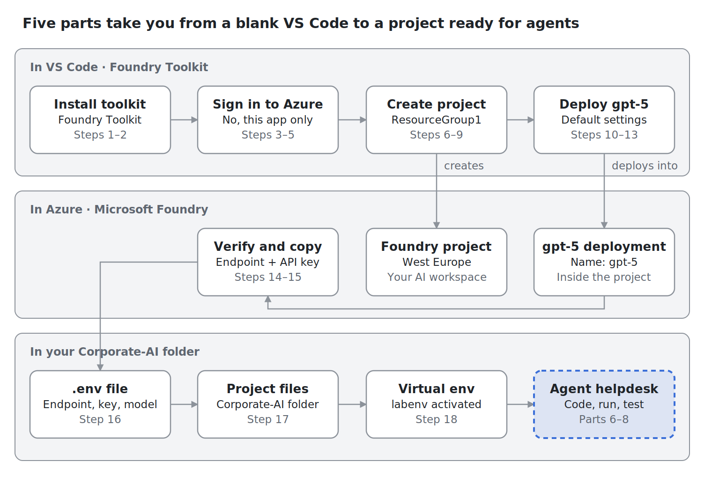
Lab setup flow – 5 parts across VS Code, Azure and your project folder
Read the top row left to right, follow the endpoint and key down from Azure, then finish along the bottom row. The dashed box is Parts 6 to 8.

How the agents work
Five agents share one job: an orchestrator routes the request, specialists investigate, and a resolution agent writes the answer.
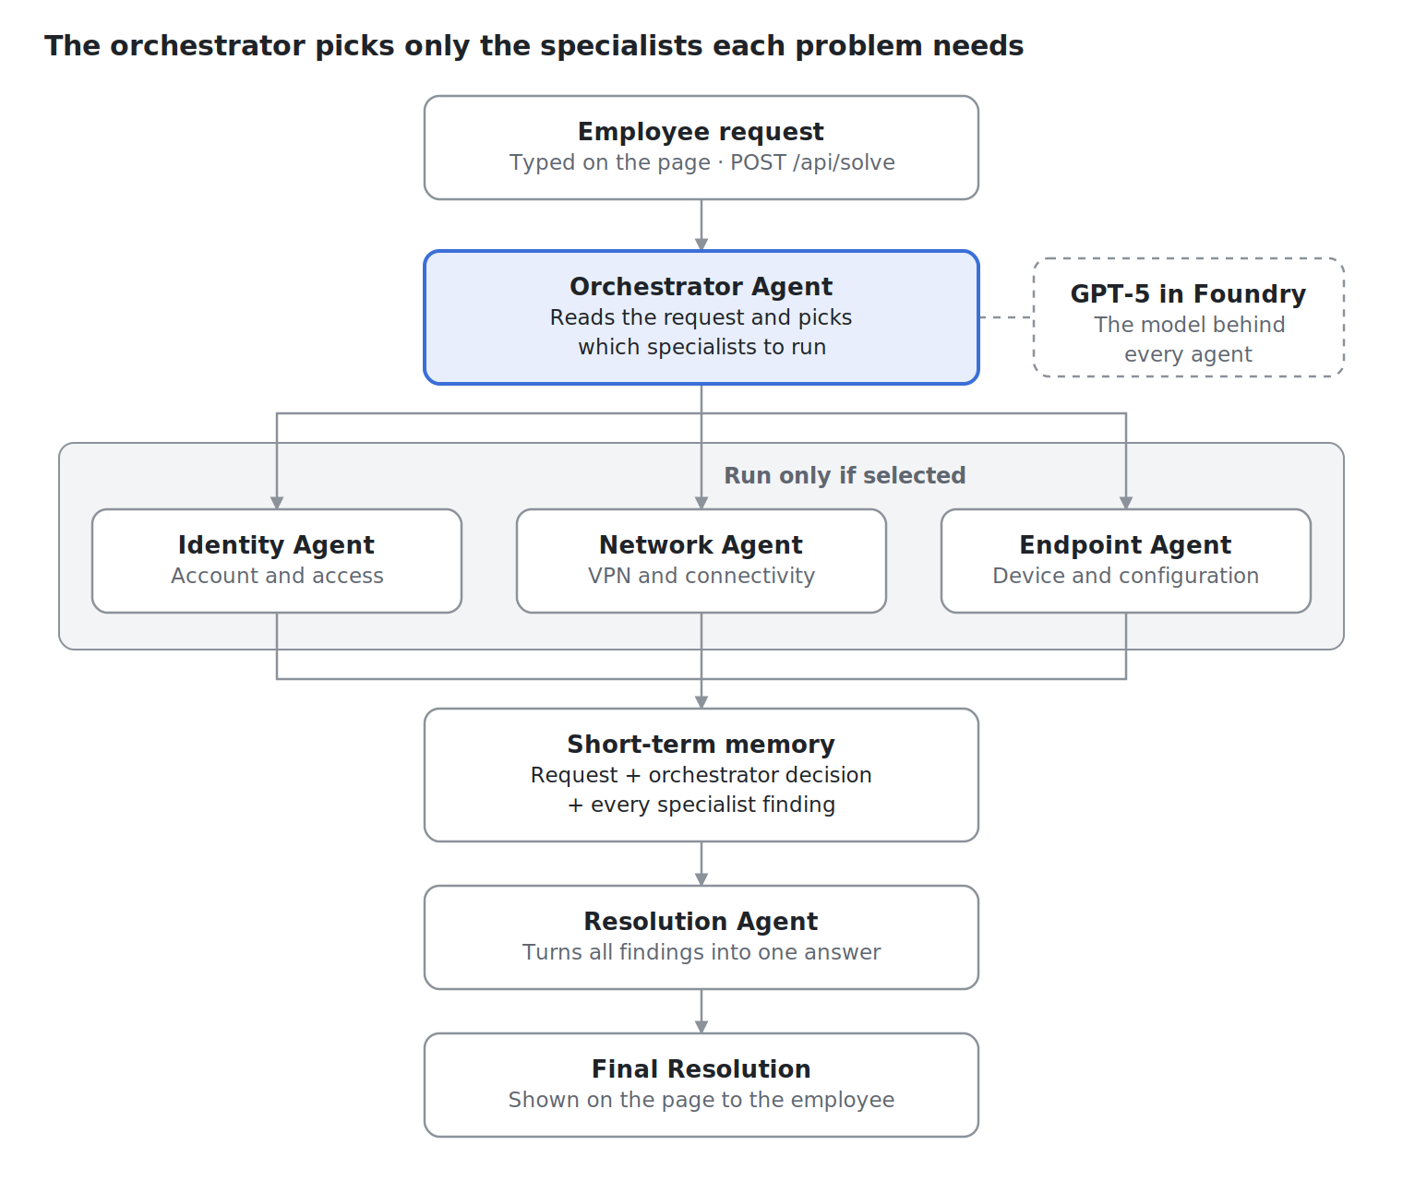
Corporate AI agent flow – 1 orchestrator, 3 specialists, 1 resolution agent
Each specialist receives the same shared context: the employee request and the orchestrator’s decision. Their findings go into short-term memory, which the Resolution agent reads in one go. You see this flow live in the app’s Activity Feed and Short-Term Memory panels.

Prerequisites
☐ Lab sandbox credentials: a username like User1-xxxxxxxx@LODSPRODMCA.onmicrosoft.com and its password.
☐ An Azure subscription with a resource group you can use (the lab uses ResourceGroup1 in West Europe).
☐ Visual Studio Code, recent version (the screenshots use 1.140).
☐ Python 3 installed. Check with python --version.
☐ The Corporate-AI project folder (all code is in the Appendix – Source code).
Keep your key private. The API key you copy in Part 4 is a password to your model. Never paste it into chat, email, screenshots or source control.

Part 1 – Install Foundry Toolkit and sign in to Azure
You connect VS Code to your Azure lab account so you can create and manage Foundry resources from the editor.

Step 1 – Install Foundry Toolkit for VS Code
- In VS Code, click the Extensions icon in the left bar (or press Ctrl+Shift+X).
- In the search box, type foundry.
- Select Foundry Toolkit for VS Code published by Microsoft (blue verified tick).
- Click Install.
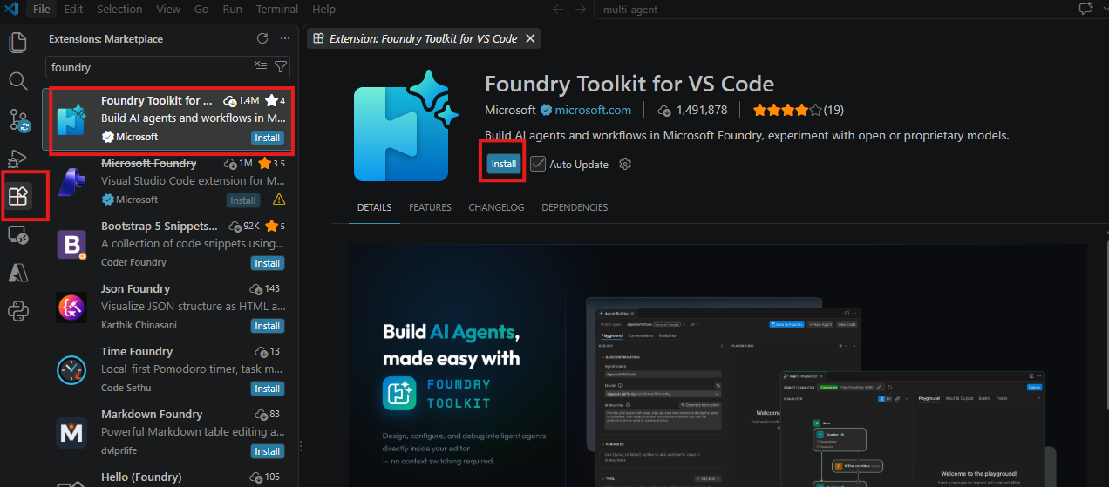
Install Foundry Toolkit for VS Code
Pick the exact extension named Foundry Toolkit for VS Code. Other results with “Foundry” in the name are not part of this lab.

Step 2 – Open the Foundry Toolkit
- Click the new Foundry Toolkit icon at the bottom of the left bar.
- The My Resources panel opens, showing Set Foundry Project, Models, Agents, Tools, Knowledge and Evaluations.
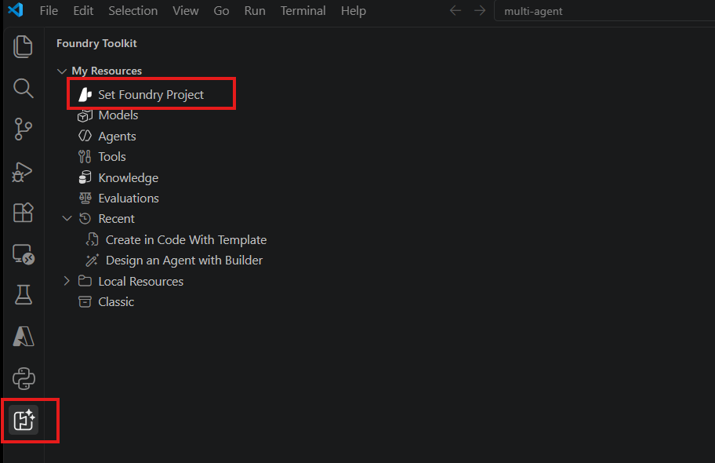
Foundry Toolkit panel

Step 3 – Start the Azure sign-in
- Click the Azure icon in the left bar.
- Under Resources, click Sign in to Azure…
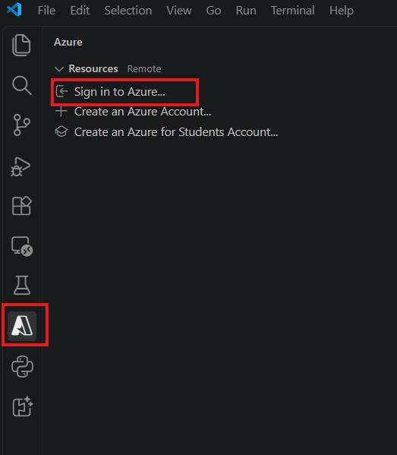
Sign in to Azure

Step 4 – Enter your lab credentials
- A Microsoft sign-in window opens. Enter your lab username, for example User1-xxxxxxxx@LODSPRODMCA.onmicrosoft.com.
- Click Next, enter the lab password, and sign in.
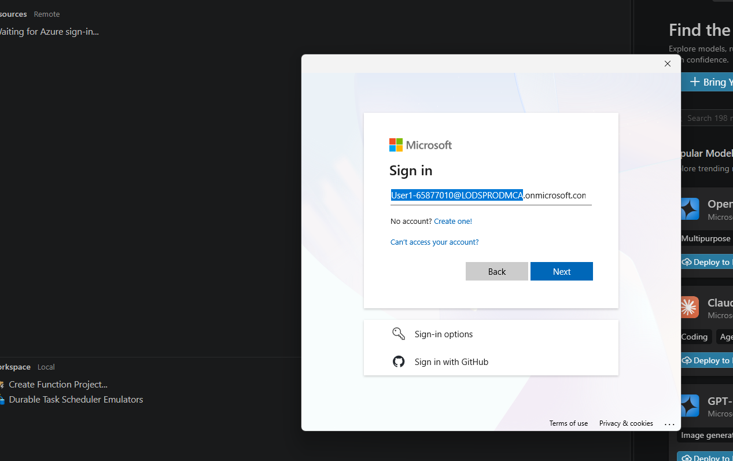
Enter your lab username

Step 5 – Choose “No, this app only”
- When asked Sign in to all apps and websites on this device?, click No, this app only.
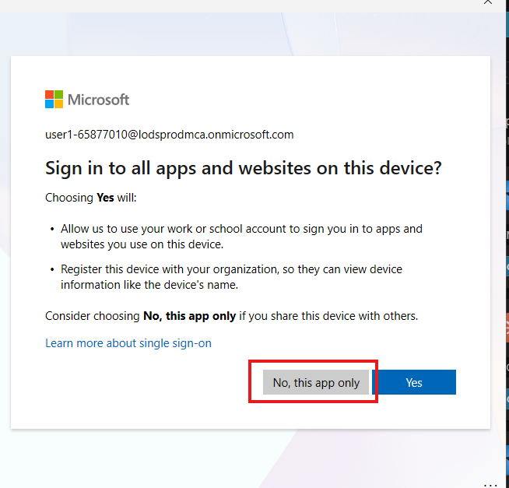
Select No, this app only
Why “No”? Choosing Yes registers the lab machine with the sandbox organisation. “This app only” signs in VS Code and nothing else, which is the right choice on a shared or temporary machine.
Checkpoint: the Azure panel shows your subscription instead of “Sign in to Azure…”.

Part 2 – Create the Foundry project
A Foundry project is the workspace that holds your models and agents. You create it from VS Code in four clicks.

Step 6 – Choose Create project
- Open the Foundry Toolkit panel and click Set Foundry Project.
- At the top of VS Code, a menu appears. Click Create project (Create a new project and set as default).
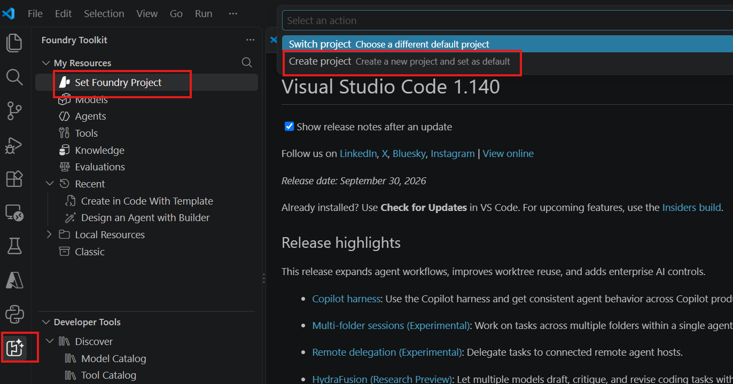
Set Foundry Project, then Create project

Step 7 – Choose the resource group
- In Choose a resource group, select ResourceGroup1 (westeurope).
- Do not click Create new resource group; the lab sandbox already has one for you.
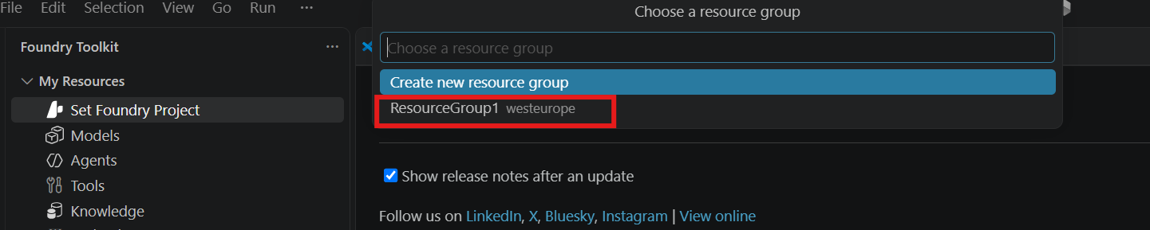
Choose ResourceGroup1

Step 8 – Enter the project name
- In Enter project name, keep the suggested name or type one, for example ai-agents-project65877010.
- Press Enter to confirm.
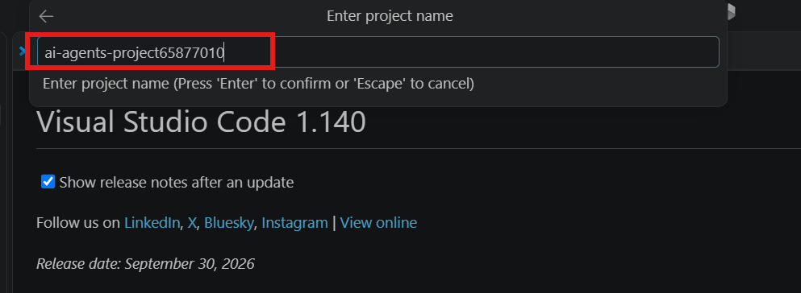
Enter the project name
The number at the end comes from your lab user ID, so your name will differ. Write it down; you will look for it in Step 14.

Step 9 – Confirm the project was created
- Wait for the notification Microsoft Foundry Project: “…” Deployed successfully. at the bottom right.
- Check that My Resources now shows your project name and region (westeurope) at the top, instead of Set Foundry Project.
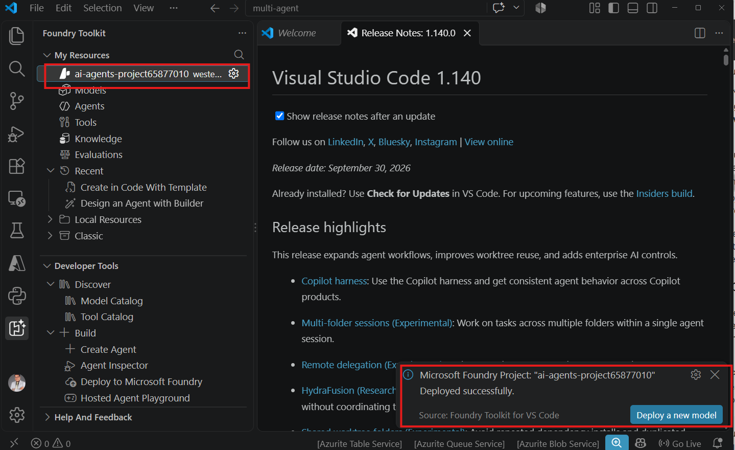
Project created successfully
Creation can take a few minutes. Do not close VS Code while it runs.

Part 3 – Deploy the GPT-5 model
The agents need a model to think with. You deploy GPT-5 into your new project from the model catalog.

Step 10 – Open the model catalog
- In My Resources, click Models.
- In the Models tab that opens, click Catalog.
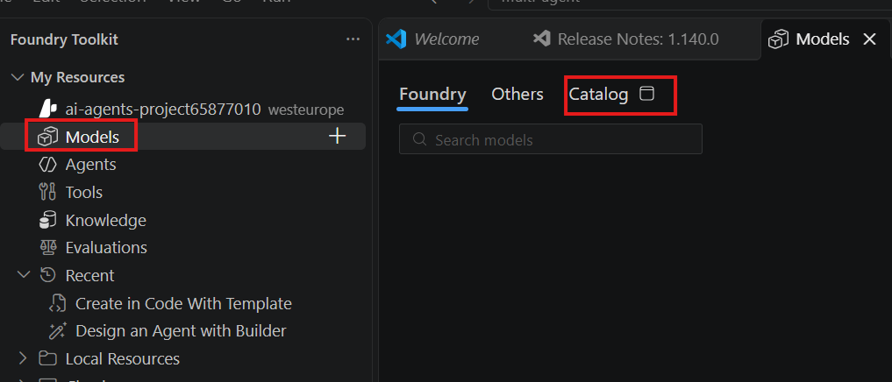
Models, then Catalog

Step 11 – Search for GPT-5
- In the search box, type gpt-5.
- Under Microsoft Foundry Hosted Models, find the card OpenAI gpt-5 (“designed for logic-heavy and multi-step tasks”).
- On that card, click Deploy.
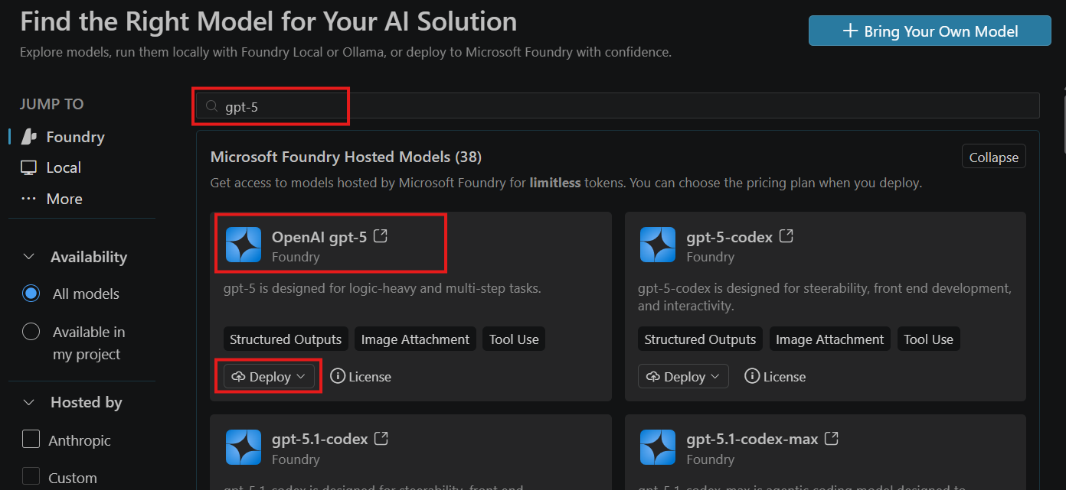
Search for gpt-5 and click Deploy
Choose OpenAI gpt-5, not the codex versions. Codex models are tuned for writing code; this lab uses the general-purpose model.

Step 12 – Deploy with default settings
- From the Deploy menu, click Deploy with default settings.
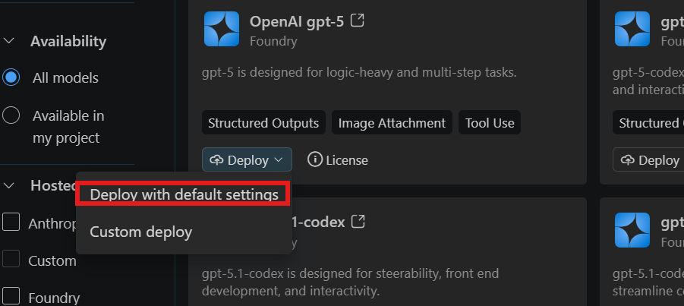
Deploy with default settings
Default settings name the deployment gpt-5, the same as the model. Your .env file uses this name in Step 16.

Step 13 – Confirm the deployment
- Wait for the notification Model deployed successfully at the bottom right.
- Optional: click Open In Playground and send a short message such as Hello to check the model answers.
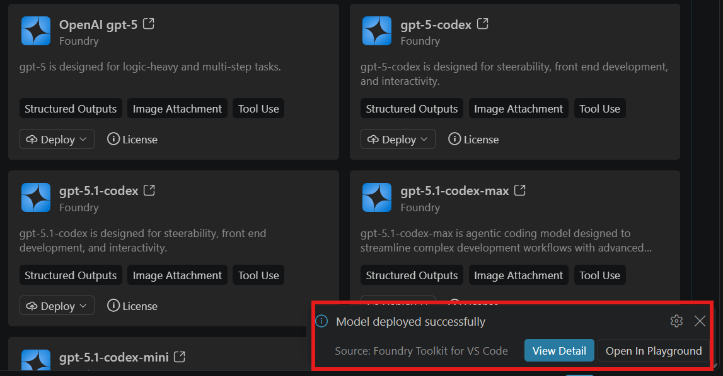
Model deployed successfully

Part 4 – Verify in the portal and copy the endpoint and key
You check that VS Code really created the project in Azure, then copy the two values your code needs.

Step 14 – Verify the project in Microsoft Foundry
- In your browser, go to https://ai.azure.com and sign in with the same lab account.
- Check that the New Foundry toggle is on.
- Under All resources, find your project (for example ai-agents-project65877010). Type should be Project, region West Europe, created by your lab user.
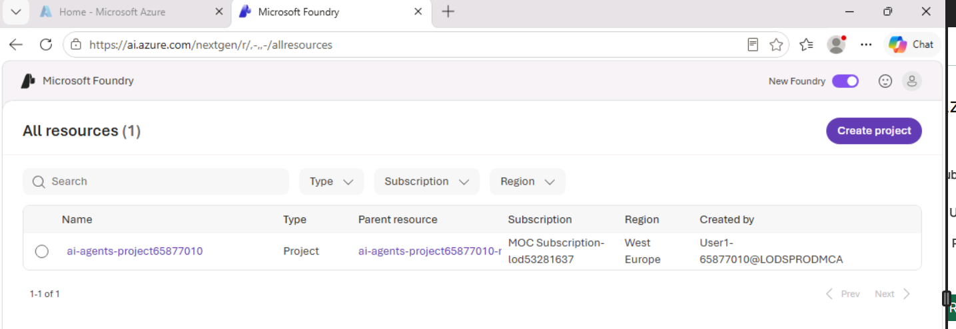
Verify the project in Microsoft Foundry

Step 15 – Copy the project endpoint and API key
- Click your project name to open it, then go to Models and open the gpt-5 deployment.
- Click Continue in code. The Call gpt-5 in code panel opens.
- Click the copy icon next to Project endpoint and paste it into Notepad.
- Click the copy icon next to API Key and paste it into Notepad on a new line.
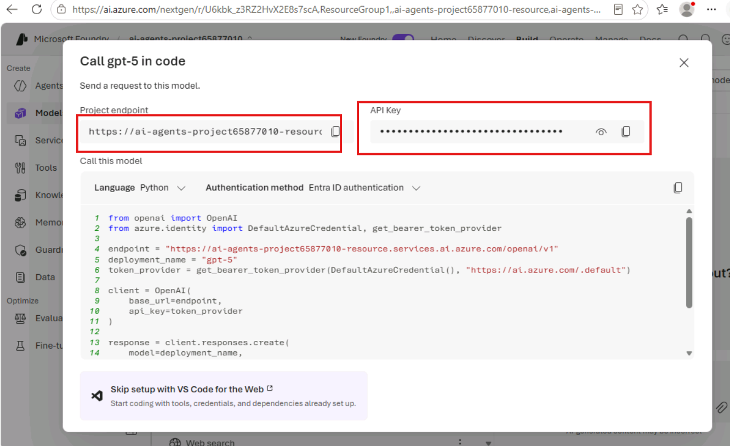
Copy the project endpoint and API key
Value | Example | Used as
Endpoint | https://ai-agents-project65877010-resource.services.ai.azure.com | AZURE_OPENAI_ENDPOINT
API key | a long string of letters and numbers | AZURE_OPENAI_API_KEY
Deployment name | gpt-5 | AZURE_OPENAI_DEPLOYMENT
Endpoint tip: use only the base address ending in .azure.com. If the copied value ends in /openai/v1, remove that part.
Note: the sample code in the panel uses Entra ID sign-in. This lab uses the API key from .env instead.

Part 5 – Set up the local project
Now you prepare the Corporate-AI folder on your machine: your secrets file, the project files and a Python virtual environment.

Step 16 – Create the .env file
- Open the Corporate-AI folder in VS Code (File > Open Folder).
- In the root of the folder (not inside static), create a file named exactly .env.
- Add these three lines with your own values from Step 15, then save:
AZURE_OPENAI_ENDPOINT=https://<your-project>-resource.services.ai.azure.com
AZURE_OPENAI_API_KEY=<your-api-key>
AZURE_OPENAI_DEPLOYMENT=gpt-5
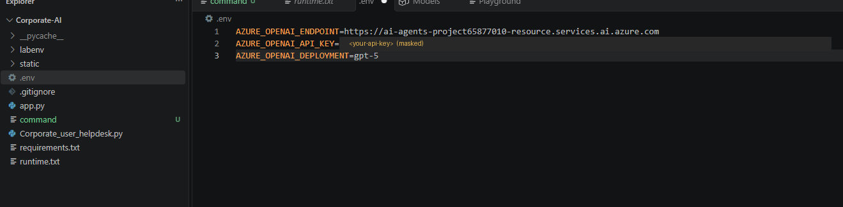
.env file in the project root (key masked)
No quotes and no spaces around =. AZURE_OPENAI_DEPLOYMENT must match the deployment name from Step 12 exactly.

Step 17 – Check the complete project structure
When all files are in place, your Explorer should look like this:
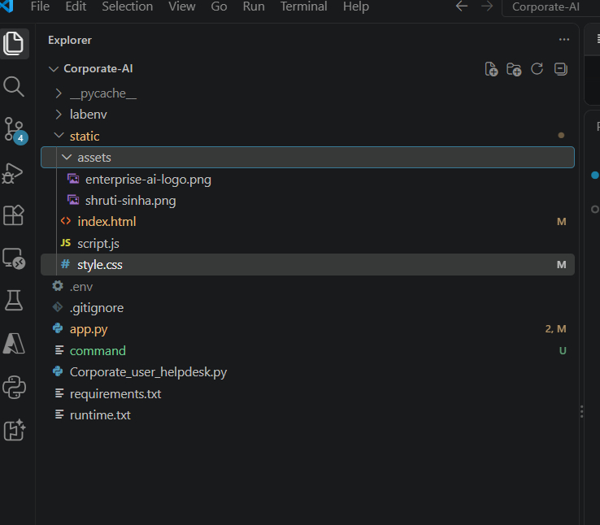
Complete project structure
Path | What it is
.env | Your endpoint, key and deployment name (Step 16)
.gitignore | Keeps .env and the virtual environment out of Git
app.py | Web API that runs the agents (Step 20)
Corporate_user_helpdesk.py | The five agent functions (Step 20)
requirements.txt | Python packages for the app
runtime.txt | Python runtime setting
command | Commands used in this lab
static/index.html, script.js, style.css | The web page and its script and styles (Step 21)
static/assets/ | Images: enterprise-ai-logo.png and the developer photo
labenv/ | The virtual environment you create in Step 18
__pycache__/ | Created by Python automatically; ignore it
Keep secrets out of Git. Make sure .gitignore contains at least .env, labenv/ and __pycache__/.

Step 18 – Create and activate a virtual environment
- Open a terminal: Terminal > New Terminal. Check that it is in the Corporate-AI folder.
- Run these three commands one at a time:
python -m venv labenv
Set-ExecutionPolicy -ExecutionPolicy RemoteSigned -Scope CurrentUser
.\labenv\Scripts\Activate.ps1
- Check that the prompt now starts with (labenv).
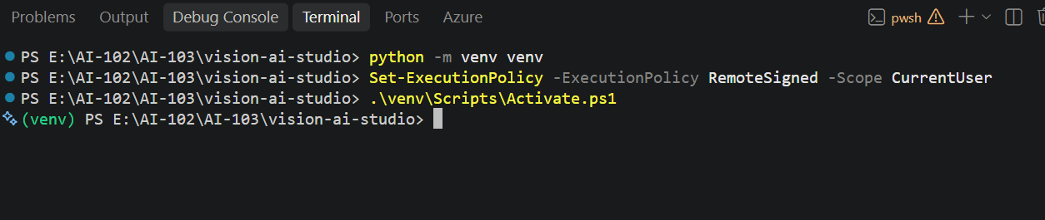
Create and activate the virtual environment
The screenshot shows the same commands with an environment named venv; in this project it is labenv, matching the folder in Step 17. On macOS or Linux, run python3 -m venv labenv then source labenv/bin/activate.
Checkpoint: the prompt shows (labenv) and your .env file holds three values. Setup is complete.

Part 6 – Install packages and add the code
You install the Python packages, then add the agent code and the web page. Copy every file in full from Appendix – Source code.

Step 19 – Install the prerequisites
- Check that the terminal prompt shows (labenv) and the folder is Corporate-AI.
- Run:
pip install fastapi uvicorn openai python-dotenv
- Wait for Successfully installed. A notice about a new pip release is safe to ignore.
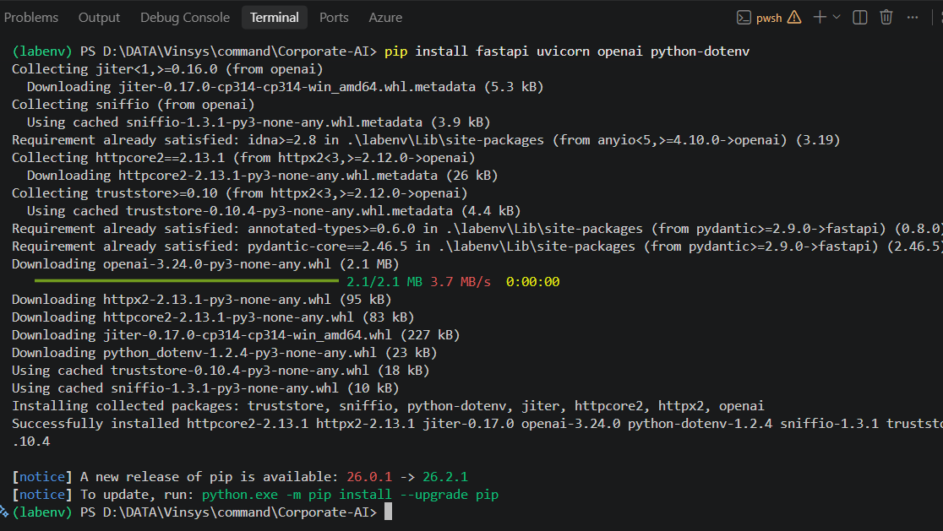
Install the prerequisites
Package | What it does in this app
fastapi | Web framework for the /api/solve endpoint (it also installs pydantic)
uvicorn | Server that runs the FastAPI app
openai | Client library that calls GPT-5 in Foundry
python-dotenv | Loads your settings from .env

Step 20 – Add the agent code
- In the root of Corporate-AI, create Corporate_user_helpdesk.py and paste its full code. This file holds all five agents.
- In the same folder, create app.py and paste its full code. This file is the web API.
Corporate_user_helpdesk.py – the agents
Part | What it does
Configuration | Reads the endpoint, key and deployment from .env, stops with a clear error if one is missing, and connects to <endpoint>/openai/v1/
call_ai() | One helper every agent uses: sends instructions + a prompt to GPT-5 with the Responses API and returns the text
orchestrator() | Picks IDENTITY, NETWORK and/or ENDPOINT. Falls back to ENDPOINT if the answer is unclear
identity_agent(), network_agent(), endpoint_agent() | Each looks only at its own area and returns a Finding and one Recommended check
resolution_agent() | Reads all findings from short-term memory and writes the final answer in three sections
solve_problem() | Runs the whole workflow in order and returns everything to the web page
Terminal demo | Lets you run the agents without the web page (Step 23B)
Each agent gets its own output budget (max_output_tokens): 800 for the orchestrator, 1,200 for each specialist and 1,800 for the resolution agent.
Why the budgets matter: GPT-5 is a reasoning model. Part of the output budget is used for thinking before it writes. If the budget is too small, it can return no text at all. call_ai() reports that as “No text was returned by the AI agent.” instead of failing silently.
app.py – the web API
Section | What it does
load_dotenv() | Loads .env first, before the agents are imported
FastAPI app + CORS | Creates the web API and allows the page to call it
POST /api/solve | Receives {"problem": "..."} and returns the result of solve_problem()
GET /api/health | Returns the status, Microsoft Foundry and your deployment name
app.mount("/", …) | Serves the static folder, so the page and API run on the same port
Key idea: the orchestrator decides which specialists run. Only the selected agents are called, which saves time and tokens.

Step 21 – Add the web files
- Inside static, create index.html, script.js and style.css and paste each file’s code.
- Inside static/assets, add the logo enterprise-ai-logo.png and a photo of yourself.
- Make it yours: in index.html, change the photo file name on line 72 to your photo, your name on lines 73 and 83, your title on line 87, and the line under it on line 91.
The page sends the request to /api/solve, then animates each agent card and fills the Activity Feed, Short-Term Memory and Final Resolution panels from the answer.
Card ids: in index.html the orchestrator card’s id is orchestrator, while the other cards end in -agent (for example identity-agent). setAgent() in script.js handles both, so do not rename these ids.

Part 7 – Run the app
One command runs both the API and the web page, because app.py serves the static folder itself.

Step 22 – Start the server
- In the terminal, check that (labenv) shows and you are in the Corporate-AI root folder (where app.py is).
- Run:
uvicorn app:app --reload
- Wait for Application startup complete and Uvicorn running on http://127.0.0.1:8000.
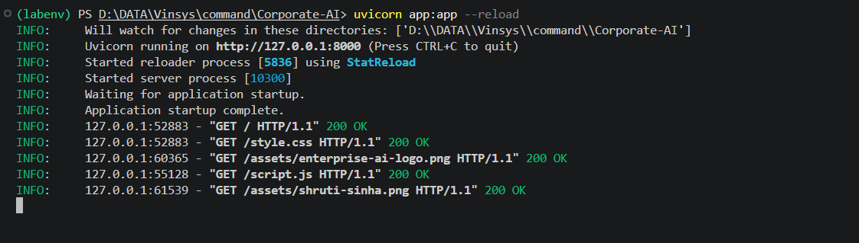
Start the app with uvicorn
app:app means “the app object inside app.py”. --reload restarts the server whenever you save a Python file.

Step 23 – Open the Enterprise AI Service Desk
- In your browser, go to http://127.0.0.1:8000.
- In the terminal, check for GET /, /style.css, /script.js and the two /assets/ images, each with 200 OK.
- On the page, check the header (logo, your name and photo), System Online and Microsoft Foundry GPT-5, and the five agent cards, all showing WAITING.
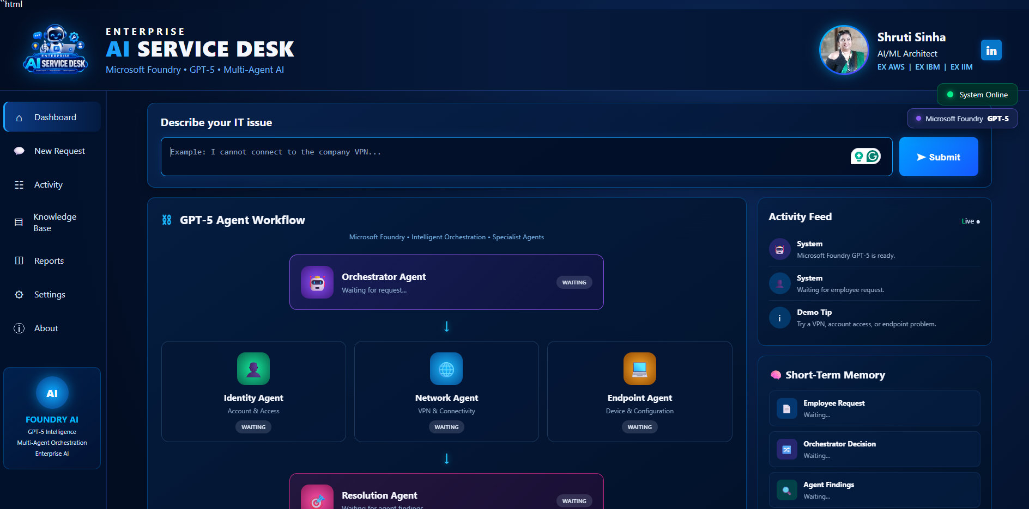
Enterprise AI Service Desk running
If an image shows as broken, its file name in static/assets does not match the name in index.html.

Step 23B (optional) – Run the agents in the terminal
You can run the same five agents without the web page. This shows the short-term memory and every specialist finding in full.
- Open a second terminal (the web server can keep running), activate labenv, and stay in the Corporate-AI folder.
- Run:
python Corporate_user_helpdesk.py
- Type a problem, for example I cannot connect to the corporate VPN from my laptop., press Enter, then type END and press Enter.
- Read the output: the request, the orchestrator decision, each specialist finding, and the resolution.

Part 8 – Test the agents
You send three IT problems and watch the orchestrator pick a different team of specialists each time.
Test | Employee request | Agents the orchestrator picked
1 | I cannot connect to the corporate VPN from my laptop. | NETWORK, ENDPOINT
2 | I cannot log in to my corporate account. It says my password is incorrect even though I am sure it is correct. | IDENTITY
3 | I can log in to my laptop, but I cannot access Outlook or Teams. Other websites are working | IDENTITY, ENDPOINT
The model decides each time, so your picks can differ slightly. What matters is that the choice fits the problem. The screenshots below come from an earlier version of the app: with the current code, the agent cards change to RUNNING and COMPLETED, and the Final Resolution uses the three sections described in Step 24.

Step 24 – Test 1: VPN problem
- In Describe your IT issue, type I cannot connect to the corporate VPN from my laptop.
- Click Submit.
- Watch the Activity Feed: the employee request, then Orchestrator Agent – Analyzing the issue…
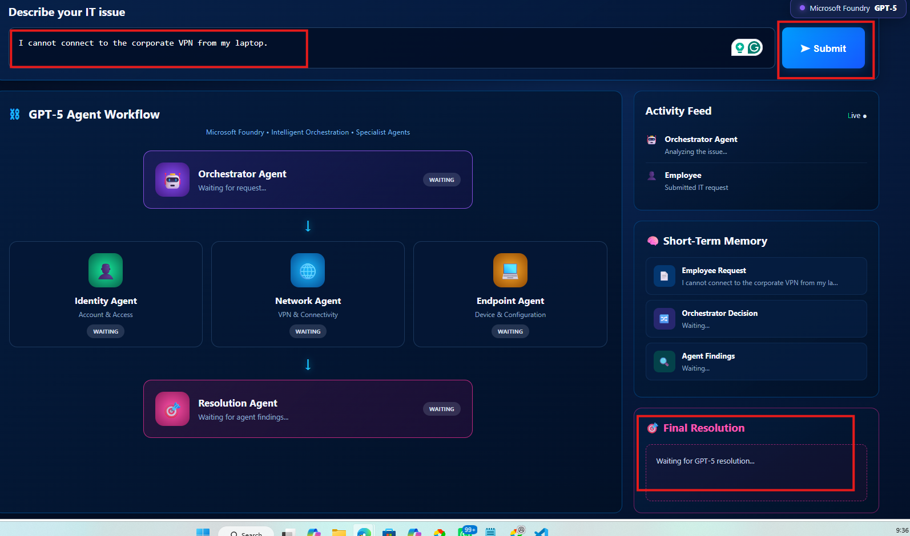
Submit the VPN problem
- When the run ends, check Short-Term Memory > Orchestrator Decision: it shows NETWORK, ENDPOINT.
- Read the Final Resolution: it has three sections, Most likely root cause, What to check and Recommended next step.
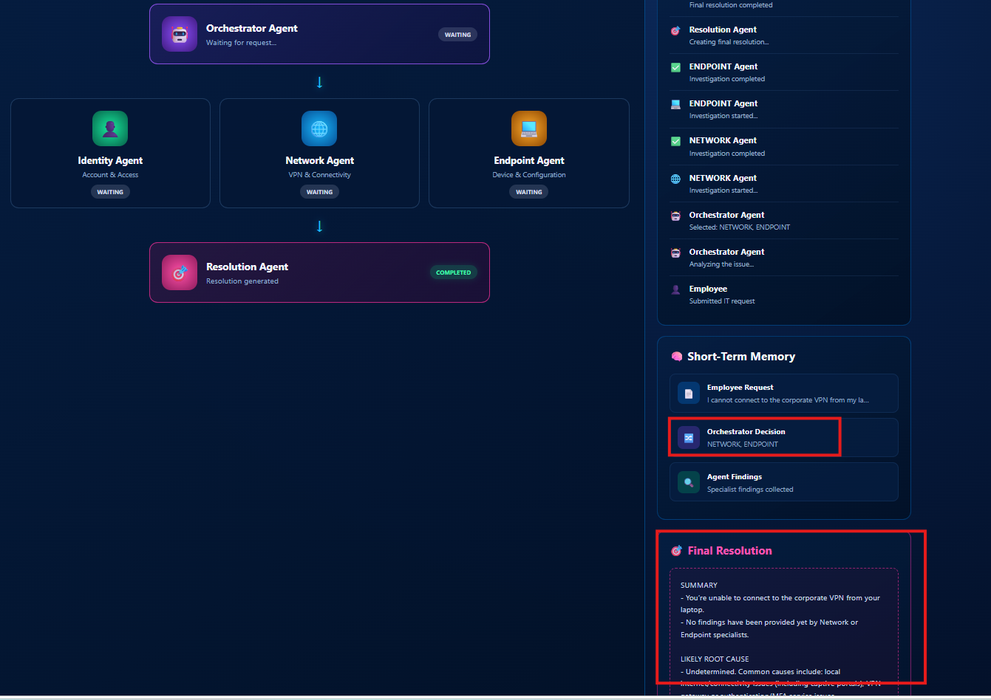
VPN problem: Network and Endpoint agents selected

Step 25 – Test 2: password problem
- Replace the text with I cannot log in to my corporate account. It says my password is incorrect even though I am sure it is correct. and click Submit.
- Check that the Orchestrator Decision is IDENTITY only. The Network and Endpoint agents are skipped.
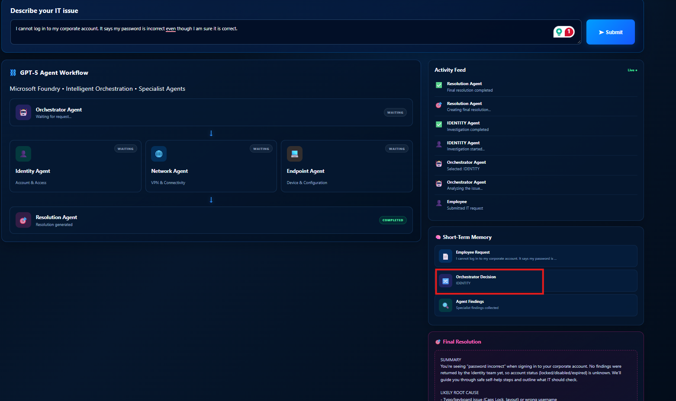
Password problem: Identity agent only

Step 26 – Test 3: Outlook and Teams problem
- Replace the text with I can log in to my laptop, but I cannot access Outlook or Teams. Other websites are working and click Submit.
- Check that the Orchestrator Decision is IDENTITY, ENDPOINT. Network is skipped because other websites work.
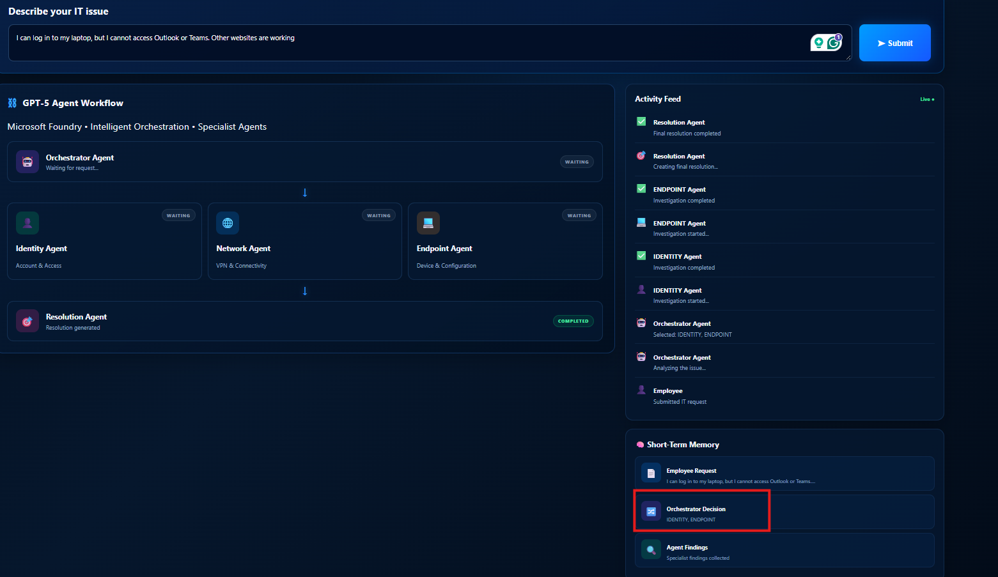
Outlook and Teams problem: Identity and Endpoint agents
Key idea: the request text drives the routing. “Other websites are working” tells the orchestrator the network is fine, so it does not call the Network agent.
Lab complete when all three tests return a Final Resolution and each Orchestrator Decision fits its problem.

Challenges (optional)
- Write your own test. Send a problem that should need all three specialists, for example a new laptop that cannot join Wi-Fi or sign in.
- Show the findings. The agent cards show status but not each agent’s finding. Add a text line to each specialist card in index.html so setAgent can display it.
- Add an agent. Add a fourth specialist, such as a Printer agent: a function in Corporate_user_helpdesk.py, a branch in app.py, and a card in index.html.

Troubleshooting
Problem | Likely cause | Fix
Sign-in window does not appear | It opened behind VS Code | Check the taskbar for a Microsoft sign-in window
Stuck on “Waiting for Azure sign-in…” | Sign-in cancelled or wrong account | Close the window, click Sign in to Azure… again, use the lab account
No resource group in Step 7 | Wrong subscription or not signed in | Check the Azure panel shows the lab subscription; sign in again
Project creation fails | Name already used or not allowed | Use only letters, numbers and hyphens; try a new name
GPT-5 has no Deploy button or deploy fails | Model not available in your region or quota | Check the region is West Europe; ask your instructor about quota
Project not listed at ai.azure.com | Signed in with a different account | Sign out, then sign in with the same lab account used in VS Code
Activate.ps1 cannot be loaded | PowerShell blocks scripts | Run the Set-ExecutionPolicy command from Step 18, then activate again
DeploymentNotFound later | .env deployment name does not match | Use gpt-5, exactly as deployed in Step 12
401 Unauthorized later | Wrong or incomplete API key | Copy the key again from Step 15; check for spaces or quotes
ModuleNotFoundError: Corporate_user_helpdesk | File missing, misnamed, or server started in another folder | Put Corporate_user_helpdesk.py next to app.py and run uvicorn from the Corporate-AI root
RuntimeError: Directory ‘static’ does not exist | uvicorn started outside the project root | cd into Corporate-AI, then run uvicorn app:app --reload
Final Resolution says Unable to connect to the AI backend | Server stopped, or an agent call to GPT-5 failed | Read the error in the uvicorn terminal; check .env values
Agent cards stay WAITING after Submit | Older copy of index.html or script.js | Use the files from Appendix – Source code (Step 21)
Address already in use (port 8000) | Another server is still running | Press Ctrl+C in the old terminal, or close it, then start again
A finding says “AI agent call failed: …” | GPT-5 call rejected: wrong endpoint, key or deployment name | Read the error text; check the three .env values against Step 15
A finding says “No text was returned by the AI agent.” | GPT-5 used its whole output budget for reasoning | Raise max_output_tokens for that agent in Corporate_user_helpdesk.py
404 Not Found from the model | Endpoint in .env already ends in /openai/v1, so the path is doubled | Use only the base address ending in .azure.com

Appendix – Source code
Copy each file into the path shown in its heading.

app.py
from dotenv import load_dotenv
load_dotenv()
from fastapi import FastAPI
from fastapi.middleware.cors import CORSMiddleware
from fastapi.staticfiles import StaticFiles
from pydantic import BaseModel
from Corporate_user_helpdesk import solve_problem, AZURE_OPENAI_DEPLOYMENT
# ============================================================
# CREATE FASTAPI APPLICATION
# ============================================================
app = FastAPI(
title="Enterprise AI Service Desk",
description="Multi-Agent IT Helpdesk powered by Microsoft Foundry GPT-5",
version="2.0"
)
# ============================================================
# CORS
# ============================================================
app.add_middleware(
CORSMiddleware,
allow_origins=["*"],
allow_credentials=False,
allow_methods=["*"],
allow_headers=["*"]
)
# ============================================================
# REQUEST MODEL
# ============================================================
class ProblemRequest(BaseModel):
problem: str
# ============================================================
# MAIN MULTI-AGENT API
# ============================================================
@app.post("/api/solve")
def solve_problem_api(request: ProblemRequest):
problem = request.problem.strip()
if not problem:
return {
"employee_request": "",
"selected_agents": [],
"findings": {},
"memory": {},
"final_answer": "Please enter an IT problem."
}
return solve_problem(problem)
# ============================================================
# HEALTH CHECK
# ============================================================
@app.get("/api/health")
def health():
return {
"status": "online",
"service": "Enterprise AI Service Desk",
"platform": "Microsoft Foundry",
"model": AZURE_OPENAI_DEPLOYMENT,
"agents": [
"Orchestrator",
"Identity",
"Network",
"Endpoint",
"Resolution"
]
}
# ============================================================
# SERVE FRONTEND
# ============================================================
app.mount(
"/",
StaticFiles(
directory="static",
html=True
),
name="static"
)

Corporate_user_helpdesk.py
# ============================================================
# ENTERPRISE AI SERVICE DESK
# MULTI-AGENT SYSTEM - MICROSOFT FOUNDRY GPT-5
# ============================================================
#
# Demonstrates:
# 1. AI Agent
# 2. Orchestrator Agent
# 3. Multiple Specialist Agents
# 4. Context Passing
# 5. Short-Term Memory
# 6. Resolution Agent
#
# Azure / Microsoft Foundry:
# - Uses the OpenAI Python SDK
# - Uses the Azure OpenAI /openai/v1 Responses API
# - AZURE_OPENAI_DEPLOYMENT must be the deployment name
#
# Can be used by:
# 1. FastAPI Web UI
# 2. Standalone Terminal Demo
# ============================================================
import json
import os
import re
from dotenv import load_dotenv
from openai import OpenAI
# Load .env so the terminal demo works too (app.py also loads it).
load_dotenv()
# ============================================================
# 1. CONFIGURATION
# ============================================================
AZURE_OPENAI_ENDPOINT = os.getenv("AZURE_OPENAI_ENDPOINT", "").strip()
AZURE_OPENAI_API_KEY = os.getenv("AZURE_OPENAI_API_KEY", "").strip()
AZURE_OPENAI_DEPLOYMENT = os.getenv(
"AZURE_OPENAI_DEPLOYMENT",
"gpt-5"
).strip()
if not AZURE_OPENAI_ENDPOINT:
raise RuntimeError(
"AZURE_OPENAI_ENDPOINT is not set. "
"Add it to your .env file before starting the application."
)
if not AZURE_OPENAI_API_KEY:
raise RuntimeError(
"AZURE_OPENAI_API_KEY is not set. "
"Add your Azure OpenAI / Microsoft Foundry API key to .env."
)
client = OpenAI(
api_key=AZURE_OPENAI_API_KEY,
base_url=f"{AZURE_OPENAI_ENDPOINT.rstrip('/')}/openai/v1/"
)
# ============================================================
# 2. SHORT-TERM MEMORY
# ============================================================
short_term_memory = {
"employee_request": "",
"orchestrator_decision": [],
"agent_findings": []
}
# ============================================================
# 3. GENERIC GPT-5 FUNCTION
# ============================================================
def call_ai(system_message, user_message, max_output_tokens=1200):
"""
Call Microsoft Foundry / Azure OpenAI using the Responses API.
GPT-5 reasoning can consume part of the output budget. Therefore
this function deliberately uses a reasonable output budget instead
of the very small local-model limit used in the old Qwen version.
"""
try:
response = client.responses.create(
model=AZURE_OPENAI_DEPLOYMENT,
instructions=system_message,
input=user_message,
max_output_tokens=max_output_tokens
)
answer = (response.output_text or "").strip()
# Important guard:
# Never silently return an empty specialist result.
if not answer:
return "No text was returned by the AI agent."
return answer
except Exception as exc:
print(f"\nAI call failed: {exc}")
return f"AI agent call failed: {exc}"
# ============================================================
# 4. ORCHESTRATOR AGENT
# ============================================================
def orchestrator(employee_request):
"""
Decide which specialist agents should investigate the incident.
The orchestrator does NOT solve the problem.
"""
prompt = f"""
You are an Enterprise IT Orchestrator Agent.
Employee request:
{employee_request}
Available specialist agents:
IDENTITY
- Account
- Password
- MFA
- User authentication
- Access
- Permissions
NETWORK
- VPN
- Wi-Fi
- Internet
- DNS
- Firewall
- Network connectivity
ENDPOINT
- Laptop
- Desktop
- Device
- VPN client
- Certificate
- Software
- Local configuration
Choose every specialist that is genuinely relevant.
Return ONLY a comma-separated list using these exact names:
IDENTITY
NETWORK
ENDPOINT
Examples:
IDENTITY, NETWORK
ENDPOINT
NETWORK, ENDPOINT
Do not explain your answer.
"""
decision = call_ai(
"You are an enterprise IT Orchestrator. "
"Your only job is to select relevant specialist agents.",
prompt,
max_output_tokens=800
).upper()
selected_agents = []
# Parse only known agent names.
for agent in ("IDENTITY", "NETWORK", "ENDPOINT"):
if re.search(rf"\b{agent}\b", decision):
selected_agents.append(agent)
# Safety fallback.
if not selected_agents:
selected_agents.append("ENDPOINT")
return selected_agents
# ============================================================
# 5. IDENTITY AGENT
# ============================================================
def identity_agent(context):
prompt = f"""
Incident context:
{context}
You are the Identity Specialist Agent.
Investigate only identity and access aspects.
Consider:
- Account status
- Password
- MFA
- User access
- Permissions
Return a concise finding in this format:
Finding:
<your finding>
Recommended check:
<one practical check>
Do not invent facts that are not present in the incident.
Do not claim that an account is locked, disabled, or reset unless
the incident provides evidence for it.
"""
return call_ai(
"You are an Enterprise Identity Specialist.",
prompt,
max_output_tokens=1200
)
# ============================================================
# 6. NETWORK AGENT
# ============================================================
def network_agent(context):
prompt = f"""
Incident context:
{context}
You are the Network Specialist Agent.
Investigate only network-related aspects.
Consider:
- VPN
- Wi-Fi
- Internet
- DNS
- Firewall
- Network availability
Return a concise finding in this format:
Finding:
<your finding>
Recommended check:
<one practical check>
Do not invent facts that are not present in the incident.
"""
return call_ai(
"You are an Enterprise Network Specialist.",
prompt,
max_output_tokens=1200
)
# ============================================================
# 7. ENDPOINT AGENT
# ============================================================
def endpoint_agent(context):
prompt = f"""
Incident context:
{context}
You are the Endpoint Specialist Agent.
Investigate only device-side aspects.
Consider:
- Laptop
- VPN client
- Software
- Device configuration
- Certificate
- Local firewall
Return a concise finding in this format:
Finding:
<your finding>
Recommended check:
<one practical check>
Do not invent facts that are not present in the incident.
"""
return call_ai(
"You are an Enterprise Endpoint Specialist.",
prompt,
max_output_tokens=1200
)
# ============================================================
# 8. RESOLUTION AGENT
# ============================================================
def resolution_agent(memory):
findings = memory.get("agent_findings", [])
# Explicitly expose findings to the resolution model.
# This prevents the model from having to infer where they are.
findings_text = "\n\n".join(
f"{item['agent']} SPECIALIST FINDING:\n{item['finding']}"
for item in findings
)
prompt = f"""
You are the Enterprise IT Resolution Agent.
Employee request:
{memory.get("employee_request", "")}
Orchestrator selected:
{", ".join(memory.get("orchestrator_decision", []))}
SPECIALIST INVESTIGATION RESULTS:
{findings_text if findings_text else "No specialist findings were returned."}
Use the specialist investigation results above.
Provide a short employee-friendly response with exactly these sections:
1. Most likely root cause
2. What to check
3. Recommended next step
Important:
- Do not invent specific facts.
- Clearly distinguish a likely cause from a confirmed cause.
- If the evidence is insufficient, say that it is not yet confirmed.
- Do not say "No findings have been provided yet" when specialist findings
are present above.
"""
answer = call_ai(
"You are an Enterprise IT Resolution Specialist. "
"Synthesize specialist findings into a practical resolution.",
prompt,
max_output_tokens=1800
)
# Last-resort deterministic fallback if the model call fails/returns empty.
if not answer or answer.startswith("AI agent call failed"):
if findings:
return (
"1. Most likely root cause\n"
"The issue requires review of the specialist findings below.\n\n"
"2. What to check\n"
+ "\n".join(
f"- {item['agent']}: {item['finding']}"
for item in findings
)
+ "\n\n"
"3. Recommended next step\n"
"Use the specialist checks above to confirm the cause."
)
return (
"1. Most likely root cause\n"
"The root cause could not be determined from the available evidence.\n\n"
"2. What to check\n"
"Review the affected account, network connection, and endpoint.\n\n"
"3. Recommended next step\n"
"Collect the relevant error message and retry the investigation."
)
return answer
# ============================================================
# 9. COMPLETE MULTI-AGENT WORKFLOW
# ============================================================
def solve_problem(employee_request):
employee_request = employee_request.strip()
if not employee_request:
return {
"employee_request": "",
"selected_agents": [],
"findings": {},
"memory": {},
"final_answer": "Please enter an IT problem."
}
# Reset short-term memory for this incident.
memory = {
"employee_request": employee_request,
"orchestrator_decision": [],
"agent_findings": []
}
# --------------------------------------------------------
# ORCHESTRATOR
# --------------------------------------------------------
selected_agents = orchestrator(employee_request)
memory["orchestrator_decision"] = selected_agents
# --------------------------------------------------------
# SHARED CONTEXT
# --------------------------------------------------------
context = f"""
Employee Request:
{employee_request}
Orchestrator Decision:
{selected_agents}
"""
# --------------------------------------------------------
# SPECIALIST AGENTS
# --------------------------------------------------------
findings = {}
if "IDENTITY" in selected_agents:
findings["IDENTITY"] = identity_agent(context)
if "NETWORK" in selected_agents:
findings["NETWORK"] = network_agent(context)
if "ENDPOINT" in selected_agents:
findings["ENDPOINT"] = endpoint_agent(context)
# --------------------------------------------------------
# STORE FINDINGS IN SHORT-TERM MEMORY
# --------------------------------------------------------
for agent, finding in findings.items():
memory["agent_findings"].append({
"agent": agent,
"finding": finding
})
# Keep module-level memory available for teaching/demo purposes.
short_term_memory.clear()
short_term_memory.update(memory)
# --------------------------------------------------------
# RESOLUTION AGENT
# --------------------------------------------------------
final_answer = resolution_agent(memory)
# --------------------------------------------------------
# RETURN COMPLETE RESULT
# --------------------------------------------------------
return {
"employee_request": employee_request,
"selected_agents": selected_agents,
"findings": findings,
"memory": memory,
"final_answer": final_answer
}
# ============================================================
# 10. TERMINAL DEMO
# ============================================================
if __name__ == "__main__":
print("\n")
print("=" * 60)
print(" ENTERPRISE AI SERVICE DESK")
print(" MULTI-AGENT DEMO")
print("=" * 60)
print("\nMicrosoft Foundry GPT-5 deployment:")
print(f" {AZURE_OPENAI_DEPLOYMENT}")
print("\nEnter the employee IT problem.")
print("Type END when finished.\n")
lines = []
while True:
line = input()
if line.strip().upper() == "END":
break
lines.append(line)
employee_request = "\n".join(lines).strip()
result = solve_problem(employee_request)
print("\n")
print("-" * 60)
print("SHORT-TERM MEMORY")
print("-" * 60)
print("\nEmployee Request:")
print(result["memory"].get("employee_request", ""))
print("\nOrchestrator Decision:")
print(result["memory"].get("orchestrator_decision", []))
print("\nSpecialist Findings:")
for finding in result["memory"].get("agent_findings", []):
print(f"\n[{finding['agent']}]")
print(finding["finding"])
print("\n")
print("=" * 60)
print(" RESOLUTION AGENT")
print("=" * 60)
print("\n")
print(result["final_answer"])
print("\n")
print("=" * 60)
print(" DEMO COMPLETE")
print("=" * 60)

static/index.html
<!DOCTYPE html>
<html lang="en">
<head>
<meta charset="UTF-8">
<meta name="viewport"
content="width=device-width, initial-scale=1.0">
<title>Enterprise AI Service Desk</title>
<link rel="stylesheet" href="style.css">
</head>
<body>
<div class="app">
<!-- =====================================================
HEADER
====================================================== -->
<header class="header">
<!-- BRAND -->
<div class="brand">
<div class="logo-container">
<img
src="assets/enterprise-ai-logo.png"
alt="Enterprise AI Service Desk"
class="main-logo"
>
</div>
<div class="brand-text">
<div class="enterprise-title">
ENTERPRISE
</div>
<h1>
<span>AI</span> SERVICE DESK
</h1>
<p>
Multi-Agent AI System
</p>
</div>
</div>
<!-- DEVELOPER PROFILE -->
<div class="developer-profile">
<div class="developer-photo-wrapper">
<img
src="assets/shruti-sinha.png"
alt="Shruti Sinha"
class="developer-photo"
>
</div>
<div class="developer-info">
<h2>
Shruti Sinha
</h2>
<p class="developer-role">
AI/ML Architect
</p>
<p class="developer-experience">
EX AWS &nbsp;|&nbsp; EX IBM &nbsp;|&nbsp; EX IIM
</p>
</div>
<div class="linkedin-badge">
in
</div>
</div>
<!-- SYSTEM STATUS -->
<div class="system-status">
<span class="status-dot"></span>
System Online
</div>
</header>
<!-- =====================================================
MAIN CONTENT
====================================================== -->
<main class="main-container">
<!-- =================================================
LEFT SIDEBAR
================================================== -->
<nav class="sidebar">
<div class="nav-item active">
<span class="nav-icon">⌂</span>
<span>
Dashboard
</span>
</div>
<div class="nav-item">
<span class="nav-icon">💬</span>
<span>
New Request
</span>
</div>
<div class="nav-item">
<span class="nav-icon">☷</span>
<span>
Activity
</span>
</div>
<div class="nav-item">
<span class="nav-icon">▤</span>
<span>
Knowledge Base
</span>
</div>
<div class="nav-item">
<span class="nav-icon">◫</span>
<span>
Reports
</span>
</div>
<div class="nav-item">
<span class="nav-icon">⚙</span>
<span>
Settings
</span>
</div>
<div class="nav-item">
<span class="nav-icon">ⓘ</span>
<span>
About
</span>
</div>
<!-- AI POWERED CARD -->
<div class="ai-powered-card">
<div class="ai-small-icon">
AI
</div>
<strong>
AI Powered
</strong>
<p>
Smarter Support
</p>
<p>
Faster Resolution
</p>
<p>
Better Experience
</p>
</div>
</nav>
<!-- =================================================
CONTENT AREA
================================================== -->
<section class="content-area">
<!-- =================================================
REQUEST CARD
================================================== -->
<section class="request-card">
<h2>
Describe your IT issue
</h2>
<div class="input-row">
<textarea
id="problem"
placeholder="Example: I cannot connect to the company VPN..."
></textarea>
<button
onclick="submitProblem()"
class="submit-button"
>
<span>
➤
</span>
Submit
</button>
</div>
</section>
<!-- =================================================
WORKFLOW + RIGHT PANEL
================================================== -->
<div class="dashboard-grid">
<!-- =================================================
AGENT WORKFLOW
================================================== -->
<section class="workflow-card">
<h2 class="section-title">
<span class="section-icon">
⛓
</span>
Agent Workflow
</h2>
<!-- ORCHESTRATOR -->
<div
class="agent orchestrator"
id="orchestrator"
>
<div class="agent-image purple">
🤖
</div>
<div class="agent-info">
<h3>
Orchestrator Agent
</h3>
<p id="orchestrator-text">
Waiting for request...
</p>
</div>
<span
class="badge waiting"
id="orchestrator-status"
>
WAITING
</span>
</div>
<div class="workflow-arrow">
↓
</div>
<!-- SPECIALIST AGENTS -->
<div class="specialists">
<!-- IDENTITY -->
<div
class="agent specialist identity"
id="identity-agent"
>
<div class="agent-image green">
👤
</div>
<h3>
Identity Agent
</h3>
<p>
Account & Access
</p>
<span
class="badge waiting"
id="identity-status"
>
WAITING
</span>
</div>
<!-- NETWORK -->
<div
class="agent specialist network"
id="network-agent"
>
<div class="agent-image blue">
🌐
</div>
<h3>
Network Agent
</h3>
<p>
VPN & Connectivity
</p>
<span
class="badge waiting"
id="network-status"
>
WAITING
</span>
</div>
<!-- ENDPOINT -->
<div
class="agent specialist endpoint"
id="endpoint-agent"
>
<div class="agent-image orange">
💻
</div>
<h3>
Endpoint Agent
</h3>
<p>
Device & Configuration
</p>
<span
class="badge waiting"
id="endpoint-status"
>
WAITING
</span>
</div>
</div>
<div class="workflow-arrow">
↓
</div>
<!-- RESOLUTION -->
<div
class="agent resolution"
id="resolution-agent"
>
<div class="agent-image pink">
🎯
</div>
<div class="agent-info">
<h3>
Resolution Agent
</h3>
<p id="resolution-text">
Waiting for agent findings...
</p>
</div>
<span
class="badge waiting"
id="resolution-status"
>
WAITING
</span>
</div>
</section>
<!-- =================================================
RIGHT PANEL
================================================== -->
<aside class="right-panel">
<!-- ACTIVITY -->
<section class="side-card">
<div class="side-card-header">
<h2>
Activity Feed
</h2>
<span class="live-status">
Live ●
</span>
</div>
<div id="activity">
<div class="activity-item">
<span class="activity-icon purple-icon">
🤖
</span>
<div>
<strong>
System
</strong>
<p>
System is ready to assist you.
</p>
</div>
</div>
<div class="activity-item">
<span class="activity-icon blue-icon">
👤
</span>
<div>
<strong>
System
</strong>
<p>
Waiting for user request.
</p>
</div>
</div>
<div class="activity-item">
<span class="activity-icon blue-icon">
i
</span>
<div>
<strong>
Tip
</strong>
<p>
Provide as much detail as possible
for accurate resolution.
</p>
</div>
</div>
</div>
</section>
<!-- MEMORY -->
<section class="side-card">
<h2>
🧠 Short-Term Memory
</h2>
<div class="memory">
<div class="memory-item">
<span class="memory-icon blue-memory">
📄
</span>
<div>
<strong>
Employee Request
</strong>
<p id="memory-request">
Waiting...
</p>
</div>
</div>
<div class="memory-item">
<span class="memory-icon purple-memory">
🔀
</span>
<div>
<strong>
Orchestrator Decision
</strong>
<p id="memory-decision">
Waiting...
</p>
</div>
</div>
<div class="memory-item">
<span class="memory-icon green-memory">
🔍
</span>
<div>
<strong>
Agent Findings
</strong>
<p id="memory-findings">
Waiting...
</p>
</div>
</div>
</div>
</section>
<!-- FINAL RESPONSE -->
<section class="side-card final-card">
<h2>
🎯 Final Resolution
</h2>
<div id="final-answer">
Waiting for resolution...
</div>
</section>
</aside>
</div>
</section>
</main>
</div>
<script src="script.js"></script>
</body>
</html>

static/script.js
/* =========================================================
ENTERPRISE AI SERVICE DESK
Frontend Controller
========================================================= */
/* ---------------------------------------------------------
SUBMIT PROBLEM
--------------------------------------------------------- */
async function submitProblem() {
const problem =
document.getElementById("problem").value.trim();
if (!problem) {
alert("Please describe the IT problem.");
return;
}
resetAgents();
document.getElementById(
"memory-request"
).innerText = problem;
addActivity(
"👤",
"Employee",
"Submitted IT request"
);
// IMPORTANT:
// The HTML id is exactly "orchestrator".
// Do not append "-agent" here.
setAgent(
"orchestrator",
"running",
"Analyzing request..."
);
addActivity(
"🤖",
"Orchestrator Agent",
"Analyzing the issue..."
);
try {
const response = await fetch(
"/api/solve",
{
method: "POST",
headers: {
"Content-Type": "application/json"
},
body: JSON.stringify({
problem: problem
})
}
);
if (!response.ok) {
throw new Error(
"Backend request failed: " + response.status
);
}
const data = await response.json();
// -------------------------
// ORCHESTRATOR
// -------------------------
setAgent(
"orchestrator",
"completed",
"Decision completed"
);
document.getElementById(
"memory-decision"
).innerText =
data.selected_agents.join(", ");
addActivity(
"🤖",
"Orchestrator Agent",
"Selected: " +
data.selected_agents.join(", ")
);
// -------------------------
// SPECIALISTS
// -------------------------
for (const agentName of data.selected_agents) {
// FIX:
// setAgent() already expects the BASE id
// and appends "-agent" internally.
//
// Therefore pass "identity", not "identity-agent".
const agentId =
agentName.toLowerCase();
setAgent(
agentId,
"running",
"Investigating..."
);
addActivity(
getAgentIcon(agentName),
agentName + " Agent",
"Investigation started..."
);
await sleep(800);
const finding =
data.findings[agentName] ||
"No finding was returned by this specialist.";
setAgent(
agentId,
"completed",
finding
);
addActivity(
"✅",
agentName + " Agent",
"Investigation completed"
);
}
// -------------------------
// MEMORY
// -------------------------
document.getElementById(
"memory-findings"
).innerText =
Object.keys(data.findings || {}).length +
" specialist finding(s) collected";
// -------------------------
// RESOLUTION
// -------------------------
setAgent(
"resolution",
"running",
"Analyzing all findings..."
);
addActivity(
"🎯",
"Resolution Agent",
"Creating final resolution..."
);
await sleep(800);
setAgent(
"resolution",
"completed",
"Resolution generated"
);
document.getElementById(
"final-answer"
).innerText =
data.final_answer ||
"No final resolution was returned.";
addActivity(
"✅",
"Resolution Agent",
"Final resolution completed"
);
}
catch (error) {
console.error(error);
setAgent(
"orchestrator",
"completed",
"Backend error"
);
document.getElementById(
"final-answer"
).innerText =
"Unable to connect to the AI backend. " +
"Check the FastAPI terminal for the error.";
addActivity(
"❌",
"System",
error.message
);
}
}
/* ---------------------------------------------------------
AGENT STATUS
--------------------------------------------------------- */
function setAgent(
agent,
status,
text
) {
// HTML specialist IDs:
// identity-agent
// network-agent
// endpoint-agent
//
// HTML orchestrator ID:
// orchestrator
//
// HTML resolution ID:
// resolution-agent
//
// Therefore handle orchestrator separately.
const elementId =
agent === "orchestrator"
? "orchestrator"
: agent + "-agent";
const statusId =
agent === "orchestrator"
? "orchestrator-status"
: agent + "-status";
const textId =
agent === "orchestrator"
? "orchestrator-text"
: agent + "-text";
const element =
document.getElementById(elementId);
if (!element) {
console.warn(
"Agent element not found:",
elementId
);
return;
}
const badge =
document.getElementById(statusId);
element.classList.remove(
"active-agent"
);
if (status === "running") {
if (badge) {
badge.innerText = "RUNNING";
badge.className = "badge running";
}
element.classList.add(
"active-agent"
);
}
else if (status === "completed") {
if (badge) {
badge.innerText = "COMPLETED";
badge.className = "badge completed";
}
}
else {
if (badge) {
badge.innerText = "WAITING";
badge.className = "badge waiting";
}
}
const textElement =
document.getElementById(textId);
if (textElement && text !== undefined) {
textElement.innerText = text;
}
}
/* ---------------------------------------------------------
ACTIVITY FEED
--------------------------------------------------------- */
function addActivity(
icon,
agent,
message
) {
const activity =
document.getElementById(
"activity"
);
if (!activity) return;
const item =
document.createElement("div");
item.className =
"activity-item";
item.innerHTML = `
<span>${icon}</span>
<div>
<strong>${agent}</strong>
<p>${message}</p>
</div>
`;
activity.prepend(item);
}
/* ---------------------------------------------------------
AGENT ICON
--------------------------------------------------------- */
function getAgentIcon(agent) {
if (agent === "IDENTITY")
return "👤";
if (agent === "NETWORK")
return "🌐";
if (agent === "ENDPOINT")
return "💻";
return "🤖";
}
/* ---------------------------------------------------------
RESET
--------------------------------------------------------- */
function resetAgents() {
const agents = [
{
key: "orchestrator",
element: "orchestrator",
status: "orchestrator-status"
},
{
key: "identity",
element: "identity-agent",
status: "identity-status"
},
{
key: "network",
element: "network-agent",
status: "network-status"
},
{
key: "endpoint",
element: "endpoint-agent",
status: "endpoint-status"
},
{
key: "resolution",
element: "resolution-agent",
status: "resolution-status"
}
];
agents.forEach(agent => {
const status =
document.getElementById(
agent.status
);
if (status) {
status.innerText =
"WAITING";
status.className =
"badge waiting";
}
const element =
document.getElementById(
agent.element
);
if (element) {
element.classList.remove(
"active-agent"
);
}
});
const activity =
document.getElementById(
"activity"
);
if (activity) {
activity.innerHTML = "";
}
const finalAnswer =
document.getElementById(
"final-answer"
);
if (finalAnswer) {
finalAnswer.innerText =
"Waiting for an IT request...";
}
}
/* ---------------------------------------------------------
DELAY
--------------------------------------------------------- */
function sleep(ms) {
return new Promise(
resolve =>
setTimeout(resolve, ms)
);
}

static/style.css
/* =========================================================
GLOBAL
========================================================= */
* {
box-sizing: border-box;
}
body {
margin: 0;
font-family:
"Segoe UI",
Arial,
Helvetica,
sans-serif;
color: #f5f7ff;
background:
radial-gradient(
circle at 70% 20%,
#0b2858 0%,
#061a3d 30%,
#020d22 70%
);
min-height: 100vh;
}
/* =========================================================
APP
========================================================= */
.app {
min-height: 100vh;
}
/* =========================================================
HEADER
========================================================= */
.header {
height: 150px;
display: flex;
align-items: center;
padding: 15px 30px;
border-bottom:
1px solid rgba(
50,
140,
255,
0.25
);
background:
linear-gradient(
90deg,
#020d22,
#061a3d,
#03132f
);
position: relative;
}
/* =========================================================
BRAND
========================================================= */
.brand {
display: flex;
align-items: center;
gap: 18px;
}
.logo-container {
width: 150px;
height: 115px;
display: flex;
align-items: center;
justify-content: center;
}
.main-logo {
width: 145px;
max-height: 110px;
object-fit: contain;
filter:
drop-shadow(
0 0 15px
rgba(0, 150, 255, 0.45)
);
}
.brand-text {
min-width: 430px;
}
.enterprise-title {
font-size: 17px;
font-weight: 700;
letter-spacing: 5px;
color: #ffffff;
}
.brand h1 {
margin: 0;
font-size: 40px;
font-weight: 800;
letter-spacing: 1px;
line-height: 1;
}
.brand h1 span {
color: #1da1ff;
}
.brand-text p {
margin: 8px 0 0;
color: #70b8ff;
font-size: 17px;
}
/* =========================================================
DEVELOPER PROFILE
========================================================= */
.developer-profile {
margin-left: auto;
display: flex;
align-items: center;
gap: 15px;
margin-right: 25px;
}
.developer-photo-wrapper {
width: 92px;
height: 92px;
border-radius: 50%;
padding: 3px;
background:
linear-gradient(
135deg,
#00d9ff,
#0066ff,
#7c3cff
);
box-shadow:
0 0 22px
rgba(0, 180, 255, 0.5);
}
.developer-photo {
width: 100%;
height: 100%;
object-fit: cover;
border-radius: 50%;
display: block;
}
.developer-info h2 {
margin: 0;
font-size: 22px;
font-weight: 700;
}
.developer-role {
margin: 5px 0;
font-size: 16px;
color: #dcecff;
}
.developer-experience {
margin: 0;
font-size: 14px;
color: #74c8ff;
font-weight: 600;
}
.linkedin-badge {
width: 38px;
height: 38px;
border-radius: 6px;
background: #0877c9;
display: flex;
align-items: center;
justify-content: center;
font-weight: 800;
font-size: 21px;
box-shadow:
0 0 12px
rgba(0, 120, 255, 0.35);
}
/* =========================================================
SYSTEM STATUS
========================================================= */
.system-status {
position: absolute;
right: 25px;
bottom: -28px;
z-index: 5;
padding: 10px 18px;
border-radius: 12px;
background:
rgba(0, 50, 40, 0.85);
border:
1px solid
rgba(0, 255, 160, 0.25);
color: #ffffff;
font-size: 14px;
}
.status-dot {
display: inline-block;
width: 11px;
height: 11px;
margin-right: 8px;
border-radius: 50%;
background: #00ef8b;
box-shadow:
0 0 10px
rgba(0, 255, 140, 0.8);
}
/* =========================================================
MAIN LAYOUT
========================================================= */
.main-container {
display: flex;
min-height:
calc(100vh - 150px);
}
/* =========================================================
SIDEBAR
========================================================= */
.sidebar {
width: 200px;
padding: 20px 10px;
background:
rgba(2, 18, 44, 0.9);
border-right:
1px solid
rgba(50, 140, 255, 0.2);
}
.nav-item {
display: flex;
align-items: center;
gap: 14px;
padding: 14px 15px;
margin-bottom: 7px;
border-radius: 10px;
color: #d9e8ff;
cursor: pointer;
transition: 0.25s;
}
.nav-item:hover {
background:
rgba(20, 100, 220, 0.18);
}
.nav-item.active {
background:
linear-gradient(
90deg,
rgba(20, 100, 220, 0.5),
rgba(15, 80, 180, 0.15)
);
box-shadow:
inset 3px 0 0 #1ba5ff;
}
.nav-icon {
width: 28px;
font-size: 20px;
text-align: center;
}
/* =========================================================
AI POWERED CARD
========================================================= */
.ai-powered-card {
margin-top: 45px;
padding: 16px 12px;
border-radius: 12px;
border:
1px solid
rgba(0, 150, 255, 0.3);
background:
linear-gradient(
145deg,
rgba(0, 80, 180, 0.25),
rgba(2, 20, 55, 0.7)
);
text-align: center;
}
.ai-small-icon {
width: 60px;
height: 60px;
margin: auto auto 8px;
display: flex;
align-items: center;
justify-content: center;
border-radius: 50%;
background:
radial-gradient(
circle,
#0caaff,
#07347c
);
box-shadow:
0 0 22px
rgba(0, 170, 255, 0.6);
font-weight: 900;
font-size: 19px;
}
.ai-powered-card strong {
color: #00baff;
}
.ai-powered-card p {
margin: 5px 0;
font-size: 11px;
color: #d8eaff;
}
/* =========================================================
CONTENT
========================================================= */
.content-area {
flex: 1;
padding: 22px 25px;
max-width: 1600px;
margin: auto;
}
/* =========================================================
REQUEST CARD
========================================================= */
.request-card {
padding: 20px 24px;
border-radius: 14px;
border:
1px solid
rgba(0, 150, 255, 0.4);
background:
linear-gradient(
145deg,
rgba(8, 36, 79, 0.85),
rgba(2, 19, 48, 0.95)
);
box-shadow:
0 10px 30px
rgba(0, 0, 0, 0.25);
}
.request-card h2 {
margin: 0 0 15px;
font-size: 20px;
}
.input-row {
display: flex;
gap: 12px;
}
textarea {
flex: 1;
min-height: 62px;
resize: none;
padding: 17px;
border-radius: 10px;
border:
1px solid
rgba(100, 160, 220, 0.35);
outline: none;
color: white;
background:
rgba(1, 13, 35, 0.8);
font-size: 15px;
}
textarea::placeholder {
color: #91a6c4;
}
textarea:focus {
border-color: #159fff;
box-shadow:
0 0 15px
rgba(0, 150, 255, 0.15);
}
.submit-button {
min-width: 145px;
border: none;
border-radius: 10px;
background:
linear-gradient(
135deg,
#009dff,
#1558ff
);
color: white;
font-size: 17px;
font-weight: 700;
cursor: pointer;
box-shadow:
0 0 18px
rgba(0, 130, 255, 0.35);
}
.submit-button:hover {
transform: translateY(-1px);
box-shadow:
0 0 25px
rgba(0, 160, 255, 0.55);
}
/* =========================================================
DASHBOARD GRID
========================================================= */
.dashboard-grid {
display: grid;
grid-template-columns:
minmax(600px, 1fr)
430px;
gap: 20px;
margin-top: 18px;
}
/* =========================================================
WORKFLOW CARD
========================================================= */
.workflow-card {
min-height: 650px;
padding: 25px;
border-radius: 14px;
border:
1px solid
rgba(0, 150, 255, 0.35);
background:
linear-gradient(
145deg,
rgba(5, 29, 65, 0.95),
rgba(2, 16, 38, 0.95)
);
}
.section-title {
margin: 0 0 28px;
font-size: 21px;
}
.section-icon {
color: #1bb7ff;
margin-right: 8px;
}
/* =========================================================
AGENTS
========================================================= */
.agent {
border-radius: 14px;
border: 1px solid
rgba(100, 160, 220, 0.25);
background:
rgba(4, 23, 53, 0.8);
transition: 0.3s;
}
.orchestrator {
width: 55%;
margin: auto;
padding: 20px;
display: flex;
align-items: center;
gap: 15px;
border-color:
rgba(160, 90, 255, 0.8);
background:
linear-gradient(
135deg,
rgba(76, 38, 160, 0.28),
rgba(15, 20, 65, 0.8)
);
}
.agent-image {
width: 60px;
height: 60px;
flex-shrink: 0;
border-radius: 15px;
display: flex;
align-items: center;
justify-content: center;
font-size: 28px;
}
.purple {
background:
radial-gradient(
circle,
#8d50ff,
#3d197b
);
}
.green {
background:
radial-gradient(
circle,
#16e99b,
#075e49
);
}
.blue {
background:
radial-gradient(
circle,
#18baff,
#064b91
);
}
.orange {
background:
radial-gradient(
circle,
#ffad2e,
#8d4600
);
}
.pink {
background:
radial-gradient(
circle,
#ff4fa7,
#8d1c5c
);
}
.agent-info {
flex: 1;
}
.agent-info h3 {
margin: 0 0 5px;
font-size: 17px;
}
.agent-info p {
margin: 0;
color: #8faed1;
font-size: 13px;
}
/* =========================================================
SPECIALISTS
========================================================= */
.specialists {
display: grid;
grid-template-columns:
repeat(3, 1fr);
gap: 15px;
}
.specialist {
padding: 20px 15px;
text-align: center;
}
.specialist .agent-image {
margin: auto auto 12px;
}
.specialist h3 {
margin: 0 0 6px;
font-size: 16px;
}
.specialist p {
margin: 0 0 15px;
color: #8da8c9;
font-size: 12px;
}
/* =========================================================
RESOLUTION
========================================================= */
.resolution {
width: 55%;
margin: auto;
padding: 20px;
display: flex;
align-items: center;
gap: 15px;
border-color:
rgba(255, 50, 155, 0.7);
background:
linear-gradient(
135deg,
rgba(130, 20, 90, 0.25),
rgba(30, 15, 55, 0.8)
);
}
.workflow-arrow {
text-align: center;
font-size: 28px;
color: #22c8ff;
margin: 10px;
text-shadow:
0 0 12px
rgba(0, 200, 255, 0.7);
}
/* =========================================================
BADGES
========================================================= */
.badge {
padding: 5px 11px;
border-radius: 20px;
font-size: 10px;
font-weight: 700;
white-space: nowrap;
}
.waiting {
background:
rgba(130, 145, 170, 0.25);
color: #d3dce9;
}
.running {
background:
rgba(255, 180, 0, 0.2);
color: #ffc44d;
box-shadow:
0 0 12px
rgba(255, 180, 0, 0.2);
}
.completed {
background:
rgba(0, 230, 130, 0.2);
color: #43f5aa;
box-shadow:
0 0 12px
rgba(0, 230, 130, 0.15);
}
/* =========================================================
RIGHT PANEL
========================================================= */
.right-panel {
display: flex;
flex-direction: column;
gap: 18px;
}
.side-card {
padding: 20px;
border-radius: 14px;
border:
1px solid
rgba(0, 140, 255, 0.3);
background:
linear-gradient(
145deg,
rgba(5, 30, 66, 0.9),
rgba(2, 17, 39, 0.95)
);
}
.side-card h2 {
margin: 0 0 17px;
font-size: 19px;
}
.side-card-header {
display: flex;
align-items: center;
justify-content: space-between;
}
.live-status {
color: #d9e8ff;
font-size: 13px;
}
.live-status::first-letter {
color: #00f28a;
}
/* =========================================================
ACTIVITY
========================================================= */
.activity-item {
display: flex;
gap: 12px;
padding: 11px 0;
border-bottom:
1px solid
rgba(100, 150, 220, 0.12);
}
.activity-item:last-child {
border-bottom: none;
}
.activity-icon {
width: 40px;
height: 40px;
flex-shrink: 0;
border-radius: 50%;
display: flex;
align-items: center;
justify-content: center;
}
.purple-icon {
background:
rgba(130, 70, 255, 0.25);
}
.blue-icon {
background:
rgba(0, 150, 255, 0.25);
}
.activity-item strong {
font-size: 14px;
}
.activity-item p {
margin: 4px 0 0;
color: #9bb0cc;
font-size: 12px;
line-height: 1.4;
}
/* =========================================================
MEMORY
========================================================= */
.memory-item {
display: flex;
gap: 12px;
padding: 13px;
margin-bottom: 9px;
border-radius: 10px;
background:
rgba(5, 30, 65, 0.75);
border:
1px solid
rgba(70, 130, 200, 0.15);
}
.memory-icon {
width: 38px;
height: 38px;
flex-shrink: 0;
border-radius: 9px;
display: flex;
align-items: center;
justify-content: center;
}
.blue-memory {
background:
rgba(0, 130, 255, 0.25);
}
.purple-memory {
background:
rgba(140, 70, 255, 0.25);
}
.green-memory {
background:
rgba(0, 220, 120, 0.2);
}
.memory-item strong {
font-size: 13px;
}
.memory-item p {
margin: 5px 0 0;
color: #8fa6c4;
font-size: 12px;
white-space: nowrap;
overflow: hidden;
text-overflow: ellipsis;
max-width: 280px;
}
/* =========================================================
FINAL RESOLUTION
========================================================= */
.final-card {
border-color:
rgba(255, 40, 160, 0.45);
}
.final-card h2 {
color: #ff54b2;
}
#final-answer {
padding: 18px;
min-height: 100px;
border-radius: 10px;
border:
1px dashed
rgba(255, 50, 160, 0.55);
background:
rgba(70, 10, 55, 0.18);
color: #cbd9ec;
line-height: 1.6;
font-size: 13px;
}
/* =========================================================
AGENT RUNNING ANIMATION
========================================================= */
.active-agent {
animation:
agentPulse 1.5s infinite;
}
@keyframes agentPulse {
0% {
box-shadow:
0 0 0
rgba(0, 180, 255, 0);
}
50% {
box-shadow:
0 0 25px
rgba(0, 180, 255, 0.35);
}
100% {
box-shadow:
0 0 0
rgba(0, 180, 255, 0);
}
}
/* =========================================================
RESPONSIVE
========================================================= */
@media(max-width: 1200px) {
.developer-profile {
display: none;
}
.dashboard-grid {
grid-template-columns: 1fr;
}
.right-panel {
display: grid;
grid-template-columns:
repeat(2, 1fr);
}
}
@media(max-width: 800px) {
.sidebar {
display: none;
}
.brand-text {
min-width: 0;
}
.brand h1 {
font-size: 26px;
}
.logo-container {
width: 90px;
}
.main-logo {
width: 85px;
}
.specialists {
grid-template-columns: 1fr;
}
.orchestrator,
.resolution {
width: 100%;
}
.right-panel {
grid-template-columns: 1fr;
}
}

