Project Charter — Vodafone–VOIS Intelligent AI Assistant
Oct 10, 2026 · @Shruti

1. Document control
This charter formally authorises the Vodafone–VOIS Intelligent AI Assistant project and gives its leads the authority to apply resources to it. It is issued for sponsor approval.
Item | Detail
Project name | Vodafone–VOIS Intelligent AI Assistant (Pilot)
Project code | VOIS-GENAI-2026-014
Client | Vodafone Intelligent Solutions (VOIS)
Document type | Project Charter
Version | 1.0 — Draft for approval
Classification | Confidential — client and delivery team only
Engagement Director | Bipeen Sinha
Project Lead & Delivery Manager | Shruti Sinha
Executive Sponsor | Rajesh Menon, Head of Enterprise Applications, VOIS
Planned duration | 20 weeks + 1 holiday week (19 Oct 2026 – 12 Mar 2027)
Revision history
Version | Date | Author | Change
1.0 | 10 Oct 2026 | Shruti Sinha | First full draft for sponsor review
0.2 | 07 Oct 2026 | Shruti Sinha | WBS, schedule and budget baseline added
0.1 | 03 Oct 2026 | Bipeen Sinha | Charter outline and engagement scope
Distribution: Executive Sponsor, Steering Committee members, Product Owner, Solution Architect, workstream leads, VOIS Information Security and the PMO.

2. Executive summary
In 21 weeks, the project will deliver a security-reviewed pilot of an AI assistant on Microsoft Azure AI Foundry. Employees, QA engineers, IT support and business users will use it to get grounded answers about SAP, Oracle, QA and testing applications.
The assistant combines three capabilities:
- Retrieval-augmented generation (RAG). GPT-5 and Foundry IQ answer questions from approved documentation and cite their sources.
- Model Context Protocol (MCP) tools. These run approved, read-only queries against SAP, Oracle and QA test systems.
- Enterprise controls. Microsoft Entra ID, role-based access, audit logging and AI security testing.
Lead use case. A QA & Testing Assistant that retrieves test procedures, explains failed test cases and summarises regression results. It gives the business a concrete outcome before the assistant expands to further applications.
Request to the sponsor:
- Approve the scope, the ₹131.7 L budget (labour, cloud, tooling and contingency) and the governance model in this charter.
- Authorise Bipeen Sinha and Shruti Sinha to lead delivery from 19 Oct 2026.
- Pilot acceptance is targeted for 12 Mar 2027.

3. Business case
VOIS teams lose time looking for application knowledge spread across SAP, Oracle, QA tools and document stores. This project tests whether a governed AI assistant can cut that effort by 40% for the pilot users.
Problem statement
- Knowledge about SAP, Oracle, testing procedures and operations is spread across wikis, SharePoint, ticket history and the heads of experts.
- QA engineers and IT support staff search manually to:
  - understand failed test cases
  - find the right procedure
  - check an application's status
- Answers vary by who is asked, and subject-matter experts are interrupted repeatedly for the same questions.
- Public AI tools cannot be used on this content, because of data-protection and access-control requirements.
Expected benefits
Benefit | Measure | Pilot target
Faster knowledge lookup | Time spent searching documentation | 40% reduction for pilot users
Faster defect triage | Time to explain a failed test case | 30% reduction
Consistent, sourced answers | Answers supported by cited sources | ≥ 90% grounded
Lower SME interruption | Repeat questions routed to SMEs | 25% reduction
Reusable AI platform | Components reusable for later apps | Foundry project, MCP layer, evaluation suite
Strategic alignment
- Supports the VOIS goals of automating operations and adopting generative AI safely.
- Builds a governed pattern on Azure AI Foundry that later business units can reuse instead of building their own.
- Read-only tooling and Entra ID controls keep the pilot inside existing security and data-handling policy.
Options considered
Option | Assessment | Decision
Do nothing | Manual search effort and SME load continue | Rejected
Off-the-shelf enterprise search | No reasoning across tools; weak SAP and Oracle integration | Rejected
Governed AI assistant pilot (RAG + MCP) | Proves value in 21 weeks with limited, read-only risk | Recommended
Full enterprise rollout now | High integration and governance risk before value is proven | Deferred to Phase 2

4. Objectives and success criteria
The project succeeds when the pilot is accepted by 12 Mar 2027, meets the agreed quality and security thresholds, and stays within the approved budget plus or minus 10%.
Objectives
- Deliver a working AI assistant that answers questions from approved SAP, Oracle, QA and testing documentation, with citations.
- Integrate read-only MCP tools with SAP, Oracle and QA test systems for status and discovery queries.
- Pass identity, authorisation, prompt-injection and data-leakage testing before release.
- Run a pilot with employees, QA engineers and IT support, and capture measured adoption and benefit data.
- Hand over a documented, supportable solution with named operational ownership.
KPIs and acceptance thresholds (baselined in Month 1, measured at Month 4 and pilot exit)
KPI | Definition | Target
Answer groundedness | Answers fully supported by retrieved sources | ≥ 90%
Citation correctness | Citations pointing to the right passage | ≥ 95%
Retrieval recall@5 | Relevant document in top 5 results, benchmark set | ≥ 85%
Tool-call success | Successful, authorised MCP calls / total | ≥ 98%
Security | Unauthorised data access in defined test scenarios | 0 incidents
Performance | P95 end-to-end response at 50 concurrent users | ≤ 8 seconds
User satisfaction | Pilot user rating, 1–5 scale | ≥ 4.0
Lookup effort reduction | Time-and-motion study, pilot users | ≥ 40%
Schedule | Pilot acceptance date | 12 Mar 2027, ± 5 working days
Cost | Actual cost vs approved budget | Within ± 10%
The targets above are proposed starting points. They are confirmed or adjusted with stakeholders at the M1 gate.

5. Scope
The pilot covers a limited set of high-value SAP, Oracle and QA use cases, with read-only tools, in non-production environments. Anything beyond that needs an approved change request.
In scope
- Discovery: user personas, use-case catalogue, functional and non-functional requirements, and an inventory of applications and APIs.
- Azure AI Foundry environment setup:
  - GPT-5 model deployment
  - Foundry IQ knowledge sources and retrieval
- Document ingestion, chunking, indexing and metadata for an approved, curated corpus.
- Grounded answers with citations and source references.
- A web chat interface with conversation flow and application navigation.
- An MCP server and client with read-only tools for application discovery and status queries.
- Proof-of-concept integrations with SAP, Oracle and QA/testing tools through approved APIs or connectors.
- Security controls:
  - Microsoft Entra ID authentication and role-based access
  - source- and application-level authorisation
  - secrets management
  - audit logging
- Testing and evaluation:
  - AI evaluation (groundedness, citations, hallucination)
  - prompt-injection and data-leakage testing
  - functional, regression and performance testing
- Observability: monitoring, tracing and alerts.
- Delivery: CI/CD pipeline, deployment to the pilot environment, UAT, training, documentation and handover.
- Optional: a proof of concept of GPT_Image-2 for visual explanations. It is not a dependency for the core assistant.
Out of scope
- Write, update or transactional operations in SAP, Oracle or any other system.
- Ingesting confidential production data without the formal approval of the data owner and Information Security.
- Full enterprise rollout across all SAP, Oracle and testing applications. This is planned as Phase 2.
- Production hosting, 24×7 support and hypercare after pilot handover. These are covered by a separate run agreement.
- Changes to the SAP or Oracle systems themselves (custom ABAP, PL/SQL or configuration), beyond read-only connector enablement.
- Mobile native apps and languages other than English.
- Licence procurement for SAP, Oracle or Microsoft products. VOIS provides these.
MVP boundaries
Dimension | Pilot boundary
Users | About 150 pilot users across QA, IT support and selected business teams
Applications | SAP (1 module), Oracle (1 instance), QA/testing toolset (1)
Content | Approved documentation corpus of about 1,200 documents
Tool permissions | Read-only, with every call authorised and logged
Environments | Development, test and pilot (non-production data)
Languages | English

6. Key deliverables and acceptance criteria
The project produces 15 major deliverables. Each one is accepted by a named approver against a stated criterion before the related phase gate closes.
# | Deliverable | Phase | Acceptance criterion | Approver
D1 | Project charter and delivery plan | M1 | Signed by Sponsor and Steering Committee | Executive Sponsor
D2 | Requirements specification and use-case catalogue | M1 | Use cases prioritised; requirements traceable to them | Product Owner
D3 | Solution architecture and integration design | M1 | Approved by the Architecture Review Board | VOIS Enterprise Architect
D4 | Security design | M1 | No open high findings from the InfoSec review | VOIS InfoSec
D5 | Azure AI Foundry environment with GPT-5 deployed | M2 | Inference validated; access restricted to the project | Solution Architect
D6 | Knowledge retrieval pipeline and curated corpus | M2 | Recall@5 ≥ 80% on the baseline benchmark | Product Owner
D7 | Web chat prototype with grounded answers | M2 | Demo passes 20 scripted questions with citations | Product Owner
D8 | MCP server and read-only tool set | M3 | Tool contracts implemented; calls logged | Solution Architect
D9 | SAP, Oracle and QA connector proofs of concept | M3 | End-to-end test workflow shown per system | System Owners
D10 | AI security test report | M4 | 0 critical or high findings open | VOIS InfoSec
D11 | AI evaluation and QA reports | M4 | KPI thresholds in Section 4 met or waived | Product Owner
D12 | Release candidate and observability dashboard | M4 | Go/no-go checklist passed | Steering Committee
D13 | UAT results and business validation report | M5 | UAT sign-off; no open severity-1 or severity-2 defects | Business leads
D14 | Pilot deployment, CI/CD pipeline and rollback procedure | M5 | Deployed; rollback tested | Run / operations lead
D15 | Handover package, guides and final project report | M5 | Support model accepted; lessons learned logged | Executive Sponsor
Acceptance process. The project team submits each deliverable with its evidence. The approver has 5 working days to accept it or return written comments. Once comments are resolved, the deliverable is resubmitted once. If the approver gives no response within the window, the matter is escalated to the Steering Committee; silence is not treated as acceptance.

7. Approach and solution overview
Delivery is hybrid: scope, budget and gates are fixed by phase, and the work inside each phase runs in Agile Scrum. There are ten 2-week sprints, inside five monthly phases, each closed by a gate.
Delivery approach
- Phase gates. Gates M1–M5 sit at the end of each month. Each needs its exit criteria to be met and Steering Committee approval.
- Sprint ceremonies. Sprint planning, a daily 15-minute stand-up, a sprint review with a demo to the Product Owner, and a retrospective.
- Backlog. The Product Owner owns and prioritises it, starting from the use-case catalogue. The QA & Testing Assistant use cases go first.
- Definition of Done:
  - code peer-reviewed
  - unit and integration tests passing
  - security checks clean
  - evaluation run on the benchmark set
  - documentation updated
- Environments. Changes are promoted through development, test and pilot by the CI/CD pipeline, with approval gates between them.
Solution components
Layer | Components
Experience | Web chat UI, conversation flow, application navigation
Identity & access | Microsoft Entra ID, role-based access, source- and app-level authorisation
Orchestration | Azure AI Foundry project; GPT-5 for reasoning; tool routing and parameter validation
Knowledge | Foundry IQ knowledge sources; chunking, indexing and metadata; citation service
Integration | MCP server with read-only tools; SAP, Oracle and QA/testing connectors via approved APIs
Platform | Azure Key Vault for secrets; monitoring, tracing, audit logs and alerts; CI/CD pipeline
The architecture diagram below shows how a user request flows through these layers.
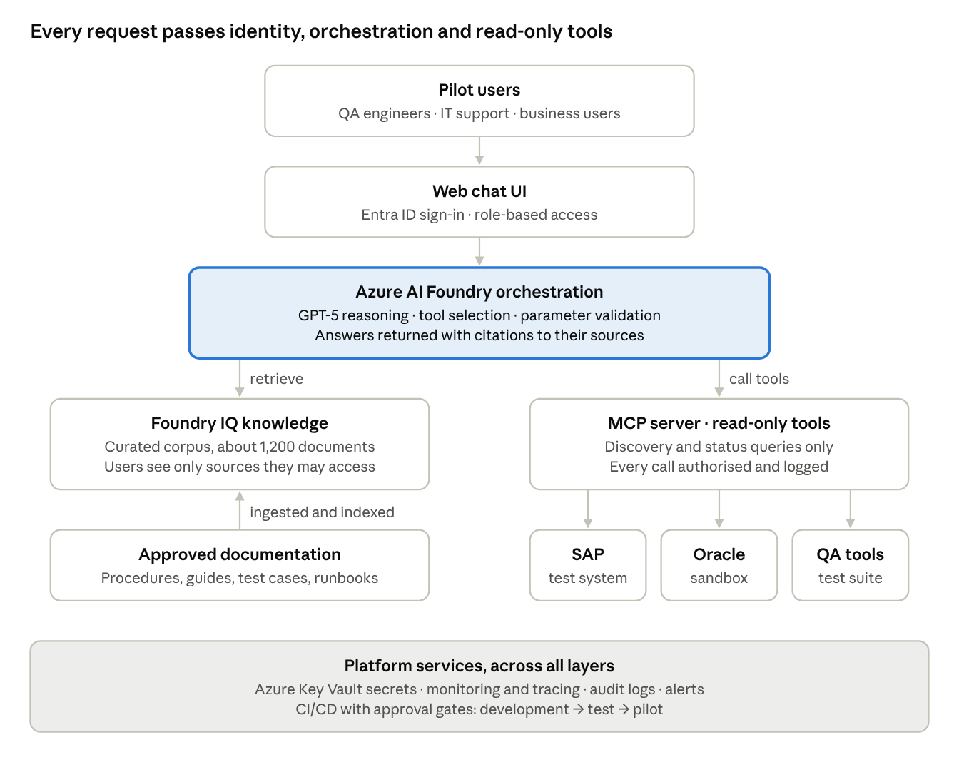
solution architecture · 6 layers, read-only integration
A question passes through Entra ID sign-in and the AI Foundry orchestrator. The orchestrator then retrieves from Foundry IQ or calls read-only MCP tools on SAP, Oracle and the QA tools. The answer comes back with its sources, and every tool call is logged.

Technical architecture
The solution runs entirely inside the VOIS Azure tenant, in one approved region, on private networking. No data or prompts leave the tenant boundary.
Azure service map (tentative; sizes confirmed at M1)
Layer | Component | Azure service | Purpose
Experience | Web chat UI | Azure App Service (Linux, P1v3) | Hosts the React chat front end and the API gateway
Experience | API front door | Azure API Management (Developer → Standard v2) | Rate limiting, authentication policies, request logging
Identity | Sign-in and roles | Microsoft Entra ID | Single sign-on, role groups, conditional access
Orchestration | AI orchestrator | Azure AI Foundry project + Azure Container Apps | Agent logic, prompt templates, tool routing, guardrails
Models | Reasoning model | GPT-5 (Azure OpenAI in AI Foundry), standard deployment | Answer generation and tool selection
Models | Embeddings | text-embedding-3-large | Vectorises documents and queries
Models | Visuals (optional) | GPT_Image-2 | Diagrams and visual explanations, proof of concept only
Knowledge | Retrieval | Foundry IQ on Azure AI Search (Standard S1) | Hybrid vector + keyword search, semantic ranking, security trimming
Knowledge | Document store | Azure Blob Storage + Document Intelligence | Raw files, OCR and layout extraction before indexing
Integration | MCP server | Azure Container Apps (private) | Read-only tools for SAP, Oracle and QA systems
Integration | Connectivity | Private Endpoints, VNet, ExpressRoute (existing) | Private path to on-premises SAP and Oracle test systems
Security | Secrets and keys | Azure Key Vault + managed identities | No credentials in code; key rotation
Security | Content safety | Azure AI Content Safety, Prompt Shields | Detects jailbreaks, prompt injection and harmful content
Data | Conversation and audit store | Azure Cosmos DB (serverless) | Chat history, feedback, tool-call audit records
Operations | Monitoring | Azure Monitor, Application Insights, Log Analytics | Tracing, latency, token usage, alerts
Operations | Delivery | Azure DevOps / GitHub Actions + Bicep | CI/CD and infrastructure as code
Request flow
- The user signs in with Entra ID. The UI receives a token carrying their role groups.
- API Management validates the token, applies rate limits and passes the request to the orchestrator.
- Content Safety and Prompt Shields screen the question for injection or jailbreak attempts.
- GPT-5 decides whether the question needs knowledge retrieval, a tool call, or both.
- For knowledge, Foundry IQ searches Azure AI Search. Results are filtered to documents the user's groups may read.
- For tools, the orchestrator calls the MCP server. The server checks the user's permission, validates the parameters and runs a read-only query against SAP, Oracle or the QA tool.
- GPT-5 writes the answer from the retrieved passages and tool results, with a citation for each claim.
- The answer, its sources and the tool-call record are logged to Cosmos DB and Application Insights, then returned to the user.
Environments
Environment | Purpose | Data | Connected systems
Development | Build and unit test | Synthetic and approved sample documents | Mock SAP/Oracle services
Test | Integration, security, performance, evaluation | Approved sample corpus | SAP test system, Oracle sandbox, QA tools (non-prod)
Pilot | UAT and pilot use by ~150 users | Approved corpus, data-owner signed | Same non-prod systems, read-only
Security architecture
- Network. All PaaS services use private endpoints. There is no public access except the web front end, which sits behind API Management and Entra ID.
- Identity. Managed identities between services. The MCP server uses a dedicated read-only service account for each system, stored in Key Vault.
- Data protection. Encryption at rest with platform-managed keys (customer-managed keys if InfoSec requires). TLS 1.2+ in transit. No model training on VOIS data.
- Authorisation. Security trimming in search, and permission checks per tool call, mapped to Entra ID groups.
- Audit. Every question, retrieved source and tool call is logged, with 90-day retention for the pilot.
Non-functional targets (pilot)
Attribute | Target
Availability | 99.5% in business hours
Response time | P95 ≤ 8 s at 50 concurrent users
Capacity | 150 users, about 3,000 questions a day at peak
Recovery | RPO 24 h, RTO 8 h (redeploy from infrastructure as code)
Data residency | Single approved Azure region, VOIS tenant only
Key architecture decisions
ID | Decision | Rationale
AD-01 | Azure AI Foundry as the single AI platform | Client mandate; enterprise controls; managed GPT-5 access
AD-02 | MCP as the tool-integration standard | Reusable, auditable tool contracts across SAP, Oracle and QA
AD-03 | Read-only tools in the pilot | Limits blast radius; write actions deferred to Phase 2
AD-04 | Hybrid search with security trimming | Better recall on technical terms; enforces document permissions
AD-05 | Infrastructure as code (Bicep) for every environment | Repeatable builds; fast recovery; audit trail of changes

8. Milestones and high-level schedule
The project runs from 19 Oct 2026 to 12 Mar 2027: 20 delivery weeks plus one week lost to public holidays. Five phase gates control progress, and none of them can be passed until its exit criteria are met.
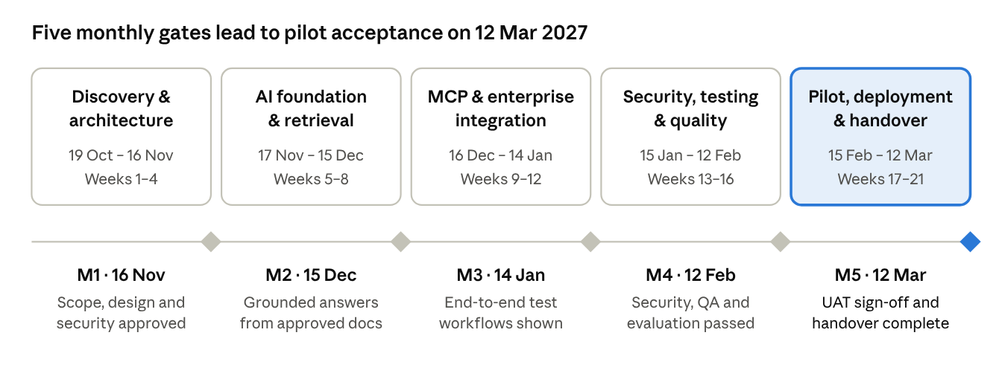
roadmap · 5 phases, 5 gates
Each diamond is a Steering Committee gate at the end of its phase. The words under each gate are its exit criterion.
The detailed schedule is the baseline WBS. It covers 51 activities and 5 milestones, with dependencies, owners and effort, and is maintained by the Project Lead. Any change to a gate date needs Steering Committee approval (Section 15).

9. Budget and funding
The requested budget is ₹131.7 lakh. It covers ₹105.6 L of delivery labour, ₹15.5 L of cloud and tooling, and ₹10.6 L of management reserve that only the Sponsor can release. All figures are planning estimates (±15%) to be confirmed at the M1 gate.
Cost summary (₹ lakh)
Cost element | Basis of estimate | ₹ L
Delivery labour | 330 person-days × ₹0.32 L blended day rate, from the WBS | 105.6
Azure consumption | AI Foundry, GPT-5 tokens, Foundry IQ, compute, storage, monitoring across dev, test and pilot (5 months) | 12.0
Tooling and licences | Evaluation, test automation and observability tools; pilot-period licences | 3.5
Base budget |  | 121.1
Management reserve | 10% of labour, released only by the Sponsor through change control | 10.6
Total requested |  | 131.7
Labour by phase (₹ lakh)
Phase | Weeks | ₹ L
M1 — Discovery and architecture | 1–4 | 17.0
M2 — AI foundation and knowledge retrieval | 5–8 | 17.3
M3 — MCP and enterprise integration | 9–12 | 23.7
M4 — Security, testing and quality | 13–16 | 23.6
M5 — Pilot, deployment and handover | 17–21 | 24.0
Financial controls
- Spend is tracked with earned value (PV, EV, AC) and reported weekly as SPI and CPI. Both should stay at 0.95 or above.
- If CPI or SPI falls below 0.90 for two consecutive weeks, the issue goes to the Steering Committee.
- Azure spend is capped with budget alerts at 80% and 100% of the monthly allocation.
- Funding is released by phase gate. Each gate approval releases the next phase's budget.
SAP, Oracle and Microsoft enterprise licences, and the time of VOIS application SMEs, are provided by VOIS and are excluded from this budget.

Tentative cost breakdown
This breakdown supports the ₹131.7 L request above. All figures are indicative, exclude GST (18%), and are re-baselined at the M1 gate once Azure sizing and SME availability are confirmed.
Delivery labour by role (₹ lakh)
Role | Name | Person-days | Day rate (₹ L) | Cost (₹ L)
Engagement Director | Bipeen Sinha | 10 | 0.55 | 5.5
Project Lead & Delivery Manager | Shruti Sinha | 50 | 0.42 | 21.0
Solution Architect | Karthik Iyer | 30 | 0.45 | 13.5
AI / RAG Engineers (2) | Priya Nair, Arjun Mehta | 70 | 0.30 | 21.0
Backend / MCP Engineers (2) | Rohan Kulkarni, Sneha Joshi | 70 | 0.26 | 18.2
Frontend Engineer | Meera Pillai | 30 | 0.22 | 6.6
QA Engineer | Divya Shetty | 35 | 0.22 | 7.7
Security Engineer | Aditya Bose | 15 | 0.38 | 5.7
DevOps Engineer | Farhan Qureshi | 20 | 0.32 | 6.4
Total labour |  | 330 | 0.32 blended | 105.6
Azure consumption, 5 months across dev, test and pilot (₹ lakh)
Service | Sizing assumption | Cost (₹ L)
GPT-5 (Azure OpenAI in AI Foundry) | Development, evaluation runs, load tests, ~3,000 pilot questions/day | 4.2
Azure AI Search (Foundry IQ) | Standard S1, test and pilot indexes | 1.8
App Service + Container Apps | Web UI, orchestrator, MCP server; 3 environments | 1.5
API Management | Developer tier (dev/test), Standard v2 (pilot) | 1.0
Cosmos DB, Blob Storage, Document Intelligence | Chat history, audit records, document extraction | 1.0
Azure Monitor, Application Insights, Log Analytics | Tracing and logs, 90-day retention | 0.9
Private endpoints, Key Vault, Content Safety | Networking and security services | 0.8
Embeddings (text-embedding-3-large) | Initial indexing plus re-indexing | 0.3
GPT_Image-2 (optional proof of concept) | Limited image generation tests | 0.5
Total Azure |  | 12.0
Azure spend ramps from about ₹0.6 L in Month 1 to about ₹3.6 L in Month 5, peaking during load testing and the pilot.
Tooling and licences (₹ lakh)
Item | Cost (₹ L)
Evaluation and test-automation tooling | 1.2
Security testing tools (DAST, AI red-teaming) | 1.0
Delivery collaboration seats (backlog, wiki, design) | 0.7
Observability add-ons | 0.6
Total tooling | 3.5
Indicative payment schedule (labour fees, on gate acceptance)
Gate | Share | Amount (₹ L) | Target date
M1 — Architecture approved | 15% | 15.8 | 16 Nov 2026
M2 — AI assistant MVP | 20% | 21.1 | 15 Dec 2026
M3 — Application integrations | 25% | 26.4 | 14 Jan 2027
M4 — Release candidate | 20% | 21.1 | 12 Feb 2027
M5 — Pilot accepted | 20% | 21.2 | 12 Mar 2027
Azure and tooling costs are billed at actuals each month. The management reserve (₹10.6 L) is drawn only through approved change requests.
Indicative run cost after the pilot (Phase 2, about 1,000 users)
Element | Monthly (₹ L)
Azure consumption (production sizing, high availability) | 4.0 – 6.0
L2/L3 application support (about 2 FTE) | 9.5 – 10.5
Model and content upkeep (evaluation, re-indexing) | 0.5 – 1.0
Total monthly run cost | 14.0 – 17.5
The run cost is for planning the Phase 2 business case only. It is not part of this charter's approval.

10. Governance, organisation and roles
The project is jointly led by Bipeen Sinha (Engagement Director) and Shruti Sinha (Project Lead & Delivery Manager). They report to a Steering Committee chaired by the Executive Sponsor.
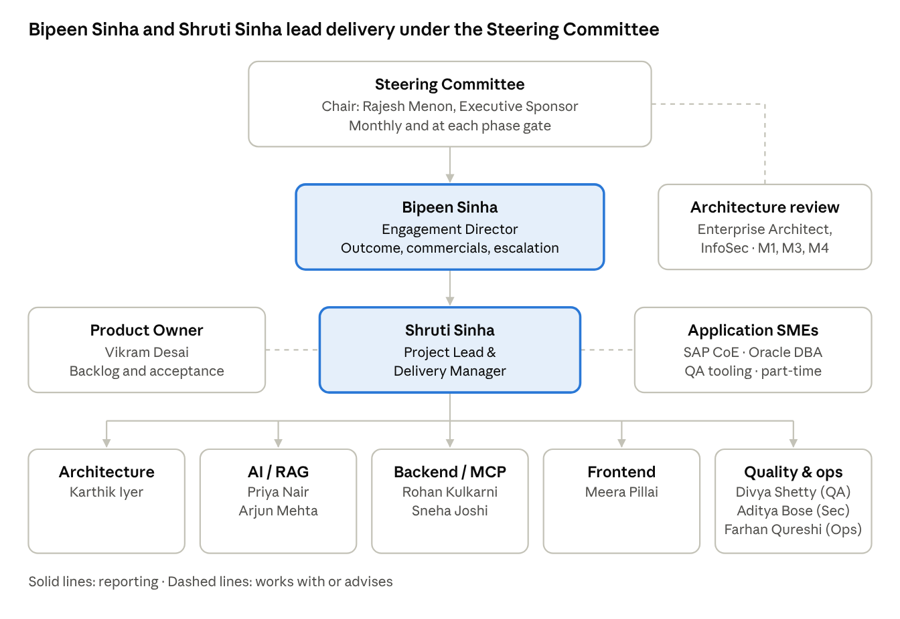
project organisation · governance and delivery team
The Steering Committee directs the project through Bipeen Sinha. Shruti Sinha runs the delivery team day to day, working with the Product Owner and the application SMEs.
Project authority
- Bipeen Sinha, Engagement Director. Accountable for overall outcome, client relationship, commercial terms and the budget. Chairs the delivery side of the Steering Committee. Approves changes up to ₹5 L or 5 working days, and is the escalation point for anything cross-organisational.
- Shruti Sinha, Project Lead & Delivery Manager. Accountable for day-to-day delivery: plan, scope, schedule, quality, RAID log and team. Runs the sprints and the weekly status. Approves changes up to ₹2 L or 2 working days that do not affect a gate date. Also gives technical leadership on the Azure AI and cloud architecture.
Governance bodies
Forum | Chair | Members | Cadence | Purpose
Steering Committee | Rajesh Menon (Sponsor) | Bipeen Sinha, Shruti Sinha, Product Owner, VOIS InfoSec, Enterprise Architecture | Monthly + each phase gate | Direction, gate approval, budget release, major changes and escalations
Project Management Board | Bipeen Sinha | Shruti Sinha, Product Owner, Solution Architect | Fortnightly | Progress, risks, change requests within delegated limits
Architecture & Security Review | VOIS Enterprise Architect | Solution Architect, Security Engineer, InfoSec | At M1, M3, M4 | Design and security approval
Delivery team stand-up | Shruti Sinha | Core team | Daily, 15 min | Progress and blockers
Sprint review | Product Owner | Core team, SMEs, invited users | Every 2 weeks | Demo and backlog acceptance
Roles and responsibilities
Role | Name | Key responsibilities
Executive Sponsor | Rajesh Menon | Owns the business case; approves charter, gates, budget and reserve
Engagement Director | Bipeen Sinha | Overall accountability, commercials, stakeholder and escalation management
Project Lead & Delivery Manager | Shruti Sinha | Planning, delivery, RAID, reporting, team leadership, cloud architecture guidance
Product Owner | Vikram Desai | Backlog, use-case priority, acceptance of deliverables, UAT leadership
Solution Architect | Karthik Iyer | Architecture, integration contracts, technical decisions, handover
AI / RAG Engineers | Priya Nair, Arjun Mehta | GPT-5, Foundry IQ, prompts, retrieval, evaluation
Backend / MCP Engineers | Rohan Kulkarni, Sneha Joshi | MCP server, tools, SAP/Oracle/QA connectors
Frontend Engineer | Meera Pillai | Chat UI and user experience
QA Engineer | Divya Shetty | Test strategy, evaluation datasets, regression, UAT support
Security Engineer | Aditya Bose | Entra ID, authorisation, AI security testing
DevOps Engineer | Farhan Qureshi | Azure environments, CI/CD, observability
Application SMEs | SAP CoE, Oracle DBA team, QA tooling owners | Use cases, API access, business validation (part-time)
Team member names other than the leads and sponsor are proposed and confirmed at mobilisation.
Decision rights (RACI summary)
Decision | Sponsor | Bipeen Sinha | Shruti Sinha | Product Owner | Steering Committee
Charter and baseline approval | A | R | R | C | C
Phase gate pass | A | R | R | C | R
Scope change > ₹5 L or gate slip | A | R | C | C | R
Scope change ≤ ₹5 L, no gate impact | I | A | R | C | I
Backlog priority | I | I | C | A/R | I
Technical architecture | I | C | A | C | I
Release to pilot (go/no-go) | A | R | R | C | R
R = Responsible · A = Accountable · C = Consulted · I = Informed

11. Stakeholders and communication plan
Stakeholders are engaged according to their influence and interest. The sponsor, InfoSec and the SAP and Oracle system owners are managed closely, because each can block a gate.
Stakeholder register
Stakeholder | Interest in the project | Influence | Interest | Engagement approach
Executive Sponsor — Rajesh Menon | Business value, budget, risk | High | High | Manage closely: monthly SteerCo, gate reviews
VOIS Information Security | Data protection, AI security | High | High | Manage closely: design reviews, test evidence
SAP & Oracle system owners | System stability, access control | High | Medium | Keep satisfied: early access requests, integration demos
Enterprise Architecture | Platform standards, reuse | Medium | High | Keep informed + review at M1, M3
QA & testing teams (pilot users) | Faster triage, accurate answers | Medium | High | Involve: use-case workshops, sprint demos, UAT
IT support teams (pilot users) | Faster resolution, fewer escalations | Medium | High | Involve: UAT, training, feedback loop
Business users | Self-service answers | Low | Medium | Keep informed: pilot onboarding, newsletters
Microsoft account team | Model availability, quotas | Medium | Medium | Consult: quota and region requests
Data protection officer | Personal-data handling | High | Medium | Consult at M1 and before pilot
Communication plan
Communication | Audience | Owner | Frequency | Channel
Weekly status report (RAG, SPI/CPI, RAID, next steps) | Sponsor, PMB, workstream leads | Shruti Sinha | Weekly, Friday | Email + dashboard
Steering Committee pack | SteerCo | Bipeen Sinha | Monthly + gates | Meeting + deck
Project Management Board | PMB | Bipeen Sinha | Fortnightly | Meeting
Sprint review demo | Product Owner, SMEs, pilot champions | Shruti Sinha | Every 2 weeks | Teams meeting
Daily stand-up | Delivery team | Shruti Sinha | Daily | Teams
Risk and issue escalations | As per escalation path | Shruti Sinha | As needed, within 24 h | Email + call
Pilot user updates | Pilot users | Product Owner | Fortnightly from Week 16 | Newsletter / Teams channel
Project closure report | Sponsor, SteerCo | Bipeen Sinha | Once, at M5 | Report + meeting

12. Assumptions, constraints and dependencies
The plan holds only if VOIS provides non-production access to SAP, Oracle and the QA tools by Week 6, and if GPT-5 and Foundry IQ are available in the chosen Azure region.
Assumptions
- GPT-5, Foundry IQ and, optionally, GPT_Image-2 are available and can be configured in the target Azure tenant and region. This is validated in Weeks 1–6.
- The pilot uses read-only MCP tools only. Write operations need a separate security review and approval.
- Approved, non-confidential sample documentation (about 1,200 documents) is supplied by Week 5.
- Application SMEs are available for about 4 hours a week each, and for 2 days during UAT.
- The core team of about 10 people is mobilised by 19 Oct 2026 and stays stable for the project.
- Pilot users (about 150) are released for onboarding and UAT in Weeks 17–20.
Constraints
- Time. Pilot acceptance by 12 Mar 2027. Five public holidays are already built into the plan.
- Budget. ₹131.7 L, including a 10% management reserve.
- Data. No confidential production data in development or test environments without formal approval.
- Platform. Microsoft Azure AI Foundry and Entra ID are mandated. No other cloud or public AI services may be used.
- Compliance. Vodafone Group information-security standards and data-protection policies apply in full.
Dependencies
ID | Dependency | Provider | Needed by | Impact if late
DEP-01 | Azure subscription and AI Foundry access approved | VOIS Cloud CoE | Week 5 | M2 slips day for day
DEP-02 | Non-production SAP access and API documentation | SAP CoE | Week 8 | SAP proof of concept at risk
DEP-03 | Oracle sandbox access and licence approval | Oracle DBA team | Week 8 | Oracle proof of concept at risk; M3 slips
DEP-04 | QA/testing tool API access | QA tooling owners | Week 9 | QA connector at risk
DEP-05 | Entra ID app registration and role groups | Identity team | Week 12 | Security work in Month 4 delayed
DEP-06 | GPT-5 quota sufficient for load testing | Microsoft / VOIS Cloud CoE | Week 14 | Performance testing throttled
DEP-07 | Pilot environment and rollback approval | VOIS Operations | Week 18 | Pilot deployment slips

13. Key risks and mitigations
The two highest risks are late SAP or Oracle access and an AI security failure. Each has a named owner and a mitigation that starts in Month 1.
Scoring: probability (P) and impact (I) are each rated 1–5, and the score is P × I. A score of 15 or more is High, 8–14 is Medium, and 7 or less is Low.
ID | Risk | P | I | Score | Mitigation | Owner
R-01 | SAP/Oracle API access, licensing or non-production environments not ready in time | 4 | 5 | 20 High | Access requests raised in Week 1; mock services; reduced M3 scope pre-agreed as a fallback | Bipeen Sinha
R-05 | Prompt injection or unsafe tool use leads to data leakage | 3 | 5 | 15 High | Read-only tools; parameter validation; permission checks; red-team testing in Month 4 | Aditya Bose
R-07 | Part-time SME availability delays use cases, validation and UAT | 4 | 3 | 12 Medium | Fixed weekly SME slots agreed at kickoff; escalation via Sponsor | Shruti Sinha
R-03 | Poor document quality or unclear ownership weakens retrieval | 3 | 4 | 12 Medium | Data-source assessment in Week 3; curated corpus; named content owners | Priya Nair
R-06 | Hallucination or evaluation thresholds not met by the release candidate | 3 | 4 | 12 Medium | Baseline evaluation in Month 2; prompt and retrieval tuning; citations enforced | Arjun Mehta
R-08 | Scope creep into write operations or more applications | 3 | 4 | 12 Medium | Change control (Section 15); write operations deferred to Phase 2 | Vikram Desai
R-02 | GPT-5 or Foundry IQ unavailable in the target region or tenant | 2 | 4 | 8 Medium | Availability checked in Weeks 1–6; fallback model and region identified | Shruti Sinha
R-04 | Confidential production data ingested into development | 2 | 5 | 10 Medium | Approved sample data only; classification gate before ingestion | Aditya Bose
R-09 | Response-time or concurrency targets missed | 2 | 3 | 6 Low | Early performance spike; caching; right-sized deployments | Farhan Qureshi
R-10 | Low pilot adoption limits feedback and the business case | 2 | 3 | 6 Low | Lead with the QA & Testing Assistant use case; onboarding and pilot champions | Vikram Desai
The full RAID log is kept in the WBS workbook. It is reviewed weekly by the Project Lead and fortnightly by the Project Management Board.

14. Quality, security and responsible AI
No release reaches pilot users without three things:
- a clean AI security test
- evaluation results at or above the Section 4 thresholds
- InfoSec sign-off
Quality management
- A test strategy is agreed in Month 1, covering unit, integration, regression, performance and UAT testing.
- An evaluation benchmark of about 250 questions with gold-standard answers is built by Week 8. It is re-run every sprint from Week 8 onwards.
- Defect severity runs from 1 to 4. A release can only go out with no open severity-1 or severity-2 defects.
- Peer review is mandatory for code, prompts and system instructions. Prompts are version-controlled like code.
Security controls
- Microsoft Entra ID single sign-on, with role-based access mapped to VOIS role groups.
- Authorisation at the source and application level: users only get answers from documents and systems they are already allowed to see.
- Secrets are held in Azure Key Vault. There are no credentials in code or configuration files.
- Every MCP tool call is logged with the user, tool, parameters and result, so it can be audited.
- Before the M4 gate, testing covers:
  - threat modelling
  - prompt-injection and jailbreak testing
  - data-leakage and unsafe-tool-request testing
Responsible AI
- Every answer must cite its sources. Where no source supports an answer, the assistant must say so instead of guessing.
- Read-only tooling means the assistant cannot change business systems.
- Users can rate answers and flag wrong ones. Feedback is reviewed weekly during the pilot.
- Microsoft Responsible AI content filters are enabled. Model, prompt and data changes are recorded in a change log.
Compliance
- Vodafone Group information-security standards apply.
- Data protection and privacy obligations are reviewed with the Data Protection Officer before ingestion and before the pilot.
- Data stays in the approved Azure region and VOIS tenant.

15. Change control, escalation and closure
Any change to scope, schedule, budget or a deliverable's acceptance criterion goes through a written change request. The size of its impact decides who can approve it.
Change control process
- Raise. Anyone may raise a change request, giving the description, the reason and the urgency.
- Assess. Shruti Sinha assesses the impact on scope, schedule, cost, quality and risk within 3 working days.
- Decide. The approver is set by the impact, as in the table below.
- Baseline. Approved changes update the WBS, budget and RAID log, and are recorded in the change log.
- Communicate. The change is announced in the next weekly status report.
Impact of change | Approver
≤ ₹2 L and ≤ 2 working days, no gate impact | Shruti Sinha (Project Lead)
≤ ₹5 L or ≤ 5 working days, no gate impact | Bipeen Sinha (Engagement Director)
> ₹5 L, any gate-date change, scope added or removed, or use of management reserve | Steering Committee / Executive Sponsor
Escalation path
Level | Escalated to | Trigger | Response time
1 | Shruti Sinha | A blocker the team cannot clear within 1 working day | Same day
2 | Bipeen Sinha | Issue risks a milestone, or a cross-team or vendor issue | 2 working days
3 | Executive Sponsor / Steering Committee | Gate at risk, budget variance over 10%, or SPI/CPI below 0.90 for 2 weeks | 5 working days, or an extraordinary SteerCo
Project closure criteria
- ☐ Pilot UAT signed off by business leads, with no open severity-1 or severity-2 defects
- ☐ KPI results measured and reported against Section 4
- ☐ Handover package accepted by the operations / run team, with support ownership named
- ☐ All deliverables D1–D15 accepted
- ☐ Final project report and lessons learned presented to the Steering Committee
- ☐ Production rollout decision recorded (go, go-with-conditions or Phase 2 re-scope)
- ☐ Financial close: actual cost reconciled and unused reserve returned
- ☐ Project environments and access reviewed; temporary access removed

16. Authorisation and sign-off
Signing this charter authorises the project to start on 19 Oct 2026 and commits the named resources and budget. It also gives Bipeen Sinha and Shruti Sinha the authority set out in Section 10.
Role | Name | Signature | Date
Executive Sponsor | Rajesh Menon
Engagement Director | Bipeen Sinha
Project Lead & Delivery Manager | Shruti Sinha
Product Owner | Vikram Desai
VOIS Information Security | To be nominated
VOIS Enterprise Architecture | To be nominated
Related documents: baseline WBS, schedule and RAID workbook; requirements specification (D2); solution architecture (D3); security design (D4).

